**Lab #2 –Logic Expressions in Hardware**

**Objective:** to correlate wiring ICs on breadboard with circuit diagrams

**Equipment required:**

* National Instruments ELVIS II Prototype Board
* 8-pin DIP switch
* 7404 – HEX Inverter
* 7408 – QUAD 2-input AND
* 7432 – QUAD 2-input OR
* Assorted resistors, R = 330 Ω
* Assorted wires

**Procedure:**

1. Implement the function F on the circuit board, as per your wiring diagram created in the Pre-Lab. Please recall that the physical implementation of test input signals A, B, and C are achieved by connecting the voltage source to one side of the switch, and resistors on the other side of the switch. In a similar manner, the output signal of your circuit should utilize an LED/resistor set-up for display of the output.

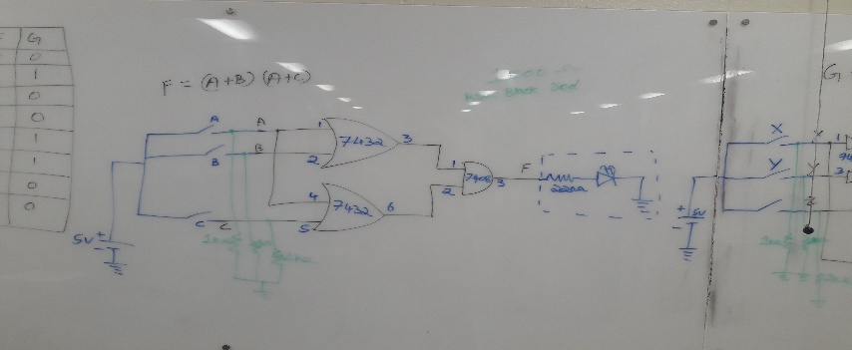

1. Representing the closed switch with “1” and the open switch with a “0,” create a table, and flip the switches to obtain all the possible combinations of inputs. Read the output via the LED and annotate the results on your table.

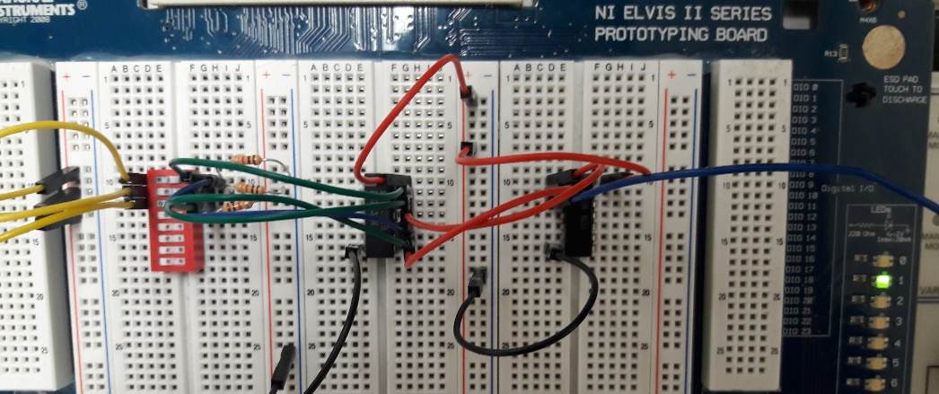

1. Repeat steps 1 and 2 for the function G, given as part of the Pre-Lab exercise.

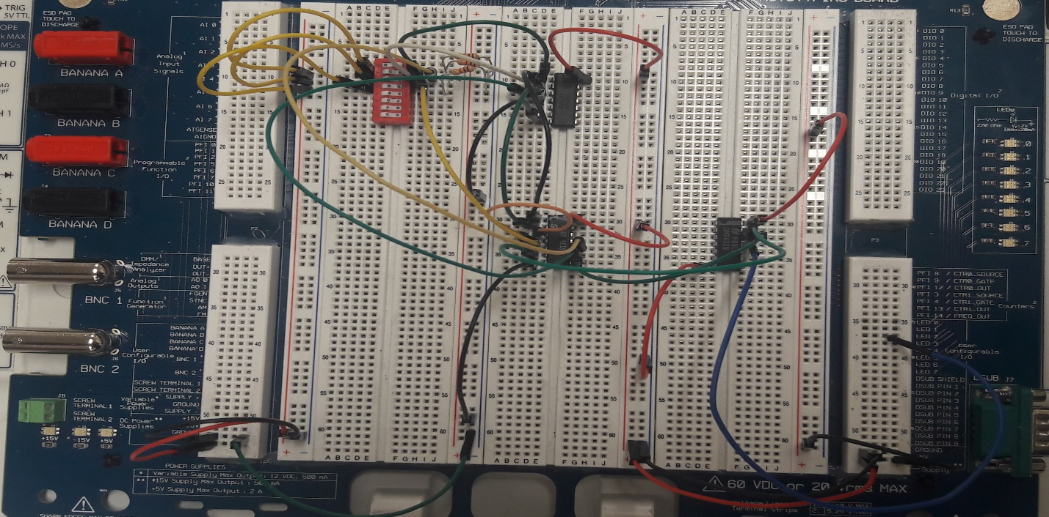

**Conclusion:**

1. Did your circuit diagram for F, produced in Step 1 of the Pre-Lab match the wiring diagram produced in Step 2 of the Pre-Lab?

Yes

1. Did your circuit diagram for G, produced in Step 1 of the Pre-Lab match the wiring diagram produced in Step 2 of the Pre-Lab? What changes were necessary in order to implement G with the IC provided on the wiring diagram?

Yes, we need to implement switches to all three of the inputs, and more wiring for all the ground pins, and resistors.

1. Did the output of the circuit you wired for functions F and G produce the expected results? That is, did the LED display match the values on the tables produced for Pre-Lab Step 3?

For function F, the LED results were correct, but for function G, the results were not right, because many of my OR gates were broken.

1. Can you think of a potential negative outcome for “cascading” 2-input gates in place of 3- or 4- or N-input gates?

Could affect the performance, it seems unnecessary, a more simplified circuit and more efficient could be made.

1. Using your answers from questions 1 through 4, write a paragraph stating what you learned in this lab.

I learned how to implement multiple gates and how to make them interact between them, I learned that if you are not careful, and don’t follow the diagram correctly you can burn an IC chip. The wires could also not be working properly and could cause more problems. We learned about resistors and where and how to implement them on a circuit. And how to use AND, NOR, OR IC chips and how they can be implemented to create complex output.