This script is to be run on preprocessed data to prepare for Univariate and/or Multivariate analysis. The script checks for common issues, completes preprocessing of VTCs if needed (link PRT, temporal filtering, and spatial smoothing), and performs several post-preprocessing (but pre-analysis) actions including SDM/MDM generation.

1. Requirements
   1. MATLAB
   2. NeuroElf toolbox for MATLAB installed (tested with neuroelf_v10_5153)
   3. Brainvoyager QX or 20 (only if performing additional VTC preprocessing)
      1. Probably requires Windows (not tested on Mac or Linux)
2. Register connection to BV if you will be doing any VTC preprocessing (to be done only once)
   1. BV20 Method:

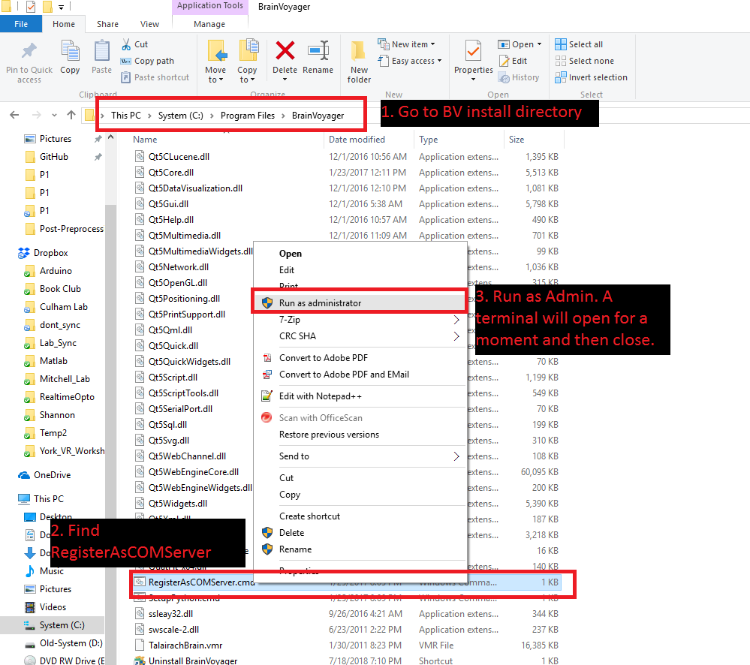

* 1. BVQX Method (supports versions 1.9 and newer):
     1. Open a command prompt with admin privileges

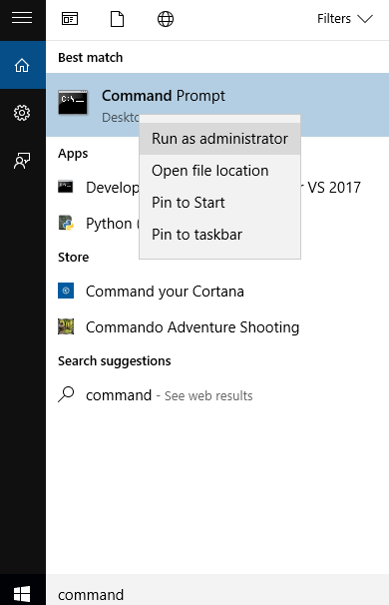

* + 1. Go to the BV install directory - likely to be in C:\Program Files (x86)
    2. Enter BrainVoyagerQX.exe -regserver  
       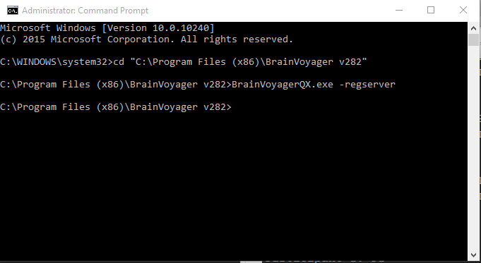

1. If you just registered the BV COM server and MATLAB is open, restart MATLAB.
2. Make a copy of the provided excel template with an informative name (e.g., project name and date), and fill in all of the fields. The excel file contains descriptions of each setting.
   1. If you want to use an existing excel settings file, but new fields have been added then you will need to run “UpdateExcelFields.m” and select the existing file to update it. Any missing fields will be added and the descriptions/etc. will be updated (the value column will not be changed). This script creates a backup of the original file.
3. Run the MATLAB script (no parameters) and select the excel file that filled in.
4. The script will now do the following:
   1. Read settings from excel
   2. Check for completeness of preprocessing outputs
   3. Check BBR values of each run (anatomical-to-functional alignment)
   4. Check motion across runs of each participant
   5. Find each PRT, copy it to the BV folder if it isn’t there already, and link it to each VTC of the corresponding run.
   6. Complete any VTC-level preprocessing (spatial smoothing and/or temporal high pass + linear trend removal). This step also checks that the expected FMR-level preprocessing was completed.
   7. Check the TR and number of volumes in each VTC.
   8. Generate SDMs from the PRTs.
   9. Generate MDMs for each participant and for all participants.
5. Text output will be displayed in MATLAB and written to a log file in the script output folder (location is defined in excel).
6. File outputs including motion plots will be saved to the script output folder.