**Requirements:**

* MATLAB (64 bit) with Psychtoolbox (<http://psychtoolbox.org/>)
* Minimum screen resolution of 480x854
* 16gb of memory (requires 10gb when videos are loaded)
* Directory organized as show below:

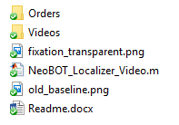

**Notes:**

* Works on most Matlab versions and on most operating systems
* Key bindings, TR, and timing can be changed in the parameters sections, along with several other settings

*Enter* ***help NeoBOT_Localizer_Video*** *in the MATLAB Command Window for more information*