- Simplified order files
  - Removed fields: Motion, Format, and Fixation
  - Converted {char} to strings and numeric
  - Saved in two formats
    - .mat used by the code because readtable sometimes fails
    - .csv for quick checks outside of MATLAB
- The fixation image is now expected to be in the Images folder with the main stims
- All parameters were moved to a “GetParameters” file
  - Obsolete parameters were removed
  - Parameters were reorganized and renamed for clarity
  - This function also calls the Psychtoolbox setup functions because they are needed to get screen number, key codes, etc.
- Made the following changes:
  - Removed all code for both video and sliding images
    - Stationary 2D and 3D images are now the only display modes
  - Improved the implementation of the manual blueline method
    - Should be more intuitive / easier to troubleshoot
    - Should also prevent situations where the display could freeze for 5-10 milliseconds at the end of each volume when looking for the trigger
      - While unlikely to have been perceptible, but missed frames may have been causing projector issues
    - Now always alternates between the left/right views even across volumes
      - No longer possible to present the same view twice in a row
  - Loaded images are no longer stored in a global variable
    - They now need to be loaded at the beginning of each run instead of being held in memory. However, the new implementation is more straightforward, and the current image files are quick to read.
  - When errors are caught, the main variables are now copied into the workspace for easier troubleshooting
  - Added parameters to streamline debugging
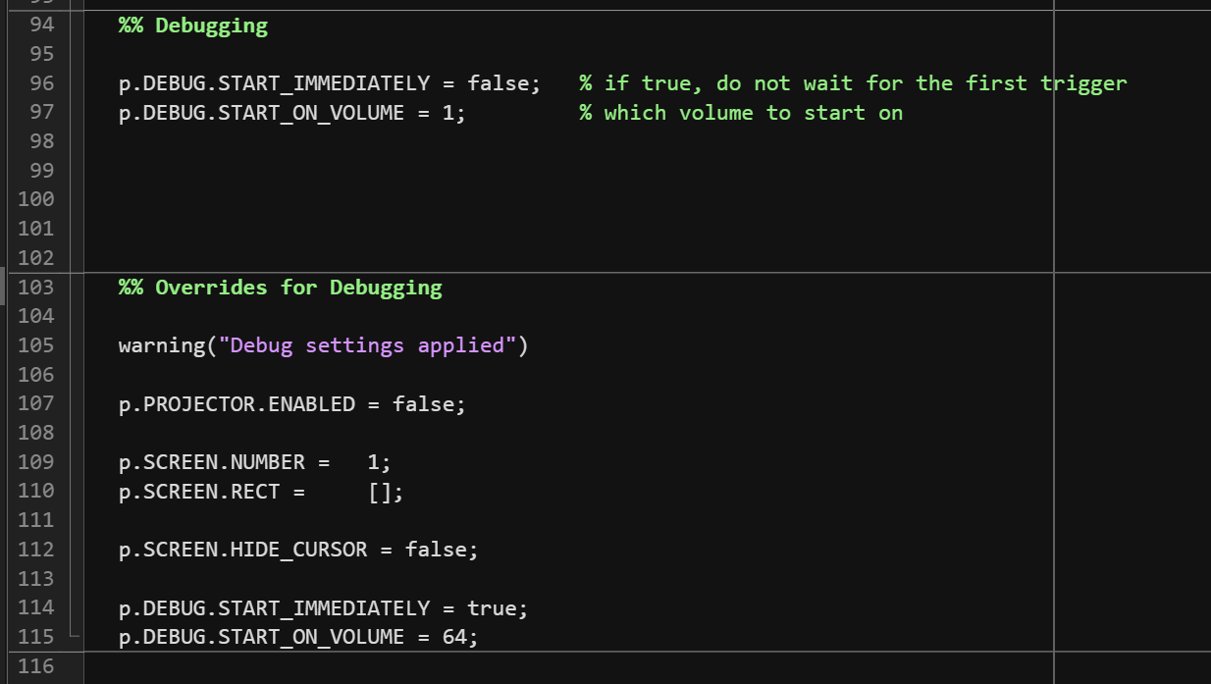
- Overview of the 3D presentation method
  - The goal is to always be presenting alternating left/right frames while still constantly checking for triggers, key presses, etc.
  - The active left + right display info is stored in s.current (s is for screen)
    - s.current.is_left indicates whether the next frame drawn will be left or right
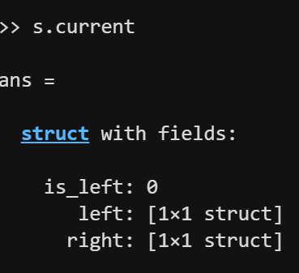
    - The s.current.left and s.current.right contain
      - Texture(s) to draw (e.g., image + fixation)
      - Location(s) to draw the texture(s)
      - Line that is associated with that view
      - text is only used during the waiting for trigger screens
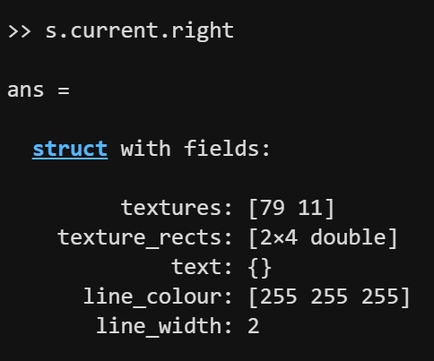
  - s.current is set by fMRI_3DCategories_PrepareVolumeFrame, which is called once at the start of each volume
    - Would be called a second time if an image needs to be removed mid-volume
    - Does not apply until the next frame is queued
  - fMRI_3DCategories_QueueNextFrame is called repeatedly and uses s.current to:
    - Check whether the next frame is left/right (and alternate for the next call)
    - Draw all required textures in their specified locations
    - Draw the 3D sync line for that view
    - Queue an asynchronous Screen flip with AsyncFlipBegin
  - The loops that are constantly checking buttons, timing, etc. should then also call the queueing function any time that the previous frame is complete
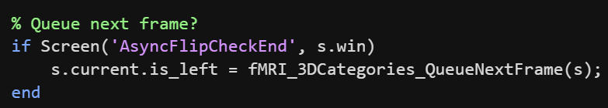
- Refactored from fully monolithic to semi-modular. The flow is now:
  - Start by manually calling fMRI_3DCategories(participant_number, run_number) in the command window
  - Sets all set parameters in fMRI_3DCategories_GetParameters
  - Performs basic startup tasks in fMRI_3DCategories_Setup
    - Store timestamp and par/run numbers, get order/data filepaths, create output folder, verify expected files, store git repo info, apply psychtoolbox settings, validate timing, prepare time-sensitive functions
  - Load the run’s order file in fMRI_3DCategories_LoadOrder
  - Create the volume-wise schedule in fMRI_3DCategories_CreateVolumeSchedule
  - Verify that all required image files exist in fMRI_3DCategories_VerifyImageFiles
  - Open the Psychtoolbox “Screen” and perform PROpixx setup in fMRI_3DCategories_OpenScreen
  - Load image files (fixation and stims), apply adjustments (e.g., resizing), and create their “Screen” textures in fMRI_3DCategories_PrepareImageTextures
  - Display 3D test while waiting for the first trigger in fMRI_3DCategories_WaitFirstTrigger
    - Time-zero (d.t0) is set when the first trigger is received
  - Perform the events of each volume in fMRI_3DCategories_DoVolume (called for each volume)
  - The main script will then save the data and close the screen
- Other functions:
  - fMRI_3DCategories_CheckKeys
    - Returns whether the trigger and/or button box keys are pressed
    - Throws an error if the stop key is pressed
  - fMRI_3DCategories_CloseScreen
    - Unhides the cursor and clears the “Screen”
  - fMRI_3DCategories_PrepareVolumeFrame
    - Sets the textures used in subsequent calls to QueueNextFrame
    - Called once at the start of each volume
      - Called a second time if the image needs to be removed mid-volume (i.e., p.TIMING.IMAGE_PRESENTATION < p.TIMING.TR)
  - fMRI_3DCategories_QueueNextFrame
    - Uses the textures set in the most recent call of PrepareVolumeFrame
    - Queues the next frame with AsyncFlipBegin
    - Alternates between left/right views with each call
    - Should only be called when AsyncFlipCheckEnd is true
      - Otherwise, it will overwrite the previously queued frame
    - The code should execute this as often as possible to ensure that alternating left/right frames are always being presented:


