Order of Direct/Mirror View and Action Metablocks
Metablock IDs 1-6 correspond to these:
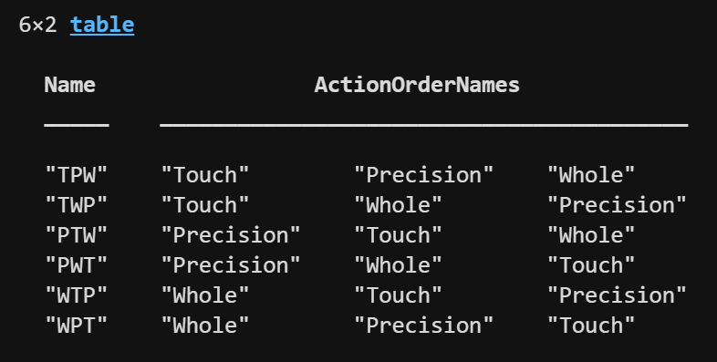

Across Participants: Initial viewing condition and very first metablock
- The first viewing condition always alternates between participants (PAR01 starts with direct view, PAR02 starts with mirror view, etc.)
- Every 6 sequential participants form a group where each has a different metablock in the first position of the first run (i.e., the very first metablock that they do)
- Each combination of first metablock and first viewing condition occurs exactly twice over the 24 participants
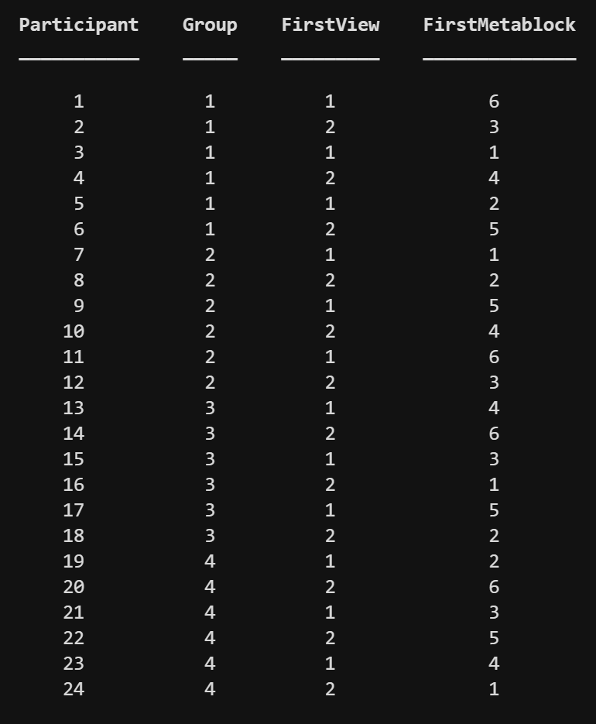

Within Participant: Metablock order
- The first metablock in run 1 is predefined above
- The first metablock in runs 2-6 use the remaining 5 metablocks and are randomized such that runs 1-3 (first viewing condition) and 4-6 (second viewing condition) both have exactly one run that begins with each action
- Then, positions 2-6 are randomly populated such that each row (run) and column (position) contain all 6 metablocks
- Additionally, each metablock follows each other metablock exactly once
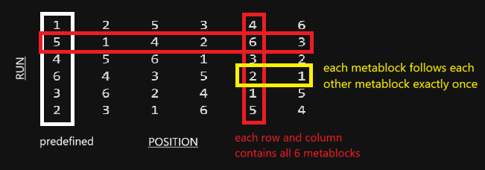

The code organizes this into a table with one row per run:
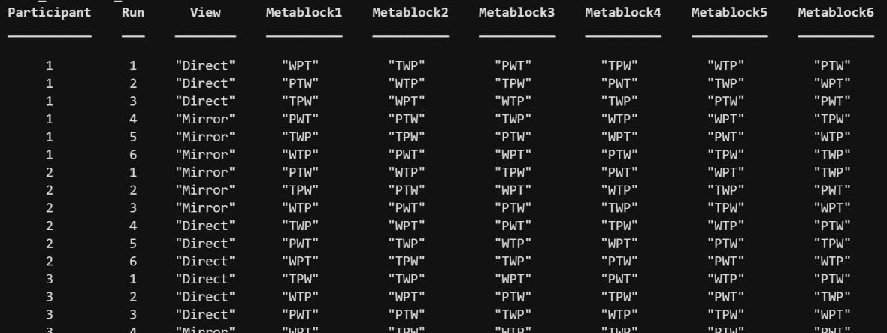

Order of Trial Positions
18 of 20 permutations used:
- There are 20 permutations of 3 left and 3 right
- LLLRRR and RRRLLL are not used leaving 18 permutations
  - Note that internal triplets (e.g., LRRRLL) were allowed
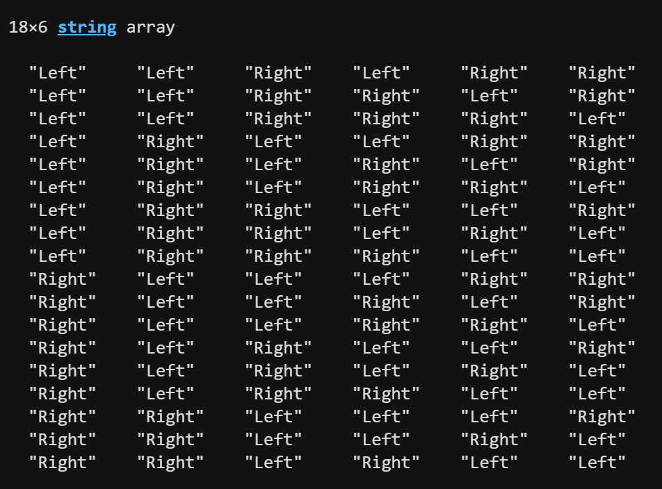

Rule 1: Every run uses all 18 permutations exactly once across the 6 metablocks x 3 actions = 18 subblocks

Rule 2: In each viewing condition (3 runs), each action uses all 18 permutations exactly once across the 3 runs x 6 metablocks = 18 subblocks

Trial order solutions are added to the table
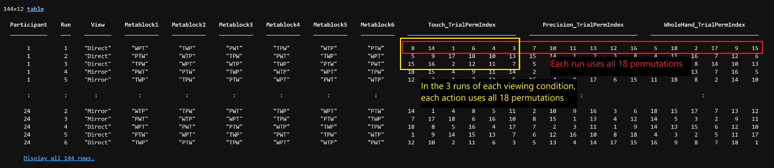

Order Files
Run orders are arranged into a table with one row per trial
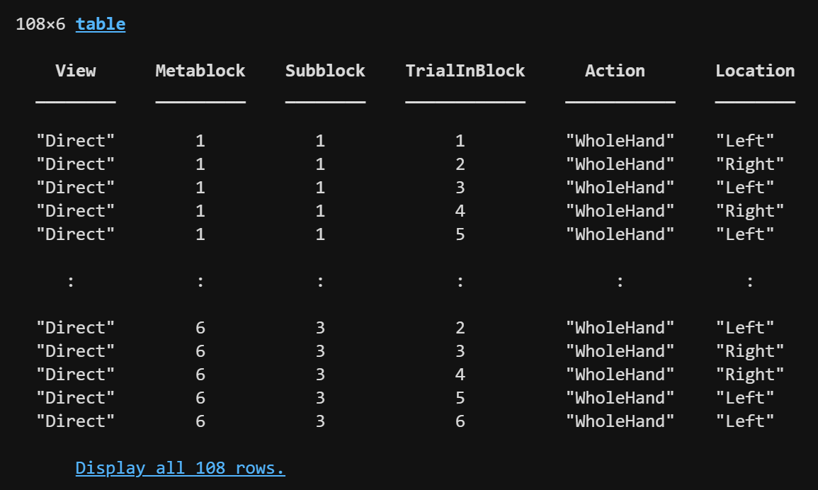

Order files do not contain timing (timing can be adjusted without needing to regenerate orders)

Order tables are written to both csv (for manual checking) and mat (for easy loading)
