Creating stimuli

# How to scramble

Blender files are found in: J:\ReachScenesStimuli

Insert solid object to the appropriate position in Blender, along XZY coordinates (the nearest point on the object should be Y=0)

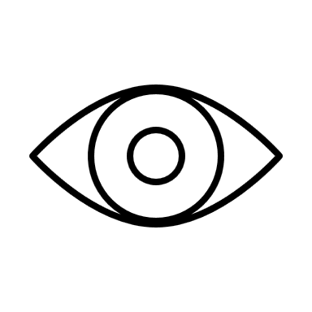

Turn on ‘edit mode’, view from perspective of observer (camera X=0, Y=-720, Z=0)

Select all visible vertex, edge, surfaces from this perspective

Split the visible region from the occluded regions of the object: press ‘P’ > ‘by selection’ to split into 2 halves

Delete occluded half



Go to ‘modifier properties’, adjust ‘Subdivision’ to be ‘Simple’ to ensure the sections are not curved



Select whole object, navigate to ‘Slice and Dice’ function. Adjust ‘slice width’ to 0.001mm. adjust ‘Number of Cuts’ to an appropriate number of horizontal and vertical slices that equate to 20 (if object is long and thin, have more horizontal than vertical, if it is square-ish then a more equal division)

If for any reason they do not slice appropriately, make manual slices with the following steps:

In edit mode, press ‘A’

Select ‘Knife’ tool, hold to adjust to ‘Bisect’

Move mouse to appropriate place to cut the object, press the left mouse button to confirm

Hold ‘Shift’ and double click on one of the orange dots, it will turn white

Got to ‘Select’ > ‘Select side of Active’, ensure all vertices on one side are selected

Press ‘P’ to split

Adjust horizontal and vertical position of each of the segments. Do not adjust the depth.



# How to create depth map

Depth maps are saved in: GitHub\fMRI_ef_scrambled-objects_2022\Stimuli\DepthMaps

In Blender, navigate to ‘View Layer Properties’ tab > ‘Passes’ > ‘Data’ > select ‘Z’

Navigate to ‘Compositing’ tab

Tick ‘Use Nodes’

Press ‘Shift + A’ > ‘Normalize’ - drag this from ‘Render Layers Depth’

Drag from ‘Normalize’ > ‘Invert’

Drag from ‘Invert Color’ > ‘Composite Image’

Make sure the object you want to be rendered is visible for rendering

Render, save

# How to create stereopairs

Stereopairs for experiment are saved in: GitHub\fMRI_ef_scrambled-objects_2022\Final Localizer Stereopairs

Ensure the nodes in the ‘Compositing’ tab are back to the original layout, connect ‘Render Layers Image’ > ‘Composite Image’

Navigate to ‘Layout’ tab, ‘Output Properties’ > tick ‘Stereoscopy’ > ‘Stereo 3D’ > adjust ‘File Suffix’ to ‘_r’ for right, and ‘_l’ for left stereo image output.

Navigate to ‘Object Data Properties’ > ‘Lens’ > ‘Type’ = ‘Perspective’

‘Focal Length’ = 43mm

‘Camera Size’ = 36mm

‘Convergence Plane Distance’ = 720mm

‘Interocular Distance’ = 63mm

‘Pivot’ = Center

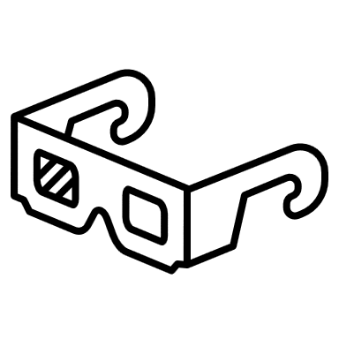

Make sure all the segments you want to be rendered are visible for rendering

Render, save