Culture as Data: Computational Upscaling and Interpretation of NFL Media Events
For the semester long project that was tasked in this IS310 class, I have chosen to learn about how in what ways news outlets shape NFL media-related events to the public to have readers make their own judgements of the individuals themselves. Upon this, I want to then view how when upscaling this with the use of LLM, I can come to see how LLM interprets key variables differently than a human like me. Firstly, when creating this dataset of NFL media-covered events, I thought about key information that would be seen in a news article. On a basic level, it would be the individual in which the news article is written about, then more about what is happening and why there is a need to write a paper about them. Oftentimes, these journals may pull out statements made from these public figures to then interpret and reflect on what is being said. In this turn, resulted in me wanting to capture information on the statement being made from the individual and the event description (i.e., in what context are they making this statement, what is happening). To capture more of the media-related factors that I would like to take into consideration for this project, I wanted to get a hold of the social media platform the statement was posted on (e.g. Instagram, Twitter, and if not social media, then Public Appearance). I then wondered if the individual was an active player at the time of the event and saw if there may be any association with being active to get into a controversy. Other variables, post status and sources are documented to further build on the media-related context.
For the interpretation-side of this dataset, to fully reach the understanding of the culture aspect of the data I was collecting, I viewed that involving variables like the kind of event being published online, the tone of the article is addressing what occurred, and then the level of media coverage this event garnered. I thought that these features would be significant in outlining the nature that digital news is when it comes to different events occurring in this specific realm of sports that is highly prominent in the U.S. When it comes to how I classify these variables, largely, the event type and media tone worked together in terms of the website text displayed about the event. To explain more into detail, if the outlet uses words like "criticized," "backlash," or some people (i.e. fans, sports enthusiasts, etc.) were upset with the player, that would be when the "Controversy" label is applied. "Apology" when the player expresses some sort of remorse or posts an apology for their past actions. "Support" when they put themselves out their way to aid another player, entity, organization, etc. "Reflection" is usually when the player looks back on their past actions or career without any apology (typically used when a player announces their retirement). Lastly, "Humor" is used when the player is engaged in a playful manner, using sarcasm, exaggeration, etc. typically when the situation is not very serious.
With another variable, Media Tone, if the media outlet is uplifting the player and is optimistic about the event, the tone in which is used is described as "Positive." But if the outlet looks at the event as a serious manner where there are consequences and stakes at hand with no encouraging words used for the player, the tone is "Negative". Lastly, if there is a mixture of the two mentioned, the tone is "Mixed." When deciding on the level of media coverage, I viewed event type and the type of sources to play a huge role in determining this. For instance, controversial events often act as catalysts for higher number of readers being influenced to click on the story. Also, when these events are covered by high-profile sources, it may maximize reader engagement and click-through rates.
After conducting heavy and manual work into creating a small dataset, I have a total of about 75 unique events that different NFL players were involved in from 2019-2026. To implement computational techniques into upscaling this work, I found the use of LLM in this world where AI is continuously talked about be most appropriate to view how it plays a role in classifying interpretative features of different events. But before this final step of getting LLM to label new unobtained events, I had to web scrape the website text using the URL of each of the 75 events I have manually handpicked into my dataset. This is an essential step when prompting LLM to use the text from different news sources to label the different interpretative variables as I have manually. In essence, after LLM labeled these events, I have compared its labeling with mine to view the agreement rate, or in other words, how LLM and my labeling may diverge in certain regards.
Firstly, with the event type, LLM matched my judgement about 67% of the time (Fig. 1). Interestingly, LLM achieved a recall of 0.97 for controversy events, correctly identifying 35 out of 36 manually labeled controversial events (Fig. 2). This indicates that controversy-related reporting tends to contain strong and recognizable lexical cues that I have identified, such as “backlash” and “criticized,” which the LLM can consistently detect. However, there is an overclassification into the controversy category as multiple events labeled as “Support” or “Humor” were interpreted as controversies. This suggests that the model may prioritize emotionally charged or conflict-oriented wording itself over the broader contextual interpretation. To explain of an example in which LLM and I interpret an event differently, when linebacker Logan Wilson made a sarcastic statement, “It still wasn’t holding in my humble opinion,” I interpreted Wilson’s response to a controversial holding call during Super bowl LVI as making some humor out of the situation rather than an attempt to reignite the controversy itself. But the LLM classified this event as a “Controversy,” could likely be due to the article using controversy-related language, including phrases like “huge defensive holding penalty,” “past controversy,” and discussion surrounding the Bengals’ Super Bowl loss. This could further explain how my interpretation comes from more of a contextual understanding of the situation, whereas LLM is on the language itself.
To further understand these differences, sentiment analysis revealed that apology events in my manual labeling had an only slightly negative average sentiment score (-0.0418), while controversy events still maintained a positive average sentiment score (0.0868). This suggests that although apology-related articles often contain negative wording surrounding criticism or past actions, I interpreted the player’s intent as apologetic rather than controversial. However, the confusion matrix showed that roughly 67% of apology events were classified as controversy by the LLM, indicating that the model may associate negative lexical cues more strongly than with apology (Fig. 2). In contrast, the LLM assigned apology events a more positive average sentiment score (0.1073), further demonstrating how its interpretations reply more heavily on surface-level language patterns than broader contextual framing.
Similar patterns emerged with Media Tone, where LLM labeling achieved an agreement rate of about 62.5% (Fig. 1). Since media tone was partially determined from the language used within the website text, LLM was able to recall the negative media tone 80% out of the time. However, differences still emerged because my interpretation considered the broader framing and context of the article rather than treating individual words or phrases too literally. Human interpretation often relies on implied meaning, tone, and situational context that may not be fully captured through surface-level lexical analysis alone.
The differences between my interpretation and LLM’s became more apparent with Media Coverage, which achieved the lowest agreement rate at about 38.9%. As mentioned before, unlike with Event Type and Media Tone, I determined the labeling of Media Coverage with my Event Type labeling and the prominence of the sources that covered the event. For example, if an event was categorized as “controversy” that was reported by a high-profile media outlet, it will be more likely to be labeled as “high” media coverage due to its increased potential for clicks, engagement, and wider dissemination. However, events that were not necessarily controversial could also receive high coverage if they were covered by prominent outlets, indicating that media visibility is shaped by both the nature of the event and the reach of the reporting source. Even when I have LLM take these elements into account, the outcomes are largely different from my own. The LLM showed a strong tendency to overpredict “high” media coverage, frequently reclassifying both “low” and “medium” coverage events into the “high” category. Though there may be limitations in how I categorize different sources as high-tier and medium-tier sources, this pattern suggests that the model is primarily responding to textual emphasis within the article content rather than integrating structural or contextual signals such as source prominence or broader media reach. As a result, while the LLM can approximate general patterns of importance, it struggles to replicate the interaction between event type and media outlet prominence that informs human judgement of the corresponding media coverage intensity.
After discussing how LLM and I diverge in our interpretative labeling, as part of this project, I have increased the number of entries of my manual dataset using automative techniques like web scraping with the GoogleNews Python package, where I asked for NFL controversy, for each year starting from 2019 to 2026. Then to exclude any largely irrelevant events, I utilized cosine similarity filtering to only include events that meet the threshold of 0.14, resulting in keeping 446 out of 644 articles covering different media-covered NFL events. With some small data cleaning before combining the manually created dataset and the GoogleNews dataset, the final dataset contains 520 entries.
The subset of 446 entries does not include my own interpretative labels, but only LLM-based labeling for the interpretative variables discussed earlier. Based on what we observed from the comparison between my labeling and the LLM’s labeling on the original 75 manually collected events, the LLM does not interpret these subjective variables (i.e., Event Type, Media Tone, and Media Coverage) in the same way I do. Due to this, when we move to the to the larger dataset, we can start to understand what kind of “culture” is being captured when interpretation is primarily driven by LLM labeling rather than human judgement.
Figure 3 shows the distribution of categories across each interpretative variable in the expanded dataset. What becomes immediately visible to me is that there is a high concentration of certain categories rather than a balance. Though this could be influenced due to the GoogleNews search prompt (“NFL controversy”), we can still observe that within the constructed NFL media dataset there is an overwhelming dominance of specific interpretative categories, particularly “Controversy” for Event Type and “Negative” for Media Tone. This suggests that when interpretation is scaled and automated through LLM labeling, the resulting dataset reflects a more compressed version of NFL media culture, where certain categories become amplified while more nuanced distinctions are reduced.
From this process of scaling interpretation through computation, it is important to reflect on what is lost. From what we found in the comparisons between human and LLM labeling, the LLM tends to operate more at the level of surface language patterns, rather than incorporating the deeper contextual and cultural reasoning that informs human interpretation. In contrast, human labeling is shaped by prior knowledge, lived experience, and an understanding of media framing, allowing for judgements that go beyond literal wording in the text. To expand this further, and acknowledge a limitation of this project, media coverage of NFL players can be shaped by broader cultural visibility outside of the text and act they take themselves. For example, certain players may receive disproportionate media attention due to their associations with high-profile celebrities or other involvements. Travis Kelce, for instance, may be covered more widely not only because of his athletic performance, but also due to his relationship with Taylor Swift, which increasingly affects his visibility and media outlook. This further not only highlights a limitation of purely computational labeling approaches, but also LLMs cannot encapsulate broader understanding of cultural context, including why certain events may be amplified across media platforms and the hidden implications and meanings of certain events. This reinforces the idea that culture in this dataset is not only embedded in textual data, but also in the wider social structures that determines whose actions are made visible and amplified in the first place and for what reasons.
To properly build upon this project, it is best to recognize the limitations of this research in general. Firstly, the non-interpretative features in the final datasets were not completely inputted due to the current scope of the research being to understand the interpretative variables come into play in terms of “culture as data.” So, in other words, there are missing values for non-interpretative variables that could not be fully imputed. Another limitation is that through web scraping using the GoogleNews package, there could be entries where the individuals involved in these media-covered events may not be NFL players, but NFL commentators, reporters, coaches, and more. In this case, I have decided to give leeway to these exceptions for the objective of this project.
There are also ethical and interpretative considerations related to representation and visibility. NFL players are public figures, but media coverage is not evenly distributed and shaped by external cultural factors such as celebrity status, team affiliation, and newsworthiness. As a result, the dataset may unintentionally amplify already highly visible individuals and events, while less covered or less sensational moments are underrepresented and in essence harder to find and come across. This may introduce structural bias into what is ultimately framed as part of “culture,” since visibility itself is not evenly produced across all players or events provided.
A key lesson learned from this process is that computational methods do not simply scale the data, but they also transform it. The transition from manual labeling to LLM-based labeling demonstrates that scaling interpretation changes the type of cultural meaning being captured in this process. Rather than expanding from human interpretation, computation produces its form of interpretation grounded in linguistic patterns in text. This highlights the tension between interpretative depth and computational scalability.
In terms of scholarly positioning, this project aligns with work in digital humanities and computational culture studies that treat cultural artifacts as data while also critically examining what may be lost in the process of computational upscaling. This project reflects the tensions of LLMs to scale interpretative labels while simultaneously revealing how computation can reshape the meaning being captured in ways that may differ from human interpretation. Within the framework of how this project was carried out, the dataset can be understood as a computationally constructed view of NFL media culture rather than the true authentic or complete representation of it. As a result, the current version reflects the limitations of large-scale text analysis and how this project was carried out, which has a potential to further expand beyond this image.
When it comes to further going beyond the current level which this project has reached, I think it would be beneficial to get data on the click-through rates of different webpages and news journals within different outlets I have taken different media-covered events from. By getting a hold of this kind of data, I can get a quantitative measure of media engagement in connection to the kind of events covered and more. This may allow better comparison and query into questions like if controversial events really result in more clicks than other kinds of events and if certain players, no matter the kind of event, get more public attention. At the same time, this can help address a limitation that media coverage is inferred through features like the kind of event type and source prominence. Through this method, I can strengthen the analysis by creating clusters or grouping based on these quantitative measures to further understand audience behaviors when interacting with digital news.

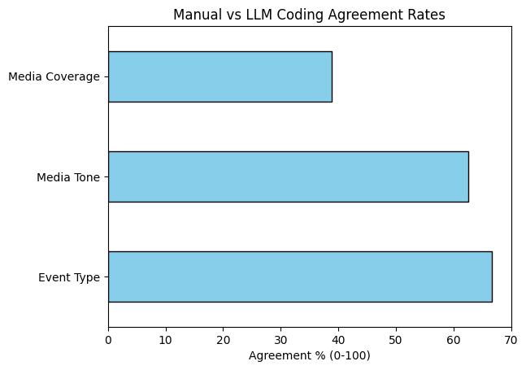
Fig 1: Distribution of categories in final dataset (LLM and manual collected entries)

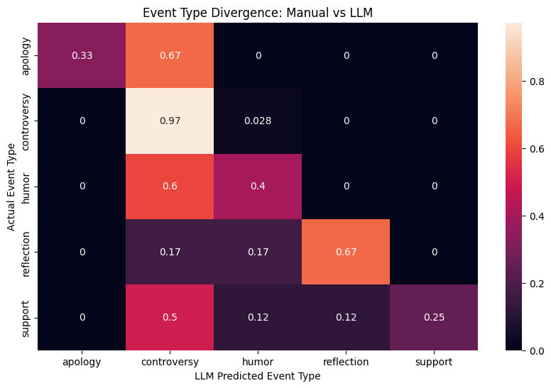
Fig 2: Heatmap showing where the LLM labeling and my labeling diverge.

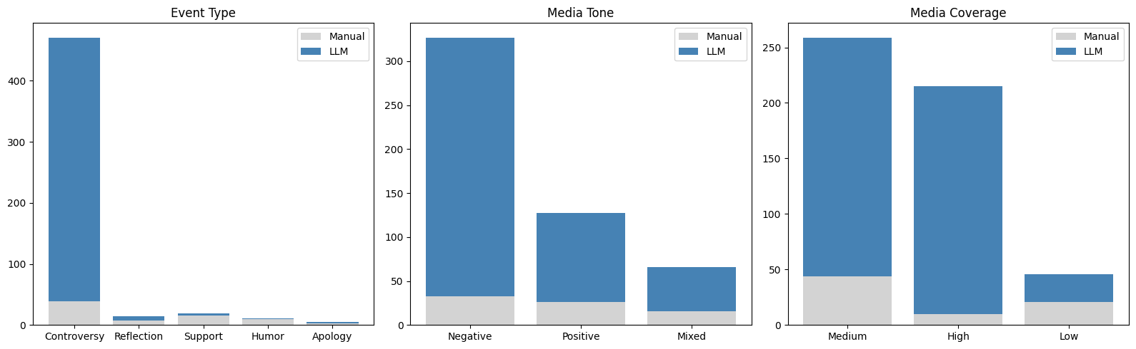
Fig 3: Distribution of categories in final dataset (LLM and manual collected entries)

