GHOST
The Owner-Controlled
Software & Data Foundation
Complete concept, layered architecture, data model, UI/UX, execution system, marketplace, cloud/local support model, and lineage from the original Web to Linked Data and Solid

Core thesis
The business owns the foundation. Software, AI, interfaces, providers, and hardware receive permission to operate on it.
Master architecture and build specification

1. Executive Summary
Ghost is an owner-controlled software and data foundation designed to separate a business or person from the applications that currently hold their identity, data, workflows, interfaces, and access rights hostage inside separate silos. It is not another CRM, website builder, automation suite, AI agent, or hardware appliance. Those are modules that can run on top of the foundation.
The central inversion: the business owns the canonical identity, structured data, permissions, and capabilities. Applications and AI systems become replaceable consumers of that foundation.

At runtime, every request follows the same durable loop: input → identity → intent → capability → policy → route → execute → verify → persist → render. The uploaded Flow blueprint defines this as the master operational loop, and the kernel/build guide makes the same separation between canonical data, policy, execution, verification, and surfaces. [F2][F3]
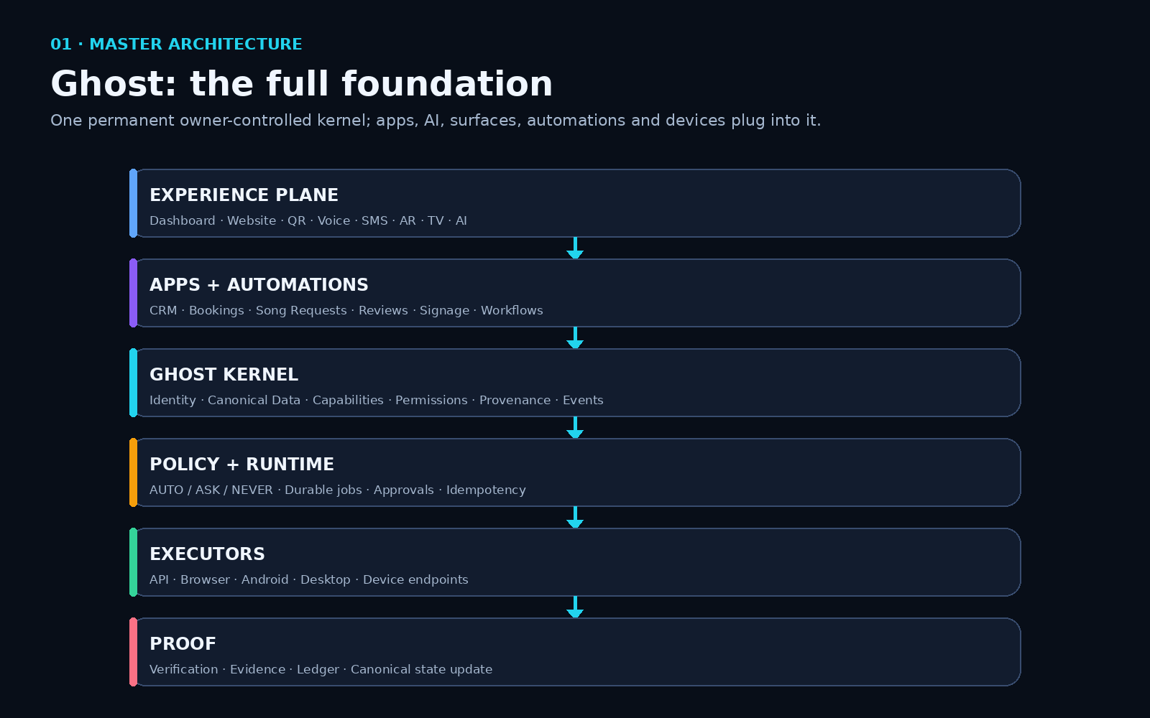
Figure 1 — Ghost as a layered owner-controlled foundation, with experiences on top and proof underneath.

1.1 What Ghost is
- A canonical identity and data foundation for a business or person.
- A schema registry that lets applications declare data without owning the storage.
- A provenance system that records where facts came from, how fresh they are, and which source is authoritative.
- A capability system that describes what can be done without tying the action to one vendor or executor.
- A deterministic permission/policy layer that decides whether an action is automatic, requires approval, or is prohibited.
- A workflow/execution system that can run through an API, browser, Android device, Linux process, cloud worker, or physical endpoint.
- A verification and evidence system that proves the real destination changed as expected.
- A surface system that renders the same data/capabilities as websites, dashboards, QR pages, forms, AI/MCP responses, AR views, TV screens, or custom interfaces.
- An open developer/marketplace layer where apps, schemas, workflows, AppMaps, adapters, surfaces, and drivers can be contributed independently.
- A local/cloud/hybrid deployment model in which the owner chooses where the foundation runs and who may support it.

1.2 What Ghost is not
- Not one giant proprietary all-in-one SaaS suite.
- Not a single AI model. AI is a routed tool used only where ambiguity or reasoning requires it.
- Not a blockchain database. Blockchain is optional for externally verifiable policy/contribution provenance; operational data stays in normal databases.
- Not an Android automation company. Android is one executor underneath stable capabilities.
- Not an MCP company. MCP is one interface into the foundation; it can be replaced without changing the foundation.
- Not a public-profile network. Public pages are surfaces rendered from structured business data.

2. The Internet Problem Ghost Is Trying to Reverse
The current software model puts applications at the center. A business has a Google representation, a Facebook representation, a Yelp representation, a CRM database, a booking database, a POS database, a website database, and often multiple customer lists. The same fact can disagree across all of them. The practical symptom is simple: a business posts “we close at 7 tonight” on Facebook while Google still tells customers it is open until 10.
TODAY
Business → Google copy
→ Facebook copy
→ Yelp copy
→ CRM copy
→ Booking copy
→ Website copy
Each product becomes another source, permission system, interface, and gatekeeper.
Ghost flips the center of gravity. The business maintains one canonical operational identity and structured foundation. External systems are connections and publication/execution targets. They no longer define what the business is.
GHOST MODEL
Business/Owner
↓ controls
Canonical identity + structured data + permissions + capabilities
↓
Google | Facebook | Yelp | Website | AI | Booking | CRM | Partners
The channels become tools attached to the owner’s foundation.

2.1 Ownership versus access
The most precise statement is not that Ghost “owns all the data.” The goal is that the owner controls the canonical representation and the access rules. Public facts can be broadly discoverable; partner data can require grants; customer data can be scoped; private operational data remains private. A business may still send copies to external services, and no technical system can guarantee that an authorized recipient never copies data it legitimately receives. Solid makes this limitation explicit. [R8][R9]
The strongest formulation: the owner is the authority over the canonical source and access policy; applications receive permission to read, write, or execute specific capabilities.

2.2 Why “one query” matters
If an AI, search engine, partner, website, or agent wants to understand a business, the ideal path is not to scrape six vendor pages and reconcile them again. The ideal path is to query the business-controlled machine-readable source once, retrieve authorized structured facts, and then render or reason over those facts.
Question: “Is this restaurant open after 9, what seafood is under $30, and is there a table for four?”
AI job: understand intent
Ghost job: query hours + menu_items + prices + availability
Result: structured answer
The AI is not used as an expensive database parser.

3. The Tim Berners-Lee / Web Architecture Lineage
Ghost should not be presented as “what Tim Berners-Lee invented.” That would overstate the historical record. The accurate claim is that Ghost intentionally extends several principles Berners-Lee repeatedly argued for: decentralization, modularity, independent invention, machine-readable data, linked identifiers, application-independent read/write storage, and user-controlled access. Ghost applies those ideas to operational business software, AI agents, automation, and physical executors.

3.1 Original Web: decentralization and independent systems
In the 1994 World-Wide Web paper, Berners-Lee and coauthors wrote that the Web was designed so two independently used projects could later be related without major centralized changes. His later design writings explicitly identify decentralization as a core distributed-system principle and warn that common central points create scaling limits and single points of failure. [R1][R3]
In his 1996 “Past, Present and Future” paper, Berners-Lee described design criteria that are strikingly relevant to Ghost: independently used systems should be connectable incrementally; users should not be constrained to a particular operating system or data model; and data should be easy to correct by the person directly knowledgeable. He also argued that Web specifications should be modular so components could be replaced while preserving the architecture. [R2]
Ghost similarity: provider, UI, AI model, executor, and hardware should be replaceable while stable owner-controlled contracts survive underneath.

3.2 Semantic Web: data that machines can understand
The 1998 Semantic Web Road Map describes a “consistent logical web of data” in which machines participate directly, rather than trying to infer all structure from human-facing pages. Berners-Lee argued that search could move from indexing words toward indexing RDF objects and querying across databases whose schemas can be related. [R4]
This is directly relevant to Ghost’s structured table strategy. Instead of repeatedly asking a large model to infer that a sentence means “Friday close time = 19:00,” the business stores that fact in a typed field and exposes a machine-readable representation.

3.3 Linked Data: stable identifiers and reusable facts
Berners-Lee’s 2006 Linked Data note gives four famous rules: use URIs as names for things, use HTTP URIs so they can be looked up, return useful standard data when looked up, and include links to other URIs. He emphasized that the value of the Web of data is unexpected reuse. [R5]
Ghost can follow the same outward model even while keeping PostgreSQL internally. A business can have a durable canonical URI, while relational records are projected as JSON-LD/Linked Data when data leaves the system.

3.4 Read-Write Linked Data: the closest direct match
The closest single historical document is Berners-Lee’s 2009 “Read-Write Linked Data” note. It describes applications operating on a layer of commodity read/write storage so that storage becomes independent of the application running on it. The stated goal is to decouple storage from application design and deployment. [R6]
READ-WRITE LINKED DATA IDEA
Application A ─┐
Application B ─┼→ shared read/write storage
Application C ─┘
GHOST EXTENSION
Apps / AI / Surfaces
↓
Identity + structured storage + provenance + permissions + capabilities + workflows + proof
This is the strongest historical parallel to the Ghost rule: uninstalling or replacing an application must not take the business data with it.

3.5 Socially Aware Cloud Storage and Solid
Berners-Lee’s 2009 “Socially Aware Cloud Storage” note explicitly describes Web 2.0 applications as site-centric systems where the site stores state and manages access. It proposes globally identified principals and access-controlled read/write storage, again making storage independent of the application. [R7]
Solid is the modern continuation of this direction. The official Solid project states that people store information in a Pod, decide which people, applications, and AI agents may read or edit it, and can change applications or providers without surrendering the underlying data. Solid developer documentation describes the core idea as separating applications from the data they create. [R8][R9]
Concept | Berners-Lee / Solid direction | Ghost implementation
Decentralization | No central authority required for every operation; independent systems interoperate. | Each business has its own canonical authority; Ghost Cloud is optional infrastructure, not the data owner.
App/data separation | Applications work over storage/data independent of the application. | Apps declare schemas and capabilities; foundation owns storage; uninstall preserves records.
Machine-readable data | Semantic Web / Linked Data. | Relational canonical tables projected as JSON/JSON-LD/MCP/API.
Stable identity | URIs/WebIDs identify resources/principals. | ghost:// URNs internally plus optional dereferenceable HTTP canonical URIs externally.
Access control | Solid WAC/ACP controls which agents may access resources. | Grants + constraints + deterministic policy + visibility rules.
Independent invention | Different systems should work together without central redesign. | Third-party apps implement Ghost contracts instead of pairwise integrations.
What Ghost adds | Not specified as a business automation stack. | Provider routing, API/browser/Android executors, AppMaps, workflows, verification, ledger, marketplace, support network.

4. The Complete Ghost Foundation — Layer by Layer
The most useful way to build Ghost is as a stack of contracts. Linux, Android, Playwright, MCP, Postgres, or any specific AI model must never become the architecture itself. Each is an implementation behind a stable Ghost interface. The uploaded backend blueprint states this rule directly: “never let a vendor name become your architecture.” [F4]
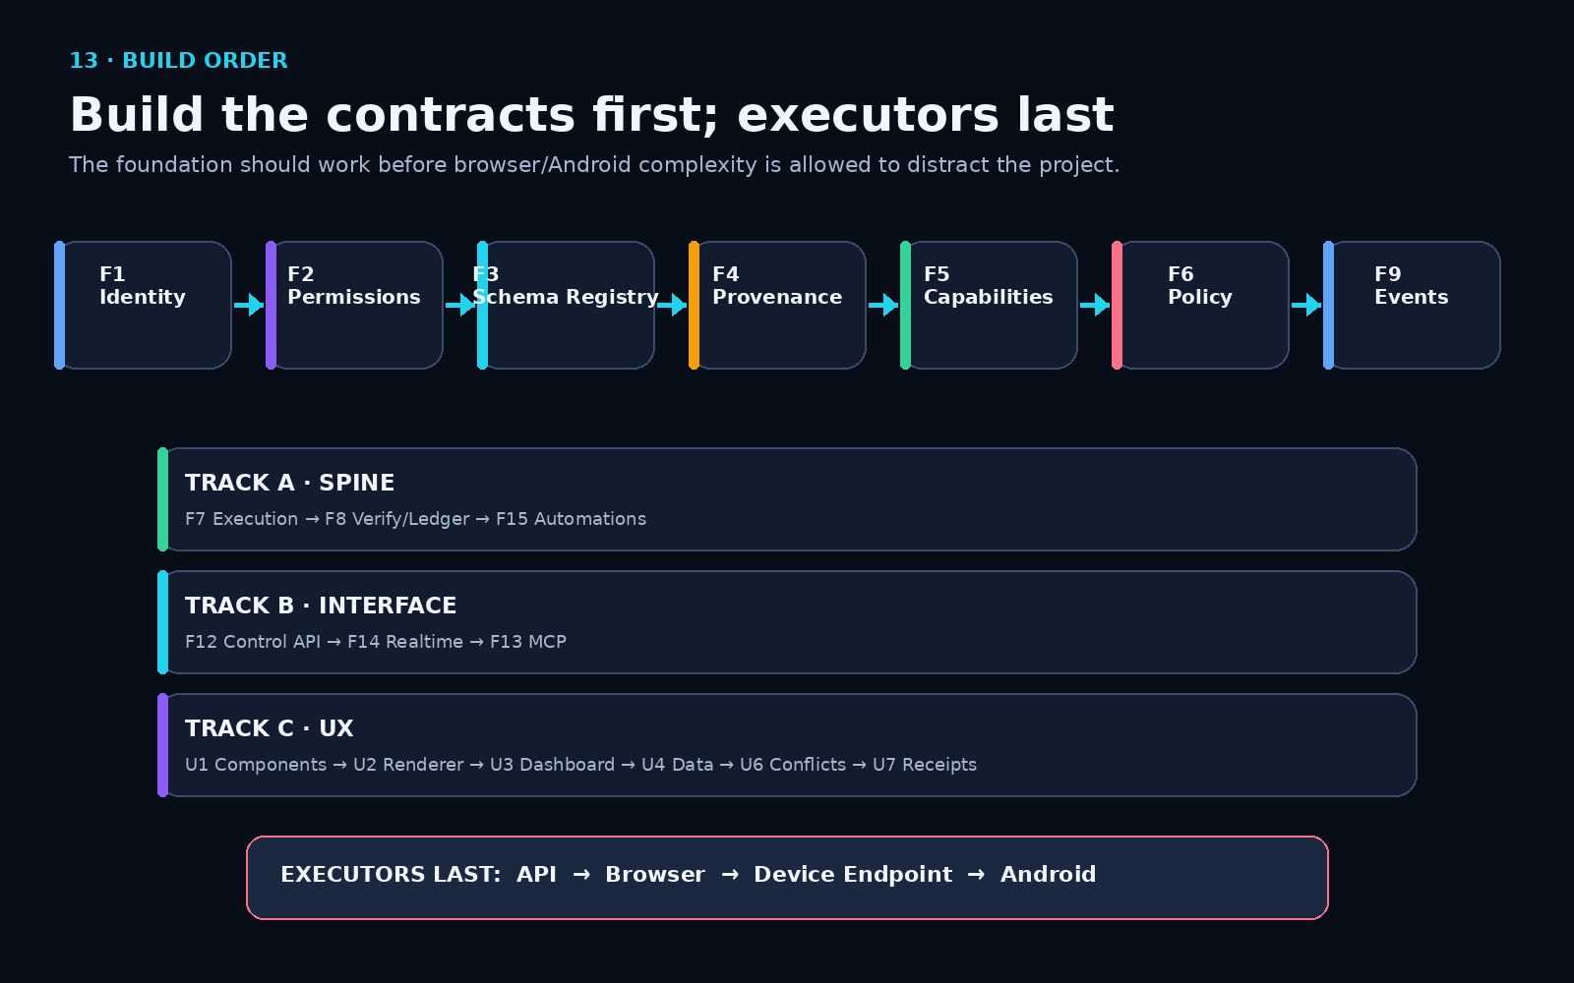
Figure 2 — The foundation is built from identity and schemas upward; executors come last.

Layer 1 — Owner-Controlled Computing Environment
Where the system physically runs: existing Linux/Mac hardware, a preconfigured Ghost Node, customer cloud, Ghost Cloud, or hybrid. Small Pi/stick devices are endpoints, not necessarily the full stack.

Layer 2 — Runtime / Compute
Containers, workers, scheduler, queues, local-model runtime, browser runtime, Android runtime interface, secrets, storage, networking, observability, update mechanism.

Layer 3 — Execution Abstraction
APIExecutor, BrowserExecutor, AndroidExecutor, LinuxExecutor, DeviceExecutor. AppMaps and deterministic scripts live here. Capabilities above never depend on one execution method.

Layer 4 — Connection / Translation
OAuth, API keys, email, iCal, webhooks, browser sessions, device accounts, file imports, external-field mappings, provider health and reauthentication.

Layer 5 — Structured Data / Knowledge
Canonical business identity plus tables for every stable business section: locations, hours, menus, products, prices, availability, bookings, events, reviews, customers, etc.; provenance attaches source and authority.

Layer 6 — Permissions / Constitution / Trust
Identity, ownership claims, membership, grants, constraints, consent, visibility, AUTO/ASK/NEVER, policy versions, optional blockchain hash anchoring.

Layer 7 — Capability System
Vendor-neutral actions such as business.hours.update, availability.search, reservation.create, social.post.publish, message.send, display.play.

Layer 8 — Workflow / Automation
Events, triggers, durable jobs, conditions, steps, approvals, retries, idempotency, resume-vs-repeat semantics, schedules, verification.

Layer 9 — Builder
Describe what is needed; inspect registry; reuse existing schemas/capabilities/components; create only missing data/UI/workflow; sandbox-test; package.

Layer 10 — App + Marketplace
Manifests, packages, app versions, schemas, dependencies, permissions, signatures, marketplace distribution, contribution provenance.

Layer 11 — Surface / UI
Public UI, owner UI, staff UI, QR, widget, website, form, voice, SMS, AR, TV, AI/MCP response. Same data/capability can have multiple completely different front ends.

Layer 12 — Experiences
The actual things people buy/use: restaurant toolkit, booking, CRM, song requests, reviews, loyalty, AR, digital signage, dealership tools, local directory, personal AI, custom apps.

5. Structured Data: Tables for Truth, JSON at the Edges
For Ghost, the primary operational database should be relational. Stable business facts that are queried, filtered, joined, indexed, synchronized, or reported should have real tables and columns. JSON/JSONB is best for flexible manifests, constraints, provider payloads, schema definitions, UI blocks, and transport. The uploaded kernel already follows this hybrid design. [F1][F2]
Rule: stable business meaning → tables/columns. Flexible configuration or interchange → JSON/JSONB. Public semantic interchange → JSON-LD where useful.

5.1 Three storage tiers
Tier | Examples | Who defines it | Why
Universal core | business, person, membership, location, customer, product, availability, booking, media | Ghost foundation | Shared identity and semantics across every app.
Industry schemas | restaurant.menu, charter.trip, lodging.unit, music.performance | Ghost/industry standard | Reusable vertical meaning without tying data to one application.
App schemas | music.song_request, specialized workflow records | App declares; foundation provisions | Developers extend the platform without owning DDL or business storage.

5.2 Why not one giant JSON blob
A giant business JSON object is initially easy but eventually undermines the platform: inconsistent shapes, harder indexes, weaker constraints, harder joins, duplicated semantics, and more model/parsing work. A query such as “all fishing trips tomorrow for four people under $700” should be a database query, not a large-model reasoning exercise.
GOOD
product(id, business_id, name, type)
pricing_tier(id, product_id, amount, pricing_basis)
availability(id, product_id, start_at, remaining)
USE JSON FOR
app_version.manifest
grant.constraints
surface.blocks
capability input/output schemas
provider-specific metadata

5.3 One table per meaningful section
Section family | Representative tables
Identity & organization | business, location, person, membership, ownership_claim
Commerce | product, service, pricing_tier, inventory, availability, booking, addon
Restaurant | menu, menu_section, menu_item, menu_option, happy_hour, special
Content & trust | event, review, media, amenity, policy, provenance tables
Operations | connection, automation, execution, verification, ledger, device

5.4 Schema registry and provisioning
The schema registry is the keystone that makes “apps do not own data” real. An app declares a versioned schema; the foundation compiles it into a physical table, attaches business foreign keys and row-level security, and exposes access only through the capability/data gateway. Apps never receive raw database credentials or DDL rights. Uninstall revokes access but preserves the provisioned business records. [F1][F2]
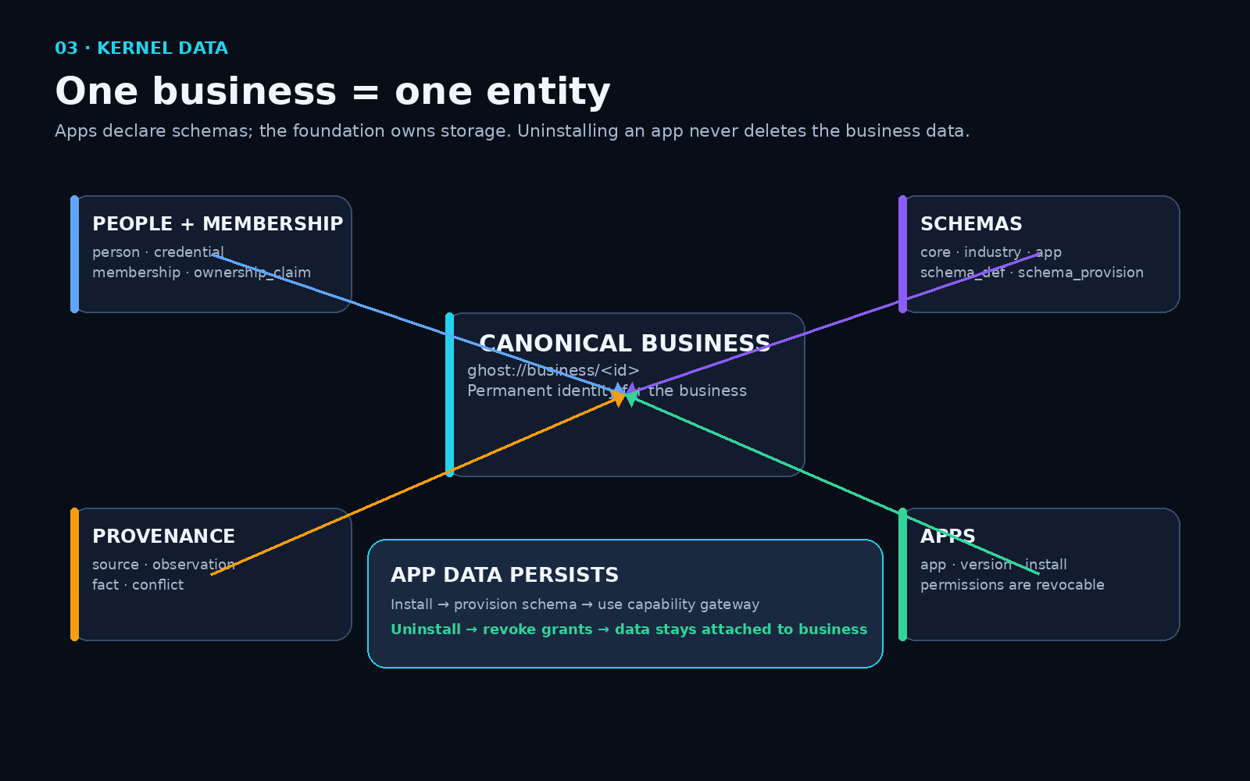
Figure 3 — Canonical business identity, schemas, apps, and provenance all attach to the same permanent foundation.

6. Provenance, Authority, Conflict Resolution, and the Synchronization Checklist
The “one update everywhere” promise only works if Ghost distinguishes canonical truth from external observations. Otherwise every platform becomes another writer that can overwrite every other platform. The provenance engine therefore stores sources, append-only observations, resolved facts, and conflicts. [F1][F2][F3]
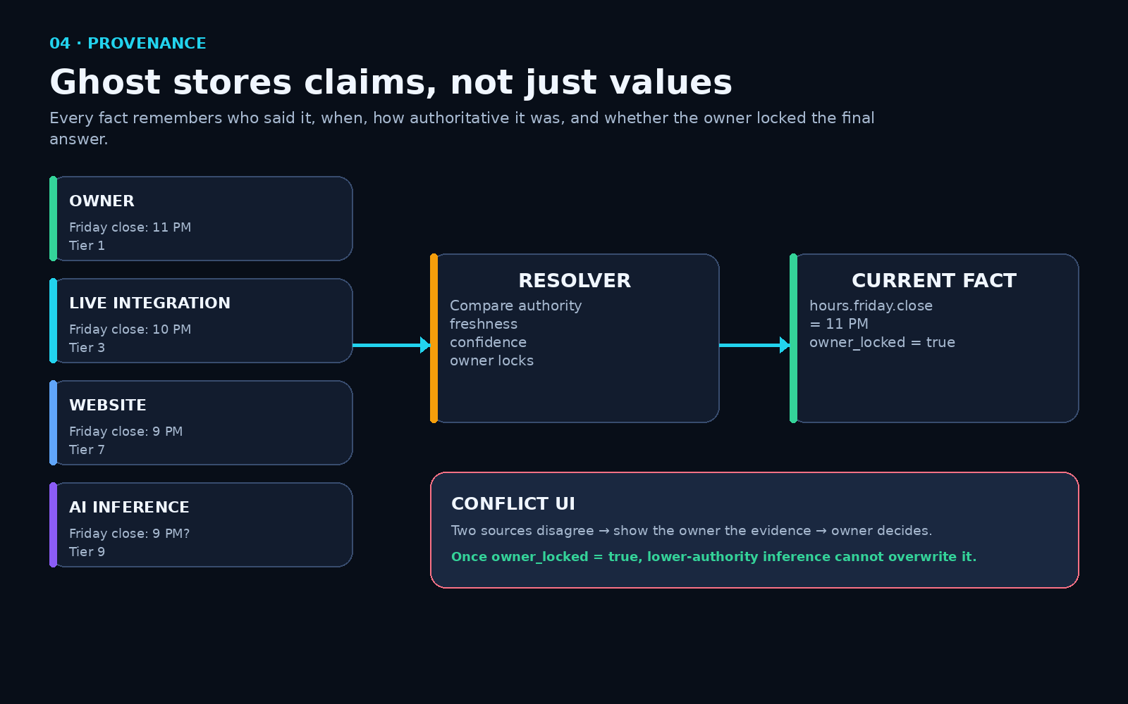
Figure 4 — Multiple external claims are observations; Ghost resolves one current fact according to authority and owner decisions.

6.1 Authority hierarchy
- Owner decision / owner-locked fact.
- Operational source of record.
- Live authorized integration.
- Verified employee.
- Transaction evidence.
- Structured public source.
- Business website observation.
- Third-party listing.
- AI inference.
The exact tiers can evolve, but the key rule should not: an inference must never silently overwrite an explicit owner decision.

6.2 Do not make “Yelp hours,” “Facebook hours,” and “Google hours” columns in the canonical hours table
The canonical hours table should contain the business’s current authoritative hours. Provider-specific values belong in observations/sync-state records. This keeps the canonical model clean while still giving the owner the checklist they want.
Channel | Observed Friday hours | Canonical Friday hours | Status | Last checked
Owner | 11:00–23:00 | 11:00–23:00 | MATCH | now
Website | 11:00–23:00 | 11:00–23:00 | MATCH | 2 min ago
Facebook | 11:00–23:00 | 11:00–23:00 | MATCH | 5 min ago
Google | 11:00–22:00 | 11:00–23:00 | MISMATCH | 3 min ago
Yelp | 11:00–22:00 | 11:00–23:00 | MISMATCH | 7 min ago

The UI can display “3 of 5 synchronized,” show the mismatches, and offer Retry, Inspect, or Owner Resolve. That gives you the visual checklist without polluting the canonical table with a new column for every platform.

6.3 Temporary closure example
Owner: “We are closing at 7 tonight because of weather.”
↓
canonical temporary_hours(date=today, close=19:00, authority=owner)
↓ event: business.hours.changed
Website / QR / MCP / AI reflect it immediately
↓
Google adapter attempts update
Facebook adapter attempts update
Yelp adapter attempts update
↓
Verification compares external state
↓
Dashboard: Website ✓ Google ✓ Facebook ✓ Yelp ⚠ 10 PM

7. The Five Maps: How Ghost Stops Guessing
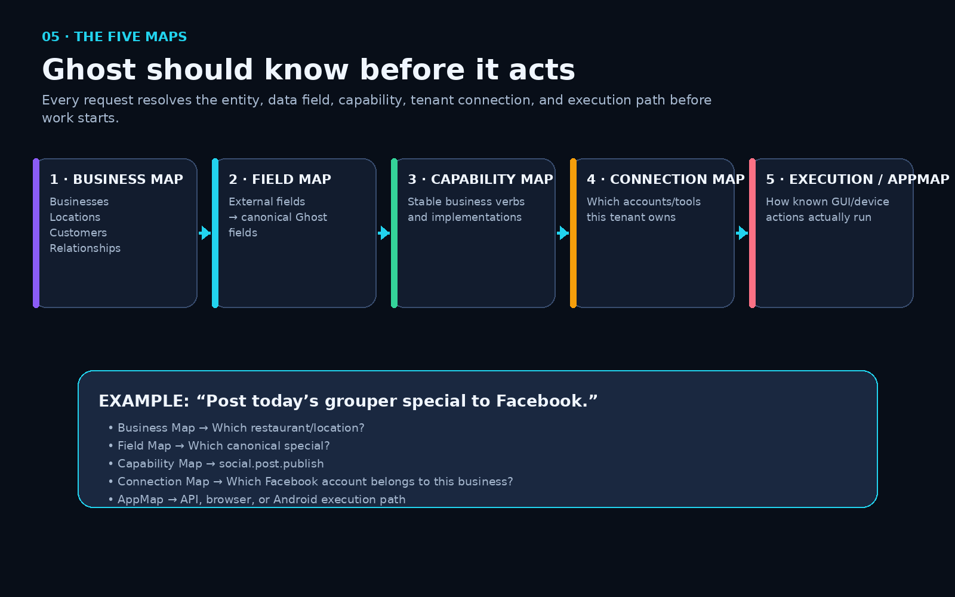
Figure 5 — Every action resolves the business, field, capability, tenant connection, and execution path before starting.
Map | What it answers | Example
Business Map | What entity/relationship is this? | Restaurant, location, customer, product.
Data / Field Map | What does this external field mean internally? | provider.close_time → hours.friday.close.
Capability Map | What stable business action exists? | social.post.publish.
Connection / Tenant Map | Which account/tool belongs to this owner? | Facebook Page + session/API connection.
Execution / AppMap | How does this known GUI/device action run? | Facebook Android publish flow v4.

8. Capabilities and Provider-Neutral Execution
Capabilities are the permanent business verbs. Applications, AI, automations, and surfaces call capabilities; they do not embed provider-specific execution logic. The capability record should define typed input, typed output, required permission, risk, idempotency, and a verification contract. The uploaded kernel makes verification mandatory for a capability. [F1]
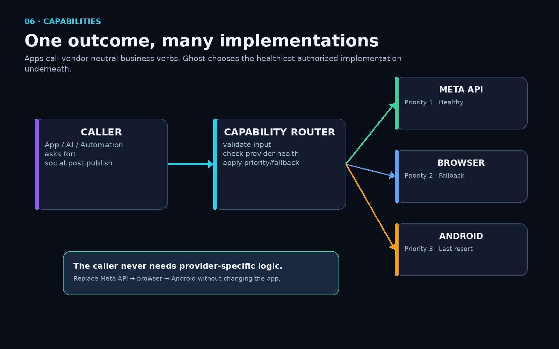
Figure 6 — One canonical action can route to an API, browser, or Android implementation without changing the caller.
Capability | Possible implementations
business.hours.update | Google Business API; browser; Android app.
social.post.publish | Official social API; browser session; Android app.
availability.read | Direct provider API; iCal/email-derived inventory; internal Ghost table.
reservation.create | Official booking provider; direct business system; manual/owner flow.
display.play | Local device endpoint; remote cloud display service.

Priority rule: deterministic/internal or official API first; browser fallback; Android/device UI only when no better authorized interface exists.

9. Permissions, Constitution, and Owner-Controlled Access
Roles are shorthand; grants are truth. A grant applies to a person, agency, app installation, connection, automation, or client and can carry constraints. Before privileged execution, the policy gate evaluates structured identity, grants, constraints, risk, and approval state. AI never participates in the final authorization decision. [F1][F2]
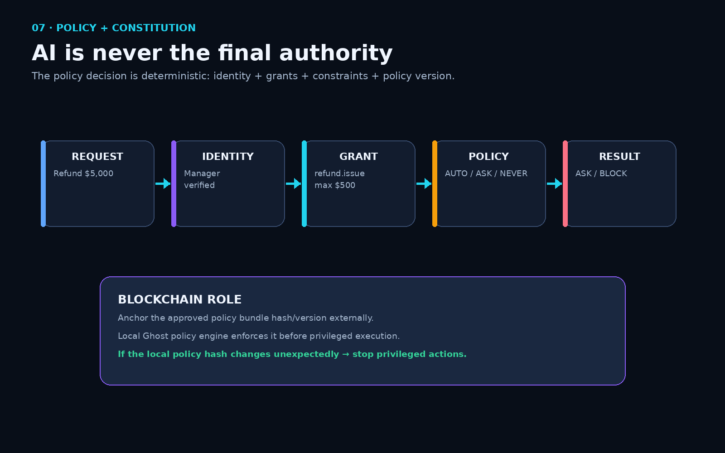
Figure 7 — AI may propose an action, but deterministic policy decides whether it may execute.
Example
Manager requests refund.issue(amount=5000)
Grant allows refund.issue(max_amount=500)
Policy result → ASK or NEVER
The language model cannot “convince” the policy engine to ignore the constraint.

9.1 Public, partner, staff, owner, and AI views
Audience | Typical access
Public | Name, location, hours, menu, prices, events, amenities, public availability.
Customer | Public data plus own booking/loyalty records and customer-facing actions.
Partner / agency | Explicitly granted business fields/capabilities only.
Staff | Operational data needed for job role.
Owner | Full business data, connections, provenance, permissions, policies.
AI / agent | Only resources/tools permitted to that client identity; no implied global access.

9.2 Blockchain role
Blockchain should not sit in the hot path for every menu edit, booking, or message. Its strongest role is externally verifiable provenance: anchoring the approved constitution/policy bundle hash, package provenance, contributor identities, licenses, and optional royalty rules. Normal databases and policy engines still perform operational work.
Policy bundle → hash → optional public blockchain anchor
Local Ghost computes active policy hash
Mismatch → privileged execution stops / enters safe mode

10. Durable Execution, Human Approval, Verification, and Proof
Executions must be durable state machines rather than “agent says done.” The kernel tracks queued, awaiting approval, running, verifying, succeeded, failed, and cancelled states. Idempotency prevents duplicate actions; resume-vs-repeat semantics prevent a restarted worker from accidentally doing the same irreversible action twice. [F1][F2]
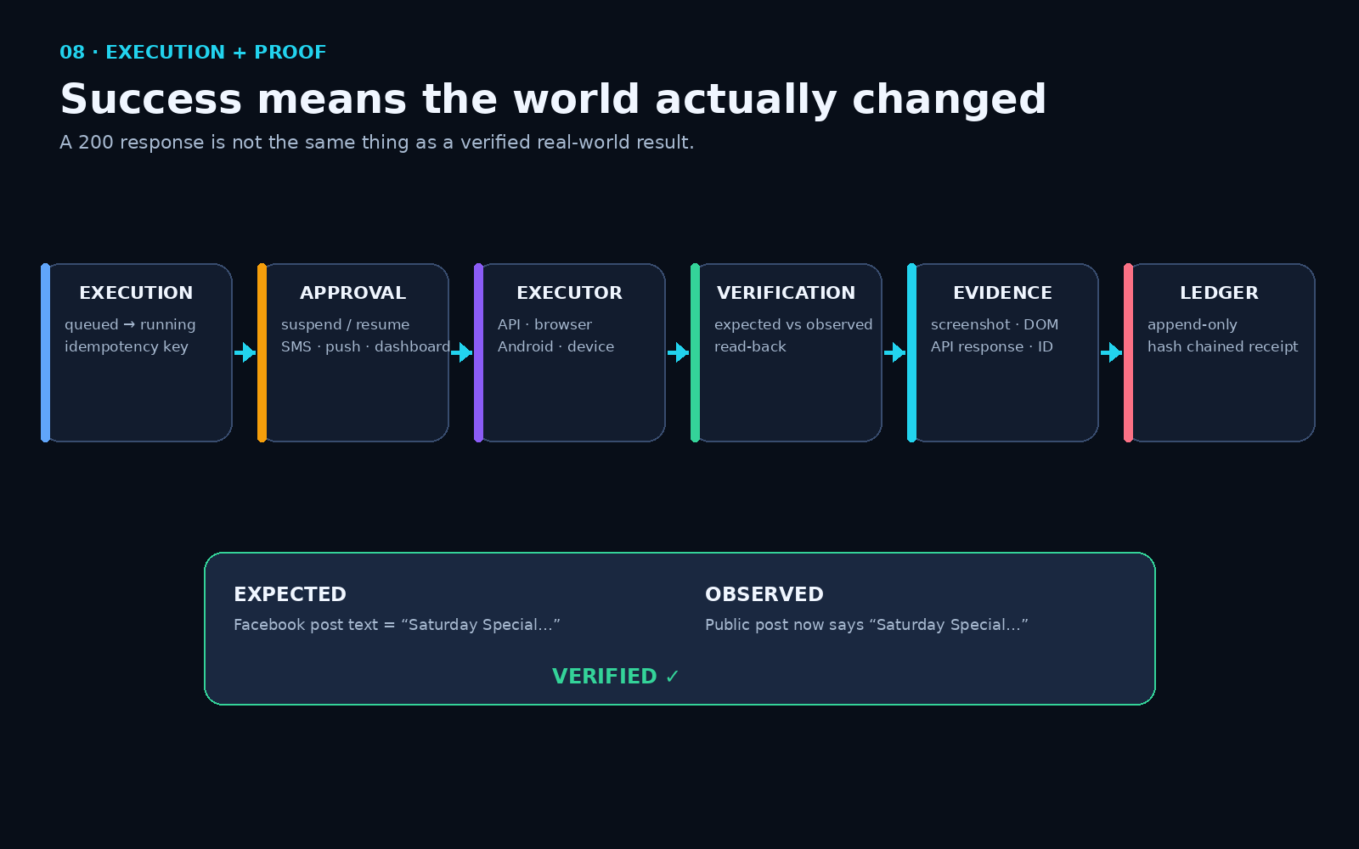
Figure 8 — Execution only becomes trusted after expected state is compared with observed state and evidence is stored.

10.1 Human-in-the-loop
Approval is a first-class workflow primitive. A task can pause before an irreversible step, send the owner a dashboard/push/SMS request, and resume later from durable state. The owner can Watch, Pause, Take Control, Return Control, Approve, Reject, or Edit depending on executor and policy. [F4]

10.2 Verification
“HTTP 200” is not proof that the external business listing now says the right thing. Verification records expected state, observed state, method, and result (verified, partial, unknown, failed). Evidence may include screenshots, DOM snapshots, provider responses, external IDs, hashes, or delivery receipts. [F1][F2]

10.3 Ledger
Every consequential action should produce a receipt containing actor, business, capability, policy version, provider/executor, timestamps, input, result, verification, and evidence references. The uploaded schema uses an append-only hash-chained ledger. [F1]

11. Events and Automation
A business change emits an event in the same database transaction that commits the change. This transactional outbox prevents the classic failure where the database updates successfully but the event is lost because a dispatcher crashes. Start with Postgres LISTEN/NOTIFY behind an event interface; move to NATS or another bus later if scale requires it. [F1][F2]
WHEN special.updated
IF special.active = true
THEN website.refresh
THEN signage.refresh
THEN social.post.prepare
ASK owner before publish
THEN social.post.publish
VERIFY destination state
Every automation step should ultimately be a capability call, so automations do not bypass permissions, routing, or verification.

12. Apps: Permission Transactions, Not Data Silos
An app package declares its schemas, capabilities, permissions, events, surfaces, runtime, and version. Installing an app is therefore a permission/provisioning transaction: validate → show requested access → owner approves → provision schema → create grants → register capabilities/events/surfaces → activate runtime. Uninstall revokes grants and runtime access but does not delete the business’s records. [F1][F2]
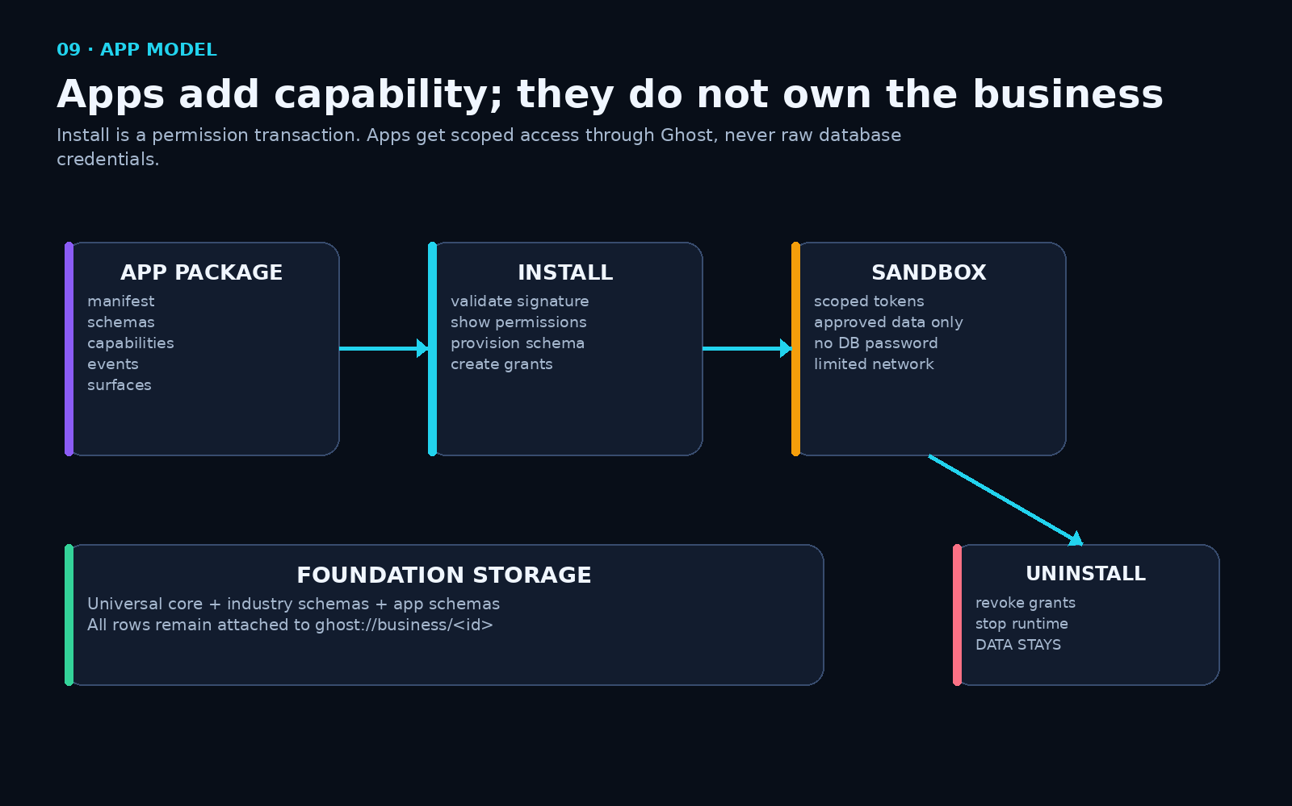
Figure 9 — App install provisions access and schemas; sandboxed code never receives the business database itself.

12.1 Sandboxing
Third-party app code should run outside the kernel with scoped tokens. Lightweight extensions can use WASM/WASI-style sandboxes; heavier apps can use isolated containers. The key contract is more important than the sandbox technology: no app gets raw database credentials, unrestricted secrets, or unrelated private data.

13. Surfaces: UI Is Replaceable
A “public profile” should not be a special silo. A surface is an authorized composition of data and capabilities for an audience. The uploaded kernel correctly states: “The website is a renderer, not a database.” [F1]
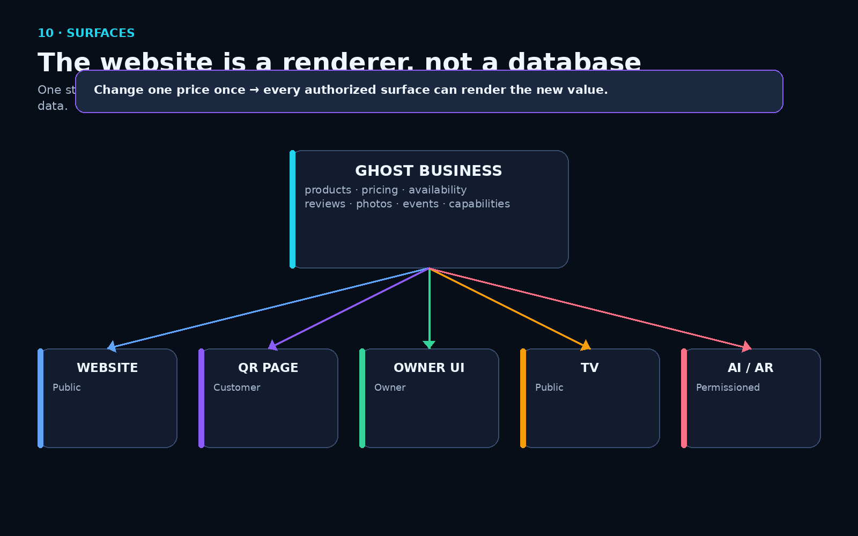
Figure 10 — Website, QR, owner dashboard, display, AI, and AR can all render the same canonical business.
Surface | Audience | Example
Website | Public | About, pricing, availability, reviews.
QR table page | Customer | Menu, recommendations, song request, loyalty.
Owner dashboard | Owner | Bookings, customers, automation, conflicts, devices.
Partner portal | Agency/partner | Only granted operational or marketing data.
TV / signage | Public/staff | Specials, events, status, media.
AI/MCP | Agent/client | Structured resources plus permissioned capability tools.
AR | Customer | Identify place/entity and render current structured facts.

14. The Builder: Reuse First, Generate Only What Is Missing
The Builder is not primarily a standalone app generator. It analyzes a requested outcome against the registry and existing business modules, then reuses identity, customers, events, messaging, analytics, schemas, capabilities, and components before generating missing pieces. The uploaded Builder UI explicitly states this rule. [F4]
Describe: “Build a song request app.”
↓
Planner checks registry
↓
Reuse: business identity, customer identity, events, permissions, QR, analytics
↓
Create missing: song_request schema + guest UI + artist queue + capabilities
↓
Sandbox tests
↓
Package manifest
↓
Install

15. AI Routing, AppMaps, and “Build Once, Run Cheap”
AI is a discovery/reasoning layer, not the permanent runtime for every deterministic action. Exact lookups use SQL/rules; intent parsing can use a small local model; novel UI mapping, repair, or complex planning can invoke a larger model. This mirrors the “build expensive, run cheap” pattern identified in the Twin research, which describes high-reasoning models during build/discovery and cheaper models during repeat runs. [F5]
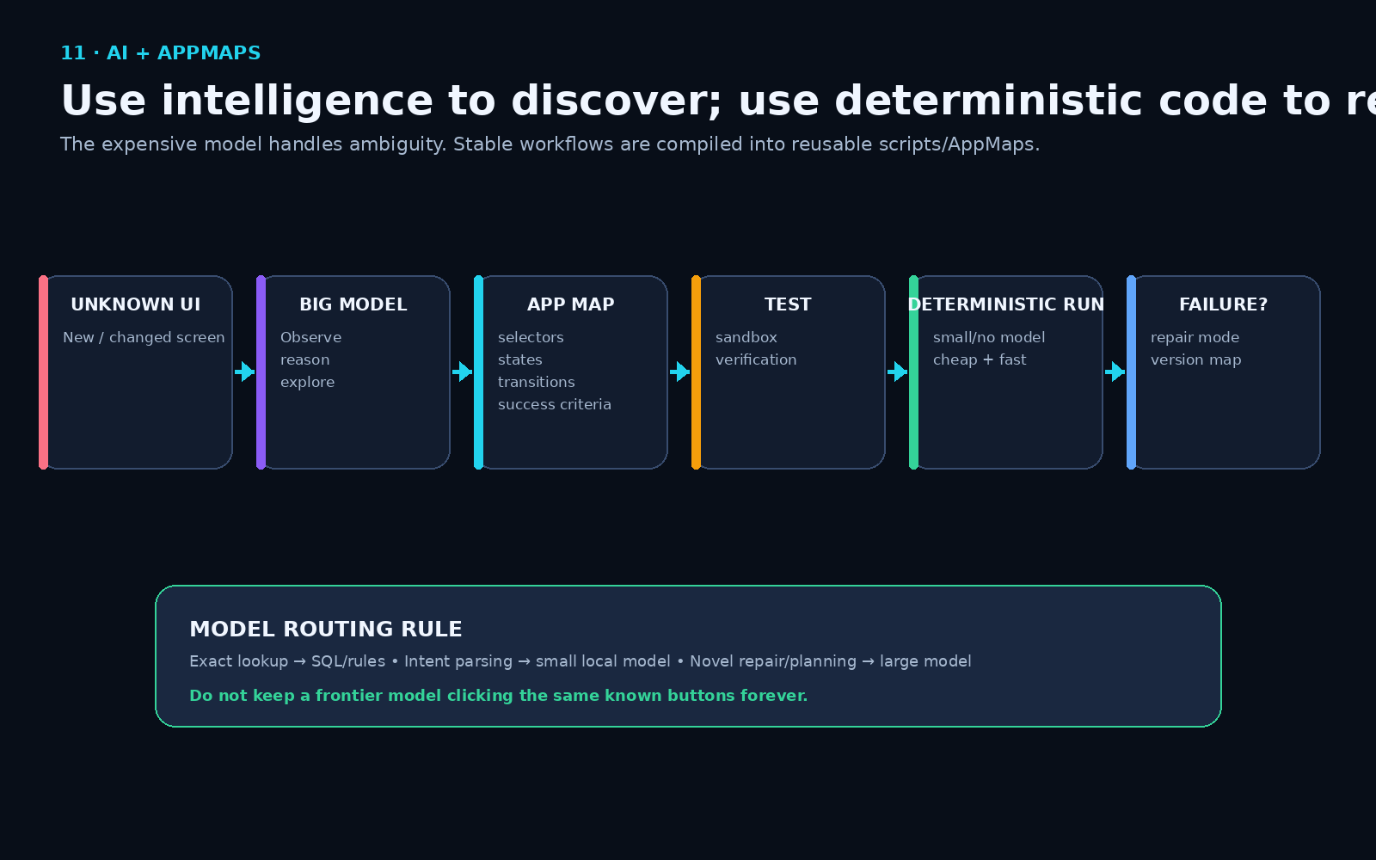
Figure 11 — Unknown UI is mapped with intelligence; known workflows are replayed deterministically until verification detects a change.

15.1 AppMap lifecycle
- Unknown interface appears.
- AI observes DOM/accessibility tree/screenshots and explores the workflow.
- Ghost records stable states, selectors, transitions, required inputs, and success criteria.
- Sandbox/test verifies the map.
- Future runs use deterministic actions with little or no large-model reasoning.
- If the UI changes and verification fails, Ghost enters repair mode, patches the AppMap, versions it, re-tests, and resumes.
The Twin research is relevant because it identifies reliability, self-healing, cost routing, and unit economics—not the basic agent idea—as the real production challenge, and it acknowledges browser automation as a costly/less reliable fallback compared with APIs. [F5]

16. Executors: API First, Browser Second, Device/Android Last
The caller sees a stable capability. The router selects an authorized implementation according to health, priority, cost, latency, and policy. The foundation build guide explicitly orders executors: API → browser → device endpoint → Android. [F2]

16.1 Browser executor
Known browser workflows should use deterministic Playwright/CDP-style actions. Browser-agent reasoning belongs in discovery/repair mode, not every repeat run. Persistent sessions, 2FA handoff, live watch, cancellation, and verification are necessary production features.

16.2 Android executor
The Linux/Ghost Node is the controller; a real Android phone/device is the execution environment for apps that do not expose adequate APIs. Prefer accessibility-tree/semantic element targeting; use vision only when needed; avoid public ADB exposure; and always keep owner Watch/Pause/Take Control available. [F4]

16.3 Device endpoint
A small Pi, signage player, or stick should advertise a narrow set of capabilities such as display.play, device.restart, heartbeat, and screenshot. It does not need to run the full database or large AI model.

17. Connections, Secrets, and Local Support
A connection represents an external system the business uses regardless of underlying method: OAuth, API key, email, iCal, browser session, or device. Secrets are stored behind opaque references; apps should never see plaintext credentials. [F1][F2]

17.1 Owner-controlled local IT support
The support model should mirror controlled remote assistance: the owner of the computer/node—not Ghost corporate—grants a trusted local technician temporary scoped access. Ghost Cloud can provide rendezvous/relay infrastructure, identity, logging, and policy enforcement without becoming the owner of the machine or business data.
Temporary grant | Example
Who | Approved local IT provider / technician identity.
Duration | 2 hours or until owner revokes.
Allowed | Read diagnostics/logs; restart specified container; update approved packages.
Denied | Export customer data; read financial records; access unrelated secrets.
Proof | Every support action enters the same verification/ledger system.

The local provider ecosystem is part of the product philosophy: the owner can choose who maintains the system instead of being trapped in one vendor’s support channel.

18. Deployment: Existing Computer, Ghost Node, Cloud, or Hybrid
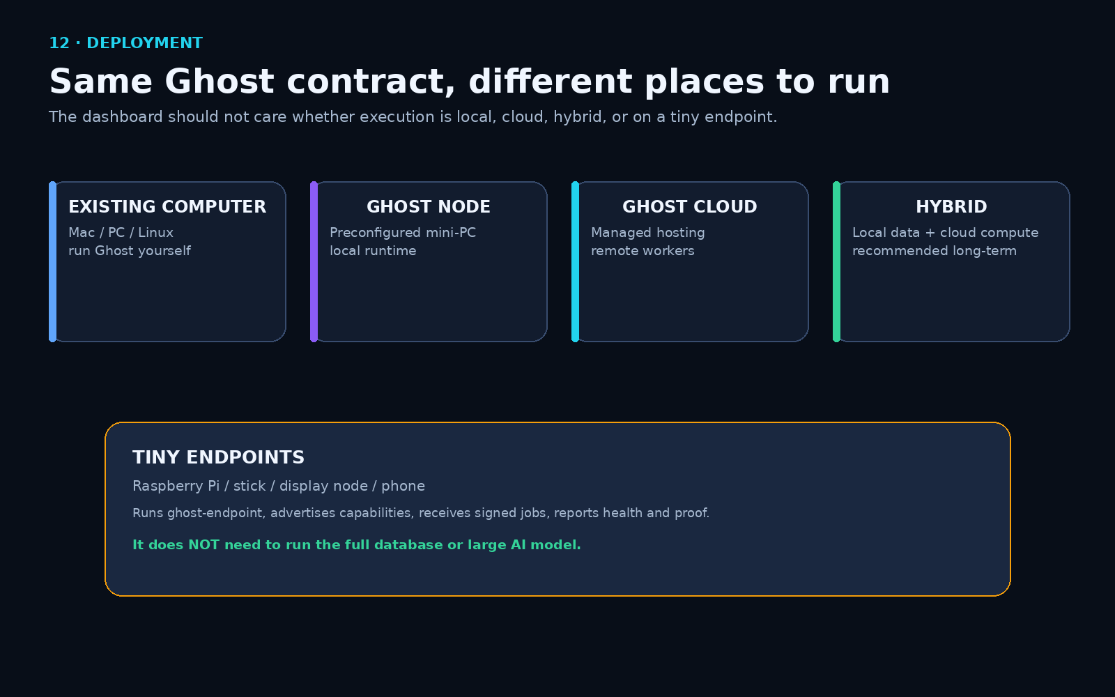
Figure 12 — Hardware is a delivery option. The Ghost contract remains the same across existing computers, local nodes, managed cloud, and hybrid deployments.
Mode | What runs where | Who it fits
Existing computer | Ghost installed on compatible owner-controlled hardware. | Technical users and businesses that already own adequate machines.
Ghost Node | Preconfigured Linux/mini-PC appliance. | Users who want plug-and-play local ownership.
Ghost Cloud | Managed control/runtime services. | Users who want convenience and no local infrastructure.
Customer cloud | Same Ghost contracts deployed into customer-selected infrastructure. | Agencies/enterprises with existing cloud standards.
Hybrid | Local data/executors + cloud heavy compute/coordination. | Best fit when privacy, persistence, and burst compute all matter.

A Mac Mini can be sold as a convenient preinstalled appliance if desired, but the architecture must not require a Mac or any single hardware vendor. The same software contract should run on compatible Linux/macOS/cloud environments.

19. Portable / Plug-and-Play Ghost Device and the Subscription Model
A second hardware form factor discussed in the concept is a portable, appliance-like Ghost device: something that can be delivered preconfigured like a small computer, stick, or bootable environment. It can attach to an existing computer rather than forcing the customer to buy a full new machine. The product is still the software foundation; the portable device is a bootstrap, identity, connectivity, and local-runtime option.

19.1 What the portable device can contain
- Secure device identity and owner keys.
- A minimal Linux runtime or bootable/containerized Ghost environment.
- Encrypted local storage for configuration, policy, and selected business data.
- Optional cellular/SIM modem so the node can establish connectivity without relying entirely on the host network.
- Agent/endpoint daemon that registers the hardware with the owner’s Ghost workspace.
- Optional small local AI runtime for intent/routing tasks.
- Ability to download approved local models or packages from the owner’s configured cloud/registry when storage and compute permit.
- Remote-support channel that remains closed until the owner grants a technician a scoped session.

19.2 Local AI can be pushed down from the cloud
The customer does not need every model preinstalled. The Ghost model registry can describe model size, hardware requirements, trust/signature, license, purpose, and version. A compatible node can download the model package from the cloud/marketplace, verify the package signature/hash, install it locally, and route eligible tasks to it. Large or rare tasks can continue to burst to cloud models if the owner’s policy allows.
Model Registry → choose compatible signed model → download → verify hash/signature → install local runtime → register capability → AI router may use it

19.3 Why a subscription still makes sense when the owner runs locally
The subscription does not have to be rent for access to the owner’s own data. It can pay for optional managed services around the local foundation: software/security updates, signed package registry, marketplace access, cloud relay, remote support rendezvous, backups, encrypted sync, heavy-model compute, remote browser/Android capacity, monitoring, domain/discovery services, and enterprise support. A self-hosted community edition can remain usable without turning the cloud subscription into a new lock-in gate.
Local ownership and recurring revenue are compatible if the recurring fee pays for continuing services and convenience rather than for permission to access the owner’s own foundation.

20. MCP, APIs, Linked Data, and the Open Business Web
MCP should be treated as one external protocol adapter. Ghost remains the authority; MCP exposes approved resources and tools. If another agent protocol replaces MCP, only the adapter changes.
Ghost facts/resources → MCP Resources
Ghost capabilities → MCP Tools
Ghost grants/policy → tool/resource visibility
Ghost ledger → every agent call auditable

19.1 One business, one machine-readable source
The long-term network model is “logically centralized per owner, federated across the Web.” Each business can have one canonical machine-readable authority while the overall network remains decentralized. Search engines, AI systems, directories, apps, and partners can discover and consume authorized data through open interfaces.
Business A Ghost ─┐
Business B Ghost ─┼→ open protocols / discovery → Search / AI / Apps / Partners
Business C Ghost ─┘
No requirement for Ghost corporate to hold every business’s database.

19.2 Semantic/open-standard projection
Ghost can remain relational internally and project outward using standard Web representations. Useful standards include JSON-LD for Linked Data in JSON, Schema.org vocabulary for common public business concepts, PROV-O for interoperable provenance, SHACL or similar shapes for machine-validatable structures, and ODRL/Solid-style policy vocabularies where useful. [R10][R11][R12][R13][R14]
Internal Ghost | Public semantic projection
business.display_name | schema:name
location address | schema:PostalAddress
hours rows | schema:OpeningHoursSpecification
review records | schema:Review
source/observation/fact | PROV-style provenance statements
visibility/grants | Solid WAC/ACP or ODRL-compatible policy representation where useful

21. End-to-End Examples

20.1 “Close early tonight”
- Owner enters or dictates “close at 7 tonight.”
- Identity resolves owner + business + location.
- Canonical temporary-hours record is written with owner authority.
- Event business.hours.changed is inserted in the same transaction.
- Website/QR/AI/MCP surfaces update directly from canonical state.
- Capability router resolves update paths for Google, Facebook, Yelp, and other channels.
- Policy allows or requests approval depending on connection/risk.
- Executors perform provider-specific updates.
- Verification reads back each external destination.
- Synchronization checklist shows match/mismatch and provides Retry/Inspect actions.
- Ledger stores the full evidence chain.

20.2 Provider-neutral table reservation
User: “Table for four tonight around 7.”
↓ intent
party_size=4, desired_time≈19:00
↓ capability
availability.search
↓ router
OpenTable / Resy / direct system / manual inventory
↓
normalized availability result
↓
reservation.create if authorized

20.3 Song Request reference app
Guest scans QR → public song-request surface → song_request.create
↓
structured record + event
↓
artist owner surface shows queue
↓
artist taps Play / Skip / Complete
↓
capability call + event + receipt

20.4 Marketing agency access
A business can grant an independent agency permission to read menus/specials/events and write social drafts or execute approved publishing while denying access to customer phone numbers, bookings, financial data, or unrelated secrets. The agency can even supply its own custom dashboard/surface on top of the same foundation.

20.5 Personal AI / AR
A consumer-facing Ghost can keep user-controlled preferences separately. When a person scans a restaurant QR or points an AR interface at a building, the personal agent can resolve the business entity, read public/authorized structured data, combine it with the person’s own preferences, and recommend without either side receiving more private data than necessary.

22. UI/UX: Make the Power Feel Simple
The default owner interface should be Linktree-simple: installed capabilities appear as expandable rows. Tap to open quick status/actions; tap again to collapse; open a full workspace only when necessary. Advanced provider, AppMap, model, cost, executor, and policy details remain available behind an advanced view. [F2][F4]
MY GHOST
[ Bookings 12 › ]
[ Customers 387 › ]
[ Song Requests 8 › ]
[ Automations 6 › ]
[ Devices 3 › ]
[ AI › ]
[ Surfaces › ]
[ + Add Capability ]

21.1 Data browser
The owner must be able to inspect their underlying business records even if every app is uninstalled. Each record should show source, update time, verification state, conflicts, visibility, and which apps/partners currently have access. This is the UI that makes the ownership thesis visible. [F2]

21.2 Permission UI
Normal users should see plain language (“ABC Marketing can update specials but cannot view customer phone numbers”), not ACL jargon. Technical policy can remain available as an advanced view.

21.3 Onboarding
Initial setup should not force a long 17-step wizard. The foundation guide proposes a shorter value-first sequence: claim → verify → discover → confirm facts → make one useful thing work. Additional tools, apps, automations, and support access can be added progressively. [F2]

23. Open Source, Marketplace, Contribution Provenance, and Royalties

22.1 What should be open
- Ghost core contracts/specification.
- Canonical schema definitions and versioning conventions.
- App manifest/package specification.
- Capability/event/surface/endpoint protocols.
- SDKs and CLI.
- Reference runtime and reference apps.
- Policy integration interfaces.
- AppMap/package signing/provenance format.

22.2 What can be commercial
- Managed Ghost Cloud and remote coordination.
- Managed backups/sync/updates.
- Verified marketplace and signing infrastructure.
- Enterprise policy/fleet management.
- Premium support and local-provider program.
- Preconfigured hardware.
- Managed AI/model routing.
- Premium apps, adapters, templates, or vertical packages.

22.3 GitHub-like contributor economics with an optional blockchain ledger
A contributor may publish an app, schema, AppMap, workflow, surface, or adapter under an open or commercial-friendly license. Ghost can record package hash, author/publisher identity, version, dependencies, license, downstream usage, and commercial transaction events. If the marketplace chooses to reward upstream components, a smart contract or conventional settlement system can automatically distribute small royalties according to declared dependency rules.
Contributor A publishes Adapter A
Contributor B builds App B and declares dependency on Adapter A
Customer buys/uses commercial App B
↓
marketplace records dependency + transaction
↓
optional smart contract / settlement engine distributes agreed share to A
The ledger provides transparent provenance and settlement evidence; it does not determine copyright ownership by itself, and open-source licenses must be respected. Some open-source licenses do not allow the exact royalty model you may want, so marketplace economics must be designed around explicit licensing choices.

22.4 Concept / idea provenance
A separate contribution ledger can preserve chat logs, documents, diagrams, commits, concept descriptions, timestamps, hashes, revisions, and declared derivations. AI can extract structured concepts from those artifacts and build a dependency/provenance graph. This can show that an artifact or concept was documented by a certain date and how later artifacts claim to derive from it. It does not, by itself, prove that an outside AI company saw, trained on, copied, or legally misappropriated that concept; those claims require separate evidence.

24. The Organization and Ecosystem
The organization can be understood as several commercial/community layers that all depend on the same open foundation rather than as unrelated products.
Layer / business | Role
Ghost Foundation | Open core: identity, data, contracts, permissions, capability/runtime standards.
Ghost Cloud | Optional hosted control plane, coordination, updates, backups, heavy compute, remote support relay.
Ghost Marketplace | Apps, schemas, adapters, AppMaps, workflows, surfaces, models, drivers; publisher economics.
Ghost Hardware | Optional preconfigured nodes/endpoints for nontechnical users.
Ghost Network | Businesses, developers, agencies, local IT providers, AI/search clients, partners.
Local Support Program | Approved technicians/providers whom the owner may grant scoped temporary access.

The company should make money from convenience, hosting, verification, marketplace distribution, support, and hardware—not from preventing the owner from leaving.

25. Exact Foundation Build Order
The uploaded build guide correctly puts the semantic/control spine before the flashy executors. The strict sequence is identity → permissions → schema registry → provenance → capability registry → policy gate → event bus. Only after that foundation is stable should execution/UI tracks expand. [F2]
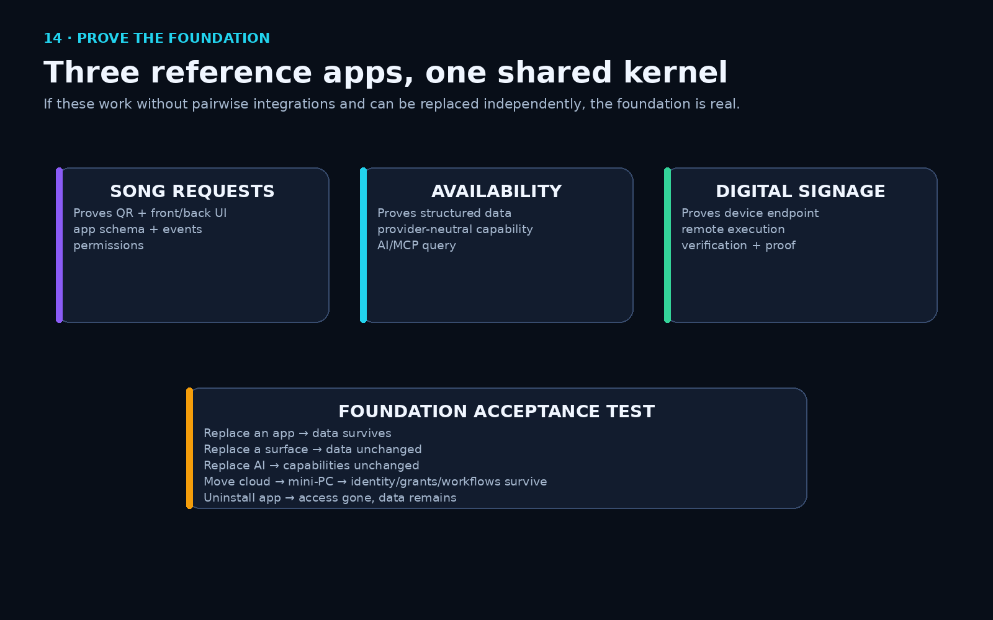
Figure 13 — Three independent reference apps prove that the kernel is actually reusable.
Phase | Build | Acceptance condition
F1 | Identity kernel | Multiple roles act on one business; every action attributable.
F2 | Permission kernel | Raw grants—not role names—fully determine behavior.
F3 | Schema registry/provisioner | Manifest schema creates typed, RLS-protected table; app cannot obtain DB credential.
F4 | Provenance engine | Conflicts detected; owner resolution cannot be overwritten by inference.
F5 | Capability registry/router | Caller invokes one capability without knowing which provider executed.
F6 | Policy gate | No privileged capability executes without a deterministic policy decision.
F9 | Event outbox/bus | State and event commit together; dispatcher crash loses no events.
F7/F8 | Execution + verification/ledger | Worker crash resumes safely; success requires observed state.
F12/F14/F13 | Control API + realtime + MCP | All external entry points use one controlled backend.
U1–U7 | Components, renderer, dashboard, data/conflict/receipt UI | Owner sees value and underlying data independently of apps.
F10/F11 | Connections/secrets + app framework | Install/uninstall/reinstall preserves data and secrets remain opaque.
Executors | API → browser → device → Android | Fallback paths add reach without becoming architectural dependencies.

26. Foundation Acceptance Test
The foundation is not “done” because the dashboard looks good. It is done when independent components can be replaced without rebuilding the owner’s digital business. The uploaded build guide defines essentially this test. [F2]
- Build three throwaway apps against the same identity, permission, event, and data contracts with no pairwise integration code.
- Replace one app; the other apps and data continue working.
- Replace the surface; canonical structured data remains unchanged.
- Replace the AI model; capabilities and workflows remain unchanged.
- Move the runtime from cloud to local mini-PC or another compatible environment; identity, grants, schemas, workflows, and data survive.
- Uninstall an app; it loses capability access but does not take business data with it.
- Replace a provider implementation (for example API → browser) without changing the calling app or automation.
- Verify a failed/mismatched external update is visible as a mismatch rather than falsely marked complete.
If replacing a component requires rebuilding the business, that component is still too tightly coupled.

27. Important Architecture Decisions Still to Settle

26.1 Consumer identity scope
The uploaded build guide correctly leaves one major decision open: whether a tourist/customer is one portable person identity across businesses or a separate customer record per business. [F2]
Option | Advantages | Risks
Portable/global person identity | Cross-business recommendations, cooperative loyalty, reusable customer preferences, consumer Ghost. | Higher consent/privacy burden; stronger separation and disclosure controls required.
Per-business customer identity | Simpler privacy model; lower cross-business inference risk. | Less portable personalization and weaker consumer-network effects.

Recommended compromise: a global person identity can exist independently, while each business relationship remains separately permissioned and cross-business preference sharing is explicitly consented rather than automatic.

26.2 Open standard versus proprietary service boundary
The foundational contracts must be open enough that an independent implementation could interoperate. This is the practical application of Berners-Lee’s “test of independent invention”: if someone else independently implemented the same open contracts, their implementation should be able to work with yours. [R3]

28. Research Source Notes and Historical References
The following sources are the primary basis for the historical/standards comparisons. Several Berners-Lee “Design Issues” pages are explicitly personal architectural notes rather than formal W3C Recommendations; the document distinguishes those from formal standards.
ID | Source | URL
R1 | Berners-Lee, Cailliau, Luotonen, Nielsen, Secret — “The World-Wide Web” (Communications of the ACM, 1994). | https://www.w3.org/People/Berners-Lee/1994/08-CACM-p76-berners-lee.pdf
R2 | Tim Berners-Lee — “The World Wide Web: Past, Present and Future” (1996). | https://www.w3.org/People/Berners-Lee/9610-IEEE-Computer.html
R3 | Tim Berners-Lee — “Principles of Design” (1998, personal design notes): simplicity, modularity, decentralization, independent invention. | https://www.w3.org/DesignIssues/Principles.html
R4 | Tim Berners-Lee — “Semantic Web Road Map” (1998, personal design notes). | https://www.w3.org/DesignIssues/Semantic
R5 | Tim Berners-Lee — “Linked Data” (2006, personal design notes). | https://www.w3.org/DesignIssues/LinkedData
R6 | Tim Berners-Lee — “Read-Write Linked Data” (2009, personal design notes). | https://www.w3.org/DesignIssues/ReadWriteLinkedData.html
R7 | Tim Berners-Lee — “Socially Aware Cloud Storage” (2009, personal design notes). | https://www.w3.org/DesignIssues/CloudStorage.html
R8 | Solid Project — About Solid / Your Data, Your Choice. | https://solidproject.org/about
R9 | Solid Project — FAQ / developer explanation of Pods, access, app-data separation. | https://solidproject.org/faq
R10 | W3C — Linked Data Platform 1.0. | https://www.w3.org/TR/ldp/
R11 | W3C — SHACL (Shapes Constraint Language). | https://www.w3.org/TR/shacl/
R12 | W3C — PROV-O / PROV family. | https://www.w3.org/TR/prov-o/
R13 | W3C — ODRL Information Model. | https://www.w3.org/TR/odrl-model/
R14 | W3C — JSON-LD 1.1. | https://www.w3.org/TR/json-ld11/

27.1 Uploaded Ghost source materials
ID | File | Used for
F1 | 01-kernel-schema.sql | Canonical PostgreSQL kernel: identity, permissions, schema registry, provenance, capabilities, execution, verification, ledger, events, connections/secrets, apps, surfaces, automations.
F2 | 02-foundation-build-guide.md | Foundation modules, front-end modules, build order, acceptance tests, unresolved consumer identity decision.
F3 | Flow .html | Master runtime loop, five maps, capability model, provenance/sync logic, developer build example.
F4 | Plans index / Clean index / prototype library | UI/UX screens for onboarding, control center, connection health, builder, device watch/takeover, deployment, permissions/ledger.
F5 | Twin deep-dive research PDF | Build-vs-buy comparison, API-first/browser-fallback, build-expensive/run-cheap, self-healing, browser reliability/cost lessons.

29. Final Definition
Ghost is best understood as an owner-controlled, federated software foundation for the AI/automation era. Each business can maintain one canonical operational identity and structured data authority; applications declare what they need instead of owning separate databases; AI and partners receive explicit access; capabilities describe outcomes independently of vendors; the router chooses API/browser/Android/device implementations; policy controls actions; verification proves results; and surfaces render the same foundation in whatever UI the owner or developer wants.
The business owns the foundation. Software rents permission to operate on it.

Historically, this is not a claim that Berners-Lee specified Ghost. It is a practical business/automation implementation that intentionally combines the original Web’s decentralization and modularity, the Semantic Web’s machine-readable data, Linked Data’s durable identifiers and reuse, Read-Write Linked Data/Solid’s app-data separation and access control, and modern agent/execution infrastructure.
The business model follows the same principle: monetize hosting, convenience, support, verification, marketplace distribution, optional hardware, and premium services—while preserving the owner’s ability to export, self-host, change provider, change AI, change UI, change executor, and change local IT support without rebuilding the business itself.

