Parser - Game Design Document

Game Concept

A rhythm and object matching game where the player is tasked with managing someones heart. The changing pace and overlapping demands compounds difficulty. This is balanced by a generous capacity to make mistakes and always being lent the opportunity to fix what has gone wrong. And of course the player is given someone elses waistline to mess with.

Fictive setting

The human body and all it’s cellular and organ demands as seen from the point of view of the heart. The rhythmic beat of the heart setting the mood for the game and key to the pace of activity. The heart is concerned with the organs’ demands, the direction to get there and the different blood cells it can issue.

Objective

The game will be composed of waves. Each wave represent 1 day in the life of the character and the player will have to send the cells to the artery leading to the correct organ in time. If the player misses the artery, fat cells will spawn near the organ and the player will have to send some platelets cells to get rid of those.
Random virus cells will cross the screen and the player will have to avoid those in order to keep his character healthy.

The goal is to keep the character alive as long as possible in order to get the highest score. The game ends when the player’s mistakes begin to accumulate and a fail state has been triggered. The player is then presented with their score in this latest run.

This difficulty will be balanced towards short and eventful play sessions. Aiming at 2 minutes 40 seconds. But it will still be possible for skillful players to extend this much further.

Game Objects

Selectable cell type:
- Platelets
Remove fat cells from the arteries
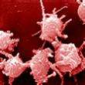
- Red cells(erythrocytes)
Energy the organs need
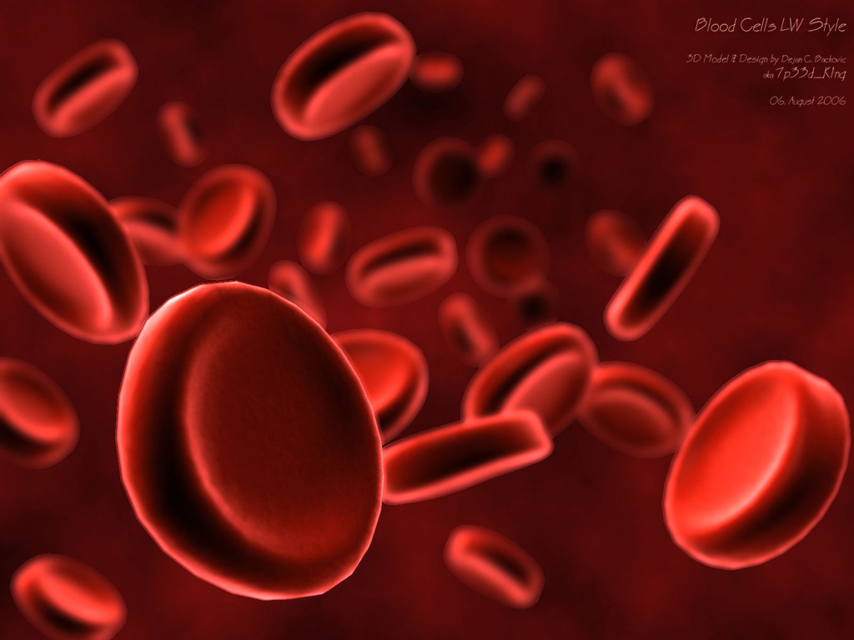
- White cells(Leukocyte)
Self defense: will help against virus infection
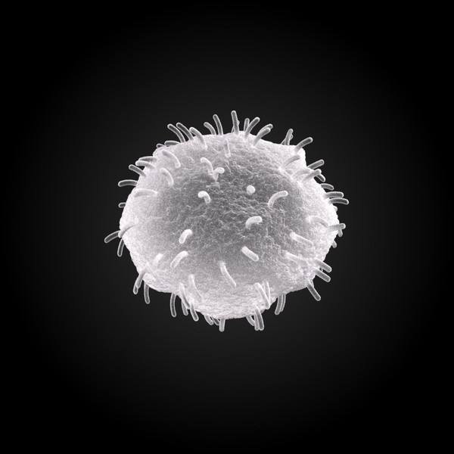

Bad cells:
- Fat
Will spawn around the artery if the player misses a shot
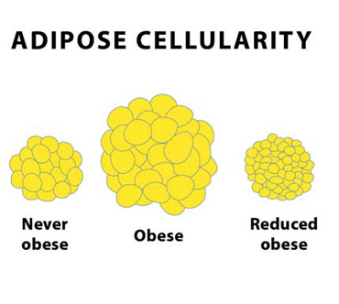
- Virus
Cross the screen randomly
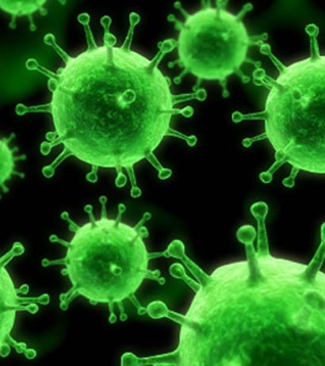

Organs:
- Stomach
- Lung
- Brain
- Muscle

Background sample
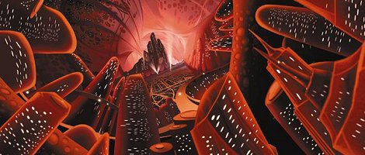

Player Controls

- The user will have to use the sensor of the phone to define the angle of the shot.
- Make touch inputs to determine the cell to use
-(prototype) use the mouse input

Features

- Changing heart rate
- Dynamically add and remove cell objects
- Set and measure cell velocity vector
- Update velocity vector with user input
- Score counter on HUD
- Human character depicting current activities, success and failure
- Event map providing clues to future events
- Scaling in and out to increase difficulty and depict greater area
- Background image setting
- Quit option
- Save score

Game Logic

WaveUpdate

get WaveList at front

current wave update

if current time is less than wave length
get WaveBehaviour
WaveBehaviour update
else
remove current wave move onto the next and add a new wave to the back of the list

Updating Cells

Iterator <Cell> cellItr

while cellItr has next
update crtCell
if crtCell returns true
remove crtCell

CellUpdate

call Super Class update to refresh coordinate information
call CellMovementBehaviour contained class
change movement vector depending on cell behaviour type

Updating Heart

call heart update method
currentBeat = get heart voltage value from variable
increment pointer to get value
if currentBeat is greater than CELL_CREATE_VOLTAGE
return true
else
return false

if update returns true then
add new cell at heartX and heartY

Collision CircleVsCircle

if ((C1x - C2x) * (C1x - C2x)) + ((C1y - C2y) * (C1y - C2y))
if less than or equal to
(C1Radius + C2Radius) * (C1Radius + C2Radius))
then
call derived class collision method
else
do nothing

Collision HeartVsFat

if ((Hx - Cx) * (Hx - Cx)) + ((Hy - Cy) * (Hy - Cy))
if less than or equal to
(HRadius - CRadius) * (HRadius - CRadius))
then
the heart completely overlaps the fat cell and you suffer a heart attack
Game Over!
else
you may carry on

User interface

PICTURES HERE

Class Structure

Failure condition

Fat cells are key to the fail state. These are created when the player makes mistakes. Fat cells can be removed. But will quickly build up if unattended.

The game ends when the heart overlaps an entire fat cell which is not moving and is touching another fat cell.

So the rules are:

- Player mistakes matching cells will result in fat cell being created
- Existing fat cells will create new cells if the player hits it with the wrong cells
- There is a limited about of area in the level
- The player can use certain cells to clear fat
- The heart beats to a certain maximum size and if it completely over laps a fat cell that is set in place the player suffers a heart attack and the game ends
- Fat cells can be pushed to the edge of the play are thus decreasing the chance of heart attack

The game area can zoom out increasing the area to play in and so increasing the amount of lea way the player has. However on zooming back in some of these fat cells will be dragged along too.

- Infection (virus)

There are different viruses that cause varying degrees of trouble. But the player must strive to deal with all of them. Viruses will only be infect one type of game object and be harmless to others. The player can tell the viruses about by their strong colour schemes.

red viruses infect organs. An infected organ will bleed red blood cells at a random direction taken from blood cell used on healthy organs. These must be fixed with white cells.

blue virus will infect the heart. This will turn the heart a blueish colour while it lasts and increase the size of the heart. This will pass with time but the enlarging affect never completely repairs. This reduces the player’s margin for spare fat.

yellow viruses infect fat cells. On hitting a fat cell these will create an area of effect that shrinks that area of fat cells into a smaller plaque that the player cannot then remove. This plaque will behave like fat cells but without the player being able to remove it.

a green virus that if the player hits it with any cell it will infect that cell and burst into many more green viruses that will behave the same. This does not last many generations. and the viruses will dissipate quickly without action by the player.

Scoring

The player will score points for each correctly executed cell and organ strike. The must points can be gained by striking organs that burn fat. organs can be increased in size with platelets and then red blood cells will strike the organ and trigger an area of effect that turns fat into lots of points.

At the end of play the player will be presented with the length of time they managed to keep their heart in good health and the relative health of their human character. This if figures derived from their score and play time. This information is rendered into days lived and blood pressure/ heart rate on average.

