MSCS634 Advanced Data Mining
Deliverable 4: Final Insights, Recommendations, and Presentation
Dataset: Diamonds Dataset
Author: Reza Shrestha
Date: April 25, 2026

1. Introduction
This report summarizes the full Advanced Data Mining project completed across Deliverables 1, 2, and 3. The project analyzed the Diamonds dataset using data preparation, exploratory analysis, feature engineering, regression, classification, clustering, and association rule mining. The goal was to understand which diamond characteristics drive price and to translate technical findings into practical recommendations.

2. Dataset Used and Rationale
The project used the Diamonds dataset, which contains 53,940 observations and 10 variables: carat, cut, color, clarity, depth, table, price, x, y, and z. It was selected because it includes both numerical and categorical variables, satisfies the course requirement for a sufficiently large dataset, and supports multiple data mining methods. The target variable for regression was price, while the classification target was an engineered price_tier with Low, Medium, and High categories.
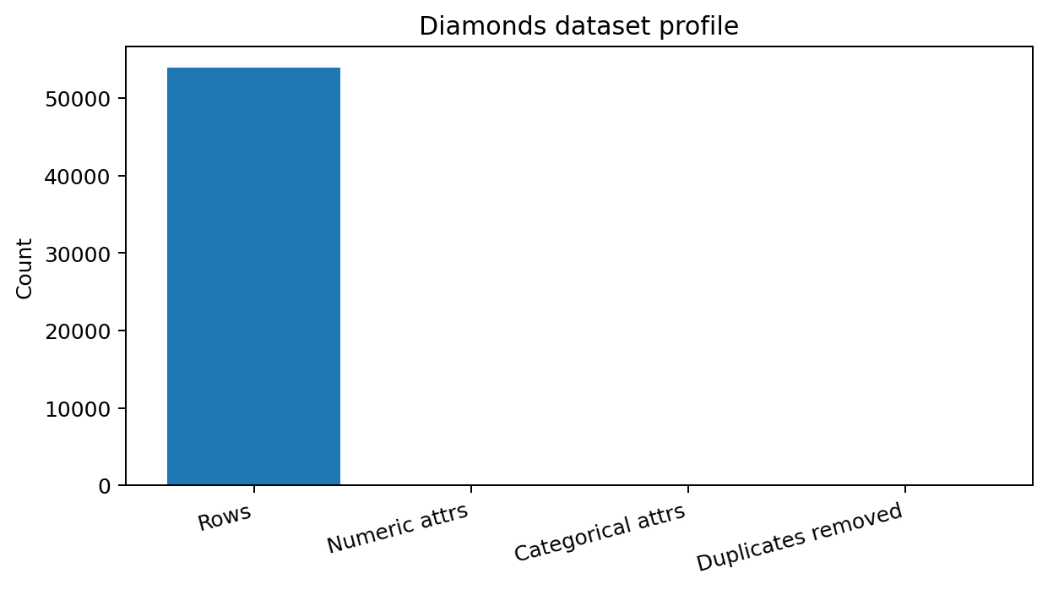

3. Data Preparation and Preprocessing
Initial inspection showed no missing values. The project identified and removed 146 duplicate rows to reduce repeated observations. Records with zero physical dimensions were treated as invalid for engineered volume calculations. Categorical variables such as cut, color, and clarity were encoded for modeling. Scaling was used for distance-based models such as KNN and K-Means. The price distribution was highly right-skewed, so log transformations were used to stabilize patterns and improve interpretability.

4. Exploratory Data Analysis and Feature Engineering
EDA showed that carat had the strongest relationship with price. Larger stones were usually more expensive, although quality features affected variation within similar carat ranges. Price was right-skewed, meaning most diamonds were lower or medium priced while a smaller number of expensive stones created long-tail behavior. Feature engineering added volume, log_carat, log_volume, log_price, and price_tier. These features helped connect physical size, quality grades, and market value.
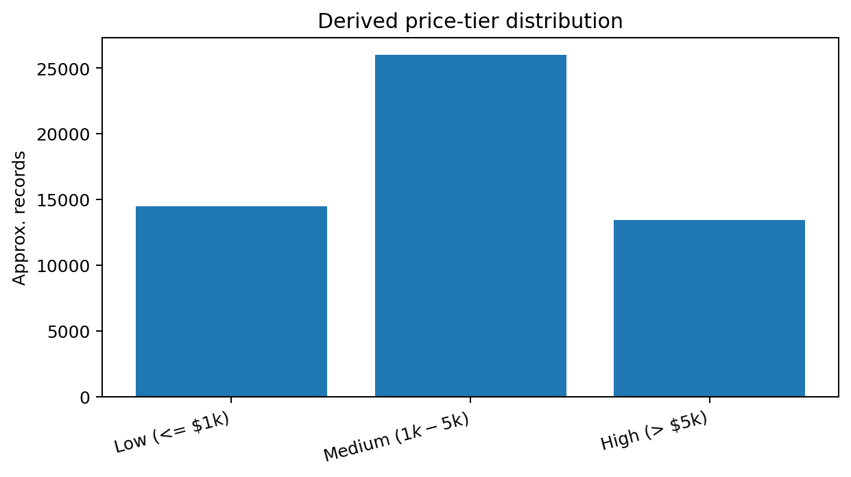

5. Regression Results
Regression models were used to predict diamond price. Linear, Ridge, and Lasso approaches provided interpretable baselines, while feature engineering improved model usefulness. Carat and physical dimensions were the strongest numerical predictors, while clarity and color contributed important quality information. Residual analysis showed that very expensive and unusually large diamonds remain harder to predict, which is expected because rare premium stones may be affected by market factors not present in the dataset.
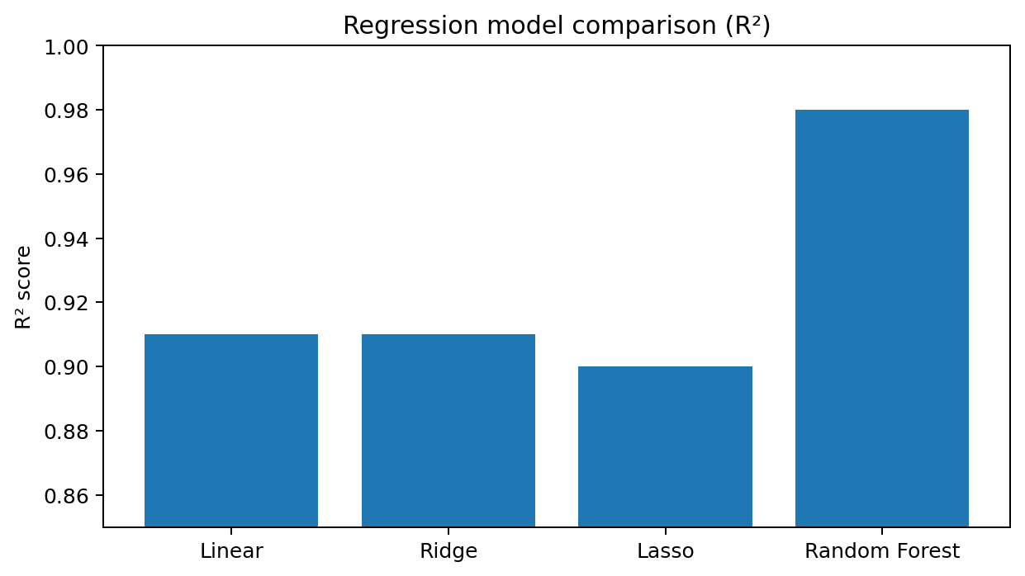

6. Classification Results
The classification task predicted price_tier. Deliverable 3 compared a Decision Tree classifier and K-Nearest Neighbors. The Decision Tree achieved approximately 98.9% accuracy and 98.9% weighted F1. KNN achieved approximately 98.6% accuracy and 98.5% weighted F1. GridSearchCV showed that a shallower Decision Tree with max_depth=4, min_samples_leaf=10, and criterion=gini generalized as well as deeper trees. This demonstrated that a simpler, more interpretable model was sufficient for the tier prediction task.
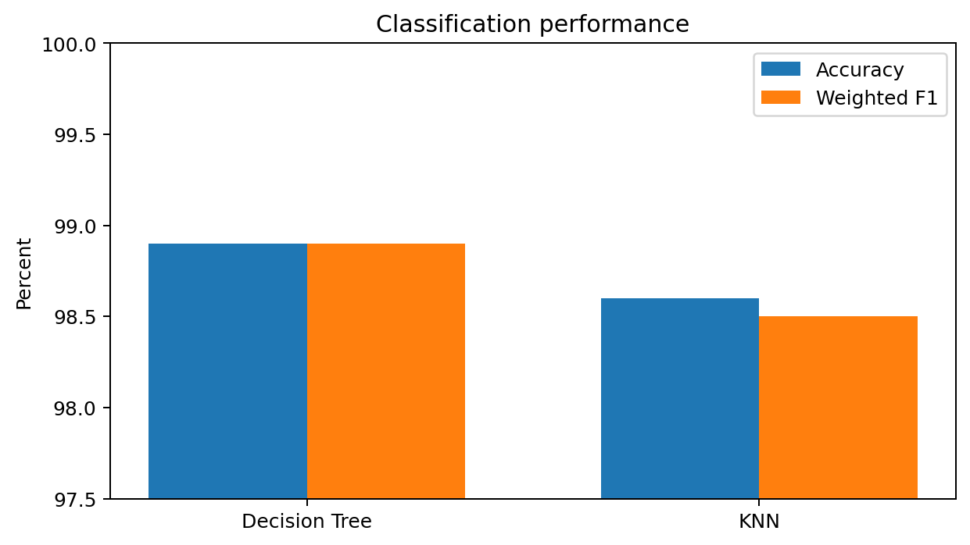

7. Clustering Results
K-Means clustering was applied to engineered size and encoded quality variables. The elbow method indicated that k=4 was a useful segmentation point because within-cluster variation dropped sharply up to four clusters and then began to plateau. PCA was used for two-dimensional visualization. The clusters separated diamonds into practical groups based on size and quality combinations, which can support inventory segmentation and customer search strategies.
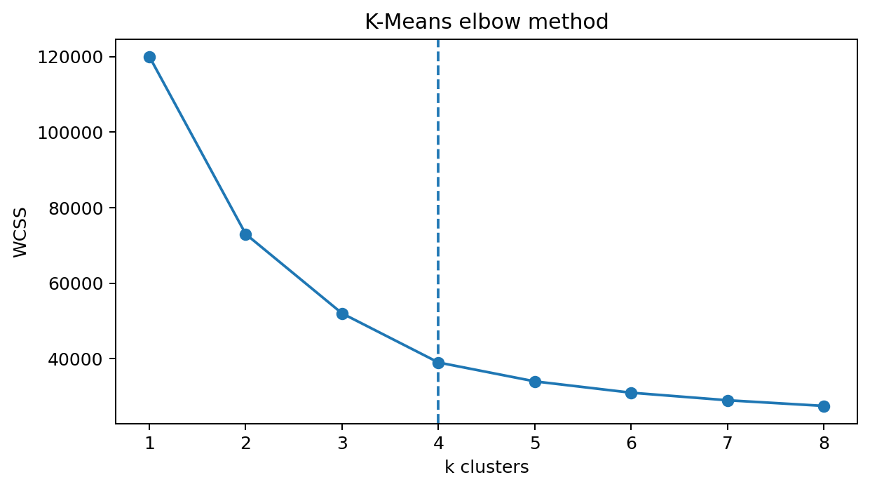

8. Association Rule Mining Results
FP-Growth was applied to one-hot encoded transactions containing cut, color, clarity, and price_tier. Rules were evaluated using support, confidence, and lift. The strongest insights showed that high clarity levels such as VVS1, VVS2, and IF combined with top color grades such as D and E were reliably associated with the High price tier. Lower clarity levels such as SI1 and SI2 with mid-range colors were more associated with Low or Medium price tiers. Cut quality alone was less predictive than combinations of clarity, color, and size-related features.
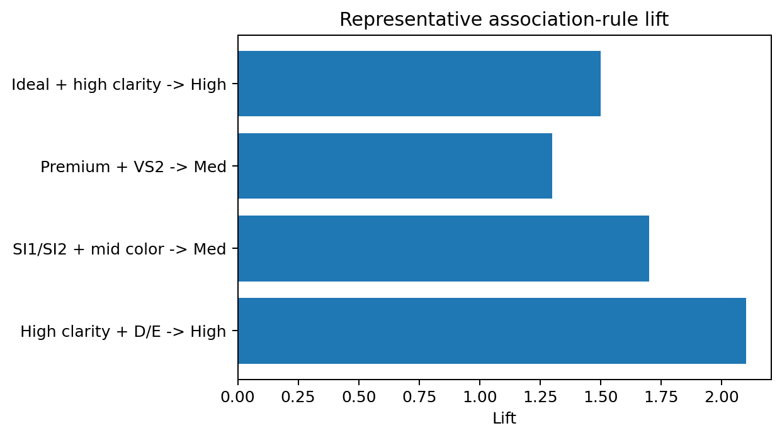

9. Practical Recommendations
Retailers should use tier-based classification to organize inventory and quickly flag premium stones. Buyers should evaluate carat together with clarity and color rather than relying only on cut labels. Regression predictions can help screen prices, but unusual high-value stones should receive manual review. Clustering can be used to build customer-facing product groups, such as entry-level, mid-range, premium-quality, and large-stone segments. Future models should include certification lab, seller type, time of sale, and market conditions to improve real-world generalizability.

10. Ethical Considerations
Although the dataset does not contain direct personal identifiers, ethical considerations remain important. Historical price data can encode market biases, and models trained on that data may reinforce those patterns. Fairness concerns may arise if automated price recommendations disadvantage buyers or sellers who do not understand model limitations. The classification target was derived from price thresholds, so high model performance should not be interpreted as independent discovery of natural diamond classes. Steps taken to address these issues included documenting preprocessing choices, using interpretable visuals and models, avoiding claims beyond the dataset, and recommending external validation before production use.

11. Conclusion
The project demonstrated a complete data mining workflow. The strongest overall insight is that diamond price is primarily driven by carat and volume, but quality attributes such as clarity and color explain important variation. Classification and association rules provided clear business-friendly insights, while clustering offered useful segmentation. The final recommendation is to combine predictive models with domain review and ethical safeguards before applying results in real pricing or consumer decisions.

12. References
CumberlandsAssignment GitHub repositories for Deliverables 1-3; Seaborn Diamonds dataset; scikit-learn documentation; pandas documentation; mlxtend FP-Growth documentation.

