Table of Contents
1.PROBLEM DEFINITION 2
1.1 Introduction: 2
1.2 Existing Scenario: 2
1.3Proposed Solution: 3
1.4 Boundaries of the System 4
1.5 Hardware and Software Requirements 4
1.5.1 Minimum Requirements 4
1.5.2 Recommended Requirements 4
2. APPLICATION ANALAYSYS 5
2.1Data Flow 5
2.2 Database Design 15
2.2.1 Entity Relationship Diagram 15
2.2.2 Detail of database 16
2.3 Architecture and Design of the Project 26
2.4 Flow Chart 28
3. Program 48
4. Test report 52
5. Task Sheet 52

1.PROBLEM DEFINITION

1.1 Introduction:

The old management system of educational universities are facing problem when they handle records by pen and paper. One of those is our client Andrews Institute of technical sciences and Management(AITMS) . It is established in the year 1976. Being the oldest university and one of the most famous universities in the territory, and is diversified into different technologies. It also uses modern technologies and equipments for educating their students like providing online classes, conducting online examinations, providing a discussion forum for the students and the staff of the university. So, they would like us to study the problem and evolve a strategy for solving the current problems.

1.2 Existing Scenario:

With existing current, they generally maintain the records of the attendance of vast of students studying variety of technologies, which the teacher needs to carry along with him/her in to the class room, and mark the presence of the students for that class.

To check with the eligibility criteria for the university exams, they need to go through all these records and calculate the percentage of their attendance. And as there are more number of students there are huge possibilities in miss-calculation while calculating the attendance.

And as per the university norms, if the student’s attendance is less than 70% he/she will not be allowed to attend the Final year exams. And if the students attendance is in between 70 – 75% then the student must pay a fine of 10/- per day the student is absent for, so that the customer can attend for the final year exams. And if the attendance is more than 75 % then there will not be any charges for attending the final year exams.

Presently the Problems faced in the current system are as follows:
- There is no automation involved to speed up the process of tracking and maintaining the records of the attendance.
- Tedious job for calculating the total and the percentage of the attendance
- Time consuming for calculating the total and the percentage of the attendance.
- Huge amount of space is being occupied for maintaining these records.

1.3Proposed Solution:

Based on the problems that are faced in the current system, the management has decided to establish a system where in they can effectively use the resources that are available with them to overcome these issues.
The decision is to implement a system (i.e., a desktop application) which can be installed on each and every machine of the staff, which is generally available in every classrooms and laboratories they have. The records of the attendance can be maintained in a database with the help of the user friendly application. With they can take the back up of the database and can easily store it in CD’s or DVD’s, etc. thus they can reduce the space required for maintaining the attendance records, as well they can automate the process, and the time consumption for calculating the total percentage of the student for that class.
The system should have the following modules
- Admin: one should be able to maintain (insert, update, delete and search) the following.
  - Records of the various courses that the university offers
  - Records of the classes based on the year and semester
  - Records of the staff along with the login details and the subjects of the courses that they deal with
  - Records of the students
  - The details of the fine based on the percentage of attendance on an average for all the classes conducted.

- Staff: one should be able to maintain (insert, update, delete and search) the following
  - Maintain the time schedule for a course, like for a year, how many subjects are available, and each subject is to be taught for how many hours a week.
  - Maintain the records of the time table for a class.
  - View the details of the students for a particular class.
  - Mark and Maintain the details of the attendance on daily basis
- The percentage of the number of days present in this year is to be calculated by the system alone
- The application must alone calculate the total fine levied on the student based on the percentage of attendance secured on an average for all the subjects

1.4 Boundaries of the System
This application of our still limited in many professional, and it only meets for fewer users

Hardware and Software Requirements

1.5.1 Minimum Requirements
 | Client | Server
Hardware | Pentium IV,600MHz  Ram 512GB  Screen Resolution : 1024*820 or higher | Pentium IV, 2.0MHz  Ram 1GB
Software | JDK 1.4.1 (or later )  Window XP or over | JDK 1.4.1 (or later )  SQL server 2005  Window XP or over

1.5.2 Recommended Requirements
 | Client | Server
Hardware | Pentium IV,1.2MHz or more better  Ram 1GB or more better | Pentium IV,3.0 MHz or more better  Ram 2GB or more better
Software | JDK 1.4.1 (or later )  Window XP or over | JDK 1.4.1 (or later )  SQL server 2005  Window XP or over

2. APPLICATION ANALAYSYS

2.1Data Flow
Define: Data Flows Diagram (DFD) describes the information flow in the system. The next step of system analysis is to consider in detail the information necessary for the implementation for functions discussed above and the one necessary for the improvement of the functions. Modeling tool frequently used for this purpose is DFD. DFD will support 4 main activities:
Analysis: DFD is used to determine requirement of users.
Design: DFD is used to map out plan and illustrate solution to analysis and users while designing a new system.
Communication: one of the strength of DFD is its simplicity and ease to understand to analysts and users;
Document: DFD is used to provide special description of requirement and system design. DFD provide an overview of key functional components of the system but it does not provide any detail on these components. We have to use other tools like database dictionary, process specification to get an idea of which information will be exchanged and how. The main components of Context Diagram:
Process
Data flow
External
Data store

The process: Shows the common function of system
The external factors: External factors can be a person, a group of persons or an organization that are sources of information for the systems and are where system products are transferred to.
The data flow: Describe the movement of information from one part of the system to another.
The data store: The Data Store is used to model a collection of data packets at rest. A store is represented graphically by two parallel lines. The name of a Data Store that identifies the store is the plural of the name of the packets that are carried by flows into and out of the Data Store

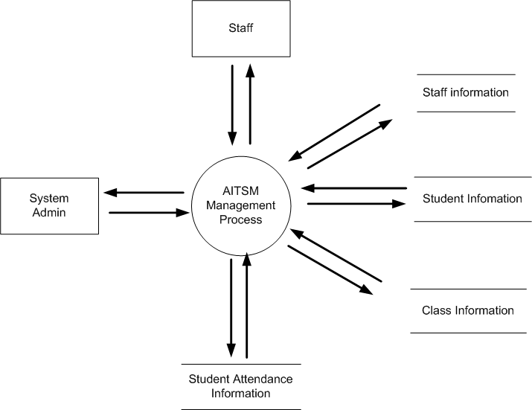

Fig 2.1.1. Context Diagram

LEVEL 0 – Context Diagram
4.0
Class
Management
3.0
Fine
Management
2.0
Academics management

5.0
Student
Management
1.0
Staff Management

Administrator

Staff

6.0
Attendance of student
Management

7.0
Schedule
Management

LEVEL 1 – Application Process

Administrator

Staff
1.0
Staff
Management

LEVEL 1–1 Staff Management Process

1.1.1
Add new staff

Staff_Subject

1.1.2
Edit prolife

Administrator
Staff

1.1.3
Delete staff

1.1.4
Search information of staff

LEVEL 1–1-1 Staff Management Process

2.1
Change Information

Staff
Staff

LEVEL 1–1-2 Staff Management Process

2.1
Add new Academics

Subjects

2.2
Edit prolife

Administrator
Courses

2.3
Delete Academics

2.4
Search information of Academics

LEVEL 1–2 Academics management Process

3.1
Add charges

Charges

Students
3.2
Edit fine, charges of Students

Administrator
Fine

Attendance

3.3
Search information of fine

LEVEL 1–3 Fine Management Process

4.1
Add new class

4.2
Edit prolife

Administrator
Class

4.3
Delete Class

4.4
Search information of class

LEVEL 1–4 Class Management Process

Administrator

Staff
5.0
Student
Management

LEVEL 1–5 Student Management Process

5.1.1
View Student

5.1.2
Add new Student

5.1.3
Edit prolife

Administrator
Students

5.1.4
Delete student

5.1.5
Search information of student

LEVEL 1–5-1 Management Student of Administrator Process

5.2.1
View Student

Administrator
Students

5.2.5
Search information of student

LEVEL 1–5-2 Management Student of Staff Process

7.1
Add new Schedule

7.2
Edit prolife

Staff

Schedule

7.3
Delete Class

7.4
Search information of class

LEVEL 1-7 Schedule Management Process.

8.2
Edit Attendance

Staff

Attendance

8.4
Search information of Student

LEVEL 1-8 Attendance of student Management Process.

2.2 Database Design

2.2.1 Entity Relationship Diagram
Our database has ten table. Figure 2.2.1 is the entity relationship diagram of our database.

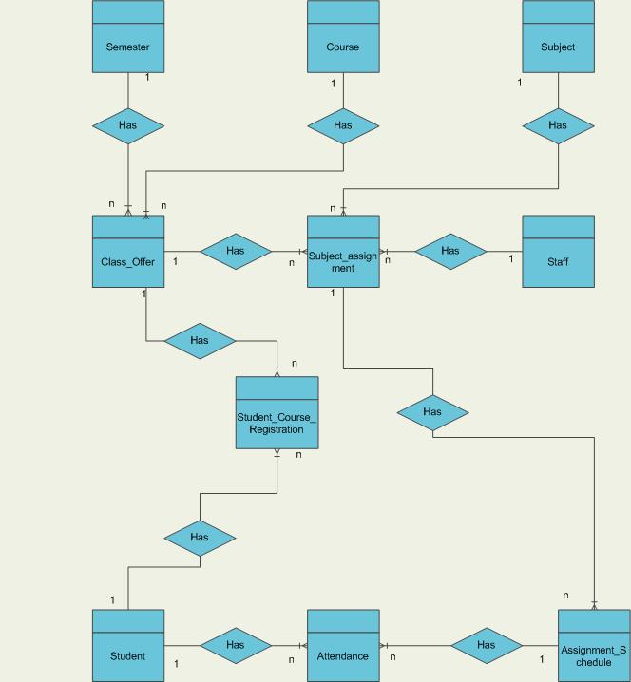

Figure 2.2.1 Entity Relationship Diagram

2.2.2 Detail of database

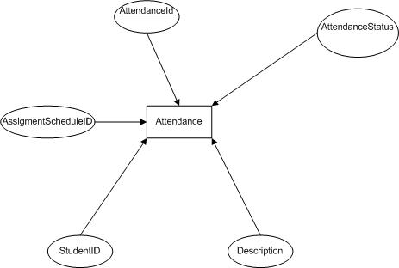

Figure 2.2.2.1 Attendance Table

Table: Attendance
Field name | Data Type | Null | Key | Description
StudentID | Varchar(50) | No | FK | Store the roll number of student
AssigmentScheduleID | int | No | FK | Store the ID of the time schedule for the classes
Status | bit | Yes |  | Store the state of attendance
Description | Varchar(50) | Yes |  | Note
AttendanceID | int | No | PK | Store the status of Attendance

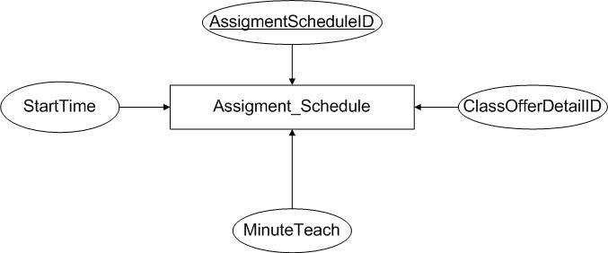

Figure 2.2.2.2 Assiment_Schedule

Table: Schedule
Field name | Data Type | Null | Key | Description
ScheduleID | int | No | PK | Store the ID
ClassOfferDetailID | int | No | FK
StartTime | Int | No
MinuteToteach | float | No

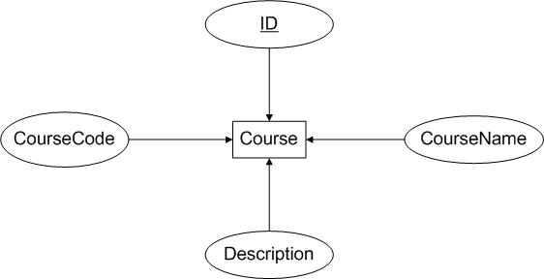
Figure 2.2.2.3 Course Table

Table: Courses
Field name | Data Type | Null | Key | Description
ID | int | No | PK | Store the name of course
CourseCode | Varchar(50) | No |  | Store the course code
Course Name | Varchar(50) | No |  | Store the course name
Description | Varchar(50) | No |  | Description about course

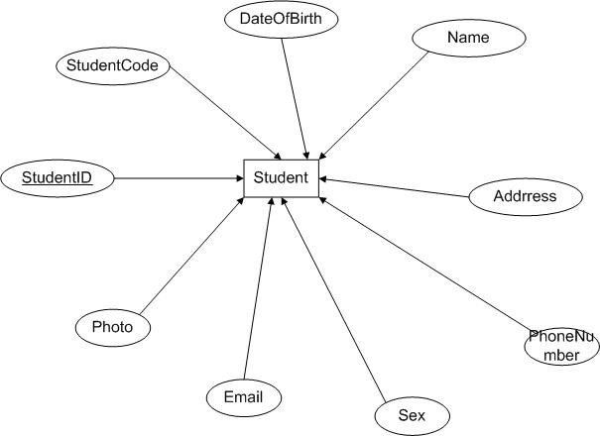

Figure 2.2.2.4 Student Table

Table: Student
Field name | Data Type | Null | Key | Description
StudentID | Int | No | PK | Id of student
Studentcode | Varchar(50) | No |  | Store the roll number
DateOfBirth | datetime | No |  | Store the day of birth
Address | Varchar(50) | No |  | Store the address of student
PhoneNumber | Varchar(20) | No |  | Store phone number
Sex | bit | No |  | Store sex of student
Email | Varchar(50) | No |  | Store email of student
Photo | byte | No |  | Store picture of student
Name | Varchar(50) | No |  | Name of student

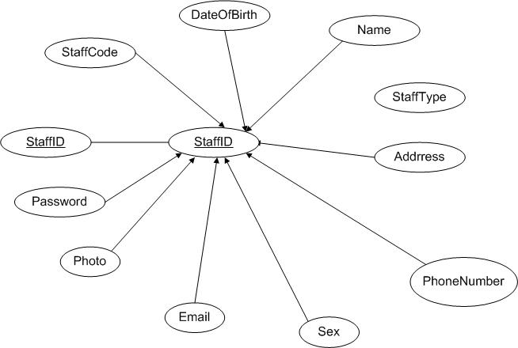
Figure 2.2.2.5 Staff Table
Table: Staff
Field name | Data Type | Null | Key | Description
StaffID | Int | No | PK | Id of student
Staffcode | Varchar(50) | No |  | Store the roll number
DateOfBirth | datetime | No |  | Store the day of birth
Address | Varchar(50) | No |  | Store the address of staff
PhoneNumber | Varchar(20) | No |  | Store phone number
Sex | bit | No |  | Store sex of staff
Email | Varchar(50) | No |  | Store email of staff
Photo | byte | No |  | Store picture of staff
Name | Varchar(50) | No |  | Name of staff
Password | Varchar(50) |  |  | Password of staff
AdminType | Int |  |  | Type of admin

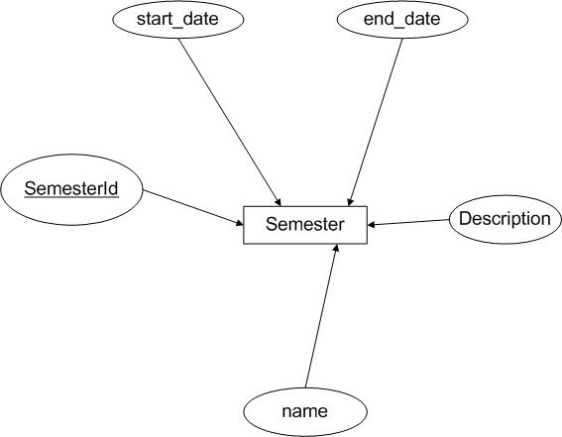

Figure 2.2.2.6 Semester Table

Table: Semester
Field name | Data Type | Null | Key | Description
name | Varchar(50) | No |  | Store the name of subject
SemesterId | int | No | PK | Store the ID of semester
StartDate | dateime | No |  | Start time of semester
EndDate | datetime | No |  | Enddate of Semester
Description | Varchar(50) | No |  | Description about semester

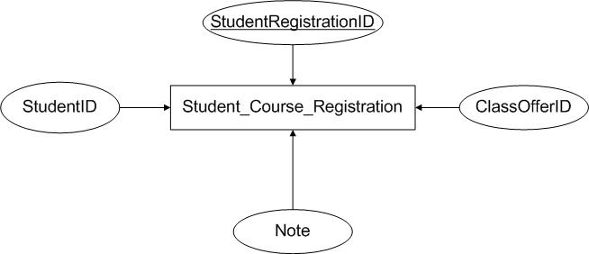

Figure 2.2.2.7Student_Course_Registration table

Table: Student_Course_Registration
Field name | Data Type | Null | Key | Description
StudentRegistrationID | int | No | PK | Store the name of subject
StudentID | int | No | FK | ID of student who register this class
ClassOfferID | Int | No | FK | Id of class which student register into
Note | Varchar(50) | No

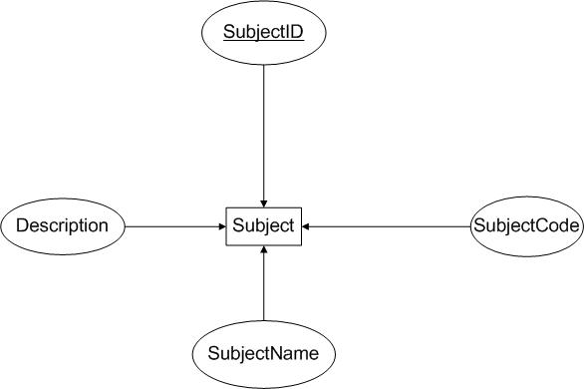

Figure 2.2.2.8 Subject table

Table: Subject
Field name | Data Type | Null | Key | Description
SubjectID | int | No | PK | Store the Id of subject
SubjectName | Varchar(50) | No |  | Name of subject
Description | Varchar(50) | No |  | Description of subject
SubjetCode | Varchar(50) | No |  | Code of Subject

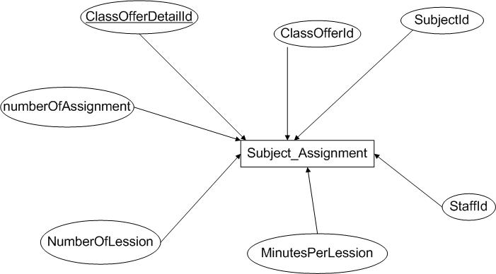

Figure 2.2.2.9 Subject_Assignment Table

Field name | Data Type | Null | Key | Description
ClassOfferDetailID | int | No | PK | Store the
ClassOfferID | int | No | FK | ID of class which has studied this subject
SubjectID | Int | No | FK | Id of subject
StaffID | Int | No | FK | ID of staff who teach this class
MinuterPerLession | Int | No |  | Minute per lesson of this subject
NumberOfLesson | Int |  |  | Number of lesson must to learn
numberOfAssignment | int |  |  | Number of assignment

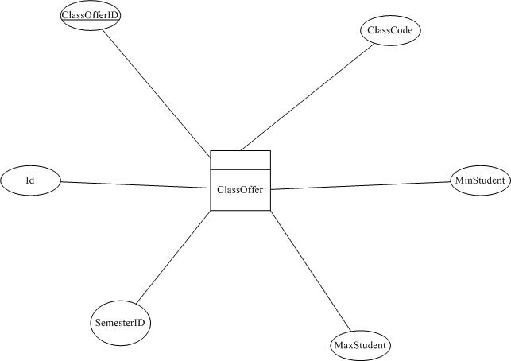

Figure 2.2.2.10 ClassOffer Table

Table: Student_Course_Registration
Field name | Data Type | Null | Key | Description
ClassCode | Varchar(50) | No | PK | Store the code of Class
StudentID | int | No | FK | ID of student who register this class
MinStudent | Int | No | PK | Min student in class
MaxStudent | int | No |  | Max student in class
SemesterID | int | no | FK | Id of semester
id | int | No | FK | Id of course

2.3 Architecture and Design of the Project

- The Application will have client server architecture; it will have two-tier architectures:

Tier 1
Presentation Tier

User Interface – GUI Components

Tier 2
Database Tier
Database Access

Figure 2.3.1Project Tier

We used Hibernate Framework to interactive with database. Hibernate is an object-relational mapping (ORM) library for the Java language, providing a framework for mapping an object-oriented domain model to a traditional relational database. Hibernate solves object-relational impedance mismatch problems by replacing direct persistence-related database accesses with high-level object handling functions. The below figure descriptions about Hibernate architect

.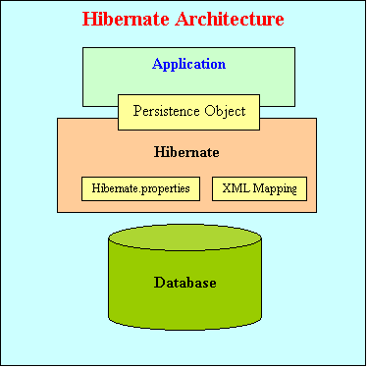

Figure 2.3.2 Hibernate Framework architect

2.4 Flow Chart

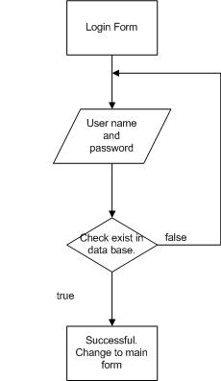

Figure 2.3.4.1 Login

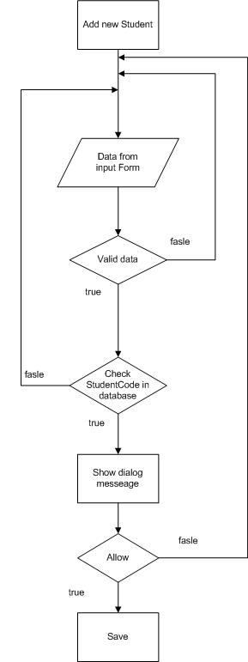

Figure 2.3.4.2 Add new student

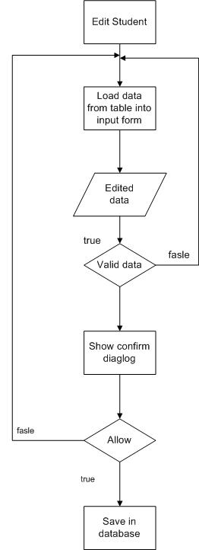

Figure 2.3.4.3 Edit student

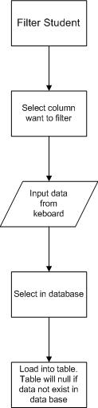

Figure 2.3.4.4 Filter student

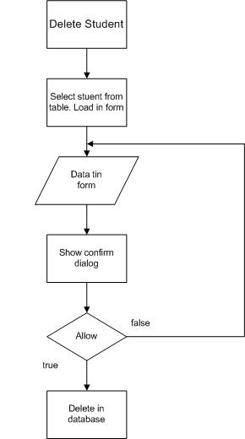

Figure 2.3.4.5 Delete student

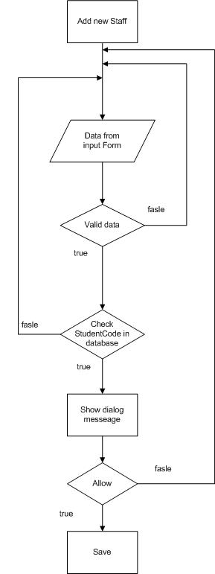

Figure 2.3.4.6 Add new staff

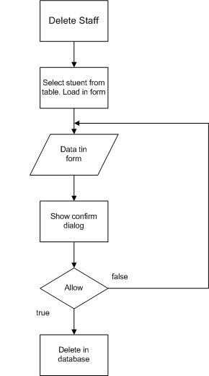

Figure 2.3.4.7 Delete Staff

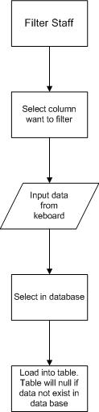

Figure 2.3.4.8 Filter Staff

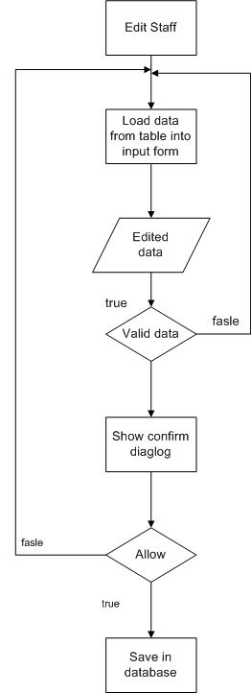

Figure 2.3.4.9 Edit staff

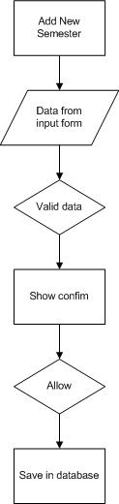

Figure 2.3.4.10 Add new semester

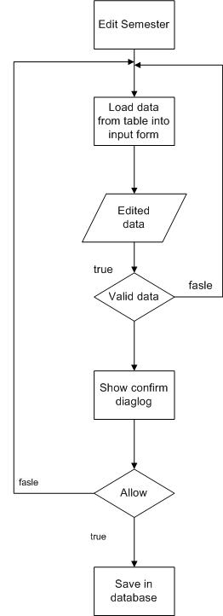

Figure 2.3.4.11 Edit semester

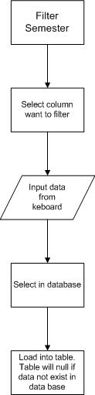

Figure 2.3.4.12 Filter semester

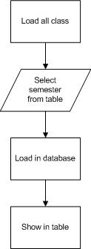

Figure 2.3.4.13 Load all class
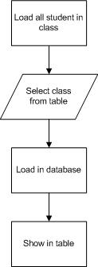

Figure 2.3.4.13 Load all student in class

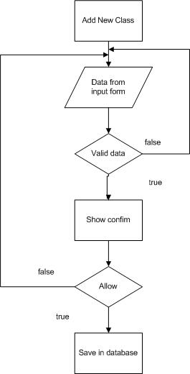

Figure 2.3.4.14 Add new Class

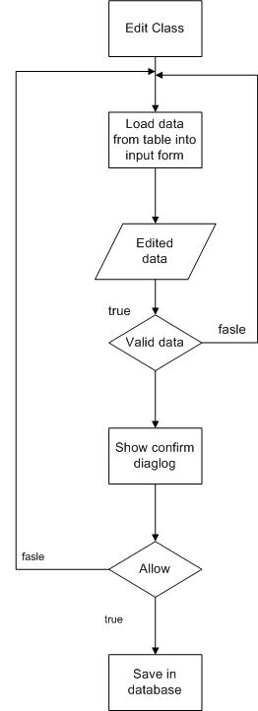

Figure 2.3.4.15 Edit Class Information

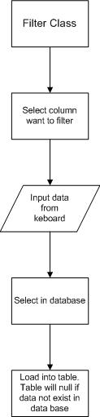

Figure 2.3.4.16 Filter Class

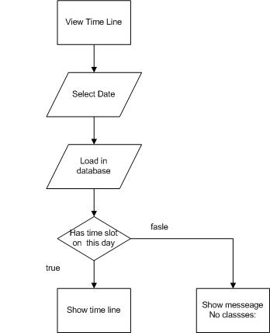

Figure 2.3.4.17View Time line

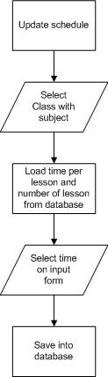

Figure 2.3.4.17Update Schedule
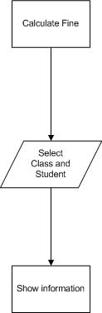

Figure 2.3.4.18 Calculate Fine

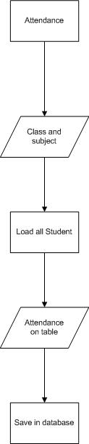

Figure 2.3.4.19 Attendance

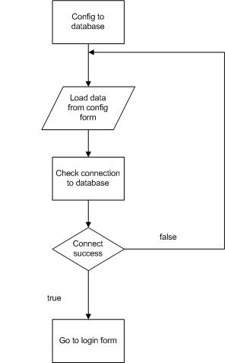

Figure 2.3.4.20 Config connection

3. Program
Program runs successful. Below are some pictures about our program.

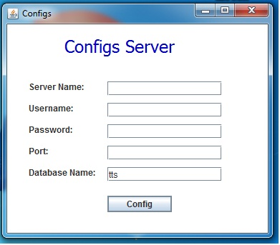

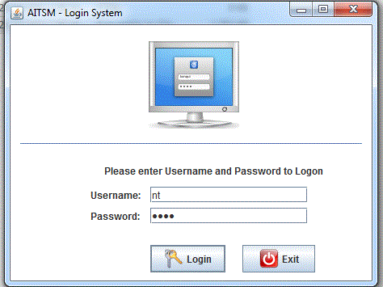

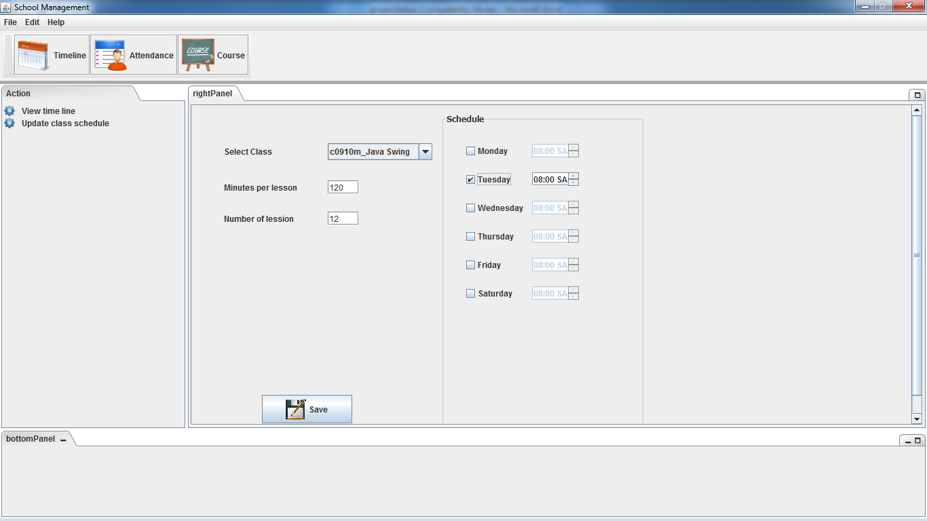

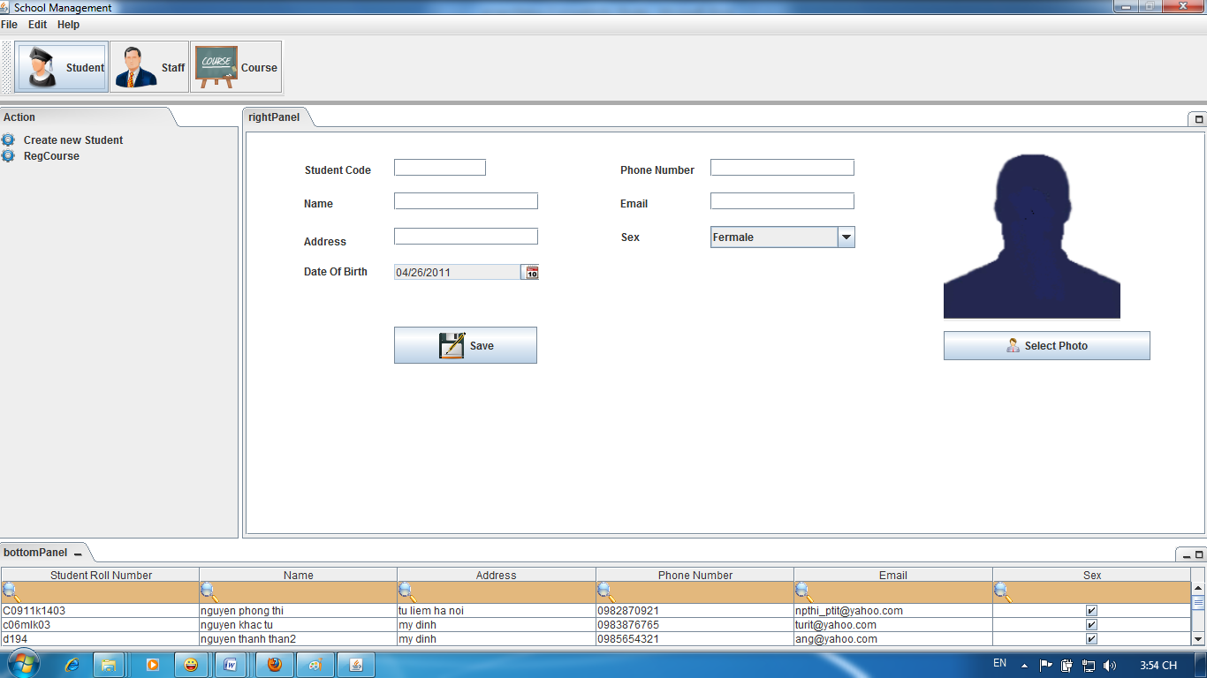

4. Test report

5. Task Sheet

