EX1:
Schematic:
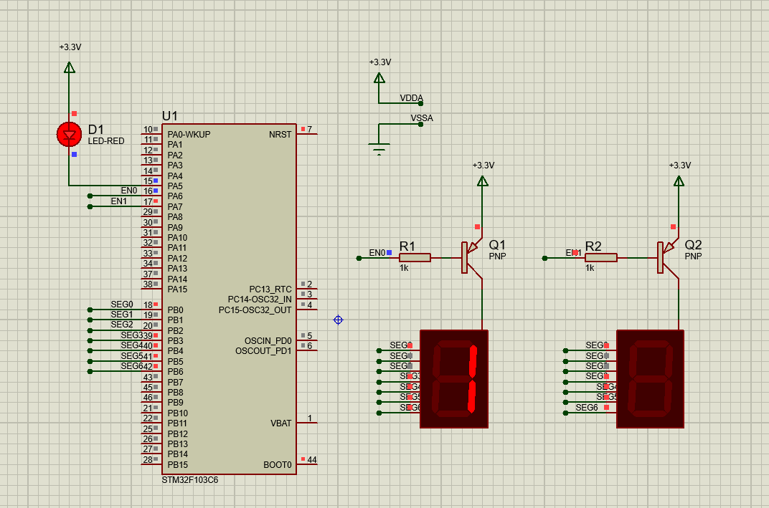
Source code:
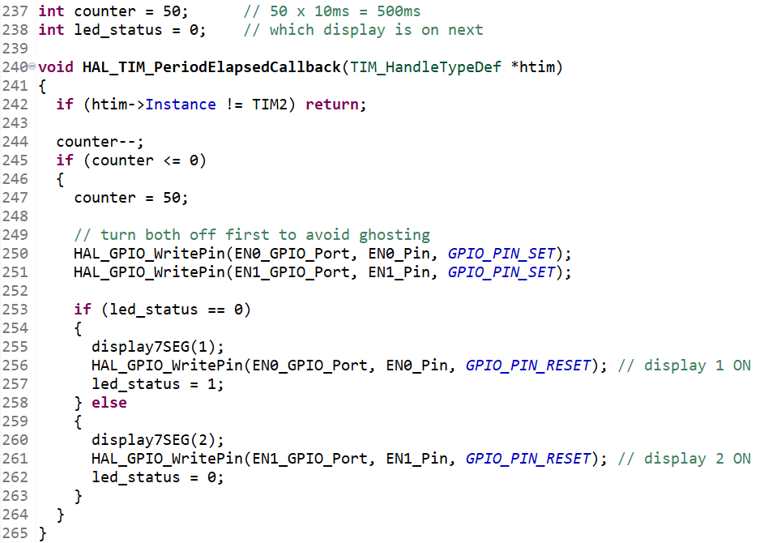

EX2:
Schematic:
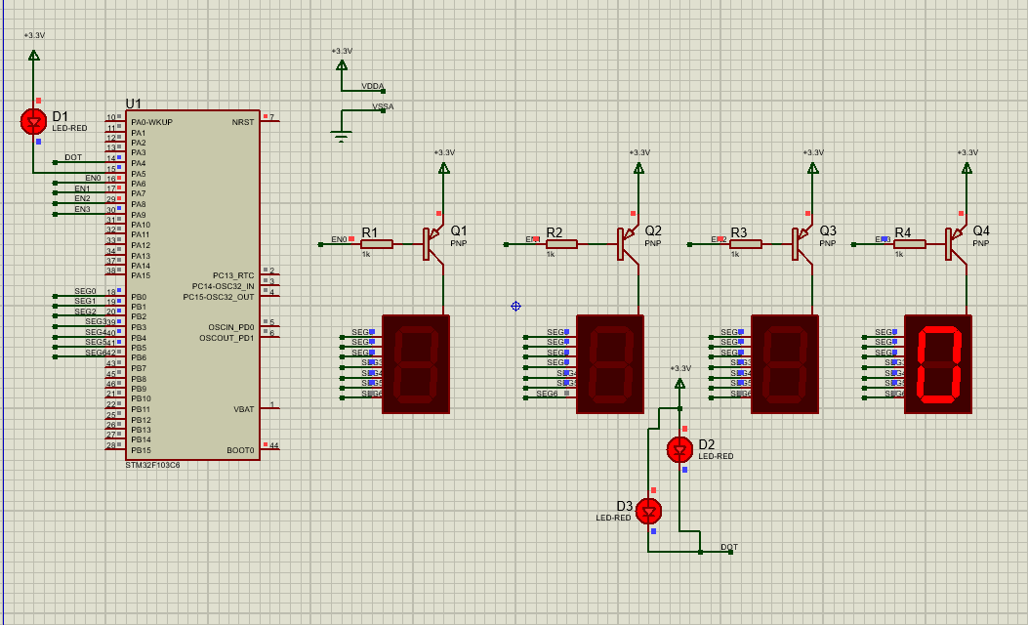

Source code:
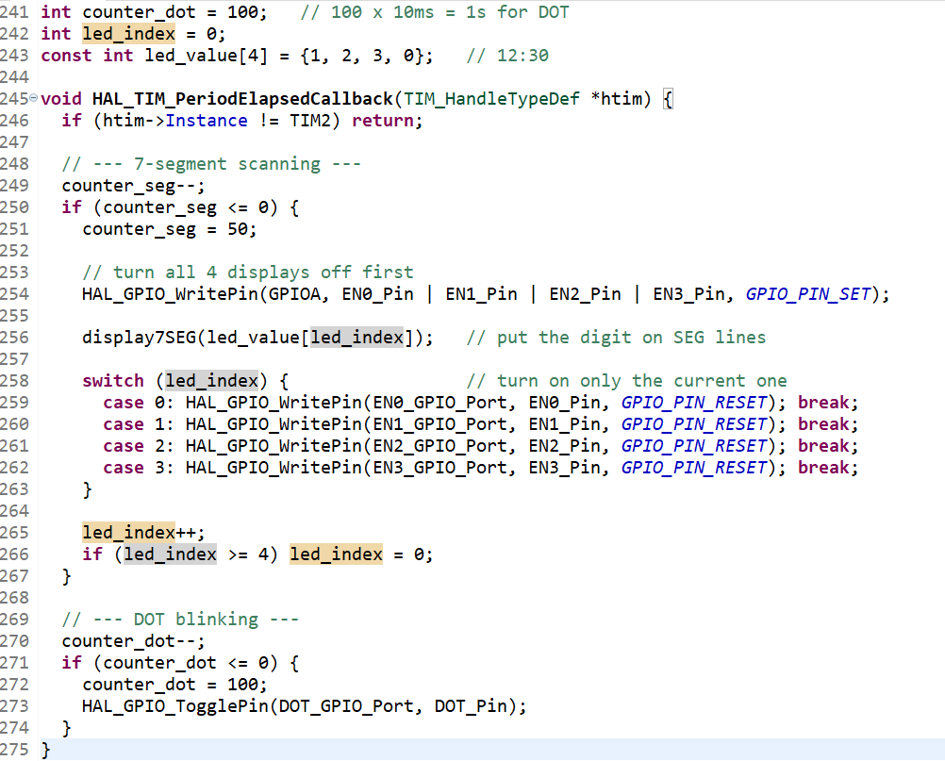

EX 3:
Schematic:
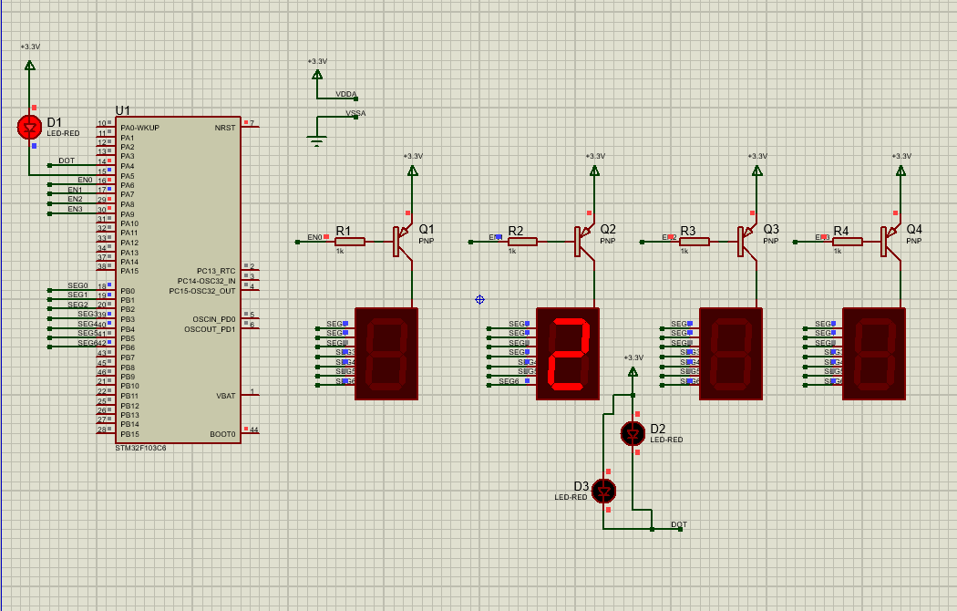

Source code:
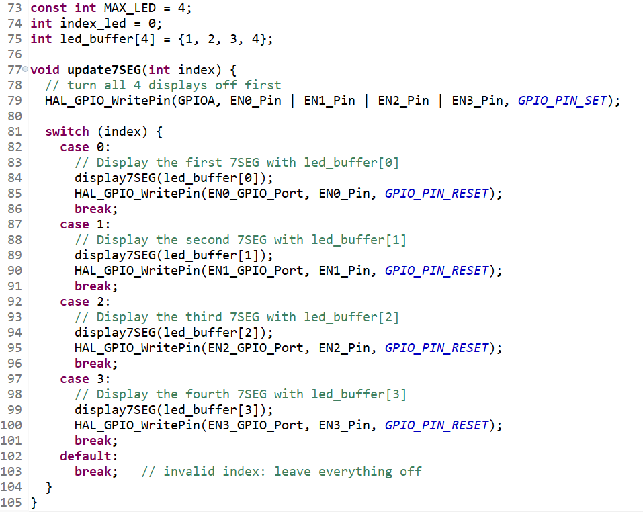

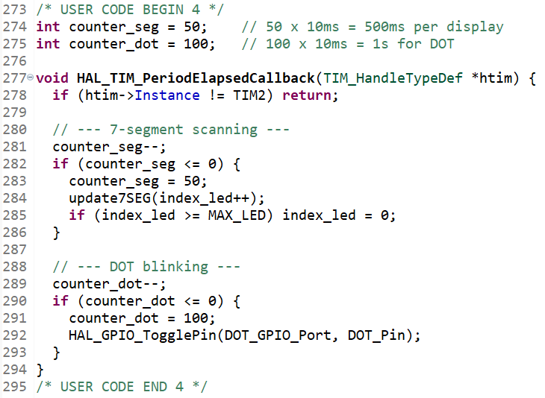

EX4:
Source code:
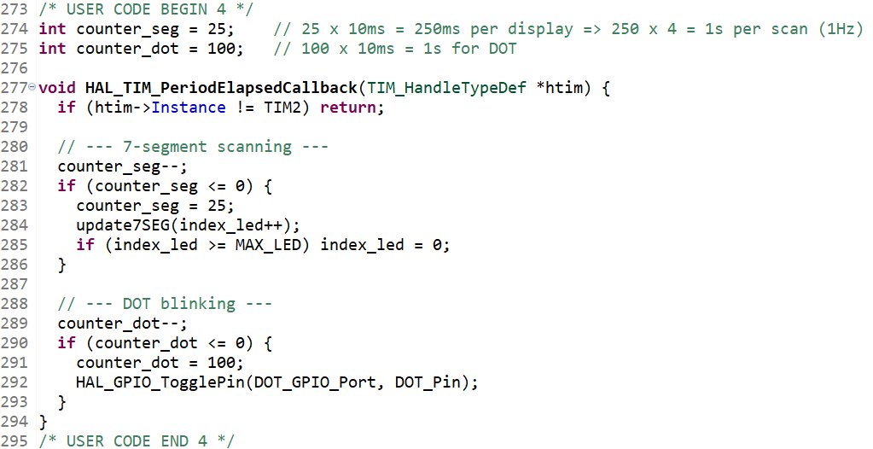

EX5:
Source code:
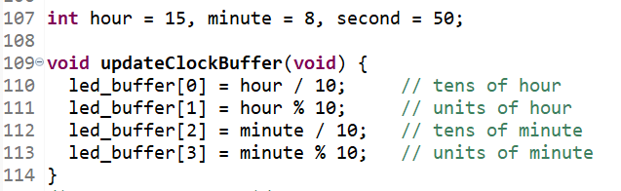

Ex6:
Report 1: What if line 1 (setTimer0(1000);) is missing?
The LED never blinks. timer0_counter starts at 0, and timer_run() only counts down when the counter is > 0. So it never counts, never reaches "0 from above", and never sets the flag. main waits forever for a flag that never comes, and setTimer0(2000) inside the if is never reached either.
Report 2: What if it's setTimer0(1)?
The LED never blinks, for the same reason. duration / TIMER_CYCLE = 1 / 10 = 0, because integer division drops the decimal. The counter is set to 0 and the flag is cleared, which is exactly the state from Report 1. Any duration under 10 ms gives 0 ticks, so the timer can't resolve it.
Report 3: What if it's setTimer0(10)? How does it compare to the first two?
10 / 10 = 1 tick. On the next interrupt the counter goes 1 → 0, and the flag is set. So the LED toggles for the first time after about 10 ms, which looks almost immediate. After that, setTimer0(2000) takes over and it toggles every 2 s as usual.
Compared to Reports 1 and 2: 10 ms is the smallest duration that works, because it's exactly one interrupt period. Anything smaller rounds down to 0 ticks and the timer never fires. The software timer's resolution is limited by TIMER_CYCLE.

EX7:
Source code:
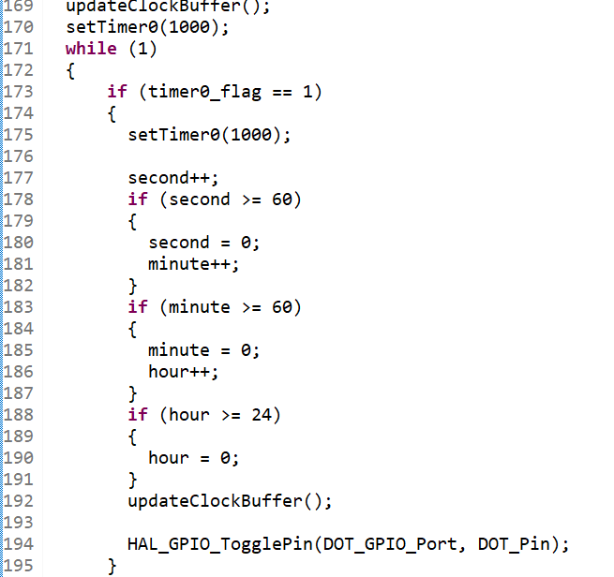

EX8:
Source code:
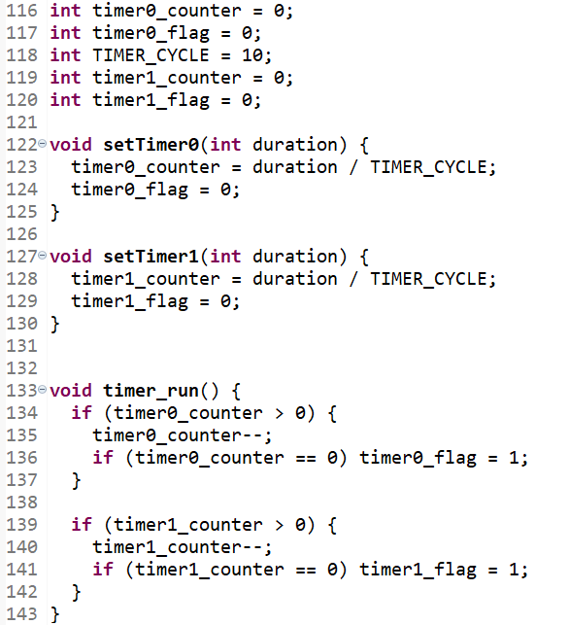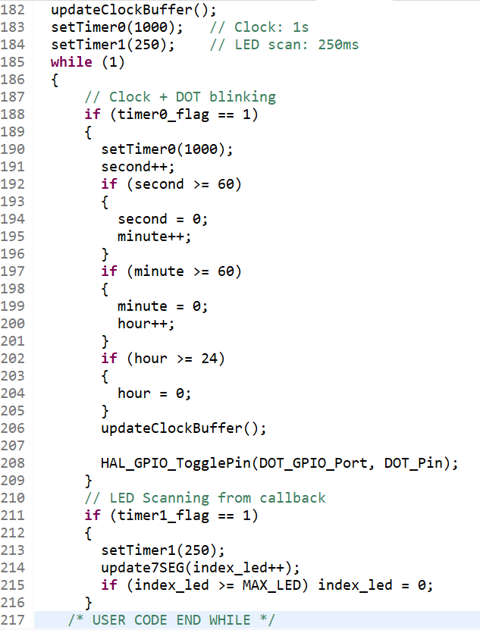

EX9:

