

**Diamond Shop System**

**Software Requirement Specification**

**Project Code: SU24NJS1803**

**Document Code: DSS-FU-SRS v1.0**

**FPT University - Ho Chi Minh City, May 07th 2024**

**Record of change**

*A - Added M - Modified D - Deleted

| **Effective Date** | **Changed Items** | **A* M, D** | **Change Description** | **New Version** |
| --- | --- | --- | --- | --- |
| 07/05/2024 | Initial | A | Write the page cover for the SRS Document | 0.10 |
| 18/05/2024 | Create the Introduction | A | Write the part of the purpose and the scope of the project | 0.20 |
| 20/05/2024 | Create the Introduction (cont.) | A | Write the part of Definitions, Acronyms, and Abbreviations, References and Overview | 0.21 |
| 21/05/2024 | Create Overall Description | A | Write the part of Product Perspective and Product Functions | 0.30 |
| 22/05/2024 | Create Overall Description (cont.) | A` | Write the part of User Characteristics, Constraints, Assumptions and Dependencies, and Requirements Subset | 0.31 |
| 24/05/2024 | Create Non-Functional Requirements | A | Write the part about Usability, Reliability, Performance and Supportability | 0.40 |
| 25/05/2024 | Create Non-Functional Requirements(cont.) | A | Write the basically for part of Design Constraints | 0.41 |
| 26/05/2024 | Create Non-Functional Requirements(cont.) | A | Write the basically for part of Legal, Copyright, and Other Notices, Applicable Standards | 0.42 |
| 27/05/2024 | Create Functional Requirements | A | Upload the image of the Diamond Shop System Use Case Diagram | 0.50 |
| 28/05/2024 | Create Functional Requirements (cont.) | A | Write for the first requirement - Interact with Shop in Customer Pages | 0.51 |
| 28/05/2024 | Create Functional Requirements (cont.) | M | Update some information for the first requirement - Interact with Shop in Customer Pages | 0.52 |
| 29/05/2024 | Create Functional Requirements (cont.) | A | Write for the second requirement - Shopping Process | 0.53 |
| 29/05/2024 | Create Functional Requirements (cont.) | M | Update some information for the second requirement - Shopping Process | 0.54 |
| 30/05/2024 | Create Functional Requirements (cont.) | A | Write for the third requirement - Certificate Management | 0.55 |
| 30/05/2024 | Create Functional Requirements (cont.) | M | Update some information for the third requirement - Certificate Management | 0.56 |
| 31/05/2024 | Create Functional Requirements (cont.) | A | Write for the fourth requirement - Warranty Management | 0.57 |
| 31/05/2024 | Create Functional Requirements (cont.) | M | Update some information for the fourth requirement - Warranty Management | 0.58 |
| 01/06/2024 | Create Functional Requirements (cont.) | A | Write for the fifth requirement - Voucher Management | 0.59 |
| 01/06/2024 | Create Functional Requirements (cont.) | M | Update some information for the fifth requirement - Voucher Management | 0.60 |
| 02/06/2024 | Create Functional Requirements (cont.) | A | Write for the sixth requirement - Diamond Price Declaration with Criterias | 0.61 |
| 02/06/2024 | Create Functional Requirements (cont.) | M | Update some information for the sixth requirement - Diamond Price Declaration with Criterias | 0.62 |
| 03/06/2024 | Create Functional Requirements (cont.) | A | Write for the seventh requirement - Diamond Product Management | 0.63 |
| 03/06/2024 | Create Functional Requirements (cont.) | M | Update some information for the seventh requirement - Diamond Product Management | 0.64 |
| 04/06/2024 | Create Functional Requirements (cont.) | A | Write for the eighth requirement - Dashboard | 0.65 |
| 04/06/2024 | Create Functional Requirements (cont.) | M | Update some information for the eighth requirement - Dashboard | 0.66 |
| 05/06/2024 | Update Overall Description | M | Update the information in Product Perspective and Product Functions | 0.67 |
| 06/06/2024 | Update Overall Description (cont.) | M | Update the information in User Characteristics, Constraints, Assumptions and Dependencies, and Requirements Subset | 0.68 |
| 07/06/2024 | Update Non-Functional Requirements | M | Update the information on Usability, Reliability, Performance and Supportability | 0.69 |
| 08/06/2024 | Update Non-Functional Requirements (cont.) | M | Update the information in Design Constraints | 0.70 |
| 09/06/2024 | Update Non-Functional Requirements (cont.) | M | Update the information in Legal, Copyright, and Other Notices, Applicable Standards | 0.71 |
| 10/06/2024 | Add Business Rules | A | Adding some new Business Rules for the project | 0.72 |
| 10/06/2024 | Add Business Rules (cont.) | A | Adding some more new Business Rules for the project | 0.73 |
| 11/06/2024 | Add Business Rules (cont.) | A | Adding some more new Business Rules for the project | 0.74 |
| 12/06/2024 | Check and Update all parts in the Document | M | Adding some more necessary information that suitable for the project | 0.75 |
| 13/06/2024 | Check and Update all parts in the Document | M | Adding some more necessary information that suitable for the project | 0.76 |
| 14/06/2024 | Delete some parts in the Document | D | Delete some parts that are not suitable for the project | 0.77 |
| 15/06/2024 | Update all exceptions for all Functional Requirements | M | Update all exceptions that the functional requirements can have in the project | 0.78 |
| 16/06/2024 | Update for Database Design | A | Add the database for the project, and upload it to Database Design | 0.79 |
| 17/06/2024 | Add Screen Flows for all actors | A | Add Screen Flows for all actors: Guest, Customer, Administrator, Sales Staff, Delivery Staff, Manager | 0.80 |
| 18-25/06/2024 | Update all Use Case Diagrams | M | Update again all images about Use case diagram for the project | 0.90 |
| 26/06 - 04/07/2024 | Add Sequence Diagram | A | Adding all sequence diagrams for all functional requirements | 0.95 |
| 5-20/07/2024 | Overview again all document | M | Update all information that is in the Document | 1.0 |

**SIGNATURE PAGE**

**ORIGINATOR:** <Name> <Date>

<Position>

**REVIEWERS:** <Name> <Date>

<Position>

<Name, if it’s needed> <Date>

<Position>

**APPROVAL:** <Name> <Date>

<Position>

**TABLE OF CONTENTS**

**1. INTRODUCTION 8**

1.1. Purpose 8

1.2. Scope 8

1.3. Definitions, Acronyms, and Abbreviations 8

1.4. References 8

1.5. Overview 9

**2. OVERALL DESCRIPTION 10**

2.1. Product Perspective 10

2.2. Product Functions 10

2.3. User Characteristics 10

2.4. Constraints 11

2.5. Assumptions and Dependencies 12

2.6. Requirements Subsets 12

2.7. Business Rules 12

**3. SCREENS FLOW 15**

3.1. For Guests 15

3.2. For Customers 16

3.3. For Administrators 17

3.4. For Sales Staffs 18

3.5. For Delivery Staffs 18

3.6. For Manager 19

**4. DATABASE DESIGN 20**

**5. FUNCTIONAL REQUIREMENTS 21**

5.1. Use case diagram for Online Diamond Shop System 21

5.2. Interact with Shop in Customer Pages 22

5.3. Shopping Process 24

5.4. Certificate Management 27

5.5. Warranty Management 29

5.6. Voucher Management 31

5.7. Diamond Price Declaration with Criterias 33

5.8. Diamond Product Management 36

5.8.1. Main Ring Management 36

5.8.2. Ring Placement Management 38

5.9. Dashboard 40

**6. SEQUENCE DIAGRAMS 42**

6.1. Interact with Shop in Customer Pages 42

6.2. Certificate Management 42

6.3. Warranty Management 43

6.4. Voucher Management 43

6.5. Shopping Process for Customer 44

6.6. Shopping Process for Sales Staff 44

6.7. Shopping Process for Delivery Staff 45

6.8. Diamond Price Declaration with Criteria 45

6.9. Main Ring Management 46

6.10. Ring Placement Management 47

6.11. Dashboard 48

**7. NON-FUNCTIONAL REQUIREMENTS 49**

7.1. Usability 49

7.2. Reliability 49

7.3. Performance 49

7.4. Supportability 49

7.5. Design Constraints 49

7.6. Legal, Copyright, and Other Notices 50

7.7. Applicable Standards 50

# INTRODUCTION

The Diamond Shop System is a comprehensive software solution designed to streamline the management and operations of diamond retail stores. This introduction provides an overview of the entire SRS, outlining its purpose, scope, definitions, acronyms, abbreviations, references, and an overview of the SRS itself.

## Purpose

The purpose of the Diamond Shop System is to provide a robust platform for diamond retailers to efficiently manage their inventory, sales, customer relationships, and operational processes. By digitizing and automating various aspects of diamond shop management, this software aims to enhance productivity, improve customer service, and optimize business performance.

## Scope

The scope of the Diamond Shop System encompasses the entire lifecycle of diamond shop operations, from inventory management and sales transactions to customer engagement and reporting. It caters to the specific needs of diamond retailers, offering functionalities tailored to the unique characteristics of the diamond industry.

## Definitions, Acronyms, and Abbreviations

| **No** | **Acronym/Abbreviation** | **Description** |
| --- | --- | --- |
| 1 | **URD** | User Requirement Document |
| 2 | **DSS** | Diamond Shop System |
| 3 | **FPTU** | FPT University |
| 4 | **SRS** | Software Requirements Specification |
| 5 | **BR** | Business Rules |
| 6 | **FU** | FPT University |

## References

The Diamond Shop System was influenced by two key websites: [Cao Hung Diamond](https://caohungdiamond.com/) and [Kim Cương Đá Quý](https://kimcuongdaquy.info/). These sites provided valuable insights into diamond retailing practices and product presentation, shaping the system's web interface. Additionally, guidance for writing the SRS document was obtained from Perforce Software's article "[How to Write a Software Requirements Specification (SRS) Document](https://www.perforce.com/blog/alm/how-write-software-requirements-specification-srs-document)." These references were instrumental in creating a comprehensive and user-focused system for diamond retailers and customers.

## Overview

The SRS serves as a comprehensive document capturing all software requirements for the Diamond Shop System. It presents a traditional, natural-language style approach to requirements specification, without the use of use-case modeling. The SRS outlines the functionalities, features, and constraints of the system, providing a solid foundation for its development and implementation.

# OVERALL DESCRIPTION

## Product Perspective

The DSS offers a comprehensive solution tailored for diamond shops, facilitating key functions such as product browsing for customers, seamless order management, meticulous warranty and diamond certificate oversight, effective promotion management, precise diamond pricing declaration, meticulous product management, and insightful dashboard capabilities for comprehensive statistical analysis and reporting.

## Product Functions

The core functions of the DSS include:

* **Product Browsing:** Guests and customers can explore our diamond store, products, collections, price lists, jewelry knowledge, and ring selection guide.
* **Order Management:** Customers select products and place orders. Sales staff receive orders and guide customers through the ring sizing process. Customers confirm the ring size and proceed with payment. Sales staff then dispatch the products, including warranty and diamond certificates, and delivery staff ship the products to the customers.
* **Warranty and Diamond Certificate Management:** Sales staff manage product warranties and diamond certificates according to GIA's 4C standards.
* **Promotion Management:** Sales staff oversee and implement promotional campaigns, ensuring effective planning, execution, and monitoring to maximize customer engagement and sales impact.
* **Diamond Pricing Declaration:** Define diamond pricing tables based on criteria including origin, carat weight, color, clarity, and cut; also establish pricing for diamond settings.
* **Diamond Product Management:** Sales staff oversee diamond products, including settings and main diamonds, calculating sale prices based on the cost price multiplied by the markup rate, which encompasses diamond cost, setting cost, and labor cost.
* **Dashboard for Statistics:** A comprehensive interface allowing managers to view and export graphical representations and tables of key performance indicators and metrics.

## User Characteristics

The system caters to the following user roles:

* **Guests:** Visitors explore all website pages, except purchase or exploring their cart and history.
* **Customers:** Users can browse, select, purchase diamond products, track their order history, and view their purchase history. They also can view all website pages like the guests
* **Sales Staff:** Responsible for managing orders, documents, categories, vouchers, collections, products, product prices, and also they can view all purchase history. Guiding customers in ring measurements. Track order status.
* **Delivery Staff:** Personnel responsible for shipping and delivering diamond products to customers, also involved in tracking order status and view some delivery order history.
* **Managers:** Monitor sales performance, ensure compliance with standards, and access comprehensive dashboard analytics. They primarily utilize the dashboard and export charts to images.
* **Admins:** Managing posts, users (including customers and all staff).

## Constraints

**Technical Constraints:**

* Compatibility with existing IT infrastructure to ensure seamless integration and data flow.
* Secure payment processing to protect customer financial information.
* Scalability to accommodate increasing user traffic and data volume as the business grows.

**Regulatory Constraints:**

* Compliance with industry standards for diamond certification (e.g., GIA's 4C standards) to maintain product authenticity and quality assurance.
* Adherence to data protection regulations (e.g., GDPR, CCPA) to safeguard customer privacy and information security.

**Operational Constraints:**

* High system availability during peak periods (e.g., promotions, holidays) to handle increased user activity without interruptions.
* Efficient inventory management and logistics to ensure timely product delivery and customer satisfaction.

**User Experience Constraints:**

* Intuitive and user-friendly interface for all user roles to enhance usability and satisfaction.
* Effective training and support resources for users to maximize system utilization and operational efficiency.

**Performance Constraints:**

* Optimal system performance to support quick order processing, real-time inventory updates, and responsive dashboard analytics.
* Reliable data retrieval and reporting capabilities for accurate business insights and decision-making.

**Maintenance Constraints:**

* Regular system maintenance, updates, and backups to prevent downtime and ensure data integrity.
* Disaster recovery plan implementation to mitigate risks and recover quickly from potential system failures.

## Assumptions and Dependencies

* **Assumptions:** Users have basic internet access and are familiar with online shopping practices. Customers are comfortable navigating and purchasing products online.
* **Dependencies:** Direct receipt of funds from customers upon purchase. Manual synchronization of diamond certification data for accurate certification information. Database synchronization for real-time updates of inventory and product information.

## Requirements Subsets

Refers to the specific categories of functional and non-functional requirements essential for the Diamond Shop System (DSS). This includes defining the capabilities and constraints related to user roles, such as guests, customers, sales staff, delivery staff, managers, and admins. Operational processes encompass functionalities like product browsing, order management, warranty and certificate oversight, promotion management, diamond pricing declaration, and comprehensive product management. Additionally, data management procedures ensure real-time inventory updates and accurate reporting through database synchronization. Regulatory compliance with industry standards for diamond certification and data protection regulations further underscores these requirements, ensuring the system's reliability, security, and seamless operation in the diamond retail environment.

## Business Rules

| **IDs** | **Descriptions** | **Types** |
| --- | --- | --- |
| BR-01 | Customer must login into the shop system with role “Customer” | Constraint |
| BR-02 | The system must redirect the customer to the personalized customer page. | Action Enabler |
| BR-03 | If the system detects an invalid username or password, it must display an error message. | Inference |
| BR-04 | Customers must have the option to re-enter their credentials or reset their password if needed. | Action Enabler |
| BR-05 | The system must provide a logout option for customers to end their session. | Action Enabler |
| BR-06 | Customers must select a payment and delivery method before submitting an order. | Constraint |
| BR-07 | The price of Ring is calculated by the total of the price of the Ring, Diamond, Diamond Placement, Ring Placement and 2% markup. | Computation |
| BR-08 | All available rings must display the correct price with additional diamond information. | Constraint |
| BR-09 | Any available orders cannot be applied to more than one voucher and warranty. | Constraint |
| BR-10 | Sales Staff is in charge of any orders that are marked “Receive at store”. | Action Enabler |
| BR-11 | Delivery Staff is in charge of any orders that are marked “Door-to-door delivery”. | Action Enabler |
| BR-12 | Sales Staff must log in to the system with their username, password and role “Sales Staff”. | Constraint |
| BR-13 | Certificates cannot have identical ID numbers. | Constraint |
| BR-14 | One Certificate can only be assigned to one Diamond. | Constraint |
| BR-15 | Warranties cannot have identical IDs. | Constraint |
| BR-16 | Only one Warranty can be assigned to one order. | Constraint |
| BR-17 | Vouchers cannot have identical IDs. | Constraint |
| BR-18 | Voucher cannot have the same name. | Constraint |
| BR-19 | Diamond Types cannot have identical IDs. | Constraint |
| BR-20 | One Diamond Type can be assigned to multiple Diamonds. | Fact |
| BR-21 | Only one Diamond can be assigned to one Diamond Type. | Constraint |
| BR-22 | The price of Diamond is shown in the price of the Diamond Placement. | Fact |
| BR-23 | Ring Price cannot have the same name. | Constraint |
| BR-24 | One Ring Price can be assigned to multiple Main Rings. | Fact |
| BR-25 | One Material, Price, Color can be used multiple times. | Fact |

# SCREENS FLOW

## For Guests

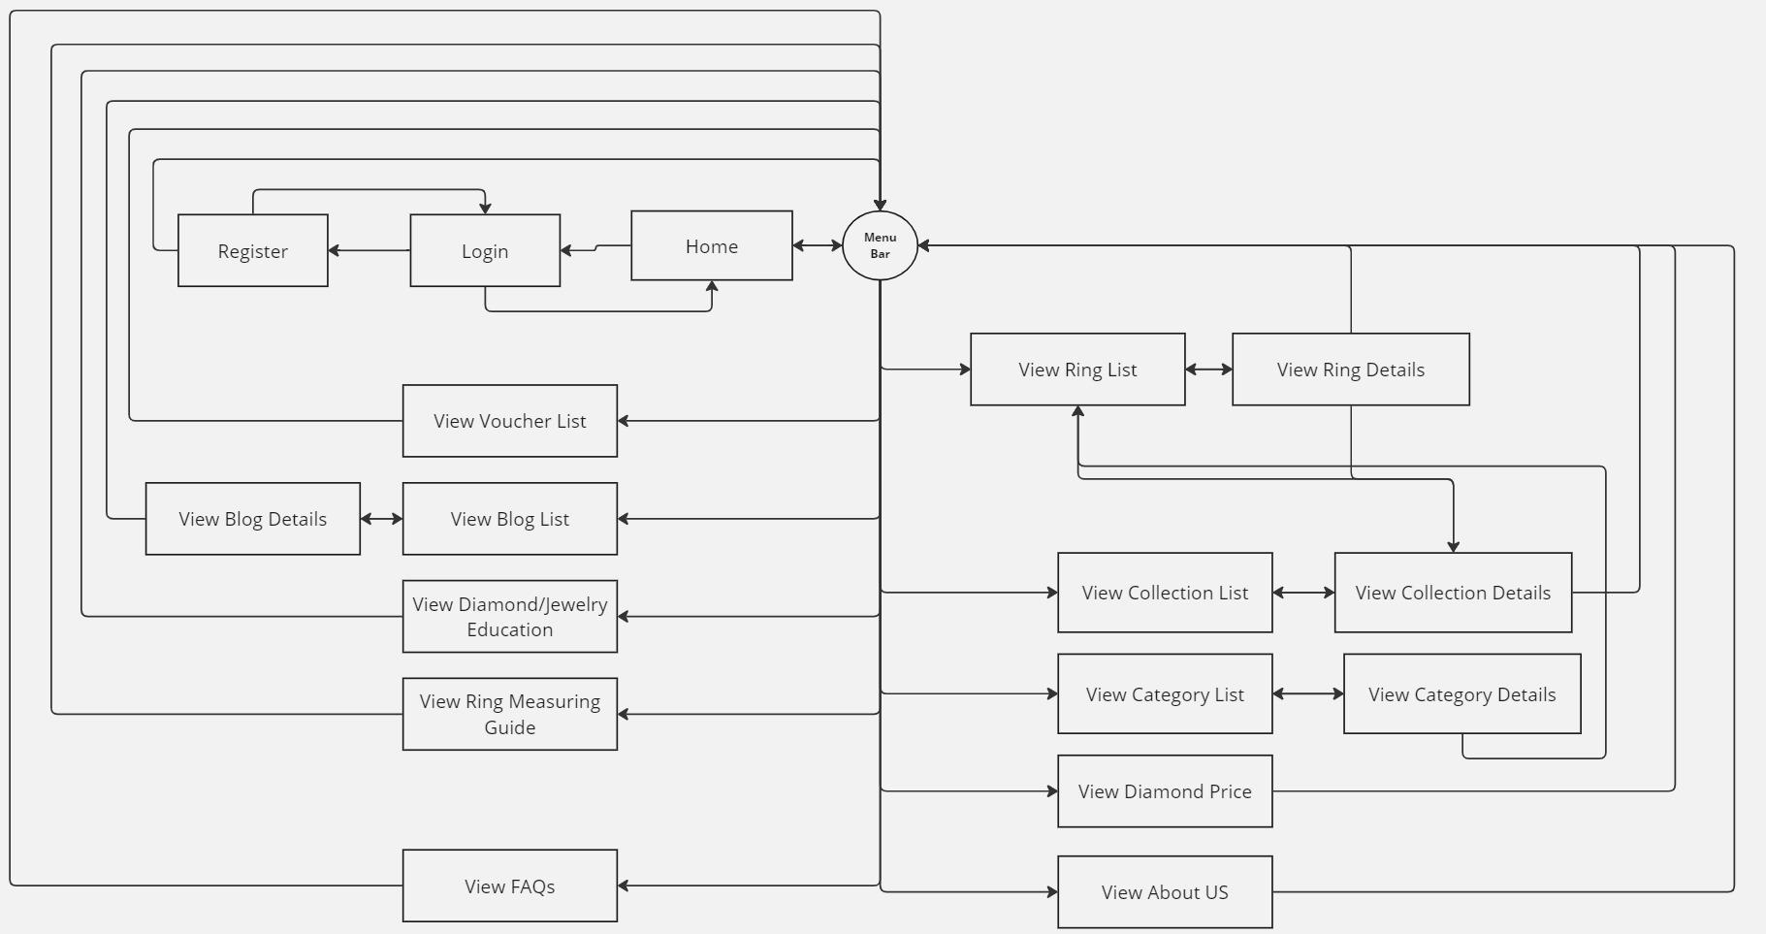

## For Customers

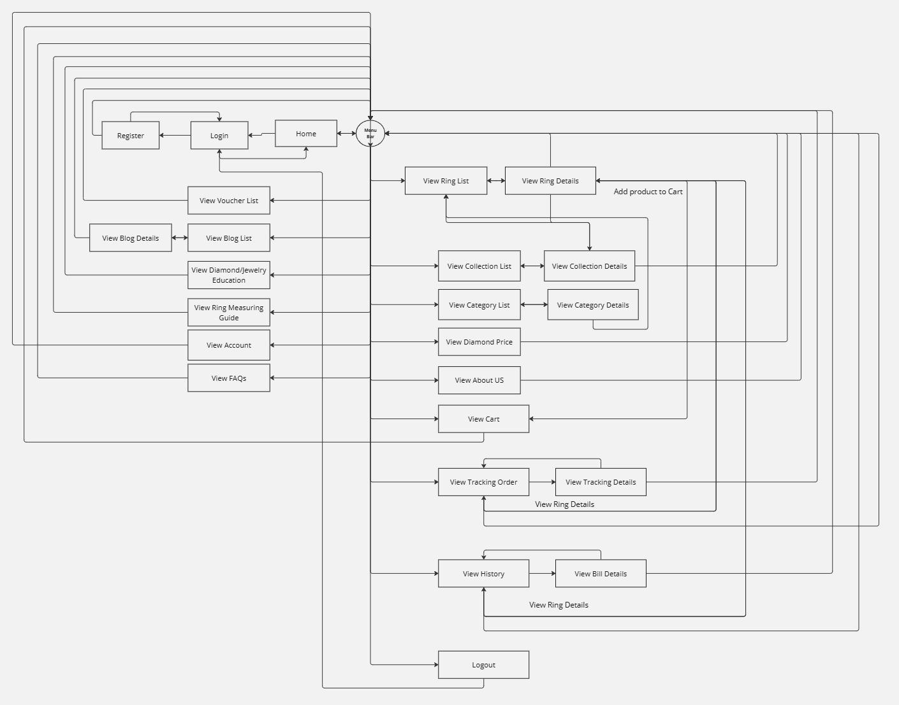

## For Administrators

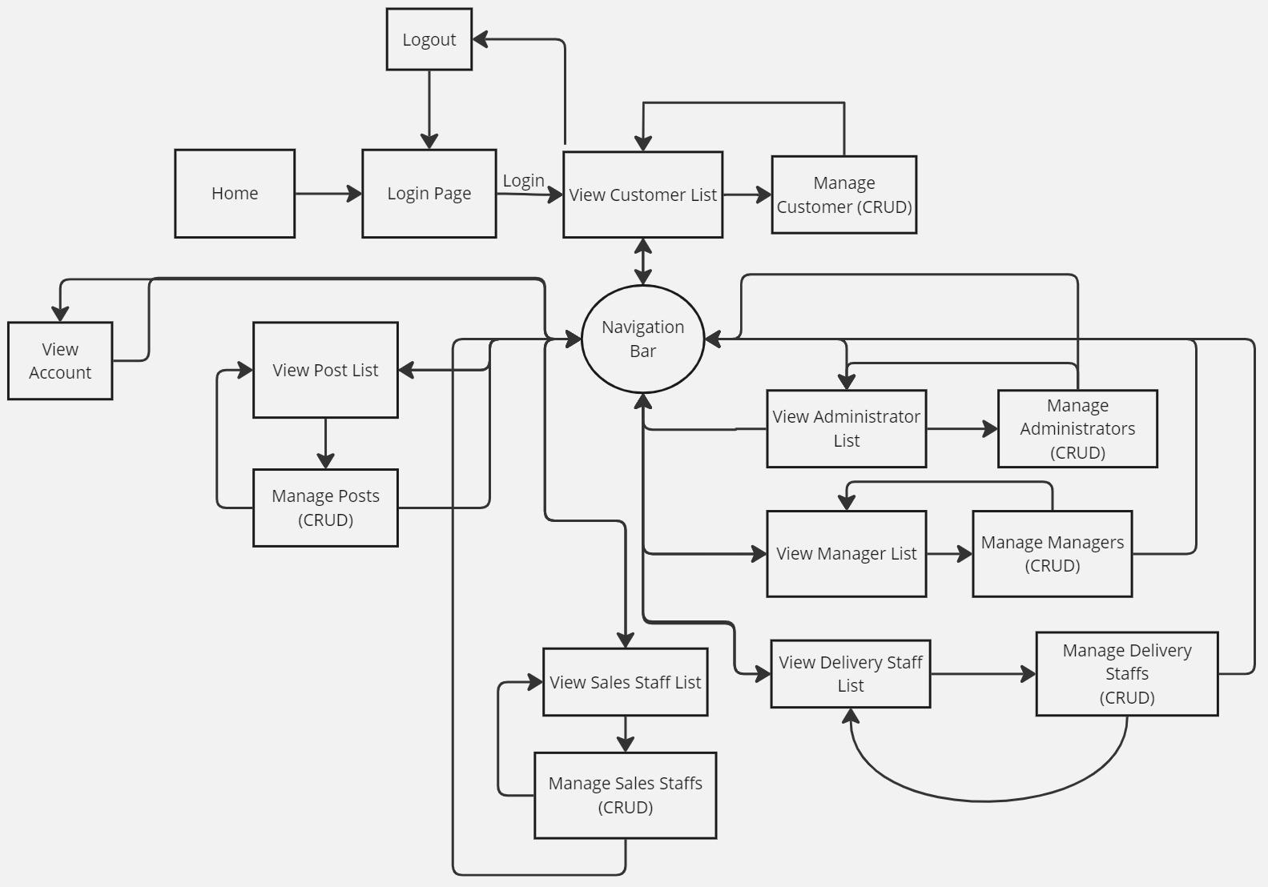

## For Sales Staffs

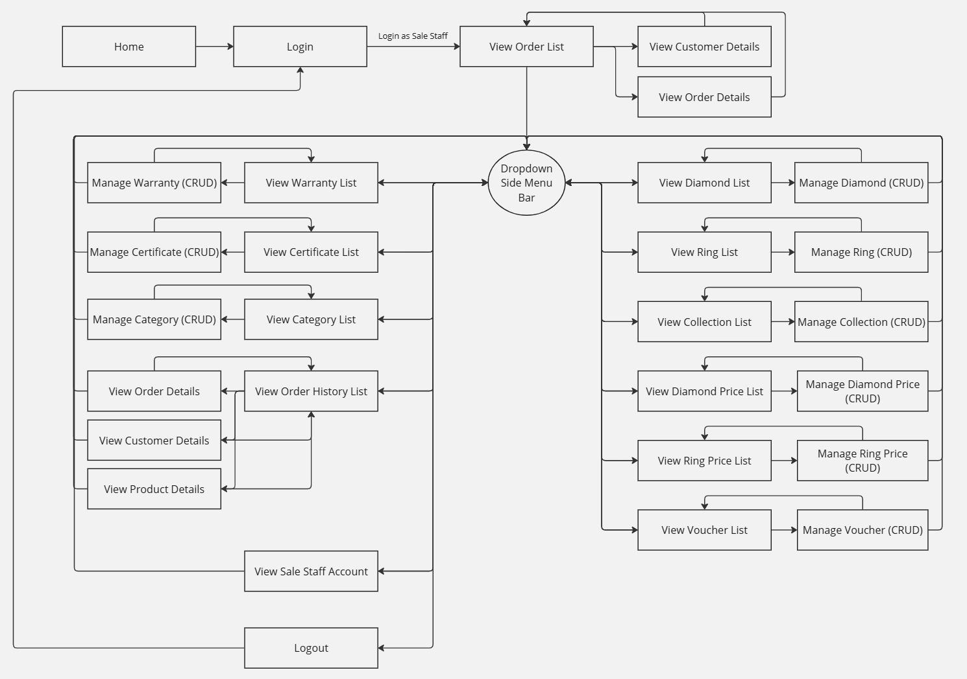

## For Delivery Staffs

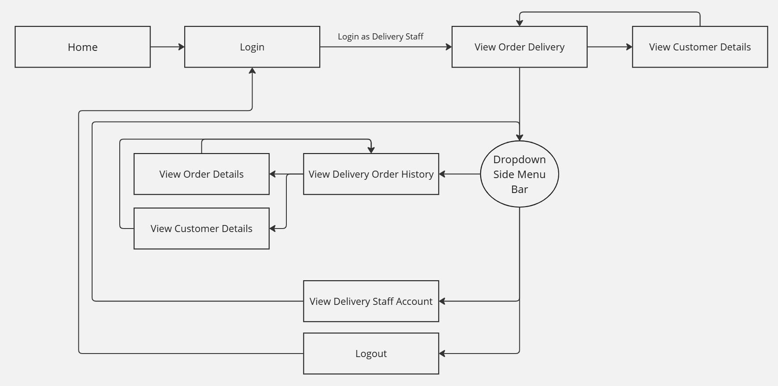

## For Manager

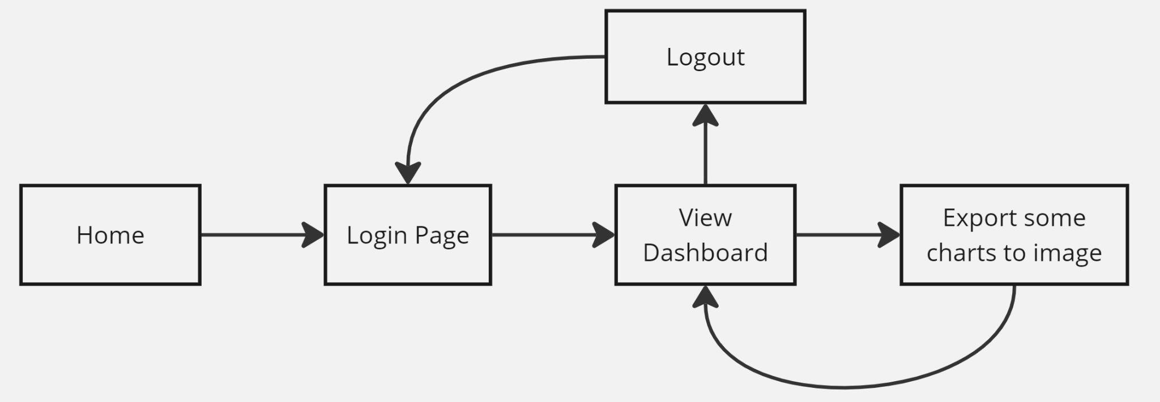

# DATABASE DESIGN

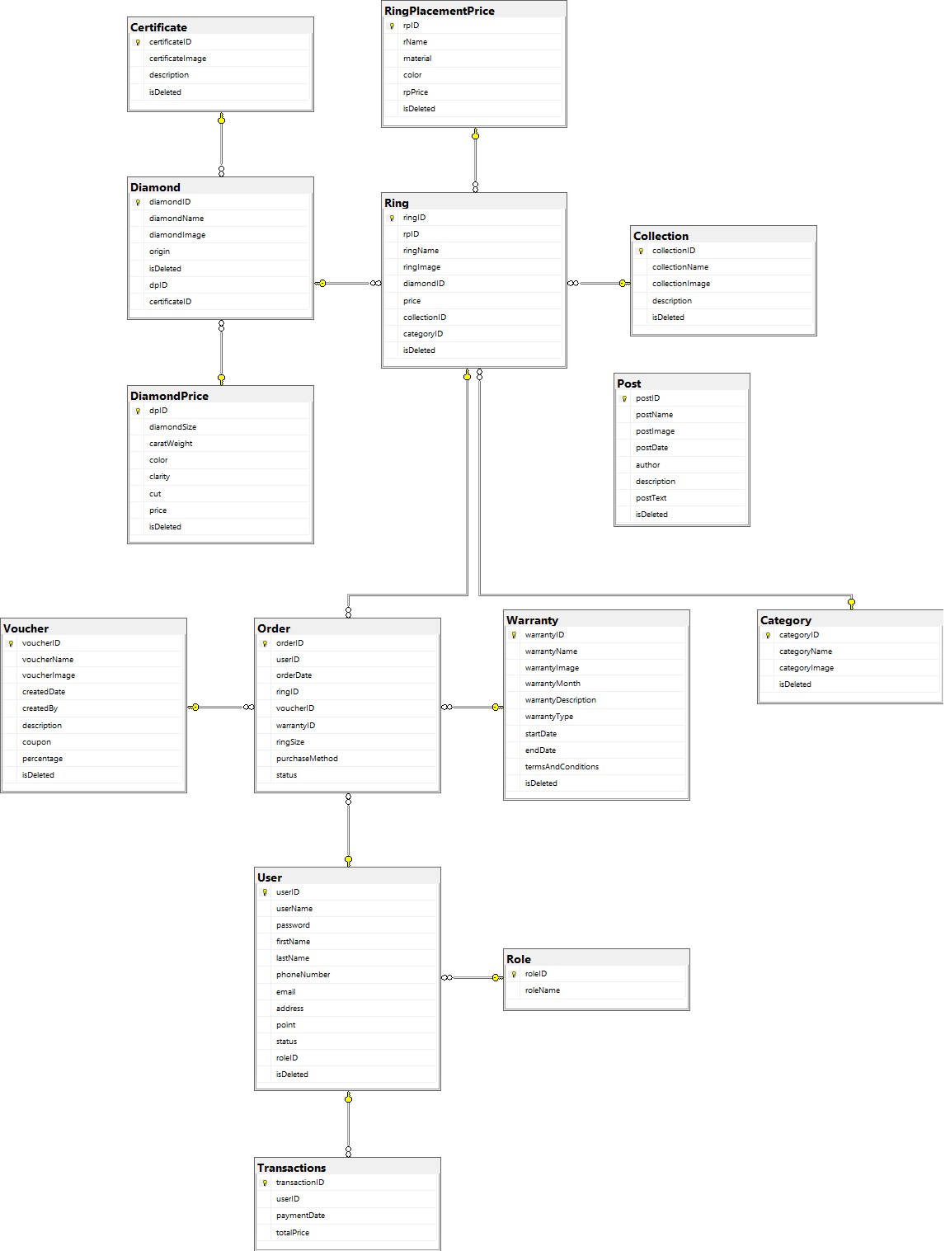

# FUNCTIONAL REQUIREMENTS

## Use case diagram for Online Diamond Shop System

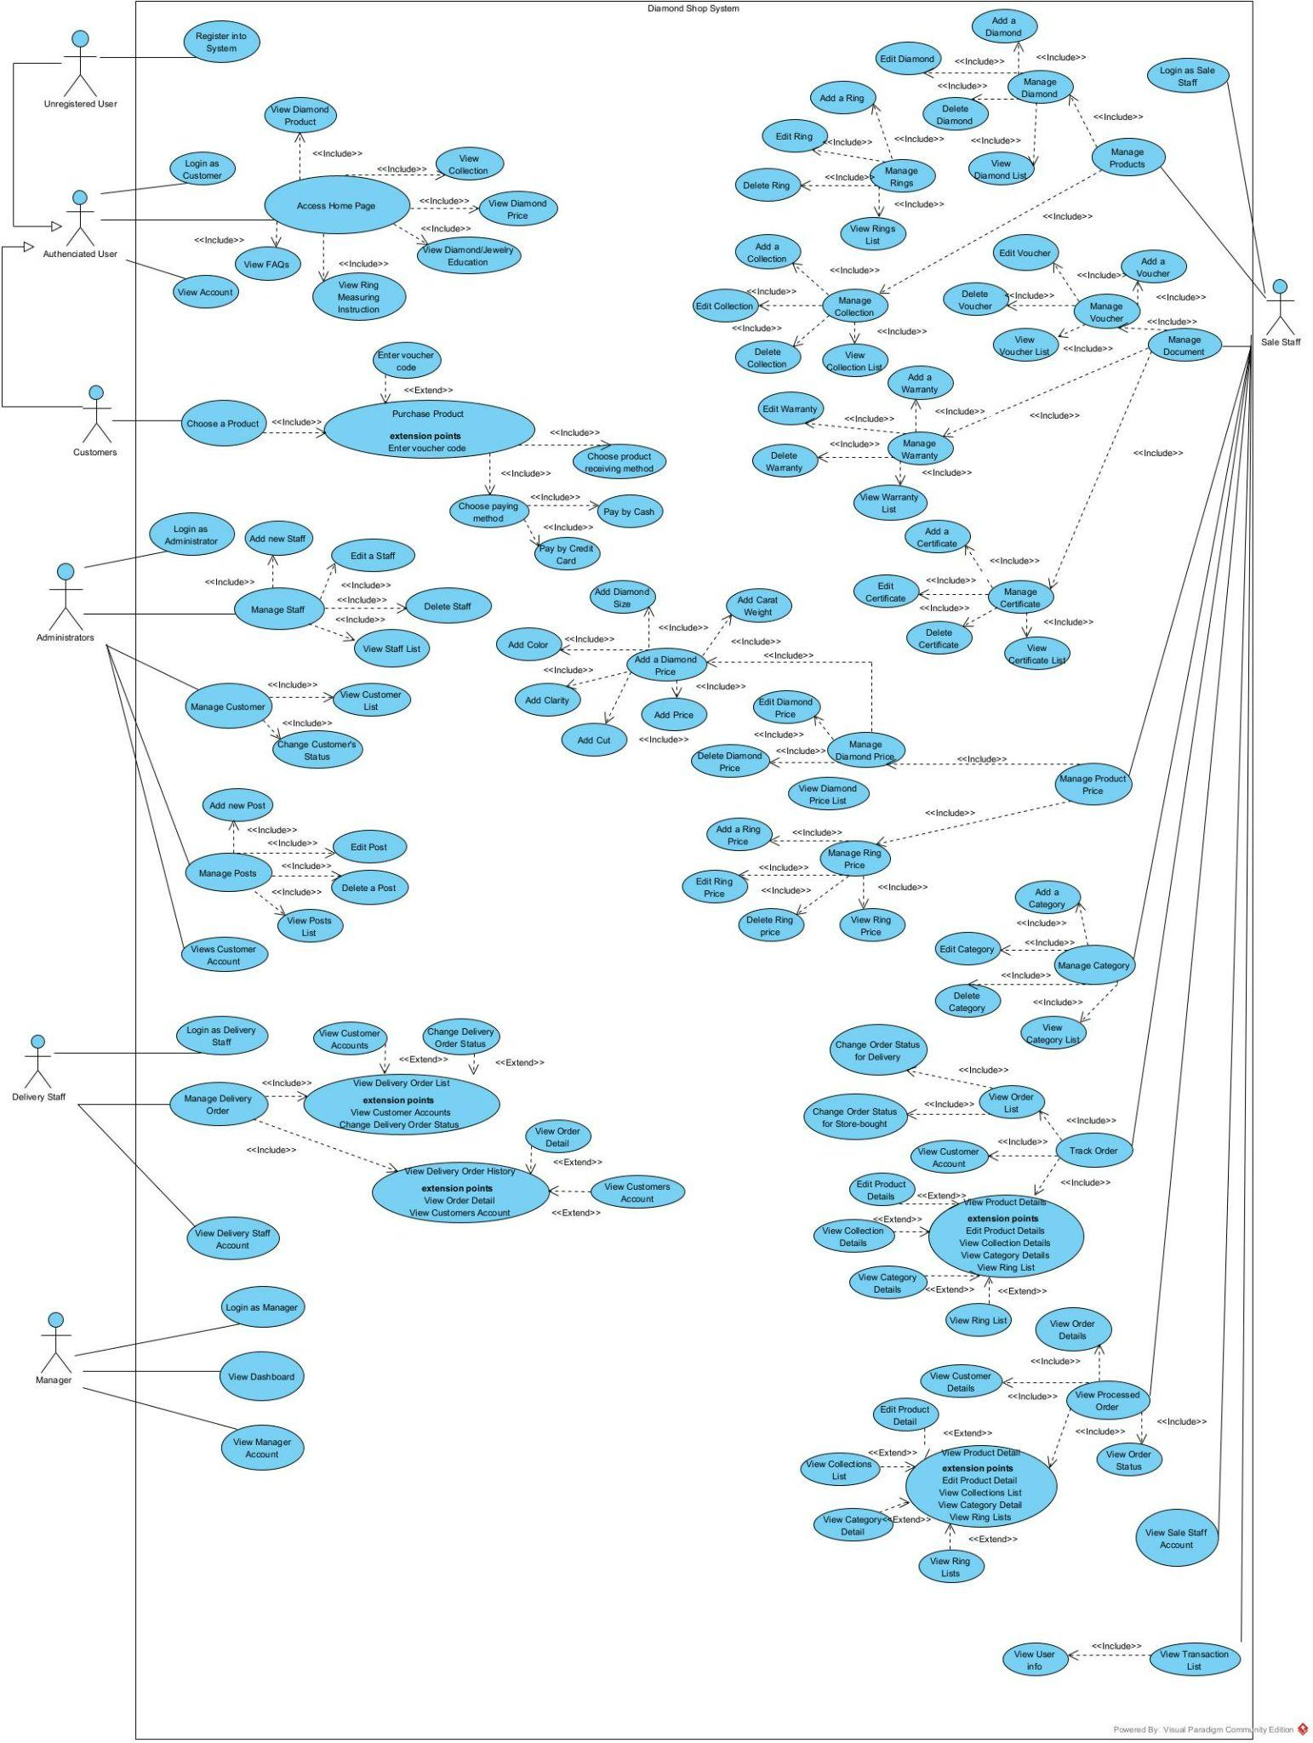

## Interact with Shop in Customer Pages

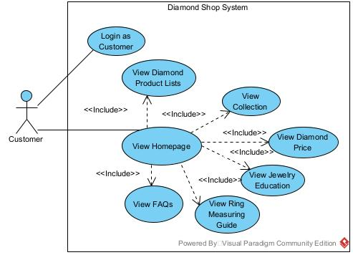

| **USE CASE-01 SPECIFICATION** | | | | |
| --- | --- | --- | --- | --- |
| **Use-case No.** | UC-01 | **Use-case Version** | | 1.0 |
| **Use-case Name** | Shop Interaction on Customer Pages | | | |
| **Author** | Hoang Nguyen Minh | | | |
| **Date** | 28/05/2024 | **Priority** | High | |
| **Actor:**  Customer, Admin, Staffs and Manager  **Summary:**  This use case describes the process by which a customer logs into the jewelry shopping system to access personalized features and complete transactions. Another actors log into the system to work with their assignments as commissioned.  **Triggers**  Requester indicates that he wants to log in the system.  **Post Conditions:**  The user is authenticated and redirected to their personalized pages.  **Main Success Scenario:**  **Navigate the homepage**  1. Personas navigate to the login page.  2. System displays the login form with fields for username and password.  3. Personas enter their username and password.  4. Personas submit the login form.  5. System validates the username and password against the stored credentials.  6. System authenticates the user and creates a session.  7. System redirects the personas to their personalized pages.  **Exceptions:**  **Invalid Username or Password**   * System detects invalid username or password. * System displays an error message: "Invalid username or password. Please try again." * Personas can re-enter credentials or choose to reset the password.   **Business Rules:**  BR-01: Customer must login into the shop system with role “Customer”.  BR-02: The system must redirect the customer to the personalized customer page.  BR-03: If the system detects an invalid username or password, it must display an error message: "Invalid username or password. Please try again."  BR-04: Customer must have the option to re-enter their credentials or choose to reset their password if the system displays an invalid username or password message.  BR-05: The system must provide a logout option for customer to end their session. | | | | |

## Shopping Process

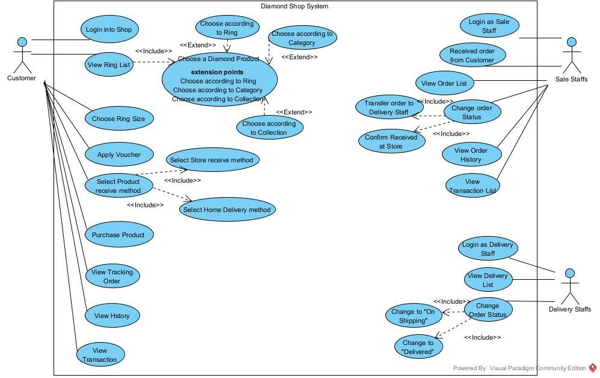

| **USE CASE-02 SPECIFICATION** | | | | |
| --- | --- | --- | --- | --- |
| **Use-case No.** | UC-02 | **Use-case Version** | | 1.0 |
| **Use-case Name** | Diamond Ring Purchase System | | | |
| **Author** | An Do Dinh, Hoang Nguyen Minh, Cuong Nguyen Phu | | | |
| **Date** | 29/05/2024 | **Priority** | High | |
| **Actor:**  Customer, Sales Staff, Delivery Staff  **Summary:**  This use case describes the process by which a customer logs in the website then proceeds to purchase a ring within the system.  **Triggers**  Customers are required to have an account in the database and be active in the system.  **Post Conditions:**  The user is authenticated and redirected to their personalized pages.  **Main Success Scenario:**  **Purchase diamond rings in the system.**   1. Personas navigate to the login page. 2. System displays the login form with fields for username and password. 3. Personas enter their username and password. 4. Personas submit the login form. 5. System validates the username and password against the stored credentials. 6. System authenticates the user and creates a session. 7. System redirects the personas to their personalized pages. 8. Customers navigate to the product page. 9. System displays all the available items in the database with the name and price tags of said item. 10. Customers choose an item listed. 11. System redirects customers to a page that lists all the information and the options to purchase said item 12. Customers choose their preferred ring size. 13. Customers submit their item to the cart. 14. System will inform them that the item is successfully added to their carts. 15. Customers choose Cart in the Order Monitor section if they are finished adding items to their cart. 16. System redirects the customers to the cart page, showing all the items that they had chosen to their cart. 17. Customers select their preferred payment and delivery method. 18. Customers submit their orders to the system. 19. The system acknowledges their orders and submits them to the database. 20. Sales Staff will receive the purchased orders from Customers. 21. Sales Staff assign the preferred Warranty to each order. 22. Sales Staff verify the order ready for Customers to receive. 23. Customers are notified their orders are valid to be received at the store.   **Additional Scenarios:**   1. Personas navigate to the login page. 2. System displays the login form with fields for username and password. 3. Personas enter their username and password. 4. Personas submit the login form. 5. System validates the username and password against the stored credentials. 6. System authenticates the user and creates a session. 7. System redirects the personas to their personalized pages. 8. Customers navigate to the product page. 9. System displays all the available rings in the database with the name and price tags of said ring. 10. Customers choose a ring that is listed in the database. 11. System redirects customers to a page that lists all the information and the options to purchase said item 12. Customers choose their preferred ring size. 13. Customers submit their items to the cart. 14. System will inform them that the item has been successfully added to their carts. 15. Customers are able to get more additional rings to their cart. 16. Customers choose Cart in the Order Monitor section if they are finished adding items to their cart. 17. System redirects the customers to the cart page, showing all the items that they had chosen to their cart, displaying the total price of all the rings present in their cart. 18. Customers can remove a ring. 19. Customers click on the name of the ring to be redirected back to the said ring information page. 20. Customers enter the coupon code in the “Enter coupon code” field if they have a coupon code. 21. System will update and display the cart with the total price reduced by how many percentages in the voucher they submitted. 22. Customers can remove the said coupon code if they have entered and submit a valid voucher. 23. System will update and display the original total price. 24. Customers select their preferred payment and delivery method. 25. If Customers choose “Pay via Credit Card”, they must fill their credit card information before their order can be acknowledged. 26. Customers submit their orders to the system. 27. The system acknowledges their orders and submits them to the database. 28. Sales Staff receive the purchased orders from Customers. 29. Sales Staff click on the Customer name that purchased the order. 30. System redirects Sales Staff to a page and shows information about the Customer. 31. Sales Staff assign the preferred Warranty to each order. 32. Sales Staff verify the order ready for Customers to receive. 33. Delivery Staff receive any order marked as “Door-to-door delivery”. 34. System redirects the Delivery Staff to a page, that shows information about the Customer. 35. Delivery Staff update any order ready to be shipped. 36. Customers are notified their orders are on shipping. 37. Deliver Staff update any orders that have been finished shipping to the desired Customers. 38. Customers are notified their orders have reached to their destination.   **Exceptions:**  **Invalid Username or Password**   * System detects an invalid username or password. * System displays an error message: "Invalid username or password. Please try again." * Personas can re-enter credentials or choose to reset the password.   **Two Coupons Apply to the same cart.**   * System will override the voucher that was applied before to a newer one. * System will display the price applied with a newly applied voucher.   **Apply an invalid Coupon.**   * Customers enter and submit a code that was deleted beforehand. * System will detect the code as invalid to apply. * System will inform the customer that the code is invalid.   **Purchase an item with no ring size.**   * System detects missing ring size fields. * System displays an error message: “Choose your ring size!” * Personas can re-enter their suitable ring size.   **Submit an order without choosing delivery method**   * System detects missing delivery fields. * System displays an error message: “Choose a delivery method!” * Personas can re-enter their preferred delivery method.   **Business Rules:**  BR-01: Customer must login into the shop system with the role “Customer”.  BR-02: The system must redirect the customer to the personalized customer page.  BR-03: If the system detects an invalid username or password, it must display an error message: "Invalid username or password. Please try again."  BR-06: Customers must select a payment and delivery method before submitting an order.  BR-07: The price of the Ring is calculated by the total price of the Ring, Diamond, Diamond Placement, Ring Placement and 2% markup.  BR-08: All available rings must display the correct price with additional diamond information.  BR-09: Any available orders cannot be applied to more than one voucher and warranty.  BR-10: Sales Staff is in charge of any orders that are marked “Receive at store”.  BR-11: Delivery Staff is in charge of any orders that are marked “Door-to-door delivery”. | | | | |

## Certificate Management

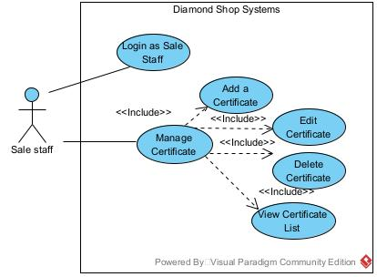

| **USE CASE-03 SPECIFICATION** | | | | |
| --- | --- | --- | --- | --- |
| **Use-case No.** | UC-03 | **Use-case Version** | | 1.0 |
| **Use-case Name** | Certificate Management | | | |
| **Author** | An Do Dinh, Hoang Nguyen Minh | | | |
| **Date** | 30/05/2024 | **Priority** | High | |
| **Actor:**  Sales Staff  **Summary:**  This use case describes the process by a sales staff adding, updating, and removing Certificates.  **Triggers**  The requester indicates that he wants to log in the system.  **Post Conditions:**  The user is authenticated and redirected to their personalized pages.  **Main Success Scenario:**  **Managing Certificate**   1. Personas navigate to the login page. 2. System displays the login form with fields for username and password. 3. Personas enter their username and password. 4. Personas submit the login form. 5. System validates the username and password against the stored credentials. 6. System authenticates the user and creates a session. 7. System redirects the personas to their personalized pages. 8. Sales Staff click on the “Create a Certificate”. 9. Sales Staff fill all the necessary information in each field. 10. Sales Staffclick on “Save” to insert a new Certificate into the database. 11. Sales Staff click on the desired Certificate to change information. 12. Sales Staff will fill in additional information on the said Certificate. 13. Sales Staffclick on “Save” to save the updated information. 14. The system displays the ring with updated information. 15. Sales Staff click on “Delete” of a Certificate. 16. System will remove the deleted Certificate out of the list, but remain in the database.   **Exceptions:**  **Exceeds the number of words in the description field (over 30 words)**   * System detects the number of characters in the field exceeding the system allowed. * System displays an error message: "Description must be between 5 and 30 words. Currently [number] words."   **Wrong Image URL Format**   * System detects that the entered image URL is not in the correct format. * System displays an error message: "Invalid image URL. It must start with "https://" and end with one of the following extensions: .jpg, .jpeg, .png, .gif, .bmp, .webp.   **Business Rules:**  BR-12: Sales Staff must log in to the system with their username, password and role “Sales Staff”.  BR-13: Certificates cannot have identical ID numbers.  BR-14: One Certificate can only be assigned to one Diamond. | | | | |

## Warranty Management

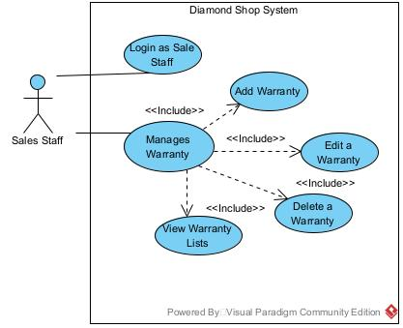

| **USE CASE-04 SPECIFICATION** | | | | |
| --- | --- | --- | --- | --- |
| **Use-case No.** | UC-04 | **Use-case Version** | | 1.0 |
| **Use-case Name** | Warranty Management | | | |
| **Author** | An Do Dinh, Hoang Nguyen Minh | | | |
| **Date** | 31/05/2024 | **Priority** | High | |
| **Actor:**  Sales Staff  **Summary:**  This use case describes the process by a Sale Staff adding, updating, removing Warranty.  **Triggers**  Requester indicates that he wants to log in the system.  **Post Conditions:**  The user is authenticated and redirected to their personalized pages.  **Main Success Scenario:**  **Managing Warranty**   1. Personas navigate to the login page. 2. System displays the login form with fields for username and password. 3. Personas enter their username and password. 4. Personas submit the login form. 5. System validates the username and password against the stored credentials. 6. System authenticates the user and creates a session. 7. System redirects the personas to their personalised pages. 8. Sales Staff click on the “Create a Warranty”. 9. Sales Staff fill all the necessary information in each field. 10. Sales Staffclick on “Save” to insert a new Warranty into the database. 11. Sales Staff click on the desired Warranty to change information. 12. Sales Staff will fill in additional information on the said Warranty. 13. Sales Staffclick on “Save” to save the updated information. 14. System displays the ring with updated information. 15. Sales Staff click on “Delete” of a Warranty. 16. System will remove the deleted Warranty out of the list but remain in the database.   **Exceptions:**  **Exceeds the number of words in the description field (over 30 words)**   * System detects the number of characters in the field exceeding the system allowed. * System displays an error message: "Description must be between 5 and 30 words. Currently [number] words."   **Wrong Image URL Format**   * System detects that the entered image URL is not in the correct format. * System displays an error message: "Invalid image URL. It must start with "https://" and end with one of the following extensions: .jpg, .jpeg, .png, .gif, .bmp, .webp.   **Exceeds the number of words in the Terms and conditions field (over 70 words)**   * System detects the number of characters in the field exceeding the system allowed. * System displays an error message: "Terms and conditions must be between 20 and 70 words. Currently [number] words."   **Business Rules:**  BR-12: Sales Staff must log in to the system with their username, password and role “Sales Staff”.  BR-15: Warranties cannot have identical IDs.  BR-16: Only one Warranty can be assigned to one order. | | | | |

## 

## Voucher Management

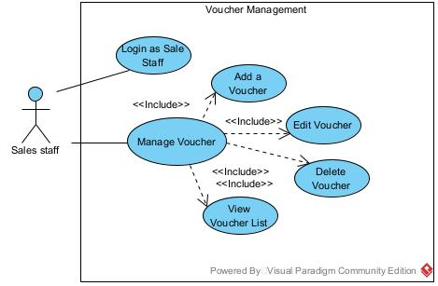

| **USE CASE-05 SPECIFICATION** | | | | |
| --- | --- | --- | --- | --- |
| **Use-case No.** | UC-05 | **Use-case Version** | | 1.0 |
| **Use-case Name** | Voucher Management | | | |
| **Author** | Hoang Nguyen Minh | | | |
| **Date** | 01/06/2024 | **Priority** | High | |
| **Actor:**  Sales Staff  **Summary:**  This use case describes the process by a sales staff adding, updating, and removing a Voucher.  **Triggers**  The requester indicates that he wants to log in the system.  **Post Conditions:**  The user is authenticated and redirected to their personalized pages.  **Main Success Scenario:**  **Managing Voucher**   1. Personas navigate to the login page. 2. System displays the login form with fields for username and password. 3. Personas enter their username and password. 4. Personas submit the login form. 5. System validates the username and password against the stored credentials. 6. System authenticates the user and creates a session. 7. System redirects the personas to their personalized pages. 8. Sales Staff click on the “Create a Voucher”. 9. Sales Staff fill all the necessary information in each field. 10. Sales Staffclick on “Save” to insert a new voucher into the database. 11. Sales Staff click on the desired Voucher to change information. 12. Sales Staff will fill in additional information on the said Voucher. 13. Sales Staffclick on “Save” to save the updated information. 14. System displays the ring with updated information. 15. Sales Staff click on “Delete” of a Voucher. 16. System will remove the deleted Voucher out of the list but remain in the database.   **Exceptions:**  **Exceeds number of words in description field (over 30 words)**   * System detects the number of characters in the field exceeding the system allowed. * System displays an error message: "Description must be between 5 and 30 words. Currently [number] words."   **Wrong Image URL Format**   * System detects that the entered image URL is not in the correct format. * System displays an error message: "Invalid image URL. It must start with "https://" and end with one of the following extensions: .jpg, .jpeg, .png, .gif, .bmp, .webp.   **Business Rules:**  BR-12: Sales Staff must log in to the system with their username, password and role “Sales Staff”.  BR-17: Voucher cannot have identical ID.  BR-18: Voucher cannot have the same name. | | | | |

## 

## Diamond Price Declaration with Criterias

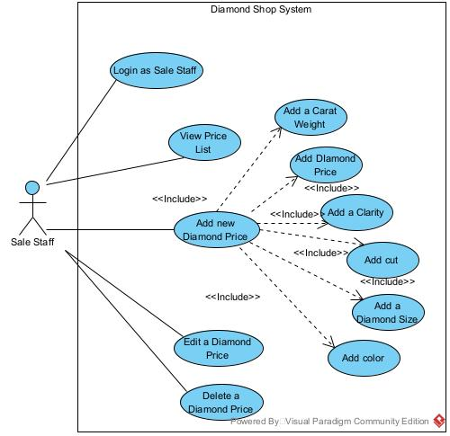

| **USE CASE-06 SPECIFICATION** | | | | |
| --- | --- | --- | --- | --- |
| **Use-case No.** | UC-06 | **Use-case Version** | | 1.0 |
| **Use-case Name** | Diamond Price Management | | | |
| **Author** | An Do Dinh, Hoang Nguyen Minh | | | |
| **Date** | 02/06/2024 | **Priority** | High | |
| **Actor:**  Sales Staff  **Summary:**  This use case describes the process by a sales staff adding, updating, and removing Diamond Price.  **Triggers**  The requester indicates that he wants to log in the system.  **Post Conditions:**  The user is authenticated and redirected to their personalized pages.  **Main Success Scenario:**  **Managing Diamond Price**   1. Personas navigate to the login page. 2. System displays the login form with fields for username and password. 3. Personas enter their username and password. 4. Personas submit the login form. 5. System validates the username and password against the stored credentials. 6. System authenticates the user and creates a session. 7. System redirects the personas to their personalized pages. 8. Sales Staff click on the “Add a Price”. 9. Sales Staff fill all the neccesary information in each field. 10. Sales Staffclick on “Save” to insert a new Diamond Price into the database. 11. Sales Staff click on the desired Diamond Price to change information. 12. Sales Staff will fill additional information on the said Warranty. 13. Sales Staffclick on “Save” to save the updated information. 14. System displays the ring with updated information. 15. Sales Staff click on “Delete” of a Diamond Price. 16. System will remove the deleted Diamond Price out of the list, but remain in the database.   **Additional Scenario:**  **Managing Diamond Price**   1. Personas navigate to the login page. 2. System displays the login form with fields for username and password. 3. Personas enter their username and password. 4. Personas submit the login form. 5. System validates the username and password against the stored credentials. 6. System authenticates the user and creates a session. 7. System redirects the personas to their personalised pages. 8. Sales Staff click on the “Add a Price”. 9. Sales Staff fill all the necessary information in each field. 10. Sales Staffclick on “Save” to insert a new Diamond Price into the database. 11. Sales Staff click on the Price to sort all Diamond Price in ascending based on price tag. 12. Sales Staff click on the Clarity to sort all Diamond Price in ascending based on name. 13. Sales Staff click on the Carat Weight to sort all Diamond Price in ascending based on the weight value. 14. Sales Staff click on the Diamond Size to sort all Diamond Price in ascending based on the size of a diamond. 15. Sales Staff click on the desired Diamond Price to change information. 16. Sales Staff will fill in additional information on the said Warranty. 17. Sales Staffclick on “Save” to save the updated information. 18. System displays the ring with updated information. 19. Sales Staff click on “Delete” of a Diamond Price. 20. System will remove the deleted Diamond Price out of the list, but remain in the database.   **Exceptions:**  **Enter a large amount of money (over 1 billion) or small money (below 1 million)**   * System detects that the entered amount exceeds the limit. * System displays a notification message: "Price must be less than or equal to 1000000000." or if the price is small, the system have a notification to alert   **Business Rules:**  BR-12: Sales Staff must log in to the system with their username, password and role “Sales Staff”.  BR-19: Diamond Types cannot have identical IDs.  BR-20: One Diamond Types can be assigned to multiple Diamonds. | | | | |

## Diamond Product Management

## Main Ring Management

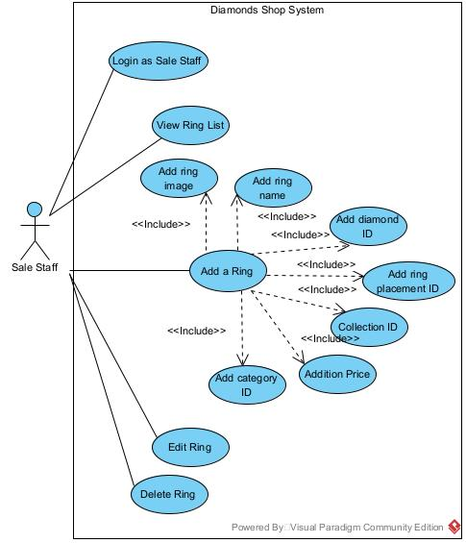

| **USE CASE-07 SPECIFICATION** | | | | |
| --- | --- | --- | --- | --- |
| **Use-case No.** | UC-07 | **Use-case Version** | | 1.0 |
| **Use-case Name** | Diamond Ring Management | | | |
| **Author** | An Do Dinh, Cuong Nguyen Phu | | | |
| **Date** | 03/06/2024 | **Priority** | High | |
| **Actor:**  Sales Staff  **Summary:**  This use case describes the process by a Sale Staff adding, updating, removing Diamond Ring.  **Triggers**  Requester indicates that he wants to log in the system.  **Post Conditions:**  The user is authenticated and redirected to their personalized pages.  **Main Success Scenario:**  **Managing Diamond Ring**   1. Personas navigate to the login page. 2. System displays the login form with fields for username and password. 3. Personas enter their username and password. 4. Personas submit the login form. 5. System validates the username and password against the stored credentials. 6. System authenticates the user and creates a session. 7. System redirects the personas to their personalized pages. 8. Sales Staff click on the “Create a Ring” 9. Sales Staff fill all the necessary information in each field. 10. Sales Staff click “Save” to save the diamond into the database. 11. Sales Staff click on the desired Diamond to change information. 12. Sales Staff will fill additional information on the said Diamond Ring. 13. Sales Staffclick on “Save” to save the updated information. 14. System displays the ring with updated information. 15. Sales Staff click on “Delete” of a Diamond Ring. 16. System will remove the deleted Diamond out of the list, but remain in the database.   **Exceptions:**  **Wrong Image URL Format**   * System detects that the entered image URL is not in the correct format. * System displays an error message: "Invalid image URL. It must start with "https://" and end with one of the following extensions: .jpg, .jpeg, .png, .gif, .bmp, .webp."   **Business Rules:**  BR-12: Sales Staff must log in to the system with their username, password and role “Sales Staff”.  BR-21: Only one Ring can be assigned to one Diamond.  BR-22: The price of Diamond is shown in the price of the Diamond Placement. | | | | |

## Ring Placement Management

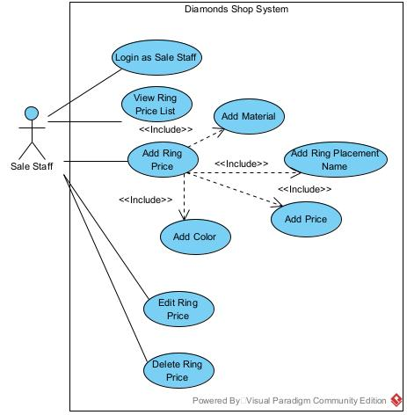

| **USE CASE-08 SPECIFICATION** | | | | |
| --- | --- | --- | --- | --- |
| **Use-case No.** | UC-08 | **Use-case Version** | | 1.0 |
| **Use-case Name** | Ring Price and Placement Management | | | |
| **Author** | An Do Dinh, Cuong Nguyen Phu, Hoang Nguyen Minh | | | |
| **Date** | 03/06/2024 | **Priority** | High | |
| **Actor:**  Sales Staff  **Summary:**  This use case describes the process by a Sale Staff adding, updating, removing a Ring Placement.  **Triggers**  Requester indicates that he wants to log in the system.  **Post Conditions:**  The user is authenticated and redirected to their personalized pages.  **Main Success Scenario:**  **Managing Diamond**   1. Personas navigate to the login page. 2. System displays the login form with fields for username and password. 3. Personas enter their username and password. 4. Personas submit the login form. 5. System validates the username and password against the stored credentials. 6. System authenticates the user and creates a session. 7. System redirects the personas to the personalized pages. 8. Sales Staff click on the “Add a Price”. 9. Sales Staff fill all the necessary information in each field. 10. Sales Staff click “Save” to save the Ring Price into the database. 11. Sales Staff click on the desired Ring Price to change information. 12. Sales Staff will fill additional information on the said Ring Price. 13. Sales Staffclick on “Save” to save the updated information. 14. System displays the ring with updated information. 15. Sales Staff click on “Delete” of a Ring Price. 16. System will remove the deleted Ring Price out of the list, but remain in the database.   **Exceptions:**  **Enter a large amount of money (over 1 billion) or small money (below 1 million)**   * System detects that the entered amount exceeds the limit. * System displays a notification message: "Price must be less than or equal to 1000000000."   **Business Rules:**  BR-12: Sales Staff must log in to the system with their username, password and role “Sales Staff”.  BR-23: Ring Price cannot have the same name.  BR-24: One Ring Price can be assigned to multiple Main Ring.  BR-25: One Material, Price, Color can be used multiple times. | | | | |

## 

## Dashboard

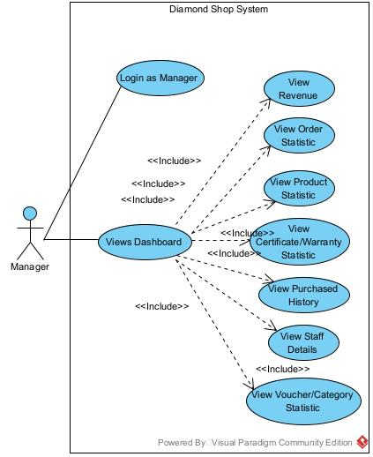

| **USE CASE-09 SPECIFICATION** | | | | |
| --- | --- | --- | --- | --- |
| **Use-case No.** | UC-09 | **Use-case Version** | | 1.0 |
| **Use-case Name** | Dashboard Viewer | | | |
| **Author** | Hoang Nguyen Minh | | | |
| **Date** | 04/06/2024 | **Priority** | High | |
| **Actor:**  Manager  **Summary:**  This use case describes the process in which a Manager views the dashboard of the system.  **Triggers**  Requester indicates that he wants to log in the system.  **Post Conditions:**  The user is authenticated and redirected to their personalized pages.  **Main Success Scenario:**   1. The Manager navigates to the login page. 2. The system displays the login form with fields for username and password. 3. The Manager enters their username and password. 4. The Manager submits the login form. 5. The system validates the username and password against the stored credentials. 6. The system authenticates the Manager and creates a session. 7. The system redirects the Manager to their personalized pages. 8. The Manager views the dashboard displaying relevant system metrics, reports, and summaries.   **Exceptions:**  **Invalid Username or Password**   * System detects invalid username or password. * System displays an error message: "Invalid username or password. Please try again."   **Business Rules:**  BR-26: All the information on the charts, diagrams must be updated in real time.  BR-27: There must be a quick response time without taking a long time to load the charts, so that the manager can quickly view them. | | | | |

## 

# SEQUENCE DIAGRAMS

## Interact with Shop in Customer Pages

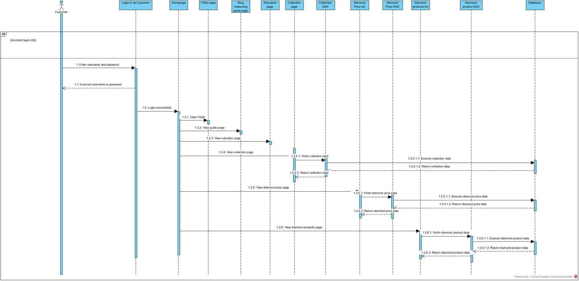

## Certificate Management

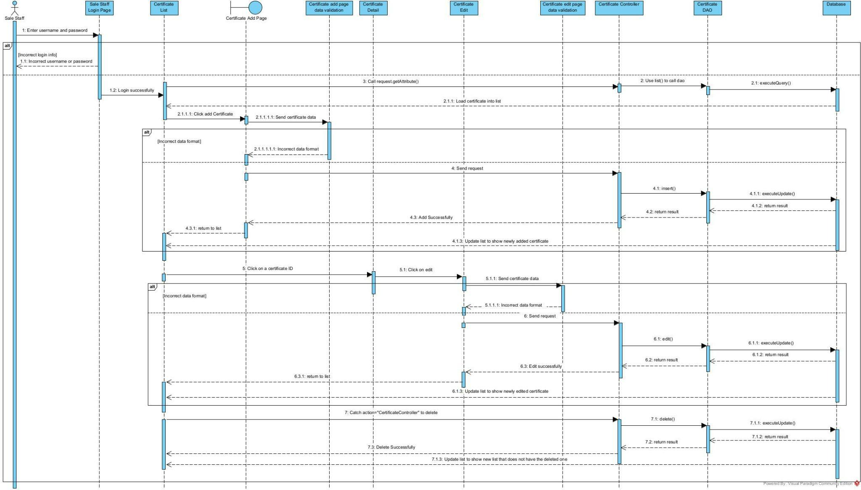

## Warranty Management

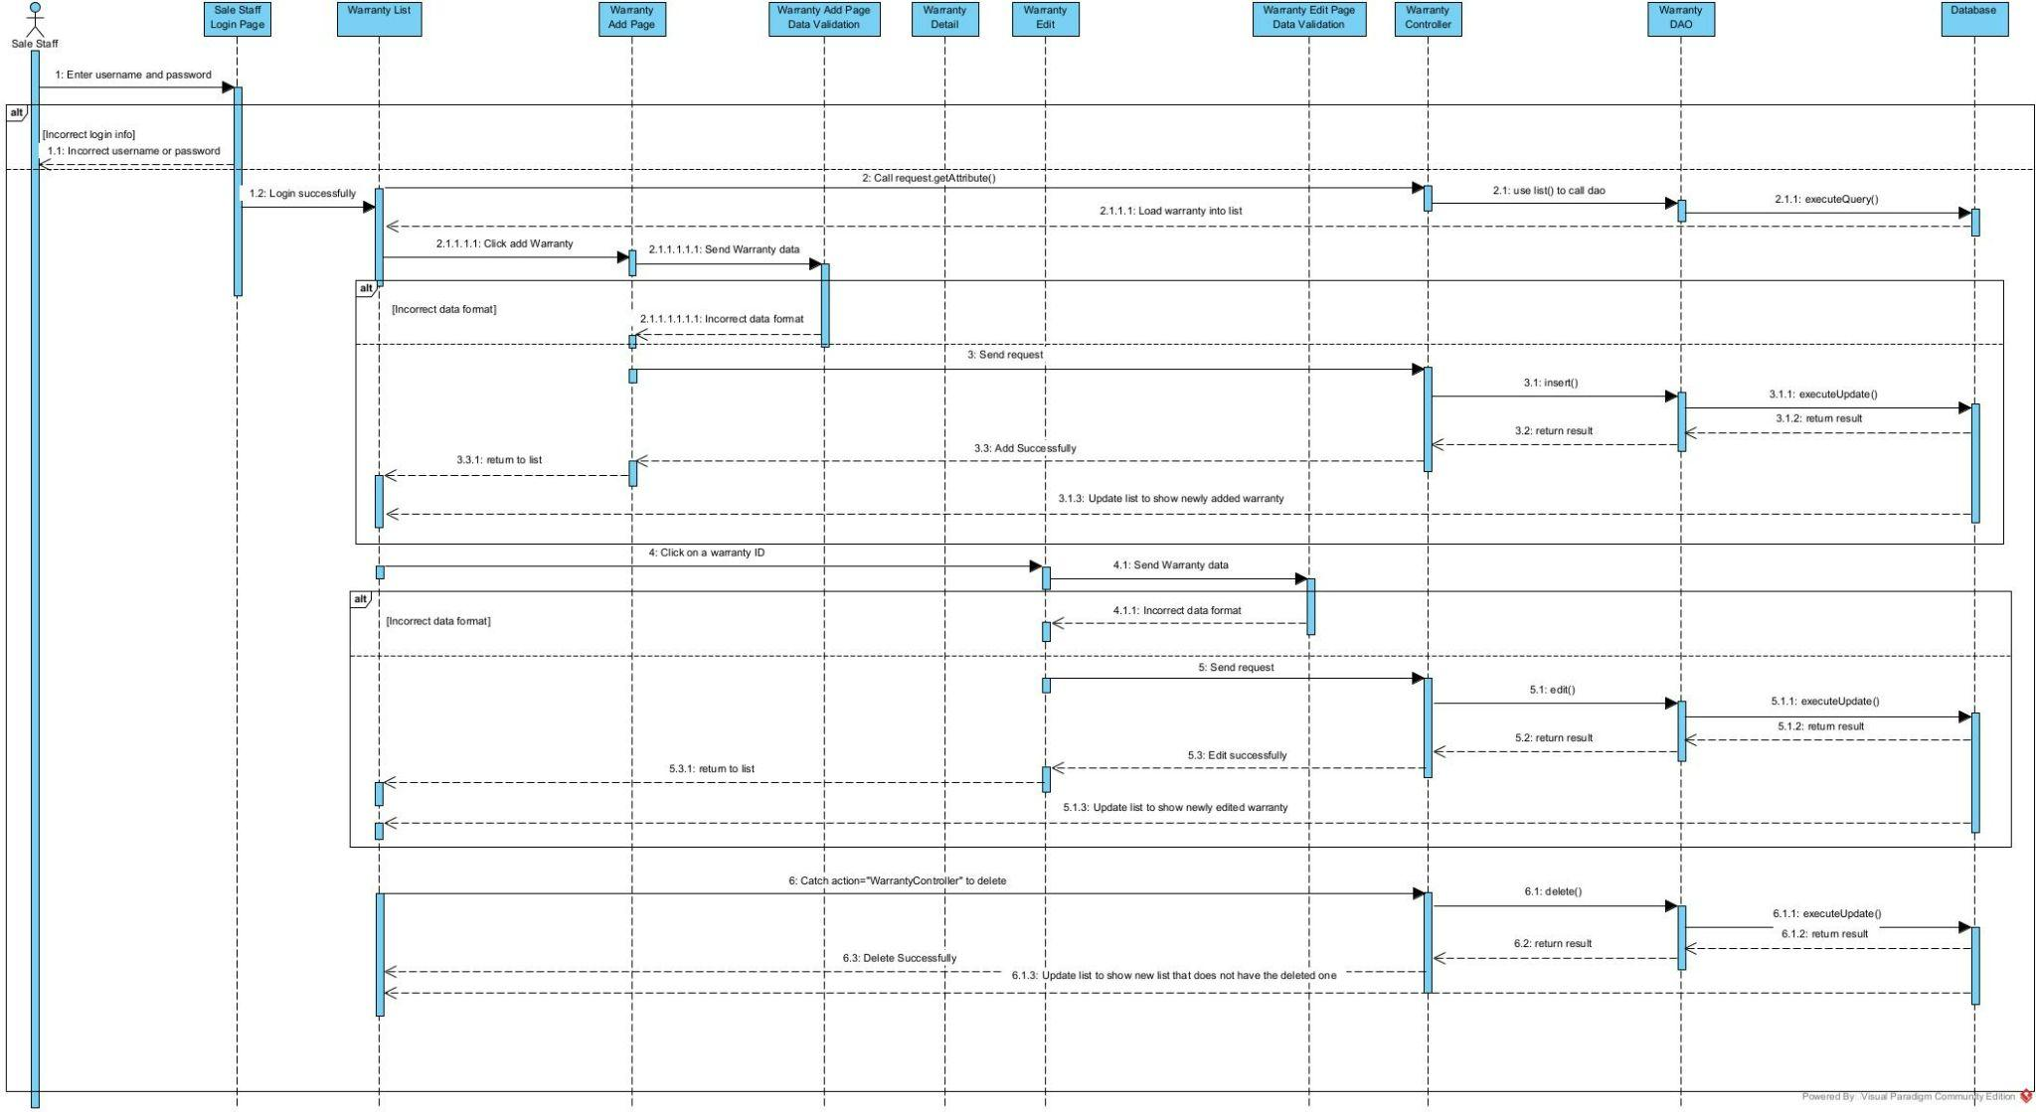

## Voucher Management

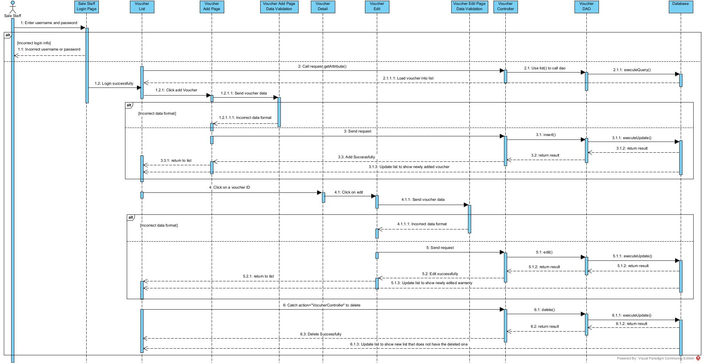

## Shopping Process for Customer

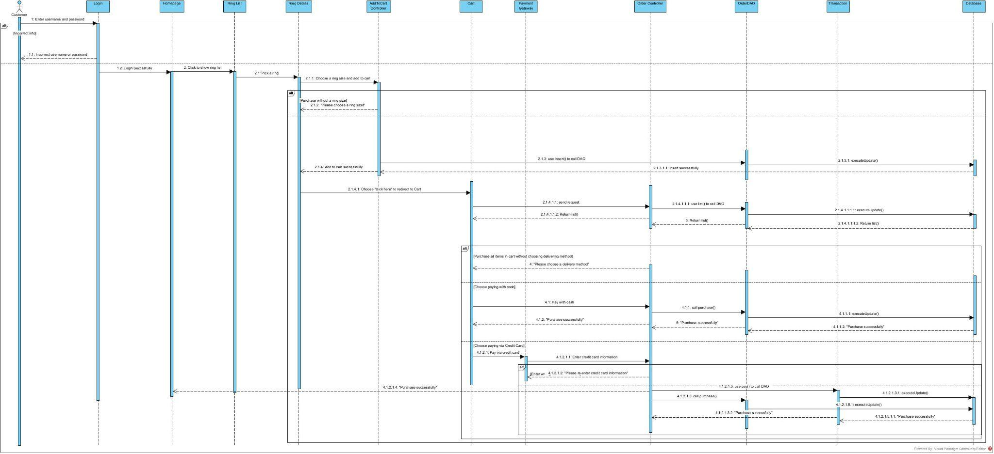

## Shopping Process for Sales Staff

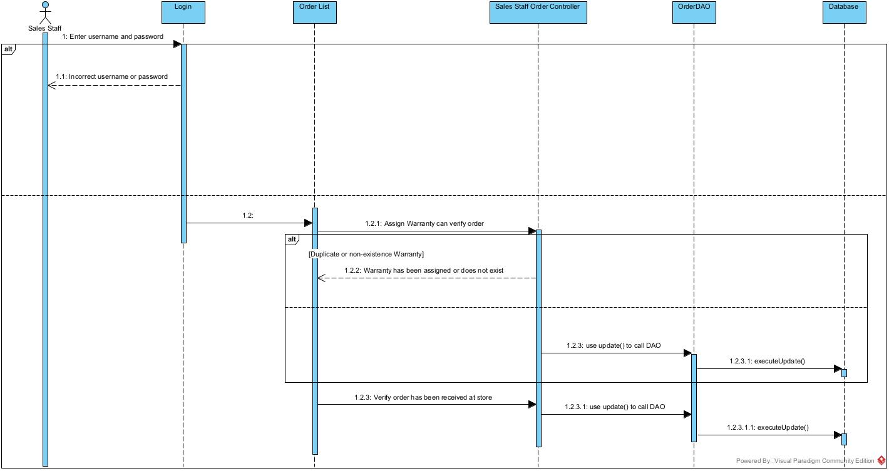

## Shopping Process for Delivery Staff

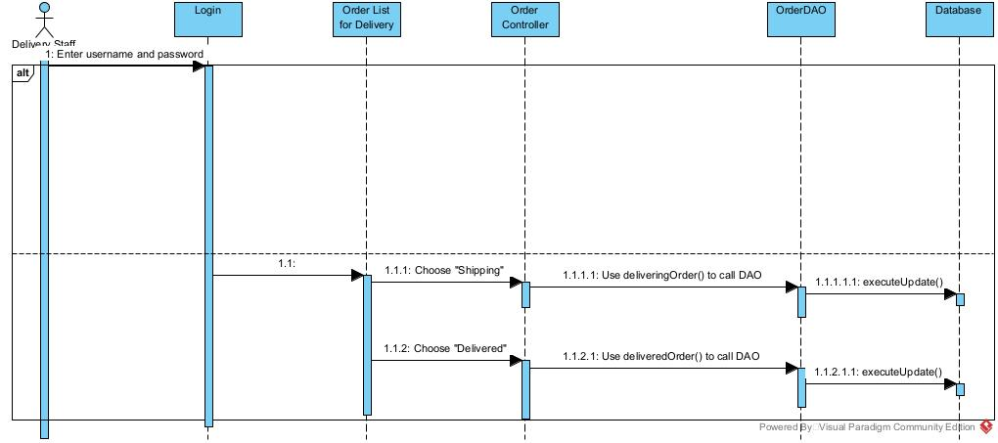

## Diamond Price Declaration with Criteria

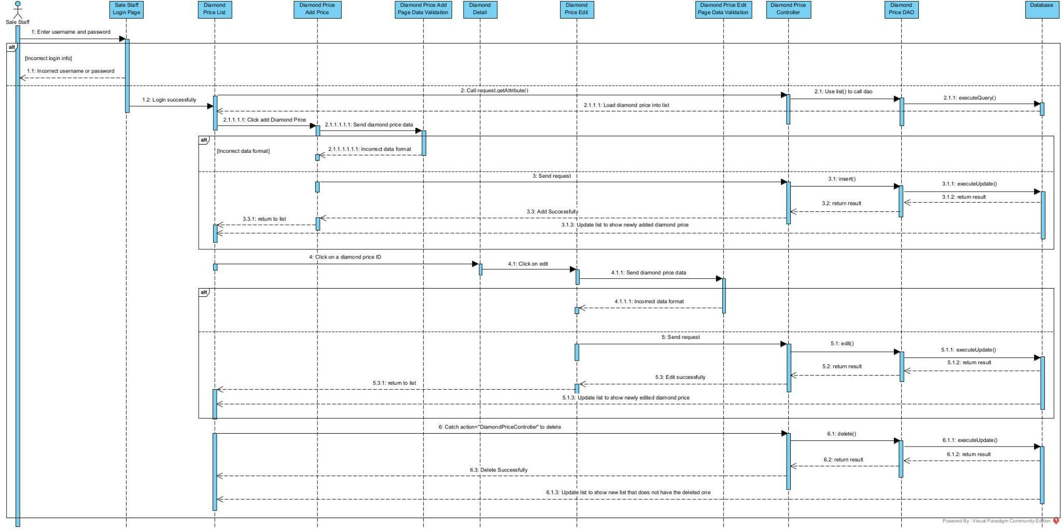

## Main Ring Management

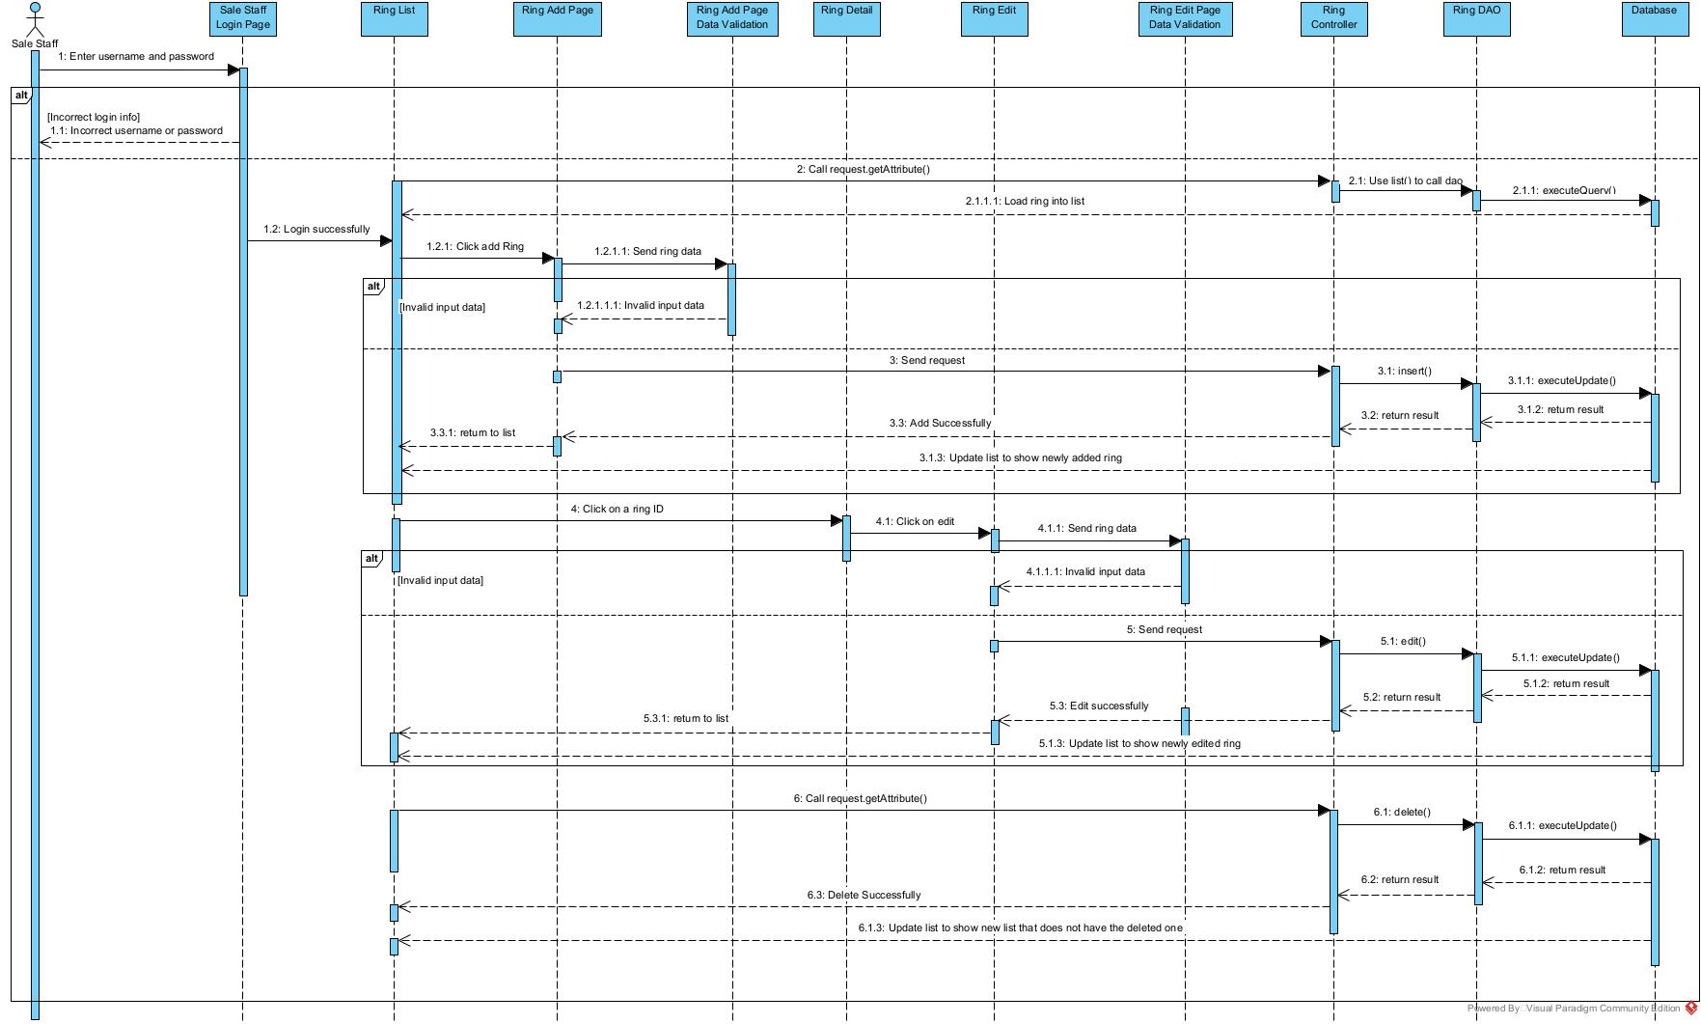

## Ring Placement Management

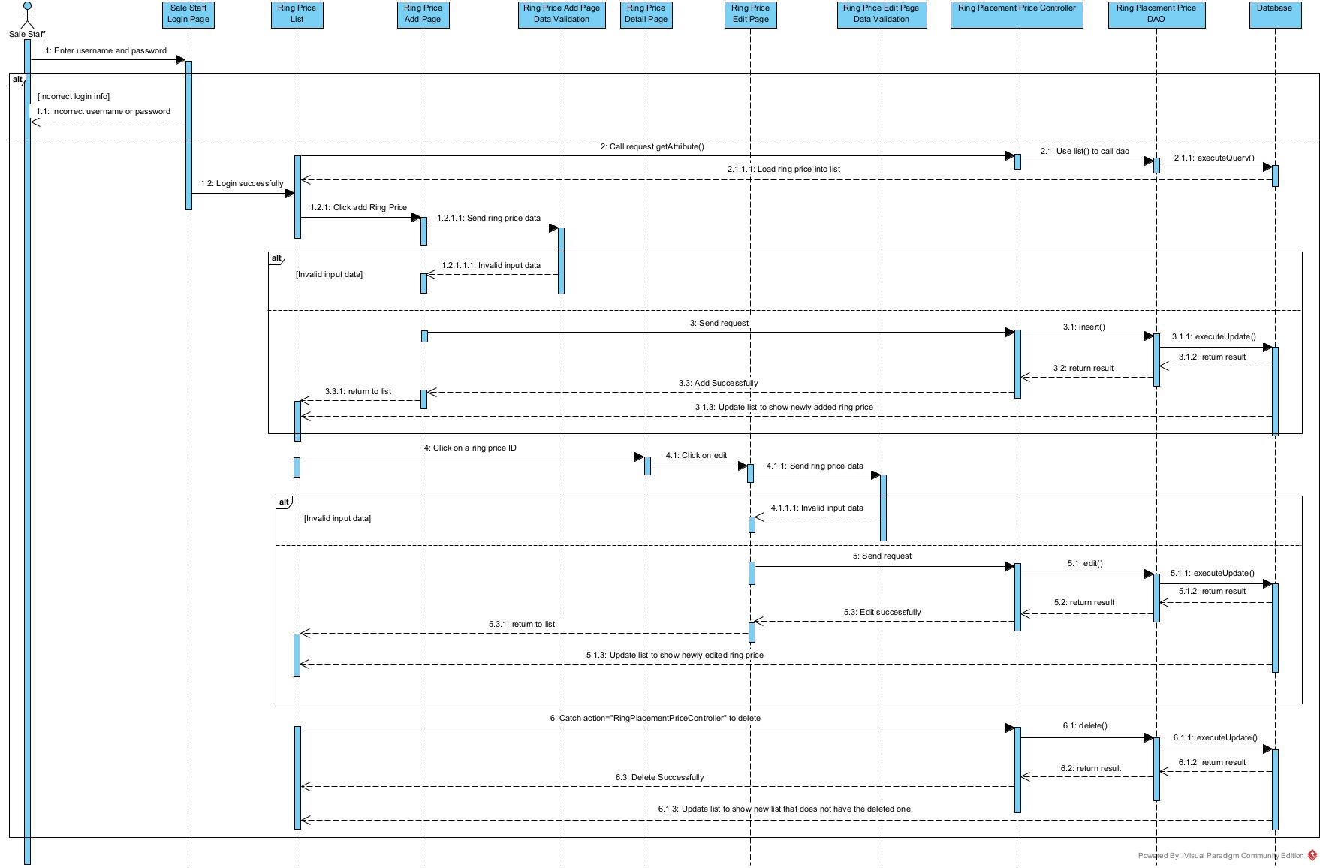

## Dashboard

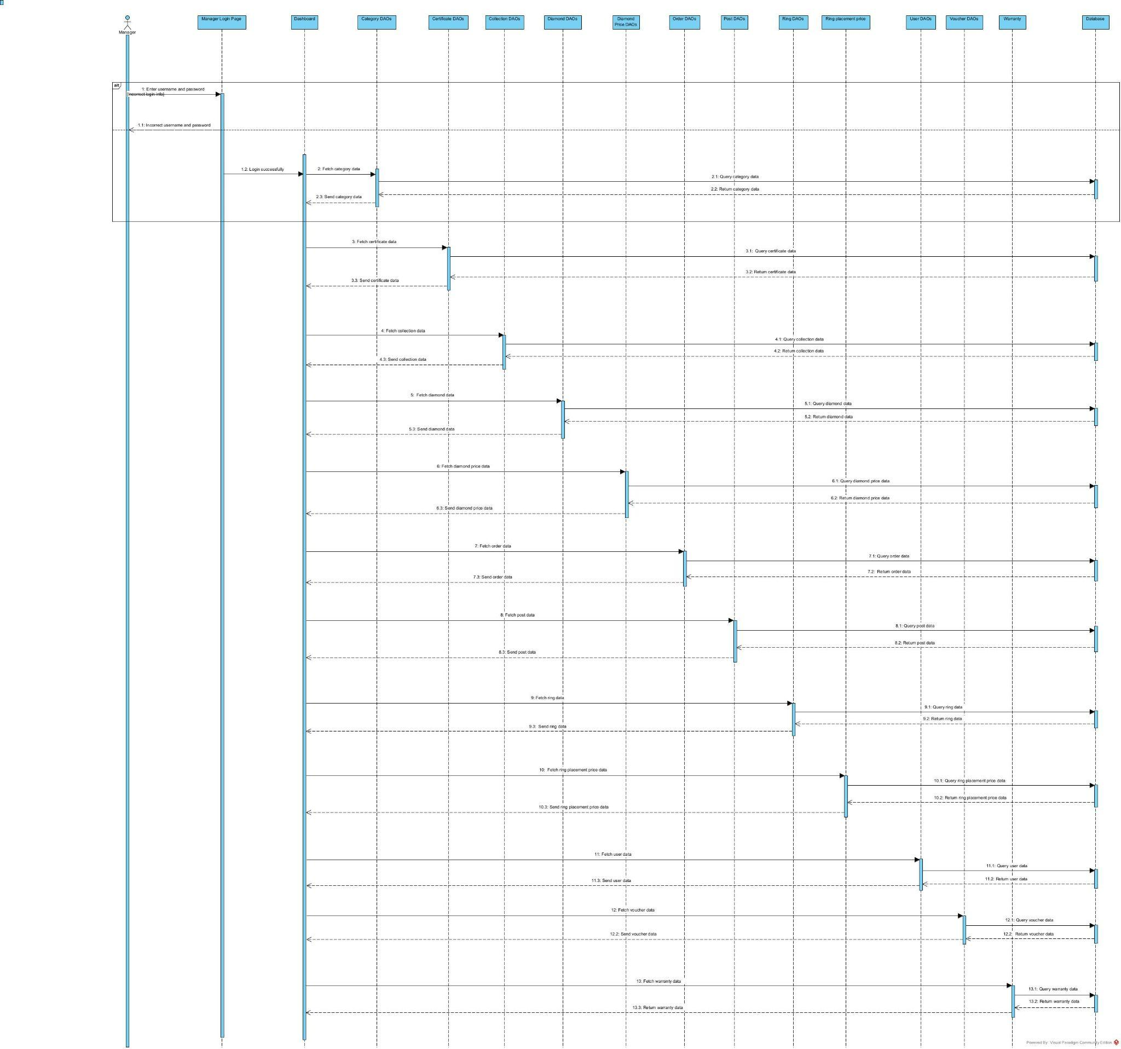

# NON-FUNCTIONAL REQUIREMENTS

## Usability

The online diamond store shall ensure that a normal user can become proficient in navigating and using the platform for 20 to 30 minutes.

The system shall provide an education section for customers that includes guides on how to select ring sizes, understand diamond pricing, and utilize voucher offers, reducing the need for external training.

## Reliability

The system shall maintain an availability of 99.9%, allowing for a maximum of 5 hours of downtime per year for maintenance.

The Mean Time Between Failures (MTBF) for the system shall be at least 5,000 hours.

The Mean Time To Repair (MTTR) shall not exceed an hour.

The system shall achieve an accuracy rate of 99.99% in managing and displaying diamond certification and warranty information.

## Performance

The system shall handle a minimum throughput of 13 transactions per minute during peak hours without performance degradation.

The system shall be capable of supporting up to 50 concurrent users, ensuring smooth operation under heavy load.

The system shall degrade gracefully, maintaining core functionality (product browsing and purchasing) even when secondary services (e.g., promotional management) are under maintenance.

## Supportability

The system shall adhere to defined coding standards and naming conventions to facilitate maintainability and readability of the codebase.

The system can run on multiple browsers, and provide optimal performance and user experience, such as:

* Google Chrome
* Microsoft Edge

## Design Constraints

The system shall be developed using Java for the backend and HTML/CSS for the frontend.

The system shall utilize an MSSQL database for storing all transactional and personal data.

## Legal, Copyright, and Other Notices

The system shall include legal disclaimers on product descriptions, warranty terms, and liability limitations to protect the company from legal liabilities associated with product sales and usage.

## Applicable Standards

The system shall adhere to industry standards for diamond certification (e.g., GIA’s 4C standards), ensuring accuracy and reliability in displaying and managing diamond information.

The user interface shall comply with web accessibility standards (e.g., WCAG) to ensure usability for users with disabilities, supporting features like screen readers and keyboard navigation.