**Tên: Nguyễn Toàn Tiến Cường**

**MSSV: 21521906**

**Github: Ex1:** <https://github.com/CuongNguyen1852003/ProfileApp>

**Ex2: https://github.com/CuongNguyen1852003/Android-Sentiment-Analysis-main**

EX1:

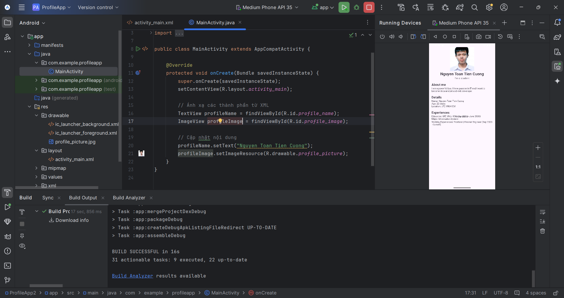

EX2: