2.
VD1
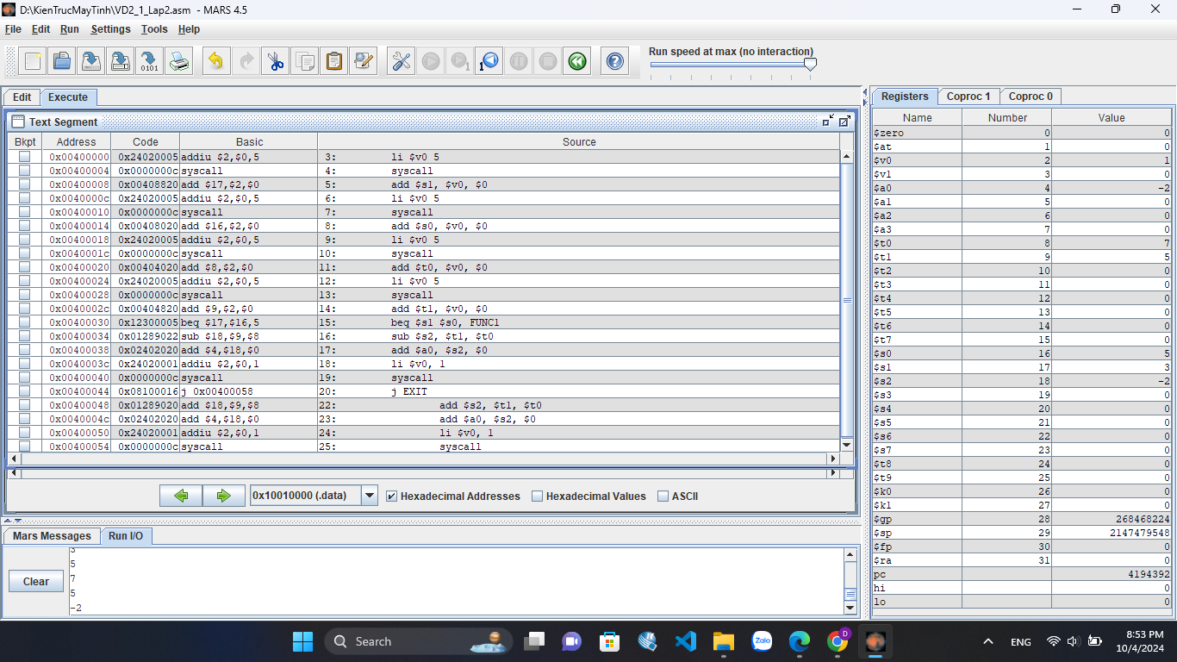
VD2
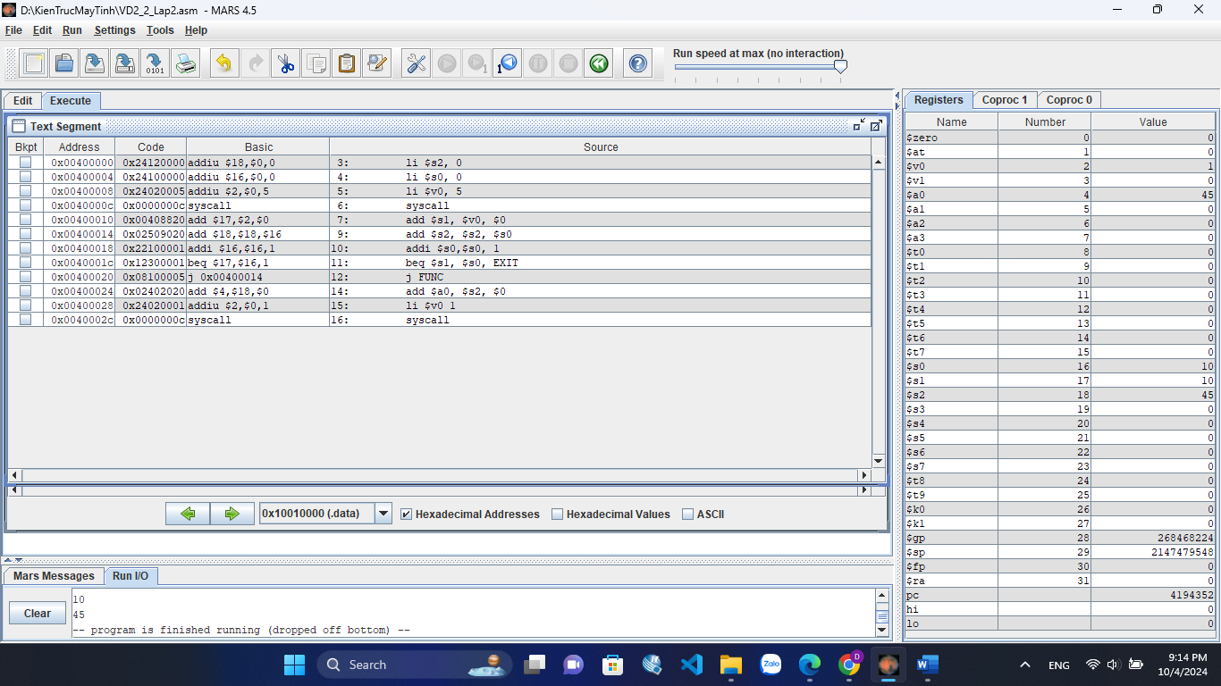
3
a)
.data
string1: .asciiz "Nhap ky tu: "
string2: .asciiz "\nKy tu truoc: "
string3: .asciiz "\nKy tu sau: "
string4: .asciiz "\ninvalid type"
string5: .asciiz "\nso"
string6: .asciiz "\nchu thuong"
string7: .asciiz "\nchu hoa"
.text
main:
li $v0, 4
la $a0, string1
syscall
li $v0, 12
syscall
add $t0, $v0, $0
addi $t1, $v0, 1
subi $t2, $v0, 1
li $v0, 4
la $a0, string2
syscall
li $v0, 11
add $a0, $t2, $0
syscall
li $v0, 4
la $a0, string3
syscall
li $v0, 11
add $a0, $t1, $0
syscall

li $t7, 48
blt $t0, $t7, NOT
li $t7, 58
blt $t0, $t7, DOSO
li $t7, 64
ble $t0, $t7, NOT
li $t7, 90
ble $t0, $t7, DOH
li $t7, 96
ble $t0, $t7, NOT
li $t7, 122
ble $t0, $t7, DOT
j NOT
DOSO: li $v0, 4
la $a0, string5
syscall
j END
DOT: li $v0, 4
la $a0, string6
syscall
j END
DOH: li $v0, 4
la $a0, string7
syscall
j END
NOT: li $v0, 4
la $a0, string4
syscall
END:

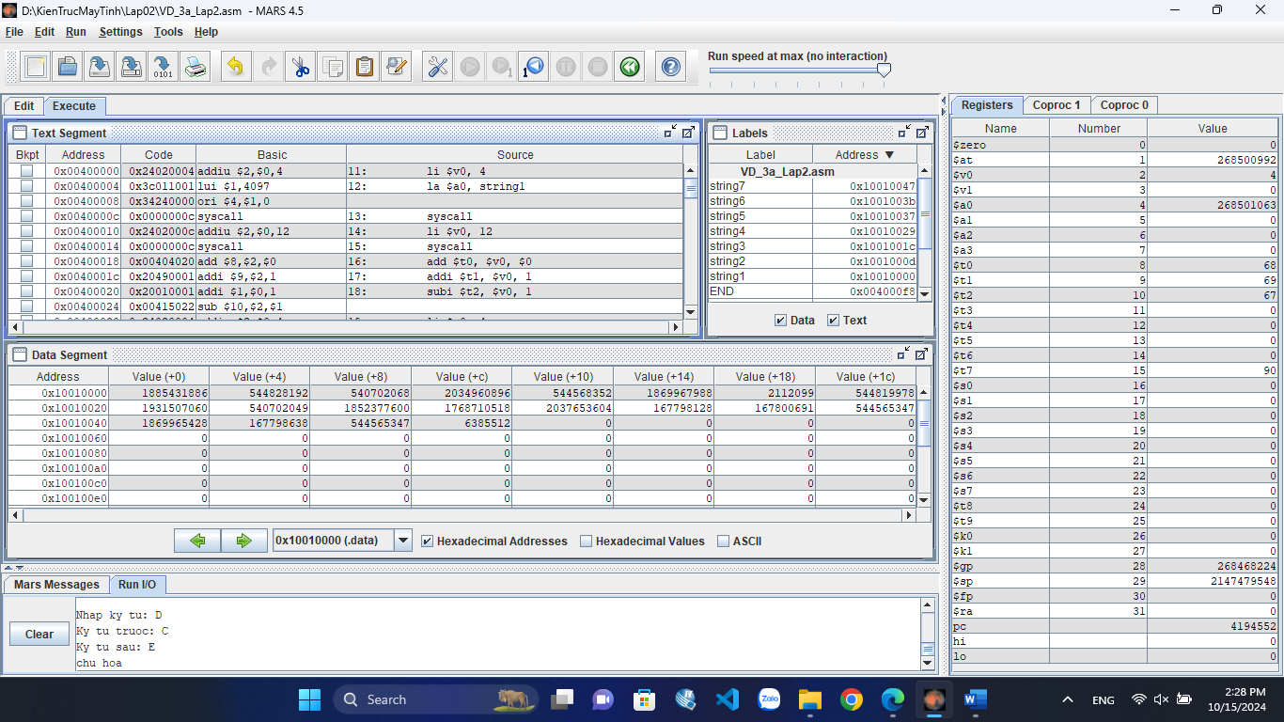
b)
.data
string: .asciiz "so nho hon la: "
string1: .asciiz "\ntong: "
string2: .asciiz "\nhieu: "
string3: .asciiz "\ntich: "
string4: .asciiz "\nthuong"
string5: .asciiz " du: "
.text
main:
li $v0, 5
syscall
add $t1, $0, $v0
li $v0, 5
syscall
add $t2, $0, $v0
li $v0, 4
la $a0, string
syscall
bgt $t1, $t2, XUATT2
li $v0, 1
add $a0, $0, $t1
syscall
j NEXT
XUATT2: li $v0, 1
add $a0, $0, $t2
syscall
NEXT:

add $t3, $t1, $t2
li $v0, 4
la $a0, string1
syscall
add $a0, $0, $t3
li $v0, 1
syscall

sub $t4, $t1, $t2
li $v0, 4
la $a0, string2
syscall
add $a0, $0, $t4
li $v0, 1
syscall

mult $t1, $t2
mfhi $t5
mflo $t6
li $v0, 4
la $a0, string3
syscall
beqz $t5, XX
li $v0, 1
add $a0, $0, $t5
syscall

XX: li $v0, 1
add $a0, $0, $t6
syscall

li $v0, 4
la $a0, string4
syscall
divu $t7, $t1, $t2
mfhi $s0
li $v0, 1
add $a0, $0, $t7
syscall
li $v0, 4
la $a0, string5
syscall
li $v0, 1
add $a0, $0, $s0
syscall

