- Thao tác với mảng
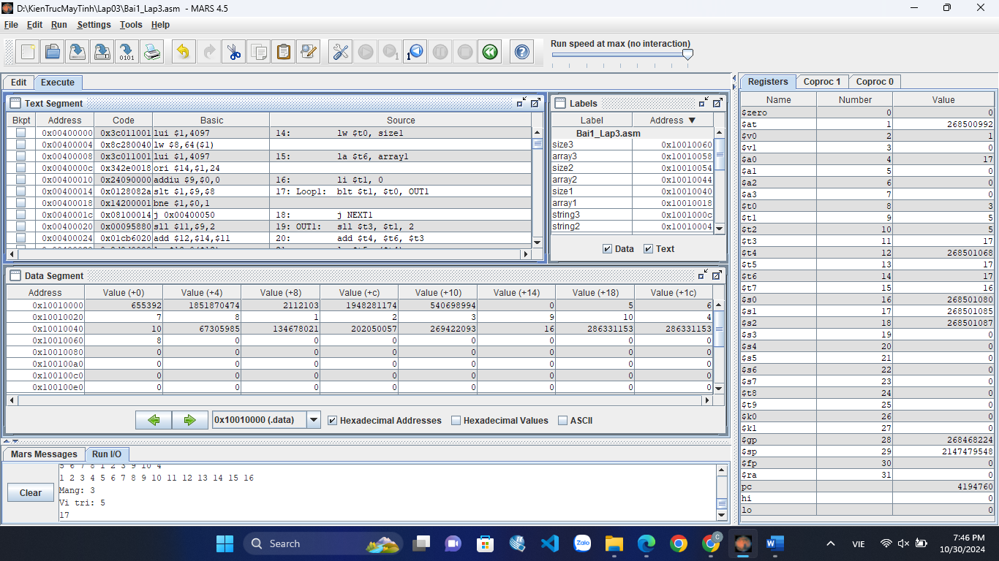
Đoạn code:

.data
string: .asciiz " "
string1: .asciiz "\n"
string2: .asciiz "\nMang: "
string3: .asciiz "Vi tri: "
array1: .word 5, 6, 7, 8, 1, 2, 3, 9, 10, 4
size1: .word 10
array2: .byte 1, 2, 3, 4, 5, 6, 7, 8, 9, 10, 11, 12, 13, 14, 15, 16
size2: .word 16
array3: .space 8
size3: .word 8
.text

lw $t0, size1
la $t6, array1
li $t1, 0
Loop1: blt $t1, $t0, OUT1
j NEXT1
OUT1: sll $t3, $t1, 2
add $t4, $t6, $t3
lw $t5, ($t4)
li $v0, 1
add $a0, $0, $t5
syscall
li $v0,4
la $a0, string
syscall
addi $t1, $t1, 1
j Loop1
NEXT1: li $v0,4
la $a0, string1
syscall
lw $t0, size2
la $t6, array2
li $t1, 0
Loop2: blt $t1, $t0, OUT2
j NEXT2
OUT2: sll $t3, $t1, 0
add $t4, $t6, $t3
lb $t5, ($t4)
li $v0, 1
add $a0, $0, $t5
syscall
li $v0,4
la $a0, string
syscall
addi $t1, $t1, 1
j Loop2
NEXT2: li $t0, 0
lw $t1, size3
lw $t7, size2
Loop3: blt $t0, $t1, DO
j NEXT3
DO: la $s0, array2
add $t3, $s0, $t0
add $t4, $s0, $t7
addi $t4, $t4, -1
sub $t4, $t4, $t0
lb $t5, ($t3)
lb $t6, ($t4)
add $t5, $t5, $t6
la $s1, array3
add $s2, $s1, $t0
sb $t5, ($s2)
addi $t0, $t0, 1
lb $t6, ($s2)
j Loop3
NEXT3: li $v0, 4
la $a0, string2
syscall
li $v0, 5
syscall
add $t0, $v0, $0
li $v0, 4
la $a0, string3
syscall
li $v0, 5
syscall
add $t1, $v0, $0
li $t3, 1
beq $t0, $t3, DO1
li $t3, 2
beq $t0, $t3, DO2
li $t3, 3
beq $t0, $t3, DO3
DO1: la $s0, array1
sll $t2, $t1, 2
add $s1, $s0, $t2
lw $t3, ($s1)
li $v0, 1
add $a0, $t3, $0
syscall
j EXIT
DO2: la $s0, array2
sll $t2, $t1, 0
add $s1, $s0, $t2
lb $t3, ($s1)
li $v0, 1
add $a0, $t3, $0
syscall
j EXIT
DO3: la $s0, array3
sll $t2, $t1, 0
add $s1, $s0, $t2
lb $t3, ($s1)
li $v0, 1
add $a0, $t3, $0
syscall
EXIT:

- Thao tác với con trỏ
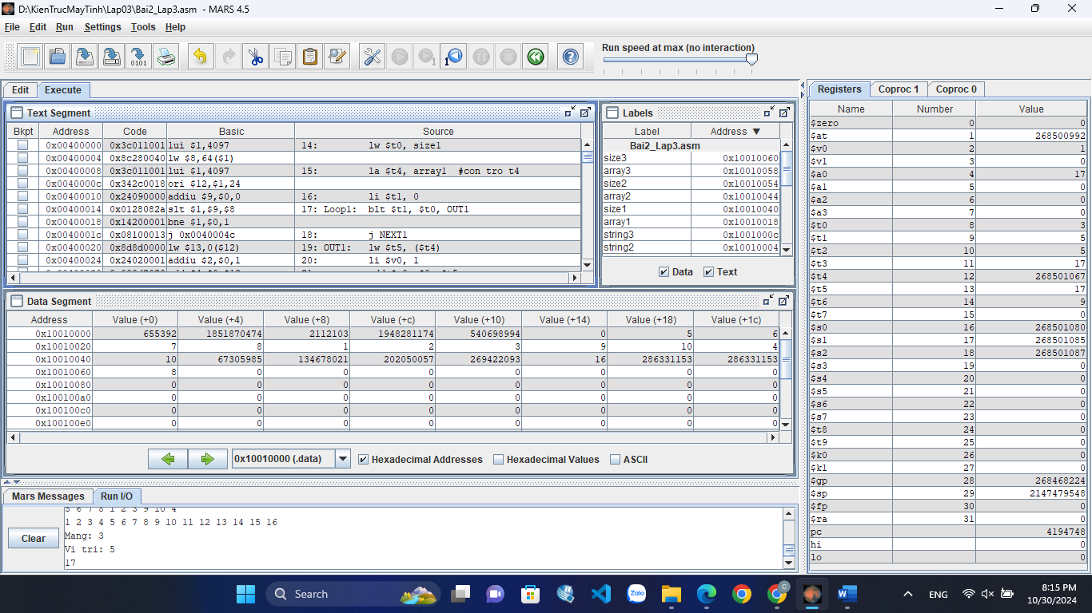
Đoạn code:

.data
string: .asciiz " "
string1: .asciiz "\n"
string2: .asciiz "\nMang: "
string3: .asciiz "Vi tri: "
array1: .word 5, 6, 7, 8, 1, 2, 3, 9, 10, 4
size1: .word 10
array2: .byte 1, 2, 3, 4, 5, 6, 7, 8, 9, 10, 11, 12, 13, 14, 15, 16
size2: .word 16
array3: .space 8
size3: .word 8
.text

lw $t0, size1
la $t4, array1 #con tro t4
li $t1, 0
Loop1: blt $t1, $t0, OUT1
j NEXT1
OUT1: lw $t5, ($t4)
li $v0, 1
add $a0, $0, $t5
syscall
li $v0,4
la $a0, string
syscall
addi $t1, $t1, 1
addi $t4, $t4, 4
j Loop1
NEXT1: li $v0,4
la $a0, string1
syscall
lw $t0, size2
la $t4, array2 #con tro t4
li $t1, 0
Loop2: blt $t1, $t0, OUT2
j NEXT2
OUT2: lb $t5, ($t4)
li $v0, 1
add $a0, $0, $t5
syscall
li $v0,4
la $a0, string
syscall
addi $t1, $t1, 1
addi $t4, $t4, 1
j Loop2
NEXT2: li $t0, 0
lw $t1, size3
lw $t2, size2
la $t3, array2 #con tro t3 o dau mang array2
add $t4, $t3, $t2
add $t4, $t4, -1 #con tro t4 o cuoi mang array2
Loop3: blt $t0, $t1, DO
j NEXT3
DO: lb $t5, ($t3)
lb $t6, ($t4)
add $t5, $t5, $t6
la $s1, array3
add $s2, $s1, $t0
sb $t5, ($s2)
addi $t0, $t0, 1
addi $t3, $t3, 1
addi $t4, $t4, -1
j Loop3
NEXT3: li $v0, 4
la $a0, string2
syscall
li $v0, 5
syscall
add $t0, $v0, $0
li $v0, 4
la $a0, string3
syscall
li $v0, 5
syscall
add $t1, $v0, $0
li $t3, 1
beq $t0, $t3, DO1
li $t3, 2
beq $t0, $t3, DO2
li $t3, 3
beq $t0, $t3, DO3
DO1: la $s0, array1
sll $t2, $t1, 2
add $s1, $s0, $t2
lw $t3, ($s1)
li $v0, 1
add $a0, $t3, $0
syscall
j EXIT
DO2: la $s0, array2
sll $t2, $t1, 0
add $s1, $s0, $t2
lb $t3, ($s1)
li $v0, 1
add $a0, $t3, $0
syscall
j EXIT
DO3: la $s0, array3
sll $t2, $t1, 0
add $s1, $s0, $t2
lb $t3, ($s1)
li $v0, 1
add $a0, $t3, $0
syscall
EXIT:

- Bài tập
3a)
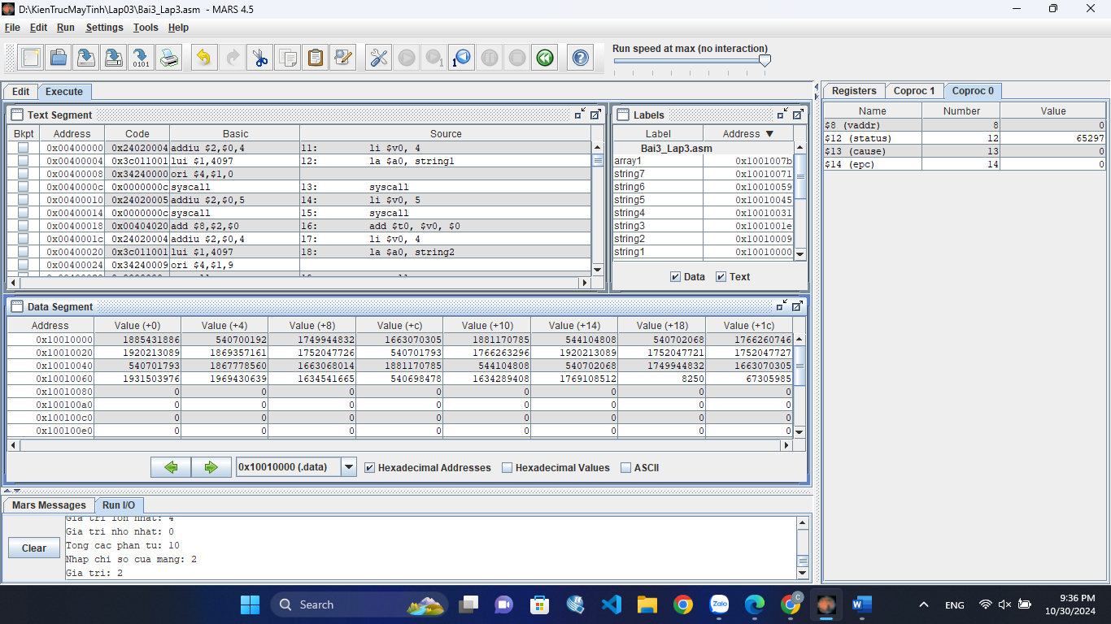
Đoạn code:

.data
string1: .asciiz "Nhap n: "
string2: .asciiz "\nNhap cac phan tu: \n"
string3: .asciiz "Gia tri lon nhat: "
string4: .asciiz "\nGia tri nho nhat: "
string5: .asciiz "\nTong cac phan tu: "
string6: .asciiz "\nNhap chi so cua mang: "
string7: .asciiz "Gia tri: "
array1: .byte
.text
li $v0, 4
la $a0, string1
syscall
li $v0, 5
syscall
add $t0, $v0, $0
li $v0, 4
la $a0, string2
syscall
la $s0, array1
li $t1, 0
Loop: blt $t1, $t0, DO
j NEXT
DO: li $v0, 5
syscall
sb $v0, ($s0)
addi $s0, $s0, 1
addi $t1, $t1, 1
j Loop

NEXT: la $s0, array1
lb $t2, ($s0)
lb $t3, ($s0)
lb $t5, ($s0)
addi $s0, $s0, 1
li $t1, 1
Loop1: blt $t1, $t0, DO1
j NEXT2
DO1: lb $t4, ($s0)
add $t5, $t5, $t4
blt $t2, $t4, SWAPMAX
DO2: bgt $t3, $t4, SWAPMIN
j NEXT1
SWAPMAX: add $t2, $t4, $0
j DO2
SWAPMIN: add $t3, $t4, $0
NEXT1: addi $t1, $t1, 1
addi $s0, $s0, 1
j Loop1
NEXT2:
li $v0, 4
la $a0, string3
syscall
li $v0, 1
add $a0, $t2, $0
syscall
li $v0, 4
la $a0, string4
syscall
li $v0, 1
add $a0, $t3, $0
syscall
li $v0, 4
la $a0, string5
syscall
li $v0, 1
add $a0, $t5, $0
syscall
li $v0, 4
la $a0, string6
syscall
li $v0, 5
syscall
la $s0, array1
add $s0, $s0, $v0
lb $t1, ($s0)
li $v0, 4
la $a0, string7
syscall
li $v0, 1
add $a0, $t1, $0
syscall

3b)
Blt $s0, $s1, Do
sll $t1, $s0, 2
add $s4, $t1, $s3
sw $s1, ($s4)
j EXIT
Do: sll $t1, $s0, 2
add $s4, $t1, $s3
sw $s0, ($s4)
EXIT:

