Sub-admin
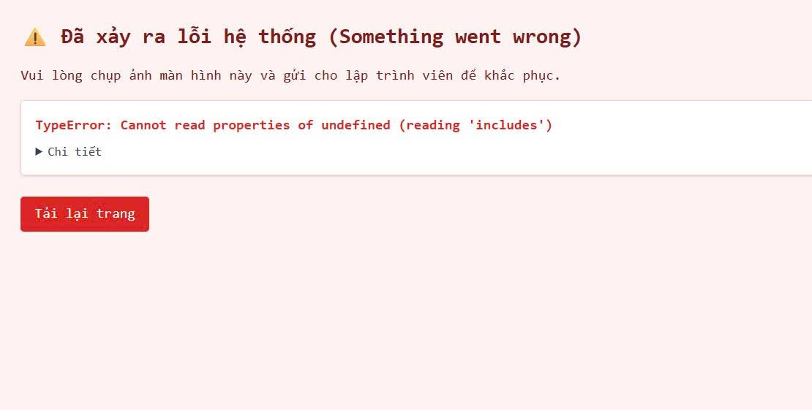
- cái sự kiện khoa của subadmin cứ đến bước cuối thì bị lỗi này nè
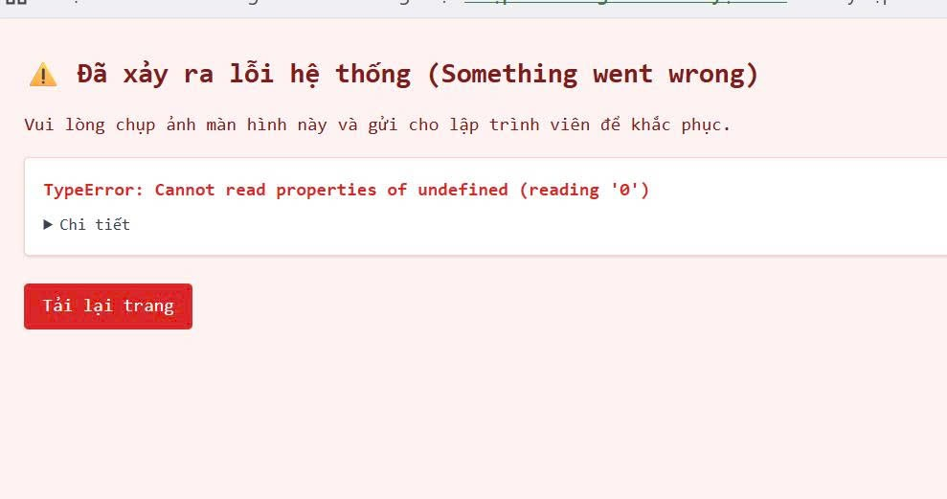
- bấm vô thi đua thì như này

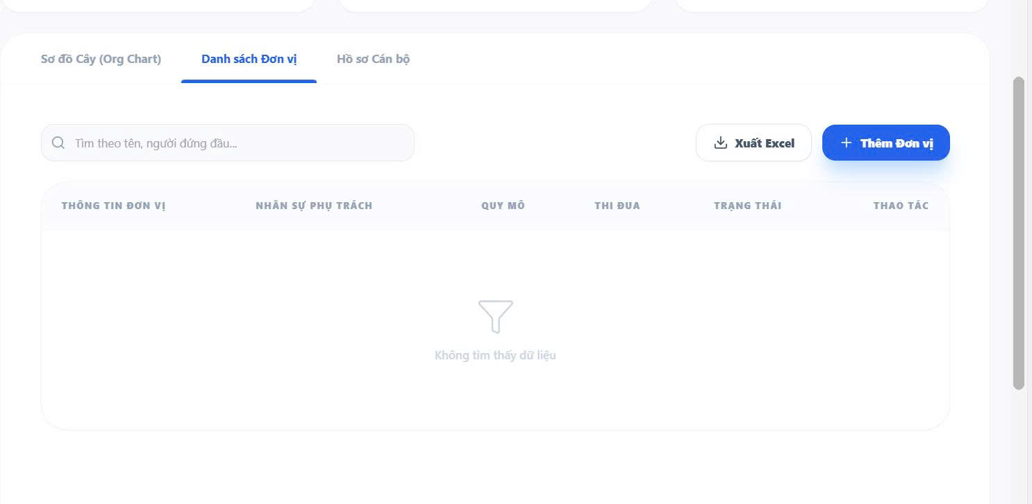
Admin
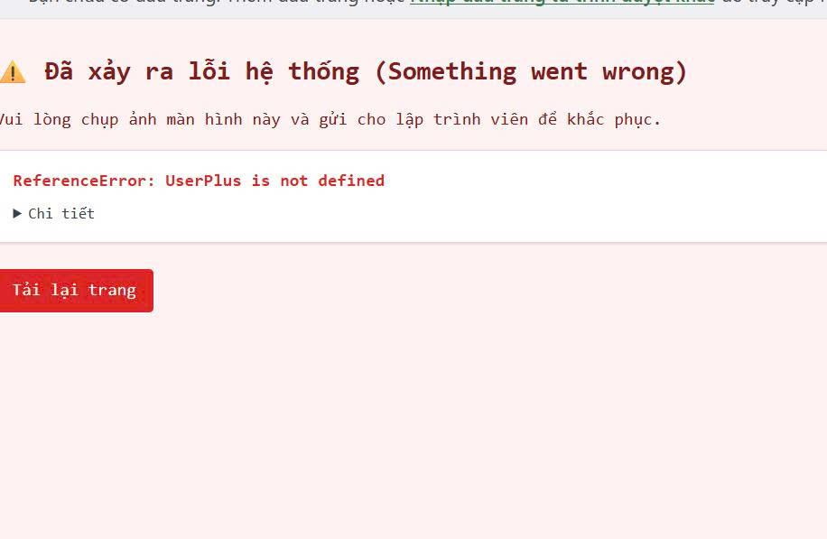

- dashboard admin khi thêm đơn vị mới ở phần danh sách đơn vị thì lỗi
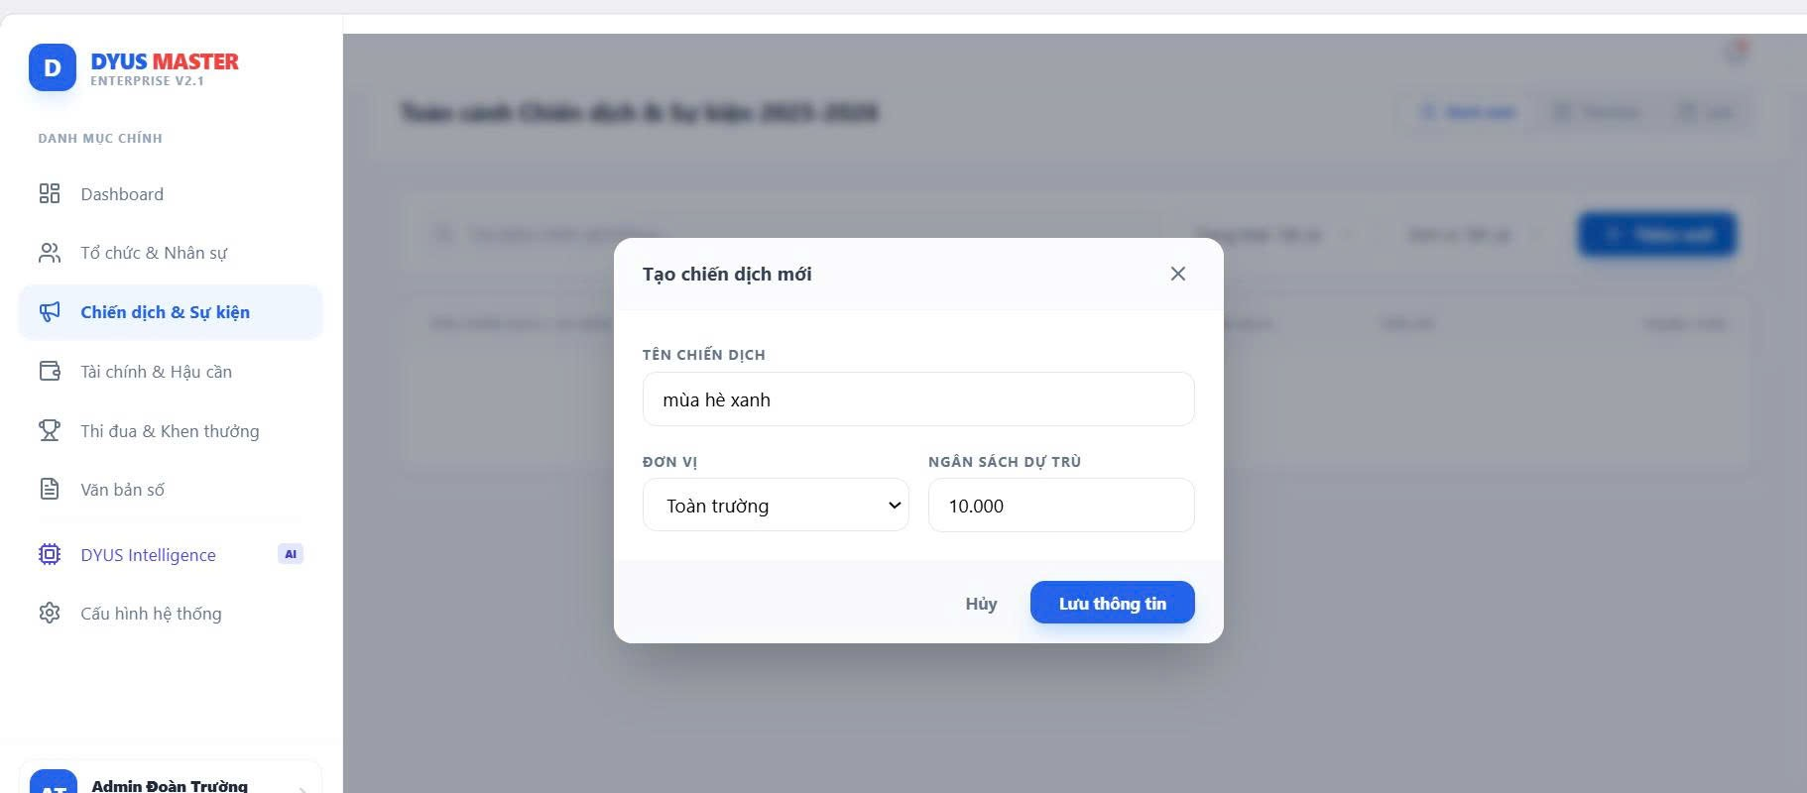
- tạo chiến dịch mới ko đc ở admin
- Tài chính hậu cần, phần nhập kho xg ko hiển thị sản phẩm
- Thi đua khen thưởng bấm vô lỗi
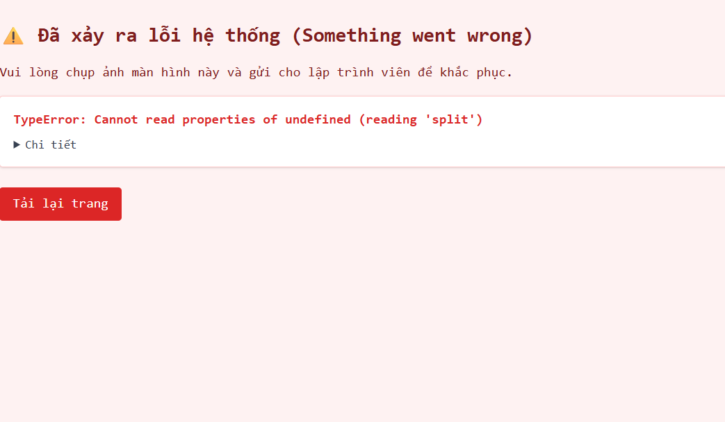

- Cài đặt phần phân quyền ko thêm đc vai trò mới với ko chỉnh đc quyền của các role
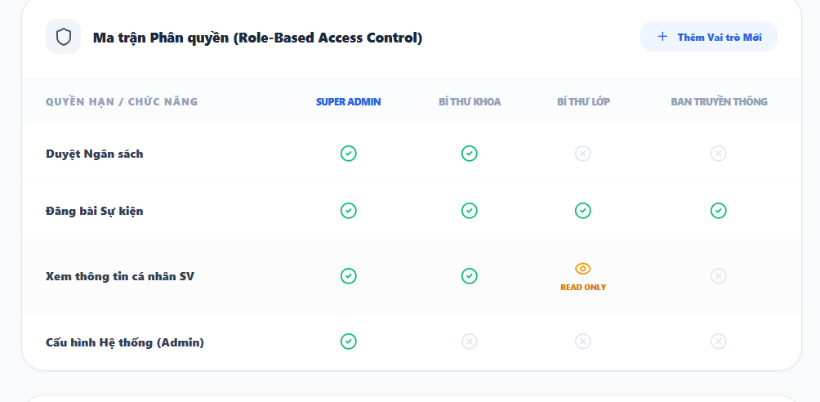

Đoàn viên
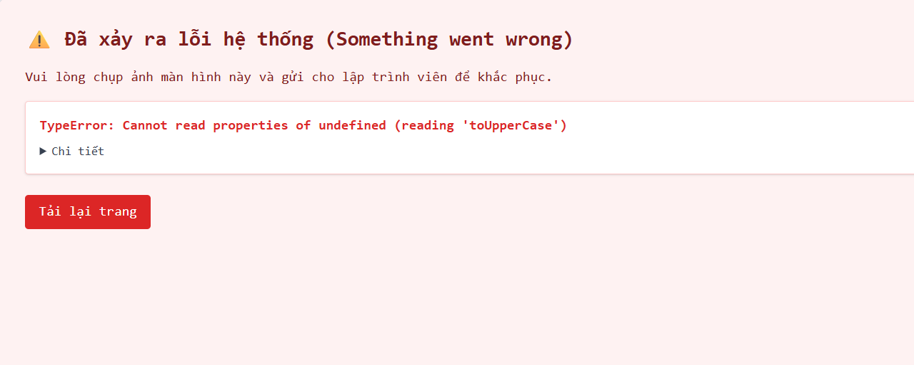
- Bấm vô văn bản thủ tục thì lỗi như ảnh
Kết quả tổng hợp (FE gọi được BE và có xử lý DB)
- POST /auth/login (login) back_end/app/api/v1/endpoints/auth.py + front_end/web/src/services/authService.js
- GET/POST/PUT/DELETE /awards, GET /awards/stats back_end/app/api/v1/endpoints/awards.py + front_end/web/src/services/awardService.js
- GET/POST/PUT/DELETE /campaigns back_end/app/api/v1/endpoints/campaigns.py + front_end/web/src/services/campaignService.js
- GET/POST /digital-documents/, GET /digital-documents/stats back_end/app/api/v1/endpoints/documents.py + front_end/web/src/services/documentService.js
- GET/POST/PUT/DELETE /events, GET /events/stats, POST /events/{id}/register, GET/PUT /events/{id}/registrations back_end/app/api/v1/endpoints/events.py + front_end/web/src/services/eventService.js
- GET /assets, GET/POST/PUT /fund-requests, GET /budgets/stats, GET /users/me/wallet_transactions back_end/app/api/v1/endpoints/assets.py, fund_requests.py, budgets.py, users.py + front_end/web/src/services/financeService.js
- GET/POST/PUT /notifications back_end/app/api/v1/endpoints/notifications.py + front_end/web/src/services/notificationService.js
- GET/POST/PUT/DELETE /organizations, GET /organizations/stats back_end/app/api/v1/endpoints/organizations.py + front_end/web/src/services/organizationService.js
- GET /public/home, GET /public/activities, GET /public/academic, GET /public/news/{id} back_end/app/api/v1/endpoints/public.py + front_end/web/src/services/publicService.js
- GET /settings (chỉ đọc) back_end/app/api/v1/endpoints/settings.py + front_end/web/src/services/systemSettingsService.js
- GET /system/dashboard back_end/app/api/v1/endpoints/system.py + front_end/web/src/services/systemService.js
- GET /ai-sentiments/admin, GET /ai-sentiments/sub-admin back_end/app/api/v1/endpoints/ai_sentiments.py + front_end/web/src/services/aiService.js
- GET/PUT /users/me, GET /users/me/devices, GET /users/me/team, GET /users/me/profile_stats, GET /users/me/obligations, GET /users/me/spending_stats, GET /users/me/events back_end/app/api/v1/endpoints/users.py + front_end/web/src/services/userService.js
FE đang gọi nhưng BE chưa có endpoint tương ứng (khớp tên)
- POST /auth/register, /auth/refresh, /auth/logout, /auth/logoutAllDevices, /auth/resetPassword, /auth/resetPassword/confirm, /auth/test front_end/web/src/services/authService.js
- GET /events/locations, GET /events/templates front_end/web/src/services/eventService.js
- GET /public/news (list) front_end/web/src/services/publicService.js
- POST /ai/chat front_end/web/src/services/chatbotService.js
- GET /admin/activity-log front_end/web/src/services/activityLogService.js
- POST /imports/ward, /imports/user, /imports/province, /imports/district front_end/web/src/services/importService.js
- GET /students, GET /students/{id} front_end/web/src/services/studentService.js
- PUT /settings (không có {setting_id}) front_end/web/src/services/systemSettingsService.js trong khi BE chỉ có PUT /settings/{setting_id}
BE có endpoint nhưng FE chưa gọi (chưa nối UI/service)
- academic_terms back_end/app/api/v1/endpoints/academic_terms.py
- ai_predictions back_end/app/api/v1/endpoints/ai_predictions.py
- ai_audits back_end/app/api/v1/endpoints/ai_audits.py
- audit_logs back_end/app/api/v1/endpoints/audit_logs.py
- asset_loans back_end/app/api/v1/endpoints/asset_loans.py
- budgets CRUD (FE chỉ dùng GET /budgets/stats) back_end/app/api/v1/endpoints/budgets.py
- roles, permissions back_end/app/api/v1/endpoints/roles.py, permissions.py
- notifications DELETE chưa được gọi back_end/app/api/v1/endpoints/notifications.py
- users CRUD tổng (list/create/delete) chưa được gọi back_end/app/api/v1/endpoints/users.py
- Sai kiểu event_id → 422
Backend nhận UUID nhưng client gửi mã như EV582798.
back_end/app/api/v1/endpoints/events.py
Thiếu trong Swagger (cần BE bổ sung)
- GET /api/v1/admin/activity-log
- POST /api/v1/ai/chat
- POST /api/v1/auth/register
- POST /api/v1/auth/refresh
- POST /api/v1/auth/logout
- POST /api/v1/auth/logoutAllDevices
- POST /api/v1/auth/resetPassword
- POST /api/v1/auth/resetPassword/confirm
- GET /api/v1/auth/test
- POST /api/v1/imports/ward
- POST /api/v1/imports/user
- POST /api/v1/imports/province
- POST /api/v1/imports/district
- GET /api/v1/public/news (list news)
- GET /api/v1/students

