Question 1:

Edit index.html to create a web page

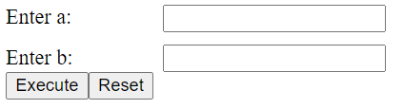

Your tasks: Assume that users fill an integer into the textfield

1. When users click "RESET" button, set value of textfield is empty. (0.5 point)

2. When users click "Execute" button, the browser makes a request to /execute with method post (The Servlet is configured in web.xml) (0.5 point):

1. Check input: If users input the value of a or b small than or equal 0, show the error message "You must input a > 0 and b > 0”. Otherwise, make the request b. (0.5 point)
2. Calculate the least common multiple output the result to servlet. (1.0 point)

Exmaple: a = -1 , b = 2 => output: You must input a > 0 and b > 0

Exmaple: a = 2 , b = 3 => output: a = 2 and b = 3 => out put: 6

Question 2:

Add MyExam.jsp to the create a web page (0.5 point)

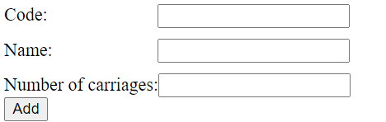

Assume that users fill fully into the textfield, when users click "Add" button, the browser makes a request to /addServlet (The Servlet is configured in web.xml) (0.5 point)

1. Check input: If users input have field empty, show the error text " You must input all texts". (1 point)

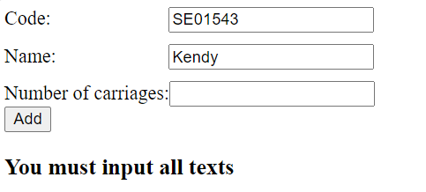

1. When user click “Add” then info will display following. (1.0 point)

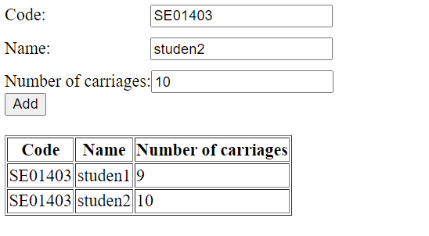

Question 3:

IMPORTANT before you start doing your solution, MUST do the following steps:

1. Create your SQL database named Y23FA1B1 by running code in script Y23FA1B1.sql.

2. You MUST use DBContext.java for your all database connection.

(5 points)

You are given a NetBeans template project (read more detail in the first page).

are asked to build a web application using the given database.

User can type /show represents your web application context path) to access Show Students Page (0.5)

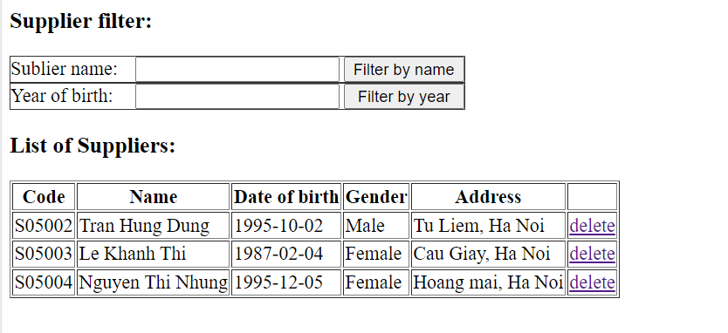

* Display form and list supplier (1 point)
* The table “List of Suppliers” must load data from [Suppliers] table.(1 point)
* Click “delete” will remove the supplier (1 point)
* When input supplier name and click “Filter by name” will filter supplier according name, list all supplier containt value input (1 point)
* When input supplier birth of year and click “Filter by year” will filter supplier according year. (0.5 point)