Making buy can sell indicator

Using a simple strategy called Simple Moving Average Crossover

Step 1: Import Packages and Libraries

import yfinance as yf
import pandas as pd
import matplotlib.pyplot as plt
import numpy as np

Step 2: Get the Stock Data

# we will use Apple (Reliance)
data = yf.download('Reliance.NS', start='2022-01-01', end='2025-11-01')
data.head()

Price | Close | High | Low | Open | Volume
Ticker | RELIANCE.NS | RELIANCE.NS | RELIANCE.NS | RELIANCE.NS | RELIANCE.NS
Date
2022-01-03 | 1093.780518 | 1095.646128 | 1075.443589 | 1076.103370 | 5421611
2022-01-04 | 1118.465088 | 1119.784652 | 1093.848914 | 1099.263652 | 10847728
2022-01-05 | 1123.697754 | 1127.064905 | 1107.021590 | 1120.239736 | 11643813
2022-01-06 | 1099.536499 | 1116.599479 | 1096.123855 | 1115.325409 | 14447422
2022-01-07 | 1108.409302 | 1118.442271 | 1097.284238 | 1106.111499 | 13112115

Step 3: Calculate Moving Averages

# Short-term and long-term moving average
data['SMA20'] = data['Close'].rolling(window=20).mean()
data['SMA50'] = data['Close'].rolling(window=50).mean()

Step 4: Create Buy/Sell Signals

# Intialize Singal Column
data['Signal'] = 0

# Properly assign signals using iloc
signal_values = np.where(data['SMA20'][20:] > data['SMA50'][20:], 1, 0)
data.iloc[20:, data.columns.get_loc('Signal')] = signal_values

# Now safely crate Positin column based on Signal Changes
data['Position'] = data['Signal'].diff()

Step 5: Plot the Strategy

plt.figure(figsize=(14,6))
plt.plot(data['Close'], label='Close Price')
plt.plot(data['SMA20'], label='SMA 20')
plt.plot(data['SMA50'], label='SMA 50')
plt.plot(data[data['Position'] == 1].index,
data['SMA20'][data['Position'] == 1],
'^', markersize=10, color='g', label='Buy Signal')
plt.plot(data[data['Position'] == -1].index,
data['SMA20'][data['Position'] == -1],
'v', markersize=10, color='r', label='Sell Signal')
plt.title('SMA Crossover Strategy')
plt.legend()
plt.grid()
plt.show()

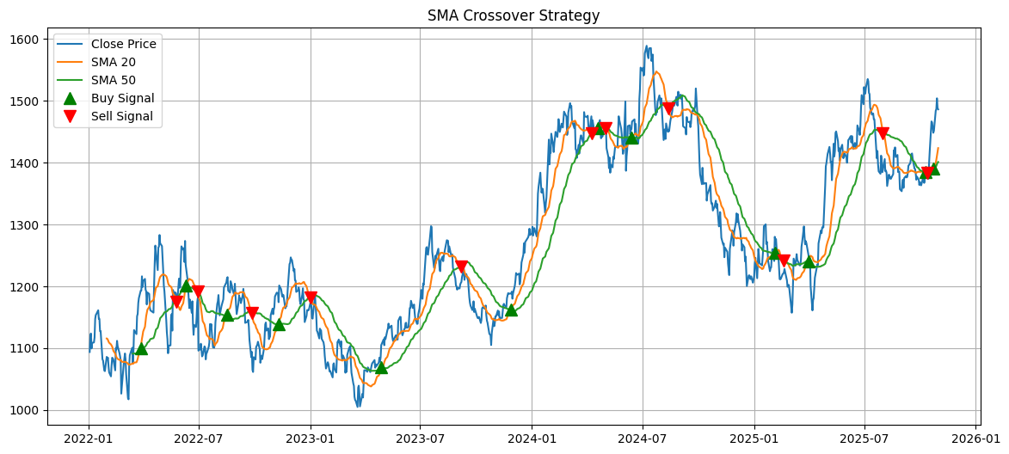

Ploting chat base on Rsi Value

RSI stands for Relative Strength Index.
It’s a simple tool that measures how fast and strong the stock price is moving.
When RSI goes above 70, it usually means the stock is getting too expensive — and it might be time to sell.
When RSI drops below 30, it means the stock might be cheap — and it could be a good time to buy.

# Get real-world stock prices so we can calculate the RSI and Bild our Startegy on Reliance but we can use any
data = yf.download('Reliance.NS', start='2022-01-01', end='2025-11-01')
data.head()

Price | Close | High | Low | Open | Volume
Ticker | RELIANCE.NS | RELIANCE.NS | RELIANCE.NS | RELIANCE.NS | RELIANCE.NS
Date
2022-01-03 | 1093.780640 | 1095.646251 | 1075.443709 | 1076.103491 | 5421611
2022-01-04 | 1118.465088 | 1119.784652 | 1093.848914 | 1099.263652 | 10847728
2022-01-05 | 1123.697632 | 1127.064782 | 1107.021470 | 1120.239614 | 11643813
2022-01-06 | 1099.536621 | 1116.599603 | 1096.123977 | 1115.325533 | 14447422
2022-01-07 | 1108.409424 | 1118.442395 | 1097.284359 | 1106.111621 | 13112115

Step 3: Calculate RSI

# Function to calcluate RSI
def calculate_rsi(series, period=14):
delta = series.diff()
gain = (delta.where(delta > 0, 0)).rolling(window=period).mean()
loss = (-delta.where(delta < 0, 0)).rolling(window=period).mean()
rs = gain / loss
return 100 - (100 / (1 + rs))
data['RSI'] = calculate_rsi(data['Close'])

Step 4: Create Buy/Sell Signals

data['Signal'] = 0
data.loc[data['RSI'] < 30, 'Signal'] = 1
data.loc[data['RSI'] > 70, 'Signal'] = -1
data['Position'] = data['Signal'].diff()

Step 5: Plot RSI Strategy

plt.figure(figsize=(14,7))
plt.plot(data['Close'], label='Close Price', alpha=0.5)
plt.scatter(data.index[data['Position'] == 1],
data['Close'][data['Position'] == 1],
label='Buy Signal', marker='^', color='green', lw=3)
plt.scatter(data.index[data['Position'] == -1],
data['Close'][data['Position'] == -1],
label='Sell Signal', marker='v', color='red', lw=3)
plt.title('RSI Trading Strategy (Buy Below 30, Sell Above 70)')
plt.xlabel('Date')
plt.ylabel('Price (USD)')
plt.legend()
plt.grid()
plt.show()

