BEAUTIFUL!

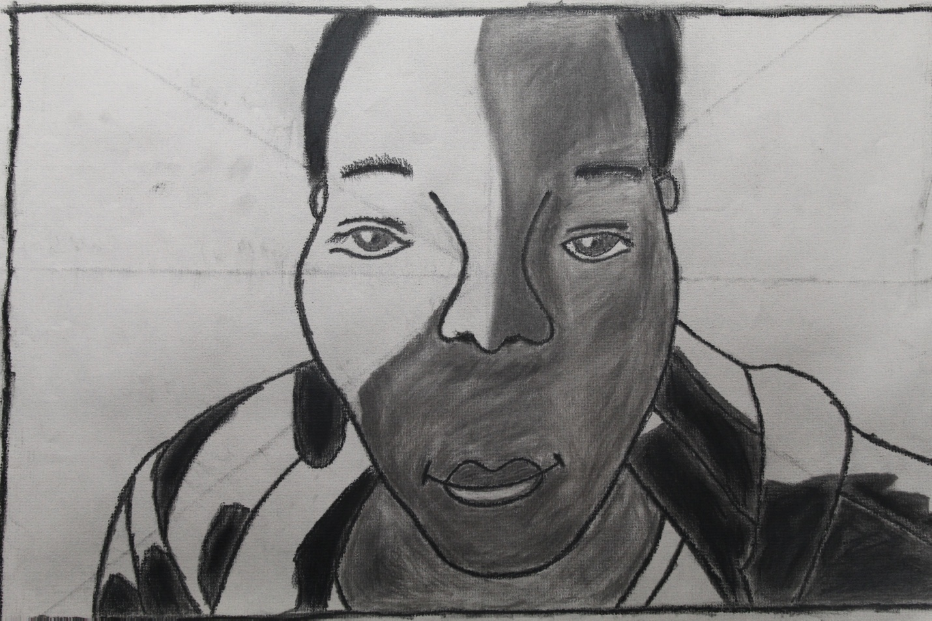

**Artwork by Alexis J. Perkins**

**Words by Nene Perkins**

**My brown eyes are beautiful**

**My round nose is beautiful**

**My brown skin is beautiful**

**My shapely hips are beautiful**

**My afro is beautiful**

**My tomboy attire is beautiful**

**I’m beautiful because I’m happy being me!**