- Configure Proxy
  - Emulator > Extended controls > Proxy
    - Hostname = 127.0.0.1
    - Port = 8080
    - Apply
    - Basically the listener for burp
      - 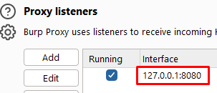
    - This is how it should look like
      - 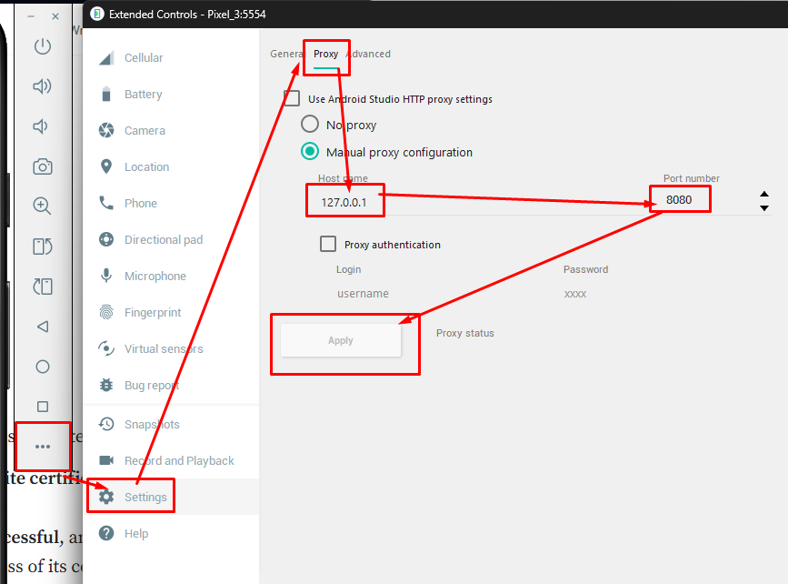
  - End result
    - 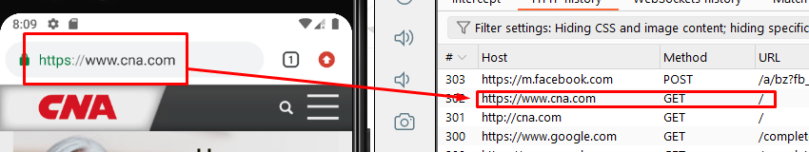
- s
- s

