CSC133
Introduction To
Computer Science
Using C++

Lecture
Notes
Version 4
Professor Picioccio
Lecture Notes

Basic Concepts

Hardware versus software

B. Computers:

1. Perform arithmetic and comparisons capabilities

2. Follow precise instructions to perform an operation

Execute instructions quickly and accurately
C. Information Processing Cycle:

1. Input Devices

The keyboard is the most common input device

The mouse is also a common input device

2. Output Devices

a. Computers produce information and send it to the outside world.

b. A video monitor is a common output device.

3. Process Information

a. The processor, or central processing unit (CPU), processes information and

performs all the necessary arithmetic calculations.

4. Store Information

a. Memory and storage devices are used to store information
b. Primary storage is the computer’s main memory
c. Secondary storage uses disks or other media

D. The CPU

1. The CPU is a complex collection of electronic circuits.

Interprets and executes instructions

Performs arithmetic and logical data manipulations

Communicates with the other parts of the computer system

5. The Computer’s Memory

a. RAM (random access memory):

(1) Is used to store program instructions and data temporarily
(2) Unique addresses and data can be stored in any locatio

(3) Can quickly retrieve information

Will not remain if power goes off (volatile)

b. ROM (read-only memory):

(1) Information is stored permanently on a chip

(2) Contains startup instructions and other permanent data.

E. Data and information storage

1. Bit Basics

a. A bit (binary digit)

b. Is the smallest unit of information

c. Can have two values: 1 or 0

d. Can represent numbers, codes, or instructions

2. Bits as Numbers

a. Each switch can be used to store a tiny amount of information, such as:

(1) An answer to a yes/no question

(2) A signal to turn on a light

b. Larger chunks of information are stored by grouping bits as units

(1) 8 bits (byte) = 256 different messages

3. Bits as Instruction

a. The computer stores instructions as collections of bits.

b. For instance, 01101010 might instruct the computer to add two numbers.

Other bit instructions might include where to find numbers stored in memory or

where to store them.

4. Bits, Bytes, and categories of quantities

a. Byte = 8 bits (1 character on the keyboard or one click)

b. Kilobyte (KB) = 1 Thousand Bytes

c. Megabytes (MB) = 1 Million Bytes

d. Gigabytes (GB) = 1 Billion Bytes

e. Terabytes (TB) = 1 Trillion Bytes

Data Organization
- bit = BInary Digit
- Smallest representable value
- 2 patterns
- ASCII
- EBCDIC
- byte = 8 related bits
- field = group of related bytes
- record = group of related fields
- file = group of related records (sometimes called a table)
- database = group of related records or files
G. Processing With Software Programs

Software programs are:
a. Stored in memory

b. Instructions that tell the computer what to do

c. Designed to solve problems

Software programs can be:
- Purchased
- Leased
- Written

H. The Language of Computers

1. Machine Language

a. Numeric codes to represent data

2. High-level language

Fall between machine language and natural human language

3. Compliers

a. Translates high-level language into machine language

4. Natural Languages

a. Include the languages spoken by humans

I. System software is a class of software that includes

1. The operating system

a. Tasks of the operating system

(1) Communication with peripherals

(2) Coordination of concurrent processing

(3) Memory management

(4) Monitoring of resources and security

(5) Management of programs and data

(6) Coordinating network communications

b. Where the Operating System Lives

(1) Some computers store their operating system in RAM

(2) Some computers store their operating system in ROM

(3) Others include only part of it in ROM while the remaining system is loaded into memory (called booting)

(4) Most of the time it works behind the scenes

2. Utility Programs

a. Translate files so different software can read them

b. Guarding against viruses

c. Allow files and directories (folders) to be managed on storage devices

How does a person get started to properly write software?

1. Programmers begin with an algorithm

2. An algorithm:

a. Is a set of step-by-step instructions (written in a natural language, e.g., English)

b. Is ambiguous

c. Consists of error-prone generalities

d. Is translated into the vocabulary of a programming language

(such as C++)
3. An algorithm example containing Food for Thought:

a. Combine 2 slightly beaten eggs with 1 tsp vanilla extract, ½ tsp

cinnamon, 1 cup milk

b. Dip 6 slices of bread in mixture

c. Fry in small amount of butter until golden brown

Serve bread with maple syrup, sugar, or tart jelly
II. The Programming Development Process
- Major phases:
- Problem identification
- Provides a high level description of what needs to be done
- Identifies the major goals of what needs to be accomplished
- Requirements analysis
- Gathers information on what the program should do
- Is similar to conducting an investigation
- Requirements specifications
- Identifies the inputs, processes, outputs
- Identifies the functionality of the processes
- Design of potential solution
- Diagrams the inputs and outputs
- Defines the data to be stored and processed
- Defines complex logic and formulas
- Defines the programming logic needed for complex logic
- Implementation
- Translating the design into a programming language such as C++, Java, and Visual Basic
- Typing in the program code
- Compiling the code
- Following programming language syntax
- Converting source code into object code
- Program text is typed into the text editor (such as C++, Java, and Visual Basic)
- Compiler translates the program text into an object file
- Linkage editor combines several object files to create an executable module
- Object module is built which is the actual file that is executed
- Executing (running) the program
- The operating system is first loaded (if not already done)
- The executable C++ or Java or Visual Basic file is placed into primary memory
- The program is executed
- Testing the program
- Making sure the program works correctly
- Activities to evaluate the testing process
- Proper input is entered
- Proper output is generated
[1] To the printer
[2] To the screen
[3] To a data file(s)
[4] Combination of all the above
- Types of errors
- Syntax – violate the rules of the language
- Logic – program works, but works incorrectly
- Installation of fully tested and working software
- Operation and maintenance

- Understanding Algorithms:
- Definition:
- Is a sequence of instructions to document programming logic
- Identifies how a specific problem should be solved
- Is a series of elementary operations and instructions about the order in which a problem should be solved
- Two methods of writing algorithms: flowcharts and pseudocode
- Pseudocode:
- Describes the essential steps needed to complete the logic of a program
- Is written in an English-like format
- Is more commonly used today
- Is closer to programming language terminology
- Important algorithm constructs:
- Sequence
- Series of steps, one after the other
- Example:
- Pick up the jar
- Hold the jar with one hand
- Unscrew the lid of the jar
- Take out the quantity wanted
- Screw the lid back on to the jar
- Put the jar back where it belongs
- Selection
- Choice is selected from alternative paths
- Examples:
Single level:
- If grade number > 70, then
The student passes the course
Else
The student does not pass the course
- Nested levels:
If temperature >= 212, then
Water = Boiling
Else
If temperature > 32 , then
Water = Drinkable Else
Water = Freezing
End if
End if
- Iteration
- Repeating a series of steps
a. Usually repeated until a condition is met to stop repeating
- Simple repetitive examples:
- Beat mixture briskly until firm
- Open and close a door twice
- A programmable example:
a. Display a message 3 times:
Set count to 1
While count <= 3
Display “hello there”
count = count + 1
End while
4. More complete algorithm examples:
- Simple calculation:
Input Name, Date, Balance, Rate
Calculate Interest = Balance x Rate
Display Name, Date, Interest
- Simple calculation of several items based on temperatures:
Input temp1, temp2, temp3
Calculate TotalTemp = temp1 + temp2 + temp3
Calculate AverageTemp = TotalTemp / 3
Display TotalTemp, AverageTemp
- Simple selection to determine which value is bigger assuming there are two different values.
Input A, B
If A is less than B
Bigger = B
Smaller = A
Else
Bigger = A
Smaller = B
End if
Display Bigger, Smaller
- Simple selection to determine which value is bigger assuming there are two different values or the values could be the same.
Input A, B
If A < B
Bigger = B
Smaller = A
Equal = “ “
Else
If B < A
Bigger = A
Smaller = B
Equal = “ “
Else
Bigger = “ “
Smaller = “ “
Equal = A
End if
End if
Display “Bigger = “, Bigger
Display “Smaller = “, Smaller
Display “Equal = “, Equal
- Repeat a process to add 3 numbers together, then calculate their average, then print out the sum and the average:
Set Count to zero
Set Sum to zero
While Count < 3
Input Number
Calculate Count = Count + 1
Calculate Sum = Sum + Number
End while
Compute Average = Sum / 3
Display Sum, Average
- Compute the sum of the numbers from 1 to N by:
Initialize count to zero
Initialize sum to zero
Input N
While count < N
Input number
Calculate sum = sum + number
Calculate count = count + 1
End while Display “count = “, count
Display “sum = “, sum
- Repeat a process to add an unknown quantity of numbers together until a value of 0 is entered, then calculate their average, then print out the count, the sum and the average without including the value of 0 entered:
Set Count to zero
Set Sum to zero
Input Number
While Number < > 0
Calculate Count = Count + 1
Calculate Sum = Sum + Number
Input Number
End while
Compute Average = Sum / Count
Display Count, Sum, Average
5. Algorithm Challenges:
- Write separate algorithms and at least one full test case for each of the following:
- Make a peanut butter and jelly sandwich where there is a choice of two types of bread, two types of peanut butter, and three types of jelly. Input the peanut butter choice, jelly choice, and bread choice, and explain how to make the sandwich after the choices are determined.
- Input and then add two daily sales amounts together, display them,
calculate and then display the total of the numbers,
determine which is the larger number, display the larger number,
determine their average, display the average.
- Input and sum 2 test grades, then input and sum 3 quiz grades,
calculate the test average and display it, calculate the quiz average and display it. Then, determine whether the quiz or the test average is larger, and display which one is larger.
- Input two variables to determine which of the following to bring with you based on the weather by building a selection structure for all the possible weather conditions:
- An umbrella is needed if it is raining
- Boots are needed if it is snowing
- A jacket is needed if the temperature is below 70 degrees
- A coat is needed if the temperature is below 40 degrees
- Otherwise, just bring yourself
Display the items that should be brought with you.
- Read in an unknown set of numbers until a negative number is read in,
accumulate each number but do not include the negative number,
calculate the average of the numbers, display the count, sum and average.
III. The C++ Environment

- A simple program:

Comments: // Simple Program 1
//
// Purpose: To demonstrate the parts of a simple C++ program

Compiler Directive: #include <iostream.h> // necessary for the cout command

Main Function: int main( )
{
Statements: cout <<”This is a simple C++ program.”;
return 0; // not needed in Turbo C++
}

- Comments.
1. Are remarks that:
a. Explain the purpose of the program
b. Explain parts of the program
c. Store information of the history
- d. They are ignored by the compiler
2. Anything typed to the right of the // is ignored, regardless of where on the line the // is placed
- Compiler Directives:
1. Are commands for the compiler which are needed to correctly compile your program
2. They are instructions to the compiler and are not looked at as part of the C++ language.
3. The most common directive is the #include statement
a. It instructs the compiler to treat the text file that is enclosed in brackets as if code lines
that were actually keyed into source code.
b. This makes additional commands available to you
c. Example: #include <iostream.h>
- Makes a set of input and output commands available.
- Makes it easy to get input from the user and print to the screen
D. Main Function:
- 1. Where every C++ program begins
2. Whole programs can be written entirely within the main function, but are usually broken down
- into several functions
3. The parenthesis that follow the word “main” are required.
- 4. The parenthesis tell the compiler that “main” is a function (which is a block of code that carries
- out a specific task)
E. Braces:
1. Are special characters used to mark the beginning and the ending of blocks of code.
2. Every open brace { must have a closing brace } .
F. Statements:
1. Is a line of C++ programming code
2. End in a semicolon (which terminates a statement)
3. A semicolon tells the compiler that the instructions are complete
- 4. Are case sensitive: “total”, “TOTAL”, “Total” are all different variables to C++
IV. Converting An Algorithm Into C++ Programming Instructions

A. When converting a completed algorithm into program instructions:
  - Try to follow the same logical flow as you built in the algorithm
  - More than one programming line of code may be needed for one line placed in the algorithm
  - Type the program code in following proper indentation, variable names, and formatting standards as you type in each line. (DO not wait until later to make it neat and readable.)
  - Add comments to the program as you build the program.
B. Examples:
1. Write an algorithm to read in and then add two daily sales amounts together.
Then, print out the two daily sales amounts and the total.
a. The algorithm to solve the problem:
(1) Ask the user for the first sales amount
(2) Ask the user for the second sales amount
- Calculate the total = first sales amount + second sales amount
- Print first sales amount
- Print second sales amount
- Print total

b. The C++ program which implements the same algorithm using all variables:

// Simple Program 2
#include <iostream.h>
int main( )
{
float firstsales, secondsales, total;
cout << "enter the first sales amount: " << endl;
cin >> firstsales;
cout << "enter the second sales amount: " << endl;
cin >> secondsales;
total = firstsales + secondsales;
cout << "First amount of sales = " << firstsales << endl;
cout << "Second amount of sales = " << secondsales << endl;
cout << "Total sales = " << total << endl;
system ("pause");
return 0;
}
- The same C++ program which implements the same algorithm, using all variables, but with proper comments placed into the program:

// Simple Program 3 With Comments
#include <iostream.h>
int main( )
{
// Define variables
float firstsales, secondsales, total;
// Input the data by prompting the user
cout << "enter the first sales amount: " << endl;
cin >> firstsales;
cout << "enter the second sales amount: " << endl;
cin >> secondsales;
// Calculate the results
total = firstsales + secondsales;
// Display the results
cout << "First amount of sales = " << firstsales << endl;
cout << "Second amount of sales = " << secondsales << endl;
cout << "Total sales = " << total << endl;
system ("pause");
return 0;
}

2. Write an algorithm to determine how much it will cost to purchase an unknown number of
stamps purchased at the post office. One first class stamp currently costs 37 cents. This can
be loaded permanently into the program. Then, print out the number of stamps, the price per
stamp, and the total amount owed to purchase all the stamps.
a. The Algorithm:
- Ask the user to enter the desired number of stamps
- Calculate the Cost = number of stamps * price per stamp
- Print the number of stamps
- Print the price per stamp
- Print the cost of all the stamps
b. The C++ program that implements the algorithm using variables and
constants:
:
// Simple Program 4
#include <iostream.h>
int main( )
{
// Define the constants
const float COST_PER_STAMP = 0.37;
// Define the variables
float stamp_quantity, total_stamps_cost;
// Request user input
cout << "Please enter the number of first class stamps wanted: ";
cin >> stamp_quantity;
// Perform calculations
total_stamps_cost = stamp_quantity * COST_PER_STAMP;
// Print the results
cout << "The number of stamps wanted is " << stamp_quantity << endl;
cout << "The cost per stamp is " << COST_PER_STAMP << endl;
cout << "The cost for all the stamps is " << total_stamps_cost << endl;
system ("pause");
return 0;
}
III. The C++ Environment

- A simple program:

Comments: // Simple Program 1
//
// Purpose: To demonstrate the parts of a simple C++ program

Compiler Directive: #include <iostream> // necessary for the cout command

Main Function: int main( )
{
Statements: cout <<”This is a simple C++ program.”<<endl;
return 0;
system ("pause");
}
- Comments.
1. Are remarks that:
a. Explain the purpose of the program
b. Explain parts of the program
c. Store information of the history
- d. They are ignored by the compiler
2. Anything typed to the right of the // is ignored, regardless of where on the line the // is placed
- Compiler Directives:
1. Are commands for the compiler which are needed to correctly compile your program
2. They are instructions to the compiler and are not looked at as part of the C++ language.
3. The most common directive is the #include statement
a. It instructs the compiler to treat the text file that is enclosed in brackets as if code lines
that were actually keyed into source code.
b. This makes additional commands available to you
c. Example: #include <iostream.h>
- Makes a set of input and output commands available.
- Makes it easy to get input from the user and print to the screen
D. Main Function:
- 1. Where every C++ program begins
2. Whole programs can be written entirely within the main function, but are usually broken down
- into several functions
3. The parenthesis that follow the word “main” are required.
- 4. The parenthesis tell the compiler that “main” is a function (which is a block of code that carries
- out a specific task)
E. Braces:
1. Are special characters used to mark the beginning and the ending of blocks of code.
2. Every open brace { must have a closing brace } .
F. Statements:
1. Is a line of C++ programming code
2. End in a semicolon (which terminates a statement)
3. A semicolon tells the compiler that the instructions are complete
- 4. Are case sensitive: “total”, “TOTAL”, “Total” are all different variables to C++
IV. C++ Reserve Words and Special Symbols
1. Are words that have a special meaning within the language
2. Must be used the way they are built into the language to be used
3. They perform a variety of functions and tasks within the language
4. Reserve words within C++ include:

and and_eq asm auto bitand
bitor bool break case catch
char class compl const
const_cast continue default delete do
double dynamic_cast else enum explicit
export extern false float for
friend goto if inline int
long mutable namespace new not
not_eq operator or or_eq private
protected public register reinterpret_cast
return signed short struct sizeof
static static_cast switch template this
throw typeid true try typedef
using typename union unsigned virtual
void volatile wchar_t while xor
xor_eq

5. Special Symbols:
- a. Are used to separate parts of an expression or a portion of a statement.
b. Some of the special symbols include:

+ - * / . ; ? , <= != == >=

V. Using the Turbo C++ Debugger
- The C++ Debugger provides a way to:
  - “Walk through” the execution of your program line by line
  - Allows you to WATCH the execution of a program
  - EXAM the contents of the program's variables during execution.
  - See how the contents of variables change after each statement is executed.
B. To watch the execution of a program, do the following:
1. Steps:
  - Open your program in the C++ text editor.
  - Click on DEBUB
  - Click on TRACE INTO.
2. How the process works:
- The program will compile and place a solid blue highlighted line on top of the
first executable statement in the program (which will be the "void main (void))"
line.
- An important note: The statement that is highlighted
has not been executed as yet.
3. To execute a statement, click the second button to the right of the lightning bolt.
a. The button has a curved arrow and parentheses on it.
b. Click this button once for each statement you want to execute.
C. How the C++ statements are recognized:
1. COUT statements will display the output window for a moment and will then place
control back in the program.
2. CIN statements will display the output window and wait for the input to be entered.
a. You should enter the data as you would normally and then press the <enter> key.
D. You may examine the contents of a variable at any time in the debug environment.
1. Steps:
a. Click on DEBUG
- b. Click on EVALUATE/MODIFY.
- Type the variable name in the box labeled EXPRESSION, and press <enter>.
- The contents of the variable will display in the box labeled RESULT.
- NOTE: the drop-down arrow to the right of the EXPRESSION box is a history list, but may not be correct or complete.
- Click CLOSE to return to the program.
E. While you are in the debugger, you may make changes to the program.
- 1. To recompile the program after you have made a change:
  - Click on DEBUG
  - Click on TRACE INTO.
  - Answer YES to "Source modified - Rebuild?".

F. To exit the debugger:
1. Steps:
a. Click DEBUG
- b. TERMINATE PROGRAM.
- 2. You will be back in the regular C++ editor mode and can continue your normal work.

VI. Standard Header Files
Standard CPP Header File Name ANSI/ISO Standard CPP Header File Name
assert.h cassert
ctype.h cctype
float.h cfloat
fstream.h fstream
iostream.h iostream
iomanip.h iomanip
limits.h climits
math.h cmath
stdlib.h cstdlib
string.h cstring
VII. Data types:
- A set of values together with a set of operations.
B. Simple Data Types
    - Integral, which is a data type that deals with integers, or numbers without a decimal part
    - Floating-point, which is a data type that deals with decimal numbers
    - Enumeration type, which is a user-defined data type
C. Integral Data Types
1. char data type is used to represent integers between –128 and 127.
                - 2. int data type is used to represent integers between –2147483648 and 2147483647
3. short is used to represent integers between –32768 and 32767
4. bool is used to represent either a true or false evaluation for boolean logic
D. Floating-Point Data Types
1. Used for decimal numbers
                - 2. Types to manipulate decimal numbers:
a. float
                - (1) Is used to represent any real number between -3.4E+38 and 3.4E+38.
                - (2) The maximum number of significant digits (the number of decimal
                - places) is 6 or 7
                - (3) Sometimes called single precision
b. double
                - (1) Is used to represent any real number between -1.7E+308 and 1.7E+308.
(2) The maximum number of significant digits in values is 15
(3) Sometimes called double precision
E. String
  - Is a sequence of zero or more characters.
  - Are enclosed in double quotation marks.
  - A string containing no characters is called a null or empty string.
  - Every character in a string has a relative position in that string.
a. The position of the first character is 0
b. The position of the second character is 1, and so on.
- The length of a string is the number of characters in it.

- The CIN Object:
A. Based on the following input statement:
cin>>payRate>>hoursWorked;
1. Whether the input is
15.50 48.30
or
15.50 48.30
or
15.50
48.30
2. The preceding input statement would store 15.50 in payRate and 48.30 in hoursWorked.

B. Valid Input for a Variable of the Simple Data Type
Data Type Valid Input for a
Char One printable character except the blank
Int An integer, possibly proceded by a (+ or -) sign
Float A decimal number, possibly preceded by a (+ or -) sign
Double If the actual data input is an interger, the input is converted to a
Decimal number with the zero decimal part
C. When reading data into a char variable, after skipping any leading whitespace characters, the extraction operator >> finds and stores only the next character; reading stops after a single character.
D. To read data into an int or double variable, after skipping all leading whitespace characters and
reading the plus or minus sign (if any), the extraction operator >> reads the digits of the number,
including the decimal point for floating-point variables, and stops when it finds a whitespace
character or a character other than a digit.
E. Example:
- 1. Suppose you have the following variable declarations:
int a,b;
double z;
char ch, ch1, ch2;
2. The following statements show how the extraction operator >> works.
 | Statement | Input | Value Stored in Memory
1 | cin>>ch; | A | ch='A'
2 | cin>>ch; | AB | ch='A', 'B' is held for later input
3 | cin>>a; | 48 | a=48
4 | cin>>a; | 46.35 | a=46, .35 is held for later input
5 | cin>>z; | 74.35 | z=74.35
6 | cin>>z; | 39 | z=39.0
7 | cin>>z>>a; | 65.78 38 | z=65.78, a=38
8 | cin>>a>>b; | 4 60 | a=4, b=60
9 | cin>>a>>ch>>z; | 57 A 26.9 | a=57, ch='A', z=26.9
10 | cin>>a>>ch>>z; | 57 A  26.9 | a=57, ch='A', z=26.9
11 | cin>>a>>ch>>z; | 57  A  26.9 | a=57, ch='A', z=26.9
12 | cin>>a>>ch>>z; | 57A26.9 | a=57, ch='A', z=26.9
13 | cin>>z>>ch>>a; | 36.78B34 | z=36.78, ch='B', a=34
14 | cin>>z>>ch>>a; | 36.78  B34 | z=36.78, ch='B', a=34
15 | cin>>a>>b>>z; | 11 34 | a=11, b=34, computer waits for the next number
16 | cin>>a>>z; | 46 32.4 68 | a=46, z=32.4, 68 is held for later input
17 | cin>>ch>>a; | 256 | ch='2', a=56
18 | cin>>a>>ch; | 256 | a=256, computer waits for the input value for ch
19 | cin>>ch1>>ch2; | A B | ch1 = 'A', ch2 = 'B'

- The COUT Object:
- The syntax of cout when used together with the insertion operator << is
cout<<expression or manipulator<<expression or manipulator...;
1. The expression is evaluated, its value is printed, and manipulator is used to format the
- output.
- 2. Endl is used to move the cursor to the beginning of the next line.
  - Other output manipulators used for precise formatting:
a. setprecision
(1) Used to control the output of floating-point numbers.
(2) The default output of floating-point numbers is scientific notation.
b. showpoint
(1) Used to show the decimal point and trailing zeros
- c. fixed
(1) To output floating-point numbers in a fixed decimal format d. setw
(1) is used to output the value of an expression in specific columns.

B. The following program illustrates how to use the manipulators setprecision, fixed, and showpoint.
// COUT Program 1
//Example: setprecision, fixed, showpoint

#include <iostream>
#include <iomanip>

int main()
{
double x,y,z;

x = 15.674; //Line 1
y = 235.73; //Line 2
z = 9525.9864; //Line 3

cout<<fixed<<showpoint; //Line 4

cout<<setprecision(2)
<<"Line 5: setprecision(2)"<<endl; //Line 5
cout<<"Line 6: x = "<<x<<endl; //Line 6
cout<<"Line 7: y = "<<y<<endl; //Line 7
cout<<"Line 8: z = "<<z<<endl; //Line 8

cout<<setprecision(3)
<<"Line 9: setprecision(3)"<<endl; //Line 9
cout<<"Line 10: x = "<<x<<endl; //Line 10
cout<<"Line 11: y = "<<y<<endl; //Line 11
cout<<"Line 12: z = "<<z<<endl; //Line 12

cout<<setprecision(4)
<<"Line 13: setprecision(4)"<<endl; //Line 13
cout<<"Line 14: x = "<<x<<endl; //Line 14
cout<<"Line 15: y = "<<y<<endl; //Line 15
cout<<"Line 16: z = "<<z<<endl; //Line 16

cout<<"Line 17: "
<<setprecision(3)<<x<<" "
<<setprecision(2)<<y<<" "
<<setprecision(4)<<z<<endl; //Line 17

return 0;
}
Output Generated:

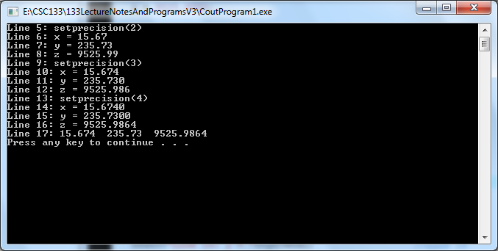

C. The following program illustrates how the manipulator setw works.
// COUT Example 2
//Example: setw

#include <iostream>
#include <iomanip>

int main( )
{
using namespace std;
int x = 19; //Line 1
int a = 345; //Line 2
double y = 76.384; //Line 3

cout<<fixed<<showpoint; //Line 4

cout<<"12345678901234567890"<<endl; //Line 5
cout<<setw(5)<<x<<endl; //Line 6
cout<<setw(5)<<a<<setw(5)<<"Hi"
<<setw(5)<<x<<endl<<endl; //Line 7

cout<<setprecision(2); //Line 8
cout<<setw(6)<<a<<setw(6)<<y
<<setw(6)<<x<<endl; //Line 9
cout<<setw(6)<<x<<setw(6)<<a
<<setw(6)<<y<<endl<<endl; //Line 10

cout<<setw(5)<<a<<x<<endl; //Line 11
cout<<setw(2)<<a<<setw(4)<<x<<endl; //Line 12
system ("pause");
return 0;
}
Output Generated:

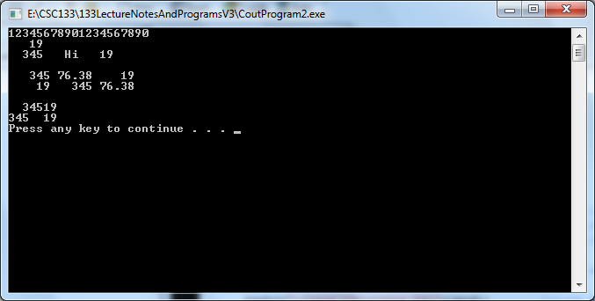

- Arithmetic Operations and Operator Precedence
A. There are five arithmetic operators:
- + addition
- - subtraction
- * multiplication
- / division
5. % remainder (modulus operator)
B. Binary and Unary Operators
                - 1. Binary operator
a. An operator that has two operands.
b. Example:
                - In the expressions:
3 + 4
23 - 45
both + and – are binary operators.
2. Unary operator
  - An operator that has only one operand.
b. Example: +27
+ is a unary operator.
C. Arithmetic expressions and their results examples:

Arithmetic Expression | Result | Description
2 + 5 | 7
13 + 89 | 102
34 – 20 | 14
45 – 90 | -45
2 * 7 | 14
5 / 2 | 2 | In the division 5/2, the quotient is 2 and the  remainder is 1. Therefore, 5/2 with the integral  operands evaluates to the quotient, which is 2.
14 / 7 | 2
34 % 5 | 4 | In the division 34/5, the quotient is 6 and the  remainder is 4. Therefore, 34%5 evaluates to the  remainder, which is 4.
-34 % 5 | -4 | In the division -34 / 5, the quotient is -6 and the  remainder is -4. Therefore, -34 % 5 evaluates to  the remainder, which is -4.
34 % -5 | 4 | In the division 34 / -5, the quotient is -6 and the  remainder is 4. Therefore, 34 % -5 evaluates to  the remainder, which is 4.
-34 % -5 | -4 | In the division -34 / -5, the quotient is 6 and the  remainder is -4. Therefore, -34 % -5 evaluates to  the remainder, which is -4
4 % 6 | 4 | In the division 4/6, the quotient is 0, and the  remainder is 4. Therefore, 4 % 6 evaluates to the  remainder, which is 4.
5.0 + 3.5 | 8.5
3.0 + 9.4 | 12.4
16.3 - 5.2 | 11.1
4.2 * 2.5 | 10.50
- Order Of Precedence:
1. According to the order of precedence rules for arithmetic operators,
*, /, %
are at a higher level of precedence than
+, -
    - Note that the operators *, /, and % have the same level of precedence.
    - Similarly, the operators + and - have the same level of precedence.
4. When operators have the same level of precedence, the operations are performed from
left to right.
5. To avoid confusion, you can use parentheses to group arithmetic expressions.
6. Example 1: Using the order of precedence rules,
3*7-6+2*5/4+6
is evaluated as:
(3 * 7) - 6 + ( ( 2 * 5) / 4 ) + 6
= 21 - 6 + (10 / 4) + 6 (Evaluate *)
= 21 - 6 + 2 + 6 (Evaluate /)
= 15 + 2 + 6 (Evaluate -)
= 17 + 6 (Evaluate first +)
= 23 (Evaluate +)
7. Example 2: Using parentheses to override the order of precedence rules
3+4*5
is evaluated as:
* is evaluated before +.
the result of this expression is 23
8. Example 3: In the expression
(3+4)*5
+ is evaluated before *
the result of this expression is 35
D. Expressions:
1. Integral (integer) expressions:
2 + 3 * 5
3 + x – y / 7
x + 2 * (y – z) + 18
2. Floating-point expressions:
12.8 * 17.5 - 34.50
x * 10.5 + y - 16.2
3. Mixed expressions:
2 + 3.5
6 / 4 + 3.9
  - * 2 – 13.6 + 18 / 2
E. Evaluating mixed expressions
                - 1. Two rules apply when evaluating a mixed expression:

a. If the operator has the same types of operands (that is, either both integers
                - or both floating-point numbers), the operator is evaluated according to the
                - type of the operands. Integer operands thus yield an integer result;
                - floating-point numbers yield a floating-point number.

b. If the operator has both types of operands (that is, one is an integer and the

other is a floating-point number), then during calculation the

integer is changed to a floating-point number with the decimal part of zero

and the operator is evaluated. The result is a floating-point number.

2. The entire expression is evaluated according to the precedence rules; the

multiplication, division, and modulus operators are evaluated before the addition

and subtraction operators.

3. Operators having the same level of precedence are evaluated from left to right.
                - 4. Grouping is allowed for clarity.
                - 5. Examples:
In these expressions, x = 15, y = 23, and z = 3.75.
Expression Value
x + y / z 21.1333
7 / 2 + 7.45 10.45
15 / 2 + 4 * 5 - 3.50 23.5

7 + 4 * 5 – 3.50
7 + 20 – 3.50
27 – 3.50
23.5
7 / 2 * 3.5 + 6 16.5
3 * 3.5 + 6
  - + 6
16.5
7.0 / 2 + 7.45 10.95
3.5 + 7.45
10.95

The Increment and Decrement Operators
  - ++
        - Adds one to a variable
        - Example:
  - val++;
  - Is the same as val = val + 1;

  - - -
a. Subtracts one from a variable
b. Example:
(1) val--;
(2) Is the same as val = val – 1;

  - Can be used in prefix mode (before) a variable
a. Examples:
(1) ++val;
(2) --val;

  - Can be used in postfix mode (after) a variable
        - Examples:
(1) val++;
(2) val--;

  - Prefix versus. Postfix
- ++ and -- operators
  - Can be used in complex statements and expressions
  - Prefix (++val, --val)
        - Increments or decrements the variable
        - Then returns the new value of the variable
- It is this returned new value of the variable that is used in any other operations within the same statement
  - Postfix (val++, val--)
        - Returns the old value of the variable
        - Then increments or decrements the variable
        - It is this returned old value of the variable that is used in any other operations within the same statement

  - Prefix Mode Example:
int x = 1;
y = 1;
x = ++y; // y is incremented to 2
// Then 2 is assigned to x
cout << x << " " << y; // Displays 2 2
x = --y; // y is decremented to 1
// Then 1 is assigned to x
cout << x << " " << y; // Displays 1 1

  - Postfix Mode Example:
int x = 1;
y = 1;
x = y++; // y++ returns a 1
// The 1 is assigned to x
// Then y is incremented to 2
cout << x << " " << y; // Displays 1 2
x = y--; // y-- returns a 2
// The 2 is assigned to x
// Then y is decremented to 1
cout << x << " " << y; // Displays 2 1

  - Prefix versus Postfix Examples:
int num;
int val;
val = 12;
cout << val++; // Displays 12
// Then val is incremented to 13
cout << ++val; // Increments val to 14
// Then displays 14
num = --val; // Decrements val to 13
// Then stores 13 in num
num = val--; // Stores 13 in num
// Then decrements val to 12

  - About Incrementing and Decrementing:
        - Can be used in arithmetic expressions
  - Example1:
        - result = num1++ + --num2;
  - Example2:
//PreAndPostFix1.cpp
#include <iostream>
using namespace std;
int main()
{
int result;
int num1 = 5;
int num2 = 7;
result = num1++ + --num2;
cout << "num1 = " << num1 << " num2 = " << num2
<< " result = " << result << endl;
system ("PAUSE");
return 0;
}

Output:
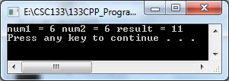

        - Must be applied to something that has a location in memory.
(1) Cannot have the following example:
(a) result = (num1 + num2)++; // Illegal syntax
c. Can be used in relational expressions
(1) Example:
(a) if (++num > limit)
d. Pre and Post operations will cause different comparisons
- Built In Functions
- The library <math.h> contains many useful mathematical functions
  - Includes trigonometric and statistical functions.
  - Some of the most useful are:
a. abs – returns the absolute of its arguments
b. ceil – returns the smallest whole number greater than or equal to a float value
c. fabs – returns the absolute value of a float value
d. floor – returns the largest whole number less than or equal to a float value
e. pow – returns a float raised to a float power
f. sqrt – returns the square root of a float value
3. Example uses of the functions:
a. abs(-7) returns 7
b. ceil(4.6) returns 5.0
ceil(5.0) returns 5.0
c. ceil(-4.7) returns -4.0
d. fabs(6.3) returns 6.3
e. floor(7.2) returns 7.0
f. floor(-3.6) returns -4.0
g. pow(2.5, 3.0) returns 15.625

h. sqrt (81.9) returns 9.3
B. This example shows you how to use some of the predefined functions.
//Predefined Functions Example 1
#include <iostream.h>
#include <math.h>
#include <ctype.h>
#include <stdlib.h>
int main()
{
int x;
double u,v;
u = 4.2; //Line 1
v = 3.0; //Line 2
cout<<"Line 3: "<<u<<" to the power of "
<<v<<" = "<<pow(u,v)<<endl; //Line 3
cout<<"Line 4: 5 to the power of 4 = "
<<pow(5,4)<<endl; //Line 4
u = u + pow(3,3); //Line 5
cout <<"Line 6: u = "<<u<<endl; //Line 6
x = -25; //Line 7
cout <<"Line 8: Absolute value of "<<x
<<" = "<<abs(x)<<endl; //Line 8
system ("PAUSE");
return 0;
}

Output Generated:

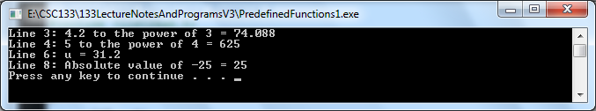

XII. Logical and Relational Expressions

A. Relational Operators:
Operator Meaning
< less than
<= less than or equal to
> greater than
>= greater than or equal to
= = equal to If x <= 0
!= not equal to

B. Logical Operators:
Operator Meaning Yields
&& and A true result only when both of its operands are true
|| or A true result when at least one operand is true
A false result only when both operands are false
! not The opposite truth value of its single operand

C. Interpretation:
Logical Expression Meaning
x < 3 Is x less than 3?
b*b - 4*a*c >= 0 Is b² - 4ac greater than or equal to 0?
answer = = ‘Yes’ Is the answer equal to 'Yes'?
flag && waive Is flag true and waive true?
x || y Is x or y true?
!END Is END false?

D. In the above example, if:
Data content Result

x = 5 x < 3 evaluates to false

a = 1 b*b-4*a*c >=0 evaluates to true
b = 2 4 – 4*a*c >=0
c = 1 4 – 4*1*1>=0
4 – 4 * 1 >= 0
4 – 4 >= 0
0 >= 0

answer = 'No' answer = = 'Yes' evaluates to false

flag = TRUE flag && waive evaluates to false.
waive = FALSE

x = 1 x || y evaluates to true.
y = 0 (Remember 1 = true and 0 = false)

END = false then !END evaluates to true

E. Precedence Order
Highest precedence starts here:
( )
!
* / %
+ -
< <= > >=
= = !=
&&
||
Lowest order of precedence ends here.

- Logical expressions containing both relational and logical operators
Expression Truth Value
1. (2<4) && (6= =5+1) true
2. (62= =6*2) && (14<15) false
3. (48= =6*2) || (11<15) true
4. (18= =6*2) ||(15>18) false
5. !(2<3) false
6. !(3>2) false
7. !(3<2) true

XIII. If Statements
- Why use them?
  - Are used to make a decision between two activities depending on
the outcome of an evaluation
2. C++ uses an if or an if-else statement.
- If structure without an Else
  - Sometimes there is a need test a condition and if the condition is
true, then perform a set of statements.
  - If has the following form:
if (logical expression)
statement to be executed if true;
or
if (logical expression)
{
statement1;
statement2;
........
statementn;
}
- The statements between the { and the } are referred to as a block of
Statements.
  - If the logical expression is true, then
every statement in the block will be executed.
  - If the expression is false,
then none of the statements will be performed.
4. Example algorithm:
input rate, hours
pay = rate * hours pay = 450
if hours > 40 then
pay = pay + (hours - 40) * .5 * rate pay = 475
endif
display the pay

example: hours = 45, rate = 10

- One equivalent C++ program:
(line numbers are not part of the code):
1 cin >> rate >> hours;
2 pay = rate * hours;
3 if (hours > 40) // add overtime pay
4 pay = pay + (hours - 40) * .5 * rate;
5 cout << "Pay = " << pay << endl;

a. Line 4: will only be executed when the logical expression
(hours > 40) is true.
b. Line 5:will be executed whether the logical expression is
true or false, statement #4 is executed.

- A variation of the program:
(line numbers are not part of the code):
1 cout << “Enter the hours then the rate”;
2 cin >> hours >> rate;
3 pay = hours * rate;
4 if (hours > 40)
5 {
6 overtime = (hours - 40)* .5 * rate;
7 cout << "Overtime pay is: " << overtime << endl;
8 pay = pay + overtime;
9 }
10 cout << "Pay = " << pay << endl;

a. Lines 6, 7, and 8 are all performed when the hours worked were greater than 40.,
C. The If Else statement
- Is used when one set of statements should be performed if a logical expression is
true and an a different set of statements should be performed if a logical expression is false.
2. Has the general form:
if (logical expression)
true-statement;
else
false-statement;
or
if (logical expression)
{
true-statement block;
true-statement block;
true-statement block;
}
else
{
false-statement block;
false-statement block;
false-statement block;
}
3. Example #1 Algorithm:
If the score is greater than or equal 60
the student is passing
otherwise
the student is failing.
4. Example #1 C++ solution is:

if (score >= 60)
cout << "passing" << endl;
else
cout << "failing" << endl;

5. Example #2 Algorithm:

If the score is greater than or equal to 70
the student is passing
the student can register for the next level course
otherwise
the student is not passing
the student should repeat the same course

6. Example #2 C++ solution is:

if (score >= 70)
{
cout << "passing" << endl;
cout <<”can register for next course” << endl;
}
else
{
cout << "failing" << endl;
cout << “should repeat the same course” << endl;
}

D. Nested If Statement
- Used when there are alternative decisions instead of two way decisions.
a. Can still use the if-else statement.
b. If statements are embedded within each other for multiple condition testing
2. Example:
- There is a need to determine whether a number is positive, zero or negative and
print an appropriate message.

- Example C++ solution using a nested if else structure:

if (num > 0)
cout << "positive";
else
if (num = = 0)
cout << "equal zero";
else
if (num < 0)
cout << "negative";
else
cout << num << “Is not a number”;
cout << endl;

- Another C++ variation using a multiway if structure but does not evaluate if the
data in the variable num has something non-numeric in it:

if (num > 0)
cout << "positive";
else if (num = = 0)
cout << "equal zero";
else
cout << "negative";
cout << endl;
- Switch Structures
A. Also known as a Case structure
1. This is the alternative to the if/else structure
2. The difference:
a. If / else statements usually requires the evaluation of a (logical) expression
b. The switch structure
                - (1) Does not require the evaluation of a logical expression
                - (2) Gives the computer the power to choose from among many alternatives
3. General syntax of the switch statement:

switch(expression)
{
case value1: statements1
break;
case value2: statements2
break;
...
case valuen: statementsn
break;
default: statements
}

4. The switch statement executes based on the following rules:
                - a. When the value of the expression is matched against a case value (which is also
                - called a label)
                - (1) The statements execute until either
                - (a) A break statement is found
                - (b) Or the end of the switch structure is reached.
                - b. If the value of the expression does not match any of the case values
                - (1) The statements following the default label execute.
                - c. If the switch structure has no default label, and if the value of the expression does

not match any of the case values in the structure, the entire switch statement is

skipped.
                - d. A break statement causes an immediate exit from the switch structure.

- Examples Set 1:
1. The following example evaluates character grades

switch(grade)
{
case 'A':
cout<<"The grade is A.";
break;
case 'B':
cout<<"The grade is B.";
break;
case 'C':
cout<<"The grade is C.";
break;
case 'D':
cout<<"The grade is D.";
break;
case 'F':
cout<<"The grade is F.";
break;
default:
cout<<"The grade of " << grade << " is invalid.";
}

2. The following example evaluates numeric grades

switch(grade)
{
case >=90:
cout<<"The grade is A.";
break;
case >=80:
cout<<"The grade is B.";
break;
case >=70:
cout<<"The grade is C.";
break;
case >=60:
cout<<"The grade is D.";
break;
case >=0:
cout<<"The grade is F.";
break;
default:
cout<<"The grade of " << grade << " is invalid.";
}

  - The following example evaluates numeric grades written incorrectly and will give
incorrect output.

switch(grade)
{
case >=90:
cout<<"The grade is A.";
case >=80:
cout<<"The grade is B.";
case >=70:
cout<<"The grade is C.";
case >=60:
cout<<"The grade is D.";
case >=0:
cout<<"The grade is F.";
default:
cout<<"The grade of " << grade << " is invalid.";
}

Think of the test case of grade = 75

4. Example set 2:
                - a. Evaluates to a logical value

                - switch(age >= 18)
{
case 1:
cout<<"Old enough to be drafted."<<endl;
cout<<"Old enough to vote."<<endl;
break;
case 0:
cout<<"Not old enough to be drafted."<<endl;
cout<<"Not old enough to vote."<<endl;
}

- If the value of age is 21
- The expression age >= 18 evaluates to 1
- It also evaluates to a boolean result of true.
- If the expression evaluates to 1, the statements following the case label
- execute.
- If the value of age is 12
- The expression age >= 18 evaluates to 0
- It also evaluates to a boolen result of false
- And the statements following the case label 0 execute.

5. Example 5:
a. Can also use true and false, instead of 1 and 0 in the case labels
b. Can rewrite the preceding switch statement as follows:

switch(age >= 18)
{
case true:
cout<<"Old enough to be drafted."<<endl;
cout<<"Old enough to vote."<<endl;
break;
case false:
cout<<"Not old enough to be drafted."<<endl;
cout<<"Not old enough to vote."<<endl;
}

6. Example 6:
a. Character evaluation
b. Is one possible method to perform data validation

switch (gender)
{
case ‘F’: case ‘f’:
cout << “This is a lady” << endl;
break;
case ‘M’: case ‘m’:
cout << “This is a man” << endl;
break;
default: cout<<"The gender that was entered is invalid.";
}

7. Example 7:
a. Relational operator evaluation
int a;
int b;
b. switch (a > b)
{
case 1 :
cout << “a greater than b” << endl;
break;
case 0 :
cout << “b greater than or equal to a” << endl;
break;
}

- Comparison of the If/Else and the Switch (Case) structures:
  - Nested if statements:
a. Can be used to select from one of several paths in a program
                - b. But the logic is sometimes difficult to follow
                - c. Example:
if (grade = = 'A' || grade = = ‘a’)
gradePoint = 4.0;
else if (grade = = 'B' || grade = = ‘b’)
gradePoint = 3.0;
else if (grade = = 'C' || grade = = ‘c’)
gradePoint = 2.0;
else if (grade = = 'D' || grade = = ‘d’)
gradePoint = 1.0;
else if (grade = = 'F' || grade = = ‘f’)
gradePoint = 0.0;
else
cout << "Invalid grade = " grade;

  - The switch statement
a. Provides a control structure for this type of situation
b. In many situations, make the logic easier to follow
                - c. Does require the use of a break statement to bypass the remainder of the structure
                - d. Example:

switch (grade)
{
case 'A' : case ‘a’:
gradePoint = 4.0;
break;
case 'B' : case ‘b’:
gradePoint = 3.0;
break;
case 'C' : case ‘c’:
gradePoint = 2.0;
break;
case 'D : case ‘d’:
gradePoint = 1.0;
break;
case 'F' : case ‘f’:
gradePoint = 0.0;
break;
default :
cout << "Invalid grade = " grade;
}

D. If statements comparisons
1. A simple program that uses an if statement.
a. Code:

1  2  3  4  5  6  7  8  9  10  11  12  13  14  15  16 | //Simple If / Else Example 1  #include <iostream>  int main()  {  using namespace std;  cout << "Enter a number: ";  int numberIn;  cin >> numberIn;  if (numberIn > 10)  cout << numberIn << " is greater than 10" << endl;  else  cout << numberIn << " is not greater than 10" << endl;  system ("PAUSE");  return 0;  }
b. The if statement only executes a single statement if the expression is true
c. The else only executes a single statement if the expression is false.
d. Output:
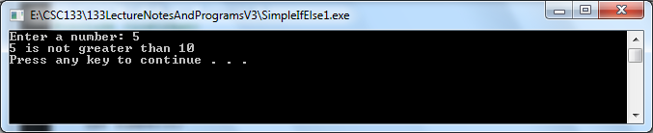

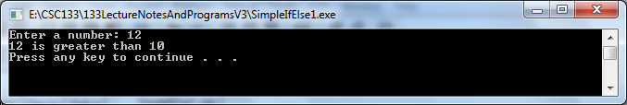

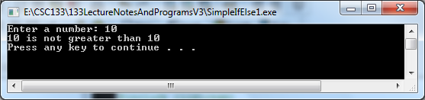

2. In order to execute multiple statements, a block can be used.
a. Code:

1  2  3  4  5  6  7  8  9  10  11  12  13  14  15  16  17  18  19  20  21  22  23  24 | //Simple If / Else Example 2  #include <iostream>  int main()  {  using namespace std;  cout << "Enter a number: ";  int numberIn;  cin >> numberIn;  if (numberIn > 10)  {  // both statements will be executed if numberIn > 10  cout << "You entered " << numberIn << endl;  cout << numberIn << " is greater than 10" << endl;  }  else  {  // both statements will be executed if numberIn <= 10  cout << "You entered " << numberIn << endl;  cout << numberIn << " is not greater than 10" << endl;  }  system ("PAUSE");  return 0;  }
  - Output:
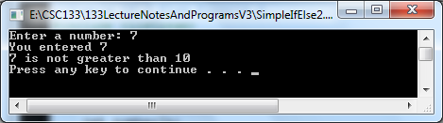

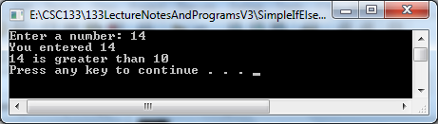

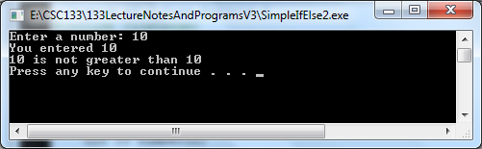

3. If-else statements can be chained together.
a. Code:

1  2  3  4  5  6  7  8  9  10  11  12  13  14  15  16  17 | //Simple If / Else Example 3  #include <iostream>  int main()  {  using namespace std;  cout << "Enter a number: ";  int numberIn;  cin >> numberIn;  if (numberIn > 10)  cout << numberIn << " is greater than 10" << endl;  else if (numberIn < 5)  cout << numberIn << " is less than 5" << endl;  // could add more else if statements here  else  cout << numberIn << " is between 5 and 10" << endl;  system ("PAUSE");  return 0;  }
b. This example used an if / else statement together
c. Output:
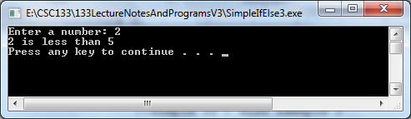
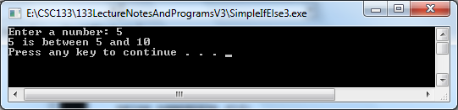
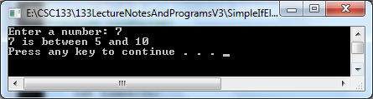
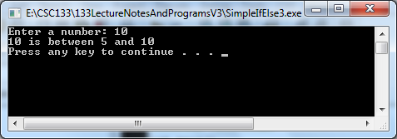
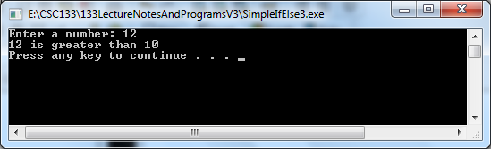
4. If statements can be nested within other if statements:
a. Code:

1  2  3  4  5  6  7  8  9  10  11  12  13  14  15  16  17  18  19  20 | //Simple If / Else Example 4  #include <iostream>  int main()  {  using namespace std;  cout << "Enter a number: ";  int numberIn;  cin >> numberIn;  if (numberIn > 10)  // it is bad coding style to nest if statements this way  if (numberIn < 20)  cout << numberIn << " is between 10 and 20" << endl;  // who does this else belong to?  else  cout << numberIn << " is greater than 20" << endl;  system ("PAUSE");  return 0;  }

b. This examples introduces a source of potential uncertainty called a dangling else situation.
c. It is hard to tell which if statements the else statement is matched up with.
d. Is it matched with the outer or inner if statement?
e. Remember that an else statement is paired up with the last unmatched if statement in the same block.
f. Therefore, in the example above, the else is matched up with the inner if statement.
g. Output:
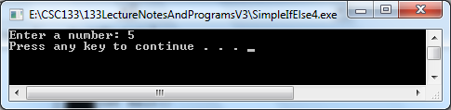

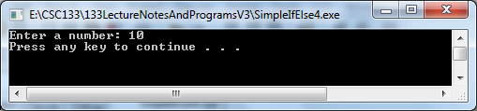

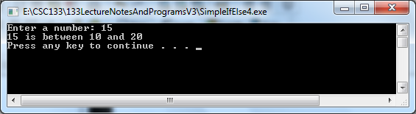

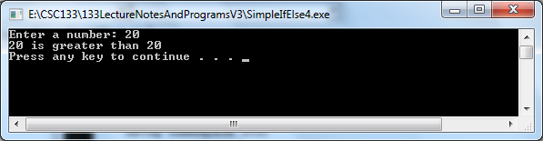

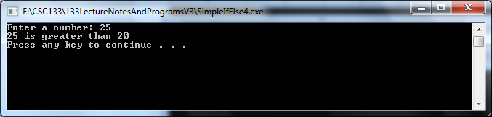

5. A way to avoid uncertainty with nested if statements, it is usually a good idea
to enclose the statement within a block by using curly braces.

6. An alternative way to write the prior code above in a more obvious format could be:
a. Code:

1  2  3  4  5  6  7  8  9  10  11  12  13  14  15  16  17  18  19 | //Simple If / Else Example 5  #include <iostream>  int main()  {  using namespace std;  cout << "Enter a number: ";  int numberIn;  cin >> numberIn;  if (numberIn > 10)  {  if (numberIn <= 20)  cout << numberIn << " is between 10 and 20" << endl;  else // attached to inner if statement  cout << numberIn << " is greater than 20" << endl;  }  system ("PAUSE");  return 0;  }
b. This coding style should make it much clearer to observe that the else statement synchronizes with the inner if statement.
c. Output:
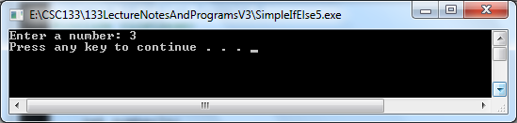
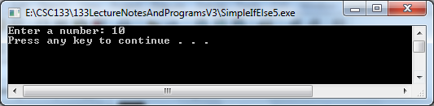
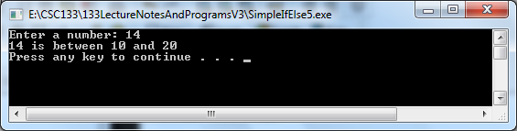
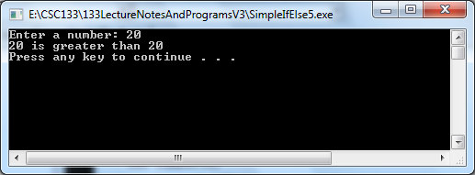
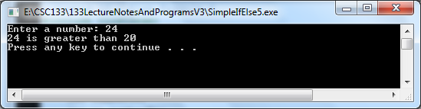

7. Encasing the inner if statement in a block also allows the ability to explicitly attach an else to the outer if statement.
a. Code:

1  2  3  4  5  6  7  8  9  10  11  12  13  14  15  16  17  18  19 | //Simple If / Else Example 6  #include <iostream>  int main()  {  using namespace std;  cout << "Enter a number: ";  int numberIn;  cin >> numberIn;  if (numberIn >= 10)  {  if (numberIn <= 20)  cout << numberIn << " is between 10 and 20"  << endl;  else  cout << numberIn << " is greater than 20”  << endl;  }  else // attached to outer if statement  cout << numberIn << " is less than 10" << endl;  system ("PAUSE");  return 0;  }
b. Using a block approach specifies that the else statement should attach to the if statement before the block.
c. By not using the block approach, the else statement would attach to the nearest unmatched if statement, which would be the inner if statement in this example.

d. Output:

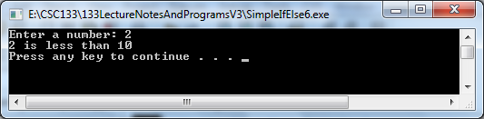

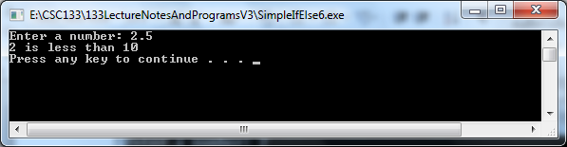

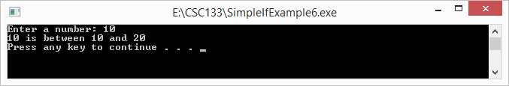

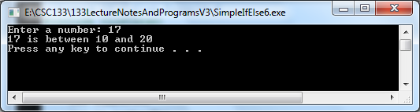

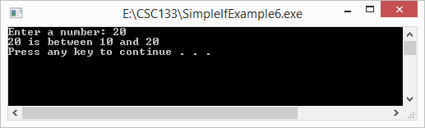

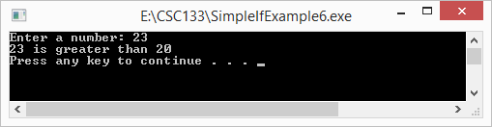

e. Using a block approach specifies that the else statement should attach to the if statement before the block.
f. By not using the block approach, the else statement would attach to the nearest unmatched if statement, which would be the inner if statement in this example.

XV. Repetitive Structures (Loops)
- Loops exist to either
      - Repeat a statement(s) certain number of times or
      - Repeat while a condition is fulfilled.

B. The While loop
1. Format:
while (expression) statement
2. Its function is to repeat each statement while the expression is true.
      - While Loop Example 1:
a. A program to count down using a while loop:
b. Code:
// While Loop Example 1
//The countdown using while
#include <iostream.h>
int main ()
{
int n;
cout << "Enter the starting number > ";
cin >> n;
while (n>0)
{ cout << n << ", ";
--n;
}
cout << "Blast Off!" << endl;
system ("PAUSE");
return 0;
}

c. Output:
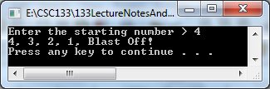
d. Explanation:
(1) The program starts and the user is prompted to insert a starting number for
the countdown.
(a) When the while loop begins
(b) If the value entered by the user fulfills the condition n>0 (that n be
greater than 0 ), then the block of instructions that follows will
execute indefinite times while the condition (n>0) remains being true.
(2) An interpretation:
a. All the process in the program above can be interpreted according to the following script: beginning in main:
(1) User assigns a value to n.
(2) The while instruction checks if (n>0).
(3) At this point there are two possibilities:
(a) true: execute statement (step 3,)
(b) false: jump statement. The program follows in step 6
(4) Execute statement:
cout << n << ", ";
--n;
(a) Prints out n on screen and decreases n by 1
(5) End of block. Return automatically to While statement
(6) Continue the program after the block: print out Blast Off! (7) End the program.
4. While Loop Example 2:
a. Code:
i = 0; //Line 1
while(i <= 20) //Line 2
{
cout<<i<<" "; //Line 3
i = i + 5; //Line 4
}
b. Output:

0 5 10 15 20

5. While Loop Example 3:
a. Code:

i = 0;
while(i <= 20)
{
i = i + 5;
cout<<i<<" ";
}

b. Output:

5 10 15 20 25

- While Loop Example 4: A counter controlled loop
  - Could use a value inputted to determine when to end a portion of the processing
  - This example adds a series of numbers together and then calculates their average
c. Input data:

5 15 18 20 35 59 70 80

(1) The first number, 5, specifies the number of values in the data set.
(2) Only 5 values are read after the value of ‘5’ is read in
(3) The other values are discarded.
d. Code:
// While Loop Example 4
//Program: Total and Average using an inputted value used for the counter
#include <iostream.h>

int main()
{
int limit; //store the number of items in the list
int number; //variable to store the number
int sum; //variable to store the sum
int counter; //loop control variable

cout<<"Line 1: Enter # of values of data for processing"
<< endl; //Line 1
cin>>limit; //Line 2
cout<<"Line 3: Enter data values to calculate"
<< endl; //Line 3
sum = 0; //Line 4
counter = 0; //Line 5
while(counter < limit) //Line 6
{
cin>>number; //Line 7
sum = sum + number; //Line 8
counter++; //Line 9
}
cout<<"Line 10: The sum of "<<limit
<<" numbers = "<<sum<<endl; //Line 10
if(counter != 0) //Line 11
cout<<"Line 12: The average = "
<<sum / counter<<endl; //Line 12
else //Line 13
cout<<"Line 14: No input."<<endl; //Line 14
system ("PAUSE");
return 0;
}
e. Output:
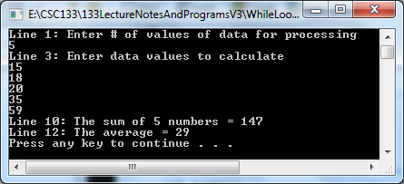
8. While Loop Example 5: A sentinel controlled loop
a. Reads in data until a predetermined value which is set up to end the processing is
entered
b. This example reads positive integers and then averages them
  - There is no preset number of data items determined when the program begins
processing.
  - Instead, when the number –999 is entered, this indicates the end of the data to be
summed and averaged.

  - Code:
// While Loop Example 5
//Program: Total and Average using a sentinel to determine
// when the data is all entered
#include <iostream.h>

const int SENTINEL = -999;

int main()
{
int number; //variable to store the inputted number
int sum = 0; //variable to store the sum
int count = 0; //variable to store the total
cout<<"Line 1: Enter numbers and end with "
<<SENTINEL<<endl; //Line 1
cin>>number; //Line 2
while(number != SENTINEL) //Line 3
{
sum = sum + number; //Line 4
count++; //Line 5
cin>>number; //Line 6
}
cout<<"Line 7: The sum of "<<count
<<" numbers is "<<sum<<endl; //Line 7
if(count != 0) //Line 8
cout<<"Line 9: The average is "
<<sum / count<<endl; //Line 9
else //Line 10
cout<<"Line 11: No input."<<endl; //Line 11
system ("PAUSE");
return 0;
}
  - Output:
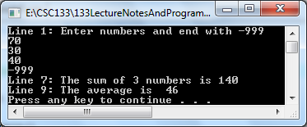
C. The Do-While loop.
1. Format:
Do statement while (condition);
2. Works the same (functionally) as the while loop except that
a. Condition in the do-while is evaluated after the execution of statement
instead of before
b. This provides at least one execution of statement even if condition is never fulfilled. 3. Do While Loop Example 1:
a. A program which echoes any number you enter until 0 is entered
b. Code:

//Echo the number
#include <iostream.h>
int main ()
{
unsigned long n;
do {
cout << "Enter a number (Enter a zero to end): ";
cin >> n;
cout << "You entered: " << n << "\n";
} while (n != 0);
system ("PAUSE");
return 0;
}
- Output:
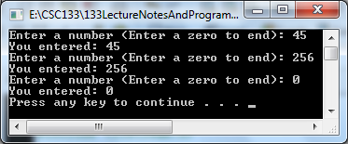

- Explanation:
(1) The do-while loop is used when the condition that has to determine its end
is determined within the loop statement
(2) The user input within the block of instructions is what determines the end
of the loop.
(a) If you never enter the 0 value in the previous example the loop will
never end.
4. Do While Loop Example 2:
a. Condition tested at end of the loop
b. Code:
i = 0;
do
{
cout<<i<<" ";
i = i + 5;
}
while(i <= 20);

c. Output:
0 5 10 15 20
d. Explanation:
(1) After the value 20 is output
(2) i = i + 5; changes the value of i to 25
(3) and so i <= 20 becomes false
- which halts the loop.
5. Do While Loop Example 3:
a. Compare:
b. Code set 1:

i = 11;
while(i <= 10)
{
cout<<i<<" ";
i = i + 5;
}

c. Output of set 1: The while loop has no output
d. Code set 2:

i = 11;
do
{
cout<<i<<" ";
i = i + 5;
}
while(i <= 10);

e. Output of set 2: The number 11 is outputted
6. Do While Loop Example #4:
a. Code:
// Do While Loop Example #4
// This program averages 3 test scores. It repeats as
// many times as the user wishes.

#include <iostream.h>
using namespace std;
int main()
{
int score1, score2, score3; // Three scores
double average; // Average score
char again; // To hold Y or N input

do
{
// Get three scores.
cout << "Enter 3 scores and I will average them: " << endl;
cin >> score1 >> score2 >> score3;

// Calculate and display the average.
average = (score1 + score2 + score3) / 3.0;
cout << "The average is " << average << ".\n";

// Does the user want to average another set?
cout << "Do you want to average another set? (Y/N) ";
cin >> again;
} while (again == 'Y' || again == 'y');
system ("PAUSE");
return 0;
}
- Output:
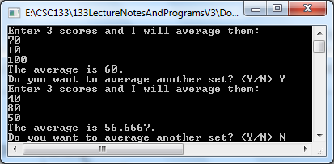
- When is a Do loop useful?
a. When it does not make sense to check a condition until after the action occurs. b. Example:
When the action is to read data that is then checked against the exit condition
- Do While Example #5
- Code:
// Do While Example #5
// Program: Warning message displayed when a value falls outside a given range.
#include <iostream.h>
const int low = 60;
const int high = 100;
int main ()
{
int pressure;
do
{
cout << "Enter a valid pressure reading between 60 and 100”
<< endl;
cin>>pressure;
} while((pressure >= low) && (pressure <= high));
cout<<"Help – there is a pressure problem"<<endl;
system ("PAUSE");
return 0;
}
- Output:
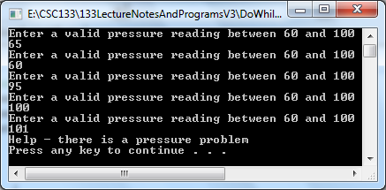

D. For loop.
1. Format:
for (initialization; condition; increase) statement;
2. Repeats a statement(s) while condition remains true
a. Like the while loop
b. Provides places to specify an initialization instruction and an increase instruction
c. Is specially designed to perform a repetitive action with a counter.
3. How it works:
a. Initialization is executed.
(1) Generally it is a initial value setting for a counter variable.
(2) This is executed only once
b. Condition is checked
(1) If it is true the loop continues,
(2) Otherwise the loop finishes and statement is skipped
c. Statement is executed.
(1) It can be either a single instruction or a block of instructions
enclosed within curly brackets { }.
  - Whatever is specified in the increase field is executed and the loop gets back to the condition test step.
- For Loop Example 1:
  - A countdown using a for loop.
  - Code:

// For Loop Example #1 - Countdown
#include <iostream.h>
int main ( )
{
for (int n=5; n>0; n--)
{
cout << n << ", ";
}
cout << "Blast Off!"<<endl;
system ("PAUSE");
return 0;
}
c. Output:
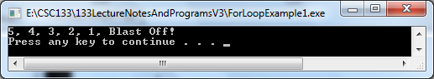

d. Explanation:
(1) The initialization and increase fields are optional.
(a) They can be avoided but not the semicolon signs among them.
(b) Example 1:
[1] for (;n<5;)
[2] could be used if you want to specify no initialization neither
increase
(c) Example 2:
[1] for (;n<5;n++)
[2] could be used if you want to include an increase field but
not an initialization.
e. Other options:
(1) Using the comma operator (,) can specify more than one instruction in any
of the fields included in a for loop
(2) Like in initialization, for example.
(3) The comma operator (,) is an instruction separator,
(a) It serves to separate more than one instruction where only one instruction is generally expected.
(4) Example:
(a) Suppose that we wanted to initialize more than one variable in a loop:
(b) for ( n=0, i=10 ; n!=i ; n++, i-- )
{
//code here...
}
(c) Example:
[1] This loop will execute 5 times if neither n nor i are
modified within the loop
[2]
for ( n=0, i=10 ; n!=i ; n++, i-- )
| | |→ increase | |-> condition
|-> initialization
{
Cout<<”n = “<< n << “i = “ << i;
}
[4] Output:
n = 0 i = 10
n = 1 i = 9
n = 2 i = 8
n = 3 i = 7
n = 4 i = 6
[5] n starts with 0 and i with 10
[6] The condition is (n!=i) (that n be not equal to i)
[7] Since n is increased by one and i decreased,
[a] The loop's condition will become false after the 5th loop
[b] When both n and i will be equal to 5
5. For Loop Example 2:
a. The following for loop outputs the line of text and a star (on separate lines) five
times:
b. Code:
for(i = 1; i <= 5; i++)
{
cout<<"Output a line of stars."<<endl;
cout<<"*"<<endl;
}
6. For Loop Example 3:
a. This loop outputs the line of text five times and the star only once.
b. Code:
for(i = 1; i <= 5; i++)
cout<<"Output a line of stars."<<endl;
cout<<"*"<<endl;

7. For Loop Example 4:
a. This for loop executes five empty statements:
b. Code:
for(i = 1; i <= 5; i++); //Line 1
cout<<"*"<<endl; //Line 2
  - The semicolon at the end of Line 1 terminates the for loop.
  - That makes the action of this for loop empty.
8. For Loop Example 5:
a. This for loop counts backwards
b. Code:
for(i = 4; i >= 1; i--)
cout<<" "<<i;
c. Output:

4 3 2 1
d. In this for loop, the variable i is initialized to 4. After each iteration of the loop,
i is decremented by 1. The loop continues to execute as long as i >= 1.
9. For Loop Example 6:
a. Increment the loop control variable by any fixed number.
b. Code:
for(i = 1; i <= 20; i = i + 2)
cout<<" "<<i;
        - Output: The first 10 positive odd integers
1 3 5 7 9 11 13 15 17 19
- For Loop Example 7:
a. Nothing happens
b. Code:

for(i = 10; i <= 9; i++)
cout<<i<<" ";

c. The initial statement sets i to 10.
d. Initially, the loop condition (i <= 9) is false, so nothing happens.
- For Loop Example 8:
a. Nothing happens
b. Code:

for(i = 9; i >= 10; i--)
cout<<i<<" ";

c. The initial statement sets i to 9.
d. Initially the loop condition (i >= 10) is false, so nothing happens

- For Loop Example 9:
a. One execution
b. Code:

for(i = 10; i <= 10; i++)
cout<<i<<" ";
- For Loop Example 10:
a. Single display of COUT where i = 11
b. Code:

for(i = 1; i <= 10; i++);
cout<<i<<" ";
c. The semicolon at the end of the for statement line terminates the for loop
d. This makes the action of the for loop empty.
e. The cout statement is all by itself and executes only once.
- For Loop Example 11:
a. Loop condition is always true
b. Code:
for(i = 1; ; i++)
cout<<i<<" ";
c. The loop condition is omitted from the for statement
d. The loop condition is always true.
e. This is an infinite loop.
- For Loop Example 12:
a. For loop that reads five numbers and finds their sum and average.
b. Code:
// For Loop Example #12 Average
#include <iostream.h>
int main ()
{
int sum = 0;
int i;
int newNum;
float average;
cout<<"Enter 5 numbers to be averaged "<<endl;
for(i = 1; i <= 5; i++)
{
cin>>newNum;
sum = sum + newNum;
}
average = sum / 5;
cout<<"The sum is "<<sum<<endl;
cout<<"The average is "<<average<<endl;
system ("PAUSE");
return 0;
}

        - Output:
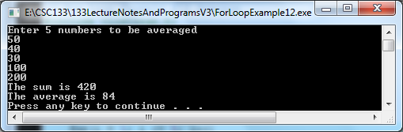

- For Loop Example 13:
a. Finds the sum of the first n positive integers
b. Code:
// For Loop Example #13 Sum of positive integers
//Program: Sum first n positive integers
//This program finds the sum of the first n positive integers.
#include <iostream.h>
int main()
{
int counter; //loop control variable
int sum; //variable to store the sum of the numbers
int N; //variable to store the number of
//first positive integers to be added
cout<<"Line 1: Enter the number of positive "
<<"integers to be added:"<<endl; //Line 1
cin>>N; //Line 2
sum = 0; //Line 3
for(counter = 1; counter <= N; counter++) //Line 4
sum = sum + counter; //Line 5
cout<<"Line 6: The sum of the first "<<N
<<" positive integers is "<<sum<<endl; //Line 6
system ("PAUSE");
return 0;
}
c. Output:
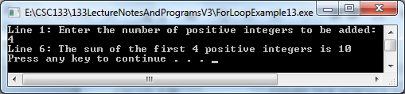

- For Loop Example 14:
a. A for loop that reads in numbers and finds their sum and average.
b. Code:
// For Loop Example #14 Student averages
#include <iostream.h>
int main()
{
int i = 0;
int numStudents = 0;
int newGrade = 0;
int gradeSum = 0;
float gradeAverage = 0;
cout<<"=============================================="<<endl;
cout << "Enter the number of students to be calculated: ";
cin >> numStudents;
cout<<"=============================================="<<endl;
for(i = 1; i <= numStudents; i++)
{
cout<< "Enter the grade to be calculated: ";
cin>>newGrade;
gradeSum = gradeSum + newGrade;
}
cout<<"=============================================="<<endl;
cout<<"The sum is "<<gradeSum<<endl;
gradeAverage = gradeSum / numStudents;
cout<<"The average is "<<gradeAverage<<endl;
cout<<"=============================================="<<endl;
system ("PAUSE");
return 0;
}

c. Output:
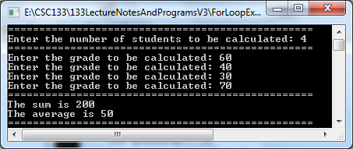
E. Nested Repetition Structures
- In a nested repetition structure, one loop (the inner loop) is placed entirely within another loop (the outer loop)
- Example Algorithm: A clock:
Initialize minutes to 0
Repeat while (the minutes are less than 60)
Initialize seconds to 0
Repeat while (the seconds are less than 60)
Move second hand 1 position, clockwise
Add 1 to seconds
End repeat while (the inner loop)
Move minute hand 1 position, clockwise
Add to minutes
End repeat while (the outer loop)

- Nested Loop With a Do Loop and a While Loop #1:
a. Code:
// Nested Loop Do And While Example #1
// This program displays a menu and asks the user to make a
// selection. A do-while loop repeats the program until the
// user selects item 4 from the menu.
#include <iostream>
#include <iomanip>
using namespace std;

int main()
{
int choice; // Menu choice
int months; // Number of months
double charges; // Monthly charges

// Constants for membership rates
const double ADULT = 40.0;
const double SENIOR = 30.0;
const double CHILD = 20.0;

// Set up numeric output formatting.
cout << fixed << showpoint << setprecision(2);

do
{
// Display the menu.
cout << "\n\t\tHealth Club Membership Menu\n\n";
cout << "1. Standard Adult Membership\n";
cout << "2. Child Membership\n";
cout << "3. Senior Citizen Membership\n";
cout << "4. Quit the Program\n\n";
cout << "Enter your choice: ";
cin >> choice;

// Validate the menu selection.
while (choice < 1 || choice > 4)
{
cout << "Please enter 1, 2, 3, or 4: ";
cin >> choice;
}

// Validate and process the user's choice.
if (choice != 4)
{
// Get the number of months.
cout << "For how many months? ";
cin >> months;

// Respond to the user's menu selection.
switch (choice)
{
case 1: charges = months * ADULT;
break;
case 2: charges = months * CHILD;
break;
case 3: charges = months * SENIOR;
}

// Display the monthly charges.
cout << "The total charges are $";
cout << charges << endl;
}
} while (choice != 4);
system ("PAUSE");
return 0;
}

  - Output:
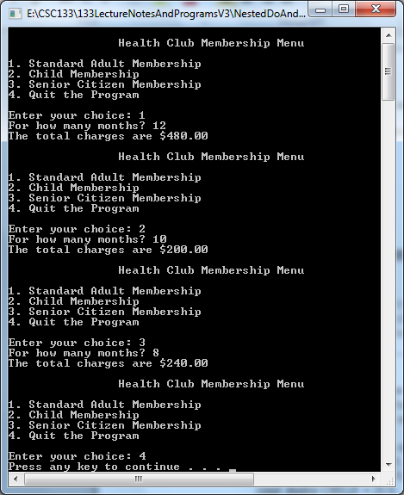

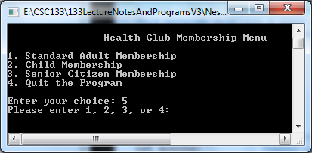

- Nested Loop With a Do Loop and a While Loop #2:
a. Code:
// Nested Loop Do And While Example #2
// This program displays a menu and asks the user to make a
// selection.
#include <iostream>
#include <iomanip>
using namespace std;

int main()
{
int choice; // Menu choice
int months; // Number of months
double charges; // Monthly charges

// Constants for membership rates
const double ADULT = 40.0;
const double SENIOR = 30.0;
const double CHILD = 20.0;

// Set the numeric ouput formatting.
cout << fixed << showpoint << setprecision(2);

do
{
// Display the menu and get a choice.
cout << "\n\t\tHealth Club Membership Menu\n\n";
cout << "1. Standard Adult Membership\n";
cout << "2. Child Membership\n";
cout << "3. Senior Citizen Membership\n";
cout << "4. Quit the Program\n\n";
cout << "Enter your choice: ";
cin >> choice;

// Validate the menu selection.
while (choice < 1 || choice > 4)
{
cout << "Please enter 1, 2, 3, or 4: ";
cin >> choice;
}

// Respond to the user's menu selection.
switch (choice)
{
case 1:
cout << "For how many months? ";
cin >> months;
charges = months * ADULT;
cout << "The total charges are $"
<< charges << endl;
break;

case 2:
cout << "For how many months? ";
cin >> months;
charges = months * CHILD;
cout << "The total charges are $"
<< charges << endl;
break;

case 3:
cout << "For how many months? ";
cin >> months;
charges = months * SENIOR;
cout << "The total charges are $"
<< charges << endl;
break;

case 4:
cout << "Program ending.\n";
break;
}

} while (choice != 4);
system ("PAUSE");
return 0;
}
  - Output:
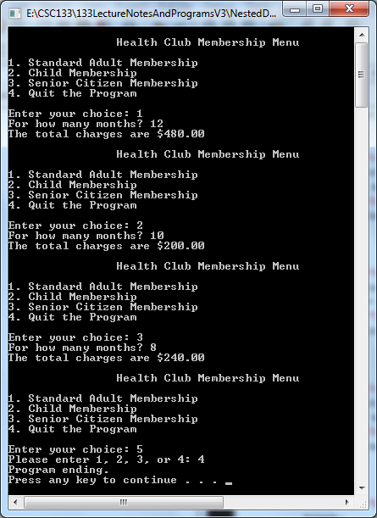
- A complete nested loop example:
- Requirements:
- A supply store divides its sales territory into two regions:
Region 1 and Region 2
- The sales manager wants a program to enter the sales amounts for both regions, one region at a time
- The program should calculate the total amount sold in the current region, and display that information
- Algorithm:
Initialize the sales to 0
Initialize the region to 1
Initialize the total region sales to 0
Repeat while the region is < 3
Enter the sales
Repeat while the sales are > 0
Add the sales to the total region sales
Enter the sales
End repeat while
Display the region and total region sales
Add 1 to the region
Assign 0 to the total region sales
End repeat while
Display end of program

- C++ Program:
- Code:
// Nested Loop While And While Example #1
#include <iostream.h>
int main()
{
int sales = 0;
int region = 1;
int totalRegionSales = 0;
while (region < 3)
{
cout << “Enter the first sales amount for Region “ << region << “: “;
cin >> sales;
while (sales > 0)
{
totalRegionSales = totalRegionSales + sales;
cout << “Enter the next sales amount for Region “
<< region << “: “;
cin >> sales;
} // end inner while
cout << endl << “Region “ << region << “sales: $ ” << totalRegionSales << endl << endl;
cout << "=========================================================="<<endl;
region = region + 1; // add 1 to the counter
totalRegionSales = 0; // reinitialize the accumulator for the
// next region
} // end outer while
cout << “End of program” << endl;
system ("PAUSE");
return 0;
}
- Output:
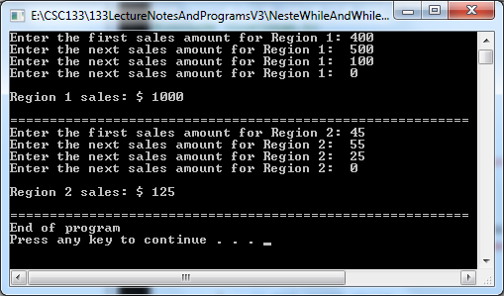
- Walking through some possible test data:
Desk Checking Table For After Processing
Region 1’s Sales Amounts
Sales | Region | totalRegionSales
0  25000  30000  10000  -1 | 1 | 0  25000  55000  65000

Desk Checking Table For After Updating The Counter And Reinitializing The Accumulator
Sales | Region | totalRegionSales
0  25000  30000  10000  -1 | 1  2 | 0  25000  55000  65000  0

Desk Checking Table For After Processing
Region 2’s Sales Amounts
Sales | Region | totalRegionSales
0  25000  30000  10000  -1  13000  10000  -1 | 1  2 | 0  25000  55000  65000  0  13000  23000

Desk Checking Table For After Updating The Counter And Reinitializing The Accumulator
Sales | Region | totalRegionSales
0  25000  30000  10000  -1  13000  10000  -1 | 1  2  3 | 0  25000  55000  65000  0  13000  23000  0

- Sample output from the test data:
First sales amount for Region 1: 25000
Next sales amount for Region 1: 30000
Next sales amount for Region 1: 10000
Next sales amount for Region 1: -1

Region 1 sales: $65000

First sales amount for Region 2: 13000
Next sales amount for Region 2: 10000
Next sales amount for Region 2: -1

Region 2 sales: $23000

End of program
Press any key to continue

6. Using a Nested For Loop
                - a. The following set of asterisks can be generate using a nested For Loop
*
**
***
****
*****
b. Code segment:
int i, j;
for(i = 1; i <= 5 ; i++) // outer loop
{
for(j = 1; j <= i; j++) // inner loop
{
cout<<"*"; // inner loop
}
cout<<endl; // outer loop
}
  - Execution of code:
Value of i Value of j Output after full iteration
1 1 *
2
2 1 **
2
3
3 1 ***
2
3
4
4 1 ****
2
3
4
5
5 1 *****
2
3
4
5
6
6
d. Explanation:
(1) The value of i as the limiting condition in another for loop nested within
this loop to control the number of stars in a line.
(2) The outer for loop starts with i = 1.
(3) When i is equal to 1, the inner for loop outputs one star and the cursor
moves to the next line.
(4) Next, i becomes 2,
- The inner for loop outputs two stars
- The cursor moves to the next line, and continues
- This process continues until i becomes 6 and the loop stops.

e. Program:
// Nested For Loop Example #1
#include <iostream.h>
int main( )
{
int i,j;
for (i=1;i<=5;i++) //outer loop
{
cout << " Outer loop i=" << i << endl;
for (j=1;j<=i;j++) //inner loop
{
// cout<<" Inner loop i="<<i<<" j="<<j<<endl;
cout<<"*";
}
cout<<endl;
}
system ("PAUSE");
return 0;
}
- Sample Output:
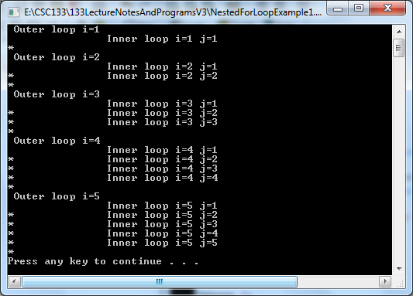
g. An alternative outer For Loop could be:
for(i = 5; i >= 1; i--)

F. Variations of loops demonstrated so far
1. Flag controlled while loop
a. A flag is a boolean variable that can only can be set to true or false.
                - b. A flag can be used to control the continuation of the execution of the while loop.
                - c. Code example:
// While Loop Bool Example #1
#include <iostream>
using namespace std;
int main( )
{
int sum; // the sum of the numbers read
bool go; // used to control the while loop
int number; // the number read

sum = 0; // initialize the sum
go = true; // initialize the boolean variable go
while (go) // loop while go
{
cout <<"Enter a number > 0: ";
cin >> number; // read next number
if ( number > 0 ) // sum number if positive
sum = sum + number; // sum the number
else
go = false; // terminate the loop
}
cout << “The sum = “ << sum << endl;
system ("PAUSE");
return 0;
}
  - Output:
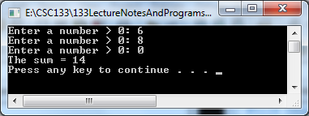
e. The loop logical expression ( go ) indicates that the loop will execute as long
as go is true.
XVI. Processing Input and Output Data Files
- Used for input and output file processing
1. Use of files is for either batch processing or real time processing
2. A file is a collection of related records
3. A record is a collection of related fields
- File types
1. Source (programming instructions in a particular language such as C++)
2. Executable (object) (the source code that has been compiled)
3. Data
a. Example student file content:
DOVER, JANE
250.00
SMITH, PAT
375.00
BROWN, BARBARA
900.25
b. Example data file name: student.txt
4. Uses of files
a. Input - read data from a file to process
b. Output – write / store data to a file for future use
c. Input/output – read data from and write data back to same file
- Components needed in C++ to utilize files in a program.
1. #include<fstream.h>
a. The C++ standard library defines two data types:
(1) ifstream
(a) Identifies the input file stream
(b) Is a data type that represents a stream of data coming
from and input file
(2) ofstream
(a) Identifies the output file stream
(b) Is a data type that represents a stream of data going to
an output file
2. What is a stream?
a. A stream in C++ is a sequence (stream or flow) of characters.
b. So far, all input and output has been implemented using the standard
input stream (cin) and the standard output stream (cout).
c. Every C++ program has these two streams and at least one other, the
standard error stream (cerr) available as long as the iostream header file is
included.
d. C++, sets up a stream from the keyboard so that data may flow from the
keyboard to the input request in a given program.
e. The extraction operator >> to extract data from the stream.
f. The input statement
char oneChar;
cin >> oneChar;
will:
(1) Examine the input stream from the keyboard
(2) Will obtain the next nonwhite space character
in the stream
(3) Will store this character in memory under the variable name:
oneChar.
(4) If no character is present in the stream, the execution pauses to wait for a character.
g. The input statement:
int number1;
cin >> number1;
will
(1) Examine the input stream from the keyboard for the next
integer.
(2) The computer will skip any leading white space and obtain
digits from the keyboard until a non-numeric character is
encountered,
(3) Will store this integer in memory under the variable name:
number1.
h. Cout sets up a stream to the screen so that the data may flow from memory
to the screen.
    - The insertion operator << is used to put data into the stream.
      - All input and output operations in C++ are performed using streams.
3. The names of the file streams need to be declared
a. ifstream infile;
(1) Will be the variable used as the input file stored on the storage drive
(2) Infile will then be used instead of cin to read data values since data
will be read from a storage drive file and not from the keyboard
b. ofstream outfile;
(1) Will be the variable used as the output file stored on a storage drive
(2) Outfile will then be used instead of cout to write values to the storage drive file since the output now will be written to a data file and not to the monitor
4. The data files need to be opened
a. infile.open(“f:input.txt”);
(1) Opens the file named input.txt that is stored on the storage drive
(2) This file will have data read from it
(3) Infile is the variable name for the input file
(4) The open set the file’s reading marker to the first value of data in
the file
(5) Each separate file has its own reading marker
b. outfile.open(“a:output.txt”);
(1) Opens the file named output.txt that is stored on the storage drive
(2) This file will have data written to or placed into it
(3) Outfile is the variable name for the output file
(4) This function also checks to see if the same named file already
exists
(a) If the file does not exist, the open statements creates a new,
empty file, and this file’s write marker is set at the
beginning of the file
(b) If the file does already exist, when the file is opened, the
old contents of the file is erased and the writing marker is
set at the beginning of the file
(6) Each separate file has its own writing marker
5. The file stream name must be used
a. When reading data from a file or writing data to a file
b. An example for input:
int number;
infile >> number;
inputs (reads) an integer from the file associated with infile
c. An example for output:
int number;
outfile << number;
outputs (writes) an integer to the file associated with outfile
6. Close all data files opened in the program
a. Not required in all versions of C++ but is a good idea to do
b. Files should be closed as soon as they are no longer needed
(1) To make them available to other users if they are shared
(2) To make an allocated file space free for other uses
c. Examples to close files:
(1) To close the input file:
infile.close( );
(2) To close the output file:
outfile.close( );
D. Example 1: Sample input and output data files and program to process the data
1. ioprg01i.txt – input file contents
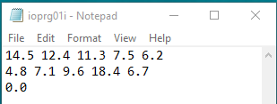

2. The ioprg01i.txt input file goes in the project folder here:

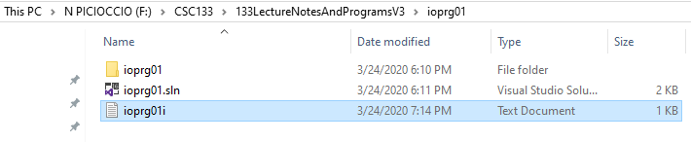

3. ioprg01.cpp - Program to process an input and an output data file
// Input and Output Files - Example 1 - ioprg01.cpp
// This program reads floating point numbers from an input file,
// sums the numbers, and then calculates their average. The results
// are written to an output file.

#include <fstream>
#include <iomanip>
#include <iostream>
using namespace std;
int main()
{
float number, sum, average;
int count;

ifstream infile; // infile represents the input file variable name
ofstream outfile; // outfile represents the output file variable name

infile.open("f:/csc133/133LectureNotesAndProgramsV3/ioprg01/ioprg01i.txt");
// opens the ioprg01i.txt file as an input file
outfile.open("f:/csc133/133LectureNotesAndProgramsV3/ioprg01/ioprg01o.txt");
// opens the ioprg01o.txt file as an output file

sum = 0.0; // accumulates all the inputted data
count = 0; // counts how many data values have been processed
average = 0.0; // holds the average of all the numbers read in

if (infile) // checks to make sure the file was successfully opened
{
outfile << “\n The numbers read in from the input data file are as follows: ”
<< endl;
outfile << setiosflags(ios::fixed) << setiosflags(ios::showpoint)
<< setprecision(2);
do
{
infile >> number;
// reads input data from the ioprg01i.txt file
outfile << setw(3) << number << endl;
// writes output data to the ioprg01o.txt file
sum += number;
++count;
} while (number != 0.0); // sentinel value used to end processing
// it is the last value in the file to be read in

// The sum of the numbers added together and their average are
// then written to the output file.
outfile << “The sum of the numbers read in is: “ << sum << endl;
// Writes the accumulated // sum to the output file
average = sum / (count – 1);
outfile << “The average of the summed numbers, not including the “
<< ”sentinel value is: “ << average << endl;
// Writes the average
// to the output file
}
else // if there was an error opening the input file
// display a message on the monitor (not to a data file)
cout << “An error occurred while opening the input data file “ << endl;
// infile.close; // Closes the input file
// outfile.close; // Closes the output file
system ("PAUSE");
return 0;
}
--------------------------
4. Output from console:

5. ioprg01o.txt – output file contents:
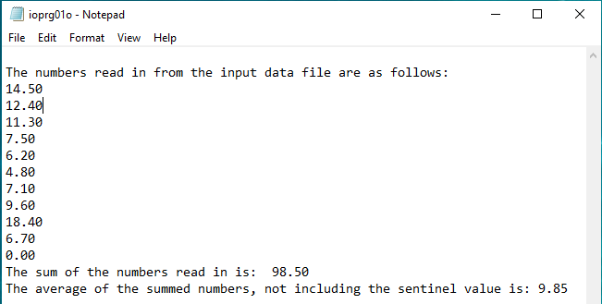

6. After program execution, there is now a Debug folder in the project group as well as the
output file that was generated with the file name of ioprg020.txt:

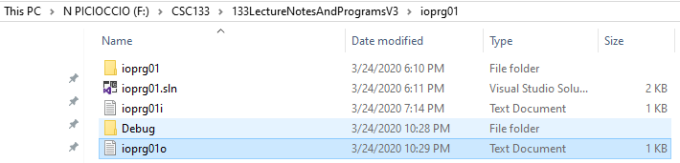

E. Example 2: Input data file that uses a sentinel and print output to the monitor

1. Program:
// Input and Output Files - Example 2 - ioprg02.cpp
// This program reads in a set of test grades, prints them, and calculates their average
// A sentinel value is used to end the program
#include <fstream>
#include <iostream>
#include <iomanip>
using namespace std;

int main( )
{
int test;
int numberOfTests = 0;
int totalTests = 0;
float averageOfTests =0;
ifstream inputFile;

const int SENTINEL = -999;

inputFile.open("f:/csc133/133LectureNotesAndProgramsV3/ioprg02/ioprg02i.txt"); // open the input file

// read in the test, accumulate them, and count how many tests are accumulated
// end processing when the sentinel is read

inputFile >> test;

cout << "The following are the classes’ test scores" << endl;
cout << “ “ << endl;

while (test != SENTINEL)
{
cout << "Test score is: " << test << endl;
totalTests = totalTests + test;
numberOfTests = numberOfTests + 1;
inputFile >> test;
}

// calculate and print the average

if (numberOfTests != 0)
averageOfTests = float(totalTests) / numberOfTests;
cout << setiosflags(ios::fixed);
cout << setiosflags(ios::showpoint);
cout << setprecision(1);
cout << “ “ << endl;
cout << "The average of the test grades is : " << averageOfTests << endl;
// inputFile.close;
system ("PAUSE");
return 0;
}
2. Contents of ioprg02i.txt input data file:
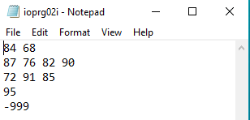

3. The ioprg02i.txt input data file is placed the project folder here:
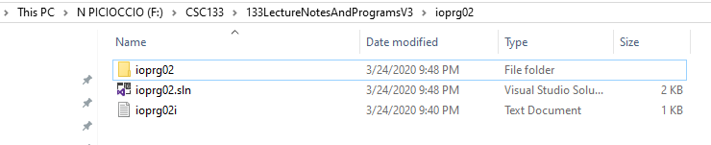

4. Sample output sent to monitor after execution:

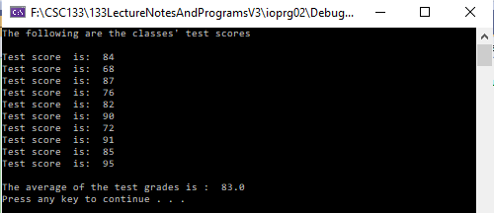

5. After program execution, there is now a Debug folder in the project group
even though the output is displayed in the system console and not stored
in and not stored in a data file:

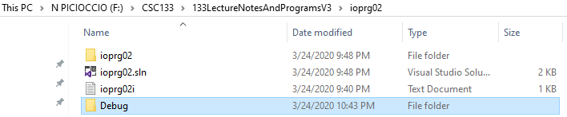

F. Example 3: Input data file that uses an EOF condition test to end processing and send

the results to the monitor

1. Program:
// Input and Output Files – Example 3 - ioprg03.cpp
// This program reads in a set of test grades, prints them, and calculates their average
// An EOF condition is used to end the program
#include <fstream>
#include <iostream>
#include <iomanip>
using namespace std;

int main( )
{
int test;
int numberOfTests = 0;
int totalTests = 0;
float averageOfTests;
ifstream inputFile;

inputFile.open("f:/csc133/133LectureNotesAndProgramsV3/ioprg03/
ioprg03i. txt"); // open the input file
// read in the test, accumulate them, and count how many tests are accumulated
// end processing when the sentinel is read

inputFile >> test;

cout << "The following are the classes’ test scores" << endl;
cout << “ “ << endl;

while (inputFile)
{
cout << "Test score is: " << test << endl;
totalTests = totalTests + test;
numberOfTests = numberOfTests + 1;
inputFile >> test;
}
// calculate and print the average
iIf (numberOfTests != 0)
averageOfTests = float(totalTests) / numberOfTests;
cout << setiosflags(ios::fixed);
cout << setiosflags(ios::showpoint);
cout << setprecision(1);
cout << “ “ << endl;
cout << "The average of the test grades is : " << averageOfTests << endl;
// inputFile.close;
system ("PAUSE");
return 0;
}

2. Contents of ioprg03i.txt input data file:
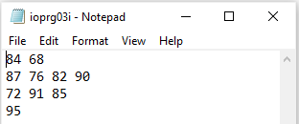

3. The ioprg03i.txt input data file is placed the project folder here:

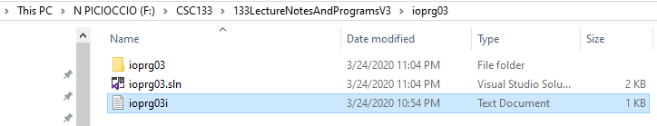

4. Sample output sent to monitor after execution:

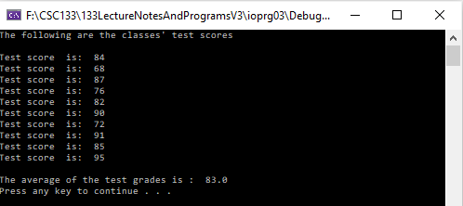

5. After program execution, there is now a Debug folder in the project group
even though the output is displayed in the system console and not stored
in and not stored in a data file:

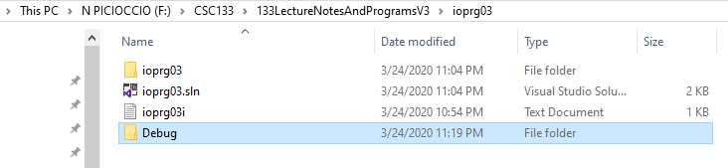
XVII. Functions
A. Two types of C++ functions
1. System defined functions
2. User-defined functions.
- User defined functions
1. Are divided into two groups
a. Functions that return a value
  - Functions that do not return a value
(1) Often referred to as the "void" function.
(2) Some have values passed into them, some do not.
- Types of function parameters:
1. Value parameters
a. Are used to pass information into a function
  - Reference parameters
a. Are used to pass information in and out of a function.
- Three basic concepts to remember when writing C++ functions (except for the function called main):
  - They must be declared
  - They must be activated
  - They must be defined
- Categories of functions:
  - 2 groups:
a. Value returning within the function name
b. Void functions do not have a data type
2. Similarities:
a. Have similar structures
b. Both have a heading component and a statement component
3. With user-defined void functions
a. Can place user-defined void functions either before or after the function main.
[1] Program execution always begins with the first statement in the function main.
[2] Like value-returning functions, void functions may or may not have formal parameters.
b. The function prototype should be placed before the function main.
c. Since a void function does not have a data type,
[1] FunctionType in the heading part is meaningless
[2] The return statement in the body of the void function is meaningless.
[a] The return statement can be used without any value
[b] This is usually done to exit a function early
F. void Functions with No Parameters
  - Function declaration
a. The C++ compiler requires specific information related to functions activated
in a program.
b. To provide this information to the compiler, a function declaration statement (or function prototype declaration) must be used
  - The syntax for declaring the function prototype is:
type function-name (formal parameter type list);
(1) type:
(a) The type of the value returned by the function.
(b) When no value is returned, the type used is "void".
(2) function-name:
(a) The identifier of the function
(3) formal parameter type list:
(a) A list of parameters with their types used in the function.
- When no parameters are used, i.e., the list is empty, the open and closed parentheses should be used
- Include the semicolon ";" at the end
  - Example 1:
(1) A function named "PrintHeading"
        - It does not return a value
        - It does not require function parameters
        - Can be declared as:
void PrintHeading( );
2. Function Activation
a. All function prototypes should be declared before their activation.
b. In a C++ program, no function will be executed unless it is
(1) "activated” or "invoked" or "called" by another function.
c. Syntax for void function activation is:
function-name(argument-list);
d. Example 1:
(1) To activate the function "PrintHeading" declared above
(2) Just specify
(a) The name of the function and
(b) Use () to indicate that the function requires no arguments:
(c) Would look like:
PrintHeading ( );
3. Function Definition
a. Is a listing of the actual instructions that should be executed in the function.
b. For example, in the function called "PrintHeading"
(1) The definition for that function would contain several output statements to
print an appropriate heading.
c. Is composed of two separate divisions:
(1) A function header
(a) The function header does not end with a semicolon
(b) The function header closely resembles the function prototype
(c) Syntax for the the function header is:
type function-name (formal parameter list)
(2) A function body.
(a) Requires a '{' at the beginning and a '}' at the end.
(b) May or may not require local declarations.
[1] If variables are needed in the function then these variables should be declared at the beginning of the function body
- Always ends with the word return.
[1] This tells the compiler to return control to the function that activated this function
(d) Syntax for the function body is:
{
[local declarations] // a phrase in [ ] means "optional"
executable statements;
return ;
}
4. Example 1:
// This is an example of a program that defines a prototype named PrintHeading, calls the // function PrintHeading from the “main” function, and executes the PrintHeading
// function.

#include <iostream>
using namespace std;

void PrintHeading(); // declcares the function prototype

int main()
{
PrintHeading();
system("PAUSE");
return 0;
}

void PrintHeading()
{
cout << "************ Mortgage Calculator – Version 1 ************" << endl;
cout << "Welcome! " << endl;
cout << "This program computes the monthly mortgage payment on a house" << endl;
cout << "You supply the information on: the loan amount, the interest rate" << endl;
cout << "and the number of years on the loan." << endl << endl;
cout << "The program will compute the monthly mortgage payment for you." << endl;
cout << "*****************************************************"
<< endl;
cout <<"To start the process ..." << endl;
return;
}
5. Example 2:

//This program draws a house by printing characters to the monitor screen.
#include <iostream>
using namespace std;

// declare all function prototypes here

void PrintIntersectingLine();
void PrintHorizontalLine();
void PrintParallelLine();
void PrintHorizontalLine();

void main()
{
PrintIntersectingLine(); //draw the roof
PrintHorizontalLine(); //draw the base of the roof
PrintParallelLine(); //draw the sides of the house
PrintHorizontalLine(); //draw the base of the house
System(“pause”);
return;
}

// function : PrintParallelLine()
// Print out two parallel lines
void PrintParallelLine()
{
cout << "| |" << endl;
cout << "| |" << endl;
cout << "| |" << endl;
cout << "| |" << endl;
cout << "| |" << endl;
return;
}

// function : PrintIntersectingLine()
// Print out two intersecting lines
void PrintIntersectingLine()
{
cout << " $ " << endl;
cout << " $ $ " << endl;
cout << " $ $ " << endl;
cout << " $ $ " << endl;
cout << " $ $ " << endl;
return;
}

// function : PrintHorizontalLine()
// Print out a horizontal line
void PrintHorizontalLine()
{
cout << "-----------" << endl;
return;
}

- Example 3:
  - Program Code:
//Int Function Example #1 - No parameters passed
//This program draws a house by printing characters to the monitor screen.
#include <iostream>
using namespace std;

// declare all function prototypes here

int PrintIntersectingLine(); //draw the roof
int PrintHorizontalLine(); //draw the base of the roof
int PrintParallelLine(); //draw the sides of the house

// the main program function goes here

int main()
{
PrintIntersectingLine(); //call the funtion to draw the roof
PrintHorizontalLine(); //call the function to draw the base of the roof
PrintParallelLine(); //call the function to draw the sides of the house
PrintHorizontalLine(); //call the function to draw the base of the house
system("pause");
return 0;
}

// the actual function contents goes here

// function : PrintParallelLine()
// Print out two parallel lines
int PrintParallelLine()
{
cout << "| |" << endl;
cout << "| |" << endl;
cout << "| |" << endl;
cout << "| |" << endl;
cout << "| |" << endl;
return 0;
}

// function : PrintIntersectingLine()
// Print out two intersecting lines
int PrintIntersectingLine()
{
cout << " $ " << endl;
cout << " $ $ " << endl;
cout << " $ $ " << endl;
cout << " $ $ " << endl;
cout << " $ $ " << endl;
return 0;
}

// function : PrintHorizontalLine()
// Print out a horizontal line
int PrintHorizontalLine()
{
cout << "-----------" << endl;
return 0;
}

  - Output

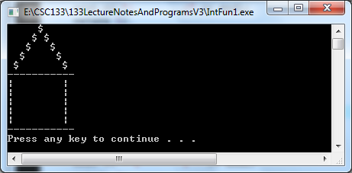

G. Functions with Value Parameters
1. Function Declaration
a. A value parameter is used to pass information into a function to be processed
within the function
b. General form for a function declaration:
type function-name (formal parameter type list);
  - Value parameters in a void function are declared by enclosing the list of types for
the parameter list in the parentheses.
d. Example 1:
(1) A function that prints out a user specified number of horizontal lines
(2) Code – version 1:
int PrintLines(int);
(3) Code – version 2:
//parameter names are used for documentation only
int PrintLines(int numOfLines);
e. Example 2:
(1) A function that prints out the final letter grade of a student, given the name of the student and their score
(2) Code 1:
int PrintGrade(string, float);
(3) Code 2:
int PrintGrade(string name, float score);
2. Function Activation
        - Need to the name of the function and provide the actual arguments enclosed in
parentheses.
b. The order and types of the list of arguments needs to correspond to those of the formal parameters declared in the function prototype.
c. The arguments can be constants, expressions, variables, or function calls
themselves.
  - If an argument is a variable, at the time of function activation, the variable must
have a value to process.
  - Example 1:
(1) Code version 1:
PrintLines(8);
(2) Code version 2:
numOfLines = 5;
PrintLines(numOfLines);
f. Example 2:
(1) Code version 1:
PrintGrade("Pat", (80+97.5)/2);
(2) Code version 2:
name = "Pat";
overallScore = (80+97.5)/2;
PrintGrade(name, overallScore);
3. Function Definition
  - The order and types of the list of formal parameters in a function header needs to
correspond exactly to the parameters declared in the function prototype.
  - About “value” parameters
(1) Is one of two types of function parameters in C++
(2) Sometimes these parameters are referred to as “call by value”
(3) Means that a copy of the value of the arguments is/are passed into the function
(4) Therefore, if a value parameter is changed within a function
(a) Only the copy of the data within the function is changed
(b) The value of the argument in the calling function does not change
c. Code and memory relationship:

(1) This section demonstrates the relationship between the actual arguments in
the calling program and formal parameters in a function
Memory

Int main ()
{ (in Main)
int a = 10; a b
float b = 6.4;
10
6.4
……
PrintData (a, b);
Return 0;
} __________________________
// function
int PrintData (int c, float d)
{
10
6.4
cout << c
<<” “ << d c d
<< endl;
return 0; (in Function)
}

4. Example 1:
a. Function definition:
int PrintLines(int numOfLines)
{
int i = 0;
while (i < numOfLines)
{
cout << "-------------" << endl;
i++;
}
return 0;
}

b. Full program:
//Value Parameters Passed Example#1 –
//This program prints the number of rows indicated from the inputted //number
//One parameter is passed into the function
#include <iostream>
using namespace std;

// declare all function prototypes here
int PrintLines(int numOfLines);
// the main program function goes here
int main()
{
int numDashes;
cout << “Enter the number of rows of dashes to display: “;
cin>>numDashes;
PrintLines(numDashes);
system("pause");
return 0;
}

int PrintLines(int numOfLines)
{
int i = 0;
while (i < numOfLines)
{
cout << "-------------" << endl;
i++;
}
return 0;
}
  - Output:
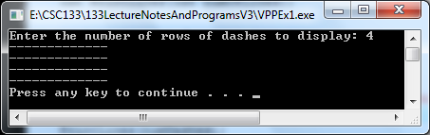

5. Example 2:
a. Function definition:
int PrintLetterGrade(string name, float average);
{
cout << endl;
cout << "The final grade for " << name << " is " ;
if (average >= 90)
{
cout << "A" << endl;
cout << "Great Work!" << endl;
}
else if (average >=80)
{
cout << "B" << endl;
cout << "Good Work!" << endl;
}
else if (average >=70)
{
cout << "C" << endl;
cout << "Average Work!" << endl;
}
else if (average >=60)
{
cout << "D" << endl;
cout << "Below Average Work…" << endl;
}
else
{
cout << "F" << endl;
cout << "Need To Work Harder…" << endl;
}
return 0;
}

b. Code:
//Value Parameters Passed Example #2 –
//Two parameter of two different data types are passed into the function

#include <iostream>
using namespace std;

// declare all function prototypes here
int PrintLetterGrade(string name, float average);

// the main program function goes here
int main()
{
string studentName;
float gradeAverage;
cout << “Enter the name of the student: “;
cin>>studentName;
cout << “Enter the grade average: “;
cin>>gradeAverage;
PrintLetterGrade(studentName, gradeAverage);
system("pause");
return 0;
}

int PrintLetterGrade(string name, float average)
{
cout << endl;
cout << "The final grade for " << name << " is " ;
if (average >= 90)
{
cout << "A" << endl;
cout << "Great Work!" << endl;
}
else if (average >=80)
{
cout << "B" << endl;
cout << "Good Work!" << endl;
}
else if (average >=70)
{
cout << "C" << endl;
cout << "Average Work!" << endl;
}
else if (average >=60)
{
cout << "D" << endl;
cout << "Below Average Work…" << endl;
}
else
{
cout << "F" << endl;
cout << "Need To Work Harder…" << endl;
}
return 0;
}
c. Output:

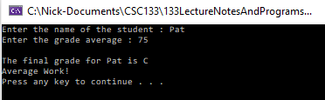

6. Example 3:
(1) Code:
// Functions Full Example 1 - Value returning function
// The following C++ program prints a triangle of stars:
// Program: Prints a triangle of stars based of lines wanted
#include <iostream>
using namespace std;

int printStars(int blanks, int starsInLine);

int main()
{
int numberOfLines;
int counter;
int numberOfBlanks;

cout<<"Enter the number of star lines wanted (1 to 20): "
<<"to be printed: "; //Line 1
cin>>numberOfLines; //Line 2
while(numberOfLines <=0 || numberOfLines > 20) //Line 3
{
cout<<"Number of star lines printed should be "
<<"between 1 and 20"<<endl; //Line 4
cout<<"Enter the number of star lines wanted "
<<"(1 to 20) to be printed—> "; //Line 5
cin>>numberOfLines; //Line 6
}
cout<<endl<<endl; //Line 7

numberOfBlanks = 30; //Line 8
for(counter = 1; counter <= numberOfLines; counter++) //Line 9
{
printStars(numberOfBlanks,counter); //Line 10
numberOfBlanks--; //Line 11
}
cout << endl;
system ("PAUSE");
return 0; //Line 12
}

int printStars(int blanks, int starsInLine)
{
int count;
for(count = 1; count <= blanks; count++) //Line 13
cout<<" "; //Line 14
for(count = 1; count <= starsInLine; count++) //Line 15
cout<<" *"; //Line 16
cout<<endl;
return 0;
}
(2) Sample Output:
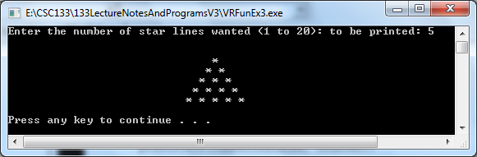

7. Functions that Return a Single Value
1. System defined functions
a. Library functions
(1) Include:
(a) sqrt()
(b) pow()
(2) Return a single value such as in the functions
(a) cout << "The square root of 5 is " << sqrt(5.0) << endl;
(b) y = sqrt(5.0);
cout << "The square root of 5 is " << y << endl;
2. User defined functions:
a. Common practice:
(1) When a function calculates a single value, this value should be returned to the calling function using the return statement
b. Consider the following function:
(1) Code:
// Function: Average()
// Purpose: This function calculates and returns the average
// of three floating point grades.
// Input to this function is test grades
float Average (float test1, float test2, float test3)
{
float avg; //average of scores
avg = (test1 + test2 + test3)/3.0;
return avg;
}
(2) Explanation:
(a) The average is returned using the return statement
(b) The "float" preceding the word "Average" in the function header indicates that the datatype of the value returned will a float value
- Full program:
// Functions Full Example 4 – Functions With Value Parameters
// Program: Computes an average of test grades utilizing a function with a // value parameter
// The results of the function is passes back through the function name

#include <iostream>
#include <iomanip>
#include <math.h>
using namespace std;

float Average (float test1, float test2, float test3);

int main ()
{
//Declare the variables
float testScore1;
float testScore2;
float testScore3;
float scoreAverage;

// Input the data
cout<<"Enter the first test score : "<<endl;
cin>>testScore1;
cout<<"Enter the second test score : "<<endl;
cin>>testScore2;
cout<<"Enter the third test score : "<<endl;
cin>>testScore3;
//Call the function and store the results in a variable
scoreAverage=Average(testScore1,testScore2,testScore3);
//Display the output
cout<<"The average of the scores is: "<<endl;
cout<<scoreAverage<<endl;
system ("PAUSE");
return 0;
}

// Function: Average()
// Purpose: This function calculates and returns the average
// of three floating point grades.
// Input to this function is test grade
float Average (float test1, float test2, float test3)
{
float avg; //average of scores
avg = (test1 + test2 + test3)/3.0;
return avg;
}
- Output:
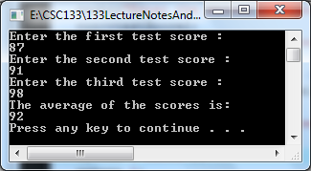

H. Functions with Reference Parameters
1. Function Declaration
a. About “reference” parameters
(1) Is the second type of parameter
(2) Sometimes these parameters are referred to as “call by reference”
(3) Applies to those arguments (parameters) whose addresses have been passed
(4) These parameters are used to either:
(a) Send back a value (output) or
(b) Both to send in (input) values and out (output) values from functions.
(5) Reference parameters have the ampersand (&) placed after their type
identifier in the function prototype and function heading.
b. Example 1:
(1) Is a function that reads and returns (outputs) the length and width of a
rectangle entered by a user
(2) Code version 1:
int GetTheData(int& length, int& width);
(3) Code version 2:
int GetTheData(int&, int&);
(4) Explanation:
(a) Both values are to be sent back to the calling function
(b) Since both are sent back, both are reference parameters.
c. Example 2:
(1) Is a function that updates (passes data in as input and sends data back as
output) the balance of a bank account by processing the current transaction amount
(2) Code version 1:
int UpdateAccountBalance(float amount, float& balance);
(3) Code version 2:
int UpdateAccountBalance(float, float&);
(4) Explanation:
(a) Amount is for input information only
(b) Amount is therefore declared to be a value parameter.
(c ) Balance is used both as an input parameter passed into the function
and as an output parameter passed back out from the function
when it completes processing
- Balance is therefore declared to be a reference parameter.
2. Function Activation
a. Unlike value parameters, the arguments corresponding to reference parameters
have to be variables
b. Reference parameters also should have been declared properly before the
activation of the function.
  - Example 1
GetTheData(length, width);
d. Example 2:
UpdateAccountBalance(1000, balance);
3. Function Definition
a. In the function heading, reference parameters must have types followed by an
ampersand (&).
b. Example 1:
int GetTheData(int& length, int& width)
{
cout << "Please enter the length of the rectangle" << endl;
cin >> length;
cout << "Please enter the width of the rectangle" << endl;
cin >> width;
return 0;
}
c. Example 2:
int UpdateAccountBalance(float amount, float& balance)
{
balance = balance + amount;
return 0;
}
d. When the parameter is a reference parameter
(1) The address of the parameter is passed to the function
(2) This means that if the reference parameter is changed in the function, the original argument is also changed in the code that called the function
e. Code and memory relationship:
(1) This section demonstrates the relationship between the actual arguments in
the calling program and formal parameters in a function
(2) The following diagram demonstrates the relationship between actual
arguments in the calling program and formal reference parameters in a
function
(a) The formal arguments are using the same memory location as the
actual arguments.
In the calling program : Memory
(in Main)
int q = 10; q r
float r;
10
?
……
// activation
ChangeArgs (q, r);
__________________________

// function definition
int ChangeArgs (int& s, float& t)
{ t = 6.0; (in Function)
s = 2 * s;
return 0;
}
(b) In the above diagram:
[1] The formal arguments are using the same memory location as the actual arguments.
[2] The picture shows that when the function is called, q (and therefore s) has the value 10.
[3] The second actual argument, r, has not been assigned a value yet and thus the formal argument t does not have a value either.
(3) The following diagram demonstrates the relationship between actual
arguments in the calling program and formal reference parameters in a
function after execution but prior to the return to the calling program.
f. Example 3: ReferencesFunctionCallExample3
//In the calling program :

#include <iostream>
using namespace std;

int ChangeArgs(int&, float&); Memory
int main() (in Main)
int q = 10; q r
float r;
20
6.0

// activation
ChangeArgs (q, r);
cout << "q= " << q << " r= " << r; __________________________
cout << endl;
system (“pause);
return 0;
// function definition
int ChangeArgs (int& s, float& t)
{ s t
t = 6.0; (in Function)
s = 2 * s;
cout << "t= " << t << " s= " << s; << endl;
return 0;
}

(a) Output generated:

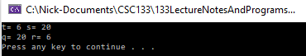

(b) In the above diagram:
[1] The values of q, r, s, and t after the two statements in the function have been executed but prior to the return to the calling program.
[2] Since t was assigned to 6.0 that r also has the value 6.0 because both r and t refer to the same memory location.
[3] Similarly the value given to s is also given to q because both q and s refer to the same memory location.
g. Example 4:
(1) Code:
// Functions Full Example 4 – Functions With Reference Parameters
// Program: Computes a grade utilizing a function with a reference parameter
// This program reads a grade number and prints the corresponding letter grade.

#include <iostream>
using namespace std;

int getNumber(int& number);
int printGrade(int number);

int main ()
{
int courseNumber;
cout<<"Line 1: Based on the grade number, this program "
<<"computes the course grade."<<endl; //Line 1
getNumber(courseNumber); //Line 2
printGrade(courseNumber); //Line 3
system ("PAUSE");
return 0;
}

int getNumber(int& number)
{
cout<<"Line 4: Enter grade number: "; //Line 4
cin>>number; //Line 5
cout<<endl<<"Line 6: Grade number is: "
<<number<<endl; //Line 6
return 0;
}

int printGrade(int number)
{
cout<<"Line 7: Your letter grade for the course is: "; //Line 7
if(number >= 90) //Line 8
cout<<"A"<<endl;
else if(number >= 80)
cout<<"B"<<endl;
else if(number >= 70)
cout<<"C"<<endl;
else if(number >= 60)
cout<<"D"<<endl;
else
cout<<"F"<<endl;
return 0;
}

(2) Sample Output:
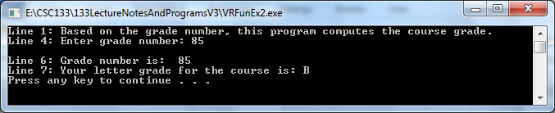

I. Functions with Reference and Value Parameters
1. With value parameters
a. The value of the actual parameter is copied into the memory cell
of its corresponding formal parameter
2. With reference parameters
a. The address of the actual parameter passes to the formal parameter
b. The content of the formal parameter is an address
c. During data manipulation, the content of the formal parameter (an address) directs
the computer to manipulate the data stored in the memory cell location
3. Example 1:
a. Code:
// Functions Full Example 1 – Functions With Reference And Value Parameters
// Shows how value and reference parameters work
#include <iostream>
using namespace std;
int functionOne(int a, int& b, char v);
int functionTwo(int& x, int y, char& w);
int main()
{
int num1, num2;
char ch;
num1 = 10; //Line 1
num2 = 15; //Line 2
ch = 'A'; //Line 3
cout<<"Line 4: Inside main: num1 = "<<num1
<<", num2 = "<<num2<<", and ch = "<<ch<<endl; //Line 4
functionOne(num1, num2, ch); //Line 5
cout<<"Line 6: After functionOne: num1 = "<<num1
<<", num2 = "<<num2<<", and ch = "<<ch<<endl; //Line 6
functionTwo(num2, 25, ch); //Line 7
cout<<"Line 8: After functionTwo: num1 = "<<num1
<<", num2 = "<<num2<<", and ch = "<<ch<<endl; //Line 8
system ("PAUSE");
return 0;
}

int functionOne(int a, int& b, char v)
{
int one;
one = a; //Line 9
a++; //Line 10
b = b * 2; //Line 11
v = 'B'; //Line 12
cout<<"Line 13: Inside functionOne: a = "<<a<<", b = "<<b
<<", v = "<<v<<", and one = "<<one<<endl; //Line 13
return 0;
}

int functionTwo(int& x, int y, char& w)
{
x++; //Line 14
y = y * 2; //Line 15
w = 'G'; //Line 16
cout<<"Line 17: Inside functionTwo: x = "<<x
<<", y = "<<y <<", and w = "<<w<<endl; //Line 17
return 0;
}

b. Output:
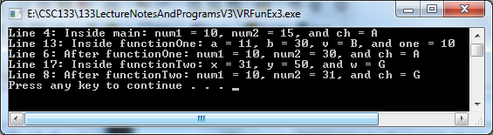
c. Execution of logic:
(1) Values of the variables after Line 3 executes
main
num1 = 10
num2 = 15
ch = A
(2) Line 4 generates the following output:
Line 4: Inside main: num1 = 10, num2 = 15, and ch = A
(3) Values of the variables just before Line 9 (one = a;) executes
main functionOne
num1 = 10 a = 10
num2 = 15 b =
ch = A v = A
one =
(4) Values of the variables after Line 9 (one = a;) executes
main functionOne
num1 = 10 a = 10
num2 = 15 b =
ch = A v = A
one = 10

(5) Values of variables after Line 10 (a++;) executes
main functionOne
num1 = 10 a = 11
num2 = 15 b =
ch = A v = A
one = 10
- Values of variables after Line 11 (b = b * 2;) executes
Notice that the variable b changed the value of num2
main functionOne
num1 = 10 a = 11
num2 = 30 b =
ch = A v = A
one = 10
- Values of variables after Line 12 (v = 'B';) executes
main functionOne
num1 = 10 a = 11
num2 = 30 b =
ch = A v = B
one = 10
(8) Line 13 generates the following output:
Line 13: Inside functionOne: a = 11, b = 30,
v = B, and one = 10
(9) Values of variables when control goes back to Line 6
main
num1 = 10
num2 = 30
ch = A
(10) Line 6 generates the following output:
Line 6: After functionOne: num1 = 10, num2 = 30, and ch = A
(11) Values of the variables before Line 14 executes
main functionTwo
num1 = 10 x =
num2 = 30 y = 25
ch = A w =
(12) Values of the variables after Line 14 (x++;) executes
Notice that the variable x changed the value of num2
main functionTwo
num1 = 10 x =
num2 = 31 y = 25
ch = A w =
(13) Values of the variables after Line 15 (y = y * 2;) executes
main functionTwo
num1 = 10 x =
num2 = 31 y = 50
ch = A w =
(14) Values of the variables after Line 16 (w = 'G';) executes
Notice that the variable w changed the value of ch.

main functionTwo
num1 = 10 x =
num2 = 31 y = 50
ch = G w =
(15) Line 17 generates the following output:
Line 17: Inside functionTwo: x = 31, y = 50, and w = G
(16) Values of the variables when control goes back to Line 8
main
num1 = 10
num2 = 31
ch = G
(17) Line 8 generates the following output:
Line 8: After functionTwo: num1 = 10, num2 = 31, and ch = G
(18) After Line 8 executes, the program terminates and processing is complete.

K. Local and Global variables
1. Local variables
a. Are visible and can only be used within the function or block in which the variable was defined
b. Exist while the function or block is active (being executed), and then are destroyed when the function is exited.
c. Are variables defined inside a function
d. They can not be used to store values between calls to the function
2. Global variables
a. Are defined before function definitions (not in any block).
b. Are visible and can be used within all functions listed after the definition of these
variables in the program
c. It is not good practice to make use of global variables within individual functions
d. It is best for each function to be as self contained as possible and can best be achieved if the function only uses variables passed as arguments or variables which are defined locally.
e. A function that uses global variables is not independent and typically cannot be used in more than one program.
f. If more than one function uses the same global variable and something goes wrong, it is difficult to discover what went wrong and where.
3. Scope of a variable.
a. Is the portion of the program where the variable is valid or "known"
b. Example 1:
(1) Code:

// Scope Of AVariable Example #1
//Purpose: This program demonstrates scope of a variable.
//include files...
#include <iostream>
using namespace std;
//global function prototypes...

int ShowScope (int& , int ); // Line 11
//global variables...
int a,b; // Line 14
int main () // Line 16
{
a = 10; // Line 18
b = 20; // Line 19
cout << "Before activating ShowScope a= " << a << " and b= " << b;
cout << endl;
ShowScope (a,b); // Line 21
cout << "\nAfter ShowScope a= " << a << " b= " << b << endl;
//end of main...
cout << endl;
system ("PAUSE"); // Line 24
return 0;
}
//Function: ShowScope()
//Purpose: Further demonstrate scope

int ShowScope (int& x, int y) // Line 31
{

//local declarations...
int a,c; // Line 35

a = 100; // Line 37
c = 200; // Line 38
x = 300; // Line 39
y = 400; // Line 40
cout << endl;
cout << "inside ShowScope, a = " << a << " b = " << b << endl;
cout << " x = " << x << " and y = " << y << endl; // Line 42
return 0;
}
- Output:
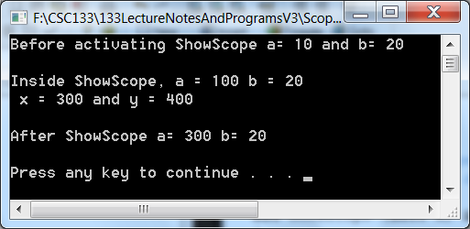

(3) Explanation:
(a) Line 14 - a and b are global variables since their definition occurs
outside of all curly braces.
(b) In ShowScope(), a, c, x and y are local variables since these variables are defined in the function header or after the function header.
(c ) There is a global variable and a local variable with the same name. [1] When this happens, any reference to this name results in
action being taken as locally as possible.
[2] The assignment a = 100 in the function called ShowScope()
only effects the local a and not the global a.
(d) a and b are global variables so their scope is the entire program
including the ShowScope() function.
- The local variables a, c, x and y are defined in ShowScope() so
their scope is the function ShowScope() and they are not known
outside of that function.
- ShowScope() has two arguments named x and y.
[1] The x argument is a pass-by-reference argument (parameter)
[2] The y argument is a pass-by-value argument. (parameter)
(3) Execution of the program would be:
(a) The global variable a receives the value 10 from the assignment statement on line 18
(b) The global variable b receives the value 20 respectively from the assignment statements on line 19
(c ) Line 21 calls ShowScope()
[1] Since x is a reference argument, x and a refer to a common memory location.
[2] Since y is a value argument, y has its own location and receives the value that was stored in b.

Global Variables In ShowScope
a 10 x
b 20 y 20
a
c
- ShowScope()
[1] Has two local variables called a and c
[2] Each of these receive their own memory locations.
[3] When ShowScope() is first called, memory is shown in the
above diagram.
[4] The contents of memory after the four assignment
statements from lines 35 through 38 have been executed is shown below
Global Variables In ShowScope
a 300 x
b 20 y 400
a 100
c 200
- Lifetime of a Variable
a. Is the period of time during which that variable exists during execution.
(1) Some variables exist only briefly.
(2) Some are repeatedly created and destroyed by a function being repeatedly executed
(3) Some exist for the entire execution of a program.
b. Two storage classes of variables:
(1) Automatic variables
(a) It’s memory location is created when the block in which it is
declared is entered.
(b) Exists while the block is active, and then it is destroyed when the block is exited.
(c) A local variable is an automatic variable because it is created when the block in which it is declared is entered and is destroyed when the block is left
(2) Static variables.
(a) Is a variable that exists from the point at which the program begins
execution and continues to exist during the duration of the program.
(b) Storage is allocated and initialized once when the program begins execution.
(c ) A global variable is considered similar to a static variable since a global variable exists during the duration of the program.
[1] Storage for the global variable is allocated and is initialized once when the declaration for the global variable is executed
[2] This means that both the global variable and the static variable have a history preserving feature
[a] They continue to exist
[b] Their contents are preserved throughout the lifetime of the program
- A local variable can be declared to be static by using the keyword “static” in the variable's declaration
[1] Example: static int num=0;
[2] This is done there is a need to remember values between function calls.
[a] This is the most common use of a static variable.
[b] When a local variable is declared as static, the program keeps the variable and its latest value even when the function that declared it is through executing.
[3] It is usually better to declare a local variable as static than instead of using a global variable.
[4] A static variable is similar to a global variable because its memory remains for the lifetime of the entire program.
[5] However, a static variable is different from a global variable because a static variable's scope is local to the function in which it is defined.
[a] Other functions in the program can not modify a static variable's value because only the function in which it is declared can access the variable.
[b] So therefore only the function in which it is
declared can change the contents of the static variable.
(3) Example 1:
(a) Code:
The following program shows how static variables work
//Program: Static and automatic variables
//Functions Example 7 With Static Variables
#include <iostream>
using namespace std;

int demo();
int main()
{
int count;
for(count = 1; count <= 5; count++)
demo();
system ("PAUSE");
return 0;
}

int demo()
{
static int x = 0;
int y = 10;
x = x + 2;
y = y + 1;
cout<<"Inside demo, x = "<<x<<" and y = "
<<y <<endl;
return 0;
}
(b) Output:
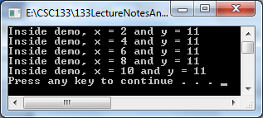
(c ) Explanation:
[1] In the function named demo
[a] x is a static variable initialized to 0
[b] y is an automatic variable initialized to 10.
[2] The function main calls the function demo five times.
[3] Memory for the variable y is allocated every time the function demo is called and the memory is deallocated when the function demo exits.
[a] This is why the function demo is called, it prints the same value for y every time.
[4] Because x is a static variable
[a] Memory for x remains allocated as long as the program executes.
[b] The variable x is initialized once to 0
[c] All the subsequent calls of the function demo use the current value of x
L. Functions example containing an algorithm and solution
1. Problem: We want to calculate how much paint is needed to paint a particular wall, and how much that is going to cost.
a. The user (the sales clerk in a paint shop) will enter the height and width of the wall
b. The user will also enter, for the kind of paint desired, how many square metres of wall can be covered per litre of paint
c. The user will also enter the cost of the paint per litre
d. We must calculate how many litres are needed (paint is only sold in litres, so fractions must be rounded up), and how much that will cost
e. Finally summarize the information for the user

2. Design
a. Get wall area from user
b. Prompt user for wall dimensions (height, width in metres)
c. Read in wall dimensions
d. Return area = height * width
e. Get cost of paint (per litre) from user
f. Prompt user, read in and return result
g. Get area of paint coverage (sq. metres per litre) from user
h. Prompt user, read in and return result
i. Calculate amount of paint needed
j. Exact amount of paint needed = area / coverage per litre
k. Round up exact amount to nearest whole number
l. Calculate cost of paint
m. Cost = number of litres needed * cost per litre
n. Display information
o. Print the room area, coverage of paint, and cost of paint per litre
p. Print number of litres needed, and corresponding cost

3. Coding implementation using call by value:
// Functions Example 5 – Without Global Variables
#include <iostream>
#include <iomanip>
#include <math.h>
using namespace std;

float Get_wall_area();
float Get_paint_cost();
float Get_paint_coverage();
int Calculate_paint(float area, float coverage);
float Calculate_cost(int litres_paint, float unit_cost);

int display_results(float area, float coverage,
float unit_cost, int litres_paint, float total_cost);

int main()
{
float area, coverage, unit_cost, total_cost;
int litres_paint;
area = Get_wall_area();
unit_cost = Get_paint_cost();
coverage = Get_paint_coverage();
litres_paint = Calculate_paint(area, coverage);
total_cost = Calculate_cost(litres_paint, unit_cost);
display_results(area, coverage, unit_cost,
litres_paint, total_cost);
system ("PAUSE");
return 0;
}

float Get_wall_area()
{
float height, width;
cout << "Please enter the room height and width "<<endl;
cout << "in metres, then enter return" << endl;
cin >> height >> width;
return(height * width);
}

float Get_paint_cost()
{
float cost;
cout << "Please enter the paint cost per litre";
cout << endl;
cin >> cost;
return(cost);
}

float Get_paint_coverage()
{
float coverage;
cout << "Please enter the number of square metres"<<endl;
cout << " of wall space that can be covered with "<<endl;
cout << "a single litre of paint" << endl;
cin >> coverage;
return(coverage);
}

int Calculate_paint(float area, float coverage)
{
return( int( ceil(area / coverage)));
}

float Calculate_cost(int litres_paint, float unit_cost)
{
return( litres_paint * unit_cost );
}

int display_results(float area, float coverage,
float unit_cost, int litres_paint, float total_cost)
{
cout << "For a wall with area " << area;
cout << " square metres, " <<endl;
cout << "we require ";
cout << litres_paint << " litres of paint, " << endl;
cout<<“each covering “ <<coverage;
cout <<“square meters”<< endl;
cout << setiosflags(ios::fixed);
cout << "costing " << setprecision(2) << unit_cost;
cout << " dollars per litre," << litres_paint << endl;
cout << "gives a total cost of $" << total_cost;
cout << endl;
return 0;
}

- Output:
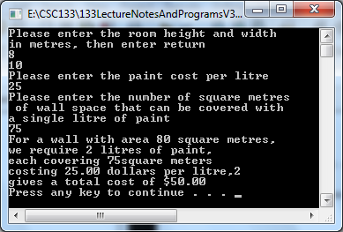

M. Another parameter passing example using call by reference
1. Code:
// Functions Full Example 6 – Withoout Global Variables
#include <iostream>
#include <iomanip>
#include <math.h>
using namespace std;

double get_area_height_width(float& height, float& width);

int main()
{
float wallheight, wallwidth, wallarea;
wallarea = get_area_height_width(wallheight, wallwidth);
cout << "area " << wallarea << " = ";
cout << "width " << wallwidth << " * ";
cout << "height " << wallheight << endl;
system ("PAUSE");
return 0;
}

double get_area_height_width(float& height, float& width)
// set width and height to user input values
// and return area = height * width
{
float area;
cout << "Please enter the wall height: " << endl;
cin >> height;
cout << "Please enter the wall width: " << endl;
cin >> width;
area = width * height;
return(area);
}
  - Output:
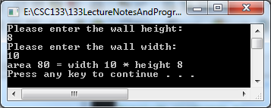
3. Explanation:
a. With the & symbols, height and width are local names for wallheight and
wallwidth, whose values can really be changed.
b. If the & symbol is not used, get_area_height_width would only receive copies of
the values of wallwidth and wallarea, and would not be able to change the values
of the `real' variables.
N. Function Overloading
1. Is when several functions can have the same name.
2. In C++, this is called overloading a function name.
3. An important rule:
a. If several functions have the same name
(1) Every function must have a different set of parameters
(2) The data types of parameters determine which function to execute.
4. Function overloading is used when you have the same logic for different data types.
5. Example 1:
a. A function could determine the larger of two data items.
b. Both items can be integers, floating-point numbers, characters, or strings.
c. The functions could be declared as follows:
(1) int largerInt(int x, int y);
(2) char largerChar(char first, char second);
(3) double largerDouble(double u, double v);
(4) string largerString(string first, string second);
d. Purpose of each function:
(1) largerInt - determines the larger of two integers
(2) largerChar - determines the larger of two characters
(3) largerDouble – determines the larger of two double precisions
(4) largerString – determines the larger of two strings
e. All of the functions perform similar operations by comparing two variable
contents to one another to determine which variable has a greater or lesser content than the other variable
f. The overloading concept occurs by using the same name for all the functions instead of giving different names each of these functions
  - Example overloading (same) name for the function: larger
  - For each function you can overload the function named larger.
  - Can write the previous function prototypes as:

(1) int larger(int x, int y);
(2) char larger(char first, char second);
(3) double larger(double u, double v);
(4) string larger(string first, string second);
  - Execution example of “larger”
(1) If the function call is larger(5,3)
(a) The function utilizing integral values executes
(2) If the function call is larger('A', '9')
(a) The function utilizing char values executes
(3) If the function call is larger(4.2,1.5)
(a) The function utilizing double values executes
(4) If the function call is larger('computer', 'science')
(a) The function utilizing string values executes
k. The logic for each function type has to handle the different data types

XVIII. One Dimensional Arrays
A. Explanation
1. Is a way of using data in groups rather than in individual pieces.
2. Group data together in a set called an array
a. Is a homogeneous data type also used to represent a group of data.
b. Might be used to store many items of the same type as a conceptual unit.
  - Examples
(1) All of the scores made on a test by students might be stored in an array
(2) The names of students in a class might be stored in an array
B. Comparison
1. A variable
a. Is a symbolic name for a specific location in main memory.
b. For example, the statements:
(1) int x;
. (a) Instructs the computer to set aside a memory location that will hold
an integer
(b) Gives the memory location the symbolic name x.
(2) x = 25;
(a) Instructs the computer to store the integer 25 in the memory location with the symbolic name x.
c. How can twenty different integers be stored in memory?
  - An array

a. Is a group of locations in memory that
(1) The locations are usually consecutive
(2) All of these locations will contain the same type of data
(3) All of these locations are referenced by the same symbolic name.
b. Are used anytime there is a need to store and manipulate more than a few pieces of data of the same type.
c. Example of when to use an array:
(1) To compute the average pay for 30 people.
a. An array is not needed since there is no need to remember the data for all 30 people.
b. Can input data for one person and add it to an accumulator
c. Can use the same variable for the next person since there is no need to remember data for the previous person.
(2) If there is a need to print out 30 scores in reverse order.
        - An array can be used to remember all 30 numbers in order to print
the 30 numbers out in reverse order.
d. Dimensions of arrays
(1) One dimensional
(a) Viewed as either one row or
(b) Viewed as one column
(2) Two dimensional
(a) Is a combination of rows and columns
(b) Sometimes referred to as a table
(3) Three dimensional
(a) Considered to be multi-tiered
- Contains rows, columns, and levels (tiers)
C. Declaring One-Dimensional Arrays
1. Example:
a. 30 integer scores need to be stored in an array
b. C ++ code to declare the array:
(1) const int MAX_SCORES = 30;
int scores[MAX_SCORES];
(2) The constant MAX_SCORES sets the upper limit on the size of the array.
(a) Using a const value to define the size of the array is not required but is good programming practice.
(b) It allocates 30 locations in memory to be set aside under the name
scores.
- Scores is the name of the array
- Int in front of scores is the data type.
- The scores array can hold up to 30 integer values.
- It is one-dimensional because it uses only one set of [ ] in its declaration.
D. Accessing an Array Element
1. To store information in an array, there is a need to:
a. Specify the name of the array
b. Specify exactly which location in the array is to be used to store the information
2. Specify locations in the array by using an index.
a. Example, using the array scores defined above.
b. C++ statement scores[i]=20; means
(1) Look at the location designated by i in the array list
(2) Store the value 20 in the designated at position i.
c. The index can be a constant, variable, or expression
(1) Examples
(a) scores[5] = 100; //index = 5
(b) scores[x] = 80; //index = the value of the variable x
(c) scores[3*x] = 75; //index = three times x
3. To determine valid values for the index, look at the definition of the array
a. Example 1:
int scores[MAX_SCORES];
75 | 95 |  |  |  | 100
Index: [0] [1] [2] [3] [4] [5] … … … … [29]

(1) The upper limit of the index is calculated from the value in brackets
(a) It is: namely MAX_SCORES - 1.
(2) The lower limit in C++ is always 0.
(3) The index may vary from 0 to MAX_SCORES - 1.
(4) The first memory location assigned to scores is designated by the first index value 0, the second by index value 1, and so on, up to the last one which is designated by the index value MAX_SCORES - 1.
b. Example 2:
int scores[MAX_SCORES + 1];
(1) Could access scores[0], scores[1],..., scores[MAX_SCORES].
E. Placing values into an array
1. Data could be entered from within the program
a. Example:
(1) Scores[0] = 75;
(2) Scores[1] = 95;
b. Places data into the first two positions of the array Scores
2. Usually a loop of some kind is used to load data into an array.
3. The following code reads in an array of values entered from the keyboard.
scores[5]
37 | 23 | 11 | 15 | 24
[0] [1] [2] [3] [4]

//Loading And Print A One Dim Array Example 1
//read in the number of scores
#include <iostream>
#include <iomanip>
using namespace std;
int main()
{
int howMany = 5;
int scores[5];

//now read in the scores
for (int i = 0; i < howMany; i++)
{
cout << "Input scores[" << i << "]: "; // User sees: Input scores[0], etc.
cin >> scores[i];
}

//print the scores
for (int i = 0; i < howMany; i++)
{
cout << endl;
cout << "The value of score at position [" << i << "] is ";
cout << scores[i] << endl;
}
return 0;
}

4. Initializing an array
a. The following loop initializes every position of the array sales to 0.0.
for(index = 0; index < 10; index++)
sales[index] = 0;
sales[10]
0 | 0 | 0 | 0 | 0 | 0 | 0 | 0 | 0 | 0
[0] [1] [2] [3] [4] [5] [6] [7] [8] [9]

F. Printing values from with an array to the monitor:
1. The following code prints values from an array
//print the scores
for (int i =0; i < 10; i++)
{
cout <<"The value of score at position [" << i << "] is ";
cout << score[i]<<endl;
}
G. Using a One-dimensional Array as a Parameter
1. A function could also be used to read data in an array.
2. Example:
a. A function might be used to read an array of values from an input file stream.
b. The array's actual size and all the elements in the array are read from the file.
c. The "actual" size of the array may not be the same as the MAX_SCORES used to declare the array.
(1) MAX_SCORES could be the biggest size that is ever need for this array.
(2) The actual size is how much of the array is being used on one particular run of the program
d. Code:
int ReadInScores (ifstream& ins, int scores[ ], int& howMany)
{
//read the number of scores
ins >> howMany;

//now read the scores
for (int i = 0; i < howMany; i++)
{
ins >> scores[i];
}
return 0;
}
3. When an array is passed as an argument
a. There is no need to indicate the size of the array.
b. The empty brackets [ ] in the parameter list tell the compiler that scores is an array of int rather than just a simple int variable.
4. Points to remember about parameters:
a. All arrays in C++ are pass-by-reference when used as function parameters.
(1) This means that when an array appears in the argument list of an activation statement
(a) The address of the array is sent to the function
(b) Not the contents of the array
(c) The array in the parameter list is an alias (will refer to) to the same array as the argument.
b. Use the reserve word const in the parameter list if an array is used and the contents of the array should NOT be altered.
(1) Example header:
(a) In the following function header:
void PrintScores(int howMany, const int scores[ ])
(b) The values in the array scores can not be changed in the PrintScores() function because const is used in the parameter list.
(c) By using const, this protects the contents of the array
(2) Example main program:
(a) Declares an array and to use the functions above to read values into the array and print them.

(b) The input data file scores.txt contains:

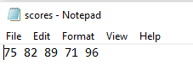

(c) Code:
//Load And Print A One Dim Array Example 2
//This example uses an input data file and outputs to the console
#include <fstream>
#include <iostream>
#include <iomanip>
using namespace std;

int ReadInScores(ifstream& inputFile, int scores[], int howMany);
int PrintScores(int howMany, int scores[]);

int main()
{
int howMany = 5; //the array has at most 5 entries
int scores[5] = { 0,0,0,0,0 }; //an array of test scores with 5 entries
ifstream inputFile; //the input file stream containing scores

//open the input file
inputFile.open("f:/csc133/133LectureNotesAndProgramsV3/LoadAndPrintAOneDimArrayExample2/scores.txt");

//activate the function to read the scores
ReadInScores(inputFile, scores, howMany);

//activate the function to print the scores
PrintScores(howMany, scores);
return 0;
}

// The ReadIn Scores Function
int ReadInScores(ifstream& inputFile, int scores[], int howMany)
{
//now read the scores
for (int i = 0; i < howMany; i++)
{
inputFile >> scores[i];
}
return 0;
}

// The PrintScores Function
int PrintScores(int howMany, int scores[])
{
for (int i = 0; i < howMany; i++)
{
cout << "The value of score at position [" << i << "] is ";
cout << scores[i] << endl;
}
return 0;
}

(d) Explanation:
[1] When an array appears as an argument in an activation statement
[a] Only the name of the array is needed
[b] It would be an error to place the brackets after the array name in the argument list.

H. Searching an Array
1. Is one of the most common list operations
2. Means that you are searching for an item in the list.
3. Common activities:
a. Searching an array for a value
b. Determining whether a value is in the array
c. If the value is in the array, determine the value's index.
4. Two commonly search techniques:
a. One that can be done on any list (a linear search) or (a sequential search)
b. One that requires the list to be sorted. (a binary search)
5. Linear search
a. Is used for an array of elements has not been sorted in any particular order
b. Can determine the location of a particular value in an array
c. Linear search technique:
(1) Look at every element in the array
(2) Look at the elements one-at-a-time beginning at the first element
(3) When the value is found in the array, quit the search immediately
(4) If the entire array is searched without quitting,
(a) The search is unsuccessful
(b) The value is not in the array.
d. Example:
(1) The method LinearSearch( ) returns the index of the searched value in the array if the value is found in the array.
(2) If the value is not found in the array, LinearSearch( ) returns -1.
(3) Code:
//CSC133-Search A One Dim Array Example 1
//read in the number of scores
#include <iostream>
#include <iomanip>
using namespace std;

int LinearSearch (int arrayList[], int aSize, int toFind);
int main()
{
int foundit;
int searchvalue;
int aSize = 12;
int arrayList[12] = {3,15,2,8,7,1,14,38,10,-2,61,5};

cout << "Enter the value you wish to search for: ";
cin >> searchvalue;
foundit = LinearSearch(arrayList, aSize, searchvalue);
if (foundit >= 0)
cout << "The value of: " << searchvalue << " was found at index: "
<< foundit << endl;
else
cout << "The value of: " << searchvalue << " was not found at and
returned a not found indicator of: " << foundit << endl;
return 0;
}

//Linear Search Function
int LinearSearch (int arrayList[], int aSize, int toFind)
{
// Look through all items, starting at the front.
for (int i = 0; i < aSize; i++)
if (arrayList[i] = = toFind)
return i;

// You've gone through the whole list without success.
return -1;
}
(4) Array content
(a) Is a list of integer values.
(b) Code:
int list[12] = {3,15,2,8,7,1,14,38,10,-2,61,5};

(5) Sample run 1:
(a) Search the one-dimensional array for the value 10.
(b) The call to the function above that would accomplish this:
index = LinearSearch(list,12,10)
(c) The diagram below shows what the function would do
to find the value: 10

start here …………… go through these…………….stop here

3 | 15 | 2 | 8 | 7 | 1 | 14 | 38 | 10 | -2 | 61 | 5
Index: 0 1 2 3 4 5 6 7 8 9 10 11
(d) After control returns to the activating function, index contains 8
(6) Sample Run 2:
(a) The illustration below is for the call index = LinearSearch(list,12,25)
[1] To find the value: 25

start here …………………….……go through these…………………………….stop here

3 | 15 | 2 | 8 | 7 | 1 | 14 | 38 | 10 | -2 | 61 | 5
Index: 0 1 2 3 4 5 6 7 8 9 10 11

(b) After control returns to the activating function
(1) The index will contain -1
(2) This means that that the function did not find 25 in the array.
(3) The search went all the way to the end of the array because the value 25 is not in the list
(c ) The previous search could have been shortened if the array is ordered
(1) This allows the process to quit as soon as a value that is bigger than the one being searched is reached
6. The Binary Search
a. Can be used on an array that has been sorted into ascending or descending order.
b. The algorithm for a binary search could be:
(1) Compare the value being searched for to the value in the middle of the array
(2) If value is the one in the middle:
(a) Then quit
(b) The value has been found in the array
(3) Else if the value < is the one in the middle
        - Look at the sublist making up the first half of the array (before the
middle item)
(4) Else if the value > the one in the middle
        - Look at the sublist making up the last half of the array (after the
middle item)
(5) If the value was not found, repeat the search on the sublist.
(6) The process is are done when the item is found or whenever the sublist that is remaining to be searched is empty

c. Possible C++ solution:
(1) Performs a binary search on an integer array with a size named aSize.
(2) The function
(a) Searches for the value toFind
(b) Returns either
[1] The index of its location in the array or
[2] The value -1 if the value was not found
meaning that it was an unsuccessful search
(3) Code:
int BinarySearch(int a[ ], int aSize, int toFind)
{
int start = 0; //the search starts with index 0
int last = aSize -1; //last is the last array index

while (start <= last) //while there is still a place to look.
{
int middle = (start + last) / 2; //Look here first
if (toFind = = a[middle]) //Found item. Quit.
return middle;
if (toFind > a[middle]) //Look in the last half
start = middle + 1;
else //OR look in the first half
last = middle - 1;
}
//the element wasn't found
return -1;
}
(4) Array declaration and content (in presorted ascending order):.
int list[12] = {-2,1,2,3,5,7,8,10,14,15,38,61};
int val; // An item to search for in the list
int index; // Index of val in the list

// .. assign something to val
index = BinarySearch(list, 12, val);

(5) The full program:
//CSC133-Binary Search Example 1
#include <iostream>
#include <iomanip>
using namespace std;

int BinarySearch(int list[ ], int aSize, int toFind);

int main()
{
int list[12] = {-2,1,2,3,5,7,8,10,14,15,38,61};
int asize = 12; // Is the array size
int index; // Index of val in the list
int searchvalue; //The value being searched for

// Input something to searchl
cout << “What value would you like to search for? “;
cin >> searchvalue;
index = BinarySearch(list, asize, searchvalue);
if (index >= 0)
cout << "The value of: " << searchvalue << " was found at index: "
<< index << endl;
else
cout << "The value of: " << searchvalue << " was not found and “
<< “returned a not found indicator of: " << index << endl;
return 0;
}
//The Binary Search Function
int BinarySearch(int arraylist[ ], int arraySize, int toFind)
{
int start = 0; //the search starts with index 0
int last = arraySize -1; //last is the last array index

while (start <= last) //while there is still a place to look.
{
int middle = (start + last) / 2; //Look here first
if (toFind = = arraylist[middle]) //Found item. Quit.
return middle;
if (toFind > arraylist[middle]) //Look in the last half
start = middle + 1;
else //OR look in the first half
last = middle - 1;
}
//the element wasn't found
return -1;
}

(6) Sample run 1:
(a) The diagram below uses a sorted version of the same list that had demonstrated the linear search.
(b) The following call to the search with the activation statement:
BinarySearch(list, asize, searchvalue)
[1] To find the value: 10
[2] Returns 7 (the index number)

first pass
second pass
third pass
fourth pass

-2 | 1 | 2 | 3 | 5 | 7 | 8 | 10 | 14 | 15 | 38 | 61
Index: 0 1 2 3 4 5 6 7 8 9 10 11
(6) Sample run 2:
(a) The diagram below uses a sorted version of the same list
(b) The following call to the search with the activation statement:
BinarySearch(list, asize, searchvalue)
[1] To find the value: 25
[2] Is an unsuccessful search
[3] On the final call:
[a] Start = 10
[b] Last = 9

first pass
second pass
third pass
fourth pass

-2 | 1 | 2 | 3 | 5 | 7 | 8 | 10 | 14 | 15 | 38 | 61
Index: 0 1 2 3 4 5 6 7 8 9 10 11

d. Why use a binary search?
(1) The binary search is more efficient than a linear search
(a) In a linear search
[1] If the size of the list is doubled, it could potentially take twice as much time to find an item.
(b) In a binary search
[1] Doubling the size of the list just adds one more item to look at.
[2] Each time a search is done through a binary search, half of the remaining list items as possible matches are eliminated
- Bubble Sort
1. Elements gradually "bubble" (or rise) to their proper positions as they are being sorted
2. Algorithm:
a. Repeatedly compare adjacent elements of an array and swap the contents of the elements if necessary
(1) Starting with the first and second elements
(2) Swapping them if they are out of order
(3) After the first and second elements are compared and swapped if necessary, the second and third elements are compared, and swapped if they are out of order.
(4) This continues until the end of the array list is reached.
(5) When the end of the list is reached,
(a) Elements one and two are compared again
(b) The process continues until all elements are in their proper order
(6) Processing is finished when it examines the entire array and no "swaps" are needed.
3. The following example data in the table shows a list of numbers - before, during, and
after a bubble sort built to achieve descending order of the numbers.
a. Several passes have to be made through the array before the array is fully sorted.
- b. The bubble sort is easy to program, but it is slow when comparing it to many
- other sorting algorithms.
c. The use of a temp variable:
(1) A temp variable is used as a temporary location for when the contents of 2 variables needs to be swapped and there is no swap function available in the compiler.
(2) The temp variable holds the contents one variable so that its contents does not get overlaid during a swap.
(3) For example:
(a) To start out:
X = 5
Y = 7
(b) To swap the values, a variable named such as “temp” can be used
(c) To reassign the values:
X = 5
Y = 7
// After the line is executed:
Temp = X // assigns the value of X which is 5 to Temp
// Temp is now 5 and X is still 5)
X = Y // assigns the value of Y which is 7 to X
// X is now 7, and Y is still 7 (the value of 5 is gone)
Y = Temp // assigns the value of Temp which is 5 to Y
// Y is now 5, and Temp is still 5
(d) The final result of the swap:
X now equals 7
Y now equals 5

4. Sample data:
Array at beginning | 57 | 42 | 79 | 59 | 93 | 49
After pass #1 (where i was = 1) | 57 | 79 | 59 | 93 | 49 | 42
After pass #2 (where i was = 2) | 79 | 59 | 93 | 57 | 49 | 42
After pass #3 (where i was = 3) | 79 | 93 | 59 | 57 | 49 | 42
After pass #4 (where i was = 4) | 93 | 79 | 59 | 57 | 49 | 42
Array at end of sort (where i was = 5) | 93 | 79 | 59 | 57 | 49 | 42
[0] [1] [2] [3] [4] [5]
5. Code:
//CSC133–One Dim Array Bubble Sort Example 1
#include <iostream>
#include <iomanip>
using namespace std;

int bubble_sort(int scores[], int& howMany);
int print_scores(int scores[], int howMany);

int main()
{
int scores[6] = { 57,42,79,59,93,49 };
int howMany = 6; // Is the array size

cout << "The contents of the array before it sorted is : " << endl;
print_scores(scores, howMany);
system("PAUSE");
bubble_sort(scores, howMany);
cout << "The contents of the array after it sorted is : " << endl;
print_scores(scores, howMany);
system("PAUSE");
return 0;
}

// Bubble Sort Function for Descending Order
// Remember that arrays are passed to functions by address - they are not returned

int bubble_sort(int scores[], int& howMany)
{
int i, j, flag = 1; // set flag to 1 to begin the initial pass
int temp; // holding variable
for (i = 1; (i <= howMany) && flag; i++)
{
flag = 0;
for (j = 0; j < (howMany - 1); j++)
{
if (scores[j + 1] > scores[j]) // the > makes it into descending
// ascending order would use <
{
temp = scores[j]; // to swap elements, temp is a temporary
scores[j] = scores[j + 1]; // placeholder used to hold one value
scores[j + 1] = temp; // being swapped so it is not overlayed
flag = 1; // indicates that a swap occurred.u
}
}
print_scores(scores, howMany);
system("PAUSE");
}
return 0;
}

// The PrintScores Function
int print_scores(int scores[], int howMany)
{
for (int i = 0; i < howMany; i++)
{
cout << "The value of score at position [" << i << "] is ";
cout << scores[i] << endl;
}
cout << endl;
return 0;
} 7. 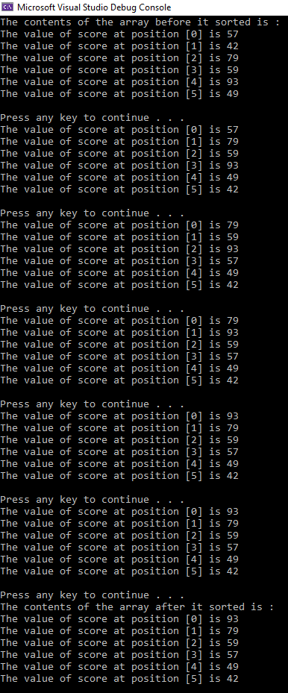

- Finding the sum and average of an array
1. This array contains sales data
- 2. Common calculations done to the data include the total sales and average sale amount
- 3. The following C++ code finds the sum of the elements of the array sale and the average
sale amount
4. Code:
sum = 0;
for(index = 0; index < 10; index++)
sum = sum + sale[index];
average = sum / 10;

K. Finding the largest element in the array
1. Code:
maxIndex = 0; maxIndex = 7
for(index = 1; index < 10; index++) index = 10
if(sale[maxIndex] < sale[index])
maxIndex = index;
largestSale = sale[maxIndex];

2. Sales array contents:

12.50 | 8.35 | 19.60 | 25.00 | 14.00 | 39.43 | 35.90 | 98.23 | 66.65 | 35.64
Index: 0 1 2 3 4 5 6 7 8 9
3. Logic to determine the largest element in the array sale
  - Before the for loop begins
(1) maxIndex is initialized to 0
(2) the for loop initializes index to 1
b. The following shows the values of maxIndex, index, and certain array elements during each iteration of the for loop:
index maxIndex sale[maxIndex] sale[index] sale[maxIndex] < sale[index]
1 0 12.50 8.35 12.50 < 8.35 is false
2 0 12.50 19.60 12.50 < 19.60 is true;
maxIndex = 2
3 2 19.60 25.00 19.60 < 25.00 is true;
maxIndex = 3
4 3 25.00 14.00 25.00 < 14.00 is false
5 3 25.00 39.43 25.00 < 39.43 is true;
maxIndex = 5
6 5 39.43 35.90 39.43 < 35.90 is false
7 5 39.43 98.23 39.43 < 98.23 is true;
maxIndex = 7
8 7 98.23 66.25 98.23 < 66.65 is false
9 7 98.23 35.64 98.23 < 35.64 is false
c. After the for loop executes
(1) maxIndex=7
- (2) giving the index of the largest element in the array sale
(3) largestSale=sale[maxIndex]=98.23.
L. Calculating a sum and printing numbers in reverse order from an array
1. Code:
//CSC133-1D-Array Processing Data Example #1
//Program to read five numbers, find their sum, and
//print the numbers in reverse order.
#include <iostream>
using namespace std;int main()
{
int item[5]; //declare an array named item of five components
int sum;
int counter;
cout<<"Enter five numbers."<<endl;
sum = 0;
for(counter = 0; counter < 5; counter++)
{
cin>>item[counter];
sum = sum + item[counter];
}
cout<<"The sum of the numbers is: "<<sum<<endl;
cout<<"The numbers in reverse order are: ";
//print the numbers in reverse order
for(counter = 4; counter >= 0; counter--)
cout<<item[counter]<<" ";
cout<<endl;
system ("PAUSE");
return 0;
}
2. Sample Run:
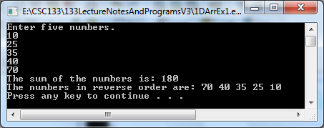
M. An out of bounds situation
1. The following loop example sets the index out of bounds
2. Code:
int list[10]; // valid indexes are 0 through 9
for (i = 0; i <= 10; i++)
list[i] = 0;
3. Explanation:
  - The list is an array of 10 components.
  - When i becomes 10, the loop test condition i<=10 evaluates to
true
(1) The body of the loop executes
- (2) Results in storing 0 in list[10]
(3) Logically, list[10] does not exist
(4) To fix this, change <= to < in the for statement comparison operation
N. The following example shows how to write functions for array processing and declare an array as a formal parameter.
1. Code:
//Function to initialize an array to 0
int initializeArray(int x[], int sizeX)
{
int counter;
for(counter = 0; counter < sizeX; counter++)
x[counter] = 0;
return 0;
}

//Function to read data and store it in an array
int fillArray(int x[], int sizeX)
{
int counter;
for(counter = 0; counter < sizeX; counter++)
cin>>x[counter];
return 0;
}

//Function to print the array
int printArray(const int x[], int sizeX)
{
int counter;
for(counter = 0; counter < sizeX; counter++)
cout<<x[counter]<<" ";
return 0;
}

//Function to find and return the sum of an array
int sumArray(const int x[], int sizeX)
{
int counter;
int sum = 0;
for(counter = 0; counter < sizeX; counter++)
sum = sum + x[counter];
return sum;
}

//Function to find and return the index of the
//largest element of an array
int indexLargestElement(const int x[], int sizeX)
{
int counter;
int maxIndex = 0; //Assume first element is the largest
for(counter = 1; counter < sizeX; counter++)
if(x[maxIndex] < x[counter])
maxIndex = counter;
return maxIndex;
}

//Function to copy one array into another array
int copyArray(const int x[], int y[], int length)
{
int counter;
for(counter = 0; counter < length; counter++)
y[counter] = x[counter];
return 0;
}

O. The following program illustrates how arrays are passed as actual parameters in a function call.
1. Code:
//CSC133-1D Array Processing Data Example #2
//Using Arrays as parameters to functions
#include <iostream>
using namespace std;

const int arraySize = 10;

int initializeArray(int x[], int sizeX);
int fillArray(int x[], int sizeX);
int printArray(const int x[], int sizeX);
int sumArray(const int x[], int sizeX);
int indexLargestElement(const int x[], int sizeX);
int copyArray(const int x[], int y[], int length);

int main()
{
int listA[arraySize] = {0}; //Line 1
int listB[arraySize]; //Line 2

cout<<"Line 3: listA elements: "; //Line 3
printArray(listA, arraySize); //Line 4
cout<<endl; //Line 5

initializeArray(listB,arraySize); //Line 6

cout<<"Line 7: ListB elements: "; //Line 7
printArray(listB, arraySize); //Line 8
cout<<endl<<endl; //Line 9

cout<<"Line 10: Enter "<<arraySize
<<" integers: "<<endl; //Line 10
fillArray(listA, arraySize); //Line 11

cout<<endl; //Line 12

cout<<"Line 13: After filling listA the elements are:"
<<endl; //Line 13
printArray(listA, arraySize); //Line 14
cout<<endl<<endl; //Line 15

cout<<"Line 16: Sum of the elements of listA is: "
<<sumArray(listA, arraySize)<<endl<<endl; //Line 16
cout<<"Line 17: Location of the largest element in listA is: "
<<indexLargestElement(listA, arraySize) + 1
<<endl; //Line 17
cout<<"Line 18: Largest element in listA is: "
<<listA[indexLargestElement(listA, arraySize)]
<<endl<<endl; //Line 18
copyArray(listA, listB, arraySize); //Line 19
cout<<"Line 20: After copying the elements of "
<<"listA into listB"<<endl
<<" listB elements are: "; //Line 20
printArray(listB, arraySize); //Line 21
cout<<endl; //Line 22
system ("PAUSE");
return 0;
}
//Function to initialize an array to 0
int initializeArray(int x[], int sizeX)
{
int counter;
for(counter = 0; counter < sizeX; counter++)
x[counter] = 0;
return 0;
}

//Function to read data and store it in an array
int fillArray(int x[], int sizeX)
{
int counter;
for(counter = 0; counter < sizeX; counter++)
cin>>x[counter];
return 0;
}

//Function to print the array
int printArray(const int x[], int sizeX)
{
int counter;
for(counter = 0; counter < sizeX; counter++)
cout<<x[counter]<<" ";
return 0;
}

//Function to find and return the sum of an array
int sumArray(const int x[], int sizeX)
{
int counter;
int sum = 0;
for(counter = 0; counter < sizeX; counter++)
sum = sum + x[counter];
return sum;
}

//Function to find and return the index of the
//largest element of an array
int indexLargestElement(const int x[], int sizeX)
{
int counter;
int maxIndex = 0; //Assume first element is the largest
for(counter = 1; counter < sizeX; counter++)
if(x[maxIndex] < x[counter])
maxIndex = counter;
return maxIndex;
}

//Function to copy one array into another array
int copyArray(const int x[], int y[], int length)
{
int counter;
for(counter = 0; counter < length; counter++)
y[counter] = x[counter];
return 0;
}

2. Sample Run:.
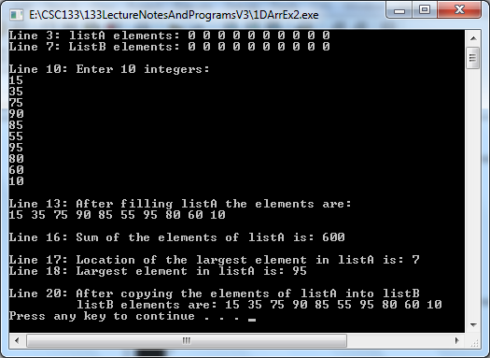

P. Parallel Arrays
1. Is when have corresponding components that hold related information in the same index location of each separate array.

2. Example:
a. There is a need to keep track of student:
(1) ID numbers (which are 4 digits long)
(2) Course grades (which are numbers)
b. There are 5 students in a class
- c. Can declare two arrays, each with 5 elements
(1) int studentId[5];
(2) char courseGrade[5];
d. What makes these arrays parallel?
- (1) studentId[0] and courseGrade[0] will store the ID and course grade of the
first student
(2) studentId[1] and courseGrade[1] will store the ID and course grade of the second student
(3) and so on up through and including element [4] for both array

3. Sample array contents:
(Index) | [0] | [1] | [2] | [3] | [4]
studentId | 1111 | 2222 | 3333 | 4444 | 5555
courseGrade | 89 | 78 | 65 | 92 | 94

4. Sample code:

//CSC133-Parallel Arrays Example 1
#include <iostream>
#include <fstream>
#include <iomanip>
#include <math.h>

using namespace std;

int studentId[5];
int courseGrade[5];
int onestudentid;
int onegrade;
int howMany = 5;
double totalCourseGrades = 0;
double avgCourseGrade = 0.0;

int main()
{
ifstream inputFile; //the input file stream containing
//open the input file
inputFile.open("f:/csc133/133LectureNotesAndProgramsV3/CSC133-
ParallelArraysExample1/studentgrades.txt");

//now read the input file
for (int i = 0; i < howMany; i++)
{
inputFile >> studentId[i];
inputFile >> courseGrade[i];
}

// sum the courseGrades
for (int ind = 0; ind < howMany; ind++)
{
totalCourseGrades = totalCourseGrades + courseGrade[ind];
}

//display the parallel arrays contents
cout << fixed << showpoint;
cout << setprecision(2);

for (int index = 0; index < howMany; index++)
{
cout << "Index: [" << index << "] is : "
<< "Student Id = " << studentId[index]
<< " & Course Grade = " << courseGrade[index] << endl;
}

avgCourseGrade = totalCourseGrades / howMany;
cout << endl << "The average of the course grades is: " << setw(6) <<
avgCourseGrade << endl;

system("PAUSE");
return 0;
}

5. Sample output:
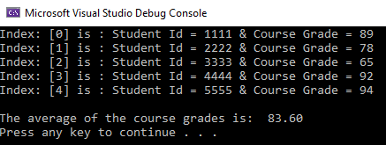

- Character Data and Strings
A. The char Data Type for Storing Characters
1. Can hold a single character value
2. Can declare character: constants, variables, and input and output character data
3. Example:
const char ASTERISK = '*';
char ch;
char letter;
letter = 'a';
cin >> ch;
cout << letter;
4 . The char data type sets aside one byte to store a character value.
5. Character Expressions and Comparisons
a. The relational operators = =, <, <=, >, >=, and != to compare also work with
character data.
(1) In C++, character data is really just a form of integer data.
(2) In the ASCII chart
(a) The digit characters '0' through '9' have code values of 48 through 57.
(b) The uppercase characters 'A' to 'Z' have the codes 65 through 90
(c) The expression 'A'<'B' will evaluate to true.
- The lowercase letters have the codes 97 through 122
- The boolean expression 'a'<'b' will evaluate to true
- An uppercase letter is less than a lowercase letter in the ASCII encoding scheme
- Thus the boolean expression 'A'<'a' will evaluate to true.
- Digits (numerals) are less than letters in the ASCII encoding scheme
- The boolean expression '9'<'A' will evaluate to true
- Since char values are just a form of integer data, it is possible to do arithmetic with them.
(k) 'C'-'A' evaluates to 2, because 67-65 equals two
(l) The code:
ch = 'a' + 10;
cout << ch;
would print the character k because:
[1] ‘k' is the tenth character after 'a'
[2] Also, because 97 (the ASCII value of 'a')
plus 10 equals 107, which is the ASCII value of 'k'.
(m) To use an ASCII character as a numeric quantity:
[1] Can use the C++ type cast operator int.
[2] It is used like a function.
[3] Examples: Thus int('0') is the value 48, int('A') is the value 65, and int('a') is the value 97.
b. The C++ type cast operator char will produce a character whose code is the given
integer.
(1) Examples:
(a) char(97) is 'a', char(48) is '0', etc.
(b) The following code would first print the letter A on one line, the number 65 on the second line, the number 37 on the third line, and the symbol % (percent sign) on the fourth line
int ac = 37;
char ch = 'A';
cout << ch << endl; // prints A
cout << int(ch) << endl; // prints 65
cout << ac << endl; // prints 37
cout << char(ac) << endl; // prints %
B. Character Functions
1. C++ has several functions to aid in the manipulation of character data.
2. To use these library functions the header file, include the ctype.h, must be included in a C++ program.
3. Some of these functions include:
1. isalpha(ch)
a. Returns true if ch is an upper or lower case letter.
b. Otherwise false is returned.
2. isdigit(ch)
a. Returns true if ch is a digit.
b. Otherwise false is returned
3. islower(ch)
a. Returns true if ch is a lowercase letter.
b. Otherwise false is returned.
4. isspace(ch)
a. Returns true if ch is a space (SP), newline (LF), formfeed (FF), carriage return (CR), tab (HT), or vertical tab (VT).
b. Otherwise false is returned
5. isupper(ch)
a. Returns true if ch is an uppercase letter.
b. Otherwise false is returned.
6. tolower(ch)
a. If ch is uppercase, the function returns the corresponding lowercase letter.
b. Otherwise, ch is returned.
7. toupper(ch)
a. If ch is lowercase, the function returns the corresponding uppercase letter. b. Otherwise, ch is returned.
C. Character Input
1. The extraction (input) operator >> can be used to read character values.
2. When reading character values using the extraction operator:
a. Any leading whitespace (blanks, tabs, newlines, etc.)
(1) Is skipped until the first non-whitespace character is found.
(2) For example:
(a) If the input is bbbbjk where (b is a blank)
(b) The code: cin >> ch;
causes the blanks to be skipped and the character j is read into ch.
b. C++ can be asked not to skip whitespace on input by setting a format state flag.
(1) Example:
(a) Causes the flag skipws to be turned off (it defaults to on, which means that whitespace is skipped over):
[1] The code: cin.unsetf(ios::skipws);
[2] After the flag is turned off, if the input is:
bbbbjk (b is a blank)
[3] Then the code cin >> ch;
[4] Will cause ch to contain a blank since whitespace is no longer skipped.
(b) Turning on and off a format state flag is difficult
[1] There is an easier mechanism to allow the input of one character at a time with whitespace treated the same way as any other character.
[2] The get( ) function reads the very next character in the input stream without skipping any whitespace.
[3] Using get( ) instead of cin in the above example
[a] If the input is:
bbbbjk (b is a blank)
[b] The code cin.get(ch);
[c] Will read a blank into the variable ch.
- C-style Character Strings (C strings)
1. The language C++ was based on the earlier language C.
a. Unlike C++, the older C language does not have the string data type.
b. In the C language
[1] Strings of characters are stored in one-dimensional arrays of type char, one character per array element.
[2] To use C formatted style strings in C++:
[a] Place a string of characters in double quotes
c. For example:
[1] cout << "Enter the test score:";
or
cout << "x=";
[2] A list of characters contained in double quotes is a C-style character string, or C string.
[3] Because C strings are stored as an array, the C string "x=" is stored as
x | = | \0
0 1 2
  - The C string is terminated by the special character '\0' called the NULL character
[1] The NULL character acts as a sentinel and marks the end of a C-style character string.
e. There is a difference between a C string and a character.
[1] Example,
[a] the C string "x" is stored as an array
x | \0 | …
0 1
[b] Versus, the character 'x' is stored as a single character
x
[c] Note that the string is enclosed in double quotes while the character is enclosed in single quotes (or apostrophes).
2. Character arrays are used to store C strings.
a. Example 1:
[1] Code:
char collegeName[10] = "Middlesex";
[2] Will cause the array, collegeName to contain:
M | i | d | d | l | e | s | e | x | \0
0 1 2 3 4 5 6 7 8 9
b. Example 2:
[1] collegeName had been initialized with a string bigger than can be stored in the array
[2] Code:
char collegeName[8] = "Middlesex";
[3] Will cause the array, collegeName to contain:
M | i | d | d | l | e | s | e | \0
0 1 2 3 4 5 6 7 . .
[4] No error message will be generated in C++
[5] The NULL character is placed at the end of the C string
[6] Not enough space was allocated for the array
[7] Unpredictable results are likely to occur
[8] It is possible that other valuable data may be overwritten
[9] This type of error is sometimes called a buffer overflow error
3. Input of C Strings
a. When reading a C string variable,
[1] A get() routine described previously could be used
[2] Example:
char line[80];
char ch;
int charCount = 0;
// Read a line of text into the character array named “line”.
// If the line is too long, only read the first 79 characters
cin.get(ch);
while ( ch!='\n' && charCount<79 )
{
line[charCount] = ch; // Nick\n N i c k \0
charCount++; // 0123 0 1 2 3 4
cin.get(ch);
}
// Place the null terminating character in the last position
line[charCount] = '\0';
b. In another method of input, the extraction (input) operator >> can be used to read in a C string.
(1) Like when reading numeric and character data
(a) Beginning whitespace characters (blanks, newline, tab, etc.) are ignored
(b) All characters up to the first whitespace character are read and placed in the variable
- When the first whitespace character is encountered, reading the data terminates and the NULL character is placed in the string.
- Example 1:
[1] Code:
char name[20];
cout << "Please enter the name: "
cin >> name;
[2] Input is: Student, College
[3] Internally, the variable name will contain:
S | t | u | d | e | n | t | , | \0
0 1 2 3 4 5 6 7 8
[4] The same input will occur no matter how many blanks, tabs, etc preceded Student
[5] The first whitespace terminates the string
- Example 2:
[1] The whitespace is used as a separator of data items.
[2] Code:
cin >> personname >> test;
[3] test is an int variable
[4] Input is:
Joseph9
[5] The personname will contain:
J | o | s | e | p | h | 9 | \0 | ?
0 1 2 3 4 5 6 7 8
[6] The variable test will not have any value read into it
4. Output of C Strings
a. A C string can be printed one character at a time using the put( ) function
b. A C string also can be printed all at once using cout.
c. Example 1:
(1) A character string called name is initialized as follows:
char name[15] = "Middlesex";
(2) The output statement
cout << endl << name;
(3) Will print the string "Middlesex" in the leftmost 9 positions of a new line
d. Example 2:
(1) If the header file, iomanip, has been added to a program
(2) The output statement:
cout << setw(15) << name;
(3) Will print "Middlesex" right justified in a field of width 15 with 6 preceding blanks.
(4) To left justify the same name, the following code can be added:
cout << setiosflags(ios::left) << setw(15) << name;
(5) This will cause "Middlesex" to be printed left-justified with 6 blanks after the name.
e. Right justification cannot be turned on
(1) Right justification must be resumed by turning off left justification
(2) The following code will do this:
cout.unsetf(ios::left);
5. Comparison of C Strings
a. There are an extensive collection of functions in C++ that allow the programmer
to manipulate C strings.
b. To use the built in functions
(1) The string.h header file must be included in your program.
(2) The function strcmp( )
(a) Compares two C strings
(b) Explanation:
[1] There are two strings: string1 and string2.
[2] If string1 < string2 // string1=”cab” string2=”category”
[a] Based on a character by character comparison
[b] A value less than 0 is returned.
[3] If string1 and string2 are the same
[a] A value of 0 is returned
[4] If string1 > string2
[a] A value greater than 0 is returned
(c) The function makes character comparisons of the elements in
string1 and string2 starting with the 0th character.
(d) The comparison stops when
[1] Characters that are not equal are found or
[2] When it reaches the end of one of the strings
(e) Examples:
[1] strcmp("A","B")
returns < 0 (negative)
[2] strcmp("James","Jami")
returns < 0 (negative) because 'e' < 'i'
[3] strcmp("135", "24")
returns < 0 (negative) because '1' < '2'
[4] strcmp("ABCD","ABC")
returns > 0 (positive)
[5] strcmp("ABC","ABCD")
returns < 0 (negative)
[6] strcmp("89", "89")
returns 0 (zero)
[7] strcmp(“James”, “jami”)
returns < 0 (negative) because ‘J’ < ‘j’
6. String comparison based on predetermined character length
a. Compares a designated number of positions of the first parameter to the second parameter
b. The function:
strncmp(parameter1, parameter2, length to compare)
c. Explanation:
(1) There are two strings: string1 and string2.
(2) If string1 < string2
(a) Based on a character by character comparison
(b) A value less than 0 is returned.
(3) If string1 and string2 are the same
(a) A value of 0 is returned
(4) If string1 > string2
(a) A value greater than 0 is returned
d. Example:
(1) Code:
strncmp(“Computers”,”Computation”, 6)
(2) Returns a value of 0 because they are equal for the 6 positions
7. Copying (assigning) a C String
a. C string assignment (or string copy) is achieved by the function strcpy( )
b. The strcpy( ) is a function that has two arguments
[1] A source string
[2] A destination string
c. This function copies the source string into the destination string.
d. No check is made to determine whether or not the destination string has enough space to receive the contents of the entire source string
e. All characters from the source string up to and including the '\0' are copied
f. Example:
(1) Code:
char teacher[15];
strcpy(teacher, "Mr. Professor");
(2) Will cause the variable teacher to contain:
M | r | . |  | P | r | o | f | e | s | s | o | r | \0 | ?
0 1 2 3 4 5 6 7 8 9 10 11 12 13 14 g. When the source string is shorter than the destination string, the remaining
characters in the destination string remain unchanged.
h. When the source string is longer than the destination string
(1) The storage locations following those allocated to the destination string
will be overwritten
(2) This could cause unexpected results and may be hard to debug
8. Copying a string up to a certain number of positions
a. Copies a designated number of positions of the second parameter to the first parameter
b. The function:
strncpy(parameter1, parameter2, length to copy)
c. Example:
[1] Code:
strncpy(firstpart, secondpart, 4)
[2] Parameter contents:
[a] firstpart = “The “
[b] secondpart = “Professor”
[3] Results:
[a] firstpart = “The Prof”
[b] secondpart = “Professor”
9. C String Length
a. A function,called strlen()
(1) Returns the number of characters in a C string
(2) The number returned is up to but not including the null character
(3) Example:
[1] Code:
strlen("Mr. Professor")
[2] Returns the value 13.
10. Concatenating two strings
a. Combines two entire strings together
b. A function,called strcat()
(1) Appends the contents of the second parameter of this function to the contents of the variable listed in the first parameter of this function
(2) Example:
[1] Code:
strcat(course, name)
[2] Contents of variable parameters:
[a] course = “Computer “ (“ “ followed by a space)
[b] name = “Science”
[3] Result:
[a] course = “Computer Science”
11. Locating a character position
a. Locates the first occurrence of a character
b. A function called strchr()
(1) Looks for the time a character appears in a string and returns that first occurrence position number in the string
(2) Example:
[1] Code:
where = strchr(statecode, lookfor)
[2] Contents of variables:
[a] statecode = “NJ”
[b] lookfor = “J”
[3] Results:
[a] the address = 2 in the variable ‘where’
12. Parsing a string into parts
a. Breaks a string up into parts called tokens
b. A function called strtok
(1) Returns the sequence of characters up to but not including the first
occurrence of the delimiter specified
(2) Example:
[1] Code:
theresult = strtok(thestring, thechar)
[2] Contents of variables:
[a] thestring = “Computer Science Students”
[b] thechar = “ “
[3] Results
[a] theresult = “Computer”

XX. Two Dimensional Arrays
A. Introduction
1. Is the most common multidimensional arrays
2. Are used to store information that we normally represent in table form.
3. All of the data in a two-dimensional array is of the same type.
  - Practical examples of applications involving two-dimensional arrays include:
a. A seating plan for a room (organized by rows and columns)
b. A monthly budget (organized by category and month)
c. A grade book where rows might correspond to individual students and columns to student scores.
B. Declaration of Two-Dimensional Arrays
1. Example:
a. Explanation:
(1) The following declarations set up storage for a two-dimensional array called labScores which contains 40 rows and 14 columns
(2) Table rows correspond to a particular student and the columns correspond to a particular lab score.
2. Code:
const int MAX_STUDENTS=40;
const int MAX_LABS=14;

int labScores [MAX_STUDENTS][MAX_LABS]; // [Row],[Column]
3. Accessing locations of a two-dimensional array
a. Requires the manipulation of two indices
  - When the two-dimensional array labScores is declared
(1) Adequate storage is set aside to hold a table containing 40 rows and 14 columns for a total of 40 * 14 = 560 integer values.
(2) To access one particular value, a particular row and column must be specified
(a) The row index ranges from 0 to MAX_STUDENTS-1 (39)
(b) The column index ranges from 0 to MAX_LABS-1 (13).
(c) Thus the table can be visualized as:
[0] [1] [2] ….. [12] [13]
[0]
[1]
[2]
[3]
…..
[39]
(3) This two dimensional array may also be visualized as a set of one dimensional array of arrays.
(a) An alternative view of this array would be:
[0] [1] [2] ….. [12] [13]
[0]

[0] [1] [2] ….. [12] [13]

[1]

[2]
…
[39]

(b) This example of a two-dimensional array may be viewed as a one-dimensional array having 40 elements where each element is an array of 14 values.
C. Accessing a Two-Dimensional Array Element
1. In this labScores example
a. To indicate that the second student (corresponding to row 1) made a 90 on lab 10 (corresponding to column 9).
(1) The following statement could be used:
labScores [1][9] = 90;
2. Array indices:
a. Can be indicated as: Integer constants (as in the above example), variables, or expressions.
b. Should be used within the bounds of the array.
D. Two-Dimensional Array Initialization
1. Can declare and initialize an array Nums with the following code:
//declaration
int Nums[3][4] = {{8, 2, 6, 5}, //row 0
{6, 3, 1 ,0}, //row 1
{8, 7, 9, 6}}; //row 2
a. Indicates a 3 row by 4 column array
b. Memory allocation for this array can be visualized as:
[0] [1] [2] [3]
[0] | 8 | 2 | 6 | 5
[1] | 6 | 3 | 1 | 0
[2] | 8 | 7 | 9 | 6
2. Placing starting values inside the array
a. For number arrays
(1) When all components of a row are not specified, the unspecified components are initialized to 0.
3. Can also initialize a 2-D array by reading in data.
a. To read entries into the labScores array.
(1) One way is to use two loops:
(a) One to control the student (row)
(b) The other to control the lab (column).
(2) This will read in all labs corresponding to the first student, then read in all labs corresponding to the second student, and so on.
(3) A function like the following could be used:
//Function: ReadScores()
//Purpose: This function inputs lab scores for
// students in a computing class.
//

int ReadScores(int labScores [MAX_STUDENTS][MAX_LABS],
//Output: student labs

int& numStudents, //Output: actual # of students = 40
int& numLabs, //Output: actual # of labs = 14
ifstream& labsinput) //Input: input file stream
{
//local variables
int student, lab; //index for the student and lab being processed

//first read the number of students and labs stored in the file.
labsinput >> numStudents >> numLabs;

//Outer loop controls which student (row) is being read
for (student = 0; student < numStudents; student++)
{
//Inner loop controls which lab (column) is being read
for (lab = 0; lab < numLabs; lab++)
labsinput >> labScores [student][lab];
}
system ("PAUSE");
return 0;
} [0] [1] [2] ….. [12] [13]
[0]
[1]
[2]
[3]
…..
[39]

- Accessing values in a two dimensional array
1. Suppose the Nums array contains the following:
[0] [1] [2] [3]
[0] | 8 | 2 | 6 | 5
[1] | 6 | 3 | 1 | 0
[2] | 8 | 7 | 9 | 6
2. The statement
Nums[2][3] = 6;
stores 6 into row number 2 and column number 3 (that is, the 3rd row and the 4th column) of the array Nums
3. Two variable can be used which will be used as row and column indices (or sometimes called “subscripts”):
int i = 2;
int j = 3;
4 The following code demonstrates that indices can be variables or constants
Nums[2][3] = 6;
is equivalent to
Nums[i][j] = 6;
as long as
a. i and j have been defined as above or
b. the values of i and j are determined in loop processing such as in a For loop

F. Two-Dimensional Arrays as Function Parameters
1. The same as with one-dimensional arrays, a two-dimensional array is automatically
passed as a pass-by-reference parameter.
2. An alternative to the example above could have a function heading like:
void ReadScores (int labScores[][MAX_LABS], //OUT: student labs
int& numStudents, //OUT: Number of students
int& numLabs, //OUT: Number of labs
ifstream& labsinput); //IN: Input file stream
3. The difference in the two function headings:
a. In the second labsScores array immediately preceding this text
(1) The second heading:
(a) Does not include the number of rows required by the array
(b) It does include the number of columns
(2) Explanation:
(a) When an array is passed, the compiler only needs to know the size of its elements, not how many elements it has.
(b) A two-dimensional array can be thought of as a one-dimensional array of elements (which is a set of arrays themselves)
(c) The compiler needs to know the size of one of the elements.
[1] Each element is a row of values which the compiler needs to know:
[a] The type of elements
[b] How many values (the number of columns) are in each row
[2] In this labScores array example:
[a] The number of columns is MAX_LABS
G. Printing a two dimensional array
1. To print the entire set of scores to an output file, a nested loop similar to the one above used for the read statement can be modified to print instead of read.
a. A function like the following could be used:
//Function: PrintScores()
//Purpose: This function print lab scores to a data file for
// students in a computing class.
//

int PrintScores(int labScores [MAX_STUDENTS][MAX_LABS],
//Output: student labs

int& numStudents, //Input: actual # of students
int& numLabs, //Input: actual # of labs
ofstream& labsoutput) //Output: Data for output file
{
//local variables
int student, lab; //index for the student and lab being processed

//Outer loop controls which student (row) is being printed
for (student = 0; student < numStudents; student++)
{
//Inner loop controls which lab (column) is being printed
for (lab = 0; lab < numLabs; lab++)
labsoutput << labScores [student][lab];
}
system ("PAUSE");
return 0;
}
H. Two-Dimensional Array Processing
1. Example #1:
a. To find an average of a row or a column.
b. In the lab scores problem, you could determine the lab average for the third student (remember, this means row 2)
  - A possible solution to this problem consists of finding the sum of all of the entries
in row 2 and dividing by the number of labs, MAX_LABS.
d. Code:
sum = 0; // Line 25
student = 2; // Line 26
for (lab = 0; lab < MAX_LABS; lab++) // Line 27
sum += labScores[student][lab]; // Line 28
average = float(sum) / MAX_LABS; // Line 29
cout << "The average for student " << student << " is " // Line 30
<< average << endl; // Line 31

[0] [1] [2] ….. [12] [13]

[2]

e. Explanation:
(1) To determine the average for the Nth student
(a) Then N-1 would replace row 2 in statement 26 above
(2) To find an average for all 40 of the students
(a) Add an outer loop to control the student index

I. Another example set of two dimensional array processing
1. The following declarations will be used in this example set:
const int rows = 7; //this can be set to any number
const int columns = 6; //this can be set to any number
int matrix[rows][columns];
int row;
int col;
int sum;
int largest;
int temp;
2. Matrix Layout based on the above declarations:
[0] [1] [2] [3] [4] [5]
[0]
[1]
[2]
[3]
[4]
[5]
[6]
3. Processing a particular row
a. To process index number 5 of matrix, (or the sixth row of matrix).
(1) The components of row number 5 of matrix are:
(a) matrix[5][0],
(b) matrix[5][1],
(c) matrix[5][2],
(d) matrix[5][3],
(e) matrix[5][4],
(f) matrix[5][5]
(2) In these components:
(a) The row position, or first index, is fixed at 5
(b) The column position, or second index ranges from 0 to 5
(3) The following for loop can be used to print row number 5:
for(col = 0; col < columns; col++)
cout << “row index 5 = “ << matrix[5][col];
(4) This next for loop is a variation but is an equivalent to the prior following for loop:
row = 5;
for(col = 0; col < columns; col++)
cout << “row index “ << row << “ = “
<< matrix[row][col];
where [row] maintains the value of 5 in this version
4. Processing a particular column:
a. To process column number 2 of matrix, that is, the third column of matrix.
(1) The components of this column are:
(a) matrix[0][2],
(b) matrix[1][2],
(c) matrix[2][2],
- matrix[3][2],
- matrix[4][2],
- matrix[5][2],
- matrix[6][2]
(2) In these components:
(a) The column position, or second index, is fixed at 2
(b) The row position, or first index, ranges from 0 to 6.
(3) The following for loop can be used to print column 2 of matrix:
for(row = 0; row < rows; row++)
cout << “column index 2 = “ << matrix[row][2];
(4) This next for loop is a variation but is an equivalent to the prior following for loop:
col = 2;
for(row = 0; row < rows; row++)
cout << “column index << col << “ = “ << matrix[row][col]
where [col] maintains the value of 2 in this version
5. Initializing a particular row
a. To initialize row number 4 to 0, (which is the 5th row to 0)
b. The following for loop initializes row number 4 to 0:
row = 4;
for(col = 0; col < columns; col++)
matrix[row][col] = 0;
6. Initializing the whole matrix
a. To initialize the entire matrix to 0
(1) Can put the row position, or first index, in a loop.
(2) Nested for loops can initialize each component of the matrix to 0:
for(row = 0; row < rows; row++)
for(col = 0; col < columns; col++)
matrix[row][col] = 0;
7. Inputting data into the matrix
a. The following for loop inputs data into row number 4, which is the 5th row of the matrix:
row = 4;
for(col = 0; col < columns; col++)
cin>>matrix[row][col];
b. By putting the row number in a loop
(1) Input data can be placed into each component of matrix.
(2) The following “for” loop inputs data into each and every component of matrix:
for(row = 0; row < rows; row++)
for(col = 0; col < columns; col++)
cin>>matrix[row][col];

8. Print data from the matrix
a. By using a nested for loop, the components of matrix can be printed out
b. The following nested “for” loops:
(1) Print the components of matrix
(2) Print the components one row per line
for(row = 0; row < rows; row++)
{
for(col = 0; col < columns; col++)
cout<<setw(5)<<matrix[row][col]<<" ";
cout<<endl;
}
[0] [1] [2] [3] [4] [5]
[0]
[1]
[2]
[3]
[4]
[5]
[6]

9. Sum the matrix by row
a. To find the sum (or add up) row number 4 components of the matrix
(1) A for loop can be used
(2) Code:
sum = 0;
row = 4;
for(col = 0; col < columns; col++)
sum = sum + matrix[row][col];
b. To find the sum of each individual row separately
(1) Put the row numbers on the outer nested for loop
(2) Put the column numbers on the inner nested for a loop
(3) Code:
//Sum of each individual row
for(row = 0; row < rows; row++)
{
sum = 0;
for(col = 0; col < columns; col++)
sum = sum + matrix[row][col];
cout<<"Sum of row "<<row+1<<" = "<<sum<<endl;
}
c. Sum the matrix by column
(1) To find the sum of each individual column separately
(2) Put the column numbers on the outer nested for loop
(3) Put the row numbers on the inner nested for a loop
(4) Code:
//Sum of each individual column
for(col = 0; col < columns; col++)
{
sum = 0;
for(row = 0; row < rows; row++)
sum = sum + matrix[row][col];
cout<<"Sum of column "<<col+1<<" = "<<sum<<endl;
}

[0] [1] [2] [3] [4] [5]
[0]
[1]
[2]
[3]
[4] | 78 | 90 | 32 | 56 | 67 | 95
[5]
[6]

Largest = 95
10. Find the largest element in each row
a. To find the largest element in row number 4:
(1) Code:
row = 4;
largest = matrix[row][0]; //assume that the first element of the
//row is the largest
for(col = 1; col < columns; col++)
if(largest < matrix[row][col])
largest = matrix[row][col];
b. To find the largest element in each row
(1) Code:
//Largest element in each row
for(row = 0; row < rows; row++)
{
largest = matrix[row][0]; //assume that the first element
//of the row is the largest
for(col = 1; col < columns; col++)
if(largest < matrix[row][col])
largest = matrix[row][col];
cout<<"Largest element of row "<<row+1<<" = "<<largest<<endl;
}

11. To find the largest value in each column
a. Use a nested for loop in the opposite order from processing the largest row value
b. Code:
//Largest element in each column
for(col = 0; col < columns; col++)
{
largest = matrix[0][col]; //assume that the first element of
//the column is the largest
for(row = 1; row < rows; row++)
if(largest < matrix[row][col])
largest = matrix[row][col];
cout<<"Largest element of col "<<col+1<<" = "<<largest<<endl;
}
J. Passing two-dimensional arrays as parameters to functions
1. Details about two-dimensional arrays:
a. Can be passed as parameters to a function
b. The whole array is passed by reference.
c. The base address or the address of the first component of the actual parameter
(1) Is passed to the formal parameter
(2) Matrix[0][0] is the first component of matrix
d. In C++, when a two-dimensional array is stored in the computer’s memory
(1) Row order form is utilized
(a) The first row is stored first,
(b) Followed by the second row,
(c) Followed by the third row,
- And so on.
e. With one-dimensional arrays
(1) When a formal parameter is declared, the size of the array is omitted.
f. Since C++ stores two-dimensional arrays in row order form,
(1) Computing the address of a component correctly means that the compiler must know where one row ends and the next row begins.
(2) When declaring a two-dimensional array as a formal parameter
(3) The size of the first dimension (the number of rows) can be omitted
(4) The size of the second dimension (the number of columns) must be provided
2. Example of passing an array as a parameter
a. The following funtion definition provides the basic code shell needed:
void example(int table[ ][5], int rowsize)
{
.
.
.
}
b. Explanation:
(1) The above function takes two values for the row and columns as a parameter:
(a) A two-dimensional array of an unspecified number of rows
(b) and also accepts 5 columns
(2) When the function call executes, the number of columns of the actual parameter must match the number of columns of the formal parameter

