Table of Contents

eCOA User Requirements Specification (URS)
Specification Version: 1.0
Prepared for Study Sponsor: Terremoto Biosciences, Inc.
Protocol Number: TER-4480-C01
Protocol Version: 1.0
Protocol Date: XX-XX-2026
CONFIDENTIAL
Generated from spec/ on this build.

1 Introduction and Purpose
CureHHT eCOA solution is composed of a sponsor portal and a mobile application with available web-based interface, which are integrated with each other and serve as the primary user interfaces for recording of nosebleed events and completion of participant questionnaires for the TER-4480-C01 study.
The Sponsor Portal is the web-based interface used by clinical staff — Study Coordinators, Clinical Research Associates, and Administrators — to manage participant linking, monitor trial progress, distribute questionnaires, and review submitted data. The Mobile Application is the participant-facing interface used to record daily nosebleed events and complete questionnaires sent from the Sponsor Portal. The two components are integrated in such that data captured in the Mobile Application is synchronized to the Sponsor Portal and onward to Rave EDC, and questionnaires initiated in the Sponsor Portal are delivered to the participant’s device.

2 Document Revision History

3 Signatures
Trial Sponsor Agreement
By my signature below I confirm that the settings have been reviewed and approved within the Trial Sponsor organization.
CureHHT Personnel Agreement
By my signature below I confirm the information contained herein will be implemented as appropriate by CureHHT on behalf of the Trial Sponsor.

4 SYSTEM-WIDE STANDARDS
This section defines system-wide functional standards, controls, and behaviors that apply across the entire solution, including the Sponsor Portal and Mobile Application, where applicable.
The requirements outlined in this section are global in nature and apply to all system features unless explicitly stated otherwise. The intent of this section is to ensure consistent interpretation, implementation, and use of common system functionality, and to avoid unnecessary repetition within individual, feature-specific requirements.
All functional requirements described in subsequent sections shall adhere to the standards and controls defined herein.

4.1 Common User Interface Elements and Actions
The system shall use a consistent set of commonly displayed elements, buttons, and interaction patterns across the Sponsor Portal and Mobile Application. Where these terms are used in subsequent requirements, their behavior shall be interpreted according to the definitions provided in this section, unless specified otherwise.

4.1.1 Buttons
Element | Behavior
Confirm | Confirms a pending Action displayed in a dialog. Proceeds with the Action upon click.
Cancel | Discards any unsaved changes and returns the User to the previous state. No data is modified.
OK | Acknowledges a system message or notification and dismisses it. No Action is confirmed or cancelled.
Submit | Finalizes and sends the current form or Questionnaire data. Once submitted, the Action cannot be undone unless explicitly permitted by the relevant requirement.
Next | Advances to the next step in a sequence. Data entered in the current step is preserved.
Back | Returns to the previous step in a sequence. Previously entered data is preserved.
Continue | Resumes a flow that was interrupted or paused. Returns the User to the point where they left off.
More details | Opens a detailed view displaying the full record associated with the current row. Represented as a button or link affordance on the row.
Close | Dismisses a modal or dialog without performing any Action. No data is modified.

4.1.2 UI Elements
Element | Behavior
Tab | A navigation element that filters a list by a category.
Search Input | A single text input that filters a list in real time across specified fields.
Status Badge | An inline label displaying the current status of a record.

4.1.3 Actions
Element | Behavior
Edit | Opens an existing record for modification. Changes are not applied until confirmed or submitted. Represented by a pencil icon.

4.1.4 Interaction Patterns
Element | Behavior
Real-time Filtering | A list updates as the User types without requiring explicit Submission.
Preserved Search State | The search input is retained when the User navigates between tabs.

4.1.5 Dialog Patterns
Element | Behavior
Acknowledgement Dialog | Displays a message informing the User of a system event or outcome. Requires the User to click OK to dismiss. No Action is cancelled or confirmed.
Confirmation Dialog | Displays the consequence of a pending Action. Requires the User to either confirm or cancel before the Action is applied.
Reason Dialog — Free Text | Displayed before a high-impact Action. Requires the User to enter a free text reason of up to 100 characters before proceeding. The Action SHALL NOT proceed until a reason is provided.
Reason Dialog — Predefined List | Displayed before a high-impact Action. Requires the User to select a reason from a Sponsor-defined list before proceeding. The Action SHALL NOT proceed until a reason is selected.

4.2 Status Registry
The system maintains defined sets of status values for the principal entities tracked across the Sponsor Portal and Mobile Application. The values and transitions in this section are authoritative; subsequent requirements that refer to a status by name shall be interpreted according to the definitions here.

4.2.1 Sponsor Portal User Status
The system maintains a defined set of status values for Sponsor Portal User accounts.
Status | Description
Pending Activation | The account has been created but the User has not yet accepted the invitation or set up their credentials.
Active | The account has been created and the User can log in and perform actions per their Role and permissions.
Inactive | The account has been deactivated and the User can no longer log in.

4.2.2 Participant Status
The system maintains a defined set of status values representing the Participant’s linking, Trial participation, device, and data synchronization state.
Status | Description
Not Connected | The Participant record has been synced from Rave EDC to the Sponsor Portal but the Mobile Application has not been linked to the Sponsor Portal.
Pending | An invitation has been sent to the Participant but the Participant has not yet linked their device.
Expired | An invitation has been sent to the Participant but expired before the Participant linked their device.
Linked - Awaiting Start | The Participant’s device is linked to the Sponsor Portal but Diary Data Synchronization has not yet been activated.
Trial Active | Diary Data Synchronization has been activated and Diary entries are being transmitted to the Sponsor Portal and Rave EDC.
Disconnected | A Study Coordinator has manually disconnected the Participant in the Sponsor Portal. Sponsor-specific rules remain applied to the Mobile Application but data is not syncing. Data will resume syncing when the Participant is reconnected.
Not Participating | The Participant has been marked as not participating following disconnection. Sponsor-specific rules are no longer applied to the Mobile Application.

4.2.3 Participant Status Transitions
The following transitions are valid. All other transitions are prohibited.
From | To | Trigger
Not Connected | Pending | Study Coordinator generates Linking Code
Pending | Linked - Awaiting Start | Participant successfully enters Linking Code for the first time
Pending | Expired | The Linking Code expires as the Participant did not use it
Expired | Pending | Study Coordinator regenerates Linking Code
Linked - Awaiting Start | Trial Active | Study Coordinator starts Trial
Linked - Awaiting Start | Disconnected | Study Coordinator disconnects Participant
Trial Active | Disconnected | Study Coordinator disconnects Participant
Disconnected | Pending | Study Coordinator initiates reconnection
Disconnected | Not Participating | Study Coordinator marks Participant as not participating
Not Participating | Disconnected | Study Coordinator reactivates Participant

4.2.4 Questionnaire Status
The system maintains a defined set of status values for Questionnaire instances.
Status | Description
Not Sent | No active Questionnaire exists for the current Cycle and a new one may be sent.
Sent | The Questionnaire has been transmitted to the Participant’s Mobile Application and is awaiting Participant completion.
Delivery Failed | Transmission of the Questionnaire to the Participant’s Mobile Application was unsuccessful and the Participant has not received it.
Ready to Review | The Participant has submitted answers and the Study Coordinator may finalize.
Closed | The Questionnaire for that Cycle has been completed by the Participant and is finalized by the Study Coordinator. Subsequent Questionnaires for that Cycle cannot be generated.

4.3 User Roles and Permissions
This section defines the Role model used across the solution: the generic Role templates provided by the platform, the inventory of actions subject to access control, and the Sponsor portal deployment’s Role assignments and permissions. All functional requirements that reference roles or permissions depend on the definitions established here.

4.3.1 Customizable Role-Based Access Control
REQ ID: DIARY-PRD-rbac-customizable

4.3.1.1 Overview
The system supports multi-Role assignment and seamless Role switching without disrupting active sessions. Self-privilege-escalation is prevented structurally by disallowing users to modify Role assignments of their own account.

4.3.1.2 Assertions
- The System SHALL allow a User Account to be assigned one or more roles.
- The System SHALL allow an active Role to be switched without terminating the User’s Session.
- The System SHALL NOT permit a User to modify the Role assignments of their own User Account.

4.3.1.3 Rationale
Clinical Trial Sponsor portals are routinely staffed by individuals who hold more than one operational Role across studies or sites (e.g. a Study Coordinator who is also an Administrator on a sister study). Forcing those users to maintain separate accounts duplicates audit trails, fragments responsibility, and increases the operational burden of account lifecycle. Allowing multi-Role assignment with seamless switching keeps a single accountable identity per individual while supporting the legitimate need to perform actions in different capacities. The structural prohibition on self-modification of Role assignments is a defense-in-depth control against privilege escalation that does not depend on any single permission check elsewhere in the system.

4.3.2 Action Inventory
REQ ID: DIARY-PRD-action-inventory

4.3.2.1 Overview
The Action Inventory enumerates every operation subject to Role-based access control. It is the authoritative source for the Sponsor-level permissions table — every permission granted or denied in a Sponsor deployment must reference an Action from this inventory. Actions not listed here cannot be granted or denied. Sponsor deployments may extend the inventory with deployment-specific actions.
Action
A discrete operation that a user can perform within the System, subject to role-based access control. An Action either changes system state or retrieves protected data.
Action Inventory
The complete enumerated set of Actions the System recognizes, comprising the platform-level inventory in this requirement and any sponsor-level extensions.
Sponsor-Level Action Extension
An additional Action defined by a specific sponsor deployment beyond the platform Action Inventory.

4.3.2.2 Assertions
- The System SHALL enforce Role-based access control for every Action in the Action Inventory.
- The System SHALL reject any attempt to perform an Action by a User whose active Role does not have permission for that Action.
- The System SHALL permit an Action to proceed when the User’s active Role has permission for that Action and the User is within the permitted scope.
- The System SHALL support Sponsor-Level Action Extensions to the Action Inventory.

4.3.2.3 Action Inventory Table
Category | Action ID | Action
Participant Management | ACT-PAT-001 | Link Participant
 | ACT-PAT-002 | Start Trial
 | ACT-PAT-003 | Disconnect Participant
 | ACT-PAT-004 | Reconnect Participant
 | ACT-PAT-005 | Mark Participant as not participating
 | ACT-PAT-006 | Reactivate Participant
 | ACT-PAT-007 | View Participant info
Questionnaire | ACT-QST-001 | Send Questionnaire
 | ACT-QST-002 | Call back Questionnaire
 | ACT-QST-003 | Finalize Questionnaire
User Account | ACT-USR-001 | Create User Account
 | ACT-USR-002 | Edit User Account
 | ACT-USR-003 | Deactivate User Account
 | ACT-USR-004 | Reactivate User Account
 | ACT-USR-005 | Unlock User Account
 | ACT-USR-006 | Resend activation email
 | ACT-USR-007 | Assign Role to User Account
 | ACT-USR-008 | Assign Site to User Account
Site | ACT-SIT-001 | View Sites
Audit Log | ACT-AUD-001 | View audit log
Administrator Settings | ACT-ADM-001 | View Administrator Settings

4.3.2.4 Rationale
The Action Inventory is the single source of truth for what operations the platform recognizes as access-controlled. Sponsor deployments author their permissions table by referencing these Action IDs; deployments may extend the inventory with Sponsor-specific actions but cannot redefine or remove platform actions. Centralizing the inventory ensures that every audit log entry, permission check, and Role binding refers to a stable, named operation rather than an ad hoc string, which is essential for FDA 21 CFR Part 11 auditability and for cross-Sponsor consistency in the platform’s compliance posture.

4.3.3 Role Definitions
REQ ID: DIARY-PRD-role-definitions
Refines: DIARY-PRD-rbac-customizable

4.3.3.1 Overview
This requirement defines the generic Role templates the platform provides and maps the Sponsor portal’s named roles to those templates. Sponsor deployments bind permissions to roles via the deployment’s permissions table; the platform-side definitions establish the shared vocabulary.
Study Coordinator
A portal user responsible for managing day-to-day participant interactions at one or more assigned Sites.
Clinical Research Associate (CRA)
A portal user responsible for monitoring Study Coordinator activities and site compliance at one or more assigned Sites.
Administrator
A portal user responsible for managing User Accounts, role assignments, and Site assignments across the study.

4.3.3.2 Assertions
- The System SHALL recognize the following roles in the Sponsor portal: Study Coordinator, Clinical Research Associate, and Administrator.
- The System SHALL map the Study Coordinator Role to the Investigator generic Role template.
- The System SHALL map the Clinical Research Associate Role to the Auditor generic Role template.
- The System SHALL map the Administrator Role to the Administrator generic Role template.

4.3.3.3 Rationale
The Sponsor portal’s named roles are deployment-facing labels chosen for clarity to clinical staff; the underlying generic Role templates (Investigator, Auditor, Administrator) carry the platform-level semantics and are the units of inheritance for cross-Sponsor permission patterns. Establishing the mapping at the platform level lets Sponsor configurations alter labels and add scope rules without diverging from the platform’s shared model, and lets cross-cutting compliance behavior key off the generic template rather than every Sponsor’s chosen name.

4.3.4 Permissions Table
REQ ID: CAL-PRD-role-definitions
Refines:
- DIARY-PRD-rbac-customizable
- DIARY-PRD-role-definitions
Satisfies: DIARY-PRD-action-inventory

4.3.4.1 Overview
The permissions table defines which roles are granted each Action from the Action Inventory (DIARY-PRD-action-inventory). It is the Sponsor-level binding from platform-defined roles (DIARY-PRD-role-definitions) to platform-defined Actions for the Callisto deployment.

4.3.4.2 Assertions
- The System SHALL enforce the per-Role Action permissions defined in the Permissions Table below.

4.3.4.3 Permissions Table
In the following tables, Y indicates the Role is granted the Action and N indicates the Role is denied the Action.

4.3.4.4 User Account Management
Action ID | Action | Study Coordinator | CRA | Administrator
ACT-USR-001 | Create User Account | N | N | Y
ACT-USR-002 | Edit User Account | N | N | Y
ACT-USR-003 | Deactivate User Account | N | N | Y
ACT-USR-004 | Reactivate User Account | N | N | Y
ACT-USR-005 | Unlock User Account | N | N | Y
ACT-USR-006 | Resend activation email | N | N | Y
ACT-USR-007 | Assign Role to User Account | N | N | Y
ACT-USR-008 | Assign Site to User Account | N | N | Y

4.3.4.5 Participant Management
All Participant* actions are restricted to participants at Sites assigned to the User.*
Action ID | Action | Study Coordinator | CRA | Administrator
ACT-PAT-001 | Link Participant | Y | N | N
ACT-PAT-002 | Disconnect Participant | Y | N | N
ACT-PAT-003 | Reconnect Participant | Y | N | N
ACT-PAT-004 | Mark Participant as not participating | Y | N | N
ACT-PAT-005 | Reactivate Participant | Y | N | N
ACT-PAT-006 | View Participant | Y | Y | N

4.3.4.6 Questionnaire Management
All Participant* actions are restricted to participants at Sites assigned to the User.*
Action ID | Action | Study Coordinator | CRA | Administrator
ACT-QST-001 | Send Questionnaire | Y | N | N
ACT-QST-002 | Call back Questionnaire | Y | N | N
ACT-QST-003 | Finalize Questionnaire | Y | N | N

4.3.4.7 Sites and Audit Log
Action ID | Action | Study Coordinator | CRA | Administrator
ACT-SIT-001 | View All Sites | N | N | Y
ACT-SIT-002 | View Assigned Sites | Y | Y | N
ACT-AUD-001 | View audit log | Y | Y | Y

4.3.4.8 Rationale
The Callisto permissions matrix encodes a strict separation between operational roles (Study Coordinator), monitoring roles (CRA), and administrative roles (Administrator). Study Coordinators perform all Participant- and Questionnaire-facing actions because the operational workflow is theirs alone; CRAs are read-only by design, with view access to participants and the audit log at their assigned sites so they can monitor compliance without altering Trial state; Administrators are confined to User Account lifecycle because their accountability is account governance, not clinical operations. Every cell in the matrix is defensible against the FDA 21 CFR Part 11 principle of separation of duties and against the operational principle that a single mistake by any Role should not cascade across boundaries.

4.3.5 Role Switching — Interface Behavior
REQ ID: DIARY-GUI-role-switching
Refines: DIARY-PRD-rbac-customizable

4.3.5.1 Overview
This requirement specifies how the Sponsor portal interface exposes Role switching to users assigned more than one Role.
Role Selector
UI element displayed in the header that shows the user’s currently active role and allows users with multiple assigned roles to switch their active role.

4.3.5.2 Assertions
Display
- The interface SHALL display the Role Selector in the header for any User assigned two or more roles.
- The interface SHALL NOT display the Role Selector for a User assigned exactly one Role.
- The Role Selector SHALL display the User’s currently active Role.
- When opened, the Role Selector SHALL display the complete list of the User’s assigned roles and SHALL visually indicate which Role is currently active.
Interaction
- When the User selects a Role from the Role Selector, the interface SHALL set that Role as the active Role.
- When the active Role changes, the interface SHALL load the default landing view for the selected Role.
- The Role Selector SHALL NOT present a confirmation step before switching roles.

4.3.5.3 Rationale
Users assigned multiple roles need an unobtrusive, always-visible affordance to confirm and change which Role is currently active, since the active Role determines visible data and available actions throughout the portal. Hiding the selector from single-Role users keeps the header uncluttered for the common case. Omitting a confirmation step keeps Role switching fast for users who switch many times per Session; the underlying audit log already records Role context for every Action so the cost of an accidental switch is bounded.

4.3.6 Action Inventory
REQ ID: CAL-PRD-role-definitions::DIARY-PRD-action-inventory

4.3.6.1 Assertions
- The System SHALL enforce Role-based access control for every Action in the Action Inventory.
- The System SHALL reject any attempt to perform an Action by a User whose active Role does not have permission for that Action.
- The System SHALL permit an Action to proceed when the User’s active Role has permission for that Action and the User is within the permitted scope.
- The System SHALL support Sponsor-Level Action Extensions to the Action Inventory.

4.3.6.2 Rationale
The Action Inventory is the single source of truth for what operations the platform recognizes as access-controlled. Sponsor deployments author their permissions table by referencing these Action IDs; deployments may extend the inventory with Sponsor-specific actions but cannot redefine or remove platform actions. Centralizing the inventory ensures that every audit log entry, permission check, and Role binding refers to a stable, named operation rather than an ad hoc string, which is essential for FDA 21 CFR Part 11 auditability and for cross-Sponsor consistency in the platform’s compliance posture.

4.4 Questionnaire Score Display

4.4.1 Questionnaire Score Display Prohibition
REQ ID: CAL-PRD-questionnaire-score-display-prohibition

4.4.1.1 Overview
The platform does not permit calculated Questionnaire scores to be displayed to any User.

4.4.1.2 Assertions
- The System SHALL NOT display calculated Questionnaire Score to any User.

4.4.1.3 Rationale
For the Callisto deployment, calculated Questionnaire scores are clinical research outputs that belong in the analysis pipeline, not the User-facing interface. Displaying a score to a Study Coordinator or to a Participant could bias subsequent Participant responses (priming effects in Patient-reported outcome instruments are well documented), undermine the blinding required by the Trial protocol, and create the impression that the score is itself a clinical finding for which the portal is the authoritative surface. The score is computed and recorded for downstream analysis; the display surface stays free of it across every Role and every screen.
Follow-up — configurability: This requirement currently encodes the only option implemented in code. Future sponsors may require different rules; introduce a configurable seam (e.g. a parameter on the CAL-PRD-* parent, or a new platform-side template the CAL- REQ Satisfies) when the need arises. Until that seam exists, this REQ is normative for the Callisto deployment.

4.5 Audit Log Visibility
This section defines per-Role visibility scope of audit log records and the User interface presentation of the Audit Log View. The content captured in each Audit Log Entry.

4.5.1 Audit Log View — Common Presentation
REQ ID: DIARY-GUI-audit-log-common

4.5.1.1 Overview
The Audit Log View uses a consistent presentation across all roles. This requirement defines the shared display, ordering, content, and empty state behavior. Role-specific GUI requirements refine this base by adding Role-specific columns, controls, and entry points.

4.5.1.2 Assertions
Display
- The interface SHALL display the Audit Log View as a table containing at minimum the following columns: Timestamp, Action, User, Details.
- The interface SHALL display Audit Log Entries in reverse chronological order, with the most recent entry first.
Content
- When an Audit Log Entry corresponds to an Action that included a free text input from the User (such as a reason, justification, or note), the interface SHALL include that text in the Details column.
- The interface SHALL display in the Details column a human-readable summary of the Action that includes, where applicable, the previous state of the affected record and the parameter or option selected as part of the Action.
Empty State
- When the Audit Log View contains no Audit Log Entries within the active scope or filter selection, the interface SHALL display a message indicating no results were found.
Action Display
- The interface SHALL display the Action name in the Action column.
- When an Action has parameters that distinguish meaningful variants (such as Questionnaire Type), the interface SHALL append the parameter to the Action name in the Action column for human readability.
Detail View
- The interface SHALL provide a More details button on each Audit Log Entry that, when selected, displays the full Audit Log Entry record as raw text.

4.5.1.3 Rationale
A consistent audit log presentation across roles reduces training overhead, allows reviewers comparing entries across roles to read them with the same mental model, and concentrates accessibility, formatting, and column-ordering decisions in one place. Reverse chronological ordering surfaces the most recent activity first, matching the typical investigative workflow of “what just happened?”. The Details column carries the free-text reason that originated with the Action so reviewers do not have to drill into the raw record to understand intent. The raw-text More details affordance preserves the full record for inspectors who need every field, while keeping the table dense enough to scan quickly.

4.5.2 Study Coordinator Audit Log View
REQ ID: DIARY-GUI-audit-log-study-coordinator
Refines: DIARY-GUI-audit-log-common

4.5.2.1 Overview
The Study Coordinator Audit Log View presents the Study Coordinator’s own Actions. Participant-related Actions are displayed alongside a Participant ID column.

4.5.2.2 Assertions
Display
- The interface SHALL display the Participant ID column in addition to the columns defined in DIARY-GUI-audit-log-common.
Controls
- The interface SHALL provide a Participant ID search input that filters the displayed Audit Log Entries by Participant ID in real time.

4.5.2.3 Rationale
A Study Coordinator’s investigative workflow centers on individual participants — confirming what was done for a specific Participant during a specific visit, or assembling documentation in response to a monitoring request. Surfacing Participant ID as a first-class column and providing a dedicated search input collapses the most common filter operation to a single keystroke. Limiting the view to the Coordinator’s own actions reinforces the separation-of-duties model encoded in the per-Role scope: Coordinators are accountable for their own Audit Trail and do not need (and should not have) visibility into peer actions.

4.5.3 CRA Audit Log View
REQ ID: DIARY-GUI-audit-log-cra
Refines: DIARY-GUI-audit-log-common

4.5.3.1 Overview
The CRA Audit Log View is accessed by selecting a Site from the CRA’s list of assigned Sites and presents Study Coordinator Actions for the selected Site. A Study Coordinator filter and a Participant ID search input enable focused review.

4.5.3.2 Assertions
Display
- The interface SHALL display the Participant ID and Site columns in addition to the columns defined in DIARY-GUI-audit-log-common.
- The interface SHALL display the name of the selected Site in the Audit Log View header.
Controls
- The interface SHALL provide a Study Coordinator selector that filters the displayed Audit Log Entries by the selected Study Coordinator.
- The interface SHALL provide a default selection in the Study Coordinator selector that displays Audit Log Entries for all Study Coordinators at the selected Site.
- The interface SHALL provide a Participant ID search input that filters the displayed Audit Log Entries by Participant ID in real time.

4.5.3.3 Rationale
CRAs perform Site monitoring — verifying that Study Coordinator activity at a specific Site is compliant and consistent with protocol. The single-Site scope makes the unit of monitoring explicit (a CRA reviews one Site at a time, not their entire assignment portfolio in a single view), the Site name in the header keeps the active scope visible, and the Coordinator selector with an “all Coordinators” default supports both audit-wide review and Coordinator-specific drill-down without forcing the CRA to apply filters manually. The Participant ID search supports the same per-Participant investigation pattern the Study Coordinator view supports, but scoped to the Site under review.

4.5.4 Administrator Audit Log View
REQ ID: DIARY-GUI-audit-log-administrator
Refines: DIARY-GUI-audit-log-common

4.5.4.1 Overview
The Administrator audit log view is presented as a dedicated tab inside the Administrator dashboard, alongside the User Account management tab where Administrator actions originate.

4.5.4.2 Assertions
- The interface SHALL present the Administrator Audit Log View on a dedicated tab within the Administrator dashboard, alongside the User Account management tab.

4.5.4.3 Rationale
Administrator actions are scoped to User Account management; placing the audit log view on the same dashboard as the User Account management surface keeps the Administrator’s investigative loop tight — review an account, switch to the audit tab, inspect the history of changes to that account, switch back. A separate top-level audit log surface would force navigation away from the Administrator’s working context for what is fundamentally an inline review activity.

4.6 Notification Behavior

4.6.1 Notification Behavior
REQ ID: DIARY-PRD-notification-behavior

4.6.1.1 Overview
This section defines system-wide standards for Push Notifications delivered by the Mobile Application to the Participant’s device. The standards defined herein apply to all notifications generated by the Mobile Application and shall not be restated within individual notification requirements.
Push Notifications delivered by the Mobile Application serve as nudges that prompt the Participant to open the application.

4.6.1.2 Definitions
Push Notification: A notification delivered by the Mobile Application to the Participant’s device notification center via the operating system’s notification service.

4.6.1.3 Assertions
Tap Behavior
- When the Participant taps a Push Notification delivered by the Mobile Application, the System SHALL open the Mobile Application to the Main Screen.
- The System SHALL NOT include response actions within the body of a Push Notification.
Offline Delivery
- When the Mobile Application is offline at the time a Push Notification is generated, the System SHALL deliver the Push Notification when the Mobile Application next establishes connectivity.

4.6.1.4 Rationale
Push notifications in the Diary Platform are nudges, not interaction surfaces: their job is to bring the Participant back into the app, where the full clinical context, validation, and Audit Trail are available. Two consequences follow. First, tapping a notification always opens the Main Screen — never a deep link into a partial workflow — so the Participant resumes from a known, audit-traceable starting point. Second, the platform never offers response actions inside the notification body (e.g. “Submit answer”, “Acknowledge”), because actions taken without the in-app context bypass authentication, validation, and the data-attribution evidence chain. Offline delivery semantics ensure that a notification generated while the device is disconnected is not dropped; the operating system’s deferred-delivery mechanism is sufficient for the nudge purpose and avoids the complexity of an app-level re-notification scheduler.

4.7 Help and Resources

4.7.1 Help and Resources
REQ ID: DIARY-PRD-help-resources

4.7.1.1 Overview
The Sponsor Portal provides users with access to in-portal help materials including video tutorials, frequently asked questions, an interactive guided tour, and a downloadable User guide. The materials surfaced are Role-aware so that each User is presented with content relevant to their responsibilities. The detailed inventory of materials, tour content, and FAQ entries is maintained in internal documentation; this requirement defines only the platform-level expectation that the help affordance exists and is available to all Sponsor Portal roles.

4.7.1.2 Definitions
Help and Resources: The collection of in-portal help materials available to Sponsor Portal users, comprising video tutorials, frequently asked questions, an Interactive Tour, and a downloadable User guide.
Interactive Tour: A guided walkthrough of the Sponsor Portal interface presented to a User on first login and replayable on demand from Help and Resources.

4.7.1.3 Assertions
Availability
- The System SHALL make Help and Resources available to every Administrator, Clinical Research Associate, and Study Coordinator from any screen of the Sponsor Portal.
Content
- The System SHALL present Help and Resources content scoped to the User’s active Role.
- Help and Resources SHALL include video tutorials, frequently asked questions, the Interactive Tour, and a downloadable User guide.
Interactive Tour
- The System SHALL present the Interactive Tour to a User on their first successful login to the Sponsor Portal.
- The System SHALL allow a User to replay the Interactive Tour on demand from Help and Resources.

4.7.1.4 Rationale
Clinical staff using the Sponsor Portal are not full-time users of the system — they engage with it intermittently during their Participant-facing workday. In-portal, always-available help is essential to keep training overhead low and to support correct use without external documentation lookups. Role-aware content keeps each User’s help surface focused on what they can actually do (a Study Coordinator should not have to filter through Administrator topics, and vice versa). The Interactive Tour on first login bootstraps new users into the portal’s primary surfaces; replayability supports occasional refreshers without rerunning onboarding. This requirement deliberately defines only the affordance and the major content categories — the precise tour script, FAQ entries, and tutorial inventory are operational artifacts maintained in internal documentation, since they evolve continuously with the product.

4.8 Configuration

4.8.1 Configuration Precedence
REQ ID: DIARY-PRD-configuration-precedence

4.8.1.1 Overview
The platform defines a baseline set of behaviors and default values that apply to every deployment. Each Sponsor deployment may, where the platform requirement explicitly permits configuration, override those defaults with values appropriate to that study’s protocol. This requirement establishes the precedence rule that resolves any apparent conflict between a platform requirement and a Sponsor configuration: when both apply to the same behavior, the Sponsor configuration governs. The rule is structural — it ensures that Sponsor-specific values such as thresholds, reason lists, reminder times, and enabled features take effect deterministically without requiring each individual platform requirement to restate the precedence relationship. The rule applies only within the bounds set by the platform requirement itself; Sponsor configuration cannot grant capabilities the platform does not expose, and cannot override platform behavior that is not declared as configurable.

4.8.1.2 Definitions
Platform Requirement: A requirement that defines behavior, structure, or default values applicable to every deployment of the System. Identified by a requirement ID of the form REQ-pXXXXX or GUI-pXXXXX.
Sponsor Configuration Requirement: A requirement that specifies the values applied to a configurable parameter exposed by a Platform Requirement for a specific Sponsor deployment. Identified by a requirement ID of the form REQ-CAL-pXXXXX for the Sponsor-specific deployment, with analogous prefixes for other deployments.
Configurable Parameter: A value, threshold, list, label, enablement flag, or option that a Platform Requirement explicitly declares as configurable per deployment.
Configuration Conflict: A state in which a Sponsor Configuration Requirement specifies a value for a Configurable Parameter that differs from the default value or behavior described in the corresponding Platform Requirement.

4.8.1.3 Assertions
- The System SHALL apply the value specified in a Sponsor Configuration Requirement in place of the default value or behavior described in the corresponding Platform Requirement when a Configuration Conflict exists.
- The System SHALL apply a Sponsor Configuration Requirement only to a Configurable Parameter that is explicitly declared as configurable by a Platform Requirement.
- The System SHALL NOT permit a Sponsor Configuration Requirement to override behavior of a Platform Requirement that is not declared as configurable.
- The System SHALL NOT permit a Sponsor Configuration Requirement to grant a capability that is not defined by a Platform Requirement.
- When no Sponsor Configuration Requirement exists for a given Configurable Parameter, the System SHALL apply the default value or behavior described in the corresponding Platform Requirement.
- When a Platform Requirement specifies that a behavior takes effect only if a corresponding Configurable Parameter is configured, and no Sponsor Configuration Requirement configures it, the System SHALL NOT apply that behavior.

4.8.1.4 Rationale
A multi-Sponsor platform must absorb deployment-specific differences (reason lists, reminder cadences, lock thresholds, enabled feature flags) without forking the codebase or rewriting platform requirements per Sponsor. The conventional pattern — a single config file silently overrides defaults — is unsuitable for an FDA-regulated platform because it loses traceability: when a behavior is wrong in production, the auditor cannot reconstruct from the requirements which value the Sponsor actually configured and why. This requirement encodes a structural precedence rule so every Sponsor overlay (REQ-CAL-pXXXXX and equivalents) becomes a first-class, citable artifact. The two-way containment — Sponsor configuration cannot exceed the platform’s exposed configurability, and cannot grant capabilities the platform does not implement — keeps the platform requirements authoritative for the set of behaviors that exist at all, and keeps Sponsor requirements authoritative for the specific values within that set. The absence-of-configuration rules (E, F) make the default-vs-opt-in semantics explicit so that a missing Sponsor requirement is never ambiguous.

5 PRODUCT REQUIREMENTS
Sponsor Portal: The web-based interface provided by the System for clinical staff and Sponsor administrators to manage User Accounts, Participants, Questionnaires, and Audit Logs. The Sponsor Portal is one of the two primary system surfaces; the other is the Mobile Application.

5.1 Administration
The Sponsor Portal supports the full User Account lifecycle: creation, activation, Site assignment, activation-email resend, edit, Deactivation, and reactivation. A consistent User-management interface — tabs, modals, the Administrator Dashboard, and the shared Reason Field Constraints that govern every free-text reason input — exposes these capabilities to the Administrator Role.

5.1.1 Create User Account
REQ ID: DIARY-PRD-user-account-create

5.1.1.1 Overview
This requirement defines the minimum identity and authorization data the System captures when an Administrator creates a new User Account. Subsequent requirements in this file refine activation, Site assignment, edits, and lifecycle transitions on the account established here.
User Account
The complete set of identity, credential, and authorization data that the Sponsor Portal maintains for a single human user.
Full Name
A common name, which is PII, of the person associated with a User Account that identifies a specific individual in the context of the Sponsor Portal.
Email Address
A unique technical identifier used as a destination for system notifications and as a username for authentication to access the system.

5.1.1.2 Assertions
- The System SHALL require a Full Name, Email Address, at least one Role, and — for non-Administrator accounts — at least one Site to be selected before a User Account is created.
- The System SHALL validate the format of the Email Address provided (e.g., presence of an “@” symbol).
- The System SHALL allow assignment of the Administrator, CRA and Study Coordinator Role during User Account creation.

5.1.1.3 Rationale
A User Account is the unit of authorization and audit attribution in the Sponsor Portal: every Action recorded in the Audit Trail is bound to the account that performed it, and every permission check resolves against the account’s assigned roles and Sites. Requiring Full Name, Email Address, Role, and (for non-Administrators) at least one Site at creation time ensures the account is fully addressable, fully scoped, and fully attributable from the moment it exists; partial accounts that lack one of these fields would either be unable to receive activation email, unable to participate in audit reporting, or unable to be authorized for any operation. Validating the email format at the creation boundary catches obvious typos before the activation flow consumes an invalid address.

5.1.2 Account Activation Workflow
REQ ID: DIARY-PRD-user-account-activation-workflow
Refines: DIARY-PRD-user-account-create

5.1.2.1 Overview
The account activation process starts when a User Account is created, reactivated, or when an activation email is sent again. Activation links are time-limited and can only be used once, which helps protect account security. A User cannot access the system until their account has been successfully activated.
Verification Link
A unique, time-limited, single-use secured URL delivered to an email address to confirm that the recipient controls that address.
Activation Webpage
A Verification Link associated with a User Account that provides a mechanism for the Account Owner to activate their account and configure their password and 2FA.

5.1.2.2 Assertions
Account States
- When the status of the User Account is Pending Activation, the User SHALL NOT be able to access the system.
Activation Webpage Lifecycle
- When a User Account is set to Pending Activation, the System SHALL create a unique Activation Webpage for that User Account.
- When an Activation Webpage is created, the System SHALL deliver it to the associated User Account owner’s registered Email Address. The username of the User is the Email Address that has been entered during User creation.
- When a User Account owner has activated their account and configured a valid Password and 2FA, the System SHALL set its status to Active.
Email Address Verification Lifecycle
- When an Administrator updates the Email Address of a User, a new Verification Link is generated and sent to that updated Email Address. When the Verification Link is used, the System SHALL replace the previous Email Address with the new Email Address as the User Account’s username.
Verification Link Behavior
- When a Verification Link is used or 14 days have passed from generation, whichever occurs first, the System SHALL invalidate the Verification Link.
- When a new Verification Link is issued for a User Account, the System SHALL invalidate any previously issued Verification Link for that User Account.
Rejection Behavior
- When a User attempts to access an invalidated Verification Link, the System SHALL reject the attempt and display the following message: “This link is no longer valid. Please contact your Administrator to request a new activation email.”

5.1.2.3 Rationale
Account activation is the boundary at which a candidate User Account (created or restored by an Administrator) becomes a credentialed account that can authenticate. Two security properties are essential at this boundary: control of the registered Email Address (verified by delivering a single-use link to that address), and a bounded window in which the verification holds (14 days). Single-use enforcement prevents the link from being replayed if it leaks; expiry caps the window during which a stolen or stale link could be exploited; invalidating prior links when a new one is issued ensures that resend operations do not leave multiple valid paths open simultaneously. The mid-lifecycle email-update path uses the same verification mechanism so that an Administrator-initiated address change cannot redirect login to an address the User does not control. The rejection message is deliberately generic — it directs the User to the Administrator without disclosing whether the underlying account exists, which preserves User-enumeration resistance.

5.1.3 Site Assignment
REQ ID: DIARY-PRD-user-account-site-assignment
Refines: DIARY-PRD-user-account-create

5.1.3.1 Overview
Sites are managed in Rave EDC. The portal displays Sites for assignment purposes only and does not allow modification, to maintain data integrity. Near real-time synchronization ensures that the Site list reflects the data within Rave EDC at all times.
Site
A clinical research location authorized by the Sponsor to enroll Participants and conduct trial activities. Each Site is uniquely identified and synchronized from Rave EDC.

5.1.3.2 Assertions
- The system SHALL include only Sites that are created in Rave EDC.
- The system SHALL refresh the list of valid Sites each time an Administrator logs in.
- An Administrator SHALL have access to all Sites.
- The system SHALL allow an Administrator to assign any Site to a User Account.

5.1.3.3 Rationale
Sites are clinical Trial entities owned by the EDC system of record, not by the portal; replicating Site authorship in the portal would create a divergent inventory and break the EDC-to-portal data-integrity contract. The portal therefore reads the Site list and never edits it, refreshing on Administrator login so that newly-created Sites are available promptly for assignment without requiring an explicit sync Action. Administrators are granted study-wide Site visibility because their accountability for User Account lifecycle requires they be able to assign any Site to any account; restricting Administrators to a Site subset would block legitimate account configuration and create operational deadlocks during staff onboarding.

5.1.4 Resend Activation Email
REQ ID: DIARY-PRD-user-account-activation-resend
Refines: DIARY-PRD-user-account-activation-workflow

5.1.4.1 Overview
A User may not receive or may lose their activation email before completing setup. Resending generates a new Activation Webpage and invalidates the previous one, ensuring only one valid link exists at any time.

5.1.4.2 Assertions
- While the status of the User Account is Pending Activation, the system SHALL allow the Administrator to resend a new activation email.
- The system SHALL NOT impose a limit on the number of resend attempts for a Pending Activation User Account.
- When an activation email is resent, the system SHALL create a new Activation Webpage for that User Account and invalidate the previous one.

5.1.4.3 Rationale
The activation email is the only delivery channel for the Activation Webpage, and legitimate failure modes (spam filtering, address typos surfaced after creation, transient email infrastructure issues) are common. Allowing unlimited resends keeps the recovery path open for the Administrator without requiring an escalation channel; the resend operation is itself audited and rate-limited only by the Administrator’s manual cadence, so abuse potential is low. Invalidating the previous link on each resend keeps the single-valid-link invariant from the parent activation workflow intact: at most one Verification Link exists per User Account at any moment, regardless of how many times the activation email has been resent.

5.1.5 Edit User Account
REQ ID: DIARY-PRD-user-account-edit
Refines: DIARY-PRD-user-account-create

5.1.5.1 Overview
This functionality allows User access to be updated as roles or responsibilities change. If access is removed or changed, the User is immediately logged out by the system to prevent access to information they should no longer see. When an Email Address is updated, the new one must be verified by the User again before using their User account.

5.1.5.2 Assertions
- The System SHALL allow an Administrator to edit any User Account other than their own.
- The System SHALL require at least one Role for non-Administrator users.
- The System SHALL require at least one Site for non-Administrator users.
- The System SHALL validate Email Address uniqueness across all existing User Accounts.
- When an Administrator changes a User Account’s Role or Site, the System SHALL enforce the change immediately.
- When an Administrator changes a User Account’s Email Address, the System SHALL deliver a Verification Link to the new Email Address.
- When an Administrator initiates an Email Address change, the System SHALL notify the User Account owner at the original Email Address that a change has been initiated.

5.1.5.3 Rationale
User edits encode three risks the platform contains structurally. First, an Administrator editing their own account could escalate privilege or remove their own Deactivation safeguard; prohibiting self-edit closes that channel. Second, Role or Site changes that take effect on the next login leave a window in which a User retains stale authorization; enforcing the change immediately collapses that window. Third, an email change is effectively a credential change (the email is the username and the activation channel), so the new address must be verified by the same mechanism used at account creation, and the prior address must be notified so that an unauthorized change initiated against an unattended Administrator Session is visible to the legitimate account owner.

5.1.6 Deactivate User Account
REQ ID: DIARY-PRD-user-account-deactivate
Refines: DIARY-PRD-user-account-create

5.1.6.1 Overview
Deactivation is the Action of revoking a User Account’s ability to access the system without permanently removing the account or its associated data. A deactivated account retains all historical data and Audit Trail but cannot be used to log in or maintain active sessions.
Deactivation
The action of revoking a User Account’s ability to access the system without permanently removing the account or its associated data. A deactivated account retains all historical data and Audit Trail but cannot be used to log in or maintain active sessions.

5.1.6.2 Assertions
- The System SHALL allow the Administrator to deactivate any User Account except their own.
- The System SHALL terminate all active sessions associated with a User Account immediately upon Deactivation.
- The System SHALL prevent login to a deactivated User Account.
- The System SHALL preserve all data and Audit Trail associated with a deactivated User Account.
- The System SHALL set the status of a deactivated User Account to Deactivated.
- When an Administrator deactivates a User Account, the System SHALL require a free text reason before applying the change. The reason SHALL be captured in the Audit Trail.

5.1.6.3 Rationale
Deactivation is the standard off-boarding mechanism for users who should no longer access the system — completion of a study assignment, Role change off the study, departure from the Sponsor or Site organization. Retaining the account record and its full Audit Trail is required by FDA 21 CFR Part 11: every historical Action attributed to that account must remain auditable indefinitely, even after the account is no longer usable. Terminating active sessions immediately is necessary because any Session in flight at Deactivation time was authenticated under the about-to-be-revoked credentials and must be invalidated to honor the access decision. Prohibiting self-Deactivation closes a denial-of-service vector against the Administrator workforce (an Administrator deactivating themselves and leaving no other active Administrator could lock out the deployment). The free-text reason is captured to support audit reviews of why each account was deactivated.

5.1.7 Reactivate User Account
REQ ID: DIARY-PRD-user-account-reactivate
Refines: DIARY-PRD-user-account-deactivate

5.1.7.1 Assertions
- The System SHALL support reactivation of any deactivated User Account.
- When a User Account is reactivated, the system SHALL restore all previously assigned roles and Site assignments.
- Upon reactivation, the status of the User Account SHALL be set to Pending Activation state.
- When an Administrator reactivates a User Account, the System SHALL require a free text reason before applying the change. The reason SHALL be captured in the Audit Trail.

5.1.7.2 Rationale
Reactivation is the inverse of Deactivation and serves the case where a previously off-boarded User resumes a Role on the study — a returning Study Coordinator, an Administrator restored after a leave of absence. Restoring previously assigned roles and Site assignments is the operational expectation: the reactivation event is logically “this same person, same responsibilities, again”, not a fresh account creation. Routing the reactivated account through Pending Activation rather than directly to Active is a security floor: the User must complete a fresh activation flow, which proves they still control the registered Email Address and produces a current credential (Password, 2FA) rather than reviving stale credentials that may have been compromised during the deactivated interval. The free-text reason is captured for the same audit purpose as Deactivation.

5.1.8 Reason Field Constraints
REQ ID: DIARY-PRD-reason-field-constraints

5.1.8.1 Overview
Where a reason is required before an Action proceeds, consistent input constraints ensure reasons are meaningful and auditable. Empty or whitespace-only submissions are rejected to ensure every high-impact Action is accompanied by a documented reason for compliance purposes. This requirement is the platform-wide template for free-text reason inputs and is referenced by every Reason Dialog (Free Text) defined elsewhere in the specification.

5.1.8.2 Assertions
- Where the System requires a reason, the System SHALL reject a Submission where the reason is empty or contains only whitespace.
- Where the System requires a reason, the System SHALL enforce a maximum input length of 100 characters.

5.1.8.3 Rationale
Free-text reason inputs accompany high-impact, irreversible actions (Deactivation, disconnection, mark-as-not-participating, record deletion) and are the principal narrative artifact the Audit Trail carries forward for those actions. Two failure modes degrade their audit value: empty or whitespace-only submissions (which let users bypass the reason requirement while passing the input control) and unbounded length (which lets users paste pages of irrelevant text that obscure the actual rationale). The whitespace rejection rule eliminates the former; the 100-character cap addresses the latter while still leaving room for a usefully descriptive sentence. Both constraints are platform-wide so reviewers see consistent reason-field behavior across every Action that requires one, and so the audit log’s free-text field has predictable bounds.

5.1.9 User Management Tabs
REQ ID: DIARY-GUI-user-management-tabs
Refines:
- DIARY-PRD-user-account-create
- DIARY-PRD-user-account-edit

5.1.9.1 Overview
The User management interface separates active and inactive accounts into distinct tabs to reduce cognitive load and prevent accidental actions on the wrong account. Real-time search and preserved search state allow Administrators to work efficiently across tabs without losing context.
User Information Modal
A modal dialog displaying the details and available actions for a selected User Account.

5.1.9.2 Assertions
Tab Display
- The interface SHALL display two tabs: Active Users and Inactive Users.
- The Active Users tab SHALL display all User Accounts with a status of Active or Pending Activation.
- The Inactive Users tab SHALL display all User Accounts with a status of Deactivated.
- The interface SHALL display the Active Users tab by default.
- The interface SHALL highlight the currently active tab.
- Each tab SHALL display the total count of User Accounts it contains inline with the tab label.
- When a User Account status changes, the interface SHALL move the account to the appropriate tab immediately.
Search Behavior
- The interface SHALL provide a single search input that filters User Accounts by Full Name and Email Address.
- The interface SHALL update search results in real time as the User types.
- The interface SHALL preserve the search state when the User switches between tabs.
Empty State
- When a tab contains no User Accounts matching the current search, the interface SHALL display a message indicating no results were found.
Row Display
- The interface SHALL display each User Account as a row showing Full Name, Email Address, Role(s), Assigned Sites, and Status.
- Each User Account row SHALL be selectable and open the User Information Modal.
- The interface SHALL display a Create User Action.

5.1.9.3 Rationale
Active and inactive accounts are operationally distinct surfaces: actions available on one are not available on the other, and the most common Administrator error in unified lists is acting on an inactive account believing it was active. Splitting into two tabs makes the active/inactive distinction structural rather than visual, and immediate row-movement on status change keeps each tab self-consistent without manual refresh. Real-time search across Full Name and Email Address matches the two identifiers Administrators use in practice (a Full Name supplied by someone reporting an issue, or an Email Address supplied by the User themselves). Preserving search state across tabs supports the recurring workflow of “search for a User, check Active, then check Inactive” without forcing the Administrator to retype the query. Row selection opens the User Information Modal rather than navigating away, so the table context remains visible behind the modal and consecutive lookups are quick.

5.1.10 Deactivate User Account
REQ ID: DIARY-GUI-user-account-deactivate
Refines: DIARY-PRD-user-account-deactivate

5.1.10.1 Overview
The Deactivation Action is available from the Active Users tab only, since deactivated accounts are no longer present there after the Action completes.

5.1.10.2 Assertions
Availability
- The interface SHALL make the Deactivation Action available for every User Account displayed in the Active Users tab, with the exception of the current User’s own account.
Interaction Flow
- When the Deactivation Action is initiated, the interface SHALL display the confirmation dialog and require a free text reason before proceeding.
- The interface SHALL not allow the Deactivation Action to proceed until a reason has been provided.
- If the User cancels the confirmation, the User Account will remain unchanged.
- When Deactivation is confirmed, the interface SHALL move the User Account to the Inactive Users tab immediately.

5.1.10.3 Rationale
The Deactivation surface is anchored to the Active Users tab because that is where the Administrator finds candidates for Deactivation; offering the same Action from the Inactive Users tab would be either a no-op (the account is already deactivated) or a confusing alternative entry point. Excluding the Administrator’s own account from the Action list closes the self-Deactivation channel from the GUI side, complementing the PRD-level prohibition and making the unavailable state visible rather than producing a back-end rejection after the Administrator has invested in the workflow. Requiring the reason at the confirmation step rather than after the Action commits gives the Administrator a final opportunity to back out and ensures the reason is captured before any state change is applied.

5.1.11 Reactivate User Account
REQ ID: DIARY-GUI-user-account-reactivate
Refines: DIARY-PRD-user-account-reactivate

5.1.11.1 Overview
Reactivation is initiated from the Inactive Users tab and immediately returns the account to the Active Users tab with Pending Activation status, requiring the User to complete the activation workflow before regaining access.

5.1.11.2 Assertions
Availability
- The interface SHALL make the reactivation Action available for every User Account displayed in the Inactive Users tab.
Interaction Flow
- When the reactivation Action is initiated, the interface SHALL display the confirmation dialog and require a free text reason before proceeding.
- The interface SHALL NOT allow the reactivation Action to proceed until a reason has been provided.
- If the User cancels the confirmation, the User Account will remain unchanged.
- When reactivation is confirmed, the interface SHALL move the User Account to the Active Users tab immediately with a status of Pending Activation.

5.1.11.3 Rationale
Reactivation is anchored to the Inactive Users tab to mirror the Deactivation pattern: the candidate set lives in the inactive tab, and the Action there is the only one available. Moving the account to the Active Users tab with Pending Activation status on confirmation makes the next-step responsibility (the User must complete the activation flow before logging in) immediately visible — the account is back in the active surface and its status badge communicates that login is gated on activation. The free-text reason is gathered at the same confirmation step as Deactivation for symmetry and to keep the Audit Trail’s reason fields populated for every reactivation event.

5.1.12 User Information Modal
REQ ID: DIARY-GUI-user-information-modal
Refines:
- DIARY-PRD-user-account-create
- DIARY-PRD-user-account-edit

5.1.12.1 Overview
The User Information Modal provides a summary view of a User Account and the primary actions available for that account. All account management actions are initiated from this modal.

5.1.12.2 Assertions
Display
- The User Information Modal SHALL display the Full Name, Email Address, Status, assigned Role(s), and Site assignments of the selected User Account.
- The User Information Modal SHALL display every Role assigned to the User Account.
- When the User Account is an Administrator, the interface SHALL indicate that the User Account has access to all Sites.
- When the User Account holds one or more non-Administrator Roles, the interface SHALL allow the viewer to select a single Role to scope the Site list.
- When a Role is selected, the interface SHALL display only the Site(s) assigned to the User Account under that Role.
- The interface SHALL display the total count of Sites assigned to the selected Role.
- The interface SHALL display each Site entry using the Site identifier and Site name.
- The interface SHALL indicate which Role is currently selected.
Actions
- The User Information Modal SHALL present an Edit User Action, a Deactivate User Action, and a Close Action for accounts displayed in the Active Users tab.
- The User Information Modal SHALL present a Reactivate User Action and a Close Action for accounts displayed in the Inactive Users tab.
- The User Information Modal SHALL NOT present a Deactivate User Action for the currently authenticated User’s own account.
- When the User selects Close, the interface SHALL dismiss the modal without making any changes.
- When the User selects Edit User, the interface SHALL open the edit workflow for that User Account.

5.1.12.3 Rationale
The User Information Modal is the per-account hub: every lifecycle Action (edit, deactivate, reactivate) launches from here, and every account-related question (who, what Role, which Sites) is answered here. Scoping the Site list by Role addresses the multi-Role case directly — a User holding both Study Coordinator and CRA roles on overlapping but distinct Site sets is shown the correct subset for whichever Role context the Administrator is reasoning about. Surfacing Sites by Role rather than as a flat union prevents the inverse error in which an Administrator believes a User has Study Coordinator access at a Site that they actually have only as a CRA. Suppressing Deactivate User on the current User’s own account mirrors the PRD-level self-Deactivation prohibition and the GUI-level Active Users tab rule, so the unavailable state is consistent across every surface a self-Deactivation attempt could originate from.

5.1.13 Administrator Dashboard
REQ ID: DIARY-GUI-administrator-dashboard

5.1.13.1 Overview
The Administrator Dashboard is the primary surface for an Administrator to manage User Accounts and review audit log activity. Organising the surface as a container with two top-level tabs separates User Account management from audit log review while keeping both areas reachable from a single entry point. The dashboard scaffolding defined here establishes the header, the top-level tab navigation, and the default landing tab; the contents of each tab are governed by the requirements referenced from those tabs.
Administrator Dashboard
The default surface presented to an Administrator upon successful authentication to the Sponsor Portal, containing top-level navigation to User Account management and audit log review.

5.1.13.2 Assertions
Header
- The interface SHALL display a header at the top of the Administrator Dashboard containing the Sponsor Portal name, the Full Name of the authenticated User, the User’s active Role, a Settings Action, and a Logout Action.
- The header SHALL remain visible on every screen of the Administrator Dashboard.
- When the Administrator selects Settings, the interface SHALL navigate to the Administrator Settings surface defined in Diary-GUI-Administrator-settings.
Top-Level Tabs
- The Administrator Dashboard SHALL display two top-level tabs: Users and Audit Logs.
- The Users tab SHALL display the User Management interface defined in Diary-GUI-User-management-tabs.
- The Audit Logs tab SHALL display the Administrator Audit Log View defined in Diary-GUI-audit-log-Administrator.
- The interface SHALL display the Users tab by default upon login.
- The interface SHALL display a visual indicator identifying the currently active top-level tab.
Logout
- When the Administrator selects Logout, the System SHALL terminate the Session and return the Administrator to the Sponsor Portal login interface.

5.1.13.3 Rationale
The Administrator Dashboard consolidates the two responsibilities of the Administrator Role — User Account management and audit review — into adjacent tabs of a single surface so the Administrator can switch between investigating an account and reviewing the audit log without navigating away from a shared context. A persistent header keeps identity (who is logged in, in what Role), system context (which Sponsor Portal), settings access, and logout reachable from any screen of the dashboard, which is necessary because an Administrator may need to log out from any state without first navigating back to a landing page. Defaulting to the Users tab on login matches the most common Administrator entry point (open the dashboard to perform account actions); the Audit Logs tab is one click away when investigation is the goal.

5.2 Questionnaire Management
The platform’s Questionnaire system rests on a clinical Questionnaire foundation, Sponsor-specific configuration surfaces, a controlled Submission gate that enforces approved structures, and change-control discipline that keeps questionnaires stable within a Trial.

5.2.1 Clinical Questionnaire System
REQ ID: DIARY-PRD-questionnaire-system

5.2.1.1 Overview
Clinical trials use structured questionnaires to collect reliable data in a consistent and compliant way. The questionnaires are carefully built to ensure accuracy and a good Participant experience. New questionnaires can be added as needed, and the content always comes from approved documents, not edited directly in the app. This requirement is the foundation that all other Questionnaire-handling requirements refine.
Questionnaire
A validated data collection instrument presented to a participant to capture self-reported clinical outcomes at protocol-defined points in a clinical trial.
Questionnaire Type
A named category of Questionnaire. Each Questionnaire Type is implemented as an individual coded component.
Trial Start
The event that formally begins a participant’s active trial participation. The trigger and label for Trial Start are sponsor-configurable.
Completion Status
The current state of a Questionnaire instance for a given participant. Valid values are defined per Questionnaire workflow.
Diary Data Synchronization
The continuous transmission of participant diary entries from the participant’s mobile application to the Sponsor Portal and Rave EDC.
Questionnaire Display Name
The participant-facing name of a Questionnaire as presented in the mobile application. Distinct from the instrument name used for internal identification and clinical reference.
Trial
A clinical study conducted under a Sponsor’s protocol in which Participants are enrolled to capture self-reported clinical outcomes through the Mobile Application. The Trial begins at Trial Start.

5.2.1.2 Assertions
Questionnaire Registry
- The System SHALL allow implementation of multiple Questionnaire Types, each as an individual coded component.
- The System SHALL track Completion Status for each Questionnaire instance.
Data Synchronization
- The System SHALL activate Diary Data Synchronization upon Trial Start.
- The System SHALL deactivate Diary Data Synchronization when a Participant is disconnected or is marked as Not Participating.
Configuration
- The System SHALL support Sponsor-configurable configuration of the trigger and workflow that activates Trial Start.
- Each Questionnaire SHALL have a Questionnaire Display Name.

5.2.1.3 Rationale
The Questionnaire subsystem is the principal source of Trial-grade clinical data in the platform, and its design choices reflect that Role. Implementing each Questionnaire Type as an individual coded component is a defense against ad hoc clinical content: every Questionnaire that ships is a deliberate engineering artifact reviewed against an approved source document, not a configuration table that a Sponsor could edit without change control. Completion Status tracking is the foundation for the workflow rules that govern how a Questionnaire moves from sent to answered to finalized; without per-instance status the platform could not distinguish “answered but not finalized” from “answered and locked”, which is a clinical and regulatory distinction. Trial Start is the gate at which Diary Data Synchronization activates because pre-Trial Diary data is Participant-private and must not be promoted to the Sponsor portal or Rave EDC until the Sponsor has acknowledged that the Participant is in Trial; making the trigger Sponsor-configurable keeps the platform protocol-neutral.

5.2.2 Sponsor Questionnaire Configuration
REQ ID: DIARY-PRD-questionnaire-sponsor-configuration
Refines: DIARY-PRD-questionnaire-system

5.2.2.1 Overview
A configuration-driven approach allows the Sponsor to tailor Questionnaire behavior to their study protocol without requiring platform code changes, ensuring that mid-study modifications are managed deliberately and do not unintentionally affect data collection.

5.2.2.2 Assertions
- The System SHALL support Sponsor-specific configuration of which Questionnaires are enabled per deployment.
- The System SHALL support Sponsor-specific configuration of Participant reminder behavior for each enabled Questionnaire.
- The System SHALL support Sponsor-specific configuration of the processing steps that occur between Participant Submission and Rave EDC synchronization for each Questionnaire.
- The System SHALL support Sponsor-specific configuration of whether a Participant may edit their answers after Submission and under what conditions.
- The System SHALL support Sponsor-specific configuration of which languages are enabled per Questionnaire.

5.2.2.3 Rationale
The five configuration axes named here — enablement, reminder behavior, post-Submission processing, post-Submission editability, and language — are the dimensions along which clinical protocols typically vary between sponsors using the same underlying Questionnaire Type. Encoding them as Sponsor configuration rather than platform code keeps the platform’s Questionnaire library stable across deployments while letting each Sponsor express the protocol-specific decisions that their IRB and operations teams require. The configuration approach is bounded — sponsors choose from the offered axes, they do not edit Questionnaire content — which preserves the change-control discipline established in the foundation requirement.

5.2.3 Clinical Data Submission Control
REQ ID: DIARY-PRD-questionnaire-submission-control
Refines: DIARY-PRD-questionnaire-system

5.2.3.1 Overview
Clinical data integrity requires that the system only accepts data conforming to approved, predefined structures. A controlled registry of approved data collection instruments ensures that unrecognized or malformed data is rejected at the point of entry, supporting Audit Trail integrity and validation requirements under 21 CFR Part 11.

5.2.3.2 Assertions
- The System SHALL maintain a controlled list of approved Questionnaire definitions.
- The System SHALL reject any data Submission that does not conform to an approved Questionnaire definition.

5.2.3.3 Rationale
A clinical Trial’s evidence chain begins at the data-ingest boundary: every Submission that reaches the Sponsor portal or Rave EDC must be traceable to an approved Questionnaire definition, because data that does not conform to a known instrument has no defensible interpretation and corrupts the Trial’s analyzability. The controlled registry is the platform’s enforcement point — submissions are matched against it at the point of entry and rejected if they do not conform, so malformed or unrecognized data never enters the data store. This is a structural prerequisite for 21 CFR Part 11 Audit Trail integrity: every data point in the Audit Trail must reference a definition that existed at the time the data was submitted.

5.2.4 Questionnaire Change Control
REQ ID: DIARY-PRD-questionnaire-change-control
Refines: DIARY-PRD-questionnaire-system

5.2.4.1 Overview
Questionnaires must stay the same throughout an active Trial so the data remain consistent and traceable. Any updates must follow a formal change process to protect the integrity of the system.

5.2.4.2 Assertions
- The System SHALL use predefined Questionnaires for all clinical data collection.
- The System SHALL NOT allow Questionnaires to be created, modified, or deleted during Trial operation. If any new Questionnaire is required, a new Questionnaire Type will be implemented. Modifications for an existing Questionnaire will follow the process outlined in the below two assertions.
- Changes to Questionnaires SHALL be subject to formal change control procedures before deployment.
- The System SHALL maintain backward compatibility to allow viewing of data collected with previous Questionnaire versions.

5.2.4.3 Rationale
Mid-Trial Questionnaire changes would silently alter the meaning of the data being collected: a question reworded between Day 30 and Day 60 of a Participant’s enrollment produces two non-comparable answer streams under the same instrument name. The change-control discipline encoded here prevents that class of error by treating every Questionnaire modification as a deliberate engineering act subject to review and approval. The new-Questionnaire-Type rule (rather than in-place edit) keeps the data semantics for any given Questionnaire Type stable for the lifetime of any Trial that uses it. Backward-compatible viewing is essential because trials regularly span multiple Questionnaire versions when long-running studies adopt updated instruments part-way through; reviewers must be able to inspect historical data captured under the previous version without that data being silently re-interpreted under the new version’s rules.

5.2.5 Start Trial Workflow
REQ ID: CAL-PRD-trial-start-workflow

5.2.5.1 Overview
Before the Trial is started, the Diary entries remain on the Participant’s device and are not transmitted to the Sponsor Portal or Rave EDC. This requirement defines the Start Trial Action that activates Diary Data Synchronization and gates the NOSE HHT and HHT-QoL Questionnaires for the Callisto deployment.
Start Trial
The action available to a Study Coordinator for a participant with Linked - Awaiting Start status that activates Diary Data Synchronization and begins the participant’s active trial participation.

5.2.5.2 Assertions
- When a Study Coordinator confirms Start Trial for a Participant with Linked - Awaiting Start status, the System SHALL change the Participant Status to Trial Active and activate Diary Data Synchronization.
- The System SHALL NOT activate Diary Data Synchronization for a Participant before Start Trial is confirmed.
- The System SHALL NOT permit NOSE HHT or HHT-QoL Questionnaires to be sent to a Participant before Start Trial is confirmed.

5.2.5.3 Rationale
Start Trial is the boundary at which a Participant transitions from pre-Trial (their device is linked but their Diary data and clinical questionnaires remain device-local) to active Trial (their data flows to the Sponsor Portal and Rave EDC, and clinical questionnaires can be administered). Anchoring synchronization activation and clinical Questionnaire eligibility to a single, Study-Coordinator-confirmed event ensures that the Trial-active state is an explicit clinical decision rather than an emergent consequence of device linking. The gate on clinical Questionnaire delivery (NOSE HHT and HHT-QoL) is necessary because those questionnaires generate Trial-grade clinical data; sending them before Start Trial would either produce data with no Trial context or force a retroactive Trial-start backdate that the Audit Trail cannot defensibly represent.

5.2.6 Start Trial Workflow Interface
REQ ID: CAL-GUI-trial-start-workflow
Refines: CAL-PRD-trial-start-workflow

5.2.6.1 Assertions
- The interface SHALL present a Start Trial button to the Study Coordinator in the Action column for participants with Linked - Awaiting Start status.
- When the Study Coordinator selects Start Trial, the interface SHALL display a Confirmation Dialog.
- The Confirmation Dialog SHALL present a Send EQ button and a cancel Action.
- When the Study Coordinator selects Send EQ, the interface SHALL update the Participant’s status to Trial Active and replace the Start Trial button with a Manage Questionnaires button in the Action column.
- If the Study Coordinator cancels the Confirmation Dialog, the Participant’s status SHALL remain unchanged.

5.2.6.2 Rationale
The Start Trial button is placed in the Action column of the Participant row so it is reachable in a single click from the Participant Dashboard, matching the daily workflow of a Study Coordinator who steps a series of newly-linked participants into Trial-active state. The Confirmation Dialog is gated by an explicit Send EQ confirmation rather than a yes/no toggle because the Action is consequential (it commits the Participant to clinical Questionnaire administration and Trial-grade data synchronization) and the labelling makes the next operational step (send the first clinical Questionnaire) visible. Replacing Start Trial with Manage Questionnaires on confirmation is the visual cue that the Participant has moved into the Trial-active workflow and the next set of actions is the per-Questionnaire workflow.

5.2.7 NOSE HHT and HHT-QoL Questionnaire Workflow
REQ ID: CAL-PRD-nose-hht-qol-workflow

5.2.7.1 Overview
NOSE HHT and HHT-QoL questionnaires are administered to participants on Day 1 of each treatment Cycle. A Study Coordinator initiates each Cycle by sending the Questionnaire(s) to the Participant’s Mobile Application. This requirement governs the per-Questionnaire workflow from send through Finalization.

5.2.7.2 Assertions
Sending
- The System SHALL enforce a limit of one active Questionnaire per Cycle per Questionnaire Type.
- When a Questionnaire fails to reach the Participant’s Mobile Application, the System SHALL change its status to Delivery Failed.
- After the first Cycle has been finalized, the System SHALL make the Start Next Cycle** available in place of Send Now** Action for that Questionnaire Type.
Deleting
- The System SHALL allow a Study Coordinator to call back a Questionnaire with Sent, Delivery Failed or Ready to Review status.
- The System SHALL NOT allow a Study Coordinator to call back a Questionnaire when it is already completed by the Participant and finalized by the Study Coordinator.
Participant Completion
- The System SHALL allow the Participant to edit their answers at any time before Finalization (i.e., while the Questionnaire has Sent or Ready to Review status). There is no limit on how many times a Participant may edit their answers.
- When a Participant submits a Questionnaire, the System SHALL change its status to Ready to Review.
Site Visit Review
- The System SHALL allow a Study Coordinator to review submitted Questionnaire answers before Finalization.
Finalizing
- The System SHALL allow a Study Coordinator to finalize a Questionnaire with Ready to Review status.
- Upon Finalization, the System SHALL lock the answers, calculate the Questionnaire score, and transmit answers to Rave EDC.
- When the Finalization operation fails, the System SHALL automatically retry the operation in the background. The Questionnaire SHALL remain in Ready to Review status throughout.
- While a Finalization retry is in progress, the System SHALL display the following message to the Study Coordinator: “Submission is taking longer than expected. The system is retrying. No Action is required.”
- Upon successful Finalization, the System SHALL change the Questionnaire status to Not Sent.

5.2.7.3 Rationale
NOSE HHT and HHT-QoL are administered once per treatment Cycle, and the workflow encoded here reflects that cadence: at most one active Questionnaire per Cycle per Type, with the Cycle advancing only after Finalization completes. The send/edit/submit/review/finalize sequence mirrors the clinical workflow — the Participant fills out the instrument at home (with unlimited edits before Submission to support honest answer revision), the Study Coordinator reviews the submitted answers during a Site visit, and the Coordinator finalizes only after the review. Finalization is the locking event: it transmits to Rave EDC, calculates the score, and freezes the answers, after which call-back is no longer available. The retry-on-failure pattern with the Participant-facing message is operationally important because Rave EDC connectivity can be transient, and a failure during Finalization should not block the workflow or force the Coordinator to wait at the dialog. Returning the card to Not Sent on successful Finalization is the signal that the next Cycle can be initiated.
Follow-up — configurability: This requirement currently encodes the only option implemented in code. Future sponsors may require different rules; introduce a configurable seam (e.g. a parameter on the CAL-PRD-* parent, or a new platform-side template the CAL- REQ Satisfies) when the need arises. Until that seam exists, this REQ is normative for the Callisto deployment.

5.2.8 Manage Questionnaires Modal
REQ ID: CAL-GUI-manage-questionnaires-modal
Refines: CAL-PRD-nose-hht-qol-workflow Questionnaire Card : The UI component displayed within the Manage Questionnaires Modal representing a single Questionnaire Type for a participant, showing its current status and available actions.
Select Starting Cycle Dialog
The dialog displayed when a Study Coordinator selects Send Now for the first time for a given Questionnaire Type, allowing selection of the Starting Cycle before sending.

5.2.8.1 Assertions
Modal
- The interface SHALL display the Manage Questionnaires Modal with the Participant ID in the modal header.
- The interface SHALL display one Questionnaire Card per Questionnaire Type.
- The interface SHALL present a close Action that dismisses the modal without making any changes.
Questionnaire Card — Display and Actions
- Each Questionnaire Card SHALL display the Questionnaire Type name and the current Questionnaire Status. Date and time information SHALL be paired inline with the Cycle it describes (e.g., “Cycle 1 . Apr 24, 2026, 11:34 AM”), not as a standalone field.
- The interface SHALL present Cycle information, Status Badge placement, and available actions on each Questionnaire Card according to the following table:
Questionnaire Status | Cycle Fields Displayed | Status Badge Placement | Actions Available
Not Sent — never sent | None | Below Questionnaire Type name | Send Now
Not Sent — after finalize or call back | Finalized Cycle (with date), Next Cycle | Inline with Finalized Cycle row | Start Next Cycle
Sent | Current Cycle | Inline with Current Cycle row | Call Back (Trash icon)
Delivery Failed | Current Cycle | Inline with Current Cycle row, with information icon | Finalize, Call Back (Trash icon)
Ready to Review | Current Cycle (with completion date) | Inline with Current Cycle row | Finalize, Call Back (Trash icon)
Closed | Finalized Cycle (with date) | Inline with Finalized Cycle row, as combined badge (“Closed . End of Treatment” or “Closed . End of Study”) | None
Delete Interaction
- When a Study Coordinator selects the call back (Trash icon) Action, the interface SHALL display a Reason Dialog — Free Text before proceeding.
- When the Study Coordinator confirms the call back Action, the interface SHALL update the Questionnaire Card status to Not Sent.
- When the Study Coordinator cancels the Reason Dialog, the Questionnaire SHALL remain unchanged.
Send Now
- The Send Now Action is displayed only when the first Questionnaire of each Questionnaire Type will be sent to the Participant. When a Study Coordinator selects Send Now, the interface SHALL display the Select Starting Cycle Dialog.
- The Select Starting Cycle Dialog SHALL present a Confirm and Send button and a Cancel Action.
- When the Study Coordinator confirms the Select Starting Cycle Dialog, the interface SHALL update the Questionnaire Card status to Sent.
- If the Study Coordinator cancels the Select Starting Cycle Dialog, the Questionnaire Card SHALL remain unchanged.
Start Next Cycle
- When a Study Coordinator selects Start Next Cycle, the interface SHALL update the Questionnaire Card status to Sent without displaying the Select Starting Cycle Dialog.
Delivery Failed Troubleshooting
- When the Questionnaire Status is Delivery Failed, the interface SHALL display an information icon adjacent to the Status Badge. When the Study Coordinator selects this icon, the interface SHALL display a Troubleshooting Popover with guidance on resolving delivery issues.
- The Troubleshooting Popover SHALL dismiss when the Study Coordinator clicks outside its bounds or selects a close Action within it.

5.2.8.2 Rationale
The Manage Questionnaires Modal is the per-Participant control surface for the clinical Questionnaire workflow, and its design favors a card-per-type layout because the Study Coordinator’s mental model is “what is the state of NOSE HHT for this Participant, and what is the state of HHT-QoL?” rather than a flat list of every Questionnaire ever sent. The status-driven Action table collapses the workflow’s branch logic into a visible matrix: each status has exactly the actions it can take, no others appear, and the status badge sits next to the Cycle it describes so the Cycle context is never ambiguous. The Select Starting Cycle Dialog appears only on the first send because that is the only moment at which the Starting Cycle is a Coordinator choice — every subsequent Cycle is auto-incremented per CAL-PRD-questionnaire-cycle-tracking. The information-icon Troubleshooting Popover handles the Delivery Failed state inline without requiring a separate screen, because the Coordinator’s diagnostic loop typically completes (try resending, check connectivity) without leaving the modal.
Follow-up — configurability: This requirement currently encodes the only option implemented in code. Future sponsors may require different rules; introduce a configurable seam (e.g. a parameter on the CAL-PRD-* parent, or a new platform-side template the CAL- REQ Satisfies) when the need arises. Until that seam exists, this REQ is normative for the Callisto deployment.

5.2.9 Questionnaire Finalization Workflow
REQ ID: CAL-GUI-questionnaire-finalization-workflow
Refines: CAL-PRD-nose-hht-qol-workflow Finalization Dialog : The Confirmation Dialog displayed to the Study Coordinator when the Finalize button is selected, containing a Cycle dropdown for selecting the Cycle value before confirming finalization.

5.2.9.1 Assertions
Finalization Dialog
- When a Study Coordinator selects Finalize, the interface SHALL display the Finalization Dialog containing a Cycle dropdown.
- The Cycle dropdown SHALL present the following selectable options: the Current Cycle N Day 1 value, End of Treatment, and End of Study.
- The Finalization Dialog SHALL present a Finalize Questionnaire button and a Cancel Action.
Finalization Outcomes
- When the Study Coordinator finalizes the Questionnaire with a Cycle N Day 1 value selected, the interface SHALL update the Questionnaire Card status to Not Sent and display the Finalized Cycle (paired with the Finalization date and time) and the Next Cycle on the card.
- When the Study Coordinator finalizes the Questionnaire with a Terminal Cycle value (End of Treatment or End of Study) selected, the interface SHALL update the Questionnaire Card status to Closed and display the Terminal Cycle value alongside the Closed status as a combined badge.
- When the Study Coordinator cancels the Finalization Dialog, the Questionnaire SHALL remain unchanged.
- When the Study Coordinator cancels the Terminal Cycle Warning Dialog, the Questionnaire SHALL remain unchanged and the Study Coordinator SHALL be returned to the Finalization Dialog.

5.2.9.2 Rationale
Finalization is the Action that locks a Questionnaire’s answers and commits its score to Rave EDC, and the Finalization Dialog captures the two pieces of information that must be set at lock time: the Cycle value being finalized and the Coordinator’s confirmation. Presenting the Current Cycle N Day 1 plus the two terminal options (End of Treatment, End of Study) covers every legitimate Finalization case — most cycles finalize to their own N Day 1, and the two terminal cases mark the Participant’s endpoint for this Questionnaire Type. The Terminal Cycle Warning Dialog (referenced as a cancel path here) exists because terminal Finalization is irreversible — no further Questionnaires of this type can be sent — and warrants a confirmation step distinct from the standard Finalization confirmation. Cancelling either dialog returns the Questionnaire to its prior state so the Coordinator can revisit the choice without unintended side effects.
Follow-up — configurability: This requirement currently encodes the only option implemented in code. Future sponsors may require different rules; introduce a configurable seam (e.g. a parameter on the CAL-PRD-* parent, or a new platform-side template the CAL- REQ Satisfies) when the need arises. Until that seam exists, this REQ is normative for the Callisto deployment.

5.2.10 Questionnaire Cycle Tracking
REQ ID: CAL-PRD-questionnaire-cycle-tracking
Refines: CAL-PRD-nose-hht-qol-workflow

5.2.10.1 Overview
Each Questionnaire must be traceable to a specific protocol Cycle for regulatory compliance and data integrity. Automatic Cycle incrementing reduces manual error. Because the protocol allows only one Questionnaire of each type per Cycle, no two completed questionnaires of the same type for a given Participant may share the same Cycle value. Some participants start the study using paper records, meaning their first electronic Questionnaire may not be Cycle 1 Day 1. A Study Coordinator may select the starting Cycle when sending the first Questionnaire of each type. Cycle tracking is independent per Questionnaire Type.
Cycle
The protocol event identifier assigned to a Questionnaire representing the treatment cycle during which it was administered. Valid values are Cycle N Day 1 (where N is a positive whole number), End of Treatment, and End of Study.
Current Cycle
The Cycle value assigned to the most recently sent Questionnaire of a given Questionnaire Type for a participant.
Finalized Cycle
The Cycle value of the most recently finalized Questionnaire of a given Questionnaire Type for a participant.
Next Cycle
The Cycle value that will be assigned when the next Questionnaire of that Questionnaire Type is sent. Always the next sequential Cycle N Day 1 value following the Finalized Cycle (the Finalized Cycle N incremented by 1).
Starting Cycle
The Cycle value assigned to the first Questionnaire of a given Questionnaire Type sent to a participant.
Terminal Cycle
A Cycle value of End of Treatment or End of Study indicating no further Questionnaires of that Questionnaire Type will be sent to the participant.
Cycle N Day 1
A Cycle value identifying the first day of the Nth treatment cycle, where N is a positive whole number (Cycle 1 Day 1, Cycle 2 Day 1, etc.).

5.2.10.2 Assertions
Cycle Assignment
- The System SHALL assign a Cycle value to each Questionnaire at the time it is sent.
- The System SHALL NOT allow two Questionnaires of the same Questionnaire Type for the same Participant to share the same Cycle value.
- When a Study Coordinator sends the first Questionnaire of a given Questionnaire Type to a Participant, the System SHALL require the Study Coordinator to select a Starting Cycle before the Questionnaire is sent.
- For each subsequent Questionnaire of a given Questionnaire Type, the System SHALL assign the Next Cycle value automatically by incrementing the Cycle N value by 1.
- When a Questionnaire is called back before Finalization, the System SHALL reassign the same Cycle value to the next Questionnaire of that Questionnaire Type for that Participant.
Terminal Cycles
- When a Questionnaire is finalized with a Terminal Cycle value, the System SHALL change the Questionnaire status to Closed.
- The System SHALL NOT allow a Terminal Cycle value to be assigned to more than one Questionnaire of the same Questionnaire Type per Participant.
- When the Questionnaire status is Closed, the System SHALL NOT permit a new Questionnaire of that Questionnaire Type to be sent to that Participant.
Configuration
- The System SHALL support per-Sponsor configuration request of whether Cycle tracking is enabled for a given deployment.
- When Cycle tracking is enabled, the System SHALL support per-Sponsor configuration request of whether the Study Coordinator is required to select a Starting Cycle when sending the first Questionnaire of a given Questionnaire Type to a Participant.
- When the Starting Cycle selection is disabled, the System SHALL assign Cycle 1 Day 1 as the Starting Cycle for all participants.

5.2.10.3 Rationale
The Cycle value is the protocol coordinate that lets Rave EDC and downstream analyses know which treatment Cycle a given Questionnaire answer corresponds to. Two Questionnaires of the same Questionnaire Type sharing a Cycle value would break that coordinate (which Cycle did the Participant actually answer for?), so the uniqueness rule is structural rather than advisory. Automatic incrementing of Next Cycle removes a category of manual data-entry error from the Coordinator’s workflow; the Starting Cycle Coordinator-selection at first-send accommodates the paper-then-electronic pattern in which the first electronic Cycle is not Cycle 1. Reassigning the same Cycle value to the next Questionnaire after a call-back preserves the protocol coordinate across the call-back/resend round-trip — the call-back is operationally an “undo and redo” rather than a “skip and advance”. Terminal cycles end the Questionnaire Type stream for the Participant; uniqueness of terminal cycles per Type per Participant prevents the ambiguous case of two End-of-Treatment markers for the same instrument.

5.2.11 Questionnaire Session Resume and Timeout
REQ ID: CAL-PRD-questionnaire-session-resume-timeout
Refines: DIARY-PRD-questionnaire-session-timeout

5.2.11.1 Overview
Session resume, expiry behavior, state preservation, and clock semantics are defined by the platform-side DIARY-PRD-questionnaire-session-timeout requirement. This requirement specifies only the Sponsor portal-specific configuration values for the Callisto deployment.

5.2.11.2 Assertions
- The NOSE HHT and HHT-QoL questionnaires SHALL be configured with a Session Timeout of 30 minutes.
- The NOSE HHT and HHT-QoL questionnaires SHALL be configured with a Timeout Warning Notification threshold of 5 minutes before expiry.

5.2.11.3 Rationale
The 30-minute Session Timeout matches the typical clinical-portal completion time for the NOSE HHT and HHT-QoL instruments (10-20 minutes for a Participant working through the questions, with comfortable headroom for interruption). The 5-minute warning threshold gives the Participant enough time to either complete the Session or actively dismiss the warning before expiry without being so early that the warning becomes background noise. Both values are Sponsor-configurable at the platform level (DIARY-PRD-questionnaire-session-timeout); this Callisto overlay pins the specific values that the deployment is operating under.

5.3 Participant Workflows
The Participant lifecycle in the Sponsor Portal is governed by linking-code generation and use, Participant registration, the link / disconnect / reconnect / mark-not-participating / reactivate workflows, and the Participant Dashboard GUI through which the Study Coordinator operates them.

5.3.1 Linking Code Lifecycle Management
REQ ID: DIARY-PRD-linking-code-lifecycle

5.3.1.1 Overview
The Mobile Linking Code** mechanism provides a secure, time-limited channel through which clinical staff can link a Participant’s device to the Sponsor Portal** without requiring the Participant to authenticate directly. Single-use enforcement and unpredictability ensure that codes cannot be reused or guessed, while configurable expiry balances security with the practical time Participants need to complete the linking process.
Mobile Linking Code
A unique, time-limited, single-use code generated by the System and provided to a Participant by clinical staff. The Participant enters the code in the Mobile Application to establish a connection between their device and the Sponsor Portal.
Participant Linking Code
The Mobile Linking Code that was used to establish the connection between a Participant’s device and the Sponsor Portal. Displayed for reference and troubleshooting purposes. Cannot be used to establish a new connection.

5.3.1.2 Assertions
Generation
- When a Study Coordinator initiates the Participant linking workflow, the System SHALL generate a unique Mobile Linking Code for that Participant.
- The System SHALL generate each Mobile Linking Code such that it cannot be predicted or derived from any other known value.
- The System SHALL generate Mobile Linking Codes in a format that is short and alphanumeric to support easy communication to the Participant.
Expiry
- The System SHALL expire a Mobile Linking Code after a configurable duration from the time of generation.
- When a new Mobile Linking Code is generated for a Participant, the System SHALL immediately invalidate any previously active Mobile Linking Code for that Participant.
Single-Use
- The System SHALL invalidate a Mobile Linking Code immediately upon successful use.
Rejection
- The System SHALL reject any attempt to link using a Mobile Linking Code that is expired, already used, or does not exist.
Visibility
- The System SHALL retain the Participant Linking Code against the Participant record after successful use for reference and troubleshooting purposes.

5.3.1.3 Rationale
The Mobile Linking Code** is the bridge between two systems that otherwise do not share a credential surface: the Sponsor Portal** (operated by clinical staff with managed accounts) and the Mobile Application (operated by a Participant with no account). Three properties are essential to that bridge. Unpredictability prevents a code from being guessed or derived in the gap between Study Coordinator generation and Participant entry. Single-use enforcement prevents a code that has been written down, photographed, or otherwise leaked from being replayed by a second device. Expiry caps the window during which a leaked or stale code can be used at all. Keeping the code short and alphanumeric is a usability requirement — clinical staff dictate codes to Participants over phone or in person, and codes that require strict capitalization or special characters fail in practice. Retaining the Participant Linking Code** after use (under the Participant Linking Code definition rather than the active Mobile Linking Code**) lets clinical staff confirm which code was used for troubleshooting and audit purposes, without that retention re-enabling use of the spent code.

5.3.2 Linking Code Lifecycle Configuration
REQ ID: CAL-PRD-linking-code-lifecycle-configuration
Refines: DIARY-PRD-linking-code-lifecycle

5.3.2.1 Assertions
- The Mobile Linking Code expiry duration SHALL be configured to 72 hours from the time of generation.

5.3.2.2 Rationale
The 72-hour expiry window balances two operational realities: a Participant may receive their Mobile Linking Code from clinical staff at a Site visit and then have several days before they next have the opportunity to install the Mobile Application and complete the linking process; and the longer a code remains valid the larger the window in which a leaked or photographed code could be misused. Three days is sufficient time for the common Participant onboarding cadence (clinic visit on Monday, home setup by Thursday) without leaving the code valid for a full week, which would exceed any plausible legitimate use window.

5.3.3 Participant Registration
REQ ID: DIARY-PRD-participant-registration

5.3.3.1 Overview
Clinical Trial portals require a defined mechanism for making Participant records available to clinical staff. The platform exposes this as a Sponsor-configurable hook; concrete bindings (e.g. Rave EDC synchronization) live in Sponsor overlay requirements.
Participant
An individual whose Mobile Application has been linked to the Sponsor Portal for the purpose of clinical trial data collection. A Participant has been registered in the Sponsor Portal as a clinical trial subject.

5.3.3.2 Assertions
- The System SHALL support a Sponsor-configurable mechanism for adding Participant records to the Sponsor Portal.
- When a Participant record is added to the Sponsor Portal, the System SHALL assign an initial Participant status as defined by the Sponsor configuration.

5.3.3.3 Rationale
Participant records originate outside the Sponsor Portal in the systems that own clinical Trial enrollment (EDC, IRB-approved enrollment workflows). Modelling registration as a Sponsor-configurable mechanism rather than as a platform-fixed hook lets each Sponsor wire the portal to the system of record they actually use, while keeping the platform’s downstream workflows — linking, disconnection, Finalization — agnostic to the upstream source. The Sponsor-configurable initial status accommodates protocols that begin participants in different states (paper-then-electronic, electronic-from-day-one) without hard-coding a single starting point.

5.3.4 Participant Registration Configuration
REQ ID: CAL-PRD-participant-registration-configuration
Refines: DIARY-PRD-participant-registration

5.3.4.1 Overview
The Sponsor portal uses Rave EDC as the Participant registration source. Near real-time synchronization ensures that Participant records are available in the Sponsor Portal as soon as they are created in Rave EDC, without requiring manual intervention from clinical staff.
Rave EDC
The electronic data capture system used by the portal as the authoritative source of participant and site records.
Participant ID
The unique identifier assigned to a Participant in Rave EDC and synchronized to the Sponsor Portal. The Participant ID is the primary reference used to identify a Participant across the System.

5.3.4.2 Assertions
- The System SHALL synchronize Participant records from Rave EDC to the Sponsor Portal in near real-time.
- The System SHALL synchronize the Participant ID and assigned Site for each Participant record.
- When a Participant record is synchronized from Rave EDC for the first time, the System SHALL assign an initial Participant status of Not Connected.
- The System SHALL NOT permit Participant records to be created, edited, or deleted manually in the Sponsor Portal.

5.3.4.3 Rationale
Rave EDC is the clinical system of record for the Callisto deployment, and binding the Sponsor Portal’s Participant registration to it preserves the single-source-of-truth property: every Participant in the portal corresponds to a Rave EDC enrollment, and the Participant ID carries the same value across both systems. Near real-time synchronization removes the operational delay that would otherwise force clinical staff to wait for a manual sync after enrollment. Initial Not Connected status reflects the lifecycle reality that EDC enrollment precedes device linking by hours or days; the portal-side Not Connected state is what makes the Participant a candidate for the Link New Participant Workflow. Prohibiting manual create/edit/delete in the portal closes the divergence risk: if portal-side authorship were allowed, the portal could hold records that Rave EDC does not, breaking the cross-system identity match.

5.3.5 Link New Participant Workflow
REQ ID: DIARY-PRD-participant-link-new

5.3.5.1 Overview
Linking connects a Participant record in the Sponsor Portal to the Participant’s Mobile Application, enabling data synchronization and Questionnaire distribution. The workflow is initiated by clinical staff and completed by the Participant entering the Mobile Linking Code** in the Mobile Application**.

5.3.5.2 Assertions
- The System SHALL allow a Study Coordinator to initiate the linking workflow for a Participant with Not Connected status.
- When a Study Coordinator initiates the linking workflow, the System SHALL generate a Mobile Linking Code.
- When a Participant successfully enters a valid Mobile Linking Code** in the Mobile Application** for the first time, the System SHALL link the Participant’s device to the Sponsor Portal.

5.3.5.3 Rationale
The first-link workflow has two halves separated by a human-physical handoff: the Study Coordinator generates a Mobile Linking Code** in the portal, and the Participant** enters that code in the Mobile Application. The platform’s responsibilities are bounded by that handoff: the portal generates an unguessable, single-use code (per DIARY-PRD-linking-code-lifecycle) and accepts the corresponding entry on the mobile side. Gating the initiation on Not Connected status keeps the workflow’s precondition explicit — a Participant record must exist (typically via the Sponsor registration mechanism) and must not already be linked. The first-time qualifier on the Mobile Application entry distinguishes initial linking from subsequent reconnection, which uses the same mechanism but a different workflow (DIARY-PRD-participant-reconnection).

5.3.6 Participant Disconnection Workflow
REQ ID: DIARY-PRD-participant-disconnection

5.3.6.1 Overview
Disconnection temporarily severs the link between a Participant’s device and the Sponsor Portal without removing the Participant record or their historical data. Clinical staff may disconnect a Participant when there are issues with the device, technical problems, or other circumstances prevent normal Trial participation.

5.3.6.2 Assertions
- The System SHALL allow a Study Coordinator to disconnect a Participant whose current status permits disconnection.
- The System SHALL require a reason before disconnection is applied.
- The System SHALL support Sponsor-configurable reason format for disconnection, either as a free text field or a predefined list.
- The System SHALL preserve all Participant data and history upon disconnection.
- When a Participant is disconnected, the System SHALL stop synchronizing data from the Participant’s Mobile Application to the Sponsor Portal.
- When a Participant is disconnected, Sponsor-specific rules SHALL remain applied to the Participant’s Mobile Application.

5.3.6.3 Rationale
Disconnection sits between linking (the Participant is in Trial) and mark-as-not-participating (the Participant has left the Trial). It encodes the case where the link is operationally broken — a device fault, a connectivity issue, a temporary withdrawal — but the Participant is still expected to resume. Preserving all data and history is the audit-trail requirement; the disconnection event must not erase the historical record. Continuing to apply Sponsor-specific rules to the Mobile Application is the operational requirement; the Participant should still see locked records, validation rules, and Questionnaire restrictions that apply to their Trial Role, because they may reconnect at any time and the Mobile Application must not silently revert to personal-use behavior in the interim. The reason format is Sponsor-configurable because some sponsors require a controlled vocabulary for downstream analysis (CAL- overlay encodes one such list) while others want free-text capture.

5.3.7 Disconnection Reason Options
REQ ID: CAL-PRD-participant-disconnection-reason-options
Refines: DIARY-PRD-participant-disconnection

5.3.7.1 Assertions
- The disconnection reason SHALL be selected from a predefined list.
- The predefined disconnection reason options SHALL be: Device Issues, Technical Issues, and Other.

5.3.7.2 Rationale
The Callisto deployment elects the predefined-list option for disconnection reasons (over the free-text alternative the platform supports) because operational reporting at Sponsor and Site level benefits from a controlled vocabulary: trend analysis of disconnection causes requires categories that aggregate consistently across many disconnect events. The three categories cover the realistic distribution of disconnect causes — hardware faults (Device Issues), connectivity or software faults (Technical Issues), and the unavoidable residual (Other) — without forcing the Study Coordinator to guess between fine-grained distinctions that would not survive downstream aggregation anyway.
Follow-up — configurability: This requirement currently encodes the only option implemented in code. Future sponsors may require different rules; introduce a configurable seam (e.g. a parameter on the CAL-PRD-* parent, or a new platform-side template the CAL- REQ Satisfies) when the need arises. Until that seam exists, this REQ is normative for the Callisto deployment.

5.3.8 Participant Reconnection Workflow
REQ ID: DIARY-PRD-participant-reconnection

5.3.8.1 Overview
Reconnection restores a disconnected Participant’s link to the Sponsor Portal, enabling them to resume Trial participation. A new Mobile Linking Code is generated to ensure the previous invalidated code cannot be reused.

5.3.8.2 Assertions
- The System SHALL allow a Study Coordinator to reconnect a Participant with Disconnected status.
- The System SHALL require a reason before reconnection is applied.
- The reconnection reason SHALL be captured via a Reason Dialog — Free Text by default and is Sponsor-configurable.
- When reconnection is confirmed, the System SHALL generate a new Mobile Linking Code.
- When a Participant successfully enters the new Mobile Linking Code, the System SHALL restore the Participant’s link to the Sponsor Portal.
- When a Participant’s link is restored, the System SHALL synchronize all data recorded on the Participant’s Mobile Application during the disconnected period to the Sponsor Portal.

5.3.8.3 Rationale
Reconnection re-uses the link-code mechanism deliberately: the same unguessable, single-use, time-bounded code that establishes a first link is also the credential that re-establishes one. Generating a fresh code (rather than re-issuing the original) closes any window in which a leaked or remembered code from the prior link could be exploited; the code that was originally used has long since been invalidated by the single-use rule, and the new code carries its own independent expiry. Synchronizing the disconnected-period data on link restoration is the principal value of the disconnect/reconnect distinction over mark-as-not-participating: the Participant continued recording Diary entries locally while disconnected, and reconnection promotes that buffered data to the portal so the Trial’s clinical record is complete. The free-text reason default with Sponsor override matches the pattern used by disconnection.

5.3.9 Mark as Not Participating
REQ ID: DIARY-PRD-participant-mark-not-participating

5.3.9.1 Overview
A Study Coordinator may mark a Participant as not participating when they complete or withdraw from the Trial. This is distinct from disconnection — Sponsor-specific rules are no longer applied to the Participant’s Mobile Application and the Participant is not expected to resume participation unless explicitly reactivated.

5.3.9.2 Assertions
- The System SHALL allow a Study Coordinator to mark a Participant with Disconnected status as Not Participating.
- The System SHALL require a reason before the Action is applied.
- The System SHALL support Sponsor-configurable reason format for marking as not participating, either as a free text field or a predefined list.
- When the Action is confirmed, the System SHALL stop applying Sponsor-specific rules to the Participant’s Mobile Application.

5.3.9.3 Rationale
Mark-as-not-participating is the off-Trial state: the Participant has either completed the protocol or withdrawn, and the platform no longer needs to enforce Trial-specific rules against their device. Routing the Action through Disconnected as a precondition keeps the lifecycle linear (Linked → Disconnected → Not Participating) and prevents the case where a still-actively-linked device suddenly loses its Trial constraints without the Coordinator first severing the link. Removing Sponsor-specific rules from the Mobile Application lets a former Participant retain personal use of the app post-Trial without remaining subject to record-locking, validation thresholds, or reminder schedules that were specific to their Trial Role. Reason capture mirrors disconnection’s pattern, with the controlled-vocabulary case being more common for end-of-Trial reporting (CAL- overlay encodes the predefined list this deployment uses).

5.3.10 Mark as Not Participating Reason Options
REQ ID: CAL-PRD-participant-not-participating-reason-options
Refines: DIARY-PRD-participant-mark-not-participating

5.3.10.1 Assertions
- The reason SHALL be selected from a predefined list.
- The predefined reason options SHALL be: Subject Withdrawal, Death, Protocol Treatment/Study Complete, and Other.

5.3.10.2 Rationale
End-of-Trial reporting is sensitive to the categorical distinction between Participant-driven exit (Subject Withdrawal), Participant death (Death, which carries distinct safety-reporting implications), planned protocol completion (Protocol Treatment/Study Complete), and the residual case (Other). Encoding these as a predefined list ensures the Audit Trail and downstream analyses can aggregate exit reasons consistently and meet the reporting obligations Callisto’s regulatory submissions depend on. The categories are exhaustive enough that Other should be rare; when it does occur, the Audit Trail’s free-text reason narrative carries the specific explanation alongside the categorical tag.
Follow-up — configurability: This requirement currently encodes the only option implemented in code. Future sponsors may require different rules; introduce a configurable seam (e.g. a parameter on the CAL-PRD-* parent, or a new platform-side template the CAL- REQ Satisfies) when the need arises. Until that seam exists, this REQ is normative for the Callisto deployment.

5.3.11 Reactivate Participant
REQ ID: DIARY-PRD-participant-reactivate

5.3.11.1 Overview
A Study Coordinator may reactivate a Participant who was incorrectly marked as not participating or who has re-enrolled in the Trial. Reactivation restores Sponsor-specific rules to the Participant’s Mobile Application and makes the standard reconnection workflow available.

5.3.11.2 Assertions
- The System SHALL allow a Study Coordinator to reactivate a Participant with Not Participating status.
- The System SHALL require a free text reason before the Action is applied.
- When the Action is confirmed, the System SHALL re-apply Sponsor-specific rules to the Participant’s Mobile Application.

5.3.11.3 Rationale
Reactivation is the inverse of mark-as-not-participating: the Participant is returning to active Trial status, and the platform must restore the Trial-specific rules that were lifted at off-Trial time. Routing reactivation back through the standard reconnection workflow (rather than skipping straight to Trial Active) means the device-side link must be re-established through the same link-code mechanism used initially; this is both an audit affordance and a defense against reactivating a Participant whose device is no longer in their possession. The free-text reason captures the rationale for what is operationally an unusual event (Mark-as-Not-Participating is intended to be terminal); requiring the reason here gives the Audit Trail the context reviewers need to interpret the reactivation.

5.3.12 Participant Dashboard
REQ ID: DIARY-GUI-participant-dashboard

5.3.12.1 Overview
The Participant Dashboard is the primary surface for clinical staff to manage Participant linking, Trial status, and questionnaires. It consists of a Participant list organised by tabs, a search input, and a Participant Actions Modal accessible from each Participant row.
Participant Actions Modal
A modal dialog displayed when a Study Coordinator selects a participant row, presenting the Participant ID and the secondary actions available for that participant’s current status.

5.3.12.2 Assertions
Tab Organization
- The System SHALL organise participants into tabs based on their current Participant status.
- Each tab SHALL display a count of participants matching its status grouping.
Search
- The System SHALL provide a search input that filters participants by Participant ID.
- The search SHALL apply across all tabs regardless of the currently selected tab.
- The search SHALL support partial matching.
- The search SHALL update results in real time as the User types.
- When the search is active, each tab count SHALL update to reflect matching participants within that tab’s status grouping.
- When no participants match the search, the System SHALL display the message “No results found.”
Participant List
- The interface SHALL display the Participant ID, Site, current status as a Status Badge, and a primary Action in the Action column for each Participant row.
- The interface SHALL display the currently active tab with a visual indicator.
- When a Participant’s status changes, the interface SHALL move the Participant row to the appropriate tab immediately.
Participant Actions Modal
- The interface SHALL display the Participant Actions Modal when a Study Coordinator selects a Participant row.
- The Participant Actions Modal SHALL display the Participant ID.
- The interface SHALL present the actions available in the Participant Actions Modal according to the Action availability table.
Action Availability
- The interface SHALL display the primary Action in the Action column and the secondary actions in the Participant Actions Modal according to the Action availability table defined in CAL-GUI-Participant-dashboard-configuration.

5.3.12.3 Rationale
The Participant Dashboard is the Study Coordinator’s daily working surface, and its design choices favor speed and accuracy over visual variety. Tab-by-status organisation keeps the candidate set for any given Action small and self-consistent — a Coordinator looking to disconnect a Participant finds them under the Active tab, never mixed with Not Connected rows. Cross-tab partial-match search supports the recurring “find this specific Participant ID” workflow without forcing the Coordinator to first guess which tab they live under. Tab counts that update with the search reflect the same scoping rule, so the Coordinator can see at a glance whether the search matched within each status grouping. Row selection opens the modal rather than navigating away because the dashboard context (other Participants, current tab, search state) must remain visible behind the modal for the common workflow of consecutive lookups.

5.3.13 Participant Dashboard Configuration
REQ ID: CAL-GUI-participant-dashboard-configuration
Refines: DIARY-GUI-participant-dashboard

5.3.13.1 Overview
This requirement defines the Callisto-specific configuration of the Participant Dashboard — the concrete tab set and the per-status Action availability table. The platform-side dashboard scaffolding (tabs, search, modal) is established by DIARY-GUI-participant-dashboard; this requirement specifies how the Callisto deployment fills it in.
Participant Summary
The participant list section of the Sponsor Portal dashboard displaying all participants across the Study Coordinator’s assigned sites.

5.3.13.2 Assertions
Tabs
- The interface SHALL display three tabs: Not Connected, Active, and Inactive.
- The Not Connected tab SHALL display participants with status Not Connected, Pending, or Expired.
- The Active tab SHALL display participants with status Linked - Awaiting Start or Trial Active.
- The Inactive tab SHALL display participants with status Disconnected or Not Participating.
- The interface SHALL display the Not Connected tab by default.
Action Availability Table
- The interface SHALL display the primary Action in the Primary Action column and the secondary actions in the Participant Actions Modal according to the following table:
Status | Primary Action Column | Participant Actions Modal
Not Connected | Link Participant | Link Participant
Pending | Show Linking Code | Show Linking Code
Expired | Regenerate Code | Regenerate Code
Linked - Awaiting Start | Start Trial | Show Linking Code, Disconnect Participant
Trial Active | Manage Questionnaires | Show Linking Code, Disconnect Participant
Disconnected | Reconnect Participant | Reconnect Participant, Mark as Not Participating, Show Linking Code
Not Participating | Reactivate Participant | Reactivate Participant, Show Linking Code

5.3.13.3 Rationale
The three-tab structure (Not Connected, Active, Inactive) groups participants by operational phase rather than by individual status, which keeps the dashboard scannable as the Participant population grows: a Study Coordinator looking for a Participant who is “somewhere in onboarding” finds them under one tab without first guessing whether they are Pending, Expired, or Not Connected. The Action availability table is the operational core of the Coordinator’s workflow — it encodes which actions are valid in which state, and the primary-Action column makes the next-expected Action reachable in a single click for the common path.
Follow-up — configurability: This requirement currently encodes the only option implemented in code. Future sponsors may require different rules; introduce a configurable seam (e.g. a parameter on the CAL-PRD-* parent, or a new platform-side template the CAL- REQ Satisfies) when the need arises. Until that seam exists, this REQ is normative for the Callisto deployment.

5.3.14 Show Linking Code
REQ ID: DIARY-GUI-show-linking-code
Refines: DIARY-GUI-participant-dashboard

5.3.14.1 Overview
Show Linking Code is not a new Action — Participant linking-code visibility is already governed by the view-Participant permission. This requirement specifies how the Participant Dashboard surfaces that visibility as a pseudo-Action and what the interface displays when a Study Coordinator selects it.

5.3.14.2 Assertions
Linking Code Display
- When a Study Coordinator selects Show Linking Code for a Participant with Pending status, the interface SHALL display the Mobile Linking Code with a Copy Action and a Save as PDF Action.
- The Save as PDF Action SHALL generate a PDF containing the Mobile Linking Code and Participant instructions.
- When a Study Coordinator selects Show Linking Code for a Participant with any status other than Pending, the interface SHALL display the Participant Linking Code.

5.3.14.3 Rationale
Show Linking Code is a pseudo-Action: it does not change Participant state, it surfaces the existing view-Participant permission in a place the Coordinator already works. The split between Mobile Linking Code** (Pending) and Participant Linking Code** (every other status) reflects the linking-code lifecycle — Pending participants need the active code to complete linking; everyone else gets the historical reference for troubleshooting per DIARY-PRD-linking-code-lifecycle assertion H. The Save-as-PDF affordance supports the common workflow of giving the Participant a physical copy of their Linking Code at a Site visit.

5.3.15 Link Participant Flow
REQ ID: DIARY-GUI-link-participant-flow
Refines: DIARY-GUI-participant-dashboard

5.3.15.1 Overview
This requirement declares the Link Participant Action (ACT-PAT-001) and specifies the dialog flow a Study Coordinator follows to issue a Mobile Linking Code** for a Participant** in Not Connected status.
ACT-PAT-001 — Link Participant
The Action a Study Coordinator performs to issue a Mobile Linking Code for a Participant in Not Connected status, transitioning the Participant to Pending.

5.3.15.2 Assertions
Link Participant Flow
- When a Study Coordinator selects Link Participant, the interface SHALL display a Confirmation Dialog showing the Participant ID and the configured Mobile Linking Code expiry duration.
- When the Study Coordinator confirms, the interface SHALL display an Acknowledgement Dialog showing the generated Mobile Linking Code, a Copy Action, and the remaining time until expiry.
- When the Study Coordinator dismisses the Acknowledgement Dialog, the interface SHALL update the Participant’s Status Badge to Pending.

5.3.15.3 Rationale
The Confirmation/Acknowledgement two-step captures both halves of what the Coordinator must accomplish in a single workflow: the Confirmation Dialog records the Coordinator’s deliberate intent to issue a code (with the expiry duration shown so they can set Participant expectations), and the Acknowledgement Dialog gives the visible delivery of the generated code together with a Copy affordance and a live expiry timer. Splitting the two means the code is only generated after explicit confirmation, and the Coordinator cannot leave the dashboard without having seen the code at least once.

5.4 Sponsor Portal Authentication
Sponsor Portal authentication comprises Password composition and reuse rules, two-factor authentication, forgot-Password recovery (PRD plus the workflow GUI), and Session management.

5.4.1 Password Requirements
REQ ID: DIARY-PRD-password-requirements Password : A secret string of characters used to authenticate a user’s identity when accessing the System.
Password Reuse Limit
The configurable number of the user’s most recent Passwords that a new Password must not match.

5.4.1.1 Assertions
- The System SHALL require a Password to be a minimum of 12 characters in length.
- The System SHALL require a Password to contain at least one uppercase letter, one lowercase letter, one numeric character, and one special character.
- The System SHALL reject a Password that is commonly used or easily guessable as per NIST SP 800-63B commonly used Password list.
- The System SHALL require a Password to be changed after 90 days, unless a different interval has been configured for the deployment.
- The System SHALL prevent a User from accessing the System until their Password has been changed upon expiry.
- The System SHALL reject a new Password that matches any of the User’s previous Password Reuse Limit Passwords, where Password Reuse Limit is configurable per deployment.

5.4.1.2 Rationale
The composition rules (length, character classes) and the common-Password rejection are baseline defenses against credential-guessing attacks: each rule independently raises the cost of a successful brute-force or dictionary attempt, and together they place the minimum acceptable Password well above the threshold at which automated attacks succeed against unprotected accounts. The NIST SP 800-63B reference is the authoritative source for the common-Password list and is named explicitly so the deployment can update the list as NIST updates its guidance. The 90-day expiry is a Sponsor-overridable default; the override exists because some Sponsor deployments operate under regulatory regimes that mandate a different interval. The reuse-limit rule prevents the common operator behavior of cycling between two passwords (defeats the purpose of expiry); making the limit configurable lets a deployment choose how aggressive its reuse defense should be.

5.4.2 Two-Factor Authentication
REQ ID: DIARY-PRD-two-factor-authentication

5.4.2.1 Overview
Two-Factor Authentication adds a second independent factor beyond the Password to prevent unauthorized access in the event of credential compromise. The platform supports configurable second factors so each Sponsor deployment can select the method that best fits its operational and regulatory context.
Second Factor
The independent authentication factor required in addition to the Password during login. The specific method is sponsor-configurable per deployment.
Verification Code
A single-use, time-limited code presented as the Second Factor during login.
Code Expiry
The configurable duration after which an unused Verification Code becomes invalid.

5.4.2.2 Assertions
Enforcement
- The System SHALL require Two-Factor Authentication for every login to the Sponsor Portal.
- The System SHALL NOT grant access to the Sponsor Portal until both the Password and a valid Verification Code have been successfully validated.
Verification Code Lifecycle
- When a User Account owner submits a valid Password, the System SHALL generate a Verification Code and deliver it via the configured Second Factor method.
- The System SHALL ensure each Verification Code is single-use and is invalidated immediately upon successful use.
- When a Verification Code has not been used within the Code Expiry duration, the System SHALL invalidate the Verification Code.
- When a Verification Code has been invalidated, the System SHALL require the User Account owner to restart the login process to receive a new Verification Code.
Configuration
- The System SHALL support Sponsor-configurable selection of the Second Factor method per deployment.
- The System SHALL support Sponsor-configurable Code Expiry per deployment.

5.4.2.3 Rationale
The single Password is no longer a sufficient credential for clinical Trial portal access: credential leakage from unrelated services, phishing, and shared-workstation compromise are all common, and any of them can hand an attacker a working Password without the User noticing. The Second Factor breaks that single-credential failure mode by requiring possession of an independent channel (email, authenticator app, or SMS, depending on Sponsor configuration) before access is granted. The Verification Code is single-use and time-limited because a code that survived either property would inherit the same replay vulnerability the Second Factor exists to prevent. Sponsor-configurability of the method and expiry duration recognises that the operational tradeoffs vary by deployment: a Sponsor with strict email infrastructure may choose a longer expiry; a Sponsor with authenticator-app adoption may choose a much shorter one.

5.4.3 Two-Factor Authentication Configuration
REQ ID: CAL-PRD-two-factor-authentication-configuration
Refines: DIARY-PRD-two-factor-authentication

5.4.3.1 Assertions
- The Second Factor method SHALL be configured to email delivery to the User Account owner’s registered Email Address.
- The Code Expiry SHALL be configured to 10 minutes.

5.4.3.2 Rationale
Email delivery of the Verification Code is the Callisto deployment’s chosen Second Factor because the registered Email Address is already established as the authoritative communication channel for every User Account (it is the activation channel, the Password-reset channel, and the username), and using it as the 2FA channel keeps the authentication surface coherent without introducing additional credential infrastructure (authenticator apps, SMS gateway). The 10-minute Code Expiry is short enough that a leaked code becomes useless quickly while long enough to absorb realistic email-delivery latency (typical clinical-environment email lag is under 2 minutes; the 10-minute window accommodates the long-tail cases).

5.4.4 Forgot Password
REQ ID: DIARY-PRD-password-forgot

5.4.4.1 Overview
A User Account owner who has forgotten their Password must be able to reset it without Administrator intervention. The reset mechanism uses a time-limited, single-use Verification Link delivered to the registered Email Address to confirm the requester controls the account.

5.4.4.2 Assertions
Initiation
- The System SHALL allow a User Account owner to initiate a Password reset from the Sponsor Portal login interface by providing their Email Address.
- When a Password reset is initiated, the System SHALL generate a Verification Link and deliver it to the registered Email Address.
- The System SHALL display a confirmation that an email has been sent regardless of whether the Email Address matches an existing User Account.
Verification Link Behavior
- When a Verification Link issued for Password reset is used or 24 hours have passed from generation, whichever occurs first, the System SHALL invalidate the Verification Link.
- When a new Password reset Verification Link is issued for a User Account, the System SHALL invalidate any previously issued Password reset Verification Link for that User Account.
Reset Completion
- When a User Account owner accesses a valid Verification Link, the System SHALL allow them to set a new Password.
- Upon successful Password reset, the System SHALL terminate all active sessions associated with that User Account.
- The System SHALL require Two-Factor Authentication on the next login following a successful Password reset.
Rejection Behavior
- When a User Account owner attempts to access an invalidated Verification Link, the System SHALL reject the attempt and prompt the User to initiate a new Password reset.

5.4.4.3 Rationale
Self-service Password reset is a usability requirement (users who lose their Password must not be blocked from the system pending an Administrator escalation) and a security requirement (the reset mechanism must not become an attack channel). The verification-link mechanism mirrors the activation workflow: a single-use, time-bounded URL delivered to the registered Email Address is the credential that proves control of the account. The display-confirmation-regardless rule prevents User enumeration via the reset form — an attacker submitting addresses learns nothing about which ones exist in the system. Terminating all active sessions on successful reset and requiring 2FA on the next login closes the window in which a stolen Session or stolen 2FA token from the pre-reset interval could still operate against the now-changed account. The shorter expiry (24 hours, versus 14 days for activation) reflects the higher attack value of a Password-reset link compared to an activation link.

5.4.5 Forgot Password Workflow Interface
REQ ID: DIARY-GUI-password-forgot-workflow
Refines: DIARY-PRD-password-forgot

5.4.5.1 Overview
The Forgot Password workflow spans four screens: the request screen where the User Account owner enters their Email Address, the confirmation screen shown after Submission, the reset screen reached through a valid Verification Link, and the invalid link screen reached through an invalidated Verification Link. Consistent screen behavior across the flow ensures the User Account owner can complete recovery or recognize when to start over.

5.4.5.2 Assertions
Entry Point
- The Sponsor Portal login interface SHALL present a Forgot Password Action that navigates to the Forgot Password Request screen.
Forgot Password Request Screen
- The Forgot Password Request screen SHALL present a single Email Address input field and a Submit Action.
- The Forgot Password Request screen SHALL present a Back to Login Action that returns to the login interface.
- The interface SHALL not enable the Submit Action until a value has been entered in the Email Address field.
- The interface SHALL validate that the entered value conforms to a valid Email Address format before Submission is accepted.
- When the Submit Action is invoked, the interface SHALL navigate to the Confirmation screen.
Confirmation Screen
- The Confirmation screen SHALL display a message indicating that an email has been sent if the submitted Email Address is associated with an account.
- The Confirmation screen SHALL display the duration after which the Verification Link expires.
- The Confirmation screen SHALL display guidance to check the spam folder if the email is not received.
- The Confirmation screen SHALL present a Back to Login Action that returns to the login interface.
- The Confirmation screen SHALL display the same content regardless of whether the submitted Email Address matches an existing User Account.
Reset Screen
- The Reset screen SHALL be reachable only by accessing a valid Verification Link delivered to the User Account owner’s registered Email Address.
- The Reset screen SHALL present a New Password field and a Confirm Password field.
- Each Password field SHALL present a show/hide toggle that controls whether the entered value is displayed in plain text or masked.
- The Reset screen SHALL present a Submit Action.
- The interface SHALL not enable the Submit Action until both Password fields have been populated and contain matching values.
- When the Submit Action is invoked and the Password is rejected for failing composition or reuse rules, the interface SHALL display an inline message identifying which rule was violated and SHALL not navigate away from the Reset screen.
- When the Submit Action is invoked and the Password is accepted, the interface SHALL navigate to the Sponsor Portal login interface and display a confirmation that the Password has been changed.
Invalid Link Screen
- When a User Account owner accesses an invalidated Verification Link, the interface SHALL display the Invalid Link screen.
- The Invalid Link screen SHALL display a message indicating that the Verification Link is no longer valid.
- The Invalid Link screen SHALL present an Action that navigates to the Forgot Password Request screen.

5.4.5.3 Rationale
The four-screen structure mirrors the four states the workflow can reach: requesting reset, awaiting email, completing reset, recovering from an invalidated link. Identical confirmation content regardless of whether the email matches is the GUI-level enforcement of the User-enumeration resistance established at the PRD level — divergent UI between matching and non-matching cases would leak the same information the PRD assertion is trying to hide. The inline composition-rule error on Submit is necessary because users who submitted an invalid Password must learn which rule failed without losing the typed values, otherwise the show/hide toggle gains a punitive UX where users repeatedly retype the same long Password. The Invalid Link screen’s link back to the request screen restarts the recovery loop in a single click, recognising that the most common reason for an invalidated link is the 24-hour expiry catching a User who opened the email belatedly.

5.4.6 Session Management
REQ ID: DIARY-PRD-session-management

5.4.6.1 Overview
The Sponsor Portal terminates inactive sessions to limit the window during which an unattended authenticated Session could be exploited. Session limits also ensure that Role and permission changes take effect within a bounded time.
Session
An authenticated period during which a User Account owner can access the Sponsor Portal without re-entering credentials.
Session Idle Timeout
The configurable maximum duration of inactivity allowed during a Session before the System terminates it.

5.4.6.2 Assertions
Session Establishment
- The System SHALL establish a Session when a User Account owner successfully completes Two-Factor Authentication.
Idle Timeout
- The System SHALL track elapsed inactivity from the User Account owner’s most recent interaction with the Sponsor Portal.
- When the Session Idle Timeout** is exceeded, the System** SHALL terminate the Session and require re-authentication.
Termination
- The System SHALL allow a User Account owner to explicitly terminate their Session by logging out.
- When a User Account is deactivated, the System SHALL terminate all active Sessions associated with that User Account immediately.
- When a User Account’s Role or Site assignment is changed, the System SHALL terminate all active Sessions associated with that User Account immediately.
Configuration
- The System SHALL support Sponsor-configurable Session Idle Timeout per deployment, with a default of 10 minutes.

5.4.6.3 Rationale
A Session in the Sponsor Portal is a high-value authentication artifact — it represents a successful two-factor login and confers access to clinical data and User Account management capabilities for its duration. The Idle Timeout caps the window in which an unattended workstation could be exploited; tracking inactivity from the User’s most recent interaction (rather than from Session creation) is the standard pattern that balances security against operational disruption. The cascade rules (Deactivation, Role change, Site change immediately terminate sessions) ensure that authorization changes take effect synchronously rather than waiting for the next login: a Coordinator who has lost their Role for cause cannot continue acting under the old Role until their Session happens to time out. Sponsor-configurability of the timeout duration acknowledges that the right tradeoff between security and operator disruption varies by deployment; the 10-minute default reflects clinical-portal industry baseline.

5.4.7 Login Attempt Rate Limiting Configuration
REQ ID: CAL-PRD-login-rate-limiting-configuration
Refines: DIARY-PRD-session-management

5.4.7.1 Assertions
- The Login Rate Limit Threshold SHALL be configured to 5 consecutive failed login attempts.
- The Login Rate Limit Cooldown SHALL be configured to 60 seconds.
- The Login Rate Limit error message SHALL display the text: “Too many failed attempts. Please wait 60 seconds before trying again.”

5.4.7.2 Rationale
Five consecutive failures is well above the rate at which a legitimate User mistyping their Password would trigger the rate limit (most legitimate users notice the mistake within two or three attempts), but well below the rate at which an automated brute-force attempt would be useful. The 60-second cooldown forces an attacker to amortize attempts across many waits, raising the cost of any brute-force campaign to impractical levels while imposing only a minor inconvenience on a legitimate User who has genuinely forgotten their Password (they would typically initiate a Forgot Password reset rather than retry). The exact-text error message is specified so that the User-visible behavior is consistent across the deployment and matches the cooldown duration.

5.5 Administrator Settings
This section defines the Administrator Settings surface, a read-only view available to Administrators that displays the current values of Sponsor-configured platform parameters. The surface provides Administrators with visibility into how the deployment is configured without granting modification capability.

5.5.1 Administrator Settings Surface
REQ ID: DIARY-PRD-administrator-settings

5.5.1.1 Overview
The Sponsor Portal maintains a body of Sponsor-configured platform parameters that govern System behavior. These parameters are defined in individual requirements throughout the specification and are typically static for the duration of a deployment. Administrators require visibility into the current values of these parameters to support troubleshooting, audit response, and operational verification, without needing to consult the specification or contact CureHHT personnel. The Administrator Settings surface consolidates these values into a single read-only view scoped to the Administrator Role.
Configuration Parameter
A named, sponsor-configured value that governs a specific System behavior, defined in a single source requirement and surfaced to Administrators for visibility.
Configuration Category
A grouping of related Configuration Parameters presented together within the Administrator Settings surface.
Administrator Settings
The read-only surface within the Sponsor Portal that displays Configuration Parameters to Administrators, organised by Configuration Category.

5.5.1.2 Assertions
Availability
- The System SHALL provide an Administrator Settings surface within the Sponsor Portal.
Content
- The System SHALL display each Configuration Parameter in Administrator Settings with its name, current value, and unit of measurement where applicable.
- The System SHALL display each Configuration Parameter under exactly one Configuration Category.
- The System SHALL display the current value of each Configuration Parameter as defined by the source requirement that establishes it.
Read-Only Behavior
- The System SHALL NOT permit modification of any Configuration Parameter value from the Administrator Settings surface.
Configuration
- The System SHALL support Sponsor-configurable selection of which Configuration Parameters are surfaced in Administrator Settings per deployment.
- The System SHALL support Sponsor-configurable definition of Configuration Categories per deployment.

5.5.1.3 Rationale
Sponsor-configured parameters (Session timeouts, code expiries, threshold values, reminder schedules) shape the system’s runtime behavior but are not visible to the Administrator who is operationally responsible for the deployment. Without a surface that exposes these values, troubleshooting and audit response require the Administrator to either read the specification or escalate to CureHHT, neither of which scales. Consolidating the visible parameters under the Administrator Role, with one Configuration Category per logical grouping and one source-requirement reference per parameter, gives the Administrator a single place to confirm “what is this deployment configured to do?” without granting modification capability. Modification stays out of band (the parameters are set during Sponsor onboarding and changed via CureHHT change-control) because their values are tightly coupled to compliance review; a runtime modification surface would bypass that review.

5.5.2 Administrator Settings Configuration Inventory
REQ ID: CAL-PRD-administrator-settings-inventory
Refines:
- DIARY-PRD-administrator-settings
- DIARY-PRD-configuration-precedence

5.5.2.1 Overview
This requirement defines the Configuration Parameters surfaced in Administrator Settings for the Callisto Sponsor Portal deployment, the Configuration Categories under which they are grouped, and the source requirement establishing each value.

5.5.2.2 Assertions
- The Administrator Settings surface SHALL display the following Configuration Categories in the order listed: Authentication and Sessions, Mobile Application Security, Diary Entry Rules, Questionnaire Sessions, Notifications and Reminders, and Rate Limiting.
- The Administrator Settings surface SHALL display each Configuration Parameter listed in the Configuration Parameter Inventory below under its respective Configuration Category, with the current value drawn from the source requirement named in the inventory.

5.5.2.3 Configuration Parameter Inventory
Configuration Category | Parameter | Source Requirement
Authentication and Sessions | Sponsor Portal Session Idle Timeout | Diary-PRD-Session-management
Authentication and Sessions | Password Expiry Interval | Diary-PRD-Password-requirements
Authentication and Sessions | Two-Factor Authentication Code Expiry | CAL-PRD-two-factor-authentication-configuration
Mobile Application Security | Mobile Linking Code Expiry | CAL-PRD-linking-code-lifecycle-configuration
Mobile Application Security | Diary User Authentication Idle Timeout | CAL-PRD-User-authentication-configuration
Mobile Application Security | Diary User Authentication PIN Policy | CAL-PRD-User-authentication-configuration
Mobile Application Security | Diary User Authentication PIN Length | CAL-PRD-User-authentication-configuration-PIN
Mobile Application Security | Diary User Authentication Failed Attempt Threshold | CAL-PRD-User-authentication-configuration-PIN
Diary Entry Rules | Justification Threshold | CAL-PRD-entry-time-restrictions-configuration
Diary Entry Rules | Lock Threshold | CAL-PRD-entry-time-restrictions-configuration
Diary Entry Rules | Short Duration Threshold | CAL-PRD-entry-duration-check-configuration
Diary Entry Rules | Long Duration Threshold | CAL-PRD-entry-duration-check-configuration
Questionnaire Sessions | NOSE HHT and HHT-QoL Session Timeout | CAL-PRD-Questionnaire-Session-resume-timeout
Questionnaire Sessions | NOSE HHT and HHT-QoL Timeout Warning Threshold | CAL-PRD-Questionnaire-Session-resume-timeout
Notifications and Reminders | Incomplete Record Lock Warning Offset | CAL-PRD-notification-incomplete-record-lock-configuration
Notifications and Reminders | Yesterday Entry Reminder Time | CAL-PRD-notification-yesterday-entry-configuration
Notifications and Reminders | Ongoing Epistaxis Event Reminder Interval | CAL-PRD-notification-ongoing-epistaxis-configuration
Rate Limiting | Login Rate Limit Threshold | CAL-PRD-login-rate-limiting-configuration
Rate Limiting | Login Rate Limit Cooldown | CAL-PRD-login-rate-limiting-configuration
Rate Limiting | Linking Code Rate Limit Threshold | CAL-PRD-entry-time-restrictions-configuration
Rate Limiting | Linking Code Rate Limit Cooldown | CAL-PRD-entry-time-restrictions-configuration

5.5.2.4 Rationale
The configuration inventory is the per-deployment realisation of the platform-level Administrator Settings surface: each row binds a User-visible parameter name to the source requirement that establishes its current value, so the Administrator surface can render the current value by reading the named requirement rather than maintaining a parallel value store. Six categories were chosen to reflect the operational domains an Administrator reasons about — authentication, mobile security, entry validation, Questionnaire timing, notifications, and rate limits — and the order from authentication outward to rate limiting follows the rough operational frequency with which an Administrator might consult each category. Cross-repo refines targets are used for the platform-side parents (Session management, Password rules, Administrator Settings, configuration precedence) and for the Callisto-side overlays in this and sibling files; binding the surface to the source requirements (rather than to a free-text value table) keeps the surface in sync with whatever values future change-control rounds adopt.

5.5.3 Administrator Settings Interface
REQ ID: DIARY-GUI-administrator-settings
Refines: DIARY-PRD-administrator-settings

5.5.3.1 Overview
The Administrator Settings surface is reached from the Settings Action in the Administrator Dashboard header. The surface presents Configuration Parameters as a grouped list, with each Configuration Category as a section heading and each Configuration Parameter as a row beneath it. The interface communicates the read-only nature of the view so the Administrator does not expect to edit values directly.

5.5.3.2 Assertions
Display
- The interface SHALL display the Administrator Settings surface as a full-page view that replaces the Administrator Dashboard top-level tab content.
- The interface SHALL display a header on the Administrator Settings surface containing the title Settings and a back Action that returns the Administrator to the previously active top-level tab.
- The interface SHALL display each Configuration Category as a labeled section.
- The interface SHALL display each Configuration Parameter as a row within its Configuration Category section, showing the parameter name, the current value, and the unit of measurement where applicable.
- The interface SHALL display Configuration Parameters in the order defined by the deployment configuration.
Read-Only Indication
- The interface SHALL display a notice on the Administrator Settings surface indicating that values are read-only and that changes require contacting CureHHT personnel.
- The interface SHALL NOT present any input control, edit Action, or save Action on the Administrator Settings surface.

5.5.3.3 Rationale
Settings is a low-frequency surface — an Administrator opens it during troubleshooting or audit response, not during routine workflow — so it is reached via a single header Action rather than a tab. Presenting it as a full-page view that replaces the tab content (rather than a modal or a side-panel) reflects the surface’s information density (multiple categories, many parameters per category) and lets the Administrator scan the entire configuration without scrolling between panels. The explicit read-only notice and the absence of any input control communicate the read-only contract at the GUI level: an Administrator who reaches this screen should not waste time looking for an edit affordance, and should know who to contact (CureHHT personnel) when a value needs to change. The back Action returns to the previously active tab rather than always defaulting to Users because Administrators frequently reach Settings from the audit log during an investigation and should be returned to the same investigation context.

6 MOBILE APPLICATION
The Mobile Application is a single iOS and Android application distributed through the public app stores without sponsor branding. It supports two operating modes.
Personal use mode requires no account and stores all data locally on the device, supporting private health tracking by an individual User outside of any clinical-trial context.
Linked use mode connects the application to a Sponsor Portal deployment and operates as the electronic source (eSource) for the clinical trial. The linked individual is a Participant. A single installation may be linked to multiple studies simultaneously; each link is scoped to its own sponsor, and data captured under one link is never exposed to another. Personal-use data is carried into linked mode only with the User’s explicit consent at the time of linking.
In both modes the application is offline-first: entry creation, edit, and history review work without network connectivity, and linked installations queue unsynchronized entries locally for automatic transmission when connectivity returns.
The base application contains no sponsor-identifying information — no sponsor name, logo, URL, or branding asset appears in the installed app until a Participant has completed an authenticated linking flow. This protects sponsor clinical-trial activity from inadvertent disclosure and prevents the application from being reverse-engineered to enumerate which studies use the platform.

6.1 Mobile Application Foundation
The Mobile Application foundation comprises the dual-mode (personal vs. linked) operating model, Offline-First data entry, the Diary Start Day invariant, the Sponsor-configurable Clinical Trial Privacy Policy, and Diary User Authentication.

6.1.1 Diary Mobile Application
REQ ID: DIARY-PRD-mobile-application

6.1.1.1 Overview
The Mobile Application serves dual purposes: personal health tracking for individual Users and compliant data capture for clinical trials. In personal use mode the application requires no account and stores data locally. In linked use mode the application synchronizes data with the Sponsor portal for clinical Trial participation.
Mobile Application
The iOS and Android application provided by the System for participant-reported diary data capture and questionnaire completion. Operates in personal use mode without an account or in linked use mode connected to a Sponsor Portal deployment.
User
An individual using the Mobile Application in personal use mode, without an account and without a link to a clinical trial. A User who subsequently links to a study becomes a Participant.

6.1.1.2 Assertions
- The System SHALL provide a Mobile Application for iOS platforms, available via the iOS app store.
- The System SHALL provide a Mobile Application for Android platforms, available via the Android app store.
- The Mobile Application SHALL support full offline operation for core Diary functions in both personal use mode and linked use mode.
- The Mobile Application SHALL NOT require account creation or login for personal use mode.
- The User SHALL retain control over locally-entered data, including the right to delete it from the device while in personal use mode.
- The Mobile Application SHALL obtain explicit User consent before synchronizing pre-existing local data to the Sponsor Portal upon linking.

6.1.1.3 Rationale
The dual-mode design serves two distinct populations from a single codebase: individuals tracking nosebleeds for personal health reasons (no clinical-Trial context, no Sponsor, no account) and clinical-Trial participants whose data feeds the Sponsor’s regulatory Submission. Personal mode is account-less by design — it removes onboarding friction for the first population, who would not benefit from an account they cannot use against any backend, and it keeps the device the single point of control for their data. Linked mode adds the Sponsor Portal synchronization path; the explicit-consent gate on first sync ensures the User transitioning to Participant affirmatively chooses to share their previously-private local entries with the Sponsor, rather than that data being silently uploaded on link. iOS and Android coverage is required because participants in any plausible clinical-Trial population will hold devices on both platforms; restricting to one would exclude participants without a fallback.

6.1.2 Offline-First Data Entry
REQ ID: DIARY-PRD-mobile-offline-first
Refines: DIARY-PRD-mobile-application

6.1.2.1 Overview
Offline-First architecture ensures reliable data collection regardless of network conditions. All Users benefit from local storage for immediate, reliable data entry. For Participants linked to clinical trials, automatic synchronization provides cloud backup and enables remote monitoring while maintaining the Offline-First experience.

6.1.2.2 Assertions
- The System SHALL allow Users to create Diary entries without requiring internet connectivity.
- The System SHALL allow Users to edit Diary entries without requiring internet connectivity.
- The System SHALL allow Users to view their complete entry history without requiring internet connectivity.
- For linked Participants, the System SHALL indicate which entries have not yet synchronized to the Sponsor Portal.
- For linked Participants, the System SHALL automatically synchronize unsynchronized entries when network connectivity becomes available.

6.1.2.3 Rationale
Diary entries are time-sensitive: a nosebleed event must be captured as it occurs or shortly afterward to preserve recall accuracy and satisfy the ALCOA+ Contemporaneous principle. A network-required entry model would push participants toward either delayed entry (when connectivity is restored, by which time recall has degraded) or non-entry (when connectivity never recovers in the relevant window). Offline-First inverts that: every entry succeeds locally regardless of network state, and synchronization to the Sponsor Portal is a background concern handled by the platform whenever connectivity is available. The unsynchronized indicator preserves transparency for the Participant — they can see whether their data has reached the Sponsor — without making sync a gate on entry.

6.1.3 Diary Start Day Definition
REQ ID: DIARY-PRD-diary-start-day

6.1.3.1 Overview
Clinical Trial Participants may need to record nosebleeds that occurred before their first Mobile Application usage. The Diary Start Day establishes the earliest date for which Diary entries are valid, balancing the need for historical data capture with the requirement to maintain reliable data quality. The Diary Start Day is set automatically based on the Participant’s actual entries, when a Participant records data for a date earlier than any prior entry, the Diary Start Day moves backward to that date. The Diary Start Day never moves forward, even if the earliest entry is subsequently deleted, to preserve the historical scope of the Diary and ensure that documented gaps remain visible.
Diary Start Day
The earliest date for which diary entries are valid for a given User.

6.1.3.2 Assertions
- The System SHALL establish and maintain a Diary Start Day for each User.
- The System SHALL set the Diary Start Day to the date of the earliest entry the Participant has ever recorded.
- When a Participant records an entry for a date earlier than the current Diary Start Day, the System SHALL move the Diary Start Day backward to that date.
- The System SHALL NOT allow the Diary Start Day to be set earlier than 365 days before Mobile Application installation on the current device.
- The Diary Start Day SHALL only move backward, never forward, once set.
- The System SHALL NOT prompt Users to set the Diary Start Day during onboarding.
- Data entered for dates before the Trial Start date SHALL NOT synchronize to the Sponsor Portal or Rave EDC.
- The System SHALL NOT allow the Participant to record an entry for a date in the future.
- The System SHALL display each Calendar day between the Diary Start Day and the current day, exclusive of any day for which a Daily Status has been recorded, as a missing day in the Calendar.

6.1.3.3 Rationale
The Diary Start Day is the single boundary the Mobile Application uses to distinguish “no entry expected” from “missing entry” — every day from the Diary Start Day to today is part of the Diary period and therefore a candidate for the missing-day display in the Calendar. Automatic backward expansion (set to the earliest entry, can move backward but never forward) reflects two operational realities: participants discover the need to backfill historical events incrementally rather than declaring a start date up front, and once a date is recognized as part of the Diary period, the visible gaps on dates within it are evidence the audit and Sponsor reporting rely on — collapsing those gaps by moving the start day forward when the earliest entry is deleted would silently erase that evidence. The 365-day floor below installation date caps the historical window at a clinically meaningful range while leaving room for retrospective capture early in a Trial. Future-date rejection is a contemporaneous-data integrity floor. The non-sync rule for pre-Trial dates keeps the Sponsor Portal dataset bounded to the Trial period regardless of how far back the personal Diary extends.

6.1.4 Clinical Trial Privacy Policy
REQ ID: DIARY-PRD-privacy-policy

6.1.4.1 Overview
The Mobile Application SHALL provide access to a Clinical Trial Privacy Policy governing Sponsor-side data handling for a linked study, distinct from the Application Privacy Policy.
Application Privacy Policy
The privacy policy governing the Mobile Application itself, covering platform-level data handling.
Clinical Trial Privacy Policy
The privacy policy governing a Participant’s participation in a specific clinical trial, covering sponsor-side data handling. Sponsor-configurable per deployment.

6.1.4.2 Assertions
- The System SHALL support a Sponsor-configurable Clinical Trial Privacy Policy per deployment.
- The System SHALL make the Clinical Trial Privacy Policy accessible to the Participant only when the Participant is linked to a study or is in the process of linking to a study.
- The System SHALL retain the Clinical Trial Privacy Policy version that was in effect at the time of consent against the Participant record.

6.1.4.3 Rationale
Two privacy policies coexist in the Mobile Application because two distinct controllers handle distinct data flows: the Application Privacy Policy covers platform-level data handling (the Mobile Application itself, the platform vendor’s data-processor Role), while the Clinical Trial Privacy Policy covers the Sponsor’s clinical-Trial data handling for participants in a specific study. Surfacing the Trial-specific policy only when the Participant is linked or actively linking prevents the application from showing Sponsor-specific terms to Users who are using the app in personal mode and have no relationship with the Sponsor. Retaining the version in effect at time of consent against the Participant record satisfies the regulatory expectation that the document the Participant actually consented to (which may change over the life of the Trial) is preserved as evidence of informed consent.

6.1.5 Clinical Trial Privacy Policy Configuration
REQ ID: CAL-PRD-privacy-policy-configuration
Refines: DIARY-PRD-privacy-policy

6.1.5.1 Assertions
- The Clinical Trial Privacy Policy SHALL be made available at [URL placeholder].

6.1.5.2 Rationale
The Callisto deployment binds the platform-configurable Clinical Trial Privacy Policy to a single hosted URL. The URL placeholder will be replaced with the production policy location before deployment goes live; the obligation is that the policy is hosted at a stable, retrievable URL the Mobile Application can link to from the Linking Consent text on the Join the Study screen and from the Participation Status Badge. A platform-configurable URL (rather than embedded content) lets the legal text be updated independently of mobile-app release cycles, while the version-retention rule in the parent REQ ensures every Participant’s consent is anchored to the specific version they read at the time of consent.
Follow-up — configurability: This requirement currently encodes the only option implemented in code. Future sponsors may require different rules; introduce a configurable seam (e.g. a parameter on the CAL-PRD-* parent, or a new platform-side template the CAL- REQ Satisfies) when the need arises. Until that seam exists, this REQ is normative for the Callisto deployment.

6.1.6 Diary User Authentication
REQ ID: DIARY-PRD-user-authentication

6.1.6.1 Overview
The Mobile Application captures acute Epistaxis Event data and supporting Diary entries that must be recorded as close to event onset as feasible. Diary User Authentication protects Participant data on the device by requiring authentication at three sensible boundaries — opening the Mobile Application, coming back to the Mobile Application after switching away, and resuming after a stretch of inactivity — while keeping that authentication step as lightweight as possible so it does not deter contemporaneous recording. Which authentication path applies for a given Participant is determined by the PIN Policy — a tri-state setting that ranges from no in-application PIN at all, to PIN as a fallback when Device Authentication is unavailable, to PIN always — combined with whether Device Authentication is enabled on the Participant’s device. A successful authentication on the active path within the Idle Timeout is trusted (no prompt); otherwise the Participant is prompted to authenticate via the active path. The whitepaper at docs/whitepapers/authentication-strategy.md (Sections 2–5) develops the regulatory rationale.
Diary User Authentication
The access-control mechanism that gates Participant data and Participant Actions in the Mobile Application, satisfied via the Active Authentication Path for the Participant.
Device Authentication
Authentication performed by the device operating system using the credential the Participant has configured at the device level, including device passcode, fingerprint, or face recognition.
PIN Policy
The setting that determines whether the in-application PIN mechanism is used for a given Participant. Permitted values: Not Required (the in-application PIN mechanism is never used), Required When Device Authentication Is Not Enabled (the in-application PIN mechanism is used only when Device Authentication is not enabled on the Participant’s device), and Required (the in-application PIN mechanism is always used).
Active Authentication Path
The authentication path engaged by Diary User Authentication for a given Participant, derived from the PIN Policy and the Device Authentication state on the Participant’s device:
- In-application PIN when the PIN Policy is Required, or when the PIN Policy is Required When Device Authentication Is Not Enabled and Device Authentication is not enabled on the Participant’s device.
- Device Authentication when the PIN Policy is not Required and Device Authentication is enabled on the Participant’s device.
- None when the PIN Policy is Not Required and Device Authentication is not enabled on the Participant’s device.
Idle Timeout
The configurable elapsed time, used both as the maximum Participant in-app inactivity before re-authentication is required and as the trust window for the most recent successful authentication on the Active Authentication Path.

6.1.6.2 Assertions
When — Authentication Triggers
- The System SHALL require Diary User Authentication when the Participant opens the Mobile Application.
- The System SHALL require Diary User Authentication when the Participant comes back to the Mobile Application after switching away.
- The System SHALL require Diary User Authentication when the Participant has been inactive in the Mobile Application for longer than the Idle Timeout.
How — Authentication Path
- When a successful authentication on the Active Authentication Path for the Participant occurred within the Idle Timeout, the System SHALL satisfy Diary User Authentication without further Participant interaction.
- When the Active Authentication Path for the Participant is Device Authentication and no successful Device Authentication event occurred within the Idle Timeout, the System SHALL prompt the Participant to authenticate via Device Authentication.
- When the Active Authentication Path for the Participant is In-application PIN and no successful in-application PIN entry occurred within the Idle Timeout, the System SHALL prompt the Participant to authenticate via the in-application PIN mechanism.
- When the Active Authentication Path for the Participant is None, the System SHALL satisfy Diary User Authentication without further Participant interaction.
While Prompting
- While the System is prompting the Participant for authentication, the System SHALL NOT display Participant data and SHALL NOT permit any Participant Action other than authentication.
Configuration
- The System SHALL allow a User in personal-use mode to select the PIN Policy for the User’s own use.
- The System SHALL support Sponsor-configurable PIN Policy per deployment; when a User is linked to a Sponsor deployment, the Sponsor’s PIN Policy SHALL govern for that Participant, overriding any prior personal-mode selection.
- The System SHALL support Sponsor-configurable Idle Timeout per deployment.

6.1.6.3 Rationale
Device Authentication already addresses casual device access at the OS level; an additional in-application step adds seconds to the acute-event recording flow without materially raising the access-control bar against that threat. Trusting a fresh device unlock supports under-ten-second nosebleed recording — the contemporaneous-data property anchoring the Sponsor’s data-integrity case. The three triggers cover realistic re-entry points after the device could have changed hands; Idle Timeout does double duty as both the in-app inactivity bound and the trust window for prior authentication, so a Sponsor tunes one number for both.
The PIN Policy spans three points along the access-control spectrum: Not Required trusts the OS lock alone; Required When Device Authentication Is Not Enabled ensures a PIN floor for devices without a credential; Required invokes the in-application PIN unconditionally as a procedural control beyond OS unlock. Users choose in personal-use mode; Sponsors override on link. Identity assurance otherwise rests on device–subject pairing, procedural controls, and monitoring (see docs/whitepapers/authentication-strategy.md Section 6).

6.1.7 Diary User Authentication Configuration
REQ ID: CAL-PRD-user-authentication-configuration
Refines: DIARY-PRD-user-authentication

6.1.7.1 Overview
These values configure parent Diary User Authentication for the Callisto deployment. Configuration values specific to the in-application PIN mechanism are bound separately in CAL-PRD-User-authentication-configuration-PIN.

6.1.7.2 Assertions
- The Idle Timeout SHALL be configured to 15 minutes.
- The PIN Policy SHALL be configured to Required When Device Authentication Is Not Enabled for Participants linked to the Callisto deployment.

6.1.7.3 Rationale
The 15-minute Idle Timeout is long enough to cover routine interruptions (a Participant putting the device down to answer a door, take a call, attend to a child) without forcing repeated re-authentication during an active Diary Session; it is short enough that an unattended device left in a public space cannot be picked up much later and still access Participant data without authentication. The same threshold applies whether the Active Authentication Path is Device Authentication or the in-application PIN mechanism, so a Participant using Device Authentication and a Participant using the in-application PIN mechanism experience the same inactivity boundary.
Binding the PIN Policy to Required When Device Authentication Is Not Enabled for the Callisto deployment overrides any prior personal-mode selection once a User links to the study: every Callisto Participant with a device-level credential continues on the lightweight Device Authentication path, while every Callisto Participant without a device-level credential is gated by the in-application PIN mechanism, so the study has a uniform authentication floor across the Participant population. Callisto does not adopt the stricter Required policy — which would invoke the in-application PIN mechanism even for Participants with device-level authentication enabled — because the additional in-application step would not meaningfully strengthen the access-control posture for those Participants while imposing the friction the parent REQ is designed to avoid.

6.1.8 Diary User Authentication — In-Application PIN Mechanism
REQ ID: DIARY-PRD-user-authentication-pin
Refines: DIARY-PRD-user-authentication

6.1.8.1 Overview
When the Active Authentication Path selected by the parent Diary User Authentication is In-application PIN, the Participant authenticates by entering a numeric secret within the Mobile Application. This REQ covers initial PIN setup, PIN entry to satisfy authentication, PIN change from settings, lockout on repeated failed entries, and Sponsor-initiated PIN Reset for recovery.
PIN
A numeric secret of configurable length set by the Participant and used to satisfy Diary User Authentication when the in-application PIN mechanism is the active path.
PIN Reset
A Sponsor-initiated command that clears the Participant’s PIN and returns the Participant to the PIN setup state on next access.
Failed Attempt Threshold
The configurable number of consecutive failed PIN entry attempts that triggers a Participant lockout pending PIN Reset.

6.1.8.2 Assertions
PIN Entry
- The System SHALL satisfy Diary User Authentication upon successful PIN entry by the Participant.
PIN Setup
- When the Participant has not yet set a PIN, the System SHALL require the Participant to set a PIN before any Participant data is accessible.
- The System SHALL require the Participant to enter the PIN twice during setup and SHALL reject the setup when the two entries do not match.
PIN Change
- The System SHALL allow the Participant to change their PIN from the Mobile Application settings, after first authenticating with their existing PIN.
Failed Attempts and PIN Reset
- The System SHALL track consecutive failed PIN entry attempts.
- When the number of consecutive failed PIN entry attempts reaches the configured Failed Attempt Threshold, the System SHALL prevent Participant access to the Mobile Application until a PIN Reset is received.
- The System SHALL accept a PIN Reset issued by the Sponsor for the Participant and SHALL clear the Participant’s PIN.
- Following a PIN Reset, the System SHALL require the Participant to set a new PIN before any Participant data is accessible.
- The System SHALL reset the failed attempt counter upon successful PIN entry.
Configuration
- The System SHALL support Sponsor-configurable PIN length per deployment.
- The System SHALL support Sponsor-configurable Failed Attempt Threshold per deployment.

6.1.8.3 Rationale
The in-application PIN mechanism is the Diary User Authentication path engaged when the PIN Policy plus Device Authentication state on the Participant’s device resolve to the In-application PIN Active Authentication Path — either because the PIN Policy is Required, or because the PIN Policy is Required When Device Authentication Is Not Enabled and the device does not have Device Authentication enabled. The double-entry rule at PIN setup catches mistyped secrets before they become a lock-out risk. The PIN change path is gated by re-entry of the existing PIN to prevent an unattended Mobile Application from being trivially repurposed by another person. The Failed Attempt Threshold bounds the brute-force surface: on reaching it, the Participant is held in a locked state until the Sponsor issues a PIN Reset, restoring continuity of access through a controlled, attributable channel rather than an in-application self-recovery that would re-open the brute-force surface. Failed-attempt counter reset on success prevents accumulated rare typos from compounding into a lockout over normal use. The trigger timing for Diary User Authentication (open, return, Idle Timeout of inactivity) is governed by the parent REQ and applies uniformly across paths.

6.1.9 Diary User Authentication Configuration — In-Application PIN Mechanism
REQ ID: CAL-PRD-user-authentication-configuration-pin
Refines: DIARY-PRD-user-authentication-pin

6.1.9.1 Overview
These values configure the in-application PIN mechanism defined in Diary-PRD-User-authentication-PIN for the Callisto deployment.

6.1.9.2 Assertions
- The PIN length SHALL be configured to 4 digits.
- The Failed Attempt Threshold SHALL be configured to 5 consecutive failed attempts.

6.1.9.3 Rationale
A 4-digit PIN is the everyday-credential length Participants encounter elsewhere (bank cards, transit, app-level locks) and balances memorability against the brute-force surface, which is further bounded by the Failed Attempt Threshold lockout after 5 attempts. The 5-attempt Failed Attempt Threshold matches the Login Rate Limit Threshold used on the Sponsor Portal, keeping the failed-attempt boundary consistent across the two authentication surfaces; on reaching it, the Participant is held in a locked state until the Sponsor issues a PIN Reset, in line with the recovery model defined by the parent REQ.

6.2 Questionnaires Overview
The platform implements three clinical questionnaires: the Daily Epistaxis Record (the daily eDiary instrument), the NOSE HHT survey, and the HHT-QoL survey. Each requirement binds the instrument to its validated source document and to the computer-readable data file that is the single implementation reference.

6.2.1 Daily Epistaxis Record Questionnaire
REQ ID: DIARY-PRD-questionnaire-daily-epistaxis

6.2.1.1 Overview
Daily epistaxis tracking is the core data collection activity in HHT clinical trials because nosebleed frequency, duration, and severity are the primary outcome measures for evaluating treatment efficacy. Participant self-reporting captures events as they occur rather than relying on retrospective recall during clinical visits, supporting the Contemporaneous principle of ALCOA+. “No nosebleeds” and “Don’t remember” entries are valid daily summaries that distinguish between confirmed absence of events and missing data, which is critical for data integrity in regulatory submissions.
Daily Epistaxis Record
The primary nosebleed tracking instrument used in the HHT Clinical Diary, derived from Clark et al. (2018) with modifications.
Epistaxis Event
A single nosebleed occurrence recorded by the participant with timing, duration, and intensity data.

6.2.1.2 Assertions
- The system SHALL implement the Daily Epistaxis Record Questionnaire for capturing Participant-reported nosebleed events.
- The source instrument SHALL be documented with citation: Clark et al. “Nosebleeds in hereditary hemorrhagic telangiectasia: Development of a Participant-completed daily eDiary.” Laryngoscope Investig Otolaryngol. 2018. doi:10.1002/lio2.211.
- All modifications to the source instrument SHALL be documented and traceable to their justification.
- The instrument content, field definitions, and validation rules SHALL be implemented in a computer-readable data file that has been manually checked for accuracy.

6.2.1.3 Rationale
The Daily Epistaxis Record is the primary instrument the Diary platform exists to capture; every other surface (Calendar, Day View, recording flow, notifications, score calculations) is in service of getting reliable instances of this record into the clinical dataset. Binding the requirement to the Clark et al. (2018) source instrument anchors the Diary content to a validated reference so the platform’s implementation can be audited against an external definition rather than re-derived locally. Any modification to the source is required to carry its own documented justification because clinical instruments derive their interpretive validity from the published version; undocumented deviations would break the chain back to the validated source and undermine the dataset’s regulatory standing. The single computer-readable data file is the implementation reference — the same artifact the application loads and the specification references — which prevents drift between what the spec says and what the application runs.

6.2.2 NOSE HHT Questionnaire
REQ ID: DIARY-PRD-questionnaire-nose-hht

6.2.2.1 Overview
The NOSE HHT (Nasal Outcome Score for Epistaxis in Hereditary Hemorrhagic Telangiectasia) is a validated 29-question Participant-reported outcome measure assessing the physical, functional, and emotional impact of nosebleeds on HHT participants. The platform implements this instrument faithfully from the validated source. Questionnaire content is defined in the source document and transcribed once into a computer-readable data file — the data file is the single implementation reference, eliminating duplication and ensuring the application and the specification never diverge.
NOSE HHT
The Nasal Outcome Score for Epistaxis in Hereditary Hemorrhagic Telangiectasia, a validated clinical instrument published in JAMA Otolaryngology — Head and Neck Surgery, 2020.
True Copy
A complete, unaltered reproduction of the source document obtained directly from the original publisher URL.

6.2.2.2 Assertions
- The system SHALL implement the NOSE HHT Questionnaire as defined in the source document referenced in assertion B.
- A True Copy of the source document SHALL have been obtained from: https://jamanetwork.com/journals/jamaotolaryngology/fullarticle/2771847
- The True Copy SHALL be referenced by the computer-readable data file that implements this Questionnaire.
- The source document SHALL be transcribed into a computer-readable data file that has been manually checked for accuracy. This transcribed version will serve as the official reference for all questions, answer choices, and scoring rules used in the system.
- The System SHALL present the 29 NOSE HHT questions organized into the three categories defined in the source instrument: Physical, Functional, and Emotional.
- The Questionnaire Display Name for the NOSE HHT Questionnaire SHALL be “NOSE HHT Survey”.

6.2.2.3 Rationale
The NOSE HHT is a validated clinical instrument; its interpretive validity depends on faithful reproduction of the published questions, answer choices, and scoring rules. The True Copy obligation anchors the platform’s implementation to the publisher’s authoritative version — the same document any auditor can independently retrieve from the cited URL — and removes any ambiguity about which variant of the instrument the platform uses. Transcription into a computer-readable data file is the bridge between the human-readable source and the running application: the application loads the data file directly, so the spec’s reference to the data file and the application’s runtime behavior are guaranteed to match. The three-category presentation (Physical, Functional, Emotional) matches the source instrument’s structure and is required for Participant comprehension and downstream score interpretation.

6.2.3 HHT-QoL Questionnaire
REQ ID: DIARY-PRD-questionnaire-hht-qol

6.2.3.1 Overview
The HHT-QoL Questionnaire is a validated 4-question Participant-reported outcome measure assessing how nosebleeds and HHT-related problems affect participants’ daily activities and social engagement. The platform implements this instrument faithfully from the validated source. Questionnaire content is defined in the source document and transcribed once into a computer-readable data file — the data file is the single implementation reference, eliminating duplication and ensuring the application and the specification never diverge.
HHT-QoL
A validated clinical instrument published in Blood Advances, 2022, measuring the impact of HHT symptoms on participants’ daily and social activities.

6.2.3.2 Assertions
- The system SHALL implement the HHT-QoL Questionnaire as defined in the source document referenced in assertion B.
- A True Copy of the source document SHALL have been obtained from: https://ashpublications.org/bloodadvances/article/6/14/4301/484568
- The True Copy SHALL be referenced by the computer-readable data file that implements this Questionnaire.
- The source document SHALL be transcribed into a computer-readable data file that has been manually checked for accuracy. This transcribed version will serve as the official reference for all questions, answer choices, and scoring rules used in the system.
- The system SHALL emphasize the key phrases — interrupted, avoided, had to miss, and other than nosebleeds — in the HHT-QoL questions, matching the formatting of the original validated instrument.
- The Questionnaire Display Name for the HHT-QoL Questionnaire SHALL be “HHT Quality of Life Survey”.

6.2.3.3 Rationale
The HHT-QoL is a short (4-question) validated quality-of-life instrument complementing the NOSE HHT’s symptom focus with an activities-and-engagement perspective. The True Copy and transcription requirements track the same faithfulness obligation that applies to the NOSE HHT (assertion-for-assertion): the published source defines the instrument, and the platform’s data file is the single reference the application consumes. The key-phrase emphasis (italics on “interrupted”, “avoided”, “had to miss”, “other than nosebleeds”) is a substantive part of the published instrument’s wording — these emphases are how the original instrument signals which words the Participant should be asked to weigh most carefully — and dropping them would silently re-engineer the question stems away from the validated form. Preserving them keeps the platform’s rendering aligned with the source.

6.3 Participant Questionnaire Workflow
The Participant-facing workflow over Portal-Sent Questionnaires comprises the rules that govern how a Participant moves through Preamble, questions, Review, and Submission, the corresponding interface behavior, and the Session Timeout / Session Expiry mechanism that bounds how long an in-progress Questionnaire can be left idle.

6.3.1 Portal-Sent Questionnaire Rules
REQ ID: DIARY-PRD-questionnaire-portal-sent-rules

6.3.1.1 Overview
Portal-Sent Questionnaires are initiated by a Study Coordinator from the Sponsor Portal and delivered to the Participant via push notification. The rules below define what the Participant sees (Preamble), how they progress through the Questionnaire, when their answers become a Submission, and the editing window between Submission and Finalization.
Portal-Sent Questionnaire
A Questionnaire initiated by a Study Coordinator from the Sponsor Portal and delivered to the participant via push notification.
Preamble
The introductory content block presented to the participant before questionnaire questions begin informing the participant of the estimated completion time and that answers will not be saved until Submission.
Submission
The participant action that signals all questions are answered and the Questionnaire is ready for Study Coordinator review.
Finalization
The Study Coordinator action that permanently locks participant answers, triggers score calculation and pushes the data to Rave EDC.

6.3.1.2 Assertions
Preamble
- The System SHALL present the Preamble to the Participant each time the Participant opens a Portal-Sent Questionnaire.
- The Preamble SHALL inform the Participant of the estimated time required to complete the Questionnaire.
- The Preamble SHALL inform the Participant that their progress will be retained while completing the Questionnaire and that answers are submitted only when they complete Submission.
- The System SHALL require the Participant to confirm readiness before proceeding from the Preamble to the questions.
- When the Participant indicates they are not ready, the System SHALL return the Participant to the Main home screen.
Completion Rules
- The System SHALL present one question at a time during Portal-Sent Questionnaire completion.
- The System SHALL NOT permit the Participant to skip any question in a Portal-Sent Questionnaire.
- The System SHALL preserve in-progress answers locally while the Participant is completing the Questionnaire and SHALL NOT commit answers as a Submission until the Participant completes Submission.
- The System SHALL make completion progress available to the Participant throughout the Questionnaire.
- The System SHALL allow the Participant to navigate back and forth between the questions before Submission.
- The System SHALL allow the Participant to exit the Questionnaire at any point before Submission without losing in-progress answers, subject to the Session Timeout defined in Diary-PRD-Questionnaire-Session-timeout.
- The System SHALL present a review of all answers to the Participant before Submission, allowing the Participant to modify any answer before proceeding.
Submission
- The System SHALL require an explicit Participant Action - clicking the Submit button - to complete Submission.
Edit Rules
- The System SHALL allow the Participant to edit their answers with no time limit after Submission until Finalization.
- The System SHALL NOT permit the Participant to edit their answers after Finalization.

6.3.1.3 Rationale
The Preamble exists because a Portal-Sent Questionnaire is a non-trivial commitment of Participant time (the NOSE HHT has 29 questions; an ad-hoc Questionnaire can be longer); telling the Participant up front how long it will take and that progress is preserved between sessions reduces the rate at which participants start and abandon mid-flow. One-question-at-a-time presentation matches the validated-instrument format (the source documents present questions one at a time on paper) and prevents the Participant from scanning ahead, which could bias later answers. Skipping is prohibited because the validated scoring algorithms require complete responses; partial questionnaires are not interpretable. The in-progress-preservation rule is the Participant-side guarantee that “Exit” is safe — combined with the Session Timeout override (which can discard in-progress answers if the Participant has been idle too long), it gives the Participant flexible but bounded continuation. Editing is open between Submission and Finalization because Submission signals “Participant is done”, but the Study Coordinator review may surface answer issues the Participant should be able to correct without resubmitting from scratch; Finalization is the irreversible boundary because that is when the score is computed and the data ships to Rave EDC.

6.3.1.4 Screen reference
See: 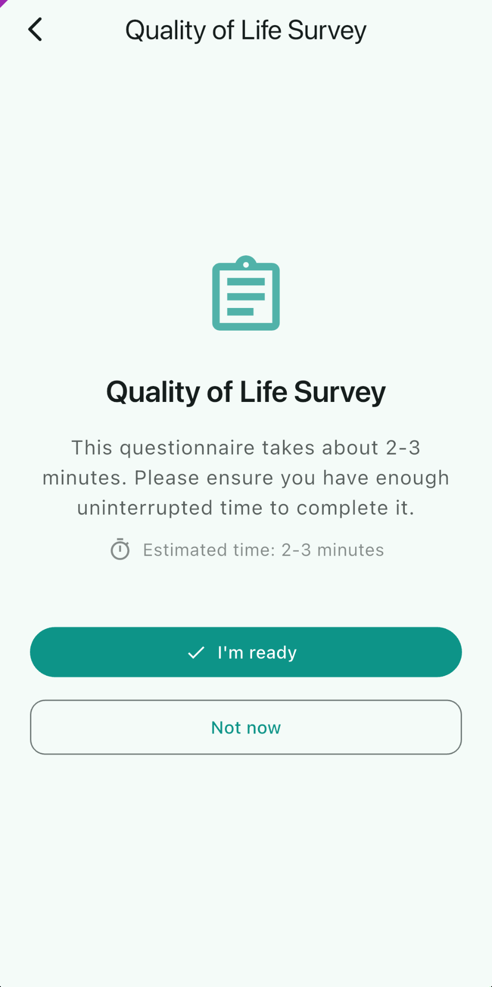

6.3.2 Portal-Sent Questionnaire Workflow
REQ ID: DIARY-GUI-questionnaire-portal-sent-workflow
Refines: DIARY-PRD-questionnaire-portal-sent-rules

6.3.2.1 Overview
The interface for a Portal-Sent Questionnaire spans four screens: the Preamble, the per-question screen, the Review Screen (after the final question), and the post-Submission Acknowledgement Dialog. The behavior on each screen tracks the PRD-level rules above and adds the visual affordances (Progress Indicator, navigation controls, Action labels) participants use to move through the flow.
Review Screen
The screen presented to the participant after answering the final question, displaying all questions and selected answers before Submission.

6.3.2.2 Assertions
Preamble
- The interface SHALL present the Preamble with two actions: an I’m Ready button and a Not Now button.
- When the Participant selects Not Now, the interface SHALL navigate the Participant to the home screen.
- When the Participant selects I’m Ready, the interface SHALL navigate the Participant to the first question.
Question Screen
- The interface SHALL present a Progress Indicator showing the Participant’s current position within the Questionnaire (Question #X out of Y).
- The interface SHALL display the Questionnaire Display Name as the screen title on every question screen.
- The interface SHALL present a back navigation control on every question screen.
- The interface SHALL present a Next Action on every question screen.
- The Next Action SHALL be disabled until the Participant selects an answer.
- When the Participant selects an answer and selects Next, the interface SHALL advance to the next question.
- When the Participant navigates back to a previously answered question, the interface SHALL display the previously selected answer.
Review Screen
- After the Participant answers the final question, the interface SHALL present the Review Screen.
- The Review Screen SHALL present all questions and the Participant’s selected answers.
- The Review Screen SHALL allow the Participant to navigate to any individual question to change their answer.
- The Review Screen SHALL present a submit Action.
Editing an Answer
- When the Participant navigates to an individual question from the Review Screen and changes an answer, the interface SHALL present a Save button.
- When the Participant selects Save, the interface SHALL return the Participant to the Review Screen.
Submission
- When the Participant confirms Submission, the interface SHALL display an Acknowledgement Dialog confirming the Questionnaire has been submitted successfully.
Post-Submission Editing
- When the Participant re-opens a submitted Questionnaire before Finalization, the interface SHALL present the Review Screen.
Finalization
- When the Participant opens a finalized Questionnaire, the interface SHALL present the Questionnaire in a read-only state with no edit or submit actions available.

6.3.2.3 Rationale
The four-screen structure (Preamble, Question, Review, Acknowledgement) makes the Questionnaire’s logical structure visible to the Participant: a clearly demarcated start (Preamble with I’m Ready / Not Now), per-question progress visibility (Question #X out of Y title), a final aggregated review before commit (Review Screen with per-question edit affordance), and an explicit confirmation that the Submission landed (post-Submission Acknowledgement Dialog). The Next-disabled-until-answered rule combined with the prohibition on skipping is how the platform enforces the no-skipped-questions PRD assertion at the GUI layer. Returning to the Review Screen on re-open between Submission and Finalization keeps the Participant’s mental model aligned with the PRD-level edit window — they always re-enter through the aggregated review, not into a partial-flow ambiguity, so the next Action is either “Submit again” or “I’m finished, close this”. The read-only state after Finalization is the GUI-side counterpart of the PRD-level “no edit after Finalization” rule.
Follow-up — configurability: This requirement currently encodes the only option implemented in code. Future sponsors may require different rules; introduce a configurable seam (e.g. a parameter on the CAL-PRD-* parent, or a new platform-side template the CAL- REQ Satisfies) when the need arises. Until that seam exists, this REQ is normative for the Callisto deployment.

6.3.2.4 Screen reference
See:
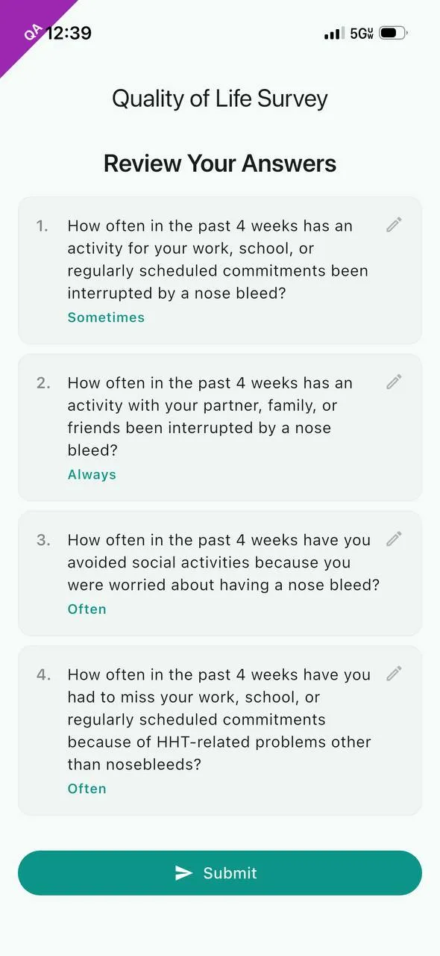
Questionnaire Review Screen

Questionnaire Preamble Screen
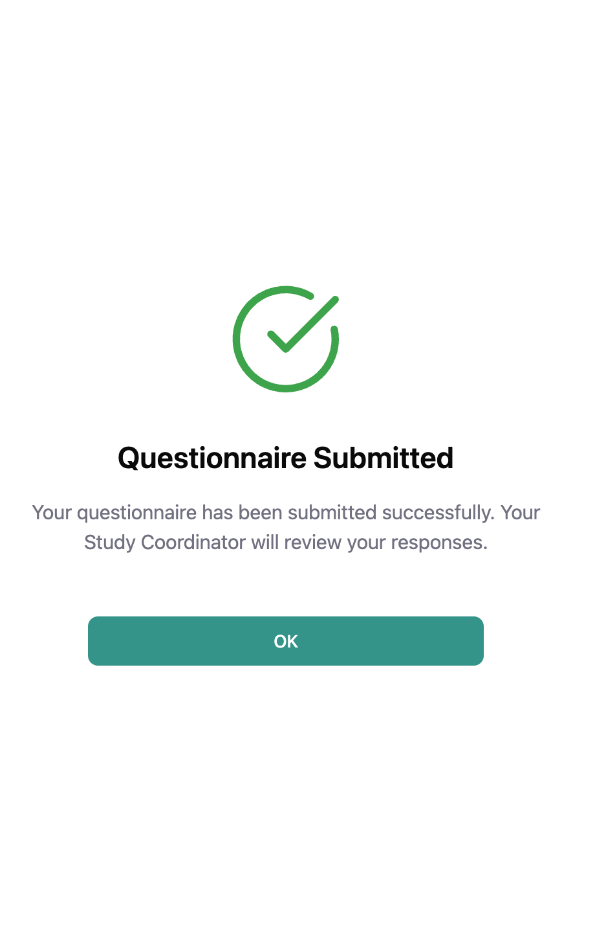
Post-Submission Acknowledgement Dialog

6.3.3 Portal-Sent Questionnaire Call-Back — Participant Experience
REQ ID: CAL-GUI-questionnaire-call-back-participant
Refines: DIARY-GUI-questionnaire-portal-sent-workflow

6.3.3.1 Overview
Participants need clear, immediate feedback when a Portal-Sent Questionnaire is called back so they do not waste effort on an inactive Questionnaire or become confused about its disappearance.
Call-Back Notice
An Acknowledgement Dialog informing the Participant that a Portal-Sent Questionnaire assigned to them has been called back by the study team.

6.3.3.2 Assertions
Open Questionnaire Interruption
- When a Portal-Sent Questionnaire is called back while the Participant has it open, the interface SHALL display the Call-Back Notice.
- The Call-Back Notice SHALL NOT be dismissible by tapping outside the dialog.
- When the Participant acknowledges the Call-Back Notice, the interface SHALL navigate the Participant to the Main Screen.
Task List
- When a Portal-Sent Questionnaire has been called back, the interface SHALL remove the corresponding Questionnaire Task from the Task List.
Next Session Notification
- When a Portal-Sent Questionnaire has been called back and the Participant did not have it open at the time of call-back, the interface SHALL display the Call-Back Notice on the Participant’s next Application Session.
Offline Submission Attempt
- When the Participant attempts to submit a Portal-Sent Questionnaire that has been called back, the interface SHALL display the Call-Back Notice.

6.3.3.3 Rationale
A call-back removes the Questionnaire from the Participant’s active task set, but if the Participant has the Questionnaire open at the moment of call-back (or attempts to submit one whose call-back happened while they were offline), they need explicit feedback that the Questionnaire is no longer assigned to them. The Call-Back Notice provides that feedback in three contexts: live interruption (open now, called back now), deferred notification (called back while not open, surface on next Session), and offline Submission attempt (called back while offline, surface when Submission tries to land). The non-dismissible-by-outside-tap rule (assertion B) prevents the Participant from accidentally clearing the notice without reading it. Removing the Questionnaire Task from the Task List immediately on call-back closes the entry point on the Main Screen so the Participant does not navigate into the called-back Questionnaire from there. Routing acknowledgement to the Main Screen rather than back into the now-defunct Questionnaire flow is the only sensible destination — the Questionnaire is no longer interactable, so returning the Participant to it would be a dead end.
Follow-up — configurability: This requirement currently encodes the only option implemented in code. Future sponsors may require different rules; introduce a configurable seam (e.g. a parameter on the CAL-PRD-* parent, or a new platform-side template the CAL- REQ Satisfies) when the need arises. Until that seam exists, this REQ is normative for the Callisto deployment.

6.3.3.4 Screen reference
See: 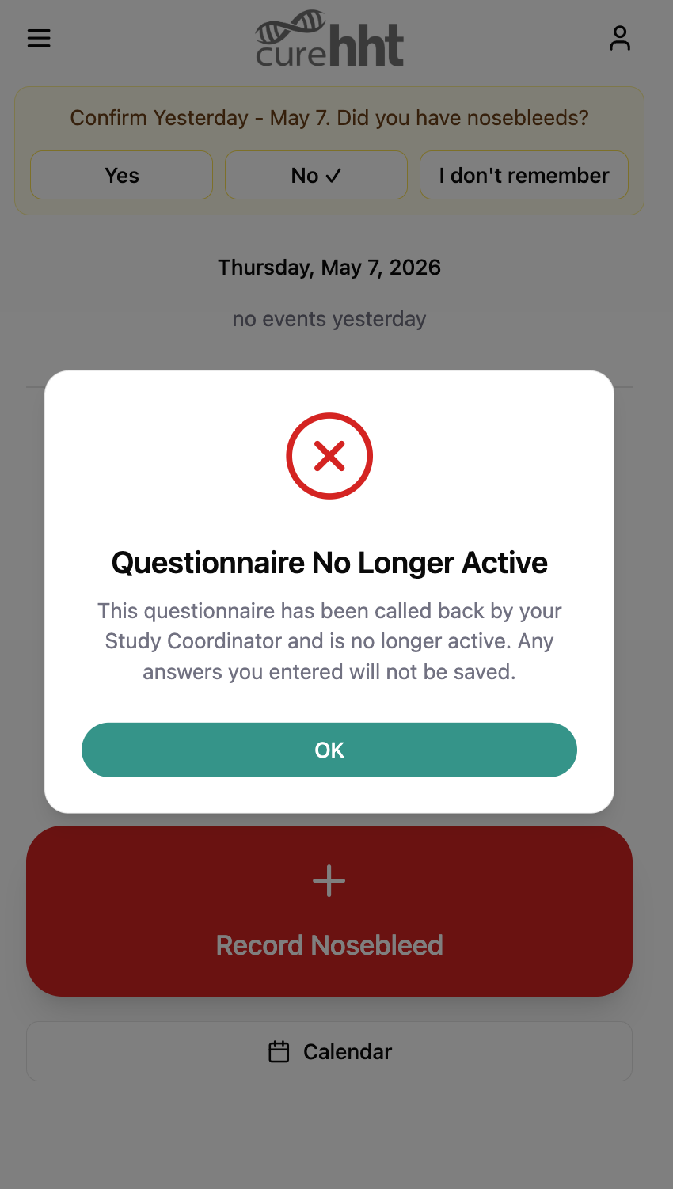

6.3.4 Questionnaire Session Timeout
REQ ID: DIARY-PRD-questionnaire-session-timeout
Refines: DIARY-PRD-questionnaire-portal-sent-rules

6.3.4.1 Overview
A configurable Session timeout allows each Questionnaire to enforce appropriate completion constraints based on its length and clinical requirements.
Session Timeout
The configurable maximum duration of inactivity allowed during questionnaire completion. When exceeded, the session expires and the answers selected so far are not retained.
Session Expiry
The state reached when a participant has not completed a questionnaire within the configured Session Timeout duration.
Timeout Warning Notification
Push notification delivered to the participant when the Session Timeout is approaching.
Session Expiry Notification
Push notification delivered to the participant when Session Expiry has occurred.

6.3.4.2 Assertions
Timeout Tracking
- When a Questionnaire is configured with a Session Timeout, the System SHALL track elapsed inactivity from the Participant’s most recent interaction with the Questionnaire.
- The System SHALL only advance the inactivity timer while the Participant is not actively interacting with the Questionnaire.
- When the Session Timeout is exceeded before the Participant submits the Questionnaire, the System SHALL discard all answers selected so far.
Expiry Behavior
- When a Participant returns to a Questionnaire in a state of Session Expiry, the System SHALL present the Questionnaire from the beginning including the Preamble.
Notifications
- When a Questionnaire is configured with a Session Timeout, the System SHALL deliver a Timeout Warning Notification to the Participant when the Session Timeout is approaching.
- When a Questionnaire is configured with a Session Timeout, the System SHALL deliver a Session Expiry Notification to the Participant when Session Expiry has occurred.
State Preservation
- When a Questionnaire is not configured with a Session Timeout, the System SHALL preserve and restore the Participant’s in-progress answers on return with no timeout constraint.
- When a Questionnaire with a Session Timeout has not yet expired, the System SHALL return the Participant to their in-progress Questionnaire on return.
Configuration
- Each Questionnaire definition SHALL support optional configuration of Session Timeout duration.
- Each Questionnaire definition SHALL support configuration of the threshold before expiry at which the Timeout Warning Notification is delivered.

6.3.4.3 Rationale
Some clinical questionnaires (e.g. the NOSE HHT, the HHT-QoL) require contemporaneous answering — a Participant’s frame of reference shifts measurably if they pause for hours between questions, and the resulting answers no longer reflect a single moment of self-report. A configurable Session Timeout lets each Questionnaire enforce a “complete this in one sitting” constraint without baking a single duration into the platform. Discarding in-progress answers on expiry rather than retaining them is what gives the timeout its clinical meaning: the next attempt starts fresh from the Preamble, with a Participant frame of reference that the Sponsor can interpret. The opt-out (no Session Timeout configured) covers the case where in-progress preservation is fine (e.g. an ad-hoc Questionnaire with no contemporaneous requirement). The two notifications — Warning before expiry, Expiry on the event — give the Participant a chance to return before answers are discarded (Warning) and clear feedback when answers have already been discarded (Expiry).

6.3.4.4 Screen reference
See:
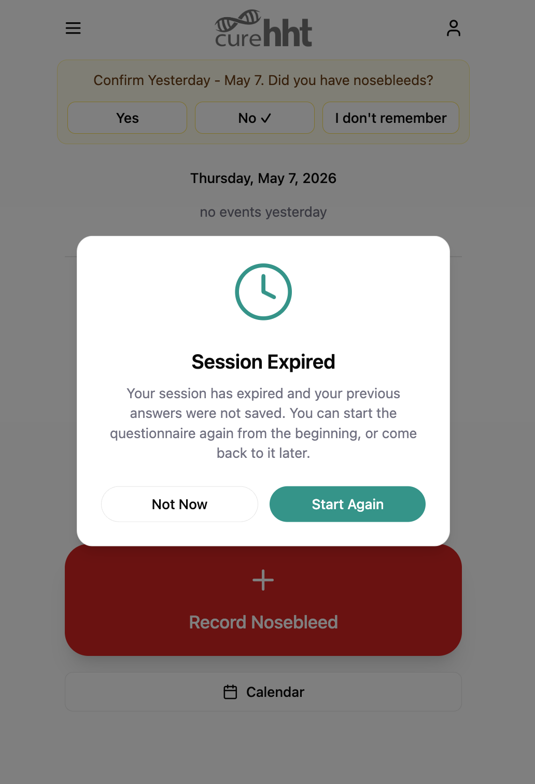
Session Expiry Dialog
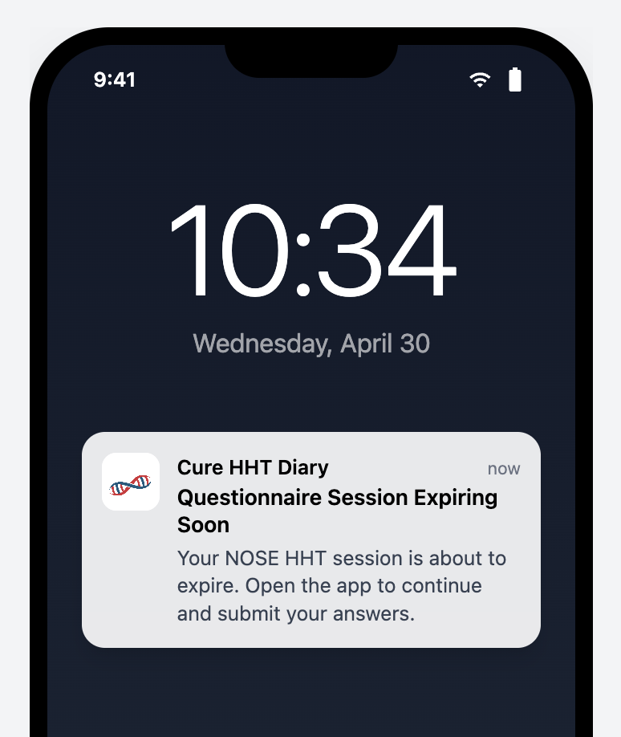
Timeout Warning Notification
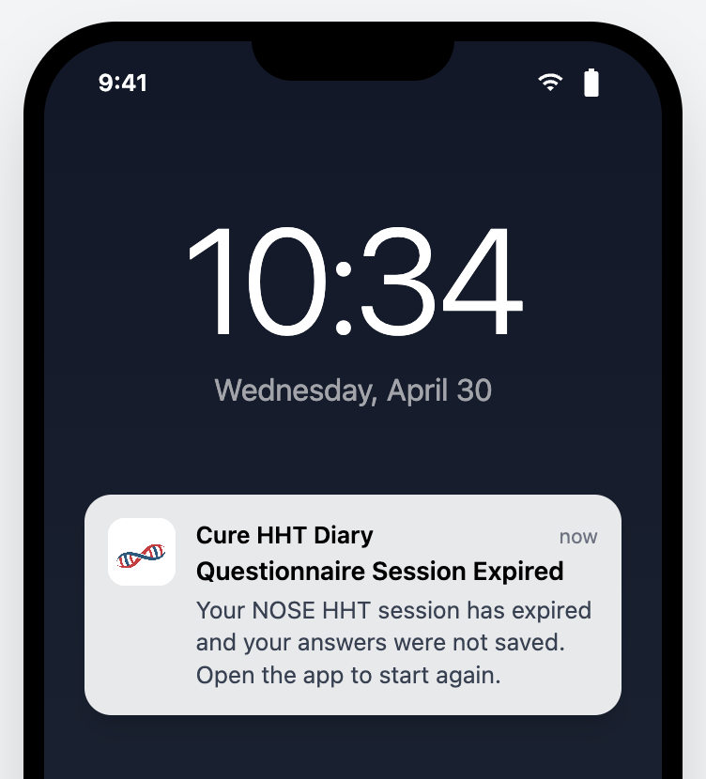
Session Expiry Notification

6.3.5 Questionnaire Session Expiry
REQ ID: DIARY-GUI-questionnaire-session-expiry
Refines: DIARY-PRD-questionnaire-session-timeout

6.3.5.1 Overview
The interface for Session Expiry consists of three surfaces: the Timeout Warning Notification (push notification before expiry), the Session Expiry Dialog (in-app dialog on return after expiry), and the Session Expiry Notification (push notification when expiry occurs). On return to an active (not-yet-expired) Session, the interface restores the Participant to where they left off.
Session Expiry Dialog
The Acknowledgement Dialog displayed to the participant when they open a questionnaire that has reached Session Expiry.

6.3.5.2 Assertions
Timeout Warning
- When a Timeout Warning Notification is delivered, the interface SHALL present it as a push notification indicating that the Questionnaire Session is approaching expiry.
Expired Session on Return
- When the Participant opens a Questionnaire that has reached Session Expiry, the interface SHALL display a Session Expiry Dialog informing the Participant that their Session has expired and their previous answers were not saved.
- The Session Expiry Dialog SHALL present a Start Again button and a Not Now button.
- When the Participant selects Start Again, the interface SHALL dismiss the Session Expiry Dialog and present the Preamble.
- When the Participant selects Not Now, the interface SHALL navigate the Participant to the home screen.
Session Expiry Notification
- When a Session Expiry Notification is delivered, the interface SHALL present it as a push notification indicating that the Questionnaire Session has expired.
Active Session on Return
- When the Participant returns to a Questionnaire with a Session that has not yet reached Session Expiry, the interface SHALL restore the Participant to the question they were on when they left, with their in-progress answers intact.

6.3.5.3 Rationale
The Session Expiry Dialog is the in-app companion to the Session Expiry Notification: the notification tells the Participant the Session expired while they were away from the app; the dialog confirms it when they return and tells them their prior answers are gone. Start Again / Not Now are the two realistic next-actions — restart now from the Preamble, or defer until later — and both are made explicit so the Participant does not face a silent reset on next open. Restoring the active-Session Participant to their last question (with in-progress answers intact) is the GUI-side guarantee that the PRD’s in-progress-preservation rule actually surfaces to the Participant; if the interface always re-entered through the Preamble, the preservation would be invisible and the Participant would lose confidence that pausing is safe.
Follow-up — configurability: This requirement currently encodes the only option implemented in code. Future sponsors may require different rules; introduce a configurable seam (e.g. a parameter on the CAL-PRD-* parent, or a new platform-side template the CAL- REQ Satisfies) when the need arises. Until that seam exists, this REQ is normative for the Callisto deployment.

6.3.5.4 Screen reference
See: 

6.4 Daily eDiary: HHT Epistaxis Data Capture
The daily eDiary data-capture flow for Epistaxis Events comprises the platform-level data capture standard, the Participant-facing recording flow (Start, Max Intensity, End), and the deletion flow (in-flight during recording and post-save from event history).

6.4.1 HHT Epistaxis Data Capture Standard
REQ ID: DIARY-PRD-epistaxis-capture-standard

6.4.1.1 Overview
The HHT Epistaxis Data Capture Standard defines the requirements for Participant-reported nosebleed event collection in HHT clinical trials. Epistaxis frequency, duration, and severity are primary outcome measures for evaluating treatment efficacy. Timezone-aware timestamps ensure precise duration calculation regardless of Participant location.
Daily Status
The participant’s self-reported summary of nosebleed activity for a given day. Valid values are Had Nosebleed, No Nosebleed, and Don’t Remember.
Intensity
A participant-reported measure of nosebleed severity captured on a defined six-level scale ordered from least to most severe.
Incomplete Record
An Epistaxis Event that has been saved but is missing one or more required fields: start time, Intensity, or end time.

6.4.1.2 Assertions
- The System SHALL require a Participant to record a Daily Status for each Calendar day within the Diary period.
- The System SHALL enforce mutual exclusivity of the three Daily Status values — a Participant SHALL NOT record more than one Daily Status per Diary entry.
- When a Participant records a Daily Status of Had Nosebleed, the System SHALL require the Participant to provide start time and end time for the Epistaxis Event with timezone information.
- The System SHALL calculate the duration of an Epistaxis Event from the recorded start time and end time, accounting for timezone differences.
- The System SHALL require the Participant to record an Intensity value for each Epistaxis Event.
- The System SHALL present notes options from a predefined list (defined in CAL-PRD-entry-time-restrictions-configuration) for each Epistaxis Event; the available options SHALL be Sponsor-configurable per study protocol.
- The System SHALL classify an Epistaxis Event as an Incomplete Record when it has been saved with one or more required fields not recorded.

6.4.1.3 Rationale
The Daily Status / Epistaxis Event two-level structure exists because the clinical question is two-leveled: “Did anything happen today?” (a daily-grain answer that can be Had Nosebleed, No Nosebleed, or Don’t Remember) and, when something did happen, “What were the events?” (per-event start, end, Intensity). Mutually exclusive Daily Status values prevent contradictory records (a Participant cannot simultaneously have had a nosebleed and not had one). Required start, end, and Intensity on each Epistaxis Event capture the three primary outcome measures (frequency by count, duration by interval, severity by Intensity); allowing any of these to be missing without an explicit incomplete-Record State would silently downgrade dataset quality. Timezone-aware capture is essential because participants travel and durations computed from naive timestamps across a DST boundary or international move can be off by an hour or more. The Incomplete Record classification lets the platform distinguish “in progress, missing data” from “fully captured” so the Participant can be prompted to finish and the dataset can flag what is not yet complete.

6.4.2 Record Nosebleed Event
REQ ID: DIARY-GUI-epistaxis-record
Refines: DIARY-PRD-epistaxis-capture-standard

6.4.2.1 Overview
The nosebleed recording flow walks the Participant through three steps — Start time, Max Intensity, End time — visible at all times in a persistent Progress Indicator at the top of every screen. The Participant can revisit any completed step. Validation at the End Time step prevents impossible records (end before start, end after current real time) and prompts for confirmation on entries that look like they may have been recorded too quickly after the event.
Progress Indicator
The persistent bar displayed at the top of every screen in the recording flow showing the three steps — Start, Max Intensity, and End — and their completion state.
Time Picker
The time selection component presenting the current time as default, a date selector, a timezone selector, and minute adjustment controls of -15, -5, -1, +1, +5, and +15 minutes.

6.4.2.2 Assertions
Flow Structure
- The interface SHALL display the Progress Indicator on every screen throughout the recording flow showing the Start, Max Intensity, and End steps.
- The interface SHALL highlight the active step in the Progress Indicator and show the recorded value for each completed step.
- The interface SHALL allow the Participant to navigate to any previously completed step by tapping it in the Progress Indicator.
- The interface SHALL present a Back navigation Action on every screen throughout the recording flow.
Nosebleed Start Time
- The interface SHALL present a Time Picker for the Participant to set the nosebleed start time.
- The interface SHALL present a Set Start Time button that confirms the start time and advances to the Max Intensity screen.
Max Intensity
- The interface SHALL present the six Intensity options as a selectable grid: Spotting, Dripping, Dripping quickly, Steady stream, Pouring, and Gushing.
- The interface SHALL NOT advance to the End Time screen until the Participant has selected one of the Intensity options.
- When the Participant selects an Intensity option, the interface SHALL highlight the selected option and automatically advance to the End Time screen.
Nosebleed End Time
- The interface SHALL present a Time Picker for the Participant to set the nosebleed end time.
- When the Participant selects Set End Time, the interface SHALL save the record and return the Participant to the home screen.
- The System SHALL validate that end time is greater than or equal to start time.
- The System SHALL restrict end time selection to times not exceeding the current real time.
- The System SHALL require confirmation when creating entries less than 2 minutes old.

6.4.2.3 Rationale
The three-step structure (Start, Max Intensity, End) matches the clinical model of an event (when it began, how bad it got, when it ended); making the Progress Indicator persistent across every screen of the flow keeps the Participant oriented and allows direct navigation to any completed step without back-tracking. The Time Picker’s minute-adjustment chips (-15/-5/-1/+1/+5/+15) target the realistic adjustment granularity for recording a recently-completed event and avoid the precision-mismatch of a free-text time entry. The auto-advance on Intensity selection (vs. requiring a separate Next tap) shaves friction from the most common path (set start, pick Intensity, set end) while still letting the Participant revisit via the Progress Indicator if they want to change their Intensity choice. End-time validation (no earlier than start, no later than now) catches the two impossible-time inputs at the GUI layer rather than relying on later data validation. The two-minute confirmation prompt is a soft-stop against premature Finalization — a Participant who is still actively having a nosebleed when they set the end time is reminded to check before committing.
Follow-up — configurability: This requirement currently encodes the only option implemented in code. Future sponsors may require different rules; introduce a configurable seam (e.g. a parameter on the CAL-PRD-* parent, or a new platform-side template the CAL- REQ Satisfies) when the need arises. Until that seam exists, this REQ is normative for the Callisto deployment.

6.4.3 Nosebleed Event Delete
REQ ID: DIARY-GUI-epistaxis-delete
Refines: DIARY-PRD-epistaxis-capture-standard

6.4.3.1 Overview
Deletion of a nosebleed event can happen in two contexts: in-flight during the recording flow (before the record has been saved) and post-save from event history. Both paths require a Reason Dialog — Predefined List before the deletion is applied, and the Participant may cancel at any point.

6.4.3.2 Assertions
Delete During Recording Flow
- The interface SHALL present a delete Action on every screen throughout the recording flow.
- When the Participant selects the delete Action during the recording flow, the interface SHALL display a Reason Dialog — Predefined List before proceeding.
- When the Participant confirms the delete reason, the interface SHALL discard the in-progress record and return the Participant to the home screen.
- When the Participant cancels the Reason Dialog, the interface SHALL return the Participant to the screen they were on.
Delete From Event History
- When the Participant selects the delete Action on a saved Epistaxis Event, the interface SHALL display a Reason Dialog — Predefined List before proceeding.
- When the Participant confirms the delete reason, the interface SHALL remove the event from the Participant’s Diary and return the Participant to the previous screen.
- When the Participant cancels the Reason Dialog, the Epistaxis Event SHALL remain unchanged.

6.4.3.3 Rationale
The delete Action is exposed on every screen of the recording flow because the Participant may realize partway through that they started the record by mistake (wrong date, wrong event, accidental tap) and there is no benefit to forcing them to complete the flow before deleting. Routing both in-flight delete and post-save delete through a Reason Dialog — Predefined List keeps the Audit Trail’s deletion-reason capture consistent across both contexts — a deletion at any point produces a categorized reason record. Predefined-list (rather than free-text) reasons match the dataset analyzability goal: deletion reasons are the kind of metadata downstream analysis aggregates over, and a controlled vocabulary makes that analysis tractable. The cancel path on either delete returns the Participant to where they were (in-flight: the same screen; post-save: the previous screen, with the record unchanged) so an accidental delete-tap is fully recoverable.
Follow-up — configurability: This requirement currently encodes the only option implemented in code. Future sponsors may require different rules; introduce a configurable seam (e.g. a parameter on the CAL-PRD-* parent, or a new platform-side template the CAL- REQ Satisfies) when the need arises. Until that seam exists, this REQ is normative for the Callisto deployment.

6.4.3.4 Screen reference
See: 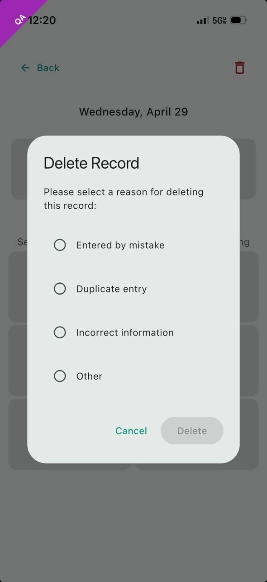

6.5 Score Calculation
The platform’s score-calculation obligations comprise the general rule that scores are computed per a validated algorithm and stored with the Questionnaire record, plus the specific algorithm bindings for the HHT-QoL and NOSE HHT instruments.

6.5.1 Questionnaire Score Calculation
REQ ID: DIARY-PRD-questionnaire-score-calculation

6.5.1.1 Overview
Validated clinical questionnaires require scoring according to published, protocol-defined algorithms to ensure data integrity and comparability across participants and studies. Storing scores with survey records ensures traceability and supports downstream Rave EDC synchronization and clinical analysis.

6.5.1.2 Assertions
- The System SHALL calculate Questionnaire scores according to the validated algorithm defined for each Questionnaire.
- The System SHALL store the calculated score with the associated Questionnaire record.
- The scoring algorithm SHALL be traceable to its source definition for each Questionnaire Type.

6.5.1.3 Rationale
Scores are the analytical artifact downstream clinical research derives outcomes from — frequency, severity, quality-of-life impact. Computing scores per the validated published algorithm rather than per a platform-local re-derivation is what gives the resulting numbers their interpretive validity: a NOSE HHT score from this platform is comparable to a NOSE HHT score from any other study only because both implement the published JAMA Otolaryngology algorithm faithfully. Storing the score with the Questionnaire record (rather than recomputing on demand) preserves the value the Participant’s answers actually produced at the time of Submission — even if the algorithm reference is later updated, the historical record reflects what was computed and shipped to Rave EDC for that Participant. Traceability to source for each Questionnaire Type is the audit-trail counterpart of the True Copy obligation on the Questionnaire definitions: any auditor must be able to follow the chain from a stored score back to the published algorithm that produced it.

6.5.2 HHT-QoL Score Calculation
REQ ID: DIARY-PRD-score-hht-qol
Refines: DIARY-PRD-questionnaire-score-calculation

6.5.2.1 Assertions
- The System SHALL calculate the HHT-QoL Questionnaire score according to the algorithm defined in: Development and performance of a hereditary hemorrhagic telangiectasia-specific quality-of-life instrument, Blood Advances, 26 July 2022, Volume 6, Number 14, DOI 10.1182/bloodadvances.2022007748.

6.5.2.2 Rationale
The HHT-QoL scoring algorithm is fully specified by the cited Blood Advances 2022 publication; the platform’s Role is to implement that algorithm faithfully against the Questionnaire’s four answer fields. Anchoring the requirement to the DOI rather than restating the algorithm here preserves the property that the published reference is the single source of truth — any platform-side restatement would create a second authority that could drift from the original. The DOI is stable across editorial revisions, so an auditor can retrieve exactly the version the platform’s implementation was checked against.

6.5.3 NOSE HHT Score Calculation
REQ ID: DIARY-PRD-score-nose-hht
Refines: DIARY-PRD-questionnaire-score-calculation

6.5.3.1 Assertions
- The System SHALL calculate the NOSE HHT Questionnaire score according to the algorithm defined in: Development and Validation of the Nasal Outcome Score for Epistaxis in Hereditary Hemorrhagic Telangiectasia (NOSE HHT), JAMA Otolaryngology – Head & Neck Surgery, November 1, 2020, Volume 146, Number 11, DOI 10.1001/jamaoto.2020.3040.

6.5.3.2 Rationale
The NOSE HHT scoring algorithm is fully specified by the cited JAMA Otolaryngology 2020 publication, which is the same publication the Questionnaire definition itself cites for the question and answer choices. Anchoring the score requirement to the same DOI keeps the Questionnaire and its score on a single source-of-truth chain: the published instrument defines what to ask and how to score the answers, and the platform’s two requirements (one for the Questionnaire content, one for the score) both reference it. As with HHT-QoL, the DOI is the stable retrieval handle an auditor uses to confirm the platform’s implementation matches the validated reference.

6.6 Diary Entry Rules
The platform-level validation rules that apply to every Diary entry comprise the two-tier (justification, lock) time-based restrictions, the Duration Reasonableness Check, and the overlapping-event detection-and-Resolution flow.

6.6.1 Time-Based Entry Restrictions
REQ ID: DIARY-PRD-entry-time-restrictions

6.6.1.1 Overview
Clinical Trial data integrity requires that Participant-reported data be contemporaneous. As time passes after an event, recall accuracy degrades and the risk of unreliable data increases. A two-tier restriction model balances the need for late data capture (with documented justification) against the need to prevent entries that are too old to be clinically reliable. The justification tier preserves ALCOA+ compliance by requiring documented reasons for non-contemporaneous entries. The lock tier enforces a hard boundary beyond which no data modification is permitted.
Justification Threshold
The configurable elapsed time from midnight (00:00) of the event date in the Participant’s local timezone after which the Participant must provide a reason before creating or editing an entry for that date.
Lock Threshold
The configurable elapsed time from midnight (00:00) of the event date in the Participant’s local timezone after which the date is fully locked and no creation, editing, or deletion of entries is permitted.
Entry Justification
A reason selected from a sponsor-defined predefined list that the Participant must provide when creating or editing an entry that has exceeded the Justification Threshold.

6.6.1.2 Assertions
Justification Tier
- When the elapsed time for an event date exceeds the Justification Threshold but has not exceeded the Lock Threshold, the System SHALL require the Participant to select an Entry Justification before saving a new entry or an edit to an existing entry for that date.
- The System SHALL NOT require an Entry Justification when the Participant deletes an entry within the justification window.
- The System SHALL NOT allow free-text entry for Entry Justification.
- The System SHALL store the selected Entry Justification with the entry record.
Lock Tier
- When the elapsed time for an event date exceeds the Lock Threshold, the System SHALL NOT permit creation of new entries for that date.
- When the elapsed time for an event date exceeds the Lock Threshold, the System SHALL NOT permit editing of existing entries on that date.
- When the elapsed time for an event date exceeds the Lock Threshold, the System SHALL NOT permit deletion of existing entries on that date.
Configuration
- The System SHALL support Sponsor-configurable Justification Threshold per deployment.
- The System SHALL support Sponsor-configurable Lock Threshold per deployment.
- The Lock Threshold SHALL be greater than or equal to the Justification Threshold.
- The System SHALL support Sponsor-configurable definition of the Entry Justification predefined list per deployment.
- When neither threshold is configured for a deployment, the System SHALL NOT apply time-based entry restrictions.
- The Lock Threshold SHALL apply only to event dates on or after the Trial Start date.

6.6.1.3 Rationale
The two-tier model exists because two distinct integrity concerns argue for two distinct boundaries. Recall accuracy degrades gradually after an event, so for some window after the event date the data is still useful but the Participant should explicitly acknowledge they are entering it late (this is the Justification Threshold — a soft boundary that captures a categorical reason on the record). Beyond a longer window, the data is no longer clinically reliable regardless of justification, so the platform makes it impossible to modify (the Lock Threshold — a hard boundary that disables create/edit/delete). Predefined-list justifications (rather than free-text) match the analyzability goal: the Audit Trail aggregates over a controlled vocabulary of reasons rather than over unbounded prose. Deletion within the justification window does not require justification because the Participant is removing data they reported, not modifying it; the Audit Trail still captures the deletion event and its own reason via the standard delete flow. The Lock >= Justification invariant ensures the two tiers compose correctly (a Justification-required state always precedes a Lock state for the same date). The “only after Trial Start date” qualifier on the Lock Threshold means pre-Trial historical entries (covered by the Diary Start Day) are not subject to the lock, since those entries are explicitly retrospective and the lock semantics don’t apply.

6.6.2 Time-Based Entry Restrictions Configuration
REQ ID: CAL-PRD-entry-time-restrictions-configuration
Refines: DIARY-PRD-entry-time-restrictions

6.6.2.1 Overview
The Callisto clinical protocol requires that nosebleed event entries older than one Calendar day include documented justification for the timing discrepancy, and that entries older than 48 hours are locked entirely to maintain data reliability. These values configure the platform mechanism defined in Diary-PRD-entry-time-restrictions.

6.6.2.2 Assertions
- The Justification Threshold SHALL be configured to 24 hours.
- The Lock Threshold SHALL be configured to 48 hours.
- The Entry Justification predefined list SHALL contain exactly four options: “Entered from paper records,” “Remembered specific event,” “Estimated event,” and “Other.”
- The Entry Justification prompt SHALL display the text: “This is an event more than one day old. Please explain why you are adding/changing it now.”

6.6.2.3 Rationale
The 24-hour Justification Threshold binds the soft “explain why this is late” boundary to one Calendar day, matching the Yesterday Entry Reminder’s daily-cadence prompt — a Participant who has not entered yesterday’s data within 24 hours has crossed into territory where the protocol requires a documented reason for the delay. The 48-hour Lock Threshold doubles the justification window, recognizing that some justifiable-late entries take an additional day to surface (a Participant who was traveling or unwell at the 24-hour mark gets a further day to backfill with justification) while still capping the editable window at two days for reliability. The four-option predefined list covers the realistic operational distribution of late-entry causes: transferring from paper records during onboarding, retrospective recall of a specific event, retrospective estimation when specifics are not recalled, and the residual “Other” for cases the three categories do not cover. The prompt text frames the obligation in plain language so the Participant understands what they are being asked to explain.

6.6.3 Duration Reasonableness Check
REQ ID: DIARY-PRD-entry-duration-check

6.6.3.1 Overview
Unusually short or long event durations may indicate data entry errors. Confirmation prompts at configurable thresholds help ensure data accuracy while allowing legitimate outlier events to be recorded.
Duration Reasonableness Check
A configurable validation rule that prompts the Participant to confirm the recorded duration of an event when it falls outside expected boundaries.
Short Duration Threshold
The configurable minimum duration below which a confirmation prompt is triggered.
Long Duration Threshold
The configurable maximum duration above which a confirmation prompt is triggered.

6.6.3.2 Assertions
Short Duration Check
- When the duration of an event is less than the Short Duration Threshold, the System SHALL prompt the Participant to confirm the duration before saving.
- The confirmation prompt SHALL provide a confirm option that saves the entry as entered and a reject option that returns the Participant to edit the duration.
Long Duration Check
- When the duration of an event is greater than the Long Duration Threshold, the System SHALL prompt the Participant to confirm the duration before saving.
- The confirmation prompt SHALL provide a confirm option that saves the entry as entered and a reject option that returns the Participant to edit the duration.
Prompt Timing
- The System SHALL display the confirmation prompt before the save operation completes.
Configuration
- The System SHALL support Sponsor-configurable Short Duration Threshold per deployment.
- The System SHALL support Sponsor-configurable Long Duration Threshold per deployment.
- The System SHALL support Sponsor-configurable enablement of each check independently per deployment.
- When a check is not enabled for a deployment, the System SHALL NOT display the corresponding confirmation prompt.

6.6.3.3 Rationale
Duration outliers are a common data-entry-error signal: a typo or wrong-timezone selection can produce a one-second or twelve-hour nosebleed that the Participant did not actually have. A soft confirmation prompt at configured boundaries catches these without rejecting legitimately-outlying events (a multi-hour nosebleed can be real for certain HHT participants). The two checks are independently enableable because a deployment may want only one direction (e.g. only the short-duration check, if long durations are clinically plausible in the protocol). The pre-save timing rule (assertion E) ensures the Participant sees the prompt at the moment of decision rather than discovering after the fact that their entry was flagged. Reject-and-edit is the inverse of confirm-and-save and gives the Participant a direct path to correct a typo without re-entering the event from scratch.

6.6.4 Duration Reasonableness Check Configuration
REQ ID: CAL-PRD-entry-duration-check-configuration
Refines: DIARY-PRD-entry-duration-check

6.6.4.1 Overview
The Callisto clinical protocol defines specific duration boundaries for nosebleed events to flag potential data entry errors. These values configure the platform mechanism defined in Diary-PRD-entry-duration-check.

6.6.4.2 Assertions
- The Short Duration Threshold SHALL be configured to 1 minute.
- The Long Duration Threshold SHALL be configured to 60 minutes.
- Both the short duration check and the long duration check SHALL be enabled.
- The short duration confirmation prompt SHALL display the text: “Duration is under 1 minute, is that correct?”
- The long duration confirmation prompt SHALL display the text: “Duration is over 1 hour, is that correct?”

6.6.4.3 Rationale
The 1-minute Short Duration Threshold catches the most likely short-side data-entry error — a Participant who tapped Set End Time immediately after Set Start Time, producing a near-zero duration that almost certainly reflects a misclick rather than a real event. The 60-minute Long Duration Threshold flags the long-side counterpart — a duration over an hour is clinically possible for some HHT participants but unusual enough that a confirmation prompt is worthwhile against the much more common case of a wrong end-date or wrong-timezone entry producing a multi-hour or multi-day duration. Both checks are enabled for the Callisto deployment because the cost of an undetected outlier (a corrupted primary outcome measure) substantially exceeds the friction cost of a one-tap confirmation when a real outlier event occurs. The prompt text is phrased as a question (“is that correct?”) rather than a warning, matching the soft-confirmation intent — the Participant is invited to confirm or correct, not blocked.

6.6.5 Overlapping Event Detection and Resolution
REQ ID: DIARY-PRD-entry-overlap-resolution

6.6.5.1 Overview
Nosebleed events cannot physically Overlap — a Participant cannot have two simultaneous, independent nosebleeds. When a new record’s time range intersects with an existing record, the system must detect the conflict and guide the Participant through Resolution before the record is committed. This ensures data integrity and prevents logically impossible entries from reaching the clinical dataset.
Overlap
A state in which the time range of a new or edited entry intersects with the time range of one or more existing entries for the same Participant.
Conflicting Record
An existing entry whose time range intersects with the entry being created or edited.
Resolution
The Participant’s choice of how to handle an Overlap between two entries.

6.6.5.2 Assertions
Detection
- The System SHALL evaluate for potential Overlap when the Participant sets the start time of a new or edited entry, and SHALL confirm the Overlap when the Participant sets the end time.
- The System SHALL evaluate Overlap by comparing the actual start and end timestamps of the new or edited entry against all existing entries for the same Participant.
- The System SHALL evaluate Overlap against both completed entries and ongoing entries.
Pre-Resolution State
- When an Overlap is detected, the System SHALL save the new entry to persistent storage immediately upon creation.
- When an Overlap is detected, the System SHALL NOT display the new entry in the Participant’s Diary history until Resolution is complete.
Resolution Sequencing
- The System SHALL present the Participant with one Conflicting Record at a time, starting with the oldest.
- After each Resolution step, the System SHALL evaluate the resulting entry for further Overlaps.
- The System SHALL repeat the Resolution flow until no Overlaps remain.
- When all Overlaps are resolved, the System SHALL commit all resulting changes as a single transaction.
Resolution Options
- For each Overlap, the System SHALL offer three Resolution options: keep the new entry and discard the Conflicting Record, keep the Conflicting Record and discard the new entry, or merge both entries into one.
Merge Behavior
- When the Participant selects merge, the System SHALL construct the merged entry using the earliest start time and the latest end time across both entries.
- When either entry in a merge is ongoing, the merged entry SHALL be ongoing.
- When the Participant selects merge, the System SHALL assign the higher severity value from the two original entries to the merged entry.
Post-Resolution Confirmation
- After any Resolution choice, the System SHALL present the resulting entry to the Participant for review and confirmation before committing.
- The Participant SHALL be able to edit the resulting entry before confirming.

6.6.5.3 Rationale
Two nosebleeds cannot physically Overlap; allowing overlapping records into the dataset would be silent data corruption. The two-stage detection (predictive on start-time, confirmatory on end-time) gives the Participant early notice that an Overlap is forming without interrupting them mid-record, then escalates to mandatory Resolution at the moment the conflict becomes a hard reality. Saving the new entry to persistent storage immediately on creation (assertion D) is the durability guarantee that the Participant’s work is not lost if the application crashes mid-Resolution; hiding it from the Diary history until Resolution completes (assertion E) keeps the Participant’s view consistent with what has actually been resolved. One-conflict-at-a-time Resolution starting with the oldest, repeated until no overlaps remain, is the only sequencing that handles the cascade case (a new record overlaps two existing records that themselves Overlap each other once merged). Three Resolution options cover the realistic choices: the new record was right and the old one was wrong (keep-new), the old record was right and the new one is a duplicate (keep-existing), or both were partial captures of one continuous event (merge). Merge using earliest-start / latest-end with the higher severity captures the union-by-time and max-by-severity that best represents one continuous event reconstructed from two partial captures. Pre-commit review is the final integrity gate — the Participant sees the resulting entry as the platform will save it and can edit any field before confirming.

6.6.5.4 Screen reference
See: 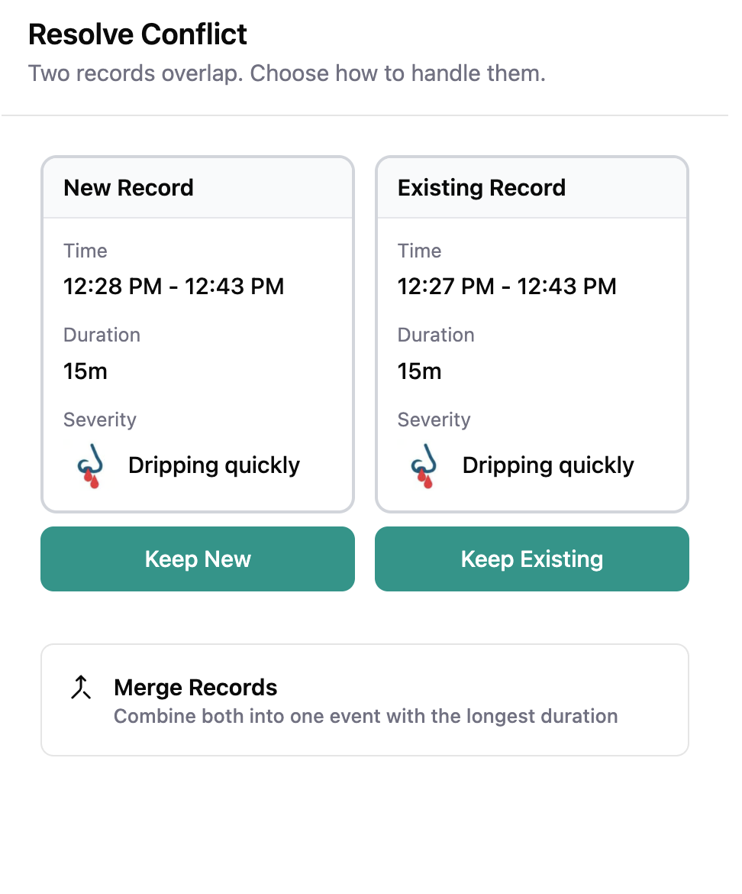

6.6.6 Overlapping Event Resolution Flow
REQ ID: DIARY-GUI-entry-overlap-resolution
Refines: DIARY-PRD-entry-overlap-resolution

6.6.6.1 Overview
When an Overlap is detected, the Participant needs early warning and a clear Resolution path. Displaying a warning as soon as the start time indicates a potential conflict gives the Participant awareness without interrupting their recording flow. Once the full time range is established, the Resolution screen provides a side-by-side comparison and straightforward actions to resolve the conflict.
Resolution Screen
The screen presented to the Participant when an Overlap is confirmed, displaying the new entry and the Conflicting Record side by side with available resolution actions.

6.6.6.2 Assertions
Early Warning
- When a potential Overlap is detected after the Participant sets the start time, the interface SHALL display a warning indicating that overlapping events have been detected and the number of conflicting records.
- The warning SHALL NOT prevent the Participant from continuing the recording flow.
Resolution Trigger
- When the Participant sets the end time and the Overlap is confirmed, the interface SHALL navigate the Participant to the Resolution Screen.
Resolution Screen
- The interface SHALL present the Resolution Screen displaying the new entry and the Conflicting Record side by side.
- Each entry on the Resolution Screen SHALL display the time range, duration, and severity.
- When the Conflicting Record is older than the Justification Threshold, the System SHALL require an Entry Justification before saving the Resolution.
- The Resolution Screen SHALL present a Keep New Action and a Keep Existing Action. The Resolution Screen SHALL present a Merge Records Action only when the Conflicting Record’s event date has not exceeded the Lock Threshold.
- The Merge Records Action SHALL display a description indicating that both records will be combined into one event.
Post-Resolution
- When the Merge Records Action is unavailable due to the Lock Threshold, the Resolution Screen SHALL display a message indicating that the Conflicting Record is locked and cannot be merged.
- After the Participant selects any Resolution option (Keep New, Keep Existing, or Merge Records), the interface SHALL navigate to the standard Record Nosebleed screen pre-filled with the resulting entry data.
- The Record Nosebleed screen SHALL allow the Participant to review and edit any field of the resulting entry before confirming.
Multiple Conflicts
- When multiple Overlaps exist, the interface SHALL present one Resolution Screen at a time.
- When all Overlaps are resolved and the Participant confirms the final entry, the interface SHALL return the Participant to the Main Screen.

6.6.6.3 Rationale
The early warning on start-time is a non-blocking signal: the Participant sees that something is going to need Resolution but is not pushed into the Resolution flow yet, because the end-time may still make the Overlap go away (e.g. the Participant moves the end time earlier than the Conflicting Record’s start). Only when the end-time confirms the conflict does the GUI commit the Participant to the Resolution Screen. The side-by-side display makes the comparison legible — same time-range / duration / severity rows for both entries — so the Participant can make an informed choice between Keep New, Keep Existing, and Merge. The Merge-availability check against the Lock Threshold is required because merging would produce edits to the Conflicting Record’s date, which the lock prohibits; surfacing the unavailability with an explanatory message (rather than silently disabling) keeps the Participant oriented. Routing the post-Resolution result through the standard Record Nosebleed screen (pre-filled) gives the Participant a final edit-and-confirm opportunity on the same surface they used to enter the original record — a single interaction model end-to-end rather than a Resolution-specific screen the Participant has to learn separately. One-at-a-time presentation for multiple overlaps matches the PRD-level Resolution sequencing rule, and the return-to-Main-Screen on completion closes the recording journey at its natural endpoint.
Follow-up — configurability: This requirement currently encodes the only option implemented in code. Future sponsors may require different rules; introduce a configurable seam (e.g. a parameter on the CAL-PRD-* parent, or a new platform-side template the CAL- REQ Satisfies) when the need arises. Until that seam exists, this REQ is normative for the Callisto deployment.

6.6.6.4 Screen reference
See: 

6.7 Mobile Application Navigation and Screens
The foundational navigation surfaces of the Mobile Application comprise the Main Screen layout (zones, task area, content area, fixed bottom actions), the two top-navigation-bar menus (User Menu, Application Menu) and their dependent screens, and the Calendar / Day View pair the Participant uses to navigate to any past date.

6.7.1 Main Screen Layout
REQ ID: DIARY-GUI-main-screen-layout

6.7.1.1 Overview
The Main Screen is the Participant’s primary interface for daily Diary use. Organizing the screen into distinct zones ensures that urgent items (disconnection alerts and tasks) are always visible, Diary content is scrollable, and the primary recording Action is always accessible. When no tasks or alerts are active, the content area expands to use the full available space.
Main Screen
The default screen displayed to the Participant upon opening the mobile application.
System Notice Area
A dedicated zone at the top of the Main Screen reserved for persistent, non-dismissable system notices that require the Participant’s attention.

6.7.1.2 Assertions
Screen Zones
- The Main Screen SHALL display the following zones in order from top to bottom: System Notice Area (when applicable), top navigation bar, Task List (when tasks are active), content area, and fixed bottom actions.
- The System Notice Area SHALL appear above the top navigation bar.
- When the System Notice Area is displayed, it SHALL NOT reduce the space available for any other Main Screen zone.
Task List Area
- When the Task List contains more tasks than the available space allows, the Task List SHALL scroll within its allocated area.
- When no tasks are active and no Disconnection Notification is displayed, the content area SHALL expand to fill the available space.
Content Area
- The content area SHALL display Diary entries grouped by date, showing Yesterday and Today sections.
- The content area SHALL be scrollable between the task area and the fixed bottom actions.
- When a date section contains no entries, the content area SHALL display a message indicating no events for that date.
Fixed Bottom Actions
- The Main Screen SHALL display a Record Nosebleed button fixed at the bottom, regardless of scroll position.
- The Main Screen SHALL display a Calendar button fixed at the bottom below the Record Nosebleed button, regardless of scroll position.

6.7.1.3 Rationale
The five-zone structure (System Notice Area, top navigation bar, Task List, content area, fixed bottom actions) reflects an attention-priority ordering: persistent system notices appear above everything because they typically encode a state the Participant must acknowledge (e.g. Disconnection Notification), and the fixed bottom actions appear at the most-reachable thumb position because they are the two highest-frequency Participant actions (Record Nosebleed, open Calendar). The Task List zone collapsing when empty (with the content area expanding to fill the space) keeps the screen from carrying empty chrome for participants in a quiet stretch of the Trial — most days, when there are no incomplete records or pending portal-sent questionnaires, the content area uses the full middle of the screen. Yesterday / Today grouping in the content area matches the everyday read pattern: the most recent days are what the Participant actually wants to see; the Calendar is the path to anything older.
Follow-up — configurability: This requirement currently encodes the only option implemented in code. Future sponsors may require different rules; introduce a configurable seam (e.g. a parameter on the CAL-PRD-* parent, or a new platform-side template the CAL- REQ Satisfies) when the need arises. Until that seam exists, this REQ is normative for the Callisto deployment.

6.7.2 Mobile Application Navigation and Screens
REQ ID: DIARY-GUI-mobile-navigation

6.7.2.1 Overview
The Mobile Application provides two menus accessible from the top navigation bar: a User Menu for account and study-related actions, and an Application Menu for application-level functions. Each menu leads to dedicated screens. The top navigation bar is visible on the Main Screen at all times.
User Menu
The menu accessed from the right side of the top navigation bar, grouping account and study-related actions.
Application Menu
The menu accessed from the left side of the top navigation bar, grouping application-level functions.

6.7.2.2 Assertions
Top Navigation Bar
- The Main Screen SHALL display a top navigation bar containing the Application Menu access on the left, the Sponsor or Application logo in the center, and the User Menu access on the right.
- The top navigation bar SHALL remain visible on the Main Screen at all times.
- Only one menu SHALL be open at a time. Opening one menu SHALL close the other if it is open.
- Tapping anywhere outside an open menu SHALL dismiss it.
User Menu
- The User Menu SHALL contain the following items: Join the Study, User Profile, and Help Center.
- When the User clicks the “Join the Study” button SHALL navigate to the Linking Code entry screen.
- When the Participant is linked to a study, “Join the Study” button SHALL not be visible on the menu.
- The Help Center screen SHALL display contact information for support.
User Profile Screen
- When the User is not linked to any study, the Clinical Trial section SHALL display a message indicating no active study link and guidance on how to join.
- When the Participant is linked to a study, the Clinical Trial section SHALL display the Participation Status Badge.
Application Menu
- The Application Menu SHALL contain the following items: Accessibility and Preferences, Application Privacy Policy, and Licenses.
- The Application Privacy Policy screen SHALL display or link to the Application Privacy Policy.
- The Licenses screen SHALL display open-source and third-party license information.

6.7.2.3 Rationale
The two-menu split (User Menu on the right, Application Menu on the left) groups actions by the question the Participant is asking: “something about my study” (User Menu: Join the Study, User Profile, Help Center) vs. “something about the app itself” (Application Menu: Accessibility, Application Privacy Policy, Licenses). Single-menu-open-at-a-time is a standard mobile-UX safety (opening one menu closes the other) so the Participant never sees two competing surfaces Overlap. Hiding Join the Study when already linked (assertion G) removes the no-op Action from the menu — once the Participant is a Participant, the Action that converted them from User to Participant is no longer meaningful. The User Profile’s Clinical Trial section is the Participant’s anchor for their study status: empty + guidance when unlinked, Participation Status Badge when linked. The Application Menu’s three items are the standard app-level metadata participants may need to reach but rarely do (privacy, accessibility, licenses).
Follow-up — configurability: This requirement currently encodes the only option implemented in code. Future sponsors may require different rules; introduce a configurable seam (e.g. a parameter on the CAL-PRD-* parent, or a new platform-side template the CAL- REQ Satisfies) when the need arises. Until that seam exists, this REQ is normative for the Callisto deployment.

6.7.3 Calendar and Day View
REQ ID: DIARY-GUI-calendar-day-view

6.7.3.1 Overview
The Calendar provides Participants with a monthly overview of their Diary activity and a way to navigate to any past date to view, add, or edit entries. The Day View is the screen displayed when a Participant selects a date from the Calendar.
Calendar
The monthly view modal displaying date states and allowing the Participant to navigate to a specific date.
Day View
The screen displayed when the Participant selects a date from the Calendar, showing the entries for that date or prompting the Participant to record a Daily Status.

6.7.3.2 Assertions
Calendar Modal
- When the Participant selects the Calendar button, the interface SHALL display the Calendar as a modal overlay.
- The Calendar SHALL display a monthly view with navigation arrows to move between months.
- Each date in the Calendar SHALL display a visual indicator representing its Diary state.
- The Calendar SHALL display a legend identifying each visual indicator state.
- The Calendar SHALL display the following date states: nosebleed events recorded, no nosebleeds confirmed, unknown / don’t remember, incomplete or missing data, not recorded, locked, and today.
- A date SHALL display the incomplete state when the Participant has one or more Incomplete Records for that date.
- A date SHALL display the missing state when the date is within the Diary period (from Diary Start Day to yesterday) and the Participant has not recorded any Daily Status for that date.
- The Calendar SHALL present a close Action that dismisses the modal and returns the Participant to the Main Screen.
Day View — No Daily Status Recorded
- When the selected date has no Daily Status recorded, the Day View SHALL display the date and the prompt “What happened on this day?” with three actions: Add nosebleed event, No nosebleed events, and I don’t recall / unknown.
- When the Participant selects No nosebleed events, the interface SHALL record a Daily Status of No Nosebleed for that date.
- When the Participant selects I don’t recall / unknown, the interface SHALL record a Daily Status of Don’t Remember for that date.
- When the Participant selects Add nosebleed event, the interface SHALL navigate the Participant to the nosebleed recording flow with the date set to the selected date.
Day View — Daily Status Recorded
- When the selected date has a Daily Status recorded, the Day View SHALL display the date, the total event count, an Add new event Action, and a list of all entries for that date.
- Each nosebleed entry in the list SHALL display the start time, timezone, severity, and duration.
- Each entry in the list SHALL be selectable.
- Submitted Portal-Sent Questionnaires SHALL appear in the entries list on the date they were submitted.
Entry Selection
- When the Participant selects an entry, the interface SHALL navigate to the nosebleed recording flow for editing if the entry has not exceeded the Lock Threshold, or display the entry details in a read-only state if it has.
Day View Navigation
- The Day View SHALL present a back Action that returns the Participant to the Calendar.
Locked Dates
- When a date has exceeded the Lock Threshold, the Calendar SHALL display that date in a greyed-out visual style distinct from other date states.
- When the Participant selects a locked date with no Daily Status recorded, the Day View SHALL display a message indicating no record exists for that date and that the date can no longer be edited. The three Action buttons (Add nosebleed event, No nosebleed events, I don’t recall / unknown) SHALL NOT be displayed.
- When the Participant selects a locked date with a Daily Status recorded, the Day View SHALL display the existing entries in a read-only state and SHALL display a message indicating the date can no longer be edited. The Add new event Action SHALL NOT be displayed.

6.7.3.3 Rationale
The Calendar is the Participant’s at-a-glance survey of their Diary period: every date’s visual indicator answers “have I recorded for this day, and if so, what?” without forcing the Participant to drill into each date. The seven-state legend (recorded events, confirmed no-events, don’t-remember, incomplete-or-missing, not-recorded, locked, today) covers every Diary-state distinction the platform tracks; collapsing two states into one indicator would hide either incomplete-record warnings or locked-date evidence that the Participant needs to see. The Day View bifurcation (no-status-recorded prompt vs. status-recorded list) reflects two distinct Participant journeys — first-time entry for a date (Add / No / Don’t recall three-Action prompt) vs. revisiting an already-recorded date (entry list with Add new event affordance). Lock-state handling on a locked date suppresses every Action that would attempt to modify the date, surfacing the lock explicitly rather than letting the Participant tap an Action and discover the rejection — the explanatory message (“can no longer be edited”) is what makes the lock comprehensible. Submitted Portal-Sent Questionnaires appearing in the date’s entry list grounds the Questionnaire as a part of the Diary record on the date it landed, rather than as an out-of-band artifact the Participant has to navigate separately to find.
Follow-up — configurability: This requirement currently encodes the only option implemented in code. Future sponsors may require different rules; introduce a configurable seam (e.g. a parameter on the CAL-PRD-* parent, or a new platform-side template the CAL- REQ Satisfies) when the need arises. Until that seam exists, this REQ is normative for the Callisto deployment.

6.8 Participant Tasks and Notifications
The Mobile Application delivers a set of push notifications and reminders to the Participant, together with the on-screen Task List and Participation Status Badge that surface task-state information in the app itself. The push notifications defined here all conform to the cross-cutting DIARY-PRD-notification-behavior template (tap behavior, no in-notification actions, offline-deferred delivery).

6.8.1 Participant Task List
REQ ID: DIARY-GUI-participant-task-list

6.8.1.1 Overview
The Task List provides Participants with a prioritized set of actions requiring their attention. Displaying tasks prominently on the Main Screen and linking directly to the relevant flows reduces friction and encourages timely data entry. Tasks are automatically resolved as the Participant addresses them, keeping the list current.
Task List
The prioritized set of actionable items displayed on the Participant’s Main Screen requiring Participant attention.
Incomplete Records Task
A task indicating the Participant has one or more saved entries with missing required data.
Questionnaire Task
A task indicating a Portal-Sent Questionnaire has been sent to the Participant and has not yet been submitted.
Yesterday Reminder Task
A task prompting the Participant to record a Daily Status for the previous day.

6.8.1.2 Assertions
Task Types and Priority
- The Task List SHALL support the following task types, displayed in the priority order listed:
Priority | Task Type | Trigger | Removal
1 | Incomplete Records Task | Participant has one or more saved entries with missing required data | All incomplete entries are completed or deleted
2 | Questionnaire Task | Study Coordinator sends a Portal-Sent Questionnaire | Sponsor finalizes the Questionnaire
3 | Yesterday Reminder Task | New day begins and the Participant has not recorded a Daily Status for the previous day | Participant records a Daily Status for the previous day
Incomplete Records Task
- The Incomplete Records Task SHALL display the count of incomplete entries.
- When the Participant selects the Incomplete Records Task, the interface SHALL navigate to a screen listing all incomplete entries.
- From the incomplete entries screen, the Participant SHALL be able to complete or delete each entry.
- The Incomplete Records Task SHALL persist regardless of the age of the incomplete entries.
Questionnaire Task
- The interface SHALL display one Questionnaire Task per Questionnaire Type.
- When the Participant selects a Questionnaire Task, the interface SHALL navigate to the Questionnaire flow for that Portal-Sent Questionnaire.
- After the Participant submits a Portal-Sent Questionnaire, the Questionnaire SHALL be accessible as a record on the day it was submitted via the Calendar.
- After the Sponsor finalizes the Portal-Sent Questionnaire, the Questionnaire Task SHALL be removed from the Task List.
- After Submission, the Questionnaire Task SHALL display a completed visual state indicating the Questionnaire has been submitted and is awaiting Sponsor review.
- While the Questionnaire Task is in a submitted state, the Participant SHALL be able to select it to review and edit their answers.
Yesterday Reminder Task
- The Yesterday Reminder Task SHALL present three response actions: Yes, No, and Don’t Remember.
- When the Participant selects No, the interface SHALL record a Daily Status of No Nosebleed for the previous day and remove the task.
- When the Participant selects Don’t Remember, the interface SHALL record a Daily Status of Don’t Remember for the previous day and remove the task.
- When the Participant selects Yes, the interface SHALL navigate the Participant to the nosebleed recording flow with the date set to the previous day.
- The Yesterday Reminder Task SHALL NOT appear if the Participant has already recorded a Daily Status for the previous day.
General Behavior
- Tasks SHALL be removed from the Task List when their removal condition is met.
- The Task List SHALL update as conditions change without requiring the Participant to refresh.

6.8.1.3 Rationale
The three task types correspond to the three categories of follow-up the platform needs to surface to the Participant: data the Participant already entered that is missing required fields (Incomplete Records Task), questionnaires the Study Coordinator has assigned that have not been submitted (Questionnaire Task), and the daily-status prompt for yesterday (Yesterday Reminder Task). The priority ordering reflects intervention urgency: incomplete records are at risk of becoming permanently locked (highest priority), questionnaires are due but not yet on a hard deadline (middle), and yesterday’s status is a soft prompt that auto-resolves over time (lowest). The Yesterday Reminder Task’s three-Action surface (Yes / No / Don’t Remember) lets the Participant resolve the task without leaving the Main Screen for the common case (Yes navigates to recording; No and Don’t Remember commit the Daily Status in place). Removing tasks the moment their removal condition is met (and not requiring a refresh) keeps the list honest — a Participant who completes their incomplete records sees the task disappear immediately, rather than being told to refresh or re-open the app. Incomplete Records Task persistence regardless of age (assertion E) is the operational counterpart of the Lock Threshold: even after the underlying record is locked and can no longer be completed, the task stays visible so the Participant is aware of the now-permanently-incomplete state.
Follow-up — configurability: This requirement currently encodes the only option implemented in code. Future sponsors may require different rules; introduce a configurable seam (e.g. a parameter on the CAL-PRD-* parent, or a new platform-side template the CAL- REQ Satisfies) when the need arises. Until that seam exists, this REQ is normative for the Callisto deployment.

6.8.2 Disconnection Notification
REQ ID: DIARY-PRD-notification-disconnection

6.8.2.1 Overview
Participants need immediate, clear notification when their Mobile Application is disconnected from the Sponsor portal. A persistent, non-dismissible notification ensures the Participant is always aware of their disconnected state and cannot accidentally or intentionally hide it.
Disconnection Notification
A persistent, non-dismissible notification displayed to the Participant when their mobile Application is disconnected from the Sponsor Portal.

6.8.2.2 Assertions
- When a Participant’s status is Disconnected, the System SHALL display a Disconnection Notification on the Main Screen.
- The Disconnection Notification SHALL persist until the Participant is reconnected to the Sponsor Portal.
- The Disconnection Notification SHALL NOT be dismissible by the Participant.
- The System SHALL support Sponsor-configurable message content for the Disconnection Notification.
- When no Sponsor-specific message content is configured, the Disconnection Notification SHALL display the following default message: “Your connection with the study has been interrupted. Please contact your study Site for assistance.”

6.8.2.3 Rationale
Disconnection is an operational state with clinical-data consequences: data the Participant enters while disconnected does not reach the Sponsor and may sit unsynced for an indeterminate period. The Participant needs to know they are disconnected so they can either resolve it (contact their Site for a new Linking Code) or at minimum understand why their data is not visible to the Sponsor. Persistent + non-dismissible is the only display mode that survives the Participant’s natural impulse to clear unfamiliar notifications: a dismissible disconnection banner would be cleared within minutes by most participants, and the disconnection would then be invisible to them on every subsequent app open. The Sponsor-configurable message + default text lets each deployment customize the language (e.g. Site contact phone numbers, terminology consistent with the Sponsor’s other communications) while keeping a working default for deployments that don’t configure it.

6.8.2.4 Screen reference
See: 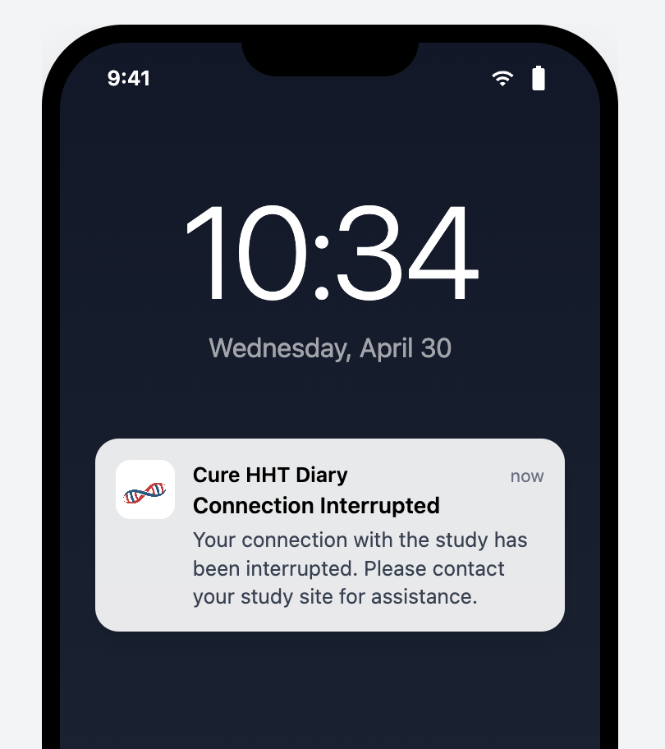

6.8.3 Participation Status Badge
REQ ID: DIARY-GUI-participation-status-badge
Refines: DIARY-PRD-notification-disconnection

6.8.3.1 Overview
The Participation Status Badge gives Participants a persistent, at-a-glance view of their clinical Trial involvement. The badge adapts its display based on the Participant’s current status so they always know whether they are connected, disconnected, or no longer participating in a study.
Participation Status Badge
The visual component displayed in the Clinical Trial section of the user profile screen showing the Participant’s current study participation state and associated details.

6.8.3.2 Assertions
Placement
- The interface SHALL display the Participation Status Badge in the Clinical Trial section of the User profile screen.
Linked State
- When the Participant’s status is Linked - Awaiting Start or Trial Active, the Participation Status Badge SHALL display the Sponsor logo, the Participant’s Linking Code, and the date and time the Participant joined.
- The Participation Status Badge SHALL include a link to the Clinical Trial Privacy Policy from the moment the Participant links to the study, and the link SHALL remain available thereafter regardless of subsequent status changes.
Disconnected State
- When the Participant’s status is Disconnected, the Participation Status Badge SHALL display a warning indicator, the Participant’s current Linking Code, and a message that the connection has been interrupted.
- When the Participant’s status is Disconnected, the Participation Status Badge SHALL present an Enter New Linking Code Action that navigates the Participant to the Linking Code entry screen.
Not Participating State
- When the Participant’s status is Not Participating, the Participation Status Badge SHALL display in an inactive visual style with the end date of participation.
Automatic Update
- The Participation Status Badge SHALL update automatically when the Participant’s status changes.
- The System SHALL support Sponsor-configurable display of the Sponsor logo on the Participation Status Badge when the Participant’s status is Not Participating.

6.8.3.3 Rationale
The badge consolidates “where do I stand with this study” into a single visual the Participant always finds in the same place (Clinical Trial section of the User Profile). Three state variants cover the three operational situations: actively-linked (Sponsor logo, Linking Code, join date — full participation context), disconnected (warning indicator, Linking Code, Enter New Linking Code Action — the recovery path is reachable from the badge itself), and not-participating (inactive style with end date — the badge persists as historical evidence of past participation without competing for attention against current state). The Clinical Trial* Privacy Policy* link persists across status changes because the policy version the Participant consented to is part of their permanent record, and they have a continuing right to retrieve it. Automatic update on status change is the standard freshness guarantee; Sponsor-configurable logo display in the Not Participating state lets the deployment decide whether the badge in its end-of-participation state still carries Sponsor branding (an end-of-Trial communication preference).
Follow-up — configurability: This requirement currently encodes the only option implemented in code. Future sponsors may require different rules; introduce a configurable seam (e.g. a parameter on the CAL-PRD-* parent, or a new platform-side template the CAL- REQ Satisfies) when the need arises. Until that seam exists, this REQ is normative for the Callisto deployment.

6.8.4 Incomplete Record Lock Warning Notification
REQ ID: DIARY-PRD-notification-incomplete-record-lock

6.8.4.1 Overview
Once an Incomplete Record reaches the Lock Threshold defined in Diary-PRD-entry-time-restrictions, the Participant cannot complete, edit, or delete it — the record is permanently retained in its incomplete state. To give Participants a final opportunity to act before this irreversible lock, the System sends a push notification at a configurable time before the lock fires. This requirement defines the platform mechanism; the trigger offset and notification text are Sponsor-configurable.
Lock Warning Offset
The configurable elapsed time before the Lock Threshold at which the System sends a push notification to the Participant about an Incomplete Record that has not been completed or deleted.

6.8.4.2 Assertions
Notification Behavior
- The System SHALL send a push notification to the Participant when an Incomplete Record reaches the Lock Warning Offset before the Lock Threshold defined in Diary-PRD-entry-time-restrictions.
- The System SHALL send the notification only once per Incomplete Record.
- When a Participant completes or deletes an Incomplete Record before the Lock Warning Offset is reached, the System SHALL NOT send the notification for that record.
Configuration
- The System SHALL support a Sponsor-configurable Lock Warning Offset per deployment.
- The System SHALL support Sponsor-configurable notification text per deployment.
- When the Lock Warning Offset is not configured for a deployment, the System SHALL NOT send the notification.
- The Lock Warning Offset SHALL be less than the Lock Threshold defined in Diary-PRD-entry-time-restrictions.

6.8.4.3 Rationale
The Lock Threshold produces an irreversible state — once exceeded, the Incomplete Record is permanently retained in its missing-field state and cannot be completed, edited, or deleted. The lock-warning notification exists because that irreversible outcome benefits from one final Participant nudge before it lands; without the warning, a Participant who simply forgot about an Incomplete Record discovers the permanent lock only on next app open, long after they could have done anything about it. Once-per-record (assertion B) prevents notification spam from a single long-lingering record; suppression on completion or deletion before the warning offset (assertion C) avoids notifying about records the Participant has already resolved. The opt-out semantics (not configured = no notification) and the Lock-Warning-less-than-Lock-Threshold invariant compose with the parent Entry Time Restrictions REQ — if a deployment hasn’t configured the parent thresholds, the warning has no boundary to anchor to and is therefore not sent.

6.8.5 Incomplete Record Lock Warning Notification Configuration
REQ ID: CAL-PRD-notification-incomplete-record-lock-configuration
Refines: DIARY-PRD-notification-incomplete-record-lock

6.8.5.1 Overview
The clinical protocol defines a 48-hour lock on Diary entries (CAL-PRD-entry-time-restrictions-configuration). To give Participants a final opportunity to complete or delete an Incomplete Record before the lock fires, a warning notification is 24 hours prior. These values configure the platform mechanism defined in Diary-PRD-notification-incomplete-record-lock.

6.8.5.2 Assertions
- The Lock Warning Offset SHALL be configured to 24 hours.
- The notification text SHALL be: “You have an incomplete nosebleed record from [date]. Complete or delete it within the next 24 hours, otherwise it will be permanently locked and you will not be able to change or remove it.”

6.8.5.3 Rationale
The 24-hour Lock Warning Offset places the warning notification at the midpoint of the 48-hour Lock Threshold window (CAL-PRD-entry-time-restrictions-configuration) — early enough that the Participant has a full day to act, late enough that the record has been in incomplete state long enough for the warning to be useful rather than premature. The notification text names the dated record explicitly so the Participant knows which entry needs Action, states the 24-hour deadline so the Participant understands the urgency, and spells out the consequence (permanent lock, no further changes) so the Action’s importance is clear without medicalized hedging.

6.8.6 Portal-Sent Questionnaire Notification
REQ ID: DIARY-PRD-notification-portal-sent-questionnaire

6.8.6.1 Overview
When a Study Coordinator sends a Portal-Sent Questionnaire from the Sponsor Portal, the Participant must be made aware that a new Questionnaire is available for completion. A push notification serves as the awareness mechanism. The Questionnaire Task on the Main Screen provides the Participant’s entry point into the Questionnaire flow once the application is open.

6.8.6.2 Assertions
Trigger
- When a Portal-Sent Questionnaire** is successfully delivered to the Mobile Application, the System SHALL deliver a Push Notification** to the Participant.
Offline Delivery
- When the Mobile Application is offline at the time a Portal-Sent Questionnaire** is sent, the System SHALL deliver the Push Notification** when the Mobile Application next establishes connectivity.
Suppression
- The System SHALL NOT deliver a Push Notification for a Portal-Sent Questionnaire** that has already been submitted by the Participant**.
- The System SHALL NOT deliver a Push Notification for a Portal-Sent Questionnaire** that has been called back by the Study Coordinator**.

6.8.6.3 Rationale
The push notification is the Participant’s awareness signal that a new Portal-Sent Questionnaire is waiting; without it, the Participant would discover the Questionnaire only when they happen to open the app, which can extend the response window beyond what the Study Coordinator intended. Trigger-on-delivery (rather than trigger-on-send-from-portal) is the correct boundary because delivery is what actually puts the Questionnaire on the Participant’s device; sending from the portal to an offline device is a Sponsor-side Action that has no Participant-side effect yet. Offline-deferred delivery follows the cross-cutting notification template — the OS deferred-delivery mechanism is sufficient for the nudge purpose. Submission and call-back suppression closes the two cases where the notification would be misleading: a Questionnaire already submitted no longer needs the Participant’s attention, and a called-back Questionnaire is no longer assigned to them and a notification would invite wasted effort on an inactive Questionnaire.

6.8.6.4 Screen reference
See: 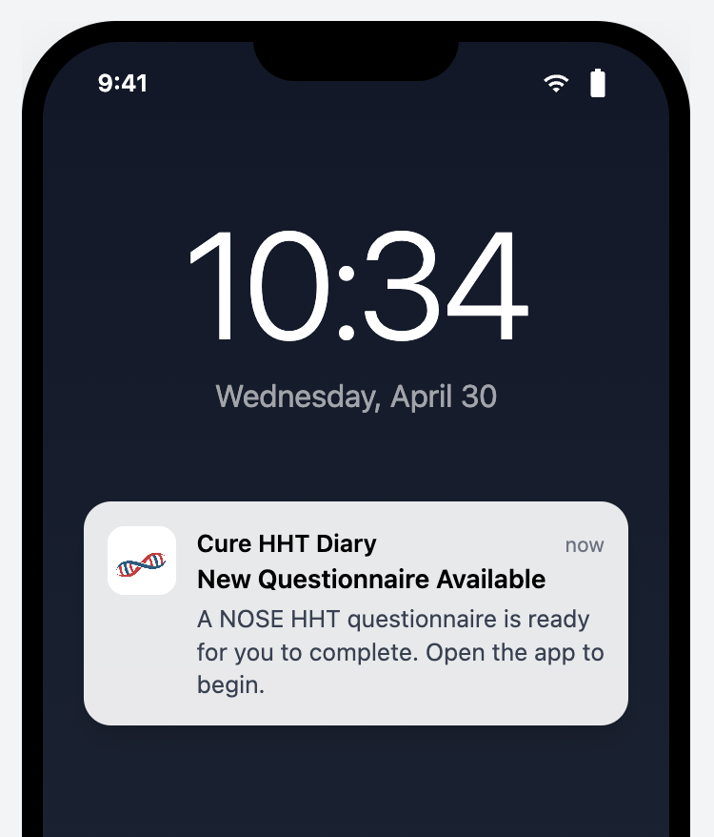

6.8.7 Yesterday Entry Reminder Notification
REQ ID: DIARY-PRD-notification-yesterday-entry

6.8.7.1 Overview
Clinical Trial data completeness under ALCOA+ principles requires a Daily Status for each Calendar day in the Diary period. A daily reminder fired at a configured time of day prompts the Participant to review the previous day and respond via the Yesterday Reminder Task on the Main Screen.
Reminder Time
The configurable time of day, in the Participant’s local timezone, at which the Yesterday Entry Reminder Notification is delivered.

6.8.7.2 Assertions
Trigger
- The System SHALL deliver a Push Notification at the Reminder Time when no Daily Status has been recorded for the previous Calendar day.
Timezone
- The System SHALL evaluate the Reminder Time against the Participant’s device local timezone.
- The System SHALL evaluate “the previous Calendar day” against the Participant’s device local timezone.
Suppression
- The System SHALL NOT deliver the Push Notification when a Daily Status has been recorded for the previous Calendar day.
- The System SHALL deliver at most one Yesterday Entry Reminder Notification per Calendar day.
Configuration
- The System SHALL support Sponsor-configurable Reminder Time per deployment.

6.8.7.3 Rationale
ALCOA+ Complete principle requires a Daily Status for every day in the Diary period; the Yesterday Entry Reminder is the platform’s mechanism for prompting participants to maintain completeness day-by-day rather than discovering large gaps weeks later. Local-timezone evaluation (both for the Reminder Time and for “previous Calendar day”) is essential because participants travel — a UTC-anchored reminder would fire at unpredictable local times for a Participant who has moved across timezones, undermining the time-of-day intent. Sponsor-configurable Reminder Time lets each deployment select a delivery time appropriate to its Participant population (e.g. morning for a working-age population). Once-per-day cap (assertion E) prevents pathological repeat-fires; suppression-on-status-recorded prevents the notification from arriving after the Participant has already addressed the yesterday gap via the Task List or Calendar.

6.8.7.4 Screen reference
See: 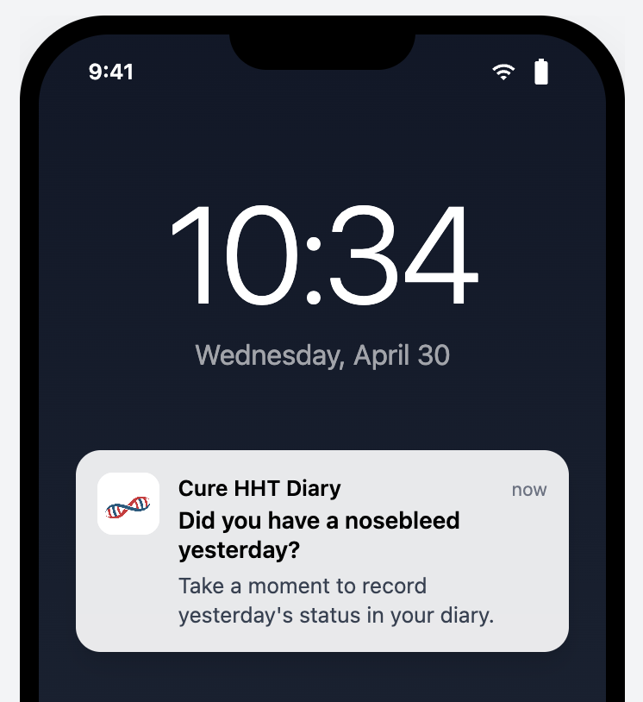

6.8.8 Yesterday Entry Reminder Configuration
REQ ID: CAL-PRD-notification-yesterday-entry-configuration
Refines: DIARY-PRD-notification-yesterday-entry

6.8.8.1 Assertions
- The Reminder Time for the Yesterday Entry Reminder Notification SHALL be configured to 09:00 (24H format) in the Participant’s local timezone.

6.8.8.2 Rationale
The 09:00 Reminder Time for the Yesterday Entry Reminder targets a morning-routine delivery window: the Participant is likely awake, has finished the previous day, and is at a natural reflect-and-record point before the day’s activities begin. A morning fire is more reliable than evening for daily-status capture because the Participant has full memory of yesterday and the day is not yet competing for their attention. Evaluating the time against the Participant’s device local timezone (per the parent REQ) keeps the 09:00 delivery consistent regardless of Participant travel.

6.8.9 Ongoing Epistaxis Event Reminder
REQ ID: DIARY-PRD-notification-ongoing-epistaxis

6.8.9.1 Overview
A Participant who starts recording an Epistaxis Event but does not complete the record may forget to return and capture the end time, resulting in inaccurate duration data. A configured sequence of escalating reminders prompts the Participant to complete the record or confirm it is still ongoing. Once the sequence has fired, no further reminders are sent.
The Participant may configure their own Reminder Schedule for personal use. A Sponsor-configured schedule overrides the personal setting for the duration of a clinical Trial.
Reminder Schedule
An ordered list of elapsed-time intervals defining the timing of successive reminder notifications for an Incomplete Record. Each interval is measured from the time of the previous notification, with the first interval measured from the Participant’s most recent interaction with the record.

6.8.9.2 Assertions
Trigger and Sequence
- The System SHALL track the elapsed time since the Participant’s most recent interaction with each Incomplete Record.
- The System SHALL deliver a Push Notification to the Participant at each interval in the Reminder Schedule.
- After the final interval in the Reminder Schedule has elapsed, the System SHALL NOT deliver further reminders for that Incomplete Record.
Reset on Interaction
- When the Participant interacts with an Incomplete Record, the System SHALL restart the Reminder Schedule from the first interval.
Termination
- When an Incomplete Record is completed, the System SHALL stop delivering reminders for that record.
- When an Incomplete Record is deleted, the System SHALL stop delivering reminders for that record.
Configuration
- The default Reminder Schedule for the Mobile Application SHALL be empty, resulting in no reminders being delivered.
- The System SHALL allow a Participant to configure their own Reminder Schedule in Mobile Application settings.
- The System SHALL support Sponsor-configurable Reminder Schedule per deployment.
- When a Sponsor-configured Reminder Schedule is in effect, the System SHALL apply the Sponsor-configured schedule and SHALL NOT apply the Participant’s personally configured schedule.

6.8.9.3 Rationale
A nosebleed event captured with an accurate start time but a missing or wildly-late end time produces unreliable duration data — one of the three primary outcome measures. The Ongoing Epistaxis Event Reminder addresses the natural failure mode where the Participant starts the record at the moment the nosebleed begins, then forgets to return when it stops because their attention has moved on. An escalating schedule (intervals measured from previous notification) gives the Participant a reasonable chance to respond without saturating their notification surface — once the final interval has fired and no response landed, further nudging is unlikely to help and the data will be flagged via the Incomplete Records Task anyway. Reset-on-interaction (assertion D) restarts the schedule when the Participant touches the record, on the inference that they are now engaged again and a fresh sequence is the right cadence. Sponsor override of the Participant’s personal schedule (assertion J) reflects the clinical-Trial priority: while participating in a study, the Sponsor’s clinical protocol drives the reminder cadence; outside a Trial, the Participant controls their own experience. Empty default (assertion G) is the right “no policy yet” state — a deployment that has not configured a schedule produces no reminders rather than guessing at intervals.

6.8.9.4 Screen reference
See: 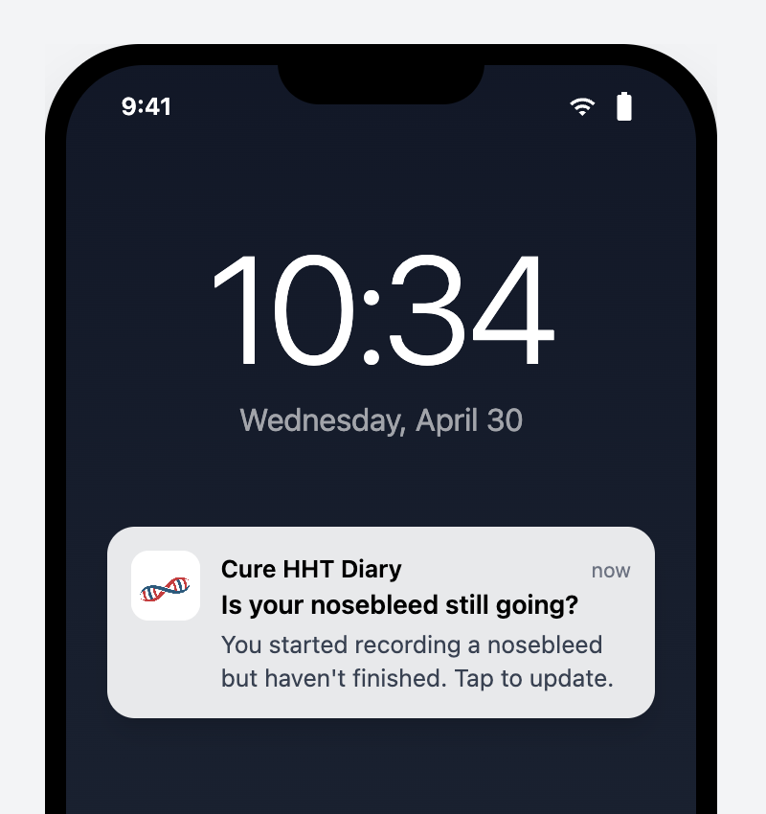

6.8.10 Ongoing Epistaxis Event Reminder Configuration
REQ ID: CAL-PRD-notification-ongoing-epistaxis-configuration
Refines: DIARY-PRD-notification-ongoing-epistaxis

6.8.10.1 Assertions
- The Reminder Schedule for the Ongoing Epistaxis Event Reminder SHALL be configured to deliver notifications at the following intervals: 5 minutes, 10 minutes, 15 minutes, 30 minutes.

6.8.10.2 Rationale
The Ongoing Epistaxis Event Reminder Schedule (5/10/15/30 minutes) is a deliberate escalation: the first three reminders fire in the window where a typical nosebleed is still resolving (5-15 minutes) — most events end within this window, and the reminders help the Participant remember to capture the end time as it happens. The 30-minute interval is the final attempt: if the Participant has not responded by then, they are likely engaged with something else or the event has ended without active capture, and further reminders would saturate without informing. The four-interval cap respects the parent REQ’s terminating-sequence rule.

6.8.11 Historical Gap Reminder
REQ ID: DIARY-PRD-notification-historical-gap

6.8.11.1 Overview
The Historical Gap Reminder addresses missing Daily Status entries on days older than yesterday but still within the editable window.
Historical Gap
A calendar day between the Diary Start Day and the current day, exclusive of the current day and the previous day, for which the Participant has not recorded a Daily Status.
Historical Gap Reminder
A daily Push Notification delivered to the Participant prompting them to address one or more Historical Gaps.

6.8.11.2 Assertions
Trigger
- The System SHALL evaluate, once per Calendar day at the configured Reminder Time, whether the Participant has any Historical Gap within the editable window.
- When the Participant has at least one Historical Gap within the editable window, the System SHALL deliver a Historical Gap Reminder to the Participant.
- The System SHALL deliver at most one Historical Gap Reminder per Calendar day.
Editable Window
- The System SHALL exclude from the Historical Gap evaluation any day for which the elapsed time has exceeded the Lock Threshold.
- In linked use mode, the System SHALL exclude from the Historical Gap evaluation any day before the Trial Start date.
Mode-Dependent Default
- In personal use mode, the Historical Gap Reminder SHALL be disabled by default.
- In personal use mode, the System SHALL allow the User to enable or disable the Historical Gap Reminder from the Mobile Application settings.
- In linked use mode, the Historical Gap Reminder SHALL be enabled by default.
Configuration
- The System SHALL support Sponsor-configurable Reminder Time per deployment.
- The System SHALL support Sponsor-configurable notification text per deployment.

6.8.11.3 Rationale
Historical gaps (days within the Diary period that have no Daily Status) accumulate when a Participant misses the Yesterday Entry Reminder window across multiple days; without a separate prompt, those gaps stay invisible to the Participant unless they happen to open the Calendar. The Historical Gap Reminder is the platform’s once-daily nudge to address them, evaluated at the same configured Reminder Time as the Yesterday reminder so the Participant gets a coherent daily reminder cadence. The editable-window exclusion (assertions D and E) prevents the reminder from prompting Action on dates the Participant can no longer modify — locked dates and pre-Trial-start dates have no Action available. The mode-dependent default (disabled in personal use, enabled in linked use) reflects the difference in motivation: a personal-use User has no external party expecting their data and may not want pressure to backfill; a linked Participant is held to a clinical-Trial completeness standard. The Participant retains the ability to override the default in personal mode (assertion G), while linked mode applies the Sponsor-configured behavior.

6.8.11.4 Screen reference
See: 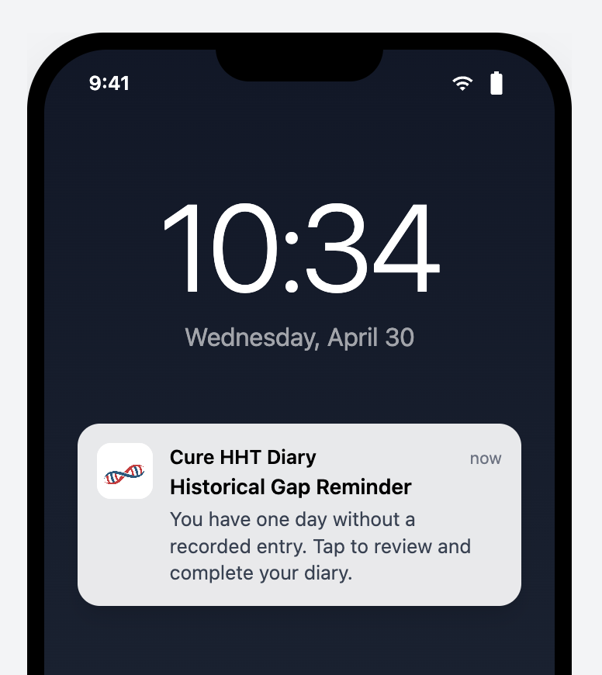

6.8.12 Historical Gap Reminder Configuration
REQ ID: CAL-PRD-notification-historical-gap-configuration
Refines: DIARY-PRD-notification-historical-gap

6.8.12.1 Assertions
- The Reminder Time for the Historical Gap Reminder SHALL be configured to 09:00 (24H format) in the Participant’s local timezone.
- The Historical Gap Reminder notification text SHALL be: “You have one day without a recorded entry. Tap to review and complete your Diary.”

6.8.12.2 Rationale
The 09:00 Reminder Time matches the Yesterday Entry Reminder Time so the Participant receives a single coherent daily-reminder cadence at the same hour rather than two notifications at unrelated times. The platform’s once-per-day cap on each reminder type ensures the Participant sees at most one Historical Gap Reminder per day even if multiple historical gaps exist; the notification text is therefore phrased to direct the Participant to the Diary (where they can address whichever gaps they choose) rather than naming any specific date. The “Tap to review and complete your Diary” call-to-Action sends the Participant to the Calendar where they can see every gap visually and choose how to backfill.

6.9 Device Linking
The Participant-side linking flow comprises the platform-level rules for error handling and rate limiting on linking-code entry, the Join the Study screen the Participant uses to enter a code and consent to the Clinical Trial Privacy Policy, and the Successful Linking Confirmation that completes the transition from User to Participant.

6.9.1 Linking Code Entry Error Handling
REQ ID: DIARY-PRD-linking-code-entry-errors

6.9.1.1 Overview
Security best practices require generic error messages that do not reveal whether a Linking Code exists, is expired, or has been used. This prevents malicious actors from enumerating valid codes or determining code status. Rate limiting protects against brute-force attacks while a configurable cooldown balances security with usability.
Linking Code Validation Failure
Any unsuccessful attempt to enter a linking code, regardless of the specific reason for failure.
Rate Limit Threshold
The configurable maximum number of consecutive Linking Code Validation Failures permitted within a single rate limit window before further attempts are temporarily blocked.
Rate Limit Cooldown
The configurable duration after which the rate limit counter resets and the User may attempt linking again.

6.9.1.2 Assertions
Error Messaging
- When a Linking Code Validation Failure occurs, the System SHALL display a single generic error message regardless of the specific reason for failure.
- The error message SHALL NOT reveal the specific reason for failure.
- When a Linking Code Validation Failure occurs, the System SHALL provide guidance to contact the Site for a new code.
Rate Limiting
- When the number of consecutive Linking Code Validation Failures reaches the Rate Limit Threshold, the System SHALL block further linking attempts and display the Rate Limit error message until the Rate Limit Cooldown has elapsed.
- The Rate Limit Cooldown SHALL be calculated from the first failed attempt in the current window.
Configuration
- The System SHALL support Sponsor-configurable Rate Limit Threshold per deployment.
- The System SHALL support Sponsor-configurable Rate Limit Cooldown per deployment.
- The System SHALL support Sponsor-configurable error message text per deployment.

6.9.1.3 Rationale
Linking codes are short, human-typeable secrets that confer access to a clinical-Trial Participant identity; the platform’s threat model has to assume that someone may attempt to guess or enumerate valid codes. Two mitigations compose: a generic error message that does not distinguish “code does not exist” from “code expired” from “code already used” (assertions A and B — distinguishing them would tell an attacker exactly which guesses are worth pursuing), and a rate limit that caps the number of attempts in a window. The Site-contact guidance (assertion C) is the legitimate-User recovery path that survives the genericity rule — a real Participant who has mistyped their code gets the same message as an enumerator, but they also get the actionable next step (contact the Site). The cooldown anchored at the first failed attempt in the window (assertion E) prevents the trivial workaround of attempting just below the threshold, waiting one second, and continuing — the window is a fixed time interval from the first miss. Sponsor-configurable threshold, cooldown, and text let each deployment tune the security/usability trade-off and customize the message.

6.9.2 Linking Code Entry Error Handling Configuration
REQ ID: CAL-PRD-linking-code-entry-errors-configuration
Refines: DIARY-PRD-linking-code-entry-errors

6.9.2.1 Overview
These values configure the platform Linking Code error handling mechanism defined in Diary-PRD-linking-code-entry-errors.

6.9.2.2 Assertions
- The Rate Limit Threshold SHALL be configured to 10 attempts.
- The Rate Limit Cooldown SHALL be configured to 1 hour.
- The Linking Code Validation Failure error message SHALL display the text: “Invalid Linking Code.”
- The Rate Limit error message SHALL display the text: “Too many attempts. Please wait an hour.”

6.9.2.3 Rationale
The 10-attempt Rate Limit Threshold is calibrated for the linking-code surface — a longer typeable code than a Password, where a Participant making honest typos may go through several attempts on a single onboarding Session before getting the code right. Setting the threshold below 10 (e.g. the Sponsor Portal’s 5) would too often lock out legitimate participants on first-time linking; setting it much higher would give enumeration attempts useful headroom. The 1-hour Rate Limit Cooldown is long enough to make brute-force enumeration impractical at the platform’s code-space (an attacker hitting the limit gets at most ~240 attempts/day against a single device, against a code space measured in millions) while keeping a realistic recovery window for a legitimate Participant who has hit the limit through honest typos — they can return after lunch or after contacting their Site for a fresh code. The generic error message “Invalid Linking Code.” satisfies the parent REQ’s no-information-leakage rule (the same text fires regardless of whether the code is unknown, expired, or used), and the Rate Limit message names the specific delay so the Participant knows when they may try again rather than retrying indefinitely.

6.9.3 Join the Study Screen
REQ ID: DIARY-GUI-join-study-screen
Refines: DIARY-PRD-linking-code-entry-errors

6.9.3.1 Overview
The Join the Study screen is presented to the User when initiating the linking workflow. It captures the Mobile Linking Code and the Participant’s explicit consent to the Clinical Trial Privacy Policy before any link is established.
Linking Consent
The explicit acknowledgement by the Participant that they have read and consent to the Clinical Trial Privacy Policy. This consent must be captured before the linking code submission is permitted.

6.9.3.2 Assertions
- The Join the Study screen SHALL display a Mobile Linking Code entry field formatted according to the configured code format.
- The screen SHALL display a Linking Consent checkbox with text confirming the Participant has read, understood, and consents to the Clinical Trial Privacy Policy.
- The Linking Consent text SHALL include a link that opens the Clinical Trial Privacy Policy.
- The Submit Action SHALL be disabled until both a complete Mobile Linking Code** is entered and the Linking Consent** checkbox is checked.
- The System SHALL retain the Linking Consent acknowledgement, including the Clinical Trial Privacy Policy version, against the Participant record upon successful link.

6.9.3.3 Rationale
The Join the Study screen has to do two things at once: capture the Linking Code (the technical secret that binds device to Participant) and capture Linking Consent (the regulatory acknowledgement that the Participant has read the Clinical Trial Privacy Policy). Co-locating them on a single screen rather than splitting across two screens reflects that both are required before linking can proceed, and a two-step split would invite the Participant to complete one without the other. The Submit-disabled-until-both-present rule is the GUI-side enforcement of the dual gate — there is no path forward without both. Retaining the consent record with the policy version against the Participant record is the audit-trail requirement: the platform must be able to demonstrate which version of the policy each Participant consented to, separately from the current version, for the lifetime of their participation. The configurable code format on the entry field is the platform-side accommodation for Sponsor-specific code shapes (length, separator characters) without imposing a single format across deployments.
Follow-up — configurability: This requirement currently encodes the only option implemented in code. Future sponsors may require different rules; introduce a configurable seam (e.g. a parameter on the CAL-PRD-* parent, or a new platform-side template the CAL- REQ Satisfies) when the need arises. Until that seam exists, this REQ is normative for the Callisto deployment.

6.9.4 Successful Linking Confirmation
REQ ID: DIARY-GUI-linking-confirmation
Refines: DIARY-PRD-linking-code-entry-errors

6.9.4.1 Overview
When a Participant successfully enters a valid Mobile Linking Code on the Join the Study screen, the interface needs to clearly confirm that the link was established and transition the Participant from personal use mode into linked use mode.

6.9.4.2 Assertions
- When the Participant successfully submits a valid Mobile Linking Code, the interface SHALL display an Acknowledgement Dialog confirming that the device has been linked to the study.
- When the Participant acknowledges the dialog, the interface SHALL navigate the Participant to the User Profile screen.

6.9.4.3 Rationale
A successful link transitions the Participant from a personal-use User to a clinical-Trial Participant — a state change that affects what data syncs, which notifications fire, and which screens display the Sponsor logo. The Acknowledgement Dialog makes the transition explicit so the Participant has a clear before/after rather than discovering the change passively. Routing to the User Profile screen after acknowledgement (rather than back to the Main Screen) lands the Participant on the screen where the new linked state is most visible: the Clinical Trial section now displays the Participation Status Badge instead of the unlinked-state guidance, which serves as the visible confirmation of the new state.
Follow-up — configurability: This requirement currently encodes the only option implemented in code. Future sponsors may require different rules; introduce a configurable seam (e.g. a parameter on the CAL-PRD-* parent, or a new platform-side template the CAL- REQ Satisfies) when the need arises. Until that seam exists, this REQ is normative for the Callisto deployment.

6.9.4.4 Screen reference
See: 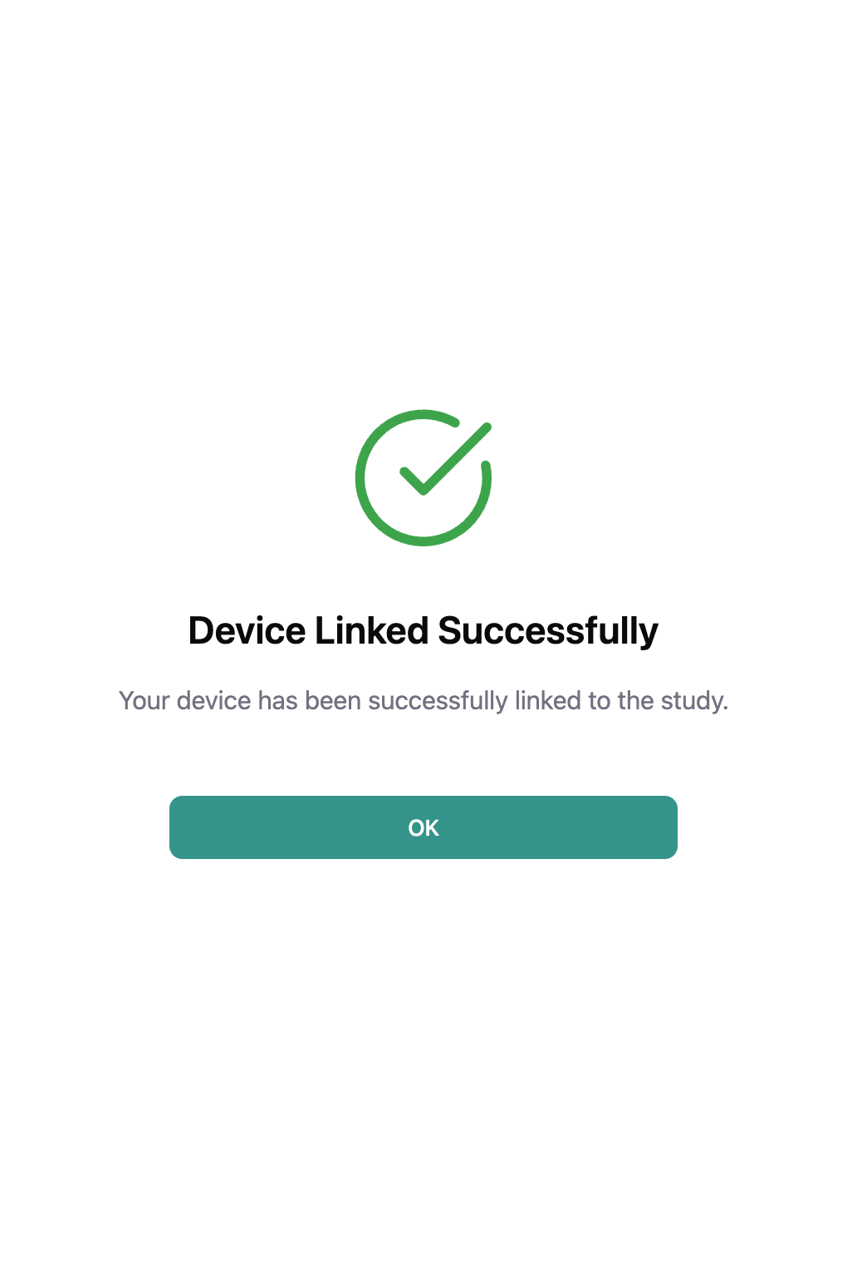

7 Appendices

7.1 Screens

7.1.1 Questionnaire Review Screen
Trigger: Participant answers the final question of a Portal-Sent Questionnaire, before Submission.
Displays: Questionnaire Display Name, every question in original order, the Participant’s selected response beneath each question, an Edit affordance per question, and a Submit action.
Outcome: Selecting Submit completes Submission.
Reference: DIARY-GUI-questionnaire-portal-sent-workflow.


7.1.2 Questionnaire Preamble Screen
Trigger: Participant opens a Portal-Sent Questionnaire.
Displays: Questionnaire Display Name, estimated time to complete.
Actions: I’m Ready (proceed to first question), Not Now (return to Main Screen). Reference: DIARY-PRD-questionnaire-portal-sent-rules, DIARY-GUI-questionnaire-portal-sent-workflow.


7.1.3 Resolve Conflict — Resolution Screen
Trigger: New or edited entry Overlaps with one or more Conflicting Records. Displays: New entry and Conflicting Record side by side, showing time range, duration, and severity for each.
Actions: Keep New (retain new entry, discard Conflicting Record), Keep Existing (retain Conflicting Record, discard new entry), Merge Records (combine both using earliest start time, latest end time, and higher severity). Conditional behavior:
- Merge Records is presented only when the Conflicting Record’s event date has not exceeded the Lock Threshold.
- When the Conflicting Record is older than the Justification Threshold, an Entry Justification is required before saving the resolution.
Outcome: Participant is navigated to the Record Nosebleed screen pre-filled with the resulting entry data for review and confirmation.
Reference: DIARY-PRD-entry-overlap-resolution, DIARY-GUI-entry-overlap-resolution.


7.1.4 Troubleshooting Popover
Trigger: Study Coordinator selects the information icon adjacent to the Status Badge on a Questionnaire Card in Delivery Failed status.
Displays: Guidance for resolving delivery issues for the affected Questionnaire.
Dismissal: Click outside the popover.
Reference: CAL-GUI-manage-questionnaires-modal.
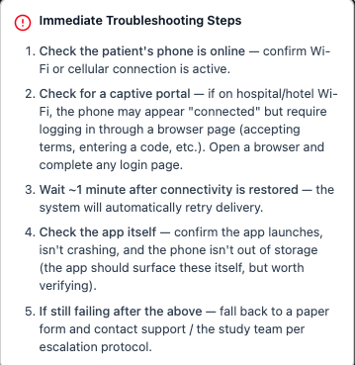

7.2 Modals

7.2.1 User Information Modal
Trigger: Administrator selects a User Account row from the User Management interface.
Target identification: Full Name, Email Address, Status.
Displays: Assigned Role(s) and Site assignments. When the User Account holds one or more non-Administrator Roles, the Administrator may select a single Role to scope the displayed Site list. When the User Account is an Administrator, the modal indicates access to all Sites. Actions (Active Users tab): Edit User, Deactivate User, Close. The Deactivate User action is not presented for the currently authenticated user’s own account.
Actions (Inactive Users tab): Reactivate User, Close.
Reference: DIARY-GUI-user-information-modal.
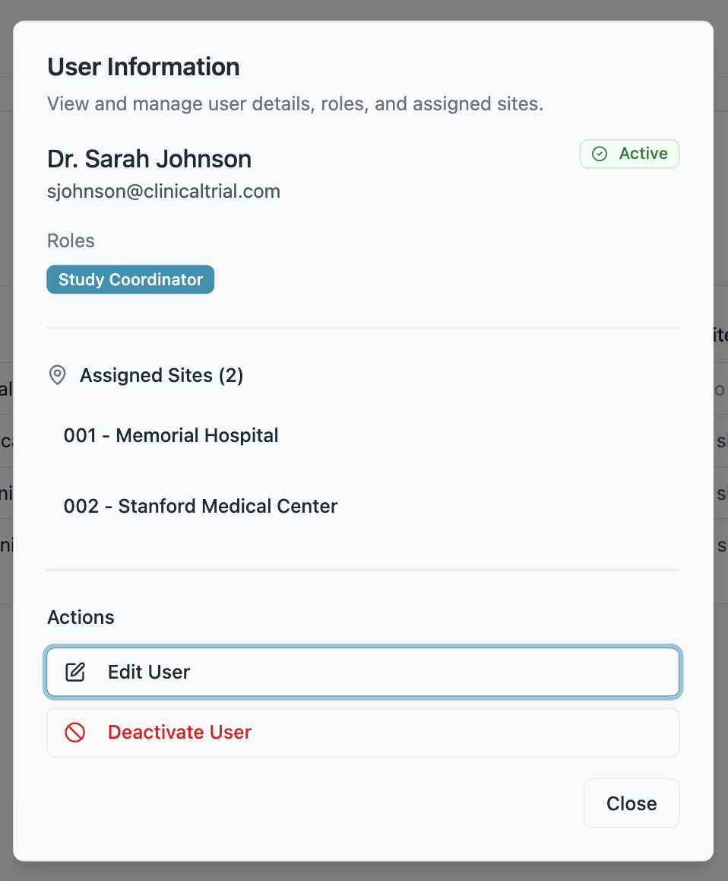

7.2.2 Show Linking Code
Trigger: Study Coordinator selects Show Linking Code for a Participant.
Target identification: Participant ID.
Variants:
- Pending status: displays the active Mobile Linking Code with Copy and Save as PDF actions. Save as PDF generates a PDF containing the Mobile Linking Code and Participant instructions.
- Any other status: displays the Participant Linking Code (the code previously used to establish the connection) with a Copy action, and indicates the code is shown for reference only.
Dismissal: Close.
Reference: CAL-GUI-participant-dashboard-configuration.
Pending Status
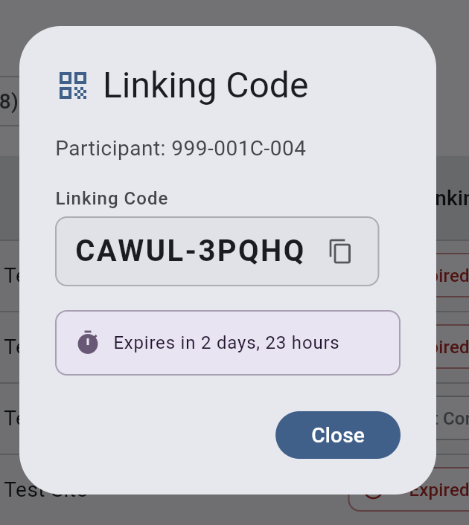
After Participant was linked to the Mobile Application
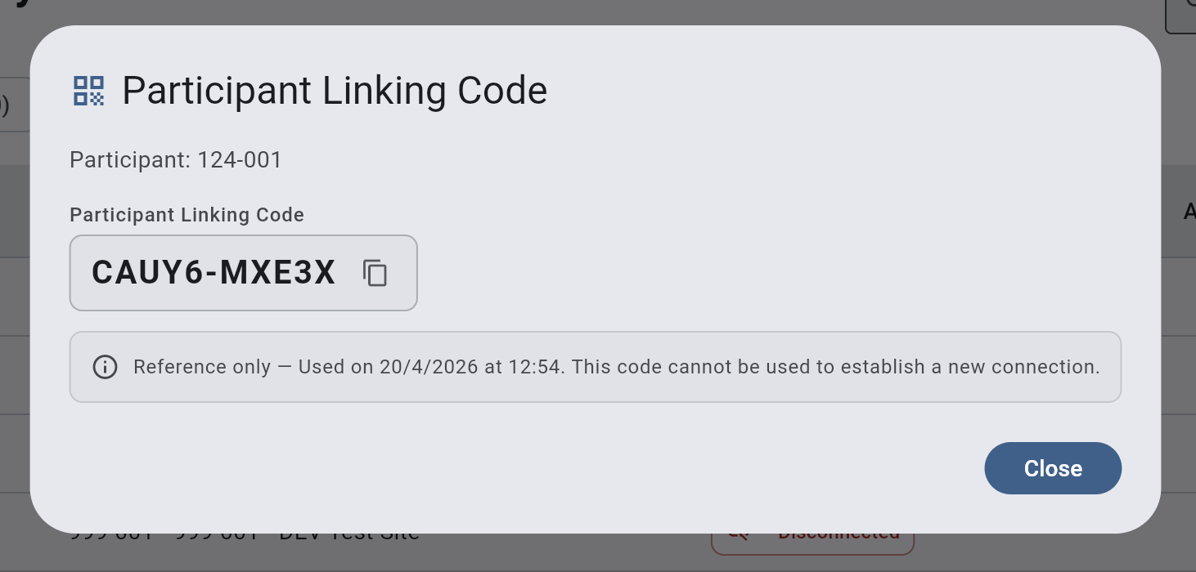

7.2.3 Manage Questionnaires Modal
Trigger: Study Coordinator selects Manage Questionnaires for a Participant with Trial Active status.
Target identification: Participant ID in the modal header.
Displays: One Questionnaire Card per Questionnaire Type enabled for the deployment. Each card shows the Questionnaire Type name and current Questionnaire Status, with content and actions varying by status and Cycle state (e.g., Send Now, Start Next Cycle, Finalize, call back).
Dismissal: Close action.
Reference: CAL-GUI-manage-questionnaires-modal.
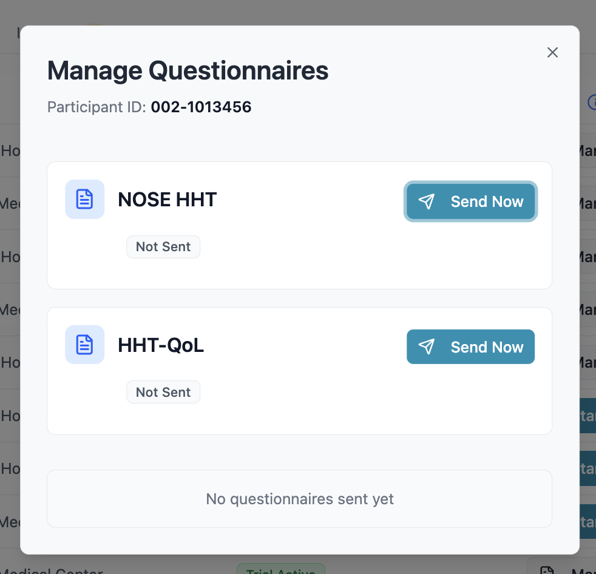

7.3 Dialogs

7.3.1 Deactivate User Account — Reason Dialog (Free Text)
Trigger: Administrator initiates deactivation of a User Account from the Active Users tab. Target identification: Full Name.
Consequence summary: The User Account will be deactivated and the user will no longer be able to access the System.
Pattern: Reason Dialog — Free Text (see §4.1).
Reference: DIARY-PRD-user-account-deactivate, DIARY-GUI-user-account-deactivate.
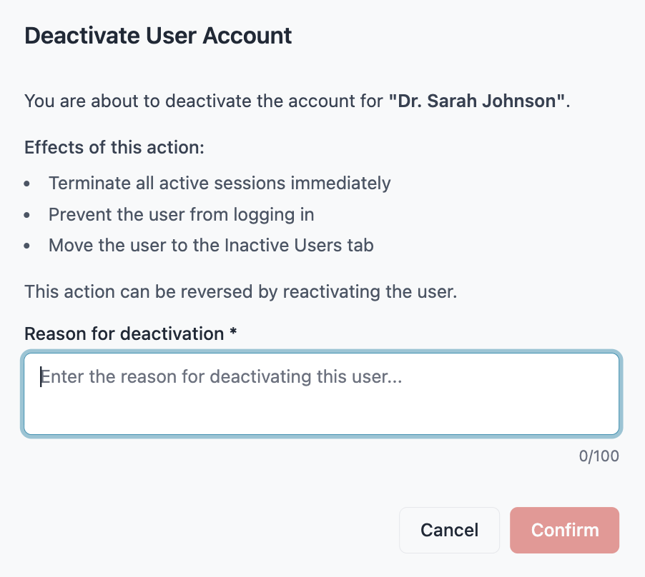

7.3.2 Reactivate User Account — Reason Dialog (Free Text)
Trigger: Administrator initiates reactivation of a User Account from the Inactive Users tab.
Target identification: Full Name.
Consequence summary: The User Account will be set to Pending Activation and the user will be required to complete the activation workflow before regaining access.
Pattern: Reason Dialog — Free Text (see §4.1).
Reference: DIARY-PRD-user-account-reactivate, DIARY-GUI-user-account-reactivate.
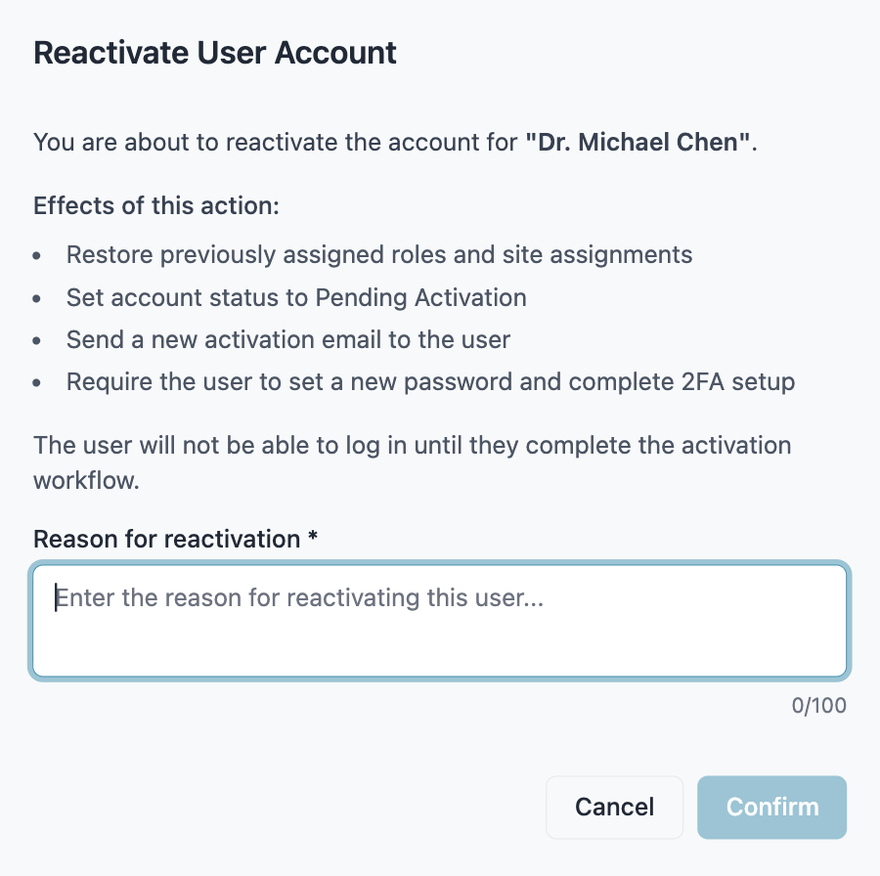

7.3.3 Link Participant — Confirmation Dialog
Trigger: Study Coordinator initiates Link Participant for a Participant with Not Connected status.
Target identification: Participant ID.
Consequence summary: A Mobile Linking Code will be generated for the Participant and will expire after the configured duration.
Pattern: Confirmation Dialog (see §4.1).
Reference: DIARY-PRD-participant-link-new, CAL-GUI-participant-dashboard-configuration.
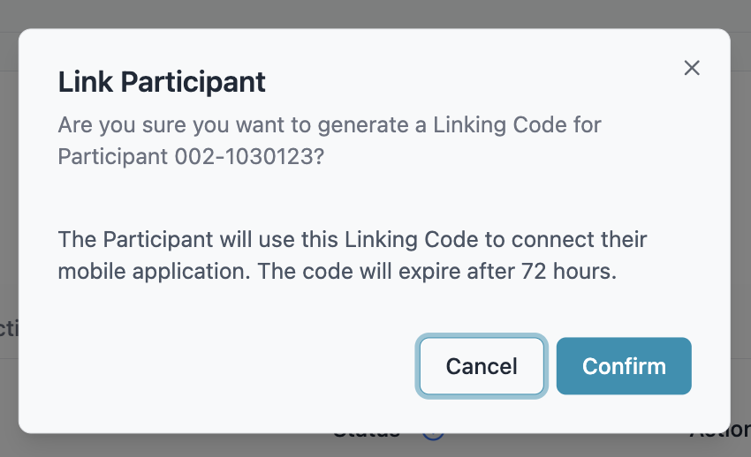

7.3.4 Linking Code Generated — Acknowledgement Dialog
Trigger: Study Coordinator confirms generation of a Mobile Linking Code from the Link Participant Confirmation Dialog (§7.3.3).
Target identification: Participant ID.
Displays: Generated Mobile Linking Code with a Copy action, and remaining time until expiry. Outcome: On dismissal, the Participant’s Status Badge updates to Pending.
Pattern: Acknowledgement Dialog (see §4.1).
Reference: CAL-GUI-participant-dashboard-configuration.
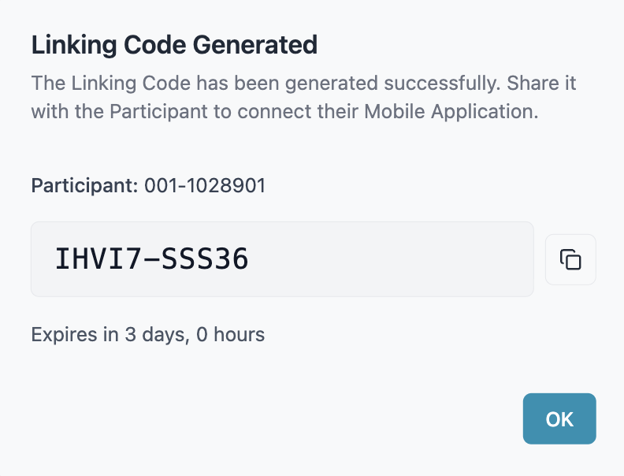

7.3.5 Start Trial — Confirmation Dialog
Trigger: Study Coordinator selects Start Trial for a Participant with Linked - Awaiting Start status.
Target identification: Participant ID.
Consequence summary: Diary Data Synchronization will be activated, transmitting diary entries to the Sponsor Portal and Rave EDC. The Participant’s status will update to Trial Active.
Pattern: Confirmation Dialog (see §4.1).
Reference: CAL-PRD-trial-start-workflow, CAL-GUI-trial-start-workflow.
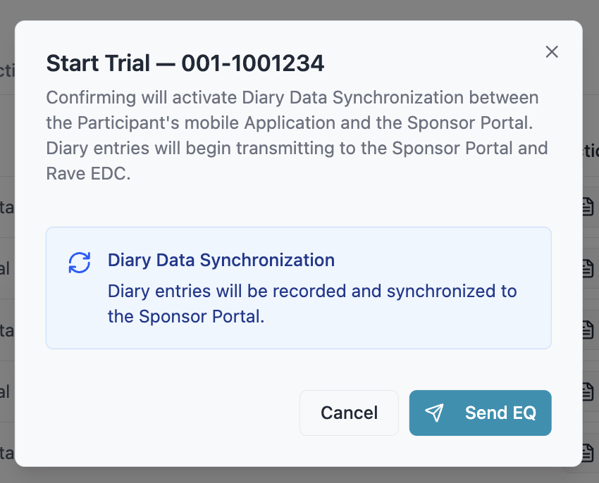

7.3.6 Disconnect Participant — Reason Dialog
Trigger: Study Coordinator selects Disconnect Participant from the Participant Actions Modal for a Participant with Linked - Awaiting Start or Trial Active status.
Target identification: Participant ID.
Consequence summary: Data synchronization between the Mobile Application and the Sponsor Portal will stop. All Participant data will be preserved.
Reason options: Device Issues, Technical Issues, Other.
Pattern: Reason Dialog — Predefined List (see §4.1).
Reference: DIARY-PRD-participant-disconnection, CAL-PRD-participant-disconnection-reason-options.
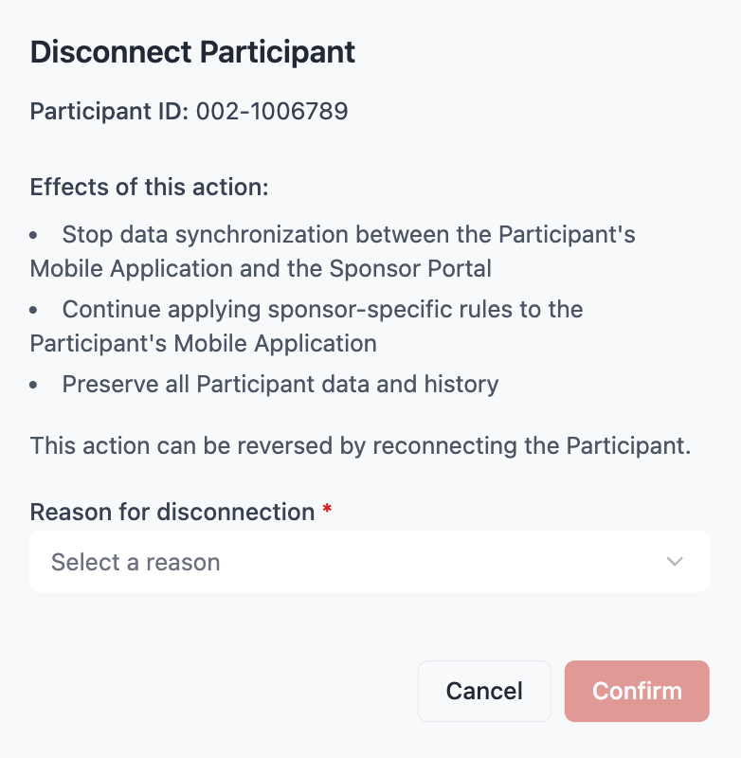

7.3.7 Reconnect Participant — Reason Dialog (Free Text)
Trigger: Study Coordinator selects Reconnect Participant from the Participant Actions Modal for a Participant with Disconnected status.
Target identification: Participant ID.
Consequence summary: A new Mobile Linking Code will be generated. The Participant must enter the new code to restore the connection.
Pattern: Reason Dialog — Free Text (see §4.1).
Reference: DIARY-PRD-participant-reconnection.
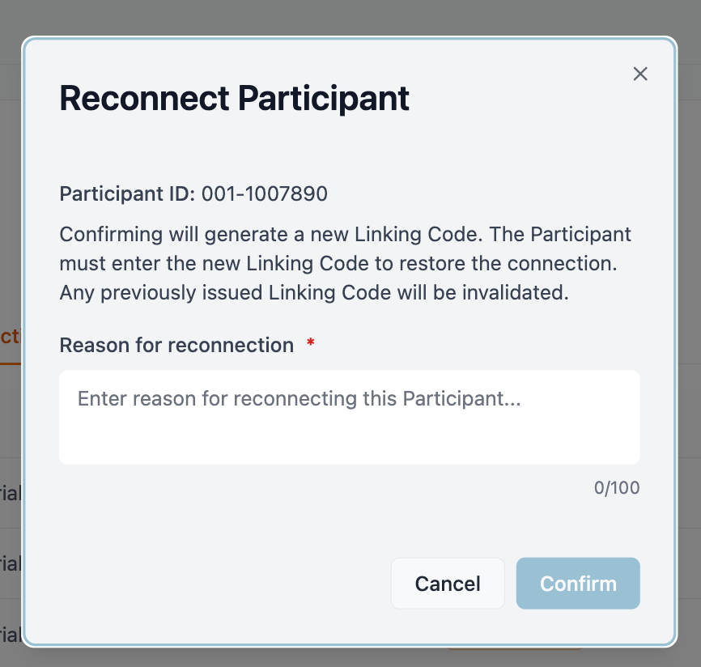

7.3.8 Mark as Not Participating — Reason Dialog (Predefined)
Trigger: Study Coordinator selects Mark as Not Participating for a Participant with Disconnected status.
Target identification: Participant ID.
Consequence summary: Sponsor-specific rules will no longer be applied to the Participant’s Mobile Application. Reason options: Subject Withdrawal, Death, Protocol Treatment/Study Complete, Other.
Pattern: Reason Dialog — Predefined List (see §4.1).
Reference: DIARY-PRD-participant-mark-not-participating, CAL-PRD-participant-not-participating-reason-options.
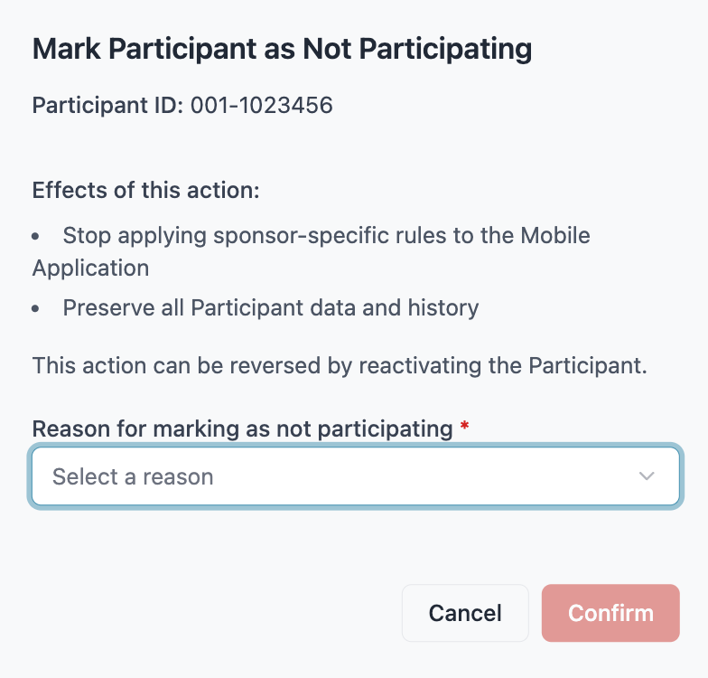

7.3.9 Reactivate Participant — Reason Dialog (Free Text)
Trigger: Study Coordinator selects Reactivate Participant from the Participant Actions Modal for a Participant with Not Participating status.
Target identification: Participant ID.
Consequence summary: Sponsor-specific rules will be re-applied to the Participant’s Mobile Application and the standard reconnection workflow will become available.
Pattern: Reason Dialog — Free Text (see §4.1).
Reference: DIARY-PRD-participant-reactivate.
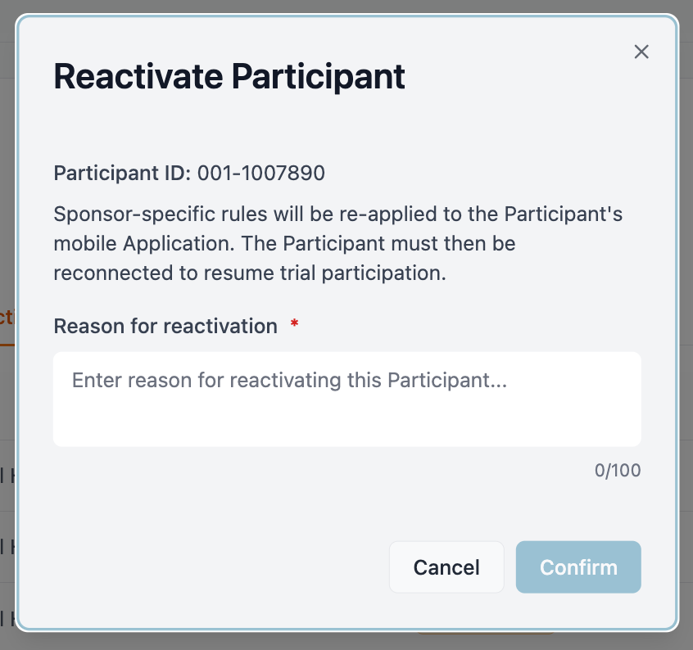

7.3.10 Delete Record — Reason Dialog — Predefined List
Trigger: Participant initiates the delete action on an Epistaxis Event, either during the recording flow or from event history.
Consequence summary: The Epistaxis Event will be removed from the Participant’s diary. Reason options: Entered by mistake, Duplicate entry, Incorrect information, Other.
Pattern: Reason Dialog — Predefined List (see §4.1).
Reference: DIARY-GUI-epistaxis-delete.


7.3.11 Post-Submission Acknowledgement Dialog
Trigger: Participant confirms Submission of a Portal-Sent Questionnaire.
Consequence summary: Confirms the Questionnaire has been submitted and informs the Participant that the Study Coordinator will review the responses.
Pattern: Acknowledgement Dialog (see §4.1).
Reference: DIARY-GUI-questionnaire-portal-sent-workflow.


7.3.12 Session Expiry Dialog
Trigger: Participant opens a Portal-Sent Questionnaire that has reached Session Expiry.
Consequence summary: Informs the Participant that the session has expired and previous answers were not saved.
Actions: Start Again (begin the Questionnaire from the Preamble), Not Now (return to Main Screen).
Pattern: Acknowledgement Dialog (see §4.1).
Reference: DIARY-PRD-questionnaire-session-timeout, DIARY-GUI-questionnaire-session-expiry.


7.3.13 Questionnaire Finalization Dialog
Trigger: Study Coordinator selects Finalize on a Questionnaire Card with Delivery Failed or Ready to Review status.
Consequence summary: Finalizes the Questionnaire — locks all Participant responses permanently, calculates the score, transmits it to Rave EDC, and prevents the Participant from editing their answers in the Mobile Application.
Actions: Finalize Questionnaire (apply finalization with the selected Cycle), Cancel (close the dialog with no changes).
Inputs: Cycle dropdown — selectable values are the Current Cycle N Day 1 value, End of Treatment, and End of Study.
Cross-flow: When a Terminal Cycle value (End of Treatment or End of Study) is selected, confirming opens the Terminal Cycle Warning Dialog before finalization is applied.
Pattern: Confirmation Dialog (see §4.1).
Reference: CAL-PRD-nose-hht-qol-workflow/I+J+K+L+M, CAL-GUI-questionnaire-finalization-workflow/A+B+C+D+E+F.
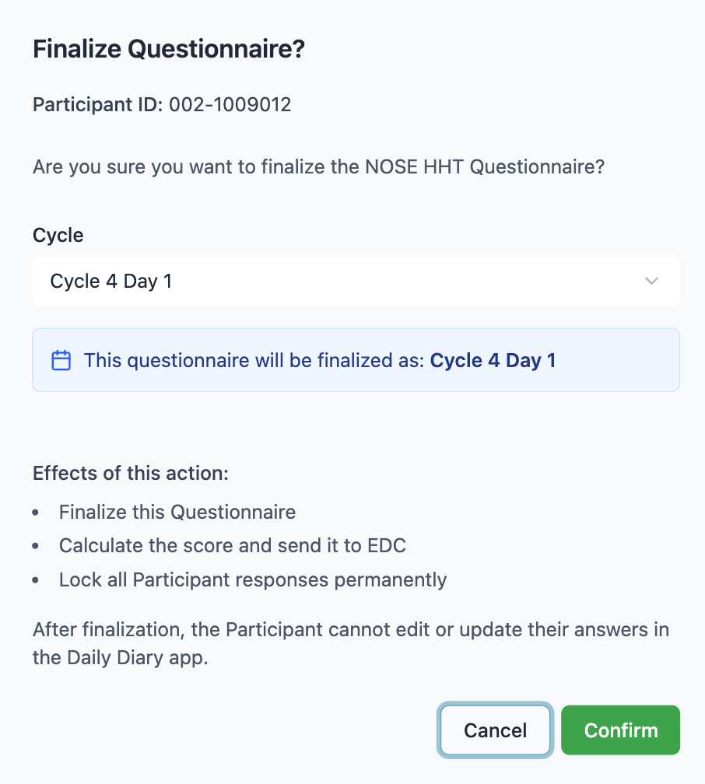

7.3.14 Terminal Cycle Warning Dialog
Trigger: Study Coordinator confirms finalization of a Questionnaire with a Terminal Cycle value (End of Treatment or End of Study) selected in the Finalization Dialog.
Target identification: Participant ID, Questionnaire Type, Terminal Cycle being assigned. Consequence summary: The Participant’s answers will be locked, the score will be transmitted to Rave EDC, and the Questionnaire Type will be closed for the Participant so no further Questionnaires of that type may be sent.
Cancellation behavior: On cancel, the Questionnaire remains unchanged and the Study Coordinator is returned to the Finalization Dialog.
Pattern: Confirmation Dialog (see §4.1).
Reference: CAL-GUI-questionnaire-finalization-workflow.
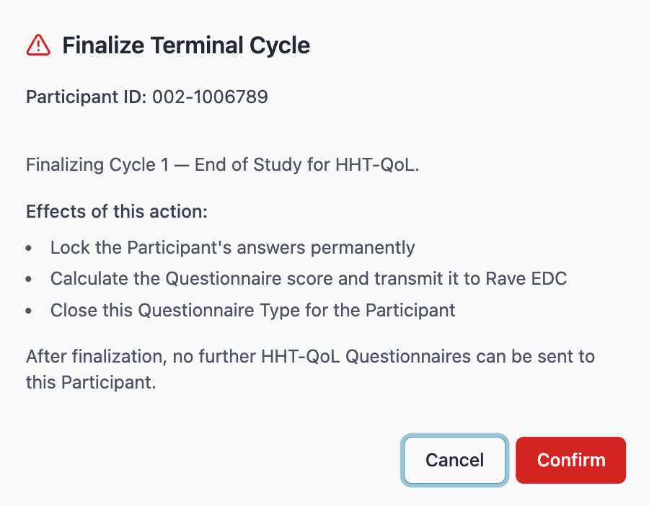

7.3.15 Call Back Questionnaire — Reason Dialog (Free Text)
Trigger: Study Coordinator initiates the call back action on a Questionnaire with Sent, Delivery Failed, or Ready to Review status.
Target identification: Participant ID, Questionnaire Type.
Consequence summary: The Questionnaire status will be set to Not Sent.
Pattern: Reason Dialog — Free Text (see §4.1).
Reference: CAL-PRD-nose-hht-qol-workflow, CAL-GUI-manage-questionnaires-modal.
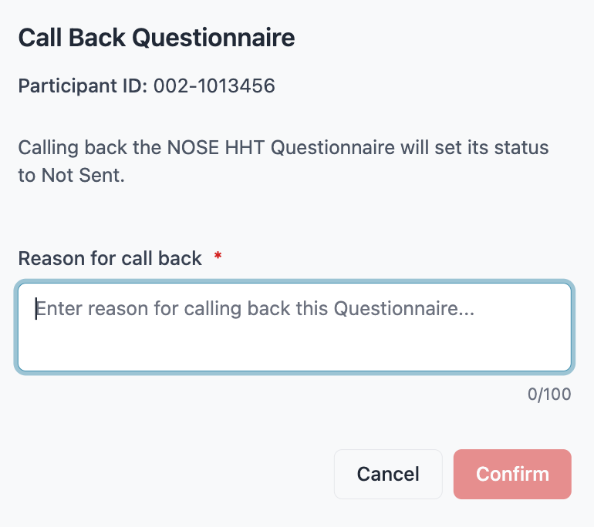

7.3.16 Call Back Notice
Trigger: A Portal-Sent Questionnaire assigned to the Participant has been called back by the Study Coordinator.
Consequence summary: Informs the Participant that the Questionnaire is no longer active and any answers entered will not be saved.
Presentation contexts:
- The Portal-Sent Questionnaire is called back while the Participant has it open.
- The Participant opens the Mobile Application after a call back has occurred.
- The Participant attempts to submit a Portal-Sent Questionnaire that has been called back while offline.
Behavior: Cannot be dismissed by tapping outside its bounds. On acknowledgement, the Participant is returned to the Main Screen and the corresponding Questionnaire Task is removed from the Task List.
Pattern: Acknowledgement Dialog (see §4.1).
Reference: CAL-GUI-questionnaire-call-back-participant.


7.3.17 Successful Linking Confirmation
Trigger: A Participant successfully submits a valid Mobile Linking Code on the Join the Study screen.
Consequence summary: Confirms to the Participant that the device has been linked to the study and transitions the Participant from personal use mode into linked use mode.
Behavior: On acknowledgement, the Participant is navigated to the User Profile screen.
Pattern: Acknowledgement Dialog (see §4.1).
Reference: DIARY-GUI-linking-confirmation.


7.4 Notifications

7.4.1 Timeout Warning Notification
A push notification delivered to the Participant when a configured Questionnaire Session Timeout is approaching expiry. Tapping the notification opens the questionnaire in the Mobile Application. The wording is sponsor-configurable per Questionnaire definition; the default text is [“Your [Questionnaire Display Name] session is about to expire. Open the app to continue and submit your answers.”]


7.4.2 Session Expiry Notification
A push notification delivered to the Participant when the configured Session Timeout has been exceeded for an in-progress Questionnaire and the Participant’s previously entered answers have been discarded. Tapping the notification opens the Mobile Application; if the Participant returns to the Questionnaire, the Session Expiry Dialog is displayed. The wording is sponsor-configurable per Questionnaire definition; the default text is [“Your [Questionnaire Display Name] session has expired and your answers were not saved. Open the app to start again.”]


7.4.3 Disconnection Notification
A persistent, non-dismissible in-app notification displayed in the System Notice Area at the top of the Main Screen when the Participant’s status is Disconnected. The notification persists until the Participant is reconnected to the Sponsor Portal. The wording is sponsor-configurable; the default text is [“Your connection with the study has been interrupted. Please contact your study site for assistance.”]


7.4.4 Portal-Sent Questionnaire Notification
A push notification delivered to the Participant when a Study Coordinator sends a Portal-Sent Questionnaire from the Sponsor Portal. Tapping the notification opens the Mobile Application; the Participant accesses the Questionnaire from the Questionnaire Task on the Main Screen. The wording is sponsor-configurable; the default text is [“A [Questionnaire Display Name] questionnaire is ready for you to complete. Open the app to begin.”]


7.4.5 Yesterday Entry Reminder Notification
A push notification delivered to the Participant at the configured Reminder Time when no Daily Status has been recorded for the previous calendar day. Tapping the notification opens the Mobile Application; the Participant accesses the Yesterday Reminder Task on the Main Screen. The wording is sponsor-configurable; the default text is [“Did you have a nosebleed yesterday? Take a moment to record yesterday’s status in your diary.”]


7.4.6 Ongoing Epistaxis Event Reminder
A push notification delivered to the Participant when an Incomplete Record has not been interacted with for the configured Reminder Interval. Tapping the notification opens the Mobile Application; the Participant returns to the Incomplete Record to either complete it or confirm the event is still ongoing. The wording is sponsor-configurable; the default text is [“Is your nosebleed still going? You started recording a nosebleed but haven’t finished. Tap to update.”]


7.4.7 Historical Gap Reminder
A push notification delivered to the Participant at the configured Reminder Time when one or more Historical Gaps exist within the editable window. Tapping the notification opens the Mobile Application; the Participant accesses the missing days via the Calendar. The wording is sponsor-configurable; the default text is [“You have one day without a recorded entry. Tap to review and complete your diary.”]


8 Glossary

8.1 A
ACT-PAT-001 — Link Participant
The Action a Study Coordinator performs to issue a Mobile Linking Code for a Participant in Not Connected status, transitioning the Participant to Pending. Defined in: DIARY-GUI-link-participant-flow (DIARY)
Action
A discrete operation that a user can perform within the System, subject to role-based access control. An Action either changes system state or retrieves protected data. Defined in: DIARY-PRD-action-inventory (DIARY)
Action Inventory
The complete enumerated set of Actions the System recognizes, comprising the platform-level inventory in this requirement and any sponsor-level extensions. Defined in: DIARY-PRD-action-inventory (DIARY)
Activation Webpage
A Verification Link associated with a User Account that provides a mechanism for the Account Owner to activate their account and configure their password and 2FA. Defined in: DIARY-PRD-user-account-activation-workflow (DIARY)
Active Authentication Path
The authentication path engaged by Diary User Authentication for a given Participant, derived from the PIN Policy and the Device Authentication state on the Participant’s device:
- In-application PIN when the PIN Policy is Required, or when the PIN Policy is Required When Device Authentication Is Not Enabled and Device Authentication is not enabled on the Participant’s device.
- Device Authentication when the PIN Policy is not Required and Device Authentication is enabled on the Participant’s device.
- None when the PIN Policy is Not Required and Device Authentication is not enabled on the Participant’s device. Defined in: DIARY-PRD-user-authentication (DIARY)
Admin (not indexed)
A staff member with privileges to create and manage User Accounts, configure sites, and manage system settings. In clinical trial deployments, the Admin is typically a sponsor employee scoped to one sponsor’s data. Scope: sponsor-wide access (all sites within one sponsor) in clinical trial context; organization-wide in non-CT deployments. Avoid: “Sponsor admin” (redundant in CT context); “super admin” (no such role). See: REQ-p00039 (Administrator Access with Audit Trail). Defined in: file:spec/glossary-core.md (DIARY)
Administrator
A portal user responsible for managing User Accounts, role assignments, and Site assignments across the study. Defined in: DIARY-PRD-role-definitions (DIARY)
Administrator Dashboard
The default surface presented to an Administrator upon successful authentication to the Sponsor Portal, containing top-level navigation to User Account management and audit log review. Defined in: DIARY-GUI-administrator-dashboard (DIARY)
Administrator Settings
The read-only surface within the Sponsor Portal that displays Configuration Parameters to Administrators, organised by Configuration Category. Defined in: DIARY-PRD-administrator-settings (DIARY)
AE / SAE (Adverse Event / Serious Adverse Event) (not indexed)
AE: any undesirable medical event occurring in a patient during a clinical trial, whether or not related to the investigational treatment. SAE: a severe adverse event resulting in death, hospitalization, disability, or other serious outcomes. Formal AE/SAE reporting is handled through the sponsor’s EDC system, not directly through the Diary Platform. SAEs require expedited reporting (typically within 24 hours). Defined in: file:spec/glossary-core.md (DIARY)
ALCOA+ Principles (not indexed)
Data integrity standards for electronic health records, widely adopted in both clinical and non-clinical contexts. The acronym expands to: Attributable, Legible, Contemporaneous, Original, Accurate, plus Complete, Consistent, Enduring, and Available. Diary Platform Implementation: Event Sourcing architecture directly implements ALCOA+ principles — every event includes user ID and timestamp (Attributable); data is stored in readable formats (Legible); events are recorded immediately (Contemporaneous); events are never modified (Original); validation is enforced at entry (Accurate); the full audit trail is preserved (Complete); Event Sourcing ensures chronological ordering (Consistent); retention policies are enforced (Enduring); query interfaces provide access (Available). Clinical Trial Context: Required by FDA and EMA for clinical trial records. See: REQ-p00011 (ALCOA+ Data Integrity Principles), prd-clinical-trials.md. Defined in: file:spec/glossary-core.md (DIARY)
Analyst (not indexed)
A researcher or data scientist with read-only access to data for analysis and reporting. Typically scoped to specific sites (may be sponsor-wide depending on assignment). Focused on data analysis, not compliance auditing. See: REQ-p00022 (Analyst Read-Only Access). Defined in: file:spec/glossary-core.md (DIARY)
Application Menu
The menu accessed from the left side of the top navigation bar, grouping application-level functions. Defined in: DIARY-GUI-mobile-navigation (DIARY)
Application Privacy Policy
The privacy policy governing the Mobile Application itself, covering platform-level data handling. Defined in: DIARY-PRD-privacy-policy (DIARY)
Audit Trail
A computer-generated, time-stamped record that captures the who, what, when, and why of every modification to an Electronic Record, satisfying 21 CFR Part 11 §11.10(e). Attributes: who (user identification), what (change description), when (timestamp in UTC), why (reason for change, if applicable), where (device/platform information). Usage Context: compliance documentation, audit procedures, data integrity requirements. Clinical Trial Context: required by FDA 21 CFR Part 11, EU Annex 11, and ICH-GCP guidelines for regulatory compliance. Implemented using the Event Store architecture (technical term) to create an Audit Trail (regulatory term). See: REQ-p00004 (Immutable Audit Trail via Event Sourcing), REQ-p70006 (Comprehensive Audit Trail), prd-clinical-trials.md. Defined in: file:spec/glossary-core.md (DIARY)
Auditor (not indexed)
An independent compliance reviewer with read-only access to all data and audit trails for regulatory compliance verification. Has full read-only access across all sites within a sponsor. Auditors can view but NEVER modify data. See: REQ-p00038 (Auditor Compliance Access). Defined in: file:spec/glossary-core.md (DIARY)

8.2 B
No terms.

8.3 C
Calendar
The monthly view modal displaying date states and allowing the Participant to navigate to a specific date. Defined in: DIARY-GUI-calendar-day-view (DIARY)
Call-Back Notice
An Acknowledgement Dialog informing the Participant that a Portal-Sent Questionnaire assigned to them has been called back by the study team. Defined in: CAL-GUI-questionnaire-call-back-participant (CAL)
Caregiver (not indexed)
A family member or trusted individual who has been granted delegated access to view or assist with a user’s diary entries. Caregivers act on behalf of the user and are subject to the same privacy protections. Usage Context: personal health tracking context where the user shares diary access with someone who helps manage their health. Defined in: file:spec/glossary-core.md (DIARY)
CDISC (Clinical Data Interchange Standards Consortium) (not indexed)
Organization developing international data standards for clinical trial data exchange. Key standards: CDASH (data collection), SDTM (data submission format), ADaM (analysis datasets). Diary ePRO data can be exported in CDISC-compliant formats for regulatory submission. Defined in: file:spec/glossary-core.md (DIARY)
Clinical Research Associate (CRA)
A portal user responsible for monitoring Study Coordinator activities and site compliance at one or more assigned Sites. Defined in: DIARY-PRD-role-definitions (DIARY)
Clinical Trial Privacy Policy
The privacy policy governing a Participant’s participation in a specific clinical trial, covering sponsor-side data handling. Sponsor-configurable per deployment. Defined in: DIARY-PRD-privacy-policy (DIARY)
Code Expiry
The configurable duration after which an unused Verification Code becomes invalid. Defined in: DIARY-PRD-two-factor-authentication (DIARY)
Completion Status
The current state of a Questionnaire instance for a given participant. Valid values are defined per Questionnaire workflow. Defined in: DIARY-PRD-questionnaire-system (DIARY)
Configuration Category
A grouping of related Configuration Parameters presented together within the Administrator Settings surface. Defined in: DIARY-PRD-administrator-settings (DIARY)
Configuration Parameter
A named, sponsor-configured value that governs a specific System behavior, defined in a single source requirement and surfaced to Administrators for visibility. Defined in: DIARY-PRD-administrator-settings (DIARY)
Conflicting Record
An existing entry whose time range intersects with the entry being created or edited. Defined in: DIARY-PRD-entry-overlap-resolution (DIARY)
CQRS (Command Query Responsibility Segregation) (not indexed)
An architectural pattern separating write operations (commands that create events) from read operations (queries that read current state). Implementation in Diary Platform: the write side creates events in the Event Store; the read side reads optimized Record State tables; Event Store and Record State are separate but synchronized. Benefits: optimizes audit trail integrity (write side) and query performance (read side). Usage Context: technical architecture documentation. See: dev-database.md. Defined in: file:spec/glossary-core.md (DIARY)
CRA (Clinical Research Associate) (not indexed)
Staff employed by the sponsor or CRO who monitor trial sites to ensure compliance with GCP, the protocol, and regulatory requirements. CRAs perform source data verification (SDV). In the Portal, CRAs typically have the Auditor role (read-only). Defined in: file:spec/glossary-core.md (DIARY)
CRF / eCRF (Case Report Form / Electronic Case Report Form) (not indexed)
The primary tool used by investigators or site staff to record clinical trial data about a patient. Key distinction: CRF/eCRF data is entered by clinical trial staff, not by patients. The Diary Platform does not implement traditional eCRFs. Patient diary entries (ePRO data) may be exported to feed into a sponsor’s EDC system. Avoid: do not use “eCRF” to refer to patient diary entries. Defined in: file:spec/glossary-core.md (DIARY)
CRO (Contract Research Organization) (not indexed)
Organization hired by a sponsor to manage aspects of a clinical trial. CRO staff typically have Auditor or Analyst roles in the Portal. Defined in: file:spec/glossary-core.md (DIARY)
CTMS (Clinical Trial Management System) (not indexed)
Software for managing operational aspects of a clinical trial. The Diary Platform is not a CTMS — it is specifically a health diary / ePRO data collection system. Sponsors typically use a separate CTMS alongside the Diary Platform. Defined in: file:spec/glossary-core.md (DIARY)
Current Cycle
The Cycle value assigned to the most recently sent Questionnaire of a given Questionnaire Type for a participant. Defined in: CAL-PRD-questionnaire-cycle-tracking (CAL)
Cycle
The protocol event identifier assigned to a Questionnaire representing the treatment cycle during which it was administered. Valid values are Cycle N Day 1 (where N is a positive whole number), End of Treatment, and End of Study. Defined in: CAL-PRD-questionnaire-cycle-tracking (CAL)
Cycle N Day 1
A Cycle value identifying the first day of the Nth treatment cycle, where N is a positive whole number (Cycle 1 Day 1, Cycle 2 Day 1, etc.). Defined in: CAL-PRD-questionnaire-cycle-tracking (CAL)

8.4 D
Daily Epistaxis Record
The primary nosebleed tracking instrument used in the HHT Clinical Diary, derived from Clark et al. (2018) with modifications. Defined in: DIARY-PRD-questionnaire-daily-epistaxis (DIARY)
Daily Status
The participant’s self-reported summary of nosebleed activity for a given day. Valid values are Had Nosebleed, No Nosebleed, and Don’t Remember. Defined in: DIARY-PRD-epistaxis-capture-standard (DIARY)
Database
The PostgreSQL database (hosted on Cloud SQL) that stores all diary entries, audit trails, User Accounts, and configuration. Architecture: Event Store (immutable audit trail); Record State (current values, derived from events); Row-Level Security policies for access control. Usage Context: use when discussing data storage, schema, or database architecture. Clinical Trial Context: may be referred to as “Clinical Trial Database” when emphasizing regulatory compliance features. See: REQ-p00046 (Clinical Data Storage System), REQ-p00003 (Separate Database Per Sponsor), prd-database.md. Defined in: file:spec/glossary-core.md (DIARY)
Day View
The screen displayed when the Participant selects a date from the Calendar, showing the entries for that date or prompting the Participant to record a Daily Status. Defined in: DIARY-GUI-calendar-day-view (DIARY)
De-identified Data
Health data with all personally identifiable information (name, email, date of birth, account identifiers) removed, leaving only a participant ID and health observations. Purpose: enables research analysis and data sharing while protecting user privacy. Clinical Trial Context: de-identified data can be shared with research partners; identified data requires explicit consent. Subject to GDPR and HIPAA requirements. See: REQ-p00016 (Separation of Identity and Clinical Data). Defined in: file:spec/glossary-core.md (DIARY)
Deactivation
The action of revoking a User Account’s ability to access the system without permanently removing the account or its associated data. A deactivated account retains all historical data and Audit Trail but cannot be used to log in or maintain active sessions. Defined in: DIARY-PRD-user-account-deactivate (DIARY)
Developer Admin (not indexed)
A system administrator with infrastructure-level access for deployment, monitoring, and maintenance. Scope is cross-sponsor system administration (database backups, infrastructure monitoring). Data Access: Developer Admins have NO routine access to patient data. A documented break-glass procedure exists for emergency situations only, with full audit trail logging of all access. Context: internal operations only, not accessible to sponsors or clinical trial users. See: ops-security.md for developer admin procedures. Defined in: file:spec/glossary-core.md (DIARY)
Device Authentication
Authentication performed by the device operating system using the credential the Participant has configured at the device level, including device passcode, fingerprint, or face recognition. Defined in: DIARY-PRD-user-authentication (DIARY)
Diary
The iOS and Android smartphone application that individuals use to record daily health observations. The primary user-facing term for the mobile application. Preferred Terms: “Diary” (primary term, patient-friendly, simple and clear); “Mobile Diary” (when distinguishing from the web Portal); “Diary app” (informal, acceptable when context is clear). Usage Context: user-facing — “Diary” or “the app”; formal documentation — “Diary mobile application”; technical documentation — “Mobile Diary” or “Diary app”. Clinical Trial Context: may use “Clinical Diary” when emphasizing regulatory compliance. Avoid: “ePRO application” (too technical, confusing to users); “eCRF” (refers to a different concept in clinical trials); “eSource” (refers to the complete platform, not just the mobile app); “Clinical Diary” as the primary name (clinical trials are a feature, not the identity). See: REQ-p00043 (Diary Mobile Application), prd-mobile-app.md. Defined in: file:spec/glossary-core.md (DIARY)
Diary Data Synchronization
The continuous transmission of participant diary entries from the participant’s mobile application to the Sponsor Portal and Rave EDC. Defined in: DIARY-PRD-questionnaire-system (DIARY)
Diary Entry
A single user-reported record of a health event (e.g., nosebleed episode) including time, severity, duration, and other relevant details. Preferred Terms: “Diary Entry” (standard term); “Health Observation” (more formal context); “Entry” (short form when context is clear). Usage Context: use “diary entry” in user-facing communication and general documentation. Clinical Trial Context: when used in clinical trials, diary entries may capture protocol-specified data elements and serve as ePRO data. Avoid: “Event” (too generic); “Record” (too technical); “Data point” (depersonalizing). See: REQ-p00042 (HHT Epistaxis Data Capture Standard). Defined in: file:spec/glossary-core.md (DIARY)
Diary Platform
The complete system comprising all software, infrastructure, and data storage components that enable individuals to record and manage personal health observations, with optional clinical trial support features. Components: Diary (mobile application); Sponsor Portal; Database; supporting infrastructure and APIs. Primary Purpose: personal health diary for tracking daily health observations. Secondary Features: clinical trial support, data sharing with healthcare providers, research contribution. Usage Context: use when referring to the entire system architecture or in formal documentation. Avoid: “Clinical Diary Platform” (implies clinical trials are primary); “eSource system”; “ePRO platform” (use only in sponsor-specific external documentation). See: REQ-p00044 (Clinical Trial Compliant Diary Platform). Defined in: file:spec/glossary-core.md (DIARY)
Diary Start Day
The earliest date for which diary entries are valid for a given User. Defined in: DIARY-PRD-diary-start-day (DIARY)
Diary User Authentication
The access-control mechanism that gates Participant data and Participant Actions in the Mobile Application, satisfied via the Active Authentication Path for the Participant. Defined in: DIARY-PRD-user-authentication (DIARY)
Disconnection Notification
A persistent, non-dismissible notification displayed to the Participant when their mobile Application is disconnected from the Sponsor Portal. Defined in: DIARY-PRD-notification-disconnection (DIARY)
Duration Reasonableness Check
A configurable validation rule that prompts the Participant to confirm the recorded duration of an event when it falls outside expected boundaries. Defined in: DIARY-PRD-entry-duration-check (DIARY)

8.5 E
eCOA (Electronic Clinical Outcome Assessment) (not indexed)
Umbrella term for electronic capture of clinical outcomes: ePRO (patient reports), ClinRO (clinician assessment), ObsRO (observer/caregiver reports), PerfO (performance measurements). The Diary is specifically an ePRO tool. Defined in: file:spec/glossary-core.md (DIARY)
EDC (Electronic Data Capture) (not indexed)
Software systems used to collect, manage, and store clinical trial data electronically, typically including eCRFs. The Diary Platform is not a full EDC system — it provides ePRO data that may be exported to a sponsor’s EDC system (e.g., Medidata Rave, Oracle InForm). Defined in: file:spec/glossary-core.md (DIARY)
Electronic Record
Any combination of text, graphics, data, or other digital information created, modified, maintained, or distributed by the platform that is subject to 21 CFR Part 11. Defined in: file:spec/glossary-core.md (DIARY)
Electronic Signature
A computer-implemented signing event that, under 21 CFR Part 11 §11.50, is legally equivalent to a handwritten signature. Diary Platform Implementation: the automatic attribution of a data entry or change to a specific User Account with timestamp and device information. Every diary entry and data modification is automatically signed with user account ID, timestamp (UTC), device information, and a cryptographic hash to prevent tampering. Users do not manually “sign” entries — the system automatically creates legally binding signatures. Usage Context: all diary entries (personal health tracking and clinical trial) are automatically attributed to the user who created them. See: REQ-p00010 (FDA 21 CFR Part 11 Compliance), prd-clinical-trials.md. Defined in: file:spec/glossary-core.md (DIARY)
EMA (European Medicines Agency) (not indexed)
European Union agency responsible for evaluating and supervising medicines. For EU clinical trials, the Diary Platform complies with EU Clinical Trial Regulation 536/2014 and EU GMP Annex 11. Defined in: file:spec/glossary-core.md (DIARY)
Email Address
A unique technical identifier used as a destination for system notifications and as a username for authentication to access the system. Defined in: DIARY-PRD-user-account-create (DIARY)
Entry Justification
A reason selected from a sponsor-defined predefined list that the Participant must provide when creating or editing an entry that has exceeded the Justification Threshold. Defined in: DIARY-PRD-entry-time-restrictions (DIARY)
Epistaxis Event
A single nosebleed occurrence recorded by the participant with timing, duration, and intensity data. Defined in: DIARY-PRD-questionnaire-daily-epistaxis (DIARY)
ePRO (Electronic Patient-Reported Outcomes) (not indexed)
Electronic collection of health information reported directly by the patient, without interpretation by clinicians. The Diary functions as an ePRO tool when used in clinical trials. Avoid: while technically accurate, avoid “ePRO” in user-facing communication. Use “Diary” instead. See: REQ-p00043 (Diary Mobile Application). Defined in: file:spec/glossary-core.md (DIARY)
eSource
The Diary Platform as a whole, when used as the original electronic source of patient-reported data in a clinical trial (as opposed to transcribing from paper diaries). Usage Context: regulatory submissions, protocol documentation, when emphasizing the system is the primary data source in a clinical trial context. Notes: “eSource” is a regulatory/clinical trial term, not the system’s primary identity. Refers to the complete platform (Diary + Database + Portal), not just the mobile app. Use only when discussing clinical trial regulatory compliance. Regulatory Basis: FDA guidance on electronic source documentation. See: REQ-p00010 (FDA 21 CFR Part 11 Compliance). Defined in: file:spec/glossary-core.md (DIARY)
ESS (Epistaxis Severity Score) (not indexed)
Standardized clinical assessment tool measuring the severity and impact of nosebleeds in HHT patients. Calculated from patient-reported diary data. Specific to HHT clinical trials. Defined in: file:spec/glossary-core.md (DIARY)
Event Sourcing
An architectural pattern where all changes to application state are stored as a sequence of immutable events, rather than overwriting data in place. Benefits: complete history and timeline reconstruction; no data loss; full audit trail for personal health records; supports clinical trial regulatory compliance (FDA 21 CFR Part 11) when needed. Technical Details: every change (create, update, delete) appends an event to the Event Store. Current state is derived by replaying events. Usage Context: technical architecture and developer documentation. See: REQ-p00004 (Immutable Audit Trail via Event Sourcing), REQ-p01000 (Event Sourcing Client Interface), prd-event-sourcing-system.md. Defined in: file:spec/glossary-core.md (DIARY)
Event Store
The immutable log of all changes to diary entries and system data, implementing the Event Sourcing architectural pattern. Every create, update, or delete operation is stored as an event that is never modified or deleted (append-only). Current state is derived by replaying events, providing a complete change history. Usage Context: developer and architecture documentation. Clinical Trial Context: the Event Store implements the Audit Trail required by FDA 21 CFR Part 11 and other regulations. See: REQ-p00004 (Immutable Audit Trail via Event Sourcing), REQ-p01000 (Event Sourcing Client Interface), prd-event-sourcing-system.md. Defined in: file:spec/glossary-core.md (DIARY)

8.6 F
Failed Attempt Threshold
The configurable number of consecutive failed PIN entry attempts that triggers a Participant lockout pending PIN Reset. Defined in: DIARY-PRD-user-authentication-pin (DIARY)
FDA (U.S. Food and Drug Administration) (not indexed)
United States federal agency responsible for regulating pharmaceuticals, medical devices, and clinical trials. See: REQ-p00010 (FDA 21 CFR Part 11 Compliance). Defined in: file:spec/glossary-core.md (DIARY)
FDA 21 CFR Part 11
U.S. Food and Drug Administration regulation (Title 21 Code of Federal Regulations Part 11) establishing requirements for electronic records and electronic signatures to be considered trustworthy, reliable, and equivalent to paper records. Key Requirements: audit trails for all data changes; electronic signatures with cryptographic integrity; controlled system access; data validation and integrity checks; records retention for regulatory-mandated periods. Diary Platform Context: core compliance framework for clinical trial features. Usage Context: regulatory submissions, compliance documentation. See: REQ-p00010 (FDA 21 CFR Part 11 Compliance), prd-clinical-trials.md. Defined in: file:spec/glossary-core.md (DIARY)
Finalization
The Study Coordinator action that permanently locks participant answers, triggers score calculation and pushes the data to Rave EDC. Defined in: DIARY-PRD-questionnaire-portal-sent-rules (DIARY)
Finalization Dialog
The Confirmation Dialog displayed to the Study Coordinator when the Finalize button is selected, containing a Cycle dropdown for selecting the Cycle value before confirming finalization. Defined in: CAL-GUI-questionnaire-finalization-workflow (CAL)
Finalized Cycle
The Cycle value of the most recently finalized Questionnaire of a given Questionnaire Type for a participant. Defined in: CAL-PRD-questionnaire-cycle-tracking (CAL)
Full Name
A common name, which is PII, of the person associated with a User Account that identifies a specific individual in the context of the Sponsor Portal. Defined in: DIARY-PRD-user-account-create (DIARY)

8.7 G
GCP (Good Clinical Practice) (not indexed)
International ethical and scientific quality standards governing clinical trial conduct, including data collection, management, and participant protection. Primary guideline: ICH E6(R2). Note: “GCP” also stands for “Google Cloud Platform” — context determines meaning. Defined in: file:spec/glossary-core.md (DIARY)
GDPR (General Data Protection Regulation) (not indexed)
European Union regulation governing data protection and privacy for EU residents. EU users have GDPR rights (access, rectification, erasure, portability). Clinical trial participation may limit some rights for data integrity reasons. Applies based on user location, not sponsor location. See: REQ-p01061 (GDPR Compliance), REQ-p01062 (GDPR Data Portability). Defined in: file:spec/glossary-core.md (DIARY)
Google Cloud Platform (GCP) (not indexed)
Cloud infrastructure provider hosting the Diary Platform: Cloud SQL (PostgreSQL database), Identity Platform (authentication), Cloud Storage (backups), per-sponsor GCP projects for multi-sponsor isolation. Note: in clinical trial contexts, “GCP” typically refers to Good Clinical Practice. Defined in: file:spec/glossary-core.md (DIARY)

8.8 H
Healthcare Provider (not indexed)
A licensed healthcare professional (physician, nurse, specialist) who reviews a user’s diary data to support clinical care. The healthcare provider typically accesses data through the Portal with the user’s consent. Usage Context: personal health tracking context where the Diary data is shared with a care team. Distinction from Investigator: a Healthcare Provider reviews diary data for clinical care purposes. An Investigator reviews diary data as part of a clinical trial protocol. See: REQ-p70001 (Sponsor Portal Application). Defined in: file:spec/glossary-core.md (DIARY)
HHT (Hereditary Hemorrhagic Telangiectasia) (not indexed)
Genetic disorder causing abnormal blood vessel formation, leading to frequent nosebleeds and other complications. The Diary Platform was initially developed for HHT patients but supports any health tracking use case. Current sponsor: Cure HHT Foundation. Defined in: file:spec/glossary-core.md (DIARY)
HHT-QoL
A validated clinical instrument published in Blood Advances, 2022, measuring the impact of HHT symptoms on participants’ daily and social activities. Defined in: DIARY-PRD-questionnaire-hht-qol (DIARY)
HIPAA (Health Insurance Portability and Accountability Act) (not indexed)
United States federal law protecting the privacy and security of individuals’ medical information. Key requirement: Business Associate Agreements (BAAs) with service providers. See: REQ-p01020 (Privacy Policy and Regulatory Compliance Documentation). Defined in: file:spec/glossary-core.md (DIARY)
Historical Gap
A calendar day between the Diary Start Day and the current day, exclusive of the current day and the previous day, for which the Participant has not recorded a Daily Status. Defined in: DIARY-PRD-notification-historical-gap (DIARY)
Historical Gap Reminder
A daily Push Notification delivered to the Participant prompting them to address one or more Historical Gaps. Defined in: DIARY-PRD-notification-historical-gap (DIARY)

8.9 I
ICF (Informed Consent Form) (not indexed)
Signed document where a patient agrees to participate in a clinical trial. Must include how the Diary will be used, what data will be shared, privacy protections, and right to withdraw. The Diary Platform supports electronic ICF signatures compliant with 21 CFR Part 11. Defined in: file:spec/glossary-core.md (DIARY)
ICH (International Council for Harmonisation) (not indexed)
Organization developing international standards for clinical trials. Key guidelines: ICH E6(R2) (Good Clinical Practice), ICH E8 (General Considerations for Clinical Studies), plus Quality (Q), Safety (S), Efficacy (E), and Multidisciplinary (M) guidelines. Defined in: file:spec/glossary-core.md (DIARY)
ICH-GCP / ICH E6(R2) (not indexed)
The foundational international ethical and scientific quality standard for clinical trials involving human subjects. The 2016 revision emphasizes risk-based monitoring and data integrity. The Diary Platform follows ICH-GCP guidelines for data integrity (ALCOA+), audit trails, source data verification, and participant protection. See: REQ-p00011 (ALCOA+ Data Integrity Principles). Defined in: file:spec/glossary-core.md (DIARY)
Idle Timeout
The configurable elapsed time, used both as the maximum Participant in-app inactivity before re-authentication is required and as the trust window for the most recent successful authentication on the Active Authentication Path. Defined in: DIARY-PRD-user-authentication (DIARY)
IMP (Investigational Medicinal Product) (not indexed)
The drug, biological product, or device being tested in a clinical trial. Diary entries help assess the IMP’s efficacy and potential side effects. Defined in: file:spec/glossary-core.md (DIARY)
Incomplete Record
An Epistaxis Event that has been saved but is missing one or more required fields: start time, Intensity, or end time. Defined in: DIARY-PRD-epistaxis-capture-standard (DIARY)
Incomplete Records Task
A task indicating the Participant has one or more saved entries with missing required data. Defined in: DIARY-GUI-participant-task-list (DIARY)
IND / NDA (Investigational New Drug / New Drug Application) (not indexed)
IND: Application to the FDA to test a new drug in humans. NDA: Application for FDA approval to market a drug. Sponsors submit Diary ePRO data as part of IND (during trials) and NDA (for approval) submissions. Defined in: file:spec/glossary-core.md (DIARY)
Intensity
A participant-reported measure of nosebleed severity captured on a defined six-level scale ordered from least to most severe. Defined in: DIARY-PRD-epistaxis-capture-standard (DIARY)
Investigator
A clinical-trial role authorized by the Sponsor to view patient data, review safety triggers, and unlock individual questionnaires within the Investigator’s assigned site. A licensed clinical researcher responsible for enrolling patients, managing a clinical trial site, and ensuring protocol compliance. Responsibilities: enroll patients using linking codes; monitor patient engagement and data quality; send questionnaires and reminders to patients; review patient diary data for protocol compliance. Access: site-specific data only (via Row-Level Security). Avoid: “Site staff”; “clinical user”; “researcher” (be specific). See: REQ-p00036 (Investigator Site-Scoped Access), REQ-p00037 (Investigator Annotation Restrictions). Defined in: file:spec/glossary-core.md (DIARY)
IRB / IEC (Institutional Review Board / Independent Ethics Committee) (not indexed)
IRB (U.S.) / IEC (international): independent ethics committee that reviews and approves clinical trial protocols, informed consent forms, and data privacy measures before a sponsor can use the Diary Platform at a trial site. Ongoing approval is required for any changes to Diary data collection procedures. Defined in: file:spec/glossary-core.md (DIARY)

8.10 J
Justification Threshold
The configurable elapsed time from midnight (00:00) of the event date in the Participant’s local timezone after which the Participant must provide a reason before creating or editing an entry for that date. Defined in: DIARY-PRD-entry-time-restrictions (DIARY)

8.11 K
No terms.

8.12 L
Linking Code
A unique, cryptographically random 10-character code used to securely connect a user’s mobile Diary to a service. In clinical trial deployments, linking codes connect a user’s device to their enrollment record at a trial site. In non-clinical-trial contexts, a similar mechanism could connect the Diary to a backup or data-sharing service. Format: 10 characters, alphanumeric, case-insensitive. Purpose: enables secure device connection without transmitting PII or creating accounts before the link is established. Usage Context: patient enrollment workflow (clinical trials), device provisioning. See: REQ-p70007 (Linking Code Lifecycle Management), REQ-d00078 (Linking Code Validation). Defined in: file:spec/glossary-core.md (DIARY)
Linking Code Validation Failure
Any unsuccessful attempt to enter a linking code, regardless of the specific reason for failure. Defined in: DIARY-PRD-linking-code-entry-errors (DIARY)
Linking Consent
The explicit acknowledgement by the Participant that they have read and consent to the Clinical Trial Privacy Policy. This consent must be captured before the linking code submission is permitted. Defined in: DIARY-GUI-join-study-screen (DIARY)
Lock Threshold
The configurable elapsed time from midnight (00:00) of the event date in the Participant’s local timezone after which the date is fully locked and no creation, editing, or deletion of entries is permitted. Defined in: DIARY-PRD-entry-time-restrictions (DIARY)
Lock Warning Offset
The configurable elapsed time before the Lock Threshold at which the System sends a push notification to the Participant about an Incomplete Record that has not been completed or deleted. Defined in: DIARY-PRD-notification-incomplete-record-lock (DIARY)
Long Duration Threshold
The configurable maximum duration above which a confirmation prompt is triggered. Defined in: DIARY-PRD-entry-duration-check (DIARY)

8.13 M
Main Screen
The default screen displayed to the Participant upon opening the mobile application. Defined in: DIARY-GUI-main-screen-layout (DIARY)
Mobile Application
The iOS and Android application provided by the System for participant-reported diary data capture and questionnaire completion. Operates in personal use mode without an account or in linked use mode connected to a Sponsor Portal deployment. Defined in: DIARY-PRD-mobile-application (DIARY)
Mobile Linking Code
A unique, time-limited, single-use code generated by the System and provided to a Participant by clinical staff. The Participant enters the code in the Mobile Application to establish a connection between their device and the Sponsor Portal. Defined in: DIARY-PRD-linking-code-lifecycle (DIARY)
Multi-Sponsor Isolation
The architectural pattern ensuring complete data separation between different organizations (sponsors) using the Diary Platform for clinical trials. Implementation: separate Cloud SQL database per sponsor; separate GCP project per sponsor; separate web portal per sponsor (sponsor-specific subdomain); shared mobile Diary app with automatic sponsor detection. Purpose: enables a single codebase to serve multiple sponsors while maintaining regulatory compliance and data privacy. Context: this is a clinical trial feature. Personal health tracking deployments may not use multi-sponsor architecture. See: REQ-p00001 (Complete Multi-Sponsor Data Separation), REQ-p00008 (Single Mobile App for All Sponsors), prd-architecture-multi-sponsor.md. Defined in: file:spec/glossary-core.md (DIARY)

8.14 N
Next Cycle
The Cycle value that will be assigned when the next Questionnaire of that Questionnaire Type is sent. Always the next sequential Cycle N Day 1 value following the Finalized Cycle (the Finalized Cycle N incremented by 1). Defined in: CAL-PRD-questionnaire-cycle-tracking (CAL)
NOSE HHT
The Nasal Outcome Score for Epistaxis in Hereditary Hemorrhagic Telangiectasia, a validated clinical instrument published in JAMA Otolaryngology — Head and Neck Surgery, 2020. Defined in: DIARY-PRD-questionnaire-nose-hht (DIARY)
NOSE-HHT (Nasal Outcome Score for Epistaxis in HHT) (not indexed)
Validated patient-reported outcome measure for assessing nosebleed impact in HHT patients. May be collected as a questionnaire within the Diary app during clinical trials. Specific to HHT clinical trials. Defined in: file:spec/glossary-core.md (DIARY)

8.15 O
Offline-First
An architectural approach where the mobile Diary application functions fully without internet connection, storing data locally and synchronizing to the cloud when connectivity is available. Benefits: users can make diary entries anywhere, anytime; no data loss if internet unavailable; reduces dependency on network reliability; improves user experience and app responsiveness. Technical Implementation: local sembast NoSQL JSON database on device, background sync service. See: REQ-p00006 (Offline-First Data Entry), REQ-p01001 (Offline Event Queue with Automatic Synchronization), dev-app.md. Defined in: file:spec/glossary-core.md (DIARY)
Overlap
A state in which the time range of a new or edited entry intersects with the time range of one or more existing entries for the same Participant. Defined in: DIARY-PRD-entry-overlap-resolution (DIARY)

8.16 P
Participant
An individual whose Mobile Application has been linked to the Sponsor Portal for the purpose of clinical trial data collection. A Participant has been registered in the Sponsor Portal as a clinical trial subject. Defined in: DIARY-PRD-participant-registration (DIARY)
Participant Actions Modal
A modal dialog displayed when a Study Coordinator selects a participant row, presenting the Participant ID and the secondary actions available for that participant’s current status. Defined in: DIARY-GUI-participant-dashboard (DIARY)
Participant ID
The unique identifier assigned to a Participant in Rave EDC and synchronized to the Sponsor Portal. The Participant ID is the primary reference used to identify a Participant across the System. Defined in: CAL-PRD-participant-registration-configuration (CAL)
Participant Linking Code
The Mobile Linking Code that was used to establish the connection between a Participant’s device and the Sponsor Portal. Displayed for reference and troubleshooting purposes. Cannot be used to establish a new connection. Defined in: DIARY-PRD-linking-code-lifecycle (DIARY)
Participant Summary
The participant list section of the Sponsor Portal dashboard displaying all participants across the Study Coordinator’s assigned sites. Defined in: CAL-GUI-participant-dashboard-configuration (CAL)
Participation Status Badge
The visual component displayed in the Clinical Trial section of the user profile screen showing the Participant’s current study participation state and associated details. Defined in: DIARY-GUI-participation-status-badge (DIARY)
Password
A secret string of characters used to authenticate a user’s identity when accessing the System. Defined in: DIARY-PRD-password-requirements (DIARY)
Password Reuse Limit
The configurable number of the user’s most recent Passwords that a new Password must not match. Defined in: DIARY-PRD-password-requirements (DIARY)
Patient
A human subject enrolled in a clinical trial who interacts with the platform via the diary application to record protocol-defined Electronic Records. Preferred Terms: “Patient” (when emphasizing health-tracking context — empathetic, widely understood); “Study Participant” (when the individual is enrolled in a clinical trial — formal clinical trial context). Usage Context: personal health tracking — “User” or “Patient”; clinical trial context — “Study Participant” or “Patient”; formal regulatory submissions — “Study Participant” (when required by convention). Key Distinction: not all Diary users are in clinical trials. Many use it purely for personal health tracking or to share with their healthcare providers. Avoid: “Subject” (outdated, depersonalizing). Defined in: file:spec/glossary-core.md (DIARY)
PHI (Protected Health Information) (not indexed)
Any individually identifiable health information protected under HIPAA (name, dates, contact information, medical record numbers, health data linked to an individual). PHI is encrypted at rest and in transit, subject to strict access controls via RBAC and RLS policies. See: REQ-p00016 (Separation of Identity and Clinical Data), prd-security-data-classification.md. Defined in: file:spec/glossary-core.md (DIARY)
PI / Sub-I (Principal Investigator / Sub-Investigator) (not indexed)
PI: lead physician at a clinical trial site. Sub-I: physicians or staff assisting the PI. Both have Investigator role access in the Portal. See: REQ-p00036 (Investigator Site-Scoped Access). Defined in: file:spec/glossary-core.md (DIARY)
PII (Personally Identifiable Information) (not indexed)
Information that can identify, contact, or locate a specific individual, protected under GDPR and other privacy regulations. Overlap with PHI: all PHI is PII, but not all PII is PHI. See: prd-security-data-classification.md. Defined in: file:spec/glossary-core.md (DIARY)
PIN
A numeric secret of configurable length set by the Participant and used to satisfy Diary User Authentication when the in-application PIN mechanism is the active path. Defined in: DIARY-PRD-user-authentication-pin (DIARY)
PIN Policy
The setting that determines whether the in-application PIN mechanism is used for a given Participant. Permitted values: Not Required (the in-application PIN mechanism is never used), Required When Device Authentication Is Not Enabled (the in-application PIN mechanism is used only when Device Authentication is not enabled on the Participant’s device), and Required (the in-application PIN mechanism is always used). Defined in: DIARY-PRD-user-authentication (DIARY)
PIN Reset
A Sponsor-initiated command that clears the Participant’s PIN and returns the Participant to the PIN setup state on next access. Defined in: DIARY-PRD-user-authentication-pin (DIARY)
Portal-Sent Questionnaire
A Questionnaire initiated by a Study Coordinator from the Sponsor Portal and delivered to the participant via push notification. Defined in: DIARY-PRD-questionnaire-portal-sent-rules (DIARY)
Preamble
The introductory content block presented to the participant before questionnaire questions begin informing the participant of the estimated completion time and that answers will not be saved until Submission. Defined in: DIARY-PRD-questionnaire-portal-sent-rules (DIARY)
PRO (Patient-Reported Outcome) (not indexed)
Any report of a patient’s health condition that comes directly from the patient, without interpretation by a clinician. Diary entries are PROs. When collected electronically via the Diary app, they become ePROs. Defined in: file:spec/glossary-core.md (DIARY)
Progress Indicator
The persistent bar displayed at the top of every screen in the recording flow showing the three steps — Start, Max Intensity, and End — and their completion state. Defined in: DIARY-GUI-epistaxis-record (DIARY)

8.17 Q
Questionnaire
A validated data collection instrument presented to a participant to capture self-reported clinical outcomes at protocol-defined points in a clinical trial. Defined in: DIARY-PRD-questionnaire-system (DIARY)
Questionnaire Card
The UI component displayed within the Manage Questionnaires Modal representing a single Questionnaire Type for a participant, showing its current status and available actions. Defined in: CAL-GUI-manage-questionnaires-modal (CAL)
Questionnaire Display Name
The participant-facing name of a Questionnaire as presented in the mobile application. Distinct from the instrument name used for internal identification and clinical reference. Defined in: DIARY-PRD-questionnaire-system (DIARY)
Questionnaire Task
A task indicating a Portal-Sent Questionnaire has been sent to the Participant and has not yet been submitted. Defined in: DIARY-GUI-participant-task-list (DIARY)
Questionnaire Type
A named category of Questionnaire. Each Questionnaire Type is implemented as an individual coded component. Defined in: DIARY-PRD-questionnaire-system (DIARY)

8.18 R
Rate Limit Cooldown
The configurable duration after which the rate limit counter resets and the User may attempt linking again. Defined in: DIARY-PRD-linking-code-entry-errors (DIARY)
Rate Limit Threshold
The configurable maximum number of consecutive Linking Code Validation Failures permitted within a single rate limit window before further attempts are temporarily blocked. Defined in: DIARY-PRD-linking-code-entry-errors (DIARY)
Rave EDC
The electronic data capture system used by the portal as the authoritative source of participant and site records. Defined in: CAL-PRD-participant-registration-configuration (CAL)
RBAC (Role-Based Access Control)
Access control paradigm where permissions are assigned to roles (User, Investigator, Admin, etc.) rather than individual users. Roles: User, Healthcare Provider, Caregiver, Investigator, Admin, Auditor, Analyst, Sponsor, Developer Admin. Usage Context: security architecture, access control documentation. See: REQ-p00005 (Role-Based Access Control), prd-security-RBAC.md. Defined in: file:spec/glossary-core.md (DIARY)
Record State
The current values of diary entries and other data, derived from the Event Store by replaying all events. In Event Sourcing architecture, this is the “read model” (also known as a Materialized View in database terminology) optimized for queries. Usage Context: developer and technical architecture documentation. Contrast: “Event Store” contains the history; “Record State” contains current values. See: REQ-p01006 (Type-Safe Materialized View Queries), prd-event-sourcing-system.md. Defined in: file:spec/glossary-core.md (DIARY)
Reminder Schedule
An ordered list of elapsed-time intervals defining the timing of successive reminder notifications for an Incomplete Record. Each interval is measured from the time of the previous notification, with the first interval measured from the Participant’s most recent interaction with the record. Defined in: DIARY-PRD-notification-ongoing-epistaxis (DIARY)
Reminder Time
The configurable time of day, in the Participant’s local timezone, at which the Yesterday Entry Reminder Notification is delivered. Defined in: DIARY-PRD-notification-yesterday-entry (DIARY)
Resolution
The Participant’s choice of how to handle an Overlap between two entries. Defined in: DIARY-PRD-entry-overlap-resolution (DIARY)
Resolution Screen
The screen presented to the Participant when an Overlap is confirmed, displaying the new entry and the Conflicting Record side by side with available resolution actions. Defined in: DIARY-GUI-entry-overlap-resolution (DIARY)
Review Screen
The screen presented to the participant after answering the final question, displaying all questions and selected answers before Submission. Defined in: DIARY-GUI-questionnaire-portal-sent-workflow (DIARY)
Role
A named set of authorities granted to a User Account that determines which Electronic Records the account may read, write, or modify. Diary Platform Roles: User, Healthcare Provider, Caregiver, Investigator, Admin, Auditor, Analyst, Sponsor, Developer Admin. See: REQ-p00005 (Role-Based Access Control), prd-security-RBAC.md. Defined in: file:spec/glossary-core.md (DIARY)
Role Selector
UI element displayed in the header that shows the user’s currently active role and allows users with multiple assigned roles to switch their active role. Defined in: DIARY-GUI-role-switching (DIARY)
Row-Level Security
Database-enforced access control that automatically filters data so users can only access records they are authorized to see, based on their role and sponsor/site assignment. Purpose: ensures data isolation and role-based access control at the database layer (defense-in-depth). Example: an investigator at Site A cannot see diary entries from patients enrolled at Site B, even if both sites belong to the same sponsor — enforced by PostgreSQL RLS policies. Relationship to RBAC: RBAC defines what actions users can perform; RLS defines what data users can access. Usage Context: security architecture, database design. See: REQ-p00015 (Database-Level Access Enforcement), REQ-p00035 (Patient Data Isolation), prd-security-RLS.md. Defined in: file:spec/glossary-core.md (DIARY)

8.19 S
SDV (Source Data Verification) (not indexed)
Process of verifying that data in the trial database matches original source documents. For the Diary Platform, diary entries are the source (eSource) — no paper transcription occurs. SDV focuses on verifying audit trails, timestamps, and data integrity. Defined in: file:spec/glossary-core.md (DIARY)
Second Factor
The independent authentication factor required in addition to the Password during login. The specific method is sponsor-configurable per deployment. Defined in: DIARY-PRD-two-factor-authentication (DIARY)
Select Starting Cycle Dialog
The dialog displayed when a Study Coordinator selects Send Now for the first time for a given Questionnaire Type, allowing selection of the Starting Cycle before sending. Defined in: CAL-GUI-manage-questionnaires-modal (CAL)
Session
An authenticated period during which a User Account owner can access the Sponsor Portal without re-entering credentials. Defined in: DIARY-PRD-session-management (DIARY)
Session Expiry
The state reached when a participant has not completed a questionnaire within the configured Session Timeout duration. Defined in: DIARY-PRD-questionnaire-session-timeout (DIARY)
Session Expiry Dialog
The Acknowledgement Dialog displayed to the participant when they open a questionnaire that has reached Session Expiry. Defined in: DIARY-GUI-questionnaire-session-expiry (DIARY)
Session Expiry Notification
Push notification delivered to the participant when Session Expiry has occurred. Defined in: DIARY-PRD-questionnaire-session-timeout (DIARY)
Session Idle Timeout
The configurable maximum duration of inactivity allowed during a Session before the System terminates it. Defined in: DIARY-PRD-session-management (DIARY)
Session Timeout
The configurable maximum duration of inactivity allowed during questionnaire completion. When exceeded, the session expires and the answers selected so far are not retained. Defined in: DIARY-PRD-questionnaire-session-timeout (DIARY)
Short Duration Threshold
The configurable minimum duration below which a confirmation prompt is triggered. Defined in: DIARY-PRD-entry-duration-check (DIARY)
Site
A physical location (hospital, clinic, research center) where clinical trial activities are conducted. Each site has one or more investigators. This is a clinical-trial-specific concept. Usage Context: sites are organizational units within a sponsor’s clinical trial. Patients are enrolled at a specific site by an investigator at that site. See: REQ-p00018 (Multi-Site Support Per Sponsor). Defined in: file:spec/glossary-core.md (DIARY)
Sponsor
The regulated entity that holds the IND or IDE and contracts the vendor to operate the platform for a specific clinical trial. An organization (pharmaceutical company, foundation, research institution) that uses the Diary Platform to support a clinical trial. Multi-Sponsor Context: the Diary Platform supports multiple sponsors simultaneously, with complete data isolation between sponsors (separate databases, portals, and configurations). Examples: Cure HHT Foundation (current), pharmaceutical companies developing HHT treatments. Key Distinction: sponsors are organizations using the clinical trial features of the Diary Platform. Not all Diary Platform deployments involve sponsors — some may be purely personal health tracking. See: REQ-p00001 (Complete Multi-Sponsor Data Separation), prd-architecture-multi-sponsor.md. Defined in: file:spec/glossary-core.md (DIARY)
Sponsor Portal
The web application used by Investigators and Sponsor staff to administer trials, review patient data, and manage User Accounts. The web-based application used by healthcare providers, administrators, and (in clinical trial contexts) investigators, sponsors, auditors, and analysts to review user data, manage accounts, and administer features. Preferred Terms: “Sponsor Portal” (primary term, used when distinguishing from mobile Diary); “Portal” (short form when context is clear). Usage Context: use to distinguish from the mobile Diary application. Components: User Data Review; Admin Dashboard; Healthcare Provider Dashboard; Investigator Dashboard (clinical trial feature); Auditor Dashboard (clinical trial feature); Analyst Dashboard; Sponsor Configuration (clinical trial feature). Note: Portal serves both personal health tracking use cases (e.g., healthcare provider reviewing a user’s diary) and clinical trial use cases (investigator monitoring trial participants). Avoid: “Admin app”; “web app” (too generic); “Clinical Trial Portal” as the primary name. See: REQ-p70001 (Sponsor Portal Application), prd-portal-auth.md. Defined in: file:spec/glossary-core.md (DIARY)
Sponsor-Level Action Extension
An additional Action defined by a specific sponsor deployment beyond the platform Action Inventory. Defined in: DIARY-PRD-action-inventory (DIARY)
Start Trial
The action available to a Study Coordinator for a participant with Linked - Awaiting Start status that activates Diary Data Synchronization and begins the participant’s active trial participation. Defined in: CAL-PRD-trial-start-workflow (CAL)
Starting Cycle
The Cycle value assigned to the first Questionnaire of a given Questionnaire Type sent to a participant. Defined in: CAL-PRD-questionnaire-cycle-tracking (CAL)
Study Coordinator
A portal user responsible for managing day-to-day participant interactions at one or more assigned Sites. Defined in: DIARY-PRD-role-definitions (DIARY)
Submission
The participant action that signals all questions are answered and the Questionnaire is ready for Study Coordinator review. Defined in: DIARY-PRD-questionnaire-portal-sent-rules (DIARY)
System Notice Area
A dedicated zone at the top of the Main Screen reserved for persistent, non-dismissable system notices that require the Participant’s attention. Defined in: DIARY-GUI-main-screen-layout (DIARY)

8.20 T
Task List
The prioritized set of actionable items displayed on the Participant’s Main Screen requiring Participant attention. Defined in: DIARY-GUI-participant-task-list (DIARY)
Terminal Cycle
A Cycle value of End of Treatment or End of Study indicating no further Questionnaires of that Questionnaire Type will be sent to the participant. Defined in: CAL-PRD-questionnaire-cycle-tracking (CAL)
Time Picker
The time selection component presenting the current time as default, a date selector, a timezone selector, and minute adjustment controls of -15, -5, -1, +1, +5, and +15 minutes. Defined in: DIARY-GUI-epistaxis-record (DIARY)
Timeout Warning Notification
Push notification delivered to the participant when the Session Timeout is approaching. Defined in: DIARY-PRD-questionnaire-session-timeout (DIARY)
Trial
A clinical study conducted under a Sponsor’s protocol in which Participants are enrolled to capture self-reported clinical outcomes through the Mobile Application. The Trial begins at Trial Start. Defined in: DIARY-PRD-questionnaire-system (DIARY)
Trial Start
The event that formally begins a participant’s active trial participation. The trigger and label for Trial Start are sponsor-configurable. Defined in: DIARY-PRD-questionnaire-system (DIARY)
True Copy
A complete, unaltered reproduction of the source document obtained directly from the original publisher URL. Defined in: DIARY-PRD-questionnaire-nose-hht (DIARY)

8.21 U
User
Any individual who uses the Diary Platform. The default term for someone using the Diary for personal health tracking outside of a clinical trial. Usage Context: personal health tracking — “User” is the standard term; clinical trial contexts — use specific role names instead (Study Participant, Investigator, etc.) since “User” is ambiguous when multiple roles exist; technical documentation — acceptable as a generic term when role is irrelevant. Note: “User” is acceptable in general documentation. In clinical trial contexts, always prefer specific role names to avoid ambiguity. Defined in: file:spec/glossary-core.md (DIARY)
User Account
The platform’s representation of an individual authorized to interact with the system, identified by a unique Email Address and bound to one or more Roles. Defined in: file:spec/glossary-core.md (DIARY)
User Information Modal
A modal dialog displaying the details and available actions for a selected User Account. Defined in: DIARY-GUI-user-management-tabs (DIARY)
User Menu
The menu accessed from the right side of the top navigation bar, grouping account and study-related actions. Defined in: DIARY-GUI-mobile-navigation (DIARY)
UTC (Coordinated Universal Time) (not indexed)
Primary time standard used worldwide, not affected by time zones or daylight saving time. All database and audit trail timestamps are stored in UTC (with the patient’s timezone offset for ePROs). Displayed in the user’s local time zone in the Diary app and Portal. Defined in: file:spec/glossary-core.md (DIARY)

8.22 V
Verification Code
A single-use, time-limited code presented as the Second Factor during login. Defined in: DIARY-PRD-two-factor-authentication (DIARY)
Verification Link
A unique, time-limited, single-use secured URL delivered to an email address to confirm that the recipient controls that address. Defined in: DIARY-PRD-user-account-activation-workflow (DIARY)

8.23 W
No terms.

8.24 X
No terms.

8.25 Y
Yesterday Reminder Task
A task prompting the Participant to record a Daily Status for the previous day. Defined in: DIARY-GUI-participant-task-list (DIARY)

8.26 Z
No terms.

9 References
CDISC Glossary
Clinical Data Interchange Standards Consortium — Glossary
URL: https://www.cdisc.org/standards/glossary Defined in: file:spec/glossary-core.md (DIARY)
FDA 21 CFR Part 11 (Regulation)
Electronic Records; Electronic Signatures
Version: 21 CFR Part 11 (current Code of Federal Regulations)
URL: https://www.fda.gov/regulatory-information/search-fda-guidance-documents/electronic-records-electronic-signatures-scope-and-application Defined in: file:spec/glossary-core.md (DIARY)
ICH E6(R2) (Guideline)
Integrated Addendum to ICH E6(R1) — Guideline for Good Clinical Practice
Version: ICH E6(R2), Step 4, 2016-11-09
URL: https://www.ich.org/page/efficacy-guidelines Defined in: file:spec/glossary-core.md (DIARY)
ISO/IEC 24760-1
IT Security and Privacy — A framework for identity management
Version: ISO/IEC 24760-1:2019
URL: https://www.iso.org/standard/77582.html Defined in: file:spec/glossary-core.md (DIARY)
NIST SP 800-63
Digital Identity Guidelines
Version: NIST Special Publication 800-63-3 (with revisions 800-63A/B/C)
URL: https://pages.nist.gov/800-63-3/ Defined in: file:spec/glossary-core.md (DIARY)

