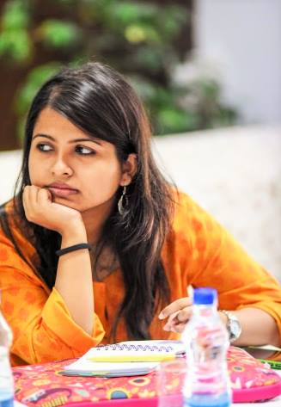**Arundhati Deka**

**Research Associate, IIT Guwahati**

Arundhati Deka is a Research Associate at the Department of Humanities and Social Sciences at Indian Institute of Technology (IIT) Guwahati, Assam. She has a Masters in Science in Environmental Studies and Resource Management from TERI School of Advanced Studies, India, and is a graduate in B. Sc. Geology (hons.) from Hansraj College, University of Delhi. Her research interest lies in development studies and particularly on water science, policy and governance; socio-hydrology and gender; and water, food and livelihood security. Currently she is working on the project – Science Communication for Water Diplomacy in the Brahmaputra. Previously she has been also been engaged with the initiative ‘Transnational Policy Dialogue for Improved Water Governance of Brahmaputra River’, for almost 4 years, which has enabled to generate a platform to work on cross cutting issues for the riparian nations of the river.