**Design:**

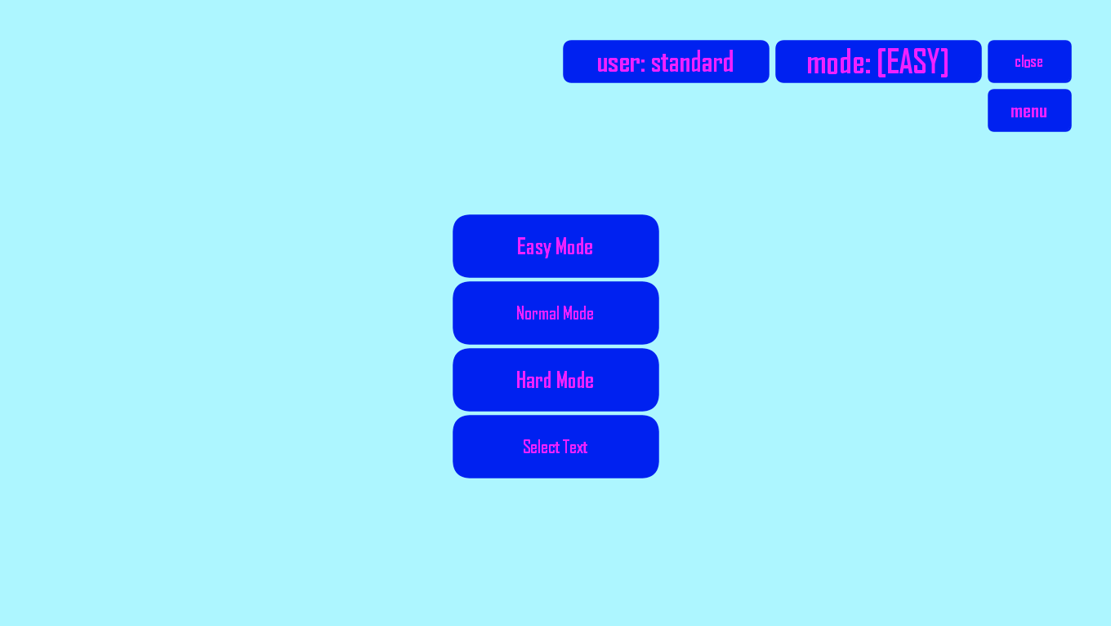

**Behavior:**

When “Settings” button is pressed, this menu waits for the “main menu” to close, the it opens. If “menu” is pressed, “settings menu” will disappear, and main menu will appear. In this menu you can see the mode the program is currently set to and change it. You can also choose the text to write: by clicking “Select Text”, a “.txt” file will open. You can Paste the text you want to write there, and close the “.txt” file.