**Design:**

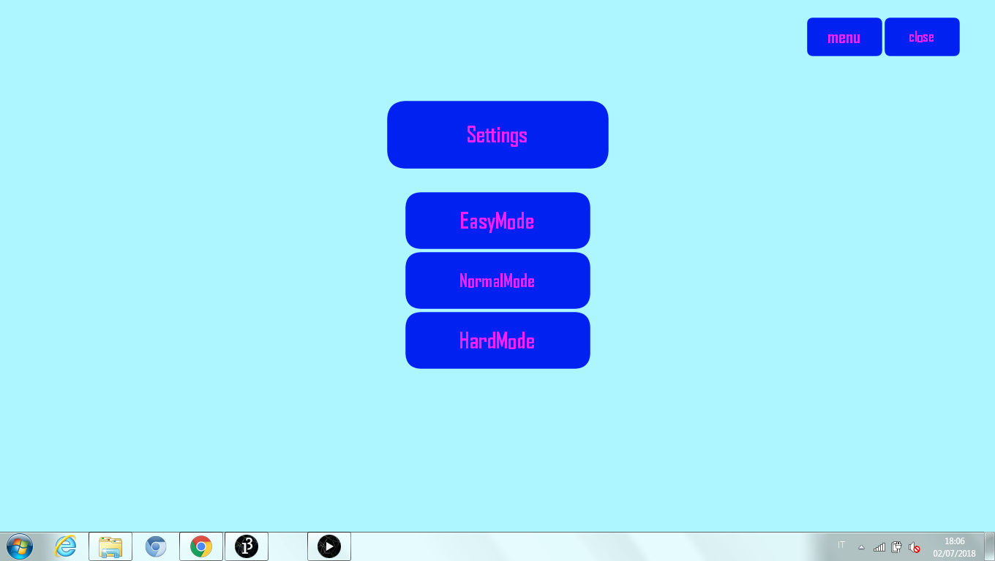

**Behavior:**

When “Settings” button is pressed, this menu waits for the “main menu” to close, the it opens. If you scroll the mouse on “settings” in this menu, nothing will happen. If “menu” is pressed, “settings menu” will disappear, and main menu will appear.