**Design:**

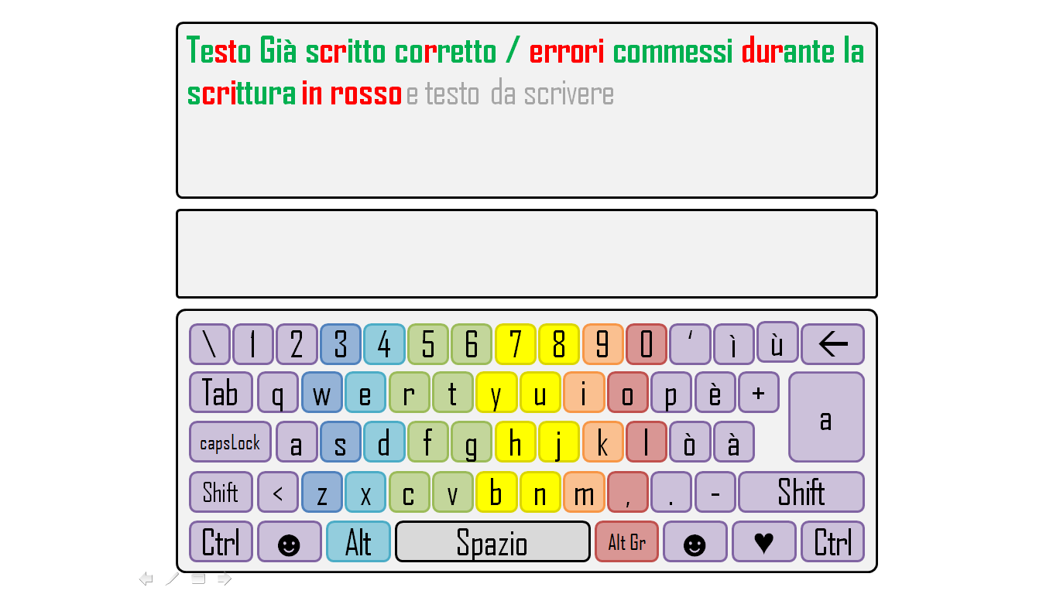

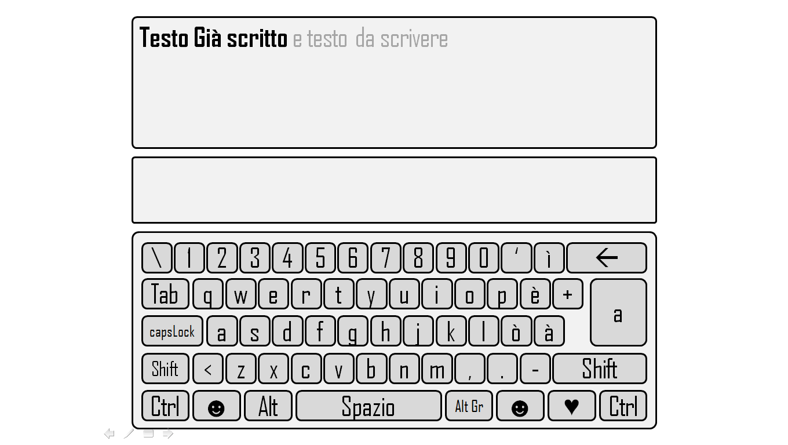

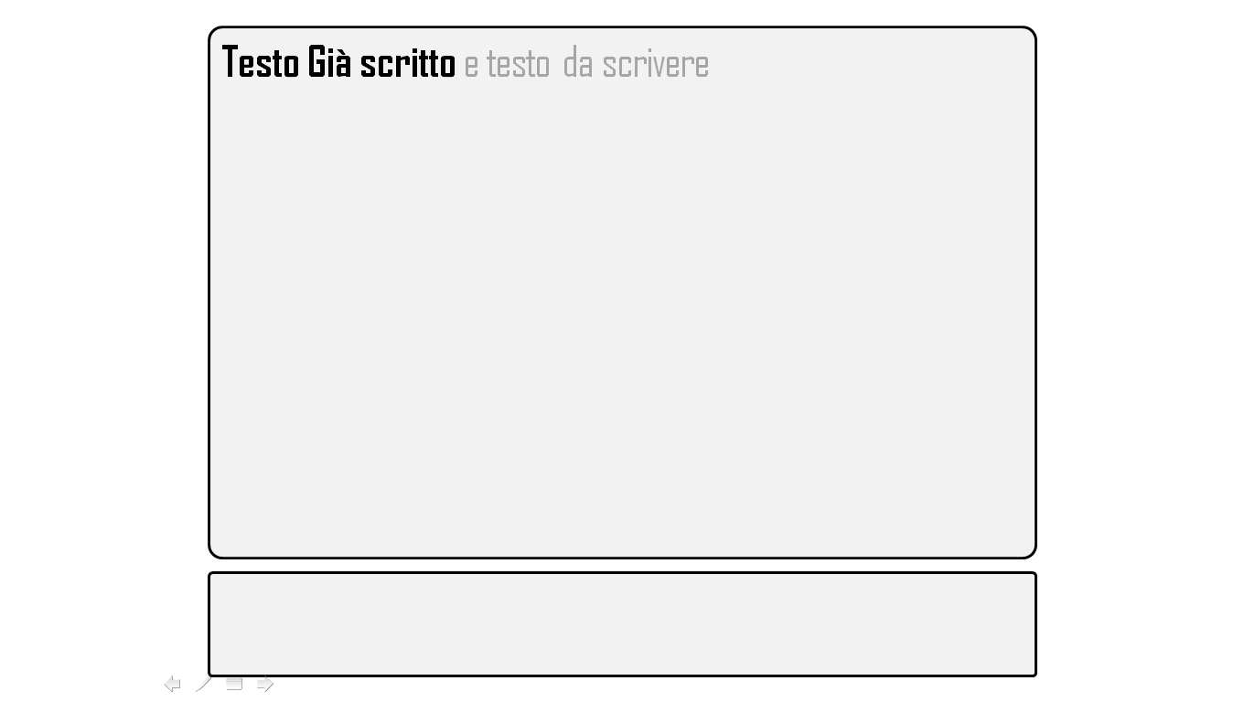

**Behavior:**

The first picture represents exercise page in “easy mode”, the second one in “medium mode”, and the third one in “hard mode”. The text which has already been written Becomes **Coloured** (green correct parts/red mistakes) or **black**, else it is light grey. In the bar in the middle there will be some counters as beats per minute, percentage of mistakes etc…