Design and Test of Microelectronic Systems SS_19
Lab 2: Model Based Design using MATLAB/Simulink
Report submitted by :
Bharath Ramachandraiah
Matrikelnr : 762596
Balaji
Matrikelnr :

May/29/2019

Content
1 Introduction 3
2 Objective 3
3 Implementation 3
3.1 Screenshot of the slider gain windows and Simulink scope of practical task No.1 3
3.2 Questionnaire 6
3.3 Preparation of new simulink model 12
3.3.1 Screenshot of new Simulink model of practical task No.2 12
3.3.2 Explain the change of the model for implementing the counter enable function 13
3.4 Screenshot of Simulink scope to prove that the counter is stopping and continuing again. 13
4 Conclusion 14

Introduction
In this lab we use the HDL Coder™ to generate a custom HDL IP core on Xilinx® Zynq® ZedBoard, and we also use Embedded Coder® to generate C code that runs on the ARM® processor to understand the workflow of Model-Based Design using MATLAB/Simulink.

Objective
The objective of the lab is to generate a custom programmable logic for HDL IP core on Xilinx Zynq ZedBoard using HDL coder and generate C code to be flashed on the ARM Cortex A9 processor using Embedded Coder and implement the design on the Xilinx Zynq platform.
Figure 1: Model Workflow with Matlab/Simulink

Implementation

Screenshot of the slider gain windows and Simulink scope of practical task No.1

Task-Description:
Use an example IP core Generation workflow “hdlcoder_led_blinking” given by MathWorks. Follow the steps to implement the design on the Xilinx Zynq Platform. Run your model on the ZedBoard in External mode.

Figure 2: IP core generation of hdlcoder_led_blinking

Elaboration:

The design shown is from the hdlcoder_led_blinking example. All settings, such as HDL and C code generation and programming of the board have been done. The interfaces used between the ARM processor and the FPGA layer can also be seen, AXI4-Lite/AXI4 in our case. Linux based firmware was also flashed on an SD-card.
The Slider Gain is adjusted for the speed of the counting, which is, in turn, the speed at which the LEDs are blinking. From the below-attached screenshots of the waveforms, we can see the difference of the counting speeds with the different slider gains.

Figure 3: Slider Gain at 15
Figure 4: Slider Gain at 11.7512

Analysis: The slider gain sets the speed of counting, which is the speed at which the LEDs
blink. There are two sets of waveforms for the two different settings of the slider gain, as
shown in the figures below.

Questionnaire
- What is the meaning of the particular jumper settings for the ZedBoard (check in user guide)?
- The Jumpers and its setting done are as follows:
Jumpers JP7-JP11 set the configuration mode for the ZedBoard. By default, the ZedBoard uses the SD Card configuration mode. The boot mode pins are MIO[8:2] and are used as follows:
1. MIO[2]/Boot_Mode[3] sets the JTAG mode
2. MIO[5:3]/Boot_Mode[2:0] select the boot mode
3. MIO[6]/Boot_Mode[4] enables the internal PLL
4. MIO[8:7]/Vmode[1:0] are used to configure the I/O bank voltages, however, these are fixed on ZedBoard and not configurable.
The following settings are used for the configuration
- After you generate the custom IP core, a HDL code generation report is getting generated. Open the high-level resource report: How many adders, registers and mux are used?

The adders, registers, and mux are used for the hdlcoder_led_blinking example are indicated in the below screen short.

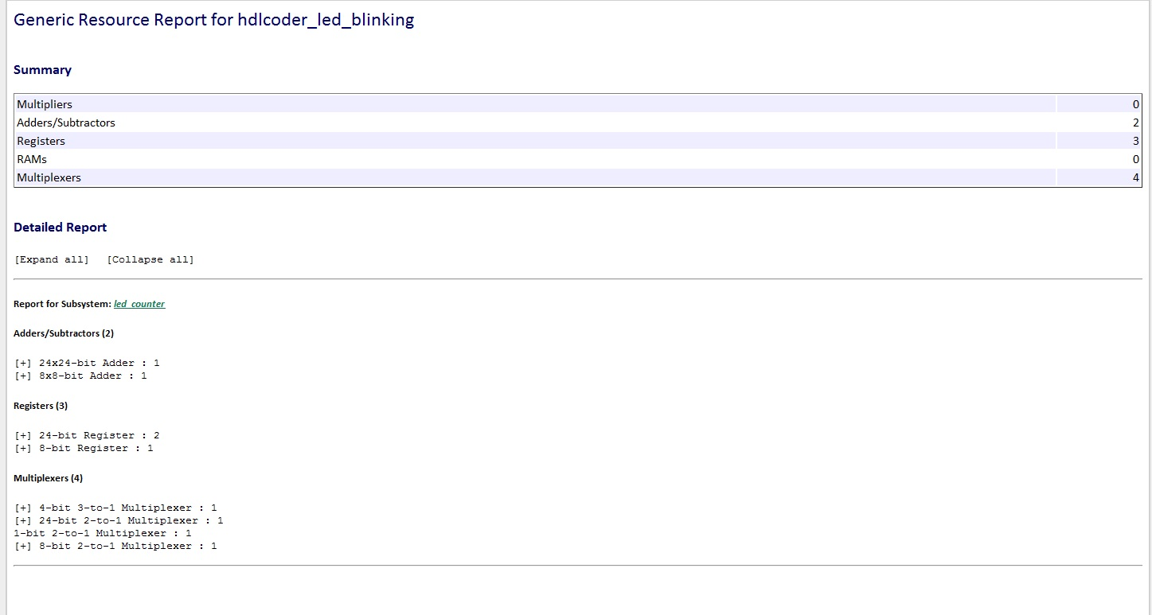
Figure 5: Generic Resource report

- Open the generated source file led_counter.vhd: what is the purpose of the
two VHDL processes defined in this file?
VHDL code for the led counter:
-- -------------------------------------------------------------
--
-- File Name: hdl_prj\hdlsrc\hdlcoder_led_blinking\led_count_ip_src_led_counter.vhd
-- Created: 2018-05-28 19:52:18
--
-- Generated by MATLAB 9.3 and HDL Coder 3.11
--
--
-- -------------------------------------------------------------
-- Rate and Clocking Details
-- -------------------------------------------------------------
-- Model base rate: 0.001
-- Target subsystem base rate: 0.001
--
--
-- Clock Enable Sample Time
-- -------------------------------------------------------------
-- ce_out 0.001
-- -------------------------------------------------------------
--
--
-- Output Signal Clock Enable Sample Time
-- -------------------------------------------------------------
-- LED ce_out 0.001

-- Read_back ce_out 0.001
-- -------------------------------------------------------------
--
-- -------------------------------------------------------------
--
-- Module: led_count_ip_src_led_counter
-- Source Path: hdlcoder_led_blinking/led_counter
-- Hierarchy Level: 0
--
-- -------------------------------------------------------------
LIBRARY IEEE;
USE IEEE.std_logic_1164.ALL;
USE IEEE.numeric_std.ALL;
USE work.led_count_ip_src_led_counter_pkg.ALL;

ENTITY led_count_ip_src_led_counter IS
PORT( clk : IN std_logic;
reset : IN std_logic;
clk_enable : IN std_logic;
Blink_frequency : IN std_logic_vector(3 DOWNTO 0); -- ufix4
Blink_direction : IN std_logic;
enable : IN std_logic;
ce_out : OUT std_logic;
LED : OUT std_logic_vector(7 DOWNTO 0); -- uint8
Read_back : OUT std_logic_vector(7 DOWNTO 0)

-- uint8
);
END led_count_ip_src_led_counter;

ARCHITECTURE rtl OF led_count_ip_src_led_counter IS

-- Constants
CONSTANT nc : vector_of_unsigned24(0 TO 15) :=
(to_unsigned(16#800000#, 24), to_unsigned(16#400000#, 24),
to_unsigned(16#200000#, 24), to_unsigned(16#100000#, 24),
to_unsigned(16#080000#, 24), to_unsigned(16#040000#, 24),
to_unsigned(16#020000#, 24), to_unsigned(16#010000#, 24),
to_unsigned(16#008000#, 24), to_unsigned(16#004000#, 24),
to_unsigned(16#002000#, 24), to_unsigned(16#001000#, 24),
to_unsigned(16#000800#, 24), to_unsigned(16#000400#, 24),
to_unsigned(16#000200#, 24), to_unsigned(16#000100#, 24)); -- ufix24 [16]

-- Signals
SIGNAL enb : std_logic;
SIGNAL Blink_direction_1 : std_logic;

SIGNAL enable_1 : std_logic;
SIGNAL Blink_frequency_unsigned : unsigned(3 DOWNTO 0); -- ufix4
SIGNAL alpha1_D_Lookup_Table_k : unsigned(3 DOWNTO 0); -- ufix4
SIGNAL alpha1_D_Lookup_Table_out1 : unsigned(23 DOWNTO 0); -- ufix24
SIGNAL alpha1_D_Lookup_Table_out1_1 : unsigned(23 DOWNTO 0) := to_unsigned(16#000000#, 24); -- ufix24
SIGNAL Relational_Operator_relop1 : std_logic;
SIGNAL HDL_Counter1_out1 : unsigned(23 DOWNTO 0); -- ufix24
SIGNAL Relational_Operator_out1 : std_logic;
SIGNAL HDL_Counter_count : unsigned(7 DOWNTO 0); -- ufix8
SIGNAL HDL_Counter_count_next : unsigned(7 DOWNTO 0); -- ufix8
SIGNAL HDL_Counter_count_step : unsigned(7 DOWNTO 0); -- ufix8
SIGNAL HDL_Counter_out1 : unsigned(7 DOWNTO 0); -- uint8

BEGIN
enb <= clk_enable;

delayMatch1_process : PROCESS (clk)
BEGIN
IF clk'EVENT AND clk = '1' THEN
IF reset = '1' THEN
Blink_direction_1 <= '0';
ELSIF enb = '1' THEN
Blink_direction_1 <= Blink_direction;
END IF;
END IF;
END PROCESS delayMatch1_process;

delayMatch_process : PROCESS (clk)
BEGIN
IF clk'EVENT AND clk = '1' THEN
IF reset = '1' THEN
enable_1 <= '0';
ELSIF enb = '1' THEN
enable_1 <= enable;
END IF;
END IF;
END PROCESS delayMatch_process;

Blink_frequency_unsigned <= unsigned(Blink_frequency);

-- <S3>/1-D Lookup Table

alpha1_D_Lookup_Table_k <= to_unsigned(16#0#, 4) WHEN Blink_frequency_unsigned = to_unsigned(16#0#, 4)
ELSE
to_unsigned(16#F#, 4) WHEN Blink_frequency_unsigned = to_unsigned(16#F#, 4)
ELSE
Blink_frequency_unsigned;
alpha1_D_Lookup_Table_out1 <= nc(to_integer(alpha1_D_Lookup_Table_k));

PipelineRegister_process : PROCESS (clk)
BEGIN
IF clk'EVENT AND clk = '1' THEN
IF enb = '1' THEN
alpha1_D_Lookup_Table_out1_1 <= alpha1_D_Lookup_Table_out1;
END IF;
END IF;
END PROCESS PipelineRegister_process;

-- Free running, Unsigned Counter
-- initial value = 0
-- step value = 1
--
-- <S3>/HDL Counter1

HDL_Counter1_process : PROCESS (clk)
BEGIN
IF clk'EVENT AND clk = '1' THEN
IF reset = '1' THEN
HDL_Counter1_out1 <= to_unsigned(16#000000#, 24);
ELSIF enb = '1' THEN
IF Relational_Operator_relop1 = '1' THEN
HDL_Counter1_out1 <= to_unsigned(16#000000#, 24);
ELSIF enable_1 = '1' THEN
HDL_Counter1_out1 <= HDL_Counter1_out1 + to_unsigned(16#000001#, 24);
END IF;
END IF;
END IF;
END PROCESS HDL_Counter1_process;

-- <S3>/Relational Operator

Relational_Operator_relop1 <= '1' WHEN HDL_Counter1_out1 = alpha1_D_Lookup_Table_out1_1 ELSE
'0';

Relational_Operator_out1 <= Relational_Operator_relop1;

-- Free running, Unsigned Counter
-- initial value = 0
-- step value = 1
--
-- <S3>/HDL Counter

HDL_Counter_process : PROCESS (clk)
BEGIN
IF clk'EVENT AND clk = '1' THEN

IF reset = '1' THEN
HDL_Counter_count <= to_unsigned(16#00#, 8);
ELSIF enb = '1' AND Relational_Operator_out1 = '1' THEN
HDL_Counter_count <= HDL_Counter_count_next;
END IF;
END IF;
END PROCESS HDL_Counter_process;

HDL_Counter_out1 <= HDL_Counter_count;

HDL_Counter_count_step <= to_unsigned(16#01#, 8) WHEN Blink_direction_1 = '1' ELSE
to_unsigned(16#FF#, 8);
HDL_Counter_count_next <= HDL_Counter_count + HDL_Counter_count_step;

LED <= std_logic_vector(HDL_Counter_out1);

Read_back <= std_logic_vector(HDL_Counter_out1);

ce_out <= clk_enable;

END rtl;

The purpose of two processes defined in the file is for two counters, with initial value 0 and step size of 1

HDL_Counter1_process is 24 bit counter and represents a clock divider counter, in order to obtain a lower clock frequency for counting. The maximum counting value is stored in a Look-Up Table
HDL_Counter_process is 8 bit counter and represents the counter whose output will be displayed on the LEDs. It uses additional logic, to also change the blinking direction of the LEDs, by dynamically changing the step value of this counter

- Open the HTML C-code generation report. Do a screenshot of the list of generated code (main file, model files, data files).

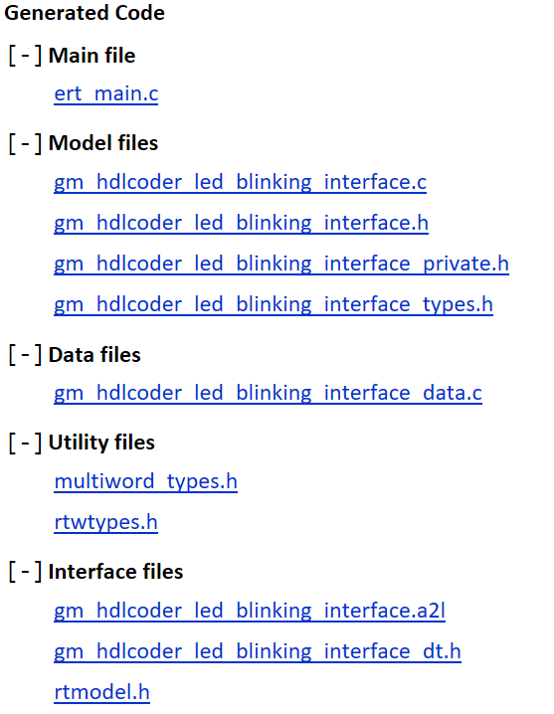
Figure 6: List of generated code

Preparation of new simulink model

Screenshot of new Simulink model of practical task No.2
Figure 7: IP core generation of hdlcoder_led_blinking with Count Enable

Explain the change of the model for implementing the counter enable function
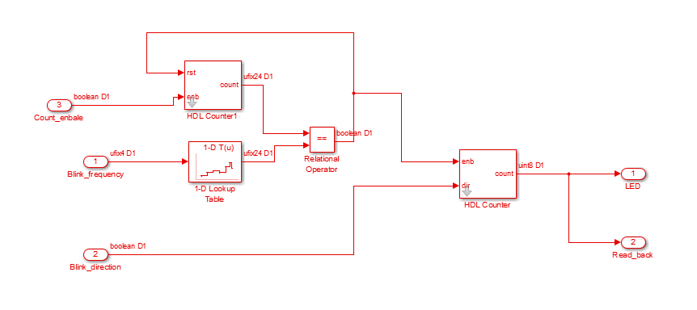
Figure 8: HDL Counter1 with Count Enable

Screenshot of Simulink scope to prove that the counter is stopping and continuing again.

Elaboration:
The Simulink scope of the hdlcoder_led_blinking with counter enable function
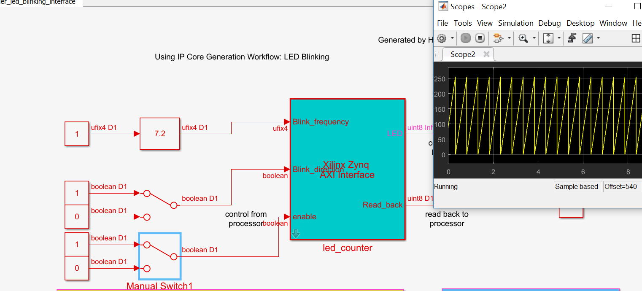
Figure 9: Count Enabled – Counter increasing

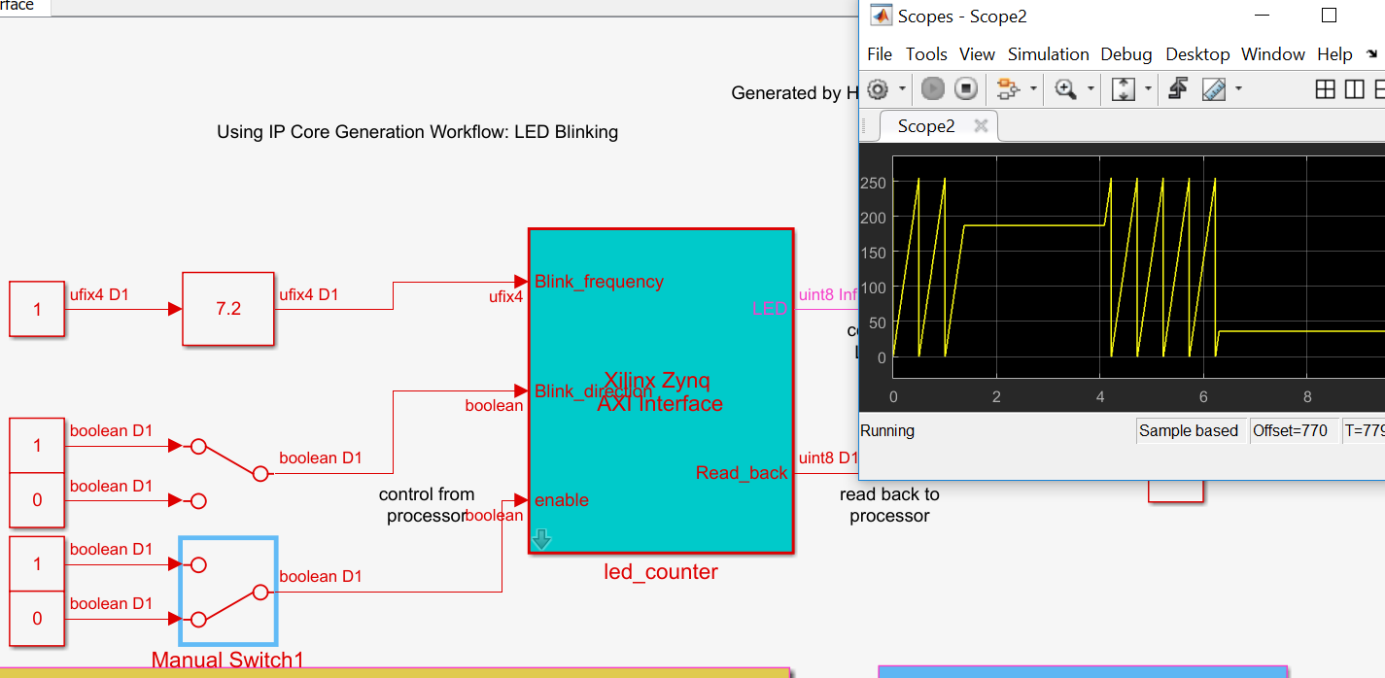
Figure 10: Count Enabled again – Counter stopped and starts incrementing again

Conclusion
A custom programmable logic for HDL IP core on Xilinx Zynq ZedBoard using HDL coder and generate C code to be flashed on the ARM Cortex A9 processor using Embedded Coder. Example hdlcoder_led_blinking is used and later the count enable port is implemented and interfaced Xilinx Zynq platform.

