Практическая работа 9
Автор: Косырев Артем Викторович.
Группа: 4пк2.
Название: Вывод информации об участке памяти.
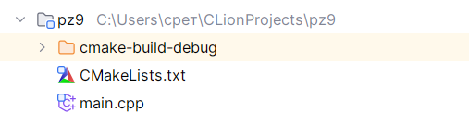
Рисунок 1 – Структура программы
#include <windows.h>
#include <iostream>
#include <iomanip>
using namespace std;
const char* GetStateString(DWORD state) {
switch (state) {
case MEM_COMMIT: return "MEM_COMMIT";
case MEM_RESERVE: return "MEM_RESERVE";
case MEM_FREE: return "MEM_FREE";
default: return "UNKNOWN";
}
}
const char* GetProtectString(DWORD protect) {
switch (protect) {
case PAGE_NOACCESS: return "PAGE_NOACCESS";
case PAGE_READONLY: return "PAGE_READONLY";
case PAGE_READWRITE: return "PAGE_READWRITE";
case PAGE_WRITECOPY: return "PAGE_WRITECOPY";
case PAGE_EXECUTE: return "PAGE_EXECUTE";
case PAGE_EXECUTE_READ: return "PAGE_EXECUTE_READ";
case PAGE_EXECUTE_READWRITE: return "PAGE_EXECUTE_READWRITE";
case PAGE_EXECUTE_WRITECOPY: return "PAGE_EXECUTE_WRITECOPY";
default: return "UNKNOWN";
}
}
int main() {
SetConsoleCP(CP_UTF8);
SetConsoleOutputCP(CP_UTF8);
SYSTEM_INFO si;
GetSystemInfo(&si);
DWORD pageSize = si.dwPageSize;
cout << "Page size: " << pageSize << endl;
LPVOID pReserved = VirtualAlloc(NULL, pageSize, MEM_RESERVE | MEM_COMMIT, PAGE_READWRITE);
if (pReserved == NULL) {
cerr << "Ошибка VirtualAlloc" << endl;
return 1;
}
cout << "Memory successfully acllocated at address: " << pReserved << endl;
memset(pReserved, 0x7F, pageSize);
cout << "Memory filled with value 0x7F\n\n";
MEMORY_BASIC_INFORMATION mbi;
SIZE_T result = VirtualQuery(
pReserved,
&mbi,
sizeof(mbi)
);
if (result == 0) {
cerr << "Ошибка VirtualQuery" << endl;
VirtualFree(pReserved, 0, MEM_RELEASE);
return 1;
}
cout << "Memory region information" << endl;
cout << "Base address: 0x" << hex << uppercase << setw(16)
<< setfill('0') << (ULONG_PTR)mbi.BaseAddress << dec << endl;
cout << "AllocationProtect: " << GetProtectString(mbi.AllocationProtect)
<< " (0x" << hex << mbi.AllocationProtect << dec << ")" << endl;
cout << "Region Size: " << mbi.RegionSize << "bytes" << endl;
cout << "State: " << GetStateString(mbi.State) << endl;
cout << "Additional information" << endl;
cout << "AllocationBase: 0x" << hex << uppercase << setw(16)
<< setfill('0') << (ULONG_PTR)mbi.AllocationBase << dec << endl;
cout << "Protect: " << GetProtectString(mbi.Protect) << endl;
cout << "Type";
switch (mbi.Type) {
case MEM_IMAGE: cout << "MEM_IMAGE"; break;
case MEM_MAPPED: cout << "MEM_MAPPED"; break;
case MEM_PRIVATE: cout << "MEM_PRIVATE"; break;
default: cout << "UNKNOWN"; break;
}
cout << "Проверка сожержимого памяти" << endl;
BYTE* pByte = (BYTE*)pReserved;
cout << "Первые 16 байт памяьт: ";
for (int i = 0; i < 16; i++) {
cout << hex << uppercase << setw(2) << setfill('0') << (int)pByte[i] << " ";
}
cout << dec << endl;
if (!VirtualFree(pReserved, 0, MEM_RELEASE)) {
cerr << "Ошибка VirtualFree" << endl;
return 1;
}
cout << "\nПамять успещно освобождена" << endl;
return 0;
}
Листинг 1 – файл main.cpp
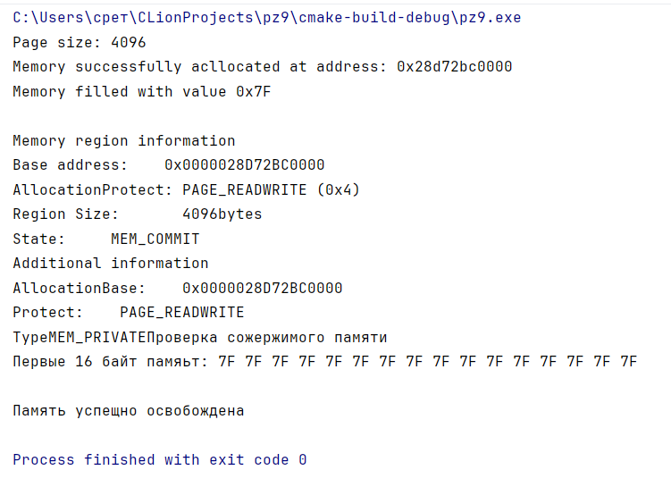
Рисунок 2 – результат выполнения задания

