Практическое задание 5
Автор: Косырев Артём Викторович.
Группа: 4пк2.
Название: Блокировка и возобновление потоков.
Цель: обработка навыков работы с потоками.
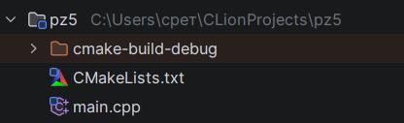
Рисунок 1 – структура проекта
#include <iostream>
#include <windows.h>
HANDLE hThread1, hThread2;
CRITICAL_SECTION cs;
volatile double currentValue = 0.0;
volatile bool terminateAll = false;
const double PAUSE_THRESHOLD = 100.0;
const double CRITICAL_VALUE = 1000.0;
DWORD WINAPI Thread2_Generator(LPVOID) {
double value = 1.0;
double ratio = 1.5;
int step = 0;
std::cout << "Thread2 started: generating geometric progression" << std::endl;
while (true) {
EnterCriticalSection(&cs);
currentValue = value;
LeaveCriticalSection(&cs);
step++;
std::cout << "[Thread2] step " << step << ": value = " << value << std::endl;
if (value >= CRITICAL_VALUE) {
std::cout << "[Thread2] CRITICAL_VALUE reached" << std::endl;
break;
}
value *= ratio;
Sleep(800);
}
std::cout << "[Thread2] finished" << std::endl;
return 0;
}
DWORD WINAPI Thread1_Generator(LPVOID) {
std::cout << "Thread1 started: monitoring Thread2" << std::endl;
bool paused = false;
while (!terminateAll) {
double value;
EnterCriticalSection(&cs);
value = currentValue;
LeaveCriticalSection(&cs);
std::cout << "[Thread1] read value " << value << std::endl;
if (value >= PAUSE_THRESHOLD && !paused && value < CRITICAL_VALUE) {
std::cout << "[Thread1] pushing Thread2" << std::endl;
SuspendThread(hThread2);
paused = true;
Sleep(3000);
std::cout << "[Thread1] resuming Thread2" << std::endl;
ResumeThread(hThread2);
}
if (value >= CRITICAL_VALUE) {
std::cout << "[Thread1] EMERGENCY TERMINATION" << std::endl;
TerminateThread(hThread2, 0);
terminateAll = true;
break;
}
Sleep(1000);
}
std::cout << "[Thread1] finished" << std::endl;
return 0;
}
int main() {
SetConsoleCP(1251);
SetConsoleOutputCP(1251);
InitializeCriticalSection(&cs);
hThread2 = CreateThread(
nullptr,
0,
Thread2_Generator,
nullptr,
0,
nullptr
);
hThread1 = CreateThread(
nullptr,
0,
Thread1_Generator,
nullptr,
0,
nullptr
);
WaitForSingleObject(hThread1, INFINITE);
WaitForSingleObject(hThread2, INFINITE);
DeleteCriticalSection(&cs);
CloseHandle(hThread1);
CloseHandle(hThread2);
std::cout << "Program finished" << std::endl;
return 0;
}
Листинг 1 – файл main.cpp
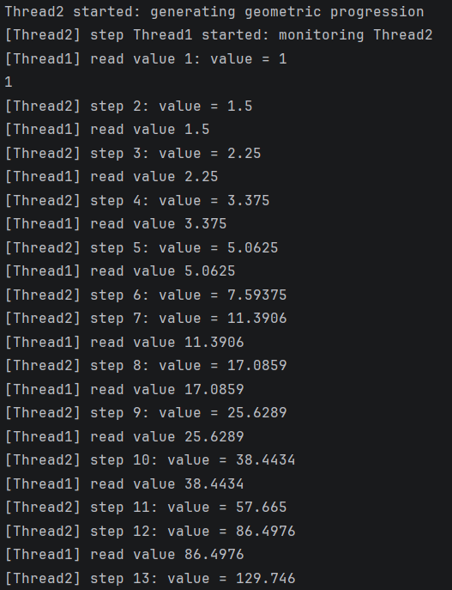
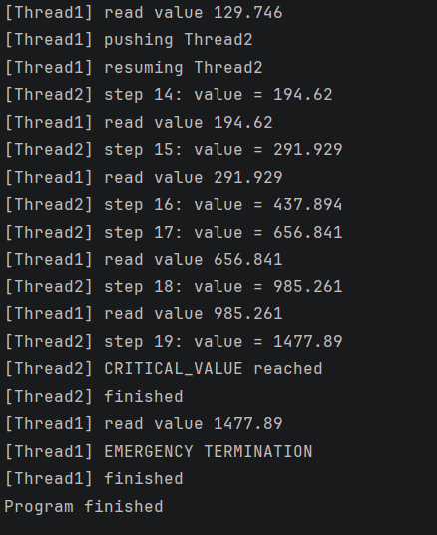
Рисунок 2 – результат программы

