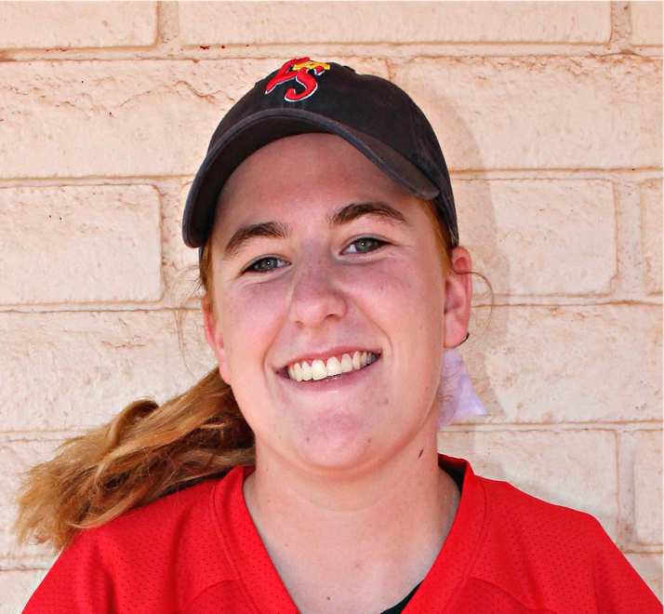

Emily Guadagno #29

## Club / Travel Experience

|  |  |  |
| --- | --- | --- |
| 2015 / 2016- 16u | Lil Saints East | Coach Rob Rodriguez |
|  | AZ Hotshots | Coach Joe Rodríguez |
| 2014 – 16u | AZ Hotshots | Coach Joe Rodriguez |
|  | Vendetta | Coach Ken Willmott |
| 2013 14u – 16u | AZ Force | Coach Dione Swan |
|  | AZ Adrenaline | Coach Marcus Gaut |
| 2012 12u – 14u | AZ Adrenaline | Coach Marcus Gaut |
|  | East Valley Pride | Coach James White |

Highlights: Team Captain for Freshman Softball Team

## Contacts

|  |  |  |  |
| --- | --- | --- | --- |
| Father | Joseph Guadagno | 602-293-6767 | jguadagno@hotmail.com |
| Mother | Deidre Guadagno | 602-293-6879 | deeguadagno@hotmail.com |
| Travel Coach | Rob Rodriguez | 480-347-8841 | lilsaintseast@gmail.com |
| Hitting Instructor | Katie Schroeder | 714-457-7723 | katieschroeder29@gmail.com |
| High School Coach (Perry High School) | Rob HeHe | 480-204-2719 | robhehe@yahoo.com |

For an up to date version of this profile please visit **http://jjg.me/EEGSite**

## Academic

|  |  |
| --- | --- |
| Graduation | 2017 |
| High School | Perry High School |
| Career Goal | Undecided |
| GPA | **2.5 *as of Sept 2016*** |
| Class Rank | **n/a** |
| SAT | Spring 2016 |
| NCAA Clearinghouse | **1506216361** |

## Primary Positions 3rd and 1st

|  |  |
| --- | --- |
| Birth Date | November 10, 1999 |
| Height | 5’ 10” |
| Weights | 180 lbs. |
| Bats | Right |
| Throws | Right |
| Email: | emilyguad29@gmail.com |
| Cell Phone | 602-516-8940 |
| Skills Video | <http://jjg.me/EEGVideo> |
| Club Batting Average | .550 |
| High School Batting Average | .556 |

## Academic and Extra-Curricular Achievements

|  |  |
| --- | --- |
| 2015 – 2016 | Volunteers locally 40 -50 hours a year with various charities |
| 2016 | Perry High School Jr. Varsity Manager (due to injury) |
| 2015 | Perry High School Junior Varsity |
| 2014 | Perry High School Freshman Softball Team  Perry High School Freshman Captain |
| 2012 – 2013 | 2013 SanTan Junior High Softball Team |
| 2012 – 2013 | 2013 SanTan Junior High Student Council Member |
| 2004 – 2015 | Girl Scout - Earned Bronze and Silver Award |

## 2016 Summer Schedule

|  |  |  |
| --- | --- | --- |
| 5/21 – 5/22 | Premier Fast Pitch – Phoenix, AZ |  |
| 6/2 – 6/6 | Triple Crown – Oklahoma, OK |  |
| 6/11 – 6/12 | USSSA Elite Select Qualifier, Phoenix, AZ |  |
| 6/25 – 6/26 | USSSA, Glendale, AZ |  |
| 7/11 – 7/17 | USSSA Elite Select National Championship, Kansas, MO |  |
| 7/29 – 7/31 | Triple Crown Showcase, San Diego, CA |  |
|  |  |  |
|  |  |  |
|  |  |  |
|  |  |  |

## Camps / Clinics

|  |  |
| --- | --- |
| 2016 | American International College Winter Camp |
| 2015 | TCS Rising Stars D1 Camp |
| 2015 | USA Preps Las Vegas Showcase |
| 2015 | Showball Summer Showcase |
| 2015 | California State University Fullerton Summer Camp |
| 2015 | Colorado State University Winter Camp |
| 2014 | Arizona State Summer Clinic |
| 2014 | Perry High School Summer and Fall Camps |
| 2013 | Perry High School Summer and Fall Camps |