Current Product Corp.

Elan Installation Guide

24 April, 2020

## Setup

Current Products Corp. strives to create products that are easy to install, and our Elan drivers are no exception. To install, navigate to the Lighting tab in Configurator. Then right-click on Lighting interfaces and select “Add New Lighting Interface”. Search for “Current_Products_Serial” if this is a hardwired install or “Current_Products_Drapery” if this is being controlled by a Current Products Bridge.

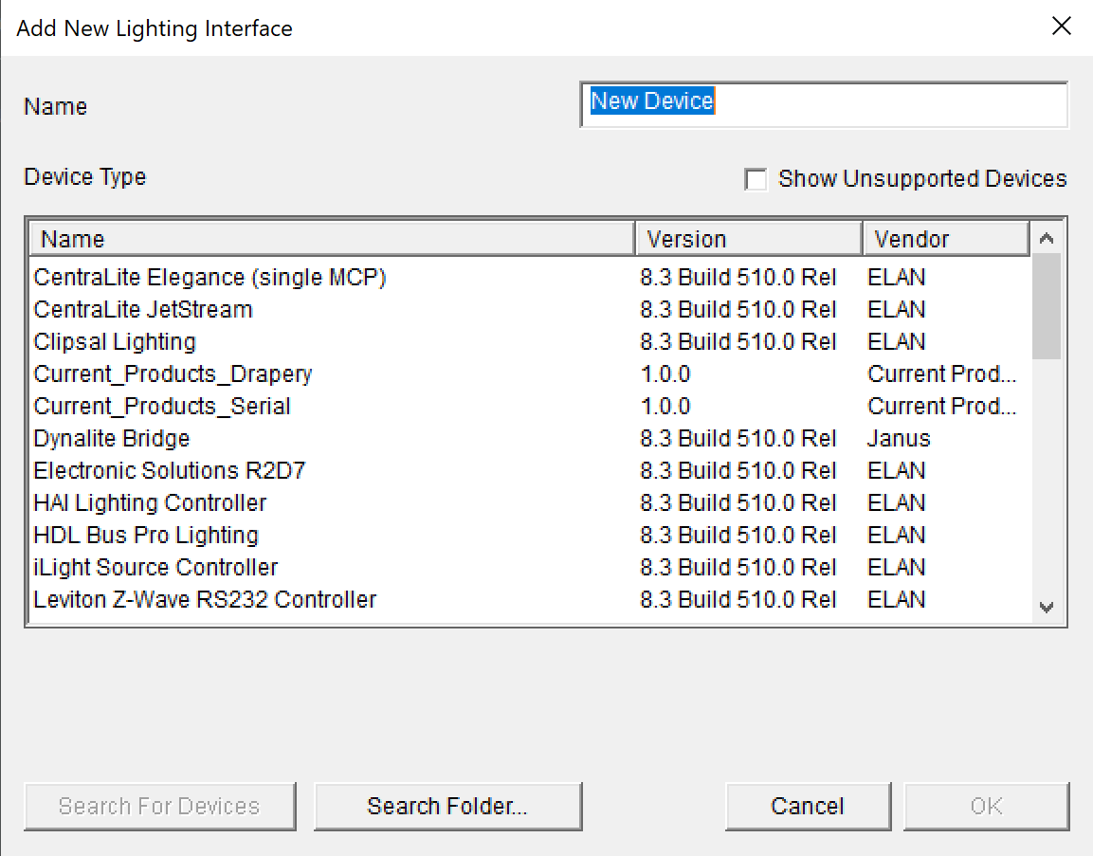

If these options aren’t available, select “Search Folder” and navigate to the directory in which you saved the drivers. Click “Okay”.

**(Cloud Control Only)**

Join all ZigBee devices to the Current Products Hub and name the devices appropriately. On the Lighting Interface Current_prodicts_Drapery page, click “authorize” and enter in your current products credentials when prompted.

**(Serial Only)**

Connect the Current Products Corp. hardwire panel to the RS232 port on the Elan control box. You will need an RS232-RS485 converter for this. Connect the devices to the hardwire panel and make sure it is powered.

Under the Lighting Interface page, select “Device Discovery”. All the devices should show up under the interface. Test which device goes to which id and rename them if it helps keep track of the devices.

## Settings

If any devices are moving in the wrong direction, there is a settings page for “Reverse Open/Close.” Here, you can enter the device id followed by P or S (for primary and secondary motor), separated by commas. The devices entered here will be reversed after hitting “Apply”. If you would like all the joined devices to open when 100% is entered, then simply enter “all” into the Device List.

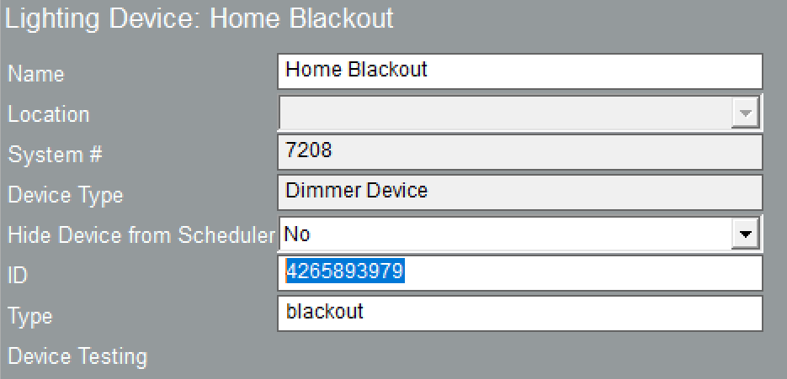

The device ID, highlighted

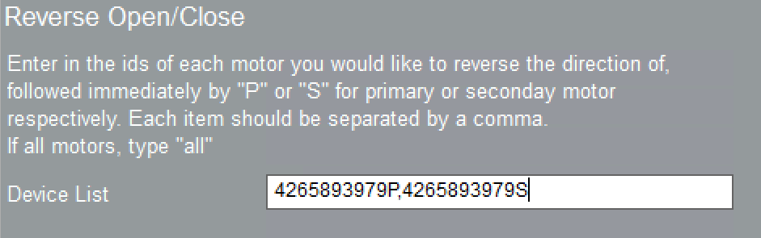

An example of how to add devices to the list of devices to reverse

## Adding a Page for the device

When adding a control for the device to the page, be sure to use the Light Dimmer Control. If the device has two motors, you will need to add a control per motor and connect it to the appropriate motor.

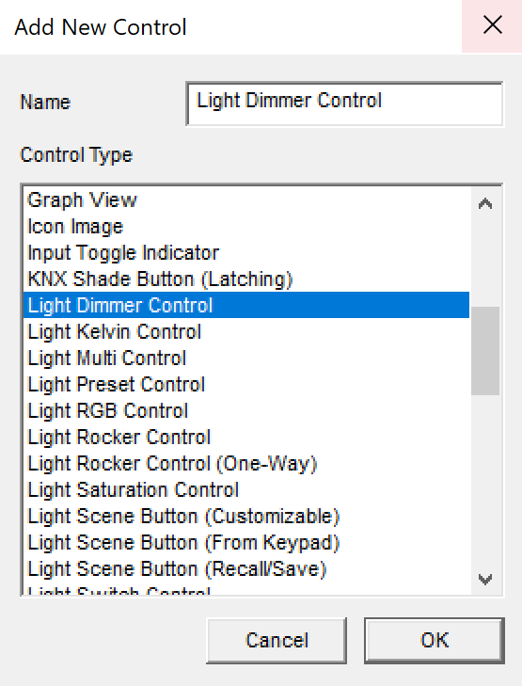

Light dimmer control

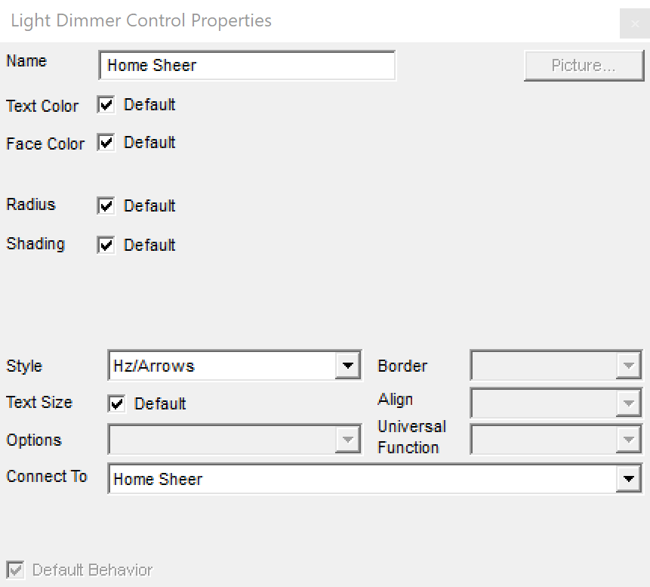

Connecting the control to the device