​

**Consider the Image data and Filter given in assets. Consider window size as (2,2). Perform the operations of Convolution, Max Pooling, and Flattening on this data.**

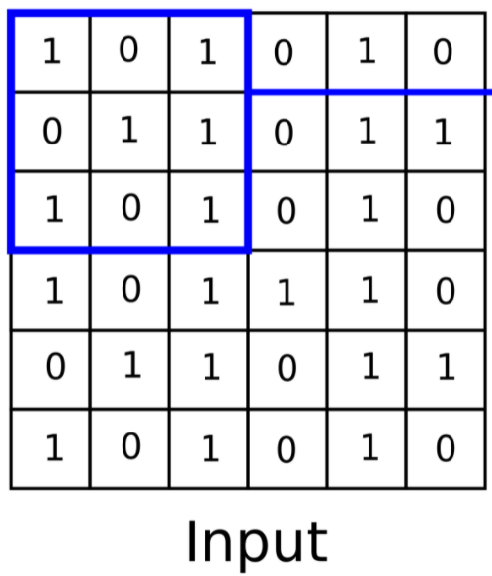Click and drag to move**​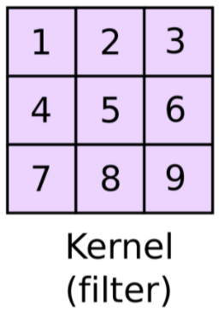Click and drag to move​**

**After Convolution**

| **30** | **19** | **30** | **21** |
| --- | --- | --- | --- |
| **31** | **25** | **38** | **26** |
| **31** | **28** | **35** | **28** |
| **31** | **22** | **31** | **22** |

**After Max Pooling**

| **31** | **38** |
| --- | --- |
| **31** | **35** |

**After Flattening**

| **31** |
| --- |
| **38** |
| **31** |
| **35** |