​

**Consider the Image data and Filter given in assets. Consider window size as (2,2). Perform the operations of Convolution, Max Pooling, and Flattening on this data.**

​

**Input Image -**

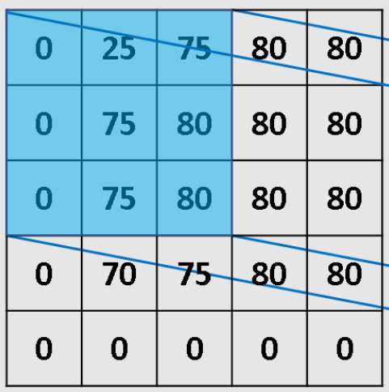Click and drag to move​

**Kernel -**

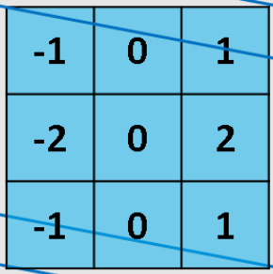Click and drag to move​**Click and drag to move​**

**After Convolution**

| **235** | **70** | **5** |
| --- | --- | --- |
| **315** | **25** | **5** |
| **230** | **25** | **10** |

**After Max Pooling**

| **315** | **5** |
| --- | --- |
| **230** | **10** |

**After Flattening**

| **315** |
| --- |
| **5** |
| **230** |
| **10** |