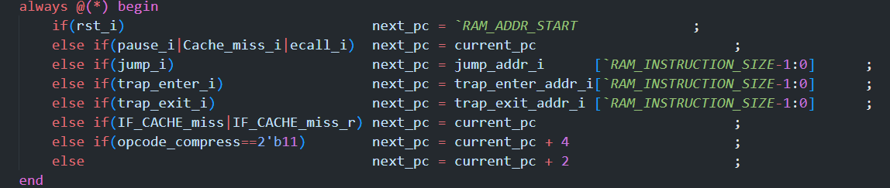



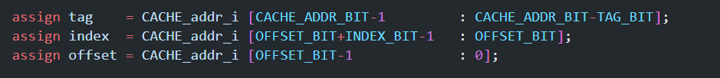

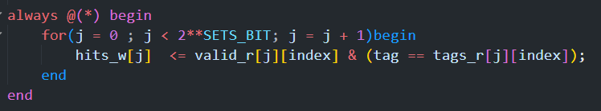

**next_pc(current_pc+4) -> addr_i -> index, tag -> miss ->**

**next_pc(current_pc) -> addr_i -> index, tag -> hit -> next_pc(current_pc+4)**

**ERROR!**