Centennial College

Diabetes Prediction System

COMP 214 – Section 004: Advanced Database Concepts

Professor: Zakiyabanu Malek

Group 1:

Pham Tuong Nguyen

Aazain Ullah Khan

Reet Kaur

Gabriel Castellon

Karadag Ebru Nida

Date: 31st March 2024

# TABLE OF CONTENTS

Data Requirements 3

I. Introduction 3

II. Database Structure 3

III. The use of sequence 3

IV. The use of index 3

V. The use of procedures 3

VI. The use of functions 4

VII. The use of triggers 4

ERD 5

Database Tables 6

SQL Commands 8

I. Create tables 8

II. Create sequences 12

III. Create indexes 13

IV. Create triggers 13

V. Insert records 14

PL/SQL Block codes 19

Screenshot of the output 32

# Data Requirements

## Introduction

The objective of this project is to develop a database storing patient information to facilitate the diagnosis of diabetes through an AI model.

## Database Structure

Our database contains 7 tables:

* DP_PATIENT: The table stores a patient's personal information.
* DP_MEDICAL_RECORDS: The table contains the patient’s weight, height, and lab results.
* DP_FAMILY_HISTORY: The table captures familial medical backgrounds related to diabetes.
* DP_RISK_FACTORS: The table contains lifestyle factors, environmental exposures, and other risk determinants.
* DP_PREDICTION_MODEL: The table stores the information of a prediction model. This table will fetch the data from the patient table and its associated tables make a prediction.
* DP_PREDICTION_RESULT: The table stores the diabetes diagnosis result of a patient after the model has predicted.
* DP_MEDICATIONS: The table stores medications the model suggests if a patient has diabetes.

## The use of sequence

The sequence assigns unique identifiers to entities like DP_PATIENT, DP_MEDICAL_RECORDS, and DP_PREDICTION_RESULT ensuring data integrity and facilitating retrieval.

## The use of index

The index is used to optimize query performance within our database by expediting data retrieval operations such as search, filtering, and sorting. This is applied across tables such as DP_PATIENT, DP_MEDICAL_RECORDS, DP_FAMILY_HISTORY, and DP_PREDICTION_RESULT.

## The use of procedures

Add_Patient_Medication Procedure

This procedure is designed to insert a new medication record into the DP_MEDICATIONS table for a specific patient. It's used when a patient is prescribed a new medication.

When a healthcare provider prescribes a new medication to a patient, this procedure is executed with the prescription details. It ensures that the patient's medication record is updated in the database.

Update_Patient_Medication Procedure

This procedure allows for the updating of an existing medication record in the DP_MEDICATIONS table. It's particularly useful for adjusting medication dosages, changing administration instructions, or updating the medication schedule.

This procedure is called when there's a need to modify the details of an existing medication prescription for a patient. Changes may be due to various reasons such as response to treatment, side effects, or updated medical guidelines.

Calculate_Medical_Statistics

This procedure is used for calculating and displaying a patient’s statistical data from medical records from the DP_MEDICAL_RECORDS table. It summarizes data such as glucose levels, insulin intake, blood pressure, skin thickness, etc. Furthermore, it provides insights on the patient’s diabetes status. This procedure can be used to create reports on patient statistics or to analyze patient data in healthcare settings

## The use of functions

FUNC_BMI_CAL

The BMI calculation function computes the Body Mass Index (BMI) using the weight and height provided as input parameters. This function is useful for assessing the relationship between body mass index and diabetes. It can help healthcare professionals or researchers analyze how BMI correlates with diabetes prevalence.

CALC_AGE

We cannot store age as a column in our database as age keeps changing and it is not effective to manually update the column. As a result, we have implemented a function that calculates the age of patients based on the date of birth column in DB_PATIENT table. It calculates the age in years using the months_between function and returns the result.

## The use of triggers

Triggers automatically execute actions in response to database events, ensuring data insertion and updating operations are carried out correctly.

# ERD

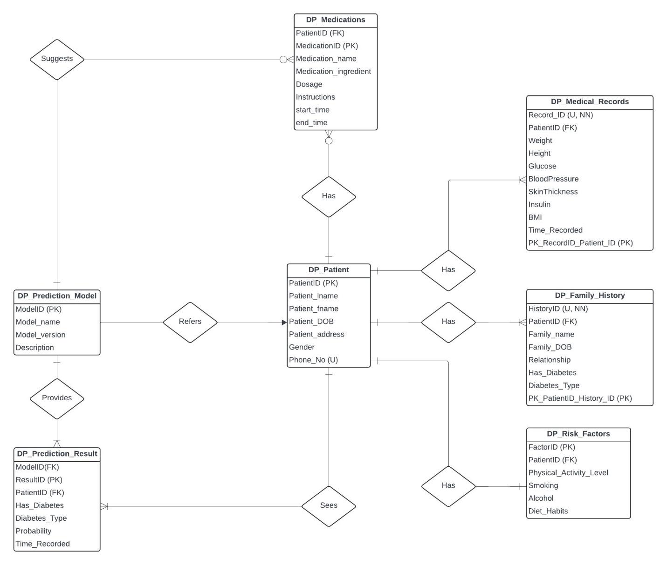

# Database Tables

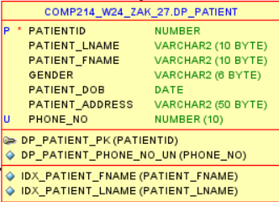

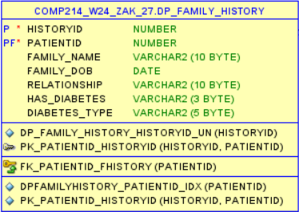

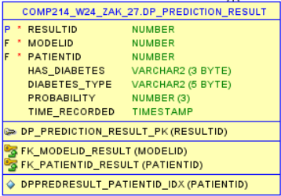

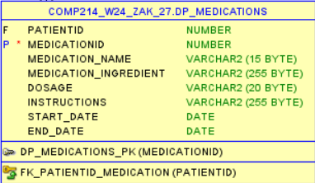

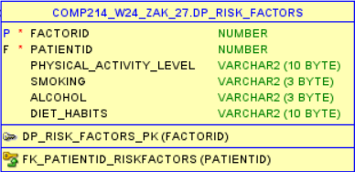

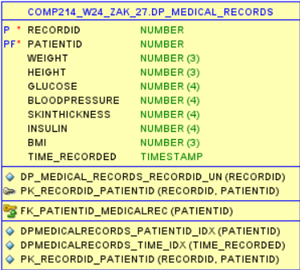

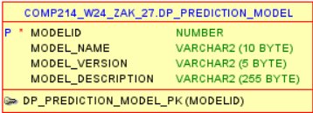

# SQL Commands

## Create tables

CREATE TABLE DP_PATIENT(

PatientID NUMBER PRIMARY KEY,

Patient_lname VARCHAR2(10),

Patient_fname VARCHAR2(10),

Gender VARCHAR2(6),

Patient_DOB DATE,

Patient_address VARCHAR2(50),

Phone_No NUMBER(10) UNIQUE

);

CREATE TABLE DP_MEDICAL_RECORDS(

RecordID NUMBER UNIQUE NOT NULL,

PatientID NUMBER NOT NULL,

Weight NUMBER(3),

Height NUMBER(3),

Glucose NUMBER(4),

BloodPressure NUMBER(4),

SkinThickness NUMBER(4),

Insulin NUMBER(4),

BMI NUMBER(3),

Time_Recorded TIMESTAMP,

CONSTRAINT FK_PatientID_MedicalRec FOREIGN KEY (PatientID) REFERENCES DP_PATIENT(PatientID),

CONSTRAINT PK_RecordID_PatientID PRIMARY KEY (RecordID, PatientID)

);

CREATE TABLE DP_FAMILY_HISTORY(

HistoryID NUMBER UNIQUE NOT NULL,

PatientID NUMBER NOT NULL,

Family_name VARCHAR2(10),

Family_DOB DATE,

Relationship VARCHAR2(10),

Has_Diabetes VARCHAR2(3),

Diabetes_Type VARCHAR2(5),

CONSTRAINT FK_PatientID_FHistory FOREIGN KEY (PatientID) REFERENCES DP_PATIENT(PatientID),

CONSTRAINT PK_PatientID_HistoryID PRIMARY KEY (HistoryID, PatientID)

);

CREATE TABLE DP_RISK_FACTORS(

FactorID NUMBER PRIMARY KEY,

PatientID NUMBER NOT NULL,

Physical_Activity_Level VARCHAR2(10),

Smoking VARCHAR2(3),

Alcohol VARCHAR2(3),

Diet_Habits VARCHAR2(10),

CONSTRAINT FK_PatientID_RiskFactors FOREIGN KEY (PatientID) REFERENCES DP_PATIENT(PatientID)

);

CREATE TABLE DP_PREDICTION_MODEL(

ModelID NUMBER PRIMARY KEY,

Model_name VARCHAR2(10),

Model_version VARCHAR2(5),

Model_description VARCHAR2(255)

);

CREATE TABLE DP_PREDICTION_RESULT(

ResultID NUMBER PRIMARY KEY,

ModelID NUMBER NOT NULL,

PatientID NUMBER NOT NULL,

Has_Diabetes VARCHAR2(3),

Diabetes_Type VARCHAR2(5),

Probability NUMBER(3),

Time_Recorded TIMESTAMP,

CONSTRAINT FK_PatientID_Result FOREIGN KEY (PatientID) REFERENCES DP_PATIENT(PatientID),

CONSTRAINT FK_ModelID_Result FOREIGN KEY (ModelID) REFERENCES DP_PREDICTION_MODEL(ModelID)

);

CREATE TABLE DP_MEDICATIONS(

PatientID NUMBER,

MedicationID NUMBER PRIMARY KEY,

Medication_name VARCHAR2(15),

Medication_ingredient VARCHAR2(255),

Dosage VARCHAR2(20),

Instructions VARCHAR2(255),

Start_Date DATE,

End_Date DATE,

CONSTRAINT FK_PatientID_Medication FOREIGN KEY (PatientID) REFERENCES DP_PATIENT(PatientID)

);

## Create sequences

CREATE SEQUENCE DP_PATIENT_PATIENTID_SEQ

START WITH 1

INCREMENT BY 1

NOCACHE

NOCYCLE;

CREATE SEQUENCE DP_MEDICAL_RECORDS_SEQ

START WITH 100

INCREMENT BY 1

NOCACHE

NOCYCLE;

CREATE SEQUENCE DP_PREDICTION_RESULT_SEQ

START WITH 900

INCREMENT BY 1

NOCACHE

NOCYCLE;

-- Apply to tables

ALTER TABLE DP_PATIENT

MODIFY PatientID DEFAULT DP_PATIENT_PATIENTID_SEQ.NEXTVAL;

ALTER TABLE DP_MEDICAL_RECORDS

MODIFY RecordID DEFAULT DP_MEDICAL_RECORDS_SEQ.NEXTVAL;

ALTER TABLE DP_PREDICTION_RESULT

MODIFY RecordID DEFAULT DP_PREDICTION_RESULT_SEQ.NEXTVAL;

## Create indexes

--DP_PATIENT table

CREATE INDEX idx_Patient_lname ON DP_PATIENT(Patient_lname);

CREATE INDEX idx_Patient_fname ON DP_PATIENT(Patient_fname);

--DP_MEDICAL_RECORDS table

CREATE INDEX dpmedicalrecords_patientid_idx ON DP_MEDICAL_RECORDS(PatientID);

CREATE INDEX dpmedicalrecords_time_idx ON DP_MEDICAL_RECORDS(Time_Recorded);

--DP_FAMILY_HISTORY table

CREATE INDEX dpfamilyhistory_patientid_idx ON DP_FAMILY_HISTORY(PatientID);

--DP_PREDICTION_RESULT table

CREATE INDEX dppredresult_patientid_idx ON DP_PREDICTION_RESULT(PatientID);

## Create triggers

CREATE OR REPLACE TRIGGER TRIGGER_ON_BMI_TIME_RECORDED

BEFORE INSERT OR UPDATE ON DP_MEDICAL_RECORDS

FOR EACH ROW

BEGIN

:NEW.BMI := FUNC_BMI_CAL(:NEW.WEIGHT, :NEW.HEIGHT);

IF :NEW.BMI = -1 THEN

RAISE_APPLICATION_ERROR(-20002, 'Invalid Input. Please check the weight and height');

END IF;

:NEW.Time_Recorded := SYSTIMESTAMP;

END;

/

CREATE OR REPLACE TRIGGER UPDATE_TIME_PREDICTION

BEFORE INSERT OR UPDATE ON DP_PREDICTION_RESULT

FOR EACH ROW

BEGIN

:NEW.Time_Recorded := SYSTIMESTAMP;

END;

/

CREATE OR REPLACE TRIGGER CHECK_DIABETES_CONDITION

BEFORE INSERT OR UPDATE ON DP_FAMILY_HISTORY

FOR EACH ROW

BEGIN

IF LOWER(:NEW.Has_Diabetes) = 'no' AND :NEW.Diabetes_Type IS NOT NULL THEN

RAISE_APPLICATION_ERROR(-20001, 'If Has_Diabetes is No, Diabetes_Type must be empty.');

END IF;

END;

/

## Insert records

-- DP_PATIENT

INSERT INTO DP_PATIENT(Patient_lname, Patient_fname, Patient_DOB, Patient_address, Gender, Phone_No) VALUES

('Smith', 'John', TO_DATE('1990-05-15', 'YYYY-MM-DD'), '123 Main St, Anytown, Canada', 'Male', 1234567890);

INSERT INTO DP_PATIENT(Patient_lname, Patient_fname, Patient_DOB, Patient_address, Gender, Phone_No) VALUES

('Johnson', 'Emily', TO_DATE('1985-09-22', 'YYYY-MM-DD'), '456 Elm St, Anycity, Canada', 'Female', 9876543210);

INSERT INTO DP_PATIENT(Patient_lname, Patient_fname, Patient_DOB, Patient_address, Gender, Phone_No) VALUES

('Williams', 'David', TO_DATE('1978-03-10', 'YYYY-MM-DD'), '789 Oak St, Anystate, Canada', 'Male', 1112223333);

INSERT INTO DP_PATIENT(Patient_lname, Patient_fname, Patient_DOB, Patient_address, Gender, Phone_No) VALUES

('Brown', 'Sarah', TO_DATE('1995-11-28', 'YYYY-MM-DD'), '321 Pine St, Anymetro, Canada', 'Female', 4445556666);

INSERT INTO DP_PATIENT(Patient_lname, Patient_fname, Patient_DOB, Patient_address, Gender, Phone_No) VALUES

('Jones', 'Michael', TO_DATE('1980-07-07', 'YYYY-MM-DD'), '555 Cedar St, Anysuburb, Canada', 'Male', 7778889999);

INSERT INTO DP_PATIENT(Patient_lname, Patient_fname, Patient_DOB, Patient_address, Gender, Phone_No) VALUES

('Garcia', 'Maria', TO_DATE('1972-12-03', 'YYYY-MM-DD'), '888 Maple St, Anyvillage, Canada', 'Female', 2223334444);

INSERT INTO DP_PATIENT(Patient_lname, Patient_fname, Patient_DOB, Patient_address, Gender, Phone_No) VALUES

('Martinez', 'Christ', TO_DATE('1992-02-18', 'YYYY-MM-DD'), '1010 Birch St, Anyhamlet, Canada', 'Male', 5556667777);

-- DP_PREDICTION_MODEL

INSERT INTO DP_PREDICTION_MODEL(ModelID, Model_name, Model_version, Model_description) VALUES

(1, 'KNN', '1.0', 'KNN is a machine learning algorithm used for classification and regression tasks.');

INSERT INTO DP_PREDICTION_MODEL(ModelID, Model_name, Model_version, Model_description) VALUES

(2, 'DT', '2.3', 'Decision Tree is a predictive modeling algorithm that maps observations about an item to conclusions about the items target value.');

INSERT INTO DP_PREDICTION_MODEL(ModelID, Model_name, Model_version, Model_description) VALUES

(3, 'RF', '1.5', 'Random Forest is an ensemble learning method for classification, regression, and other tasks that operates by constructing a multitude of decision trees.');

-- DP_FAMILY_HISTORY

INSERT INTO DP_FAMILY_HISTORY (HistoryID, PatientID, Family_name, Family_DOB, Relationship, Has_Diabetes, Diabetes_Type)

VALUES (1001, 1, 'Smith', TO_DATE('1970-05-15', 'YYYY-MM-DD'), 'Mother', 'Yes', 'Type2');

INSERT INTO DP_FAMILY_HISTORY (HistoryID, PatientID, Family_name, Family_DOB, Relationship, Has_Diabetes, Diabetes_Type)

VALUES (1002, 1, 'Smith', TO_DATE('1975-08-20', 'YYYY-MM-DD'), 'Father', 'No', NULL);

INSERT INTO DP_FAMILY_HISTORY (HistoryID, PatientID, Family_name, Family_DOB, Relationship, Has_Diabetes, Diabetes_Type)

VALUES (1003, 2, 'Johnson', TO_DATE('1965-03-10', 'YYYY-MM-DD'), 'Mother', 'Yes', 'Type1');

INSERT INTO DP_FAMILY_HISTORY (HistoryID, PatientID, Family_name, Family_DOB, Relationship, Has_Diabetes, Diabetes_Type)

VALUES (1004, 2, 'Johnson', TO_DATE('1968-11-25', 'YYYY-MM-DD'), 'Father', 'Yes', 'Type2');

INSERT INTO DP_FAMILY_HISTORY (HistoryID, PatientID, Family_name, Family_DOB, Relationship, Has_Diabetes, Diabetes_Type)

VALUES (1005, 3, 'Williams', TO_DATE('1982-07-03', 'YYYY-MM-DD'), 'Mother', 'No', NULL);

INSERT INTO DP_FAMILY_HISTORY (HistoryID, PatientID, Family_name, Family_DOB, Relationship, Has_Diabetes, Diabetes_Type)

VALUES (1006, 6, 'Garcia', TO_DATE('1978-09-12', 'YYYY-MM-DD'), 'Father', 'Yes', 'Type1');

INSERT INTO DP_FAMILY_HISTORY (HistoryID, PatientID, Family_name, Family_DOB, Relationship, Has_Diabetes, Diabetes_Type)

VALUES (1007, 4, 'Brown', TO_DATE('1955-12-28', 'YYYY-MM-DD'), 'Mother', 'No', NULL);

-- DP_RISK_FACTORS

INSERT INTO DP_RISK_FACTORS (FactorID, PatientID, Physical_Activity_Level, Smoking, Alcohol, Diet_Habits)

VALUES (2001, 1, 'Active', 'No', 'No', 'Balanced');

INSERT INTO DP_RISK_FACTORS (FactorID, PatientID, Physical_Activity_Level, Smoking, Alcohol, Diet_Habits)

VALUES (2002, 2, 'Sedentary', 'Yes', 'No', 'High Sugar');

INSERT INTO DP_RISK_FACTORS (FactorID, PatientID, Physical_Activity_Level, Smoking, Alcohol, Diet_Habits)

VALUES (2003, 3, 'Moderate', 'No', 'Yes', 'Low Fiber');

INSERT INTO DP_RISK_FACTORS (FactorID, PatientID, Physical_Activity_Level, Smoking, Alcohol, Diet_Habits)

VALUES (2004, 4, 'Active', 'No', 'No', 'Balanced');

INSERT INTO DP_RISK_FACTORS (FactorID, PatientID, Physical_Activity_Level, Smoking, Alcohol, Diet_Habits)

VALUES (2005, 5, 'Active', 'Yes', 'No', 'Low Carb');

INSERT INTO DP_RISK_FACTORS (FactorID, PatientID, Physical_Activity_Level, Smoking, Alcohol, Diet_Habits)

VALUES (2006, 6, 'Sedentary', 'Yes', 'Yes', 'High Fat');

INSERT INTO DP_RISK_FACTORS (FactorID, PatientID, Physical_Activity_Level, Smoking, Alcohol, Diet_Habits)

VALUES (2007, 7, 'Moderate', 'No', 'Yes', 'Balanced');

--DP_MEDICAL_RECORDS

INSERT INTO DP_MEDICAL_RECORDS (PatientID, Weight, Height, Glucose, BloodPressure, skinthickness, Insulin)

VALUES (1, 70, 1.80, 85, 66, 29, 0);

INSERT INTO DP_MEDICAL_RECORDS (PatientID, Weight, Height, Glucose, BloodPressure, skinthickness, Insulin)

VALUES (2, 100, 1.85, 149, 66, 0, 168);

INSERT INTO DP_MEDICAL_RECORDS (PatientID, Weight, Height, Glucose, BloodPressure, skinthickness, Insulin)

VALUES (3, 66, 1.70, 183, 72, 35, 0);

INSERT INTO DP_MEDICAL_RECORDS (PatientID, Weight, Height, Glucose, BloodPressure, skinthickness, Insulin)

VALUES (4, 50, 1.66, 137, 40, 32, 0);

INSERT INTO DP_MEDICAL_RECORDS (PatientID, Weight, Height, Glucose, BloodPressure, skinthickness, Insulin)

VALUES (5, 75, 1.73, 116, 70, 45, 88);

INSERT INTO DP_MEDICAL_RECORDS (PatientID, Weight, Height, Glucose, BloodPressure, skinthickness, Insulin)

VALUES (6, 85, 1.90, 197, 60, 0, 0);

INSERT INTO DP_MEDICAL_RECORDS (PatientID, Weight, Height, Glucose, BloodPressure, skinthickness, Insulin)

VALUES (7, 66, 1.65, 78, 50, 0, 543);

# PL/SQL Block codes

CREATE OR REPLACE PACKAGE DP_PACKAGE--header

AS

FUNCTION FUNC_BMI_CAL(

in_weight IN DP_MEDICAL_RECORDS.WEIGHT%TYPE,

in_height IN DP_MEDICAL_RECORDS.HEIGHT%TYPE)

RETURN NUMBER;

FUNCTION calc_age

(p_id in dp_patient.patientid%type)

return number;

PROCEDURE PROC_PREDICTION_RESULT (

p_ModelID IN DP_PREDICTION_MODEL.ModelID%TYPE,

p_Mec_RecID IN DP_MEDICAL_RECORDS.RecordID%TYPE);

PROCEDURE Add_Patient_Medication (

pro_PatientID IN DP_MEDICATIONS.PatientID%TYPE,

pro_MedicationName IN DP_MEDICATIONS.Medication_name%TYPE,

pro_MedicationIngredient IN DP_MEDICATIONS.Medication_ingredient%TYPE,

pro_Dosage IN DP_MEDICATIONS.Dosage%TYPE,

pro_Instructions IN DP_MEDICATIONS.Instructions%TYPE,

pro_StartDate IN DP_MEDICATIONS.Start_Date%TYPE,

pro_EndDate IN DP_MEDICATIONS.End_Date%TYPE);

PROCEDURE Calculate_Medical_Statistics (

pro_PatientID IN DP_PATIENT.PatientID%TYPE);

END;

/

CREATE OR REPLACE PACKAGE BODY DP_PACKAGE--BODY

AS

FUNCTION FUNC_BMI_CAL(

in_weight IN DP_MEDICAL_RECORDS.WEIGHT%TYPE,

in_height IN DP_MEDICAL_RECORDS.HEIGHT%TYPE)

RETURN NUMBER

IS

out_bmi DP_MEDICAL_RECORDS.BMI%TYPE;

BEGIN

IF in_weight IS NULL OR in_weight = 0 AND in_height IS NULL OR in_height = 0 THEN

out_bmi := -1;

raise_application_error(-20015,'Invalid input values');

END IF;

IF in_height > 3 THEN

out_bmi := -1;

raise_application_error(-20016,'Height must be in meter and smaller than 3');

ELSE

out_bmi := in_weight / POWER(in_height,2);

END IF;

RETURN out_bmi;

EXCEPTION

WHEN OTHERS THEN

DBMS_OUTPUT.PUT_LINE('Error occurred: ' || SQLERRM);

END FUNC_BMI_CAL;

function calc_age

(p_id in dp_patient.patientid%type)

return number is

dob dp_patient.patient_dob%type;

age number;

begin

select patient_dob into dob from dp_patient where patientid = p_id;

age := floor(months_between(sysdate, dob) / 12);

return age;

exception

when no_data_found then

return null;

when others then

return null;

end calc_age;

PROCEDURE PROC_PREDICTION_RESULT (

p_ModelID IN DP_PREDICTION_MODEL.ModelID%TYPE,

p_Mec_RecID IN DP_MEDICAL_RECORDS.RecordID%TYPE)

AS

v_PatientID DP_MEDICAL_RECORDS.PatientID%TYPE;

v_BMI DP_MEDICAL_RECORDS.BMI%TYPE;

v_Insulin DP_MEDICAL_RECORDS.Insulin%TYPE;

v_Has_Diabetes DP_PREDICTION_RESULT.Has_Diabetes%TYPE;

v_Diabetes_Type DP_PREDICTION_RESULT.Diabetes_Type%TYPE;

v_Probability DP_PREDICTION_RESULT.Probability%TYPE;

CURSOR c_medical_records IS

SELECT PatientID, BMI, Insulin

FROM DP_MEDICAL_RECORDS WHERE RecordID = p_Mec_RecID;

BEGIN

FOR medical_rec IN c_medical_records LOOP

v_PatientID := medical_rec.PatientID;

v_BMI := medical_rec.BMI;

v_Insulin := medical_rec.Insulin;

-- Just example

-- Replace this with the actual prediction logic in Python

IF v_BMI > 20 AND v_Insulin > 20 THEN

v_Has_Diabetes := 'Yes';

v_Diabetes_Type := 'Type2';

v_Probability := 0.85;

ELSE

v_Has_Diabetes := 'No';

v_Diabetes_Type := NULL;

v_Probability := 0.15;

END IF;

INSERT INTO DP_PREDICTION_RESULT (ModelID, PatientID, Has_Diabetes, Diabetes_Type, Probability)

VALUES (p_ModelID, v_PatientID, v_Has_Diabetes, v_Diabetes_Type, v_Probability);

END LOOP;

DBMS_OUTPUT.PUT_LINE('Prediction results inserted successfully.');

EXCEPTION

WHEN OTHERS THEN

DBMS_OUTPUT.PUT_LINE('Error: ' || SQLERRM);

END PROC_PREDICTION_RESULT;

PROCEDURE Add_Patient_Medication (

pro_PatientID IN DP_MEDICATIONS.PatientID%TYPE,

pro_MedicationName IN DP_MEDICATIONS.Medication_name%TYPE,

pro_MedicationIngredient IN DP_MEDICATIONS.Medication_ingredient%TYPE,

pro_Dosage IN DP_MEDICATIONS.Dosage%TYPE,

pro_Instructions IN DP_MEDICATIONS.Instructions%TYPE,

pro_StartDate IN DP_MEDICATIONS.Start_Date%TYPE,

pro_EndDate IN DP_MEDICATIONS.End_Date%TYPE)

AS

BEGIN

INSERT INTO DP_MEDICATIONS (

PatientID,

MedicationID,

Medication_name,

Medication_ingredient,

Dosage,

Instructions,

Start_Date,

End_Date

) VALUES (

pro_PatientID,

DP_MEDICAL_RECORDS_SEQ.NEXTVAL,

pro_MedicationName,

pro_MedicationIngredient,

pro_Dosage,

pro_Instructions,

pro_StartDate,

pro_EndDate

);

EXCEPTION

WHEN OTHERS THEN

-- Handle exceptions (e.g., invalid patient ID, constraint violations)

DBMS_OUTPUT.PUT_LINE('Error occurred: ' || SQLERRM);

END Add_Patient_Medication;

PROCEDURE Calculate_Medical_Statistics (

pro_PatientID IN DP_PATIENT.PatientID%TYPE)

AS

records NUMBER := 0;

avg_glucose NUMBER := 0;

max_bp NUMBER := 0;

min_skinthickness NUMBER := NULL;

totalinsulin NUMBER := 0;

p_lname DP_PATIENT.Patient_lname%TYPE;

p_fname DP_PATIENT.Patient_fname%TYPE;

has_db VARCHAR2(3);

dbtype VARCHAR2(5);

CURSOR medical_stats IS

SELECT

COUNT(*) AS total_records,

AVG(Glucose) AS average_glucose,

MAX(BloodPressure) AS max_blood_pressure,

MIN(SkinThickness) AS min_skin_thickness,

SUM(Insulin) AS total_insulin,

p.Patient_lname,

p.Patient_fname,

fh.Has_Diabetes,

fh.Diabetes_Type

FROM

DP_MEDICAL_RECORDS mr

JOIN

DP_PATIENT p ON mr.PatientID = p.PatientID

LEFT JOIN

DP_FAMILY_HISTORY fh ON p.PatientID = fh.PatientID

WHERE

mr.PatientID = pro_PatientID

GROUP BY

p.PatientID, p.Patient_lname, p.Patient_fname, fh.Has_Diabetes, fh.Diabetes_Type;

BEGIN

-- Open cursor and fetch values into variables

OPEN medical_stats;

FETCH medical_stats INTO

records,

avg_glucose,

max_bp,

min_skinthickness,

totalinsulin,

p_lname,

p_fname,

has_db,

dbtype;

CLOSE medical_stats;

-- Display statistics

DBMS_OUTPUT.PUT_LINE('Displaying statistics for patient: ' || p_fname || ' ' || p_lname);

DBMS_OUTPUT.PUT_LINE('Total Medical Records: ' || records);

DBMS_OUTPUT.PUT_LINE('Average Glucose Level: ' || avg_glucose);

DBMS_OUTPUT.PUT_LINE('Maximum Blood Pressure: ' || max_bp);

DBMS_OUTPUT.PUT_LINE('Minimum Skin Thickness: ' || min_skinthickness);

DBMS_OUTPUT.PUT_LINE('Total Insulin Administered: ' || totalinsulin);

IF has_db = 'Yes' THEN

DBMS_OUTPUT.PUT_LINE('Patient has diabetes');

DBMS_OUTPUT.PUT_LINE('Diabetes Type: ' || dbtype);

ELSE

DBMS_OUTPUT.PUT_LINE('Patient does not have diabetes');

END IF;

EXCEPTION

WHEN NO_DATA_FOUND THEN

DBMS_OUTPUT.PUT_LINE('No medical records found for the specified patient.');

WHEN OTHERS THEN

DBMS_OUTPUT.PUT_LINE('Error occurred: ' || SQLERRM);

END Calculate_Medical_Statistics;

END;

/

# Screenshot of the output

