User Manual
CIS 434
Verlaunte D Hawkins
[Year]
Introduction 2
1.1 overview 2
1.2 Key Features 2
2. Hero element: 3
2.a avatar 3
2.b aboutMe 4
2. Social media links 5
a. Icons that link to the targets to different media sites that the portfolio site user has an account for (Github, Twitter, and Instagram). 5
3. My Projects 5
2.a: 6
2.b: 6
2.c: 6
4. Contact Me 6
Getting Started 7
2.1 Cautions & warning 7
1. Using the Site 7
2.a Navigation menu 7
a. Links (opens window in a separate tab of the owner, from left to right) 8
a. Github: Links to website owners github repository 8
4.b: view my work 8
4.c: contact me 9

Introduction
verlauntehawkins.vercel.app is a personal website made by verlaunte Hawkins that serves as a visual repository for completed projects and serves as a nice-looking site that can be further built on. The website is able a responsive website capable of being navigated through by computer or mobile device. The website also serves to get a little familiar with the person’s hobby an interest.

  - overview
This personal website is a single page vertical scroll webize with eache section being its own “card” that contains objects that are fixed in place, the user can navigate through the website by scrolling up and down the page or by clicking on the projects and contact text in the navigation bar

Tools used:
- frontend: html, css, javascript
- frameworks: React
- IDE: visual studio code
- Runtime environment: Nodejs
- React libraries: framer-motion, useStates
- APIs: Emailjs

  - Key Features

- Navigation bar/header
The header element at the top of the website that serves as a navigator for the page and any future additions to the page
1.b
1.a
1.a Portfolio: This element just dictates the purpose for the site, the website usage is to serve as a portfolio, a visual representation of the code and any other artistic objects related to the project.
1.b card links: This element in the nav menu are strings that link to their respective card elements

2. Hero element:
The main body and home menu of the website, exist to serve as a hello page showing token illustration for 2.a and an about me element to the right in 2.b
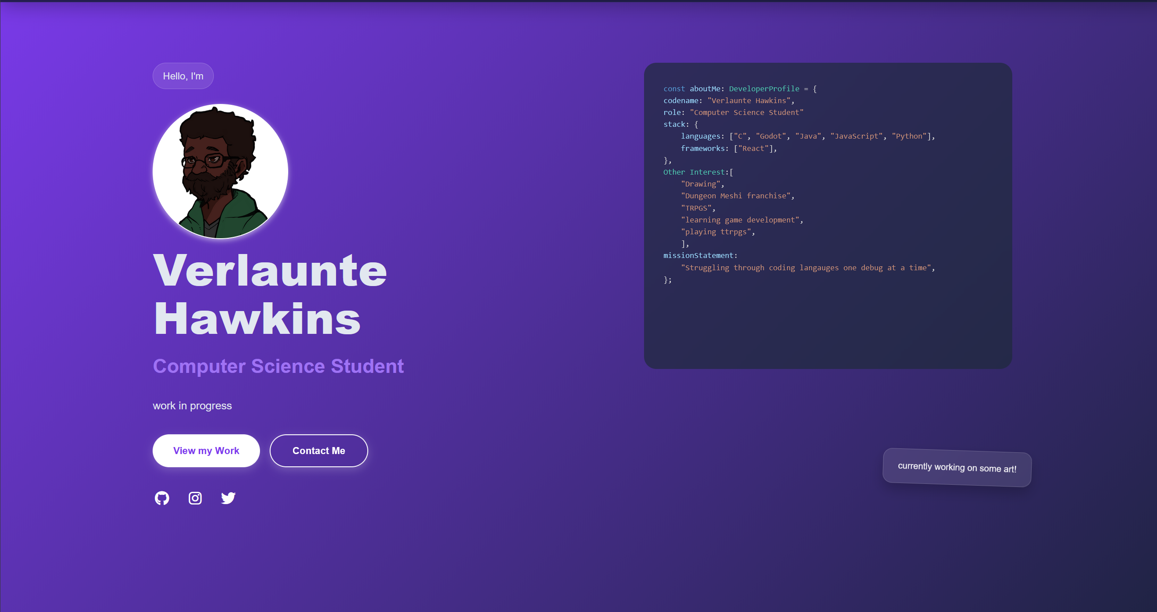

2.a avatar
Circular avatar token that can be either an avatar or logo that represents the user or a profile picture of the website owner , if that is preferred


2.b aboutMe
Container element that list some about me/ personal interest, such as proficiency in languages, hobbies and other interest.
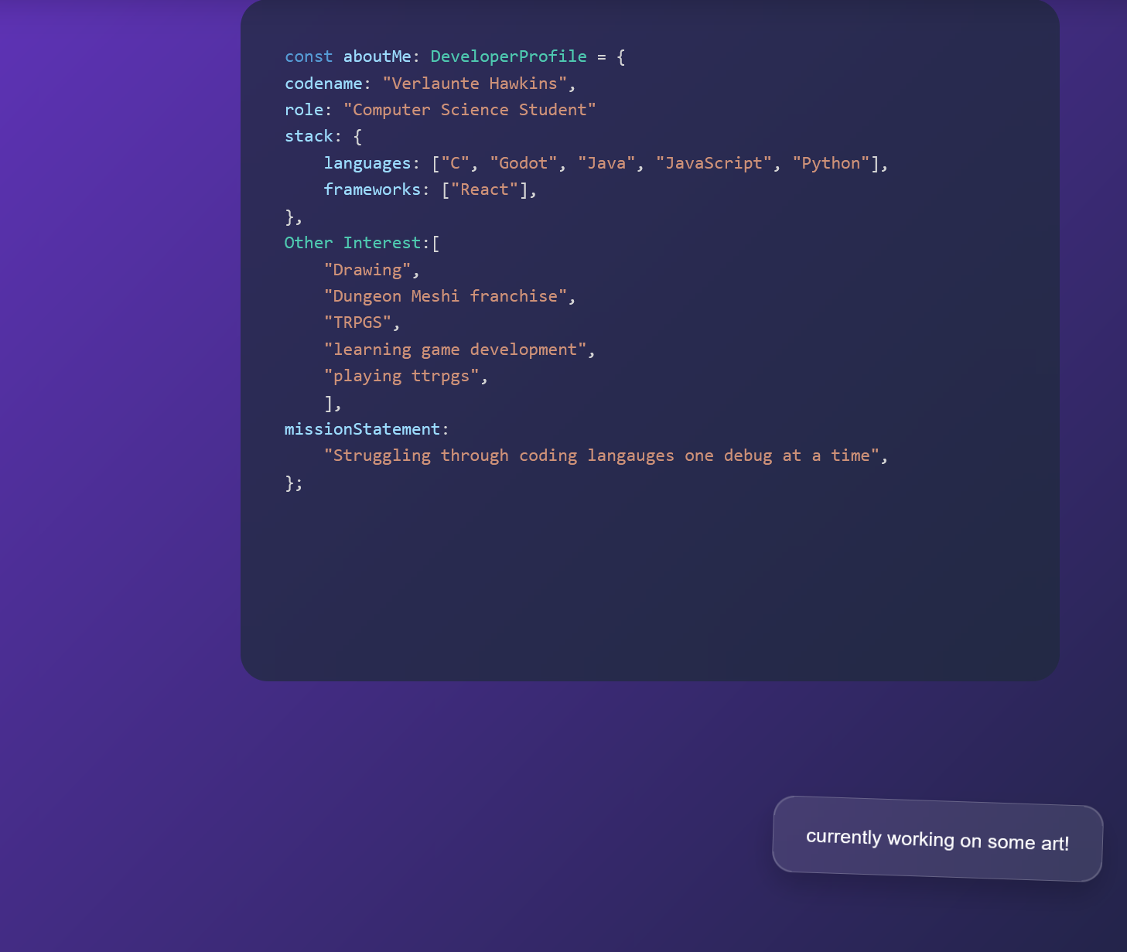
- Social media links
  - Icons that link to the targets to different media sites that the portfolio site user has an account for (Github, Twitter, and Instagram).


- My Projects
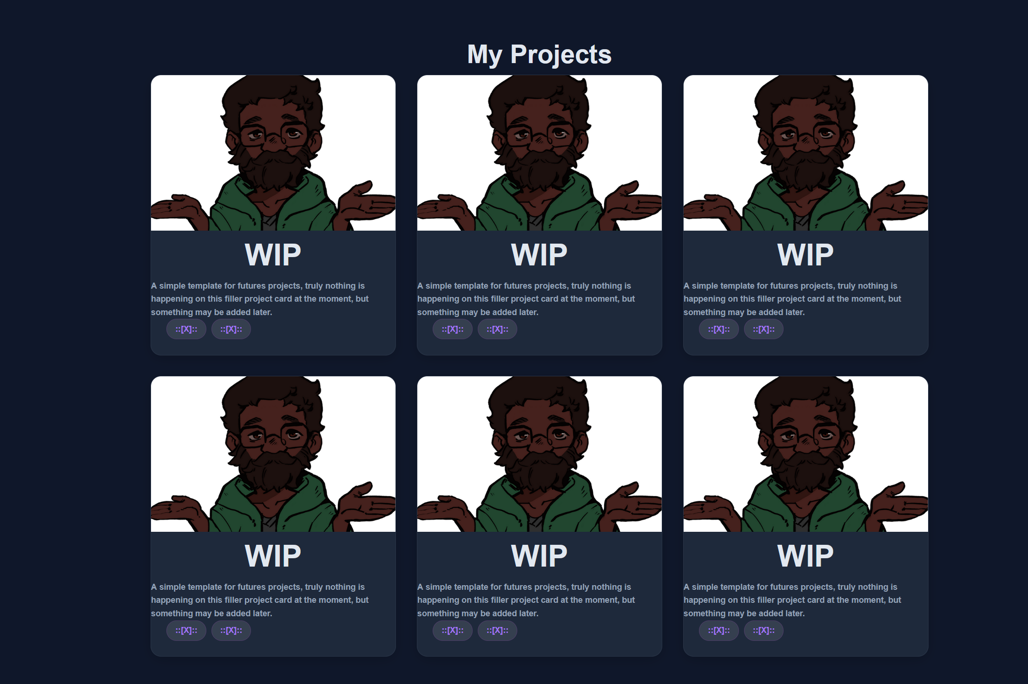
2.c
2.b
2.a

2.a:
Gallery picture that shows a visual image of the project

2.b:
Brief description of the project.

2.c:
List of Coding Languages used
- Contact Me
4.a: Visitor of website enters their name
4.b: Vistor enters their email address
4.c: visitor enters a comment they want sent to the website owner

Getting Started

2.1 Cautions & warning
The navigation bar is in a fixed position so navigating to other sections of the website has to be done manually.
Contact me page will not notify user if invalid email is entered so be careful

- Using the Site


2.a Navigation menu
Clickable options are home, projects, and contact. These options will shite the website down vertical till project card or contact card is in complete view on the viewport. Users will then have to scroll up and down to view the other cards after the navigation bar is not on the viewport screen.

4.a Hero card
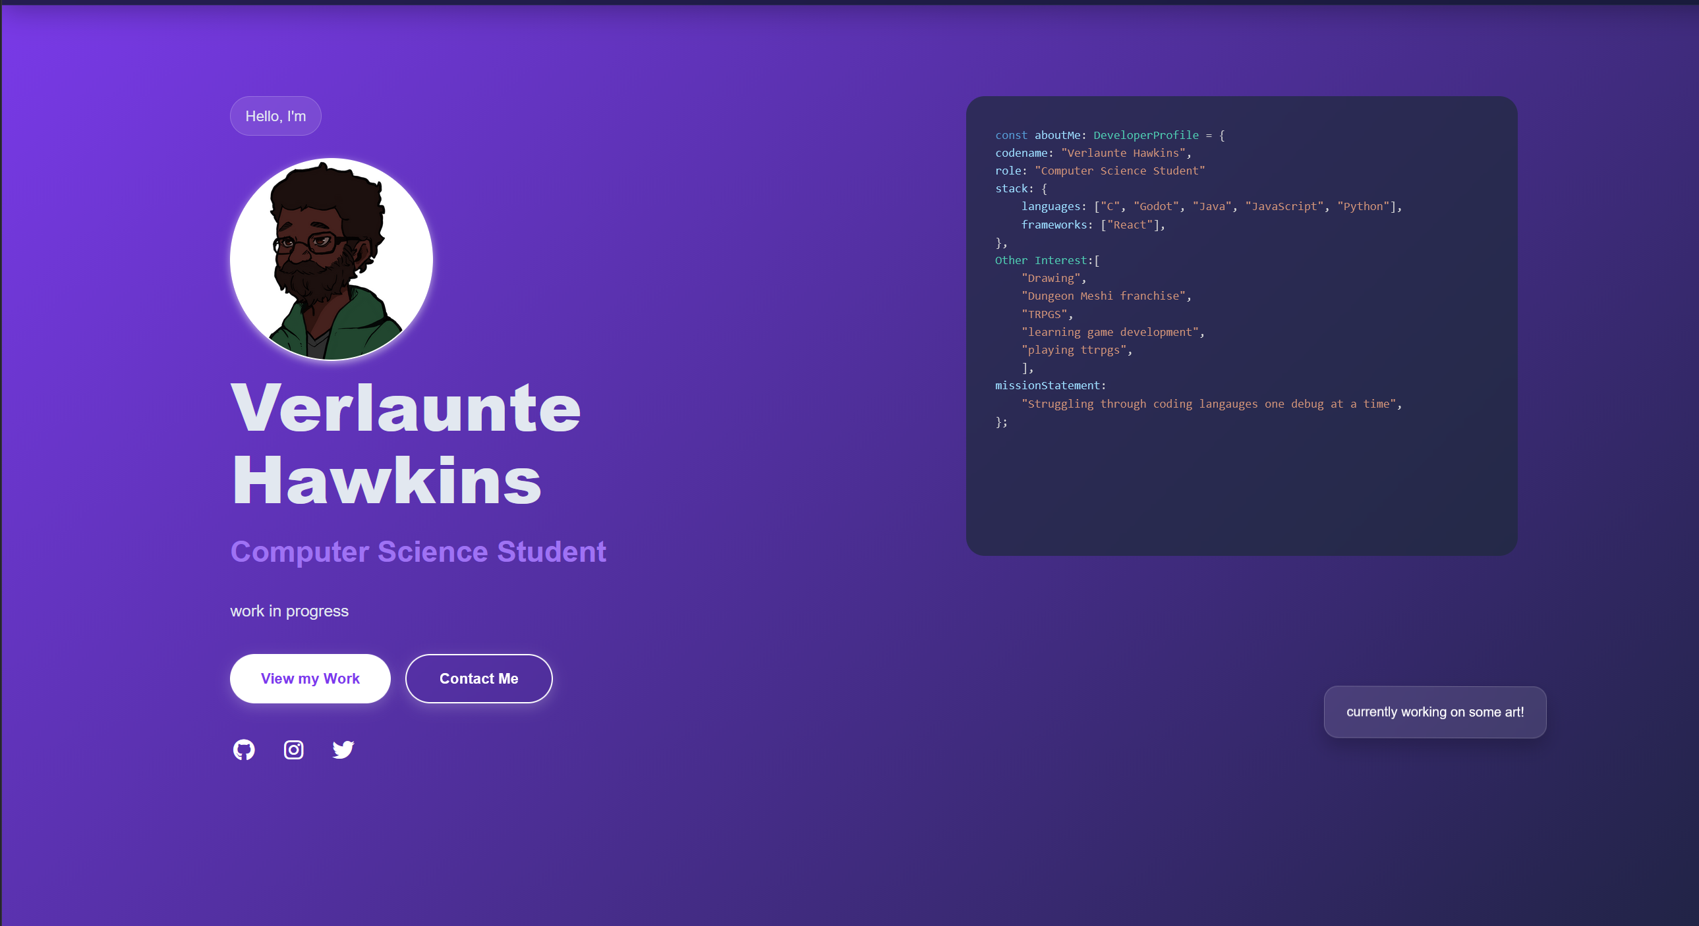
This card hold the about me info of the website. The hero card has 5 clickable items that link to either another card on the website or a different social media account owned by the website owner.
- Links (opens window in a separate tab of the owner, from left to right)

  - Github: Links to website owners github repository
  - Instagram: Links to user’s Instagram profile
  - twitter: Links to user’s twitter program

4.b: view my work
- This button links the user to the projects card tab when clicked
- The gallery of the projects menu are animated to translate up y direction on the hover and outline in a purple border to indicate selection.
- Gallery is shown as a column of 3 elements on a labtop/ desktop and a column of 2 elements on a mobile device viewport

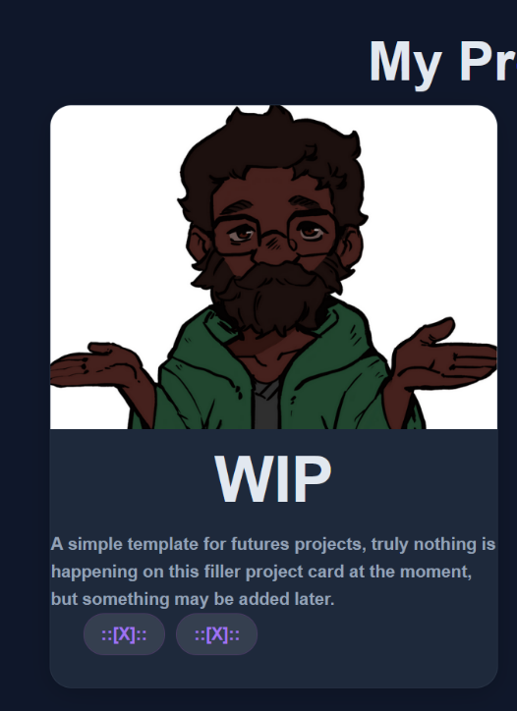
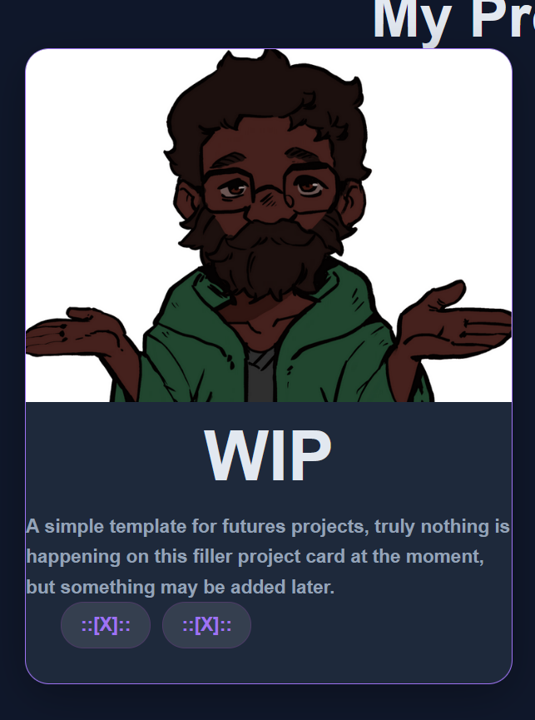

4.c: contact me
This button leads to the contact card which is a form that the viewer will fill out
to email the website owner an email with a message. If the message is successfully sent, a green box showing “message sent successfully” will be shown at the bottom of the contact form, otherwise a red box will be shown.

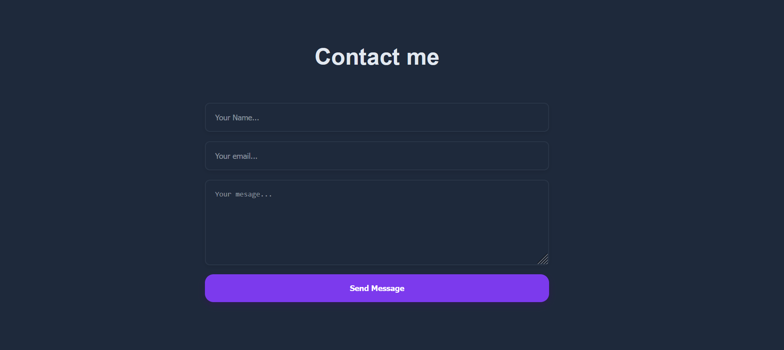

#Warning-> contact me page will not notify user if email is invalid, so be careful with using the contact me page

