# More Readers in More Places: The benefits of open access for scholarly books

Alkim Ozaygen, Lucy Montgomery, Cameron Neylon, Chun-Kai (Karl) Huang, + Springer team

Centre for Culture and Technology, School of Media, Creative Arts and Social Inquiry, Curtin University, Bentley 6102, Western Australia Springer Nature team affiliation…

## Abstract

Open access to scholarly contents has grown substantially in recent years. This includes the number of books published open access online. However, there is limited study on how usage patterns (via downloads, citations and web visibility) of these books may differ from their closed counterparts. Such information is not only important for book publishers, but also for researchers in disciplines where books are the norm. This article reports on findings from comparing samples of books published by Springer Nature to shed light on differences in usage patterns across open access and closed books. The study includes a selection of 281 281 open access books and a sample of 3653 3,653 closed books (drawn from 21,059 closed books using stratified random sampling). The books are stratified by combinations of book type, discipline and year of publication to enable likewise comparisons within each stratum and to maximise statistical power of the sample. The results show higher geographic diversity of usage, higher numbers of downloads and more citations for open access books across all strata. Importantly, open access books have increased access and usage for traditionally under-served populations.

*Keywords:* open access, books, Springer Nature, usage pattern, download, citation.

## Introduction

Open access (OA) to scholarly outputs has taken the central stage in recent years, with numerous international, regional and local initiatives leading the way in advancing rapid changes to the publishing landscape. Yet, despite the high volume of research available on journal articles (and academic outputs in general), relatively little has focused on OA books. In particular, there is limited information on the level of online usage, their geographic distribution and, importantly, how usage may be influenced by publishing books in OA forms.

There are numerous potential proxies for measuring the usage of scholarly work. These include citations, downloads, website visits, social media mentions and their various forms. Through a randomised controlled trial, Davis, Simon & Connolly (2008) is able to show that OA articles have higher numbers of downloads and more unique web page visitors than non-OA articles. Wang et al. (2015) further finds that the increased level of downloads for OA articles is sustained over time. This is found in addition to OA articles attracting more social media attention. However, research also found the OA advantage of altmetric activities to have significant differences across disciplines. The citation advantage of OA publishing remains a hotly debated issue. Although, a recent literature review shows there is relatively more research in support of the OA advantage, with the caveat that there may be a large variability across disciplines.

Most of the above findings have a strong focus on journal articles. Yet, it remains unclear whether these results can be generalised to books. In particular, there are significant differences between journal articles and books in terms of how they are hosted, shared and used online, and how they can be identified and tracked. These make the integration of usage data for books a challenging task. Counting Online Usage of Networked Electronic Resources (COUNTER) is an international effort to overcome some of these problems. It is a code of practice for compiling online usage statistics of electronic resources. Benchmarking book usage levels is another important aspect to consider. Books with different attributes (such as different languages and research fields) can have vastly different target audiences. Hence, the ability to compare books with similar attributes is essential for deep understandings of book usage.

There is a limited amount of previous work comparing downloads of OA and non-OA books with the goal of understanding the impacts of OA on the geographies of usage. The work of Snjider (2013) showed increased usage for OA books as well as some evidence of an increase in sales. Using a sample of 180 books Snijder (2013) showed that OA led to increased proportions of usage in developing countries as well as demonstrating a “digital divide” in discovery and use.

This article, which extends the findings of Snijder (2013), provides a timely update to evidence-based arguments for the benefits of OA to scholarly books. Our analysis of a larger sample allows us to investigate these effects, particularly the geographic effects, in much greater detail. Using books available from a common source (i.e., Springer Nature) also alleviate some of the challenges discussed above. Having download data by month and various disciplines for all books allows us to confirm that downloads are higher for OA books across their whole history and across all disciplines. We also update analysis on the effects of OA across downloads, citations, and web visibility for a single large sample, following on the work undertaken by Springer Nature in 2017.

## Main findings

This article reports on the analysis of usage (with downloads, citations and web visibility as proxies) and related indicators for a sample of books that is stratified by mixtures of book type, discipline and year of publication. In particular, the analysis considers the geographic usage of OA and non-OA books, examining whether OA facilitates the takeup of books by countries or regions that are traditionally underrepresented in the production and use of scholarly content.

To the best of our knowledge, this is the largest independent analysis ever conducted on the usage of OA and non-OA books. The sample size and sampling procedure allow us to be significantly more confident that there are substantial effects connecting OA status with downloads and citations for this set of books.

The main findings of our analysis are: * OA books as a group show a higher geographic diversity of usage and reach more countries, i.e., they have a greater proportion of usage in a wider range of countries. * OA books have increased access and usage for under-served populations and low or middle income countries, including a high number of countries from Africa. * OA books as a group have 10 10 times more downloads than non-OA books and 2.0 2.4 times more citations overall. * There is higher (at least 2.7-fold) usage (via downloads) of OA books across every stratum in our sample. That is for every type of book, every discipline, and each of the three years of publication in the sample, OA books show more usage than their non-OA comparison groups. This holds for every month after publication and for alternate categories such as imprints. * Books that contain the name of a country or region in their title generally show enhanced usage in that country or region. This effect is clearest for Latin America and Africa and is greater for OA titles. * Anonymous downloads are generally around double that of logged downloads. This means reporting that relies on institutional identification will be substantially undercounting the usage of OA books.

These findings are important for stakeholders by providing a robust understanding of the benefits of publishing books in OA forms. They give support to evidence-based publishing and marketing strategies for publishers. They also equip authors with enhanced knowledge for making decisions about publishing venues, formats and titles, etc. It is our hope that these findings will facilitate the advancement towards a greater diversity of readership and accessibility.

## Data and methodology

Springer Nature provided a set of 281 English-language OA titles published by its various imprints (e.g. Palgrave Macmillan, Springer, Birkhäuser) in 2015, 2016 and 2017. The titles were divided into three book types (“monographs”, “contributed volumes” and “briefs”); as well as five discipline clusters: “humanities”, “social sciences”, “business and economics”, “medical, biomedical and life sciences” and “physical sciences, engineering, mathematics and computer science”. Springer Nature also provided access to metadata relating to an additional 21,059 non-OA titles for the purposes of the study. Of the 21,059 non-OA books, a comparison set of 3653 3,653 non-OA books was selected for closer analysis. The non-OA books were selected using a stratified random sampling procedure (stratified across combinations of book type, discipline cluster and year of publication) aimed at maximising statistical power of the sample and maintaining a consistent ratio of OA to non-OA books in each stratum.

There are three primary metrics that are of interest to this study; namely downloads, citations and web visibility. The first two of these are supplied by Springer Nature. The Springer Nature downloads data includes country information for logged access (known institutional subscriber to Springer Nature). This is supplemented with the use of the IP2Location database to determine country locations of anonymous downloads. Web visibility is determined through analysis performed by a webometrics tool. In particular, we analyse URLs mentioning each book to extract information such as the number of unique domain names that references the book and country of the domain name.

We compare the average number of downloads, citations and unique domains, as well as the average downloads over time, between OA and non-OA books across different book types and discipline clusters. The geographic distributions of downloads across countries are visualised and are compared using the Gini coefficient. Further details of the data and methodology are provided in the Appendix.

The article focuses on four key questions: * Do OA books and non-OA books show different patterns of geographic usage? * Is there evidence of wider usage particularly from countries and areas that are not high users of non-OA books? * Does such performance vary, depending on the form (e.g. monograph, Brief, contributed volume) of the book, its disciplinary area or its imprint? * Is there robust evidence that OA books out-perform non-OA books on various proxy measures of usage?

## Analysis and discussion

### Open access books show more overall usage

In the first instance, we compare the average number of downloads, citations and unique domains (referencing the books) across OA and non-OA books as two groups. We also draw parallel comparisons of the two groups across book types and discipline clusters. These are summarised in Figure 1.

OA books as a group have on average 1010 times more downloads than non-OA books (first pair of bars in the top panel). There are also 2.0 2.4 times more citations for OA books. To a lesser extent (proportionally), there is also on average a higher number of unique web domains referencing OA titles. Higher levels of usage (via all three proxies) for OA books are also observed across each of the groups by book type and discipline cluster. It can be seen that the magnitudes of difference for each metric across OA and non-OA books vary across the different groups. For example, the difference between downloads of OA books and non-OA books seems to be amplified for the biomedical sciences. However, there is a consistent pattern across the different groups that OA books are seeing more usage.

The number of citations is a useful proxy of academic usage, while web visibility provides insight into how the books are being used on the web: either as linked text or references. These are additional proxies of usage to the number of downloads for books. The presence of higher levels of usage signalled by all three proxies suggest that OA books are not only being downloaded more often than their non-OA counterparts, but are also being read, used, referenced and attracting attention in different ways. This strengthens the case for a usage effect that is related to OA specifically.

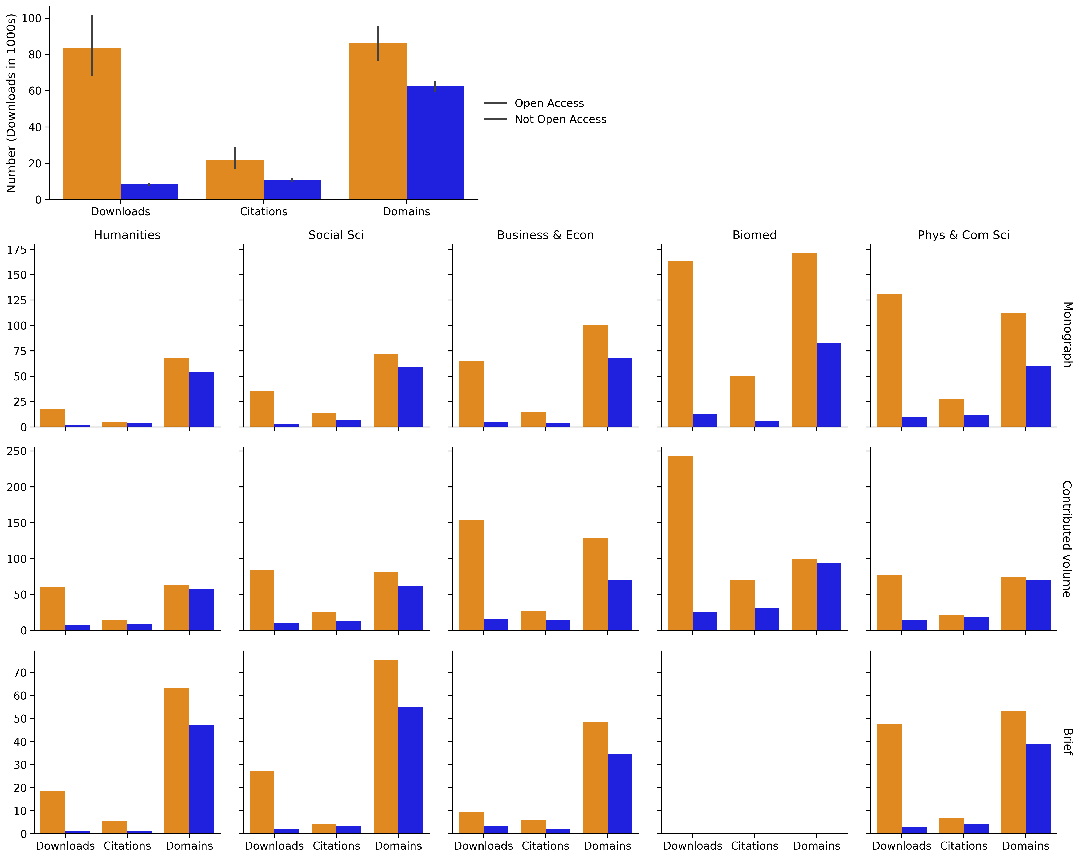

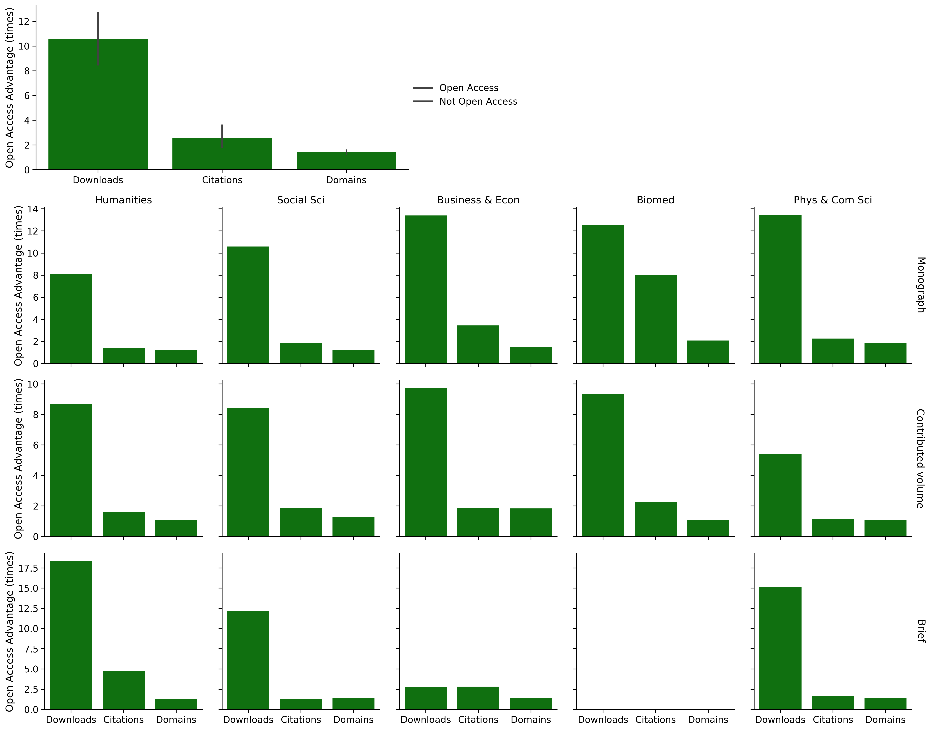

*Figure 1: Open access books show more usage and attention through average numbers of downloads, citations and web domains.* The top panel compares average numbers of downloads, citations and web visibility across all OA books and all non-OA books in our sample. Download numbers are provided in 1000s and vertical lines are the 95% confidence interval for each metric. Parallel comparison across book types and discipline clusters are given in the subsequent panels. There are no OA books in the brief category for biomedical sciences.

### Open access books show more usage over time

We are also interested in comparing the download levels over the lifetimes of the books. Using the times recorded for downloads and the publication dates of each book, we are able to provide the time series of downloads per month over 40 months from the date of publication. These are summarised in Figure 2, showing overall trends comparing all OA to all non-OA books in the corpus, and for each variation of book type and discipline cluster.

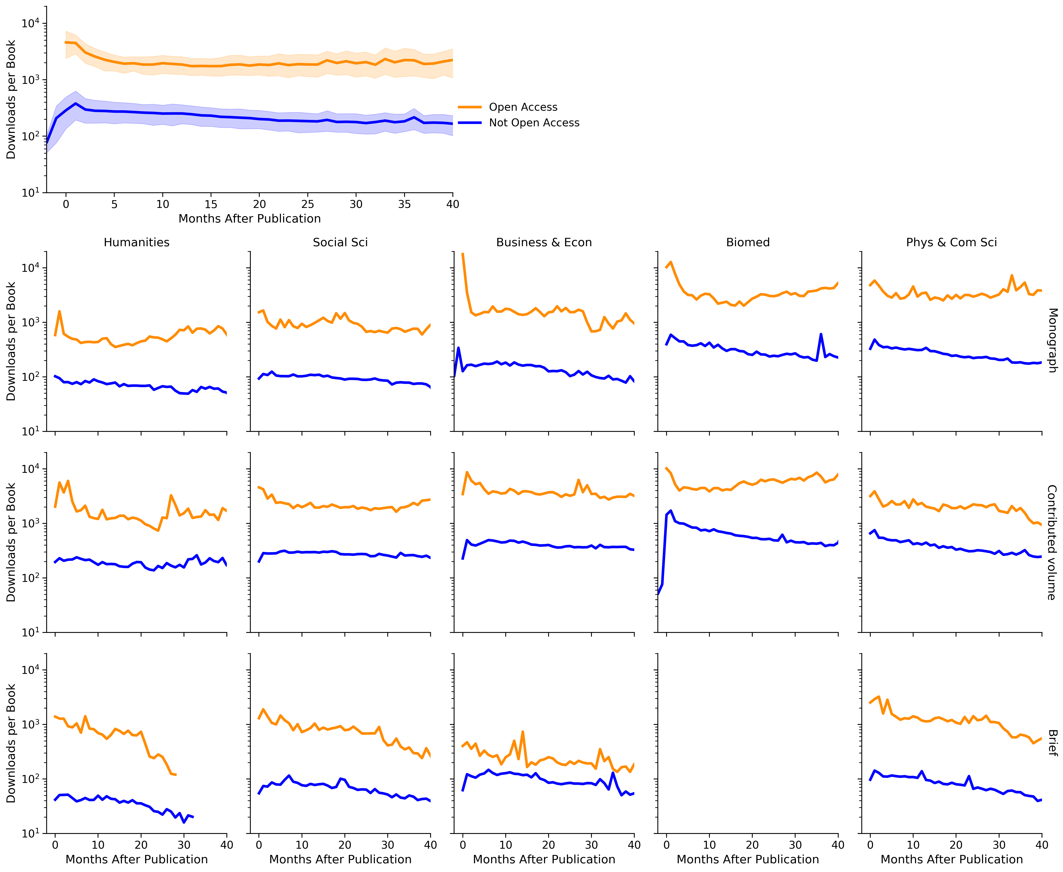

*Figure 2: Open access books depicts more downloads per book for every month since date of publication.* The number of downloads are displayed in log-scale, meaning the magnitude of differences are even greater then shown. The 95% confidence bands for downloads are shown in the top panel, which compares downloads over time for all books in the sample. Some books have usage data from prior to the official release date so show usage prior to zero months.

The top panel shows clear evidence of OA books having an advantage in the number of downloads over time. For all 40 months in the analysis, OA books have recorded significantly more downloads than their non-OA counterparts. That is, not only do OA books have a higher number of downloads to begin with, this effect is also persistent over time.

This general pattern carries over to subsets of books by book type and discipline clusters. Again, there are variations across groups but persistently higher downloads for OA books. It is also interesting to note that many groups of OA books seem to enjoy a more impactful starting point (noting the sudden shock of downloads at time zero with log-scale number of downloads displayed in many of the panels in Figure 2).

### Open access books show usage in a wider range of countries

By analysing the geolocation of downloads, we are able to provide comparisons of book usage across countries. For each book, we record the number of downloads from each country. Subsequently, we can calculate the number of downloads per book for any specific country. We do this for the set of all OA books included in our study and for the non-OA books. The results are visualised in Figure 3.

Evidently the usage (via downloads) of both non-OA and OA books is international and spans the globe. Usage of non-OA books is identified in 118 countries. In contrast, usage of OA books is identified in 201 countries. For both OA and non-OA books the highest levels of usage are seen in the USA, UK, Germany and mainland China. With only a few exceptions, OA books see higher levels of usage across the globe. There is also evidence that OA books see more average downloads from some African and Latin American countries that otherwise had very little access to non-OA titles.

An important aspect to consider is the role of population size in the geographical patterns of usage. One challenge with the analysis of academic usage is to identify a good proxy of “academic population size”. Examples of this include normalisation by the country’s number of people in tertiary education, overall academic output size and total number of citations. We provide one such example through normalising the downloads by total number of publications (see Appendix for details on this data). This is visualised in Figure S1 of the Appendix..

While total publication size may not be a perfect proxy for all potential academic usages of the books, this normalisation suggests that “usage per academic work” for both OA and non-OA books is fairly consistent across North America and North Western Europe (as well as mainland China, South Africa and Australia). Focusing on other geographical regions, and consistent with the overall download counts (see Figure S1), Egypt emerges as a heavy user of non-OA content relative to overall academic outputs, along with Uruguay, Ethiopia and Uzbekistan. Relatively heavy users of OA content relative to academic output size include Somalia, Afghanistan, Bhutan, Niger and South Sudan.

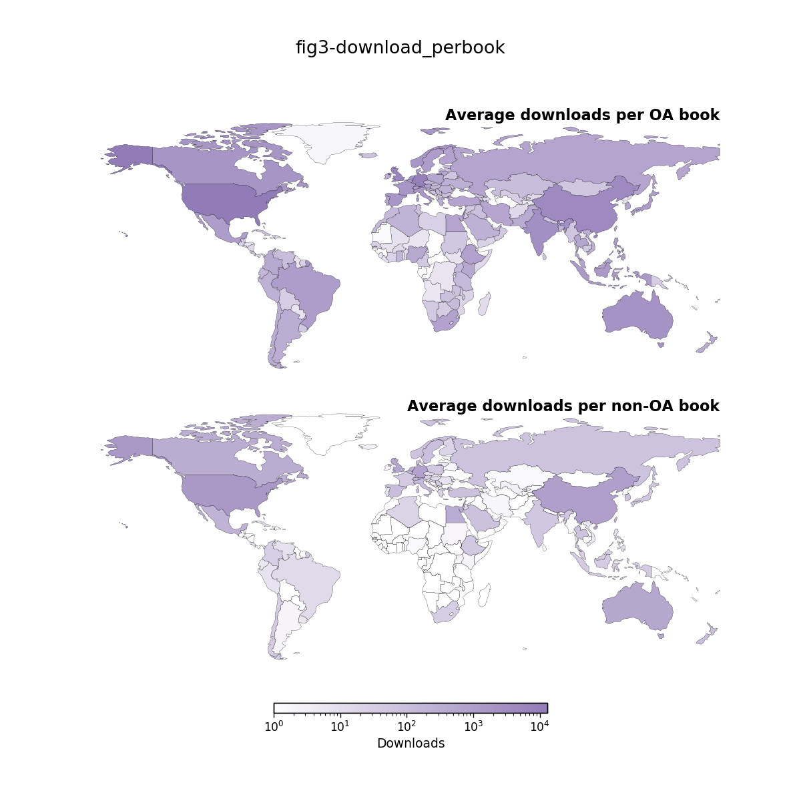

*Figure 3: The geographic distribution of downloads for OA and non-OA books.* Average usage by country across the whole corpus for OA (top) and non-OA (bottom) books. Several countries show a greater concentration of usage for OA books and these countries are predominantly in the southern hemisphere. Both maps are on the same colour scale (in log-scale).

### Open access books show increased usage for under-served populations and low to middle income countries

Overall, we find OA books having to reach more countries globally than non-OA books. Figure 3 also presented some evidence that OA books see improved usage for traditionally under-served countries and low to middle income countries. To explore this in more detail we focus on the anonymised downloads, which are solely attributed to OA books (as non-OA books can only be accessed if subscribed to, i.e., logged access). In particular, we can examine usage in countries that do not otherwise have access to Springer Nature books in digital formats. Usage of OA books was identified in 67 countries that recorded zero usage of the non-OA books in the data set. Of the 67 countries where only OA books recorded usage, 24 countries were from Africa. Usage of OA books from countries that do not otherwise purchase Springer Nature non-OA ebook titles totalled 145,353 downloads, representing 1% of the total anonymous usage of OA titles.

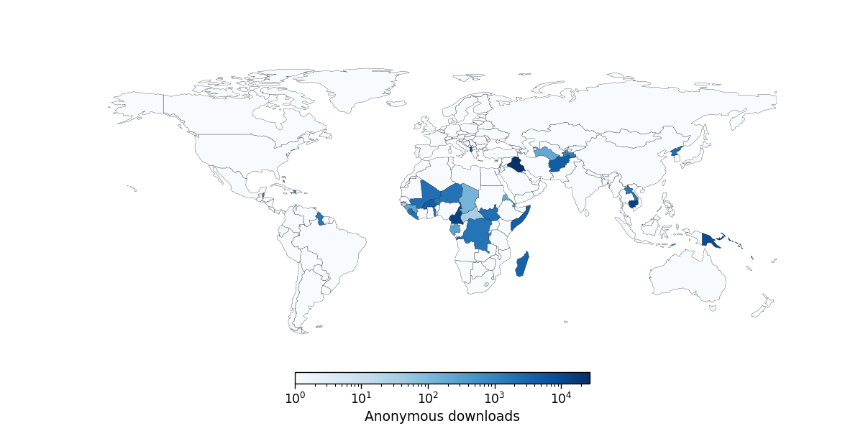

*Figure 4: Anonymous usage from countries with no logged usage.* A total of 67 countries with zero logged usage show anonymous usage with a total of 145,353 downloads representing 1% of the total anonymous usage. Of those countries, 24 were from Africa, with others mostly in the Middle East and southeast Asia. Countries with low GDP and development are significantly represented in this group.

### Open access books show higher diversity of usage

While we have provided evidence for wider usage of OA books (i.e., more countries download OA books), it is also important to understand the level of disparity amongst country usages. We can provide a more quantitative measure of this effect by examining a disparity index. That is, how much usage deviates from the situation where all countries show even usage. The Gini coefficient is a disparity index that is often used to define levels of income inequality. We can use the same calculation to measure inequalities in geographical usage and use this to compare OA and non-OA books. A lower Gini coefficient indicates more diverse usage. That is, lower inequality. The Gini coefficient is calculated for every book in our sample. Figure 5 shows a summary of these results for OA and non-OA books overall, and for different combinations of book type and discipline cluster.

For the overall corpus and for every individual category the usage by country is substantially more diverse for OA books. This form of analysis may be useful in identifying books that have significant potential to reach diverse geographic audiences. It might also be interesting to examine whether a low Gini coefficient for a non-OA book suggests potential for substantially enhanced usage if the book were converted to OA. It should be noted that there exist outliers amongst both OA and non-OA books in terms of their values in the Gini coefficient. In particular, there are exceptional books in both categories that may have broad interest (e.g., *A Theory of Philosophical Fallacies*) or narrow geographical focus (e.g., *A History of Male Psychological Disorders In Britain, 1945-1980*).

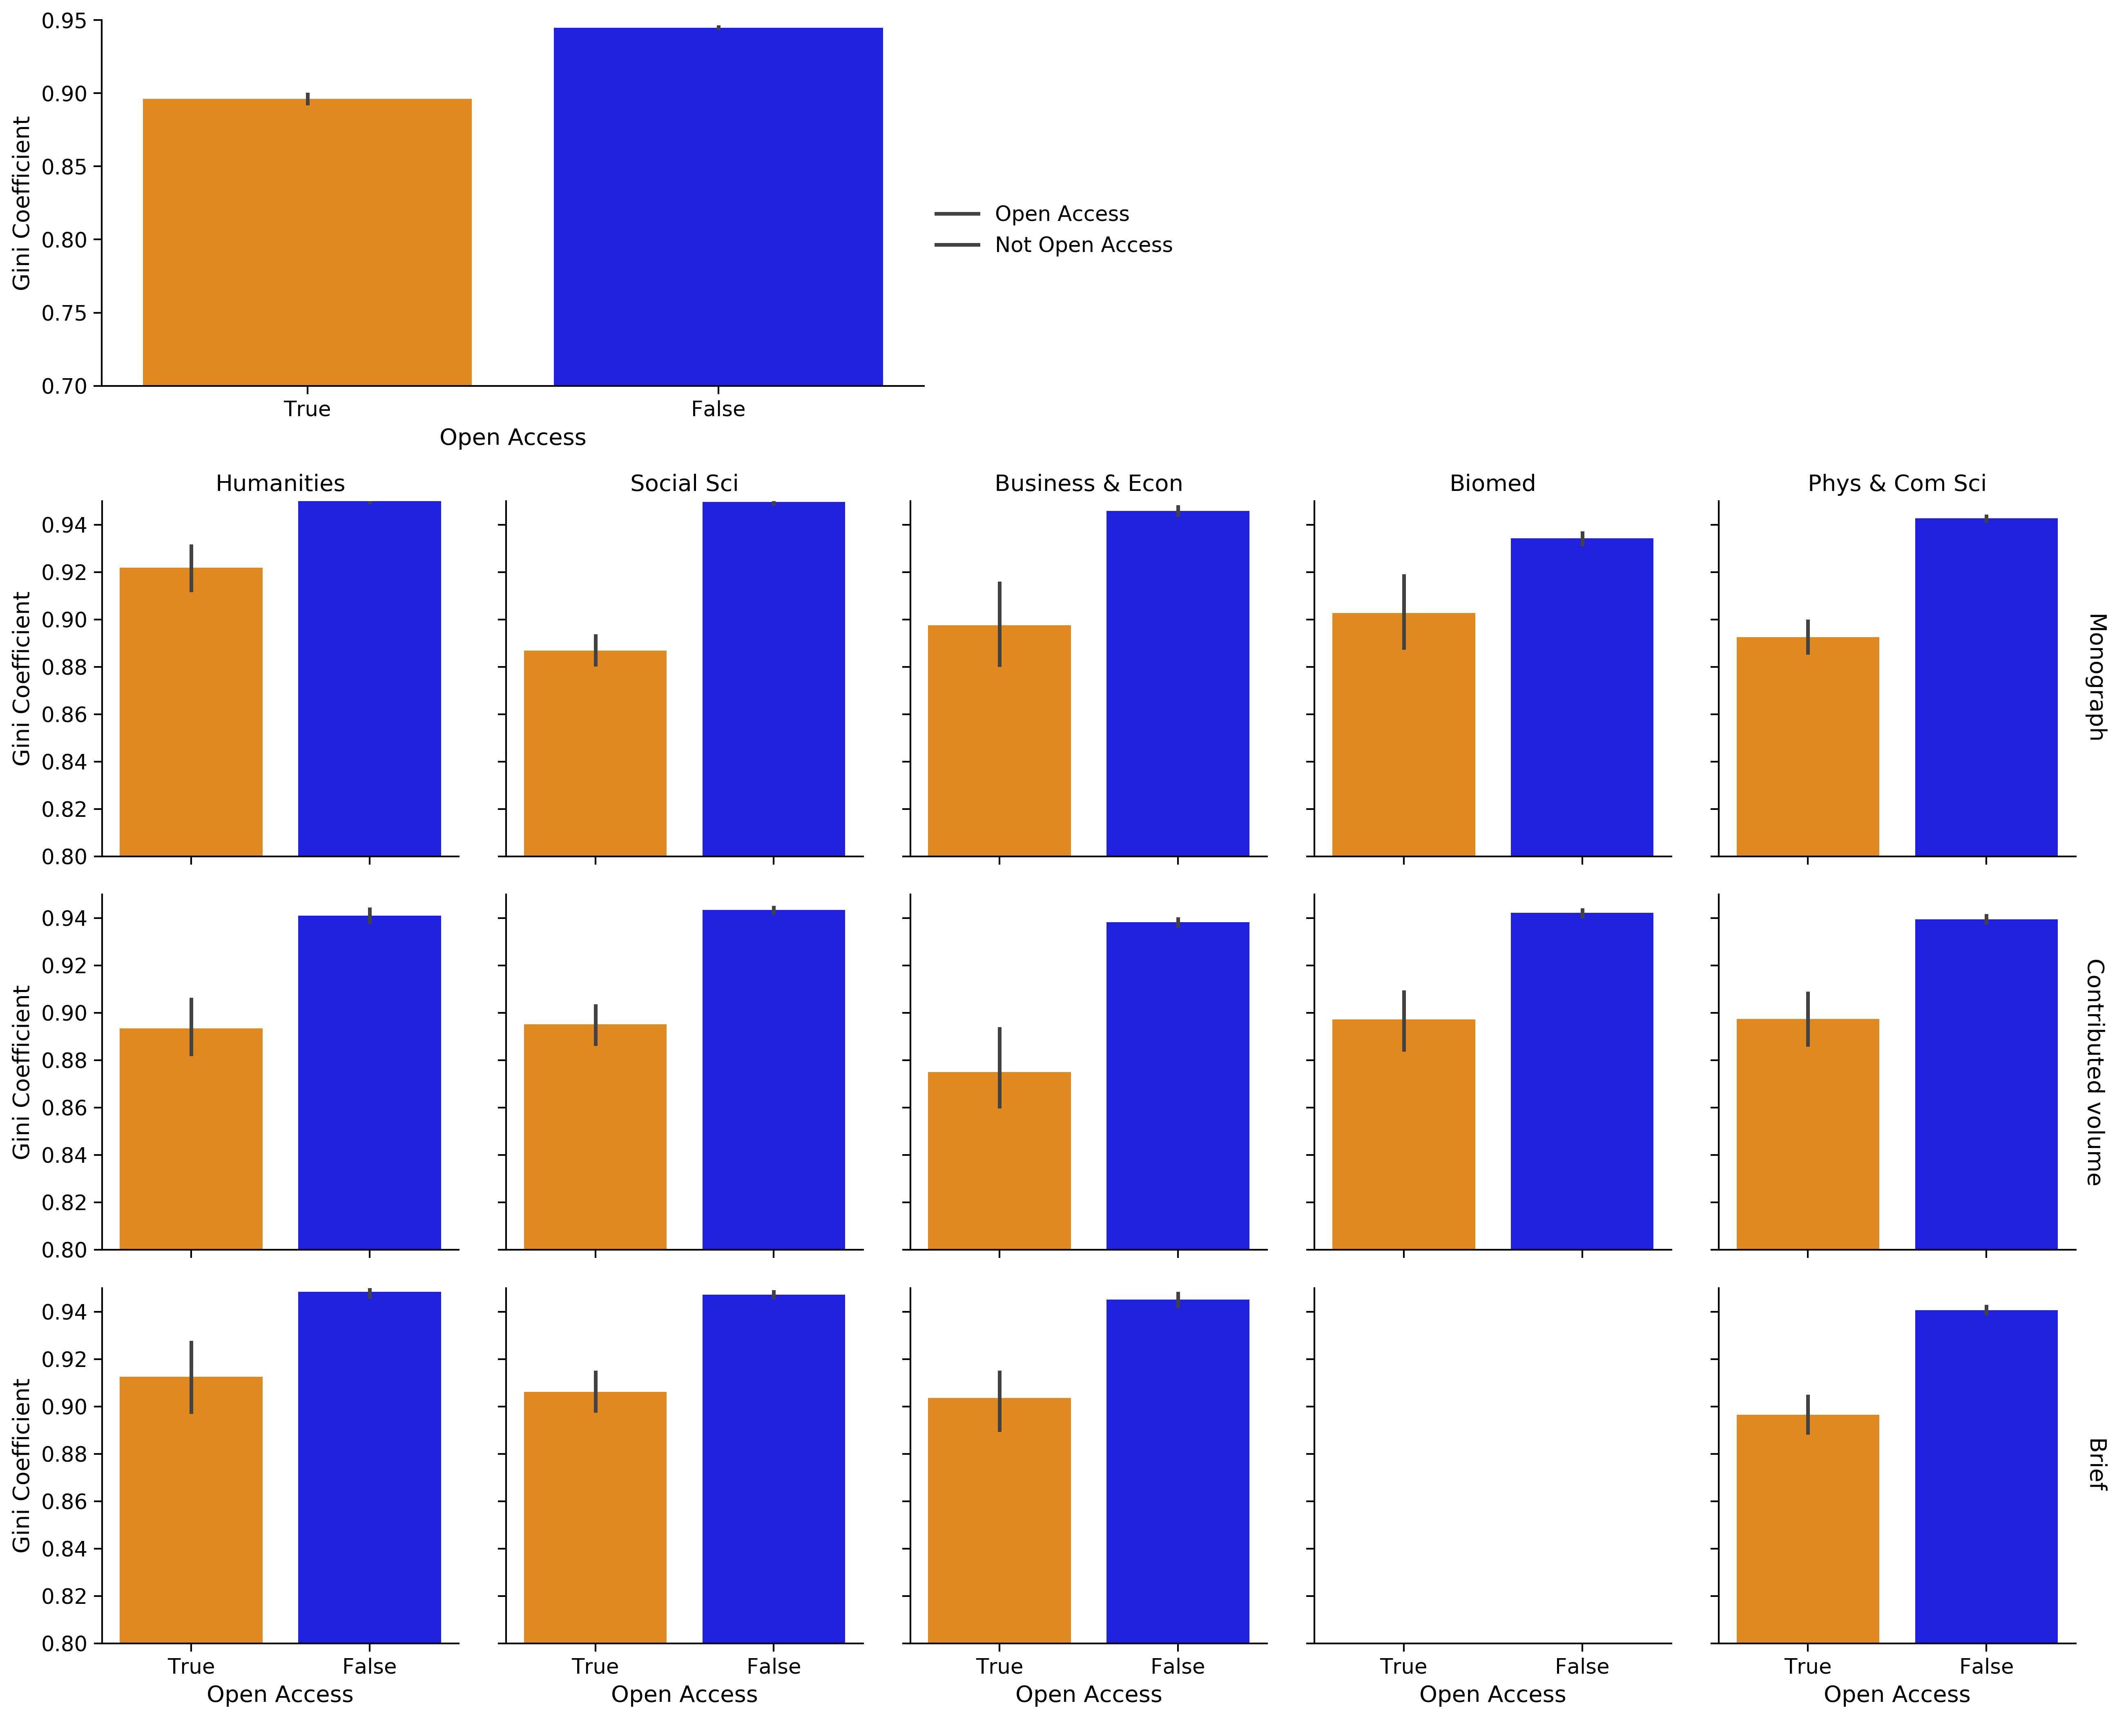

*Figure 5* Diversity of book usage amongst countries as measured by the Gini coefficient.* The Gini coefficient is a statistical measure of inequality. Here the coefficient is calculated for the contribution of each country to the overall usage of each book. A lower Gini coefficient means more diverse usage. The median Gini coefficient and the 95% confidence interval is shown. For the corpus as a whole and for every category, the median Gini coefficient of OA books is lower, meaning that the geographical usage of OA books is more diverse (i.e. less unequal).

### Open access books show enhanced title effect on geographic usage

Approximately 16% of the whole corpus of books in this study had a region or country name in their title or subtitle. The proportion of OA vs non-OA books with a geographic reference in the title is approximately the same. We hand coded title-references to countries or regions, including variations referring to language (e.g. “Chinese”) and regions (“Africa”, “Latin America” as well as possessives such as “Sub-saharan” and “Latin American”) and examined the usage from those regions focusing on Africa and Latin America as examples. We are interested in discovering whether there is a “title” effect, i.e., a book with title referencing a region shows greater usage in that region, and if this effect differs across OA and non-OA books.

The proportional increases in downloads for books referencing “Africa” in their titles are presented in Figure 6. The three panels show download patterns for all books, OA books and non-OA books, respectively. Parallel visualisations for books referencing “Latin America” are provided in Figure S2 of the Appendix.

For Africa and Latin America we see substantial enhanced usage overall from those regions featuring in the title. In both cases there is also some evidence of enhanced usage in some parts of the other region (i.e. enhanced usage in a small number of African countries for titles that have Latin America in the title). In the case of books with “Africa” in the title there is enhanced Latin America usage in Guyana, Suriname, Venezuela, and Panama. Other countries with enhanced usage are Laos, the Solomon Islands and Timor Leste.

The size of the geographic effect is strongly enhanced by OA. OA books about Africa are widely read beyond Africa as well as in Africa. There is a very large enhancement of usage compared to the whole sample across the African continent. By contrast, non-OA books with “Africa” in the title show a usage enhancement only in South Africa, Uganda, Ethiopia and Sudan. Not only does OA enhance usage in countries under-represented in global scholarship, it also enhances the global usage of scholarship about under-represented countries. See Case study in the Appendix for an example of the enhancement of usage for a book with a specific country in the title.

Similar effects are seen for Latin America, although the enhancement is not quite as localised as in the case of Africa. Usage in Latin America is strongly enhanced for all books with ‘Latin America” (including variations and possessives such as “Latin American”) in the title and the degree of enhancement is substantially stronger for OA books. In addition there is broader enhancement of usage internationally for the OA books. The overall enhancement effect is larger for books with “Latin America” (maximum enhancement of 100 usage) than it is for “Africa” (maximum enhancement of 5-fold).

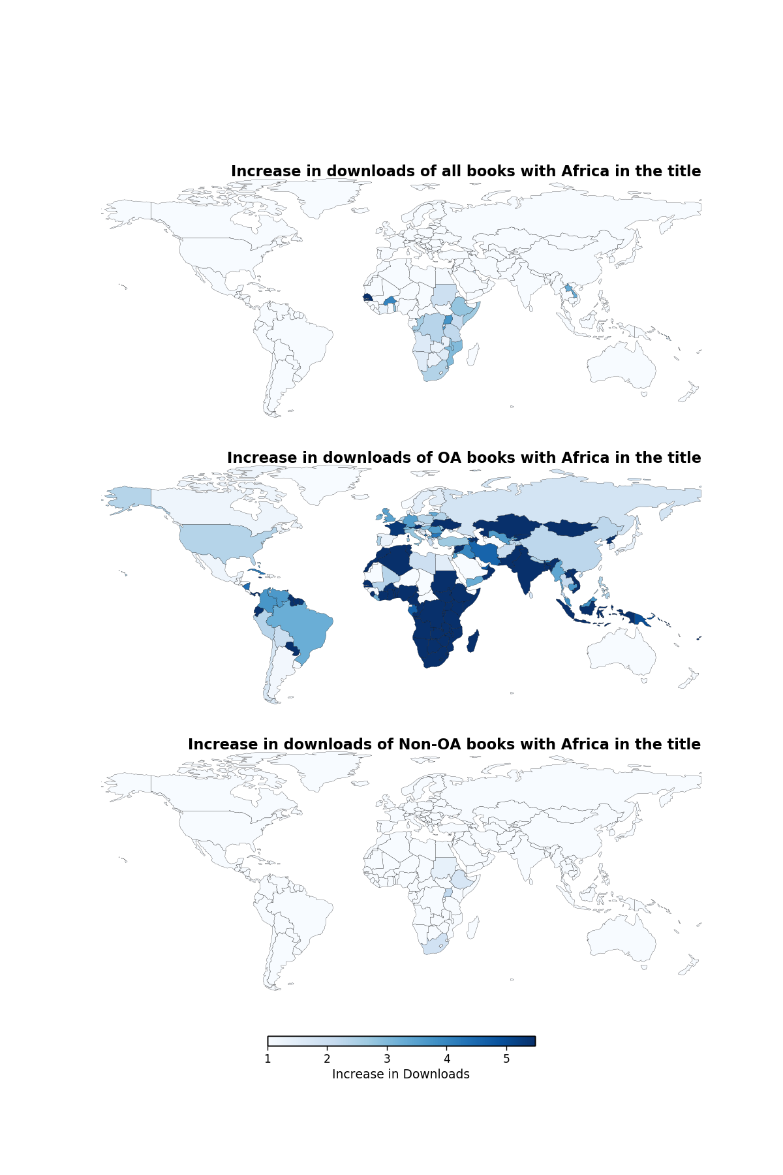

*Figure 6 Increases in usage for books with “Africa” in the title.* Overall usage for each country of books with “Africa” in the title was divided by usage for that country for the full corpus. Increases in usage are shown with countries showing unchanged or decreased usage displayed in the lightest shades. OA books show relatively more increase across a range of countries, with the enhancement concentrated in Africa.

### Anonymous usage versus logged usage

Recall that usage (via downloads) for OA books can be categorised as logged access or anonymous access. In fact, we see significant differences in usage numbers across these two types of access. The overall number of anonymous usage is always greater than logged usage for each book: generally twice as many (with exceptions for only a small number of books in our study).

We cannot directly ascribe anonymous usage to “general public” or “non-academic” usage because a proportion of this will be off-campus or personal device usage of scholars. However there are differences in the patterns of usage at the country-level. Anonymous usage is higher in Kenya, Brazil, India, and Iran. Logged usage is comparatively higher in Egypt. We have already noted that there is substantial anonymous usage in countries for which there is no logged usage (see Figure 4). There are also a wide range of countries with a very high proportion of anonymous usage, despite these countries including institutions that have access to non-OA content. This list includes Syria, Ukraine, Georgia, Guatemala and Sri Lanka. The distribution of downloads across countries for each type of access is displayed in Figure S3.

At the other end of the scale there is no obvious pattern in the countries that show a higher level of logged usage than anonymous usage for OA books. This list includes Turkey, Liechtenstein and Moldova, where logged and anonymous usage are quite close (Germany has almost precisely the same amount of logged and anonymous usage) and Egypt, Suriname and Taiwan where logged usage is higher than anonymous usage. Overall these differences will be the result of a complex mixture of usage patterns, internet provision and access, as well as Springer Nature market penetration. Iceland is a substantial outlier with only 514 anonymous downloads and nearly 25,000 logged. This is likely due to the SpringerLink subscription held by the Iceland Consortium which provides nationwide access.

### Web visibility across top level domains (TLDs)

In this study we use the number of unique domains determined by webometrics analysis as a proxy for web visibility. While OA books display higher levels of web visibility overall and for various categories of books (see Figure 1), these differences are proportionally much less than those depicted by downloads and citations.

Broadly speaking the geographical representation of pages that refer to books in the corpus is consistent with the usage via downloads and citations, with European (.uk, .de, .it), North American (.edu, .ca) and Australian (.au) top level domains (TLDs) dominating (see Table S1 in the Appendix). The top ten TLDs constitute 8080% of all web pages identified for the whole corpus of books. Overall, the difference between the number of websites and the range of TLDs between the OA and non-OA books shows a 13937% increase in unique domains referencing the OA books versus non-OA titles (with the increases for each of the top ten TLDs displayed in Figure S4). This is a relatively small increase compared to the 1010-fold effect on downloads and more than doubling of the number of citations.

Springer Nature has well established and effective pathways for marketing and digital dissemination which are applied to both OA and non-OA titles. The small effect of OA on the number of websites referring to these titles is most likely to be a result of the fact that both OA and non-OA titles benefit from these processes.

## Limitations and further work

The primary limitations of this study are that it only examines books from a single publisher; and only examines usage of OA books via a single platform: SpringerLink. Springer Nature OA books are also made available via a range of other platforms, including the OAPEN Digital Library, the Directory of Open Access Books (DOAB), and available from Google Books, Apple Books, Amazon and funders’ own platforms. Where appropriate, OA books are also indexed in Web of Science, Scopus, PubMed’s NCBI Bookshelf, PMC, Medline, as well as more than 200 more abstracting and indexing services and Google Books. Usage via those platforms is not captured in this study. We also only capture digital usage and reach of ebooks and do not consider print sales and distribution which may also show different trends for OA and non-OA books.

Springer Nature is a large publisher with an experienced and effective sales and marketing team, and online infrastructure. We would predict that the overall effect of this would be to reduce the difference between OA and non-OA books on the metrics we can measure. On the other hand, the data set used in this study is significantly larger than the sets used to inform other published studies, which have used data from small OA monograph publishers with a limited number of titles. To our knowledge this is the largest independent analysis comparing usage and visibility of OA and non-OA books ever conducted. The size of the data set increases confidence in the study’s conclusions.

A significant statistical limitation is that the study was conducted on a retrospective stratified sample. We therefore cannot completely rule out confounding effects resulting from variables beyond our control. Specifically we have not controlled for affiliation or the prestige or fame of authors. There is some risk that there is a correlation between the wealth of an institution (and therefore its ability to fund OA publication), the prestige and reach of authors, and therefore the downloads and citations of books. However, the nature of our stratified sample and the consistency of positive effects across all groups, for all types of book, for all disciplines, for all three years of publication and for all times after publication provides confidence that the effects of OA are credible.

In some cases usage numbers are small and this can exaggerate the effects seen when seeking to normalise usage. The precise size of geographic effects and to some extent the ordering should therefore not be relied on. However the broad patterns of change and directions of effect are robust and the broad geographic patterns of changes in usage are consistent across various subsamples and for individual books. Overall we are highly confident of the claim that OA enhances usage in countries which suffer exclusion from scholarly discourse.

The webometric analysis is reliant on construction of a search term that combines the title with author names. This can be expected to experience false negatives (not all web pages referring to the book will contain this information) and some false positives (particularly for short titles and common author names). Nonetheless the broad pattern of visibility should be reliable and is supported by its concordance with the geographic usage data.

## Data accessibility statement

Data and code are provided at Zenodo. As the book-level usage data is proprietary to Springer Nature we do not share this detailed data. However we do provide full code for audit and hashes to ensure the provenance of both raw and processed data. Data for webometrics, citations, normalisation, and the full set of titles analysed are provided.

Acknowledgements Springer Nature provided funding to COARD to conduct this research and also provided the data.

Competing interests This work was funded by Springer Nature through a research project by COARD (previously Knowledge Unlatched Research). Springer Nature also provided the usage and citation data and were involved in the design of the open access sample set (which includes all English language open access books published across 2015-2017 by Springer Nature). The comparison set of books that are not open access was selected from the full list of comparable books by the COARD team. Several of the co-authors are from Springer Nature and were actively involved in discussion of the analysis and preparation of the article narrative.

# Appendix

## Supplementary Figures

*Figure S1: Downloads normalised by publication count per country.* This figure shows the usage patterns of OA and non-OA books after normalisation by total publication count (as a proxy for “population”) for each country. The patterns are consistent with those observed in Figure 3, with the biggest change seemingly recorded in Latin America, Africa, Central Asia and the Middle East.

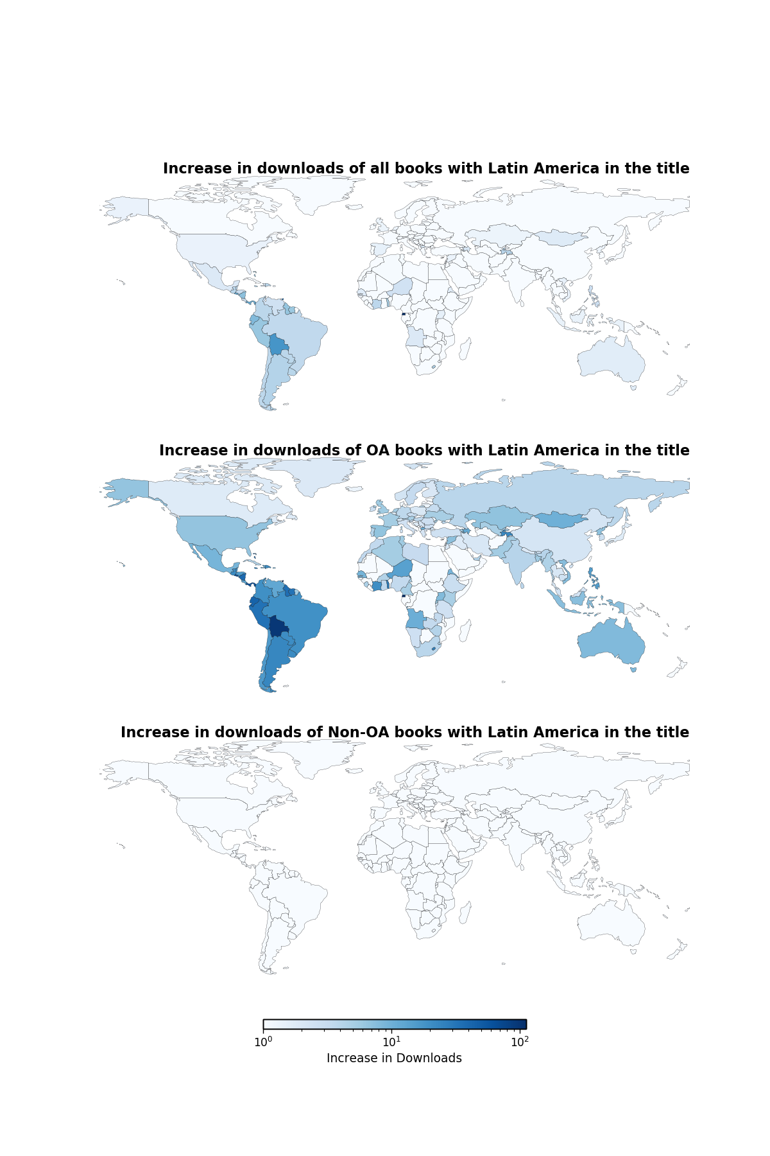

*Figure S2: Increases in usage for books with “Latin America” in the title.* Overall usage for each country of books with “Latin America” in the title was divided by usage for that country for the full corpus. Increases in usage are shown on a log scale, with countries showing unchanged or decreased usage displayed in white. OA books show relatively more increase across a range of countries, with the enhancement concentrated in Latin America.

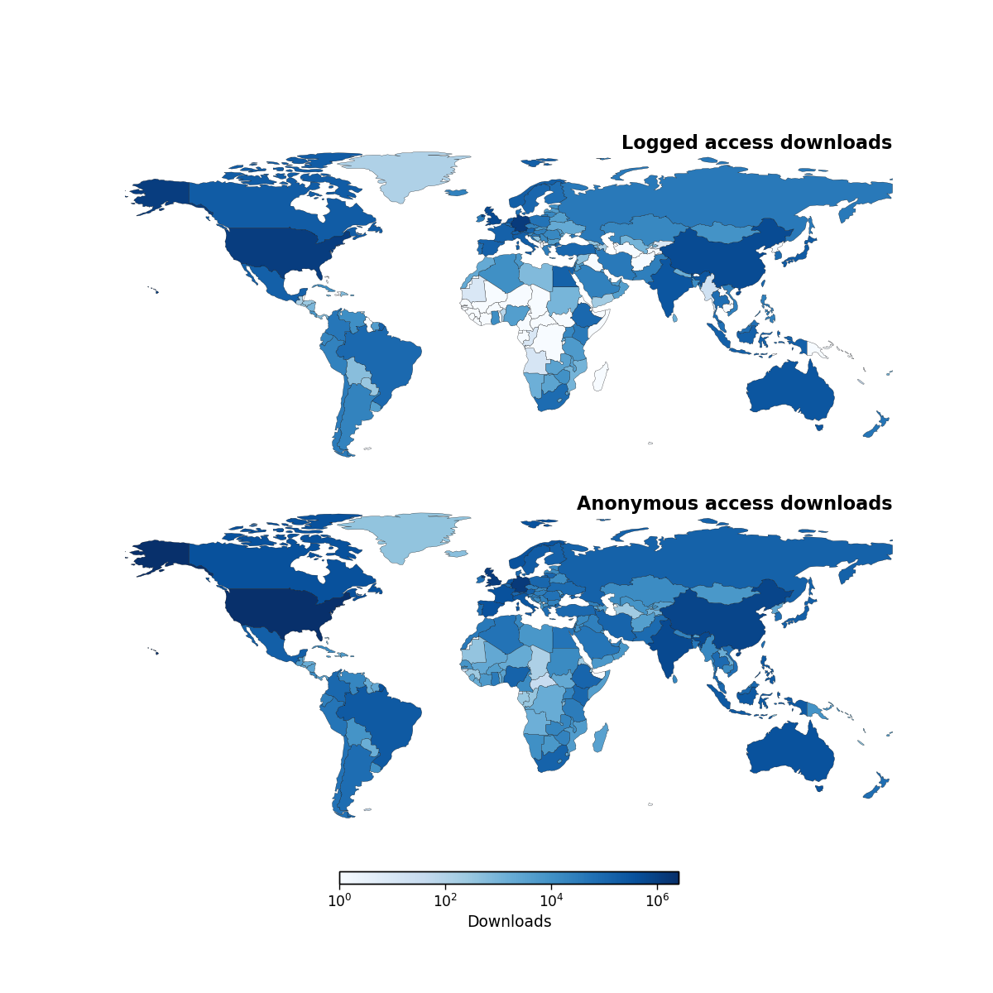

*Figure S3: Logged (top) vs anonymous (bottom) usage of OA books show different country level patterns of usage.* Anonymous usage is 2.9 times higher in Kenya, 2.3 times higher in Brazil and 2 times higher in India, and 3.2 times higher in Iran. Logged usage is 3 times higher in Egypt.

|  |  |  |  |  |  |  |
| --- | --- | --- | --- | --- | --- | --- |
| TLD | Total Sites | Total % | Non-OA | Non-OA % | OA | OA % |
| fr | 367 | 1.0 | 2172 | 0.96 | 367 | 1.51 |
| au | 410 | 2.18 | 4968 | 2.19 | 410 | 1.69 |
| it | 491 | 1.63 | 3707 | 1.63 | 491 | 2.02 |
| jp | 505 | 2.1 | 4824 | 2.12 | 505 | 2.08 |
| net | 767 | 3.57 | 8206 | 3.61 | 767 | 3.16 |
| uk | 1210 | 4.33 | 9654 | 4.25 | 1210 | 4.98 |
| de | 1233 | 4.08 | 9169 | 4.04 | 1233 | 5.08 |
| edu | 1793 | 7.67 | 17434 | 7.68 | 1793 | 7.38 |
| org | 3649 | 12.42 | 27535 | 12.13 | 3649 | 15.02 |
| com | 8404 | 40.44 | 92975 | 40.95 | 8404 | 34.6 |

*Table S1: Frequency of Top Level Domains (TLDs) across the corpus and for OA and non-OA titles.* Total Sites = number of sites identified with the specific TLD; Total % = the proportion that this TLD accounts for in the whole list of websites. Non-OA = number of sites with the specific TLD identified through non-OA books. Non-OA % = proportion that this TLD accounts for in the whole list of websites for Non-OA books. Similarly for OA and OA %.

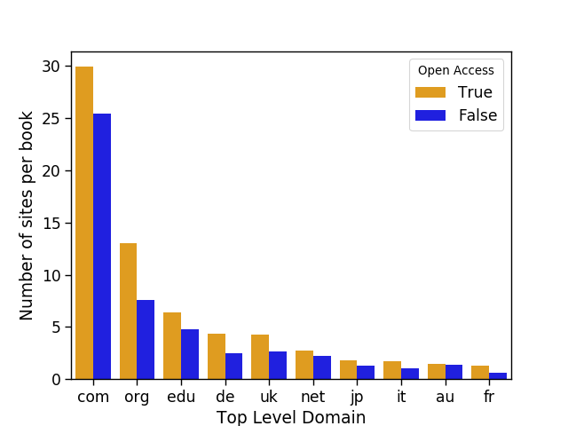

*Figure S4. Average number of sites per OA and Non-OA book for the ten highest Top Level Domains across the corpus.*

## Supplementary data and methodology

### Selection of non-OA comparator titles

A comparison set of non-OA books was used in this study to provide a baseline of usage for non-OA content. This comparison set is made up of books accessed via SpringerLink, which would generally be linked to an institutional subscription or purchase of specific book packages. Our goal is to maximise the statistical power of the sample while maintaining a consistent ratio of OA to non-OA books across various categories of books. 21,059 non-OA books were considered for inclusion in the comparator set. Books were selected for inclusion in the comparator set in the following way:

1. The OA books were divided into groups (i.e., strata) according to combinations of book type, discipline cluster and year of publication.
2. For each stratum of OA books, the number of non-OA titles with the same type, year of publication and discipline cluster was identified.
3. To construct a maximally informative set of comparison groups we identified the number of non-OA and OA titles for every stratum which had at least one OA title. This provided 37 strata out of the 45 theoretically possible strata (3 book types x 5 disciplines clusters x 3 years) as not every possible strata had an OA title. We identified that across all strata there were at least 13 non-OA titles for each OA title. We therefore generated a random stratified sample by randomly selecting 13 non-OA titles for each OA title within each group to give a total of 3,653 non-OA titles for comparison.

### Usage data

The three primary metrics of interest are number of downloads, number of citations and web visibility. These are described in detail below. * *Downloads:* Springer Nature made download data available for both the OA and non-OA titles included in the study set. The download data is COUNTER-compliant and one download refers to one chapter download. Full-book downloads are counted as one download for each chapter in the book. * *Citations:* Springer Nature also provided data on the number of citations for each book and the specific imprint that published each book (e.g. Palgrave Macmillan, Springer, Birkhäuser), page and chapter counts and Altmetric.com data. * *Web visibility:* The web visibility of the books included in the study is investigated as an additional proxy for use of the books. It provides an indication of the extent to which digital resources are being referred to, discussed, and used via the world wide web. In order to measure web visibility we used the ISBNs in the study data set to establish book titles and author surnames via the Google Books’ API. Using the author and title as search terms we analysed the visibility of all the books on the web using the Webometric Analyst 2.0 tool developed by Thelwall et al. and collected the number of URLs mentioning the title and author surname. We then extracted unique domain names and top level domains (TLDs) to analyse countries of the URLs mentioning each of these titles.

### Logged vs anonymous downloads

The data provided by Springer Nature included information about whether a download access was “logged” (originated from the IP address range of an institution that has purchased or subscribed to at least one Springer Nature product); or whether it was anonymous (originated from an IP address range not associated with a subscribing university).

Logged usage data included information relating to:

* ISBN of the accessed book
* Month of download
* Country and city information

Data relating to anonymous use was provided in the form of IP address usage logs. The final byte of the IP address was removed by Springer Nature in order to ensure the privacy of users.

### Geolocation of downloads

For logged usage data, the country and city information were provided by Springer Nature as mentioned above. To convert the IP addresses for anonymous usage to geographical usage we used the IP2Location database to identify countries and cities associated with individual IP addresses. This required replacing the last byte in the IP address (with “1”) and matching the country and city names to those used in the logged usage data.

### Data for country normalisation

To normalise country-level download data by each country’s volume of publication, citation, and enrolment in tertiary education, we collect the number of publications and citations by country through an in-house database. This database is provided by a data infrastructure run by the Curtin Open Knowledge Initiative (COKI), which collects and integrates multiple data sources on open knowledge. The COKI database on publications draws data from Microsoft Academic, Web of Science and Scopus through institutional affiliations. The affiliations are mapped against the Global Research Identifier Database (GRID) for geolocation data.

### Statistical measures and sensitivity analysis

To maximise the statistical power of our findings and enable fair comparisons across different categories of books, we have selected to benchmark our sample selection based on the number of OA books. In essence, this approach minimises the bias caused by potentially very different distributions of OA and non-OA books in terms of book types, disciplines and publication years.

A number of different averages is calculated in this study. This includes overall averages and averages restricted to certain categories (such as downloads per book in a certain strata, or average number of downloads from a certain country). Where appropriate, 95% confidence intervals are also provided. We use the Gini coefficient to measure the geographic diversity of downloads by following closely the codes available from https://zhiyzuo.github.io/Plot-Lorenz/.

Length of a book can be a potential factor for its level of usage. In particular, we would like to examine whether there is a bias caused by book length when comparing usages of OA and non-OA books. To examine whether the length of a book has a confounding effect on usage patterns we plot the length of books against the number of downloads. We consider the length of the book in terms of number of pages and number of chapters separately. These are presented in Figures S5 and S6 below, with OA and non-OA titles shown in different colours. The figures show while there is a relationship between length and number of downloads, this effect seems similar across OA and non-OA books.

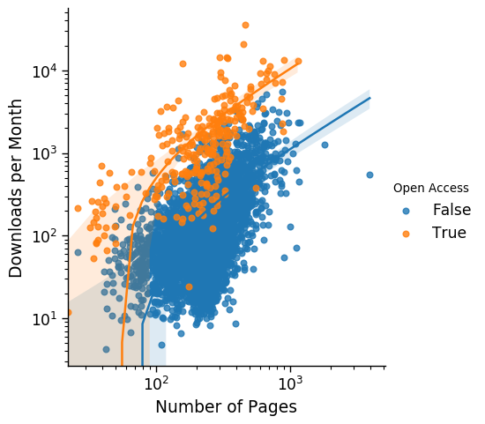

*Figure S5: Scatterplot for downloads versus number of pages for each title for OA and non-OA books.*

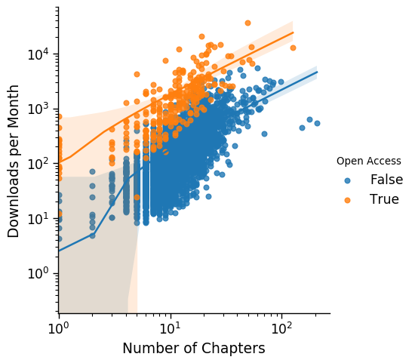

*Figure S6: Scatterplot for downloads versus number of chapters for each title for OA and non-OA books.*

### Data processing, analysis and visualisation

Data was processed and visualised using the provided Python code which is available at ###GITHUB###

## Case Study

### Digital Kenya

Publication Year: 2017

ISBN: 978-1-137-57878-5

Discipline: Economics

Product category: Contributed volume

Cluster: Business & Economics

Imprint: Palgrave Macmillan

Total number of countries: 172

Average number of countries for non-OA titles: 39

Average number of countries for non-OA titles in the same group: 48

Country Gini coefficient: 0.93

Total chapter downloads: 209731

Chapter downloads average for non-OA titles in the same category: 11985

Monthly mean average chapter downloads: 5992

Monthly mean average chapter download for non-OA titles in the same category: 379

#### Description

*Digital Kenya* (Ndemo and Weiss eds, 2017) is an edited volume written by engaged scholars and professionals in the field of ICT innovation in Kenya. Published as part of the Palgrave Studies of Entrepreneurship in Africa series, it was released open access under a CC BY v4.0 license. The open access version is hosted on SpringerLink as well as via OAPEN and a range of other platforms.

#### Overall performance

*Digital Kenya* is a high performing book in terms of downloads. Compared to its comparison group of closed books it has 15 times more monthly downloads. Anonymous downloads accounted for over 80% of all content usage, again emphasising the value of the open access status for this book.

#### Geographical reach

Given the title and focus of the book it is naturally of interest to identify whether this Open Access volume shows enhanced usage in Kenya. In the context of African usage, Kenya is a significant user of both closed and Open Access books having usage in a similar range of South Africa for closed books. However Digital Kenya shows a substantially higher proportion of its usage from Kenya. This usage is sustained over the whole period of data collection and is most obvious for anonymous usage.

Other African countries also show enhanced proportional usage with Nigeria, Ghana and South Africa showing the strongest effects. There is also evidence of a greater proportion of overall usage from Indonesia and India, potentially relating to the wider relevance of the issues discussed beyond Kenya and neighbouring countries. Interestingly the effect for Indonesia seems to be stronger for logged usage, which may be a suggestion of Open Access driving enhanced usage, even for those books where specific audiences might have access. Further analysis might address the question of whether specific areas showing enhanced usage would be likely to have had access if the book were not Open Access but otherwise the same.

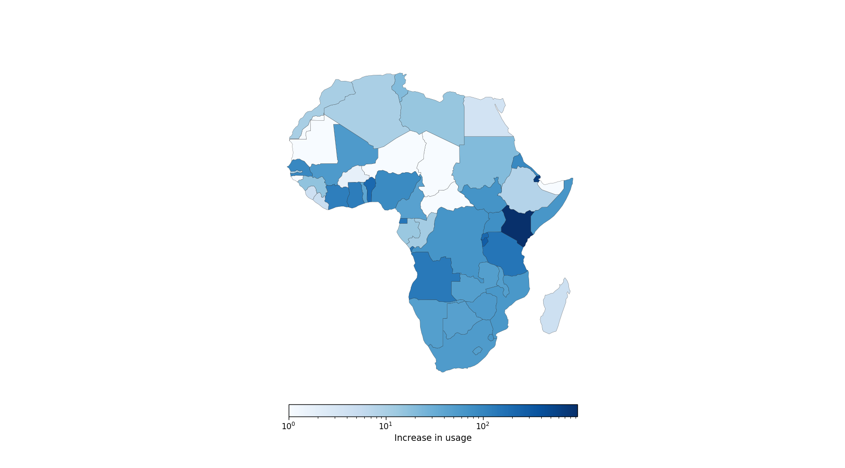

|  |  |  |
| --- | --- | --- |
| Overall (all books) | Logged (Digital Kenya) | Anonymous (Digital Kenya) |
| United States | Germany | Germany |
| Germany | United States | Kenya |
| China | Kenya | United States |
| United Kingdom | United Kingdom | United Kingdom |
| Australia | Egypt | China |
| Canada | South Africa | Netherlands |
| Egypt | Indonesia | South Africa |
| Netherlands | Switzerland | Nigeria |
| Mexico | India | India |
| India | China | France |
| KEN (46.0) |  |  |