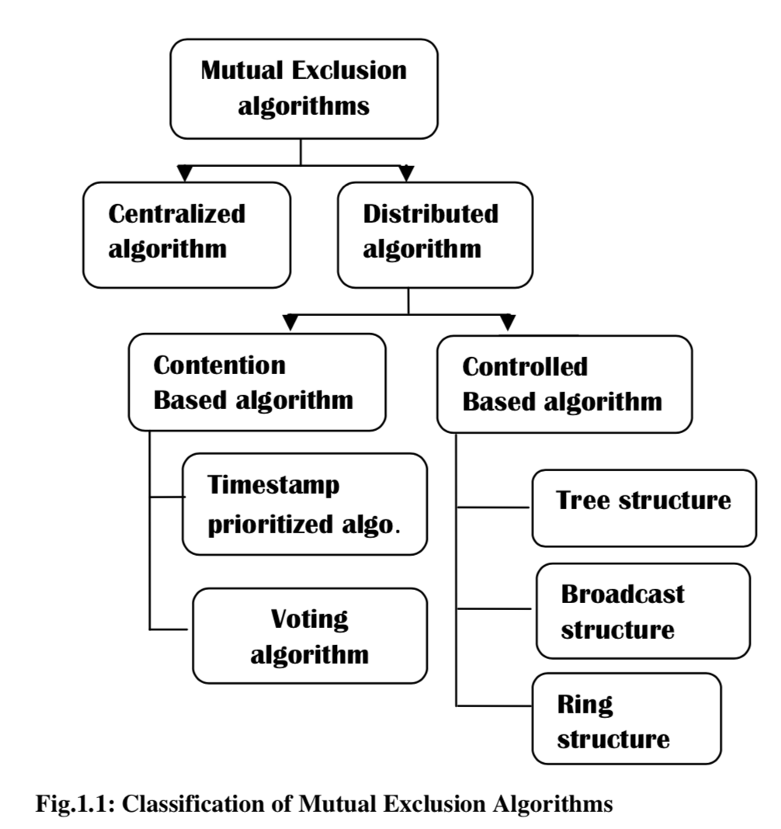

**1.Centralized Algorithm**

there is one coordinator which handles all the requests to access the shared resource/data.

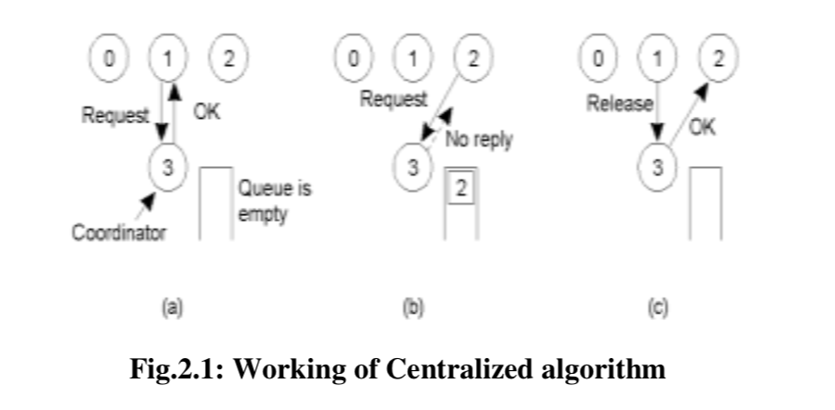

1. Timestamp based

LAMPORT’S ALGORITHM

**RICART-****AGRAWALA ALGORITHM**

2. **VOTING SCHEMES**

Maekawa's algorithm

3. *Controlled (TOKEN) BASED ALGORITHMS*

**Ring Structure: none**

**Broadcast Structure (****Suzuki-Kasami Algorithm)**

**Tree structure (****Raymond’s Algorithm)**

1. 这五类找到最新的算法
2. possible application areas of the algorithm(s)（code）
3. Suzuki-Kasami Algorithm

RICART-AGRAWALA ALGORITHM

找到Code并在电脑上运行

1. 做一个演示算法的框架（node，edge）
2. 聊天(text, JSON，server 作为log)
3. CS（金库 etc.）
4. 算法

# 5．Background Survey