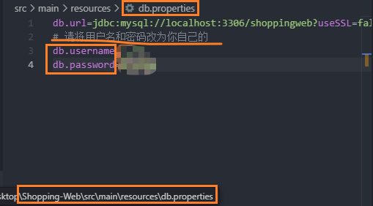

**红色字是你需要复制粘贴进MySQL查询的**

CREATE DATABASE shoppingweb DEFAULT CHARACTER SET utf8mb4;

USE shoppingweb;

-- 用户表

CREATE TABLE user (

id INT PRIMARY KEY AUTO_INCREMENT,

username VARCHAR(50) NOT NULL UNIQUE,

password VARCHAR(100) NOT NULL

);

-- 商品分类表

CREATE TABLE category (

id INT PRIMARY KEY AUTO_INCREMENT,

name VARCHAR(50) NOT NULL

);

-- 商品表

CREATE TABLE product (

id INT PRIMARY KEY AUTO_INCREMENT,

name VARCHAR(100) NOT NULL,

price DECIMAL(10,2) NOT NULL,

category_id INT,

description VARCHAR(255),

is_hot BOOLEAN DEFAULT FALSE,

stock INT DEFAULT 0,

FOREIGN KEY (category_id) REFERENCES category(id)

);

-- 订单表

CREATE TABLE orders (

id INT PRIMARY KEY AUTO_INCREMENT,

user_id INT,

order_date DATETIME,

total_amount DECIMAL(10,2),

status VARCHAR(20),

FOREIGN KEY (user_id) REFERENCES user(id)

);

-- 订单明细表

CREATE TABLE order_item (

id INT PRIMARY KEY AUTO_INCREMENT,

order_id INT,

product_id INT,

quantity INT,

price DECIMAL(10,2),

FOREIGN KEY (order_id) REFERENCES orders(id),

FOREIGN KEY (product_id) REFERENCES product(id)

);

1. **插入商品分类**

INSERT INTO category (name) VALUES

('手机数码'),

('家用电器'),

('图书音像'),

('服饰鞋包'),

('食品饮料');

**2. 插入商品（含热门、库存）**

INSERT INTO product (name, price, category_id, description, is_hot, stock) VALUES

('iPhone 15 Pro', 8999.00, 1, '苹果旗舰手机，A17芯片，超视网膜屏', 1, 50),

('小米14', 3999.00, 1, '小米新一代性能旗舰，徕卡影像', 1, 80),

('海尔冰箱', 2999.00, 2, '风冷无霜，节能静音', 0, 30),

('美的空调', 2499.00, 2, '一级能效，智能变频', 1, 40),

('《Java编程思想》', 99.00, 3, '经典Java学习书籍', 1, 100),

('耐克运动鞋', 499.00, 4, '舒适透气，运动休闲', 0, 60),

('三只松鼠坚果礼盒', 129.00, 5, '多种坚果组合，健康美味', 0, 120);

**3. 插入测试用户**

INSERT INTO user (username, password) VALUES

('testuser', '123456'),

('admin', 'admin123');

**4. 查询所有商品/分类/订单的SQL**

SELECT * FROM category;

SELECT * FROM product;

SELECT * FROM user;

SELECT * FROM orders;

SELECT * FROM order_item;

**亮点：**

**商品表的 is_hot 字段用于热门商品，页面有醒目标识。**

**商品库存量(stock)和订单明细(order_item)都能动态联动。**

**分类、商品、订单等都能一键查询，便于演示和讲解。**