**Task 1**

No required documentation

**Task 2**

Function calls are in matlab script ‘assign3.m’ as well as copied below:

%%

%Task Two CT

display_landmarks(volume_CT,[-83.3998;-209.4639;-803.00],[-26.14317;-93.6106;-643.297],5000);

display_landmarks(volume_CT,[-83.3998;-209.4639;-803.00],[9.08479;-133.96;-638.603],5000);

display_landmarks(volume_CT,[-83.3998;-209.4639;-803.00],[60.6069;-112.42;-650.373],5000);

display_landmarks(volume_CT,[-83.3998;-209.4639;-803.00],[42.0235;-75.6846;-656.996],5000);

display_landmarks(volume_CT,[-83.3998;-209.4639;-803.00],[-6.67128;-71.681;-649.853],5000);

%%

%Task Two MRI

display_landmarks(volume_MRI,[-89.7749329;-48.4298096;-167.5021362],[-34.5029;56.4774;-59.9131],2000);

display_landmarks(volume_MRI,[-89.7749329;-48.4298096;-167.5021362],[52.4359;38.6747;-67.2723],2000);

display_landmarks(volume_MRI,[-89.7749329;-48.4298096;-167.5021362],[1.56049;17.2319;-52.8177],2000);

display_landmarks(volume_MRI,[-89.7749329;-48.4298096;-167.5021362],[33.0425;74.4548;-76.3488],2000);

display_landmarks(volume_MRI,[-89.7749329;-48.4298096;-167.5021362],[-15.5747;78.1617;-68.5479],2000);

**Task 3**

**i)** [q1,r1,t1,rms]=horns([1,1,0;0,0,0],[1,0,0;0,1,0])

Expected result: [1,1,0;0,0,0]* [1,0,0;0,-1,0;0,0,-1]+[0,1,0]=[1,0,0;0,1,0]

Actual result:

q1 =

0

1

0

0

r1 =

1 0 0

0 -1 0

0 0 -1

t1 =

0

1

0

rms =

0

**ii)**

q =

0.9992

-0.0390

0.0098

0.0090

rotation =

0.9996 -0.0188 0.0190

0.0173 0.9968 0.0780

-0.0204 -0.0777 0.9968

translation =

2.0689

200.4366

573.5028

rms =

3.8520e-05

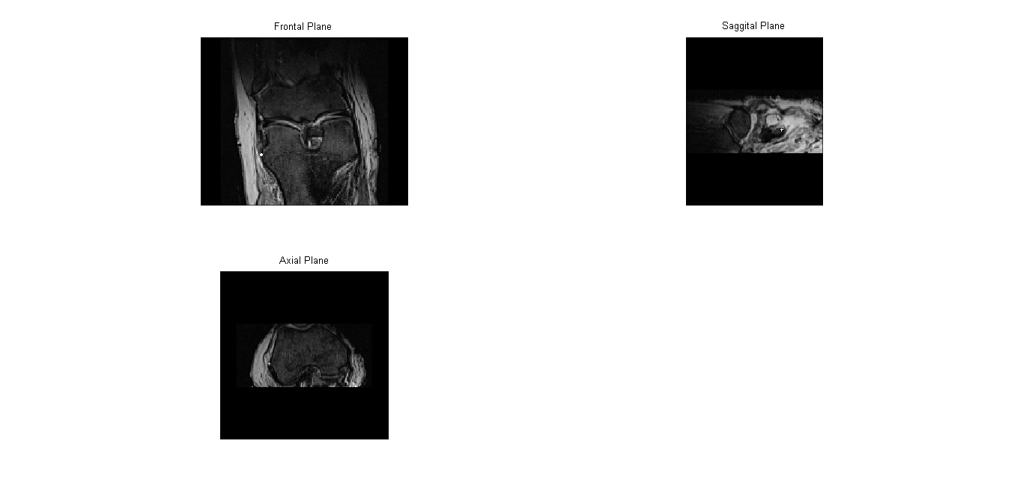

**iii)**

q2 =

0.9992

0.0390

-0.0098

-0.0090

rotation2 =

0.9996 0.0173 -0.0204

-0.0188 0.9968 -0.0777

0.0190 0.0780 0.9968

translation2 =

6.1513

-155.2100

-587.3300

rms2 =

3.8520e-05

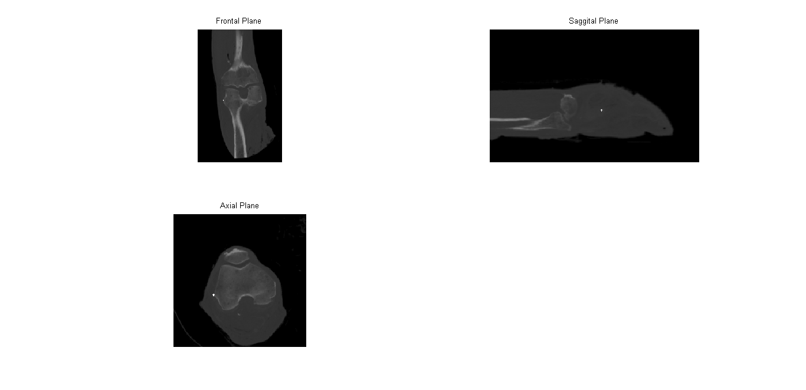

**Task 4**

**ii) See next page**

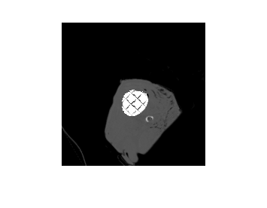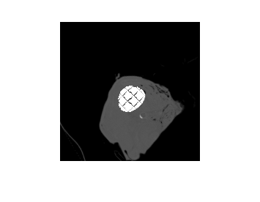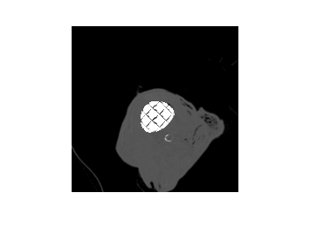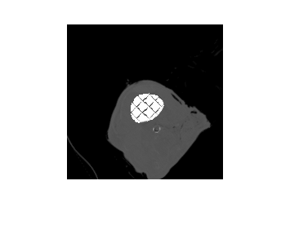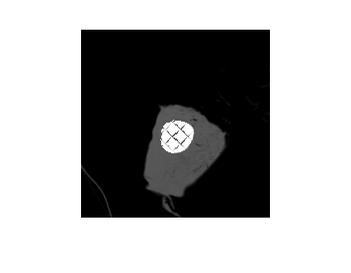

**iii) See next page**

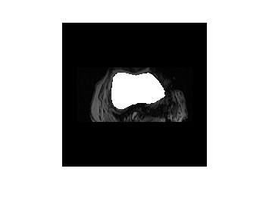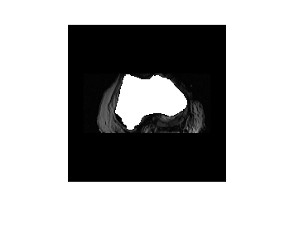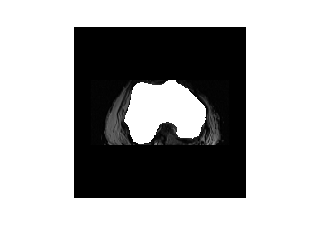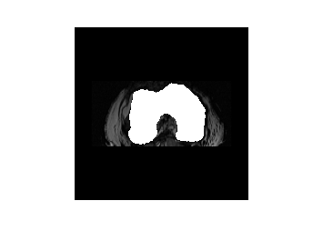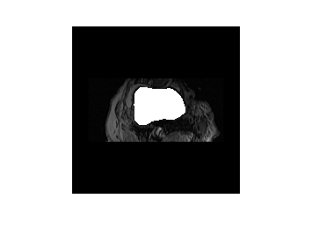

**Task 5**

**i)**

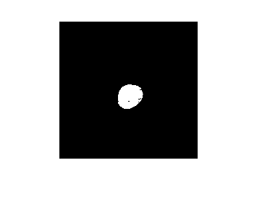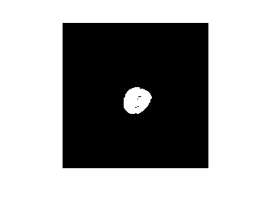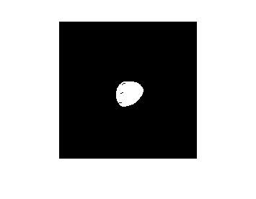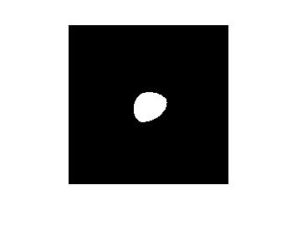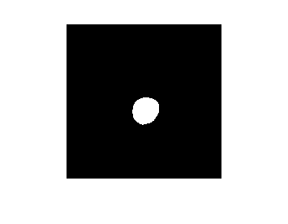

**iii) 65239mm3  
  
v)**

**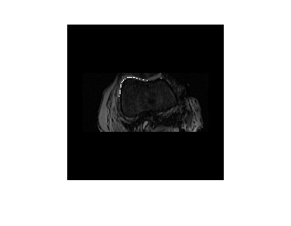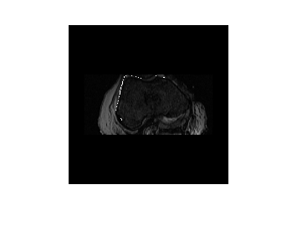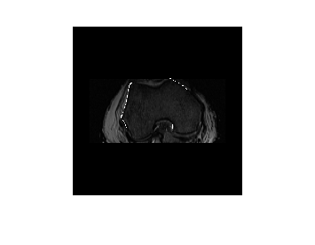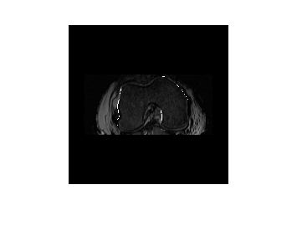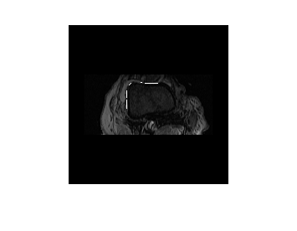  
Task 6**

1. **See next page**

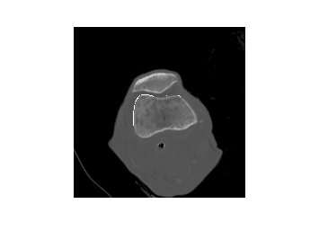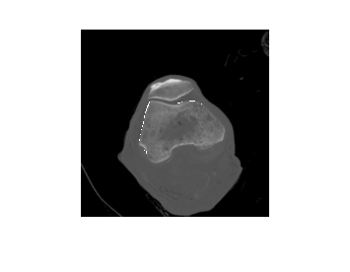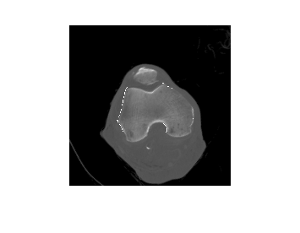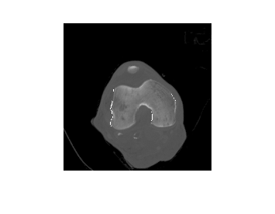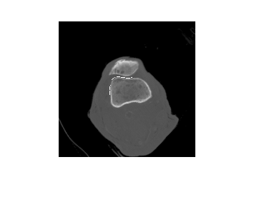

**iii)**

