Student ID: 103641460

Name: Seb Conway

# Setup Screenshot

TOUR (TourName, Description)

PK (TourName)

EVENT (TourName, EventYear, EventMonth, EventDay, Fee)

PK (EventYear, EventMonth, EventDay)

FK (TourName) References TOUR

BOOKING (EventYear, EventMonth, EventDay, ClientID, DateBooked, Payment)

FK (EventYear, EventMonth, EventYear) References EVENT

FK (ClientID) References CLIENT

CLIENT (ClientID, Surname, GivenName, Gender)

PK (ClientID)

# Task 2 Screenshot

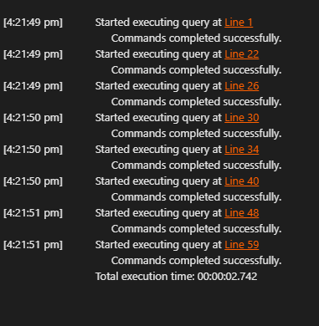

# Task 3 Screenshot