**Infrastructure proposal: Dust and smoke extraction for lasers and woodworking machines**

The following is a proposal in four parts for a re-arrangement of the dust and smoke extraction systems in the machine room and around the laser cutters, aimed at:

* freeing up space,
* improving the effectiveness of dust and smoke capture
* tidying up
* reducing noise levels in the space, particularly in the machine room

The parts of the proposal can be done independently and in any order. They are:

* Installing a rigid dust header in the machine room ($80, Bunnings)
* Installing a rigid smoke header in the vicinity of the laser cutters ($50, bunnings)
* Constructing a utilities lean-to outside the building to house fans and filters (~$200 from Gumtree or ~$450 from Bunnings)
* Re-arranging the machine room so that the dust-producing machines are in one place (free)

**Rigid dust header in machine room**

The dust capture ducting in the machine room is untidy and inefficient. While the extraction unit seems appropriately sized (it ought to be able to service 2 machines simultaneously), its actual performance is rather poor. This is most likely due to leaks, pressure loss in the flexible ducting, and pressure loss at entry and exit of the drop-out drum. Having as much of the ducting as possible in rigid PVC would help to address the first two issues (it is suggested that the drop-out drum be retired since the system does not really carry the volume to require it, and its function of capturing large objects inadvertently sucked up could be achieved in other ways).

The proposed routing of the header is as shown below. If the utilities lean-to was to be built, the tee would align with the existing exit point through the window. If the proposal to re-arrange the machines was adopted, the header would be extended through the wall in the machine room and capped allowing for possible future extension.

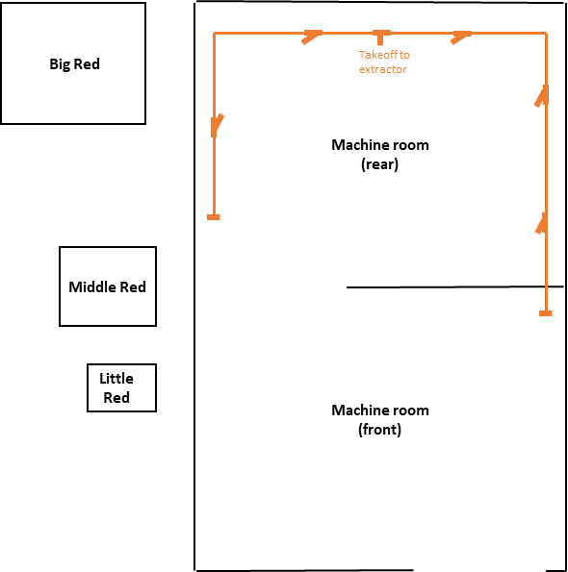

The ducting would be built in 90mm PVC stormwater pipe, which is easily available and cheap. 90mm is slightly undersized for the extractor to achieve its nameplate capacity, but should be more than adequate for the times when only one machine is using the system and would be a significant improvement on the current arrangements in any case. The final section of ducting from the header to each machine would be flexible.

An additional possibility would be to have some sort of automation that starts the extractor and opens the appropriate blast gates for the machines in use (the sliding valves that isolate each machine). That is outside the scope of the proposal, but it is proposed to design build and install blast gates that are amenable to pneumatic actuation as part of the scope.

Total cost would be around $80 for pipe and fittings.

**Rigid smoke header in for lasers**

The smoke extraction system for the lasers generally seems to work well, but the parts dealing with Middle Red and Little Red seem slightly lacking in suck. Probably this is a combination of both units are being serviced simultaneously and pressure losses in the ducting, both upstream and downstream of the fan. Rigid ducting could help for all machines, but any solution is complicated by the lack of a way to isolate machines not in use from a common header. Blast gates like those used in the dust extraction system could be used, but it is highly desirable to have automation to ensure extraction is working any time the machine is in use. Ideally the control logic would open the blast gates only for those machines in use, which could open the way for the two fans to run in parallel and service whichever machines were running.

However, such an arrangement requires significant extra work so is left outside the scope of this proposal for now. It is proposed that initially Big Red and Little / Middle Red continue to use two independent systems, each with its own rigid header extending through the wall as far as the window in the machine room per the sketch below. Total cost for pipe and fittings would be around $50.

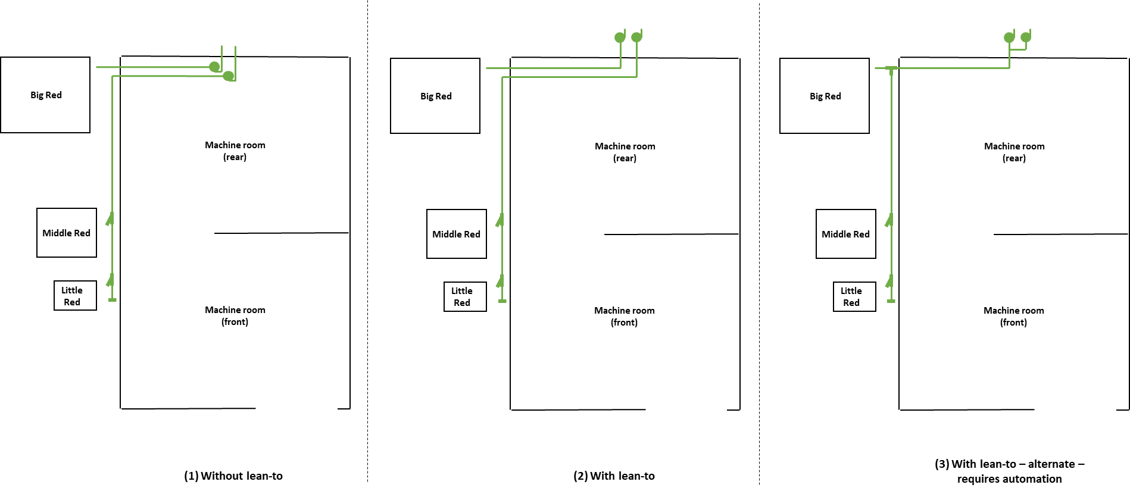

The ducting would be built in 90mm PVC stormwater pipe, with the final section from the header to each machine being flexible.

**Utilities lean-to**

The smoke and dust extraction fans and filters take up valuable floor space in the machine room and are noisy: any time a laser is running, there is an annoyance level of noise in the machine room, which rises to a hazard level if the dust extraction is run. The combined floor space taken up by the dust extractor and drop-out drum could easily accommodate an additional machine. It is proposed to construct a small lean-to on the back of the building to accommodate this equipment, as well as to improve weather protection for the compressor and air receiver. The basic concept is for the lean-to to extend 1.2m off the wall, at a height of 2.5m (just above the window), as far as the existing workbench, as shown in the (crappy) sketch below:

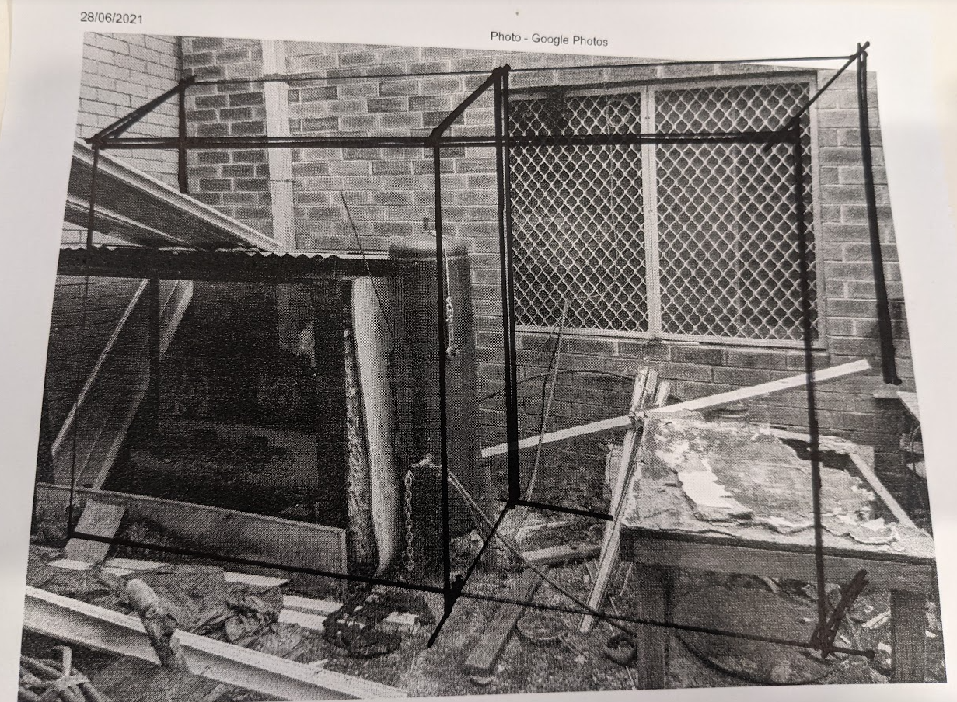

The lean-to would be clad in corrugated iron, with polycarbonate in the vicinity of the window to allow some natural light into the building. The section containing the compressor and receiver would be open at the front, whereas the section containing the fans and dust extractor would have doors on the front and would be properly weatherproof, including being flashed to the wall of the building.

Structurally the lean-to could be built in several ways. The proposed method would be to fasten a head beam to the wall, concrete three posts in the ground at the front, and frame the intervening spaces, all in treated pine. Other options are available (e.g. assemble three rectangular frames, stand them against the wall, and frame them together), if fixing to the wall cannot be done.

The cost of building the lean-to is about $450 at Bunnings prices or $200 at Gumtree prices, less in-kind materials donations or. Treated timber and corrugated iron / polycarbonate are the most expensive components.

**Re-arrange the machine room**

It is proposed to re-arrange the machine room so that the sawdust-producing machines are all in the back section of the room, i.e:

* Move the bandsaw and sanders to the back section
* Move the lathe to the front section.

This would simplify the dust extraction requirements and make it easier to keep sawdust off the metalworking equipment.

**Proposed sequencing**

On the assumption that all elements of this proposal are approved, it is proposed that they be done as follows:

* Re-arrange the machine room (because it is easy, costs nothing, and establishes the machine configuration the dust extraction system is to service)
* Rigid dust header in machine room
* Utilities lean-to
* Rigid smoke header for lasers (because in the interim, someone may decide they want to design / build an automation solution, and it would be preferable to know this in advance).