计算机科学技术学院实验报告
课程名称 | 面向对象程序设计 |  |  | 学 号
实验项目 | 实验七 |  |  | 姓 名
学 时 | 2 | 项目性质 | 综合型 | 班 级 | 2405111B
指导教师 | 蒋振刚 | 实验地点 | 实训楼424 | 日 期 | 2025年4月28日
- 实验目的和要求
第7个实验：虚拟继承
目的：验证虚拟继承在多基类继承中的作用
要求：合理设计一个至少三层的类族，通过虚拟继承，解决基类成员访问冲突的问题。

- 实验环境
系统：fedora 42
环境：g++
- 实验内容与过程
#include <iostream>
#include <string>
using namespace std;

// 基类：People
class People {
protected:
string name;
int age;
public:
People(const string& n = "Unknown", int a = 0) : name(n), age(a) {
cout << "People constructor called. Name: " << name << ", Age: " << age << endl;
}

virtual ~People() {
cout << "People destructor called. Name: " << name << endl;
}

void showBasicInfo() const {
cout << "Name: " << name << ", Age: " << age << endl;
}
};

// 第二层：两个派生类通过虚拟继承People
class Student : virtual public People {
protected:
string studentID;
float gpa;
public:
Student(const string& n = "Unknown", int a = 0,
const string& sid = "00000", float g = 0.0)
: People(n, a), studentID(sid), gpa(g) {
cout << "Student constructor called. ID: " << studentID << ", GPA: " << gpa << endl;
}

~Student() {
cout << "Student destructor called. ID: " << studentID << endl;
}

void showStudentInfo() const {
cout << "Student ID: " << studentID << ", GPA: " << gpa << endl;
}
};

class Employee : virtual public People {
protected:
string employeeID;
double salary;
public:
Employee(const string& n = "Unknown", int a = 0,
const string& eid = "E0000", double s = 0.0)
: People(n, a), employeeID(eid), salary(s) {
cout << "Employee constructor called. ID: " << employeeID << ", Salary: " << salary << endl;
}

~Employee() {
cout << "Employee destructor called. ID: " << employeeID << endl;
}

void showEmployeeInfo() const {
cout << "Employee ID: " << employeeID << ", Salary: " << salary << endl;
}
};

// 第三层：多重继承自Student和Employee
class TeachingAssistant : public Student, public Employee {
private:
string department;
int workHours;
public:
TeachingAssistant(const string& n = "TA", int a = 22,
const string& sid = "S1234", float g = 3.5,
const string& eid = "E5678", double s = 2000,
const string& dept = "Computer Science", int hours = 20)
: People(n, a), // 必须显式调用虚基类的构造函数
Student(n, a, sid, g),
Employee(n, a, eid, s),
department(dept),
workHours(hours) {
cout << "TeachingAssistant constructor called. Department: " << department
<< ", Work Hours: " << workHours << endl;
}

~TeachingAssistant() {
cout << "TeachingAssistant destructor called. Department: " << department << endl;
}

void showTAInfo() const {
// 通过虚拟继承，可以直接访问People的成员，不会产生歧义
showBasicInfo();
showStudentInfo();
showEmployeeInfo();
cout << "Department: " << department << ", Work Hours: " << workHours << " hrs/week" << endl;
}
};

int main() {
cout << "Creating a TeachingAssistant object:" << endl;
TeachingAssistant ta("Zhang San", 24, "S2023001", 3.8, "E2023045", 3000, "Computer Science", 15);

cout << "\nTeaching Assistant information:" << endl;
ta.showTAInfo();

// 验证没有歧义
cout << "\nDirectly accessing People members from TeachingAssistant:" << endl;
ta.showBasicInfo(); // 如果不使用虚拟继承，这一行会导致编译错误，因为存在歧义

return 0;
}

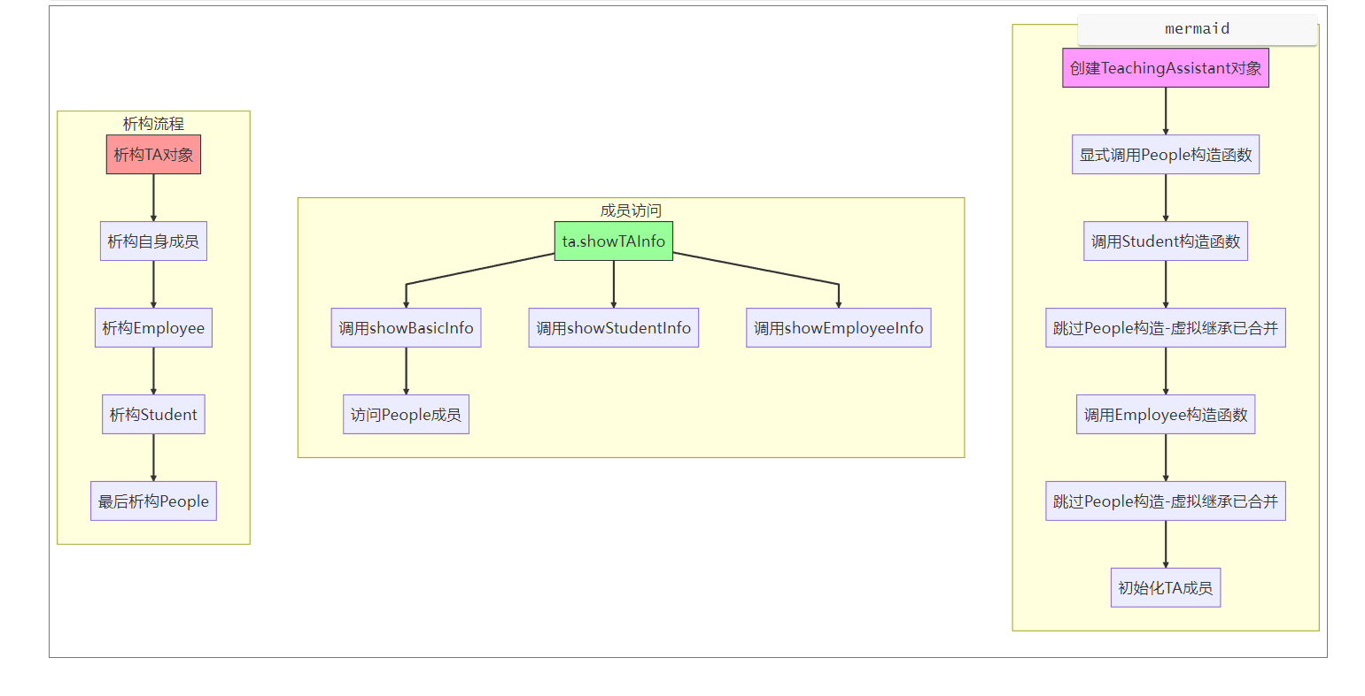
- 实验结果与分析
本实验通过三层类族验证了虚拟继承在多基类继承中的作用。当Student和Employee使用虚拟继承People时，TeachingAssistant多重继承二者后仅保留一个People子对象，彻底解决了成员访问的二义性问题。实验输出显示，创建TA对象时People构造函数仅调用一次，证明虚基类被正确共享。TA可直接调用showBasicInfo()，未触发编译错误，说明基类成员访问路径已合并。析构顺序严格按照反向构造原则执行，验证了对象结构的完整性。虚拟继承通过合并重复基类，确保派生类中仅存在单一公共基类实例，有效避免了传统多重继承导致的"菱形继承"问题。显式调用虚基类构造函数的设计，则强化了初始化控制的精确性。本实验证实虚拟继承是解决多继承冲突的关键机制。
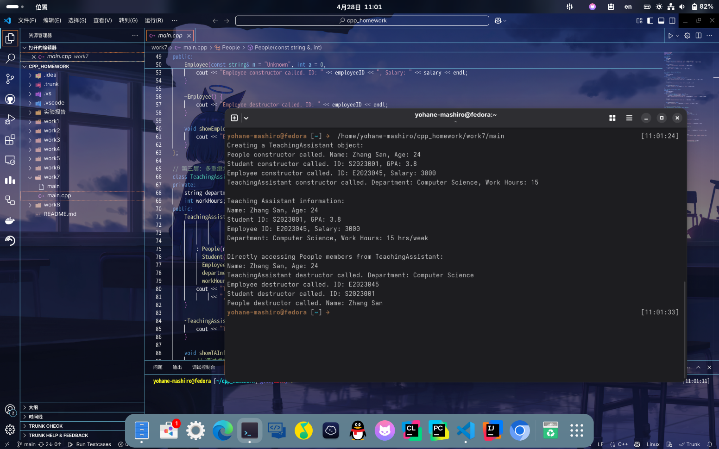
- 实验心得
通过本次虚拟继承实验，我深入理解了其在解决多继承成员冲突中的关键作用。当Student和Employee通过虚拟继承共享People基类时，TeachingAssistant多重继承后仅保留一个People实例，彻底避免了传统菱形继承中的二义性问题。实验结果验证：构造TeachingAssistant时People构造函数仅调用一次，且能直接访问showBasicInfo()，证明虚基类成员路径已合并。此外，显式调用虚基类构造函数的设计让我意识到初始化顺序的严谨性，而析构顺序的反向执行则体现了对象生命周期的完整性。实验还让我反思多继承的复杂性：尽管虚拟继承优化了内存和对象模型，但过度使用可能增加设计耦合。未来开发中，需权衡继承与组合的适用场景，优先通过合理类设计平衡复用性与可维护性。本次实验巩固了我对C++多继承机制的理解，为复杂系统设计奠定了基础。
- 教师评语

- 实验成绩

教师签名： 蒋振刚 批阅日期： 2025 年 4 月 28日
注：项目性质为 演示型、验证型、设计型、综合型和创新型。

