Click generate ticket twice

Click generate ticket twice as the system went very slow in spinning. By doing this it generated 2 tickets. With same ticket ID

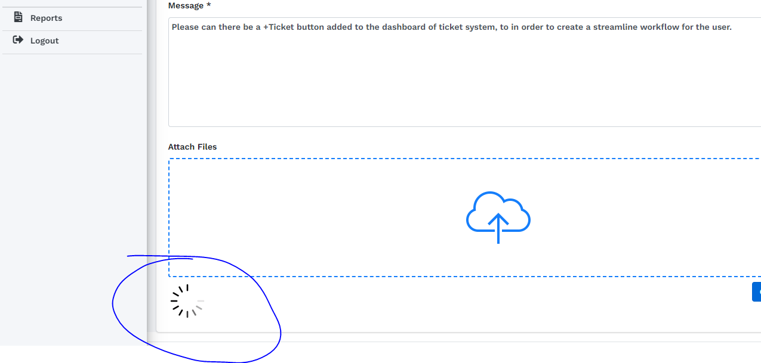

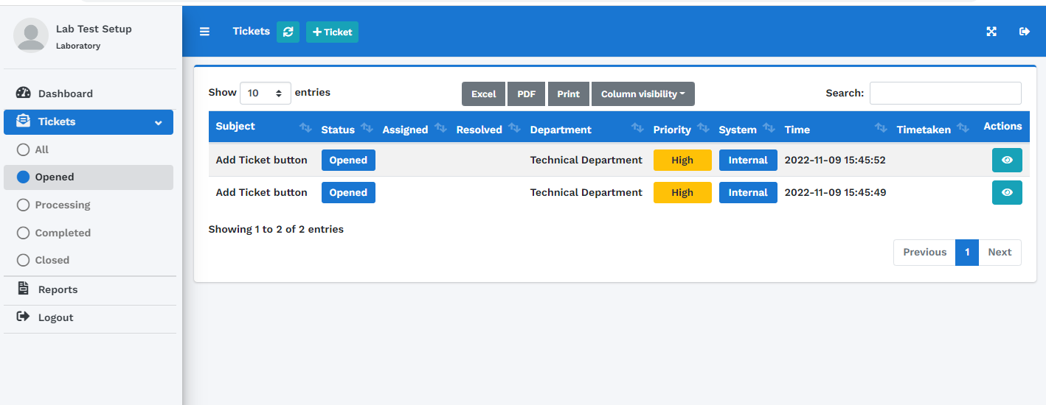

When I replied to one ticket the message is seen on one ticket. Click reply and complete, both tickets went into completed tab with the message.

