There shouldn’t be any run as sample has not been processed yet

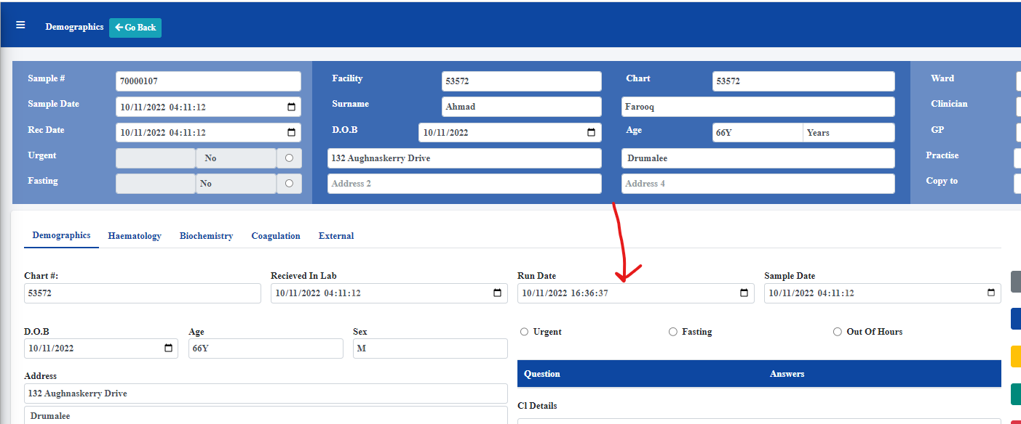

Sample date time and received in lab time should not be the same

Sample date time should be when the sample is confirmed as collected

Received in lab time is time sample is scanned into the lab

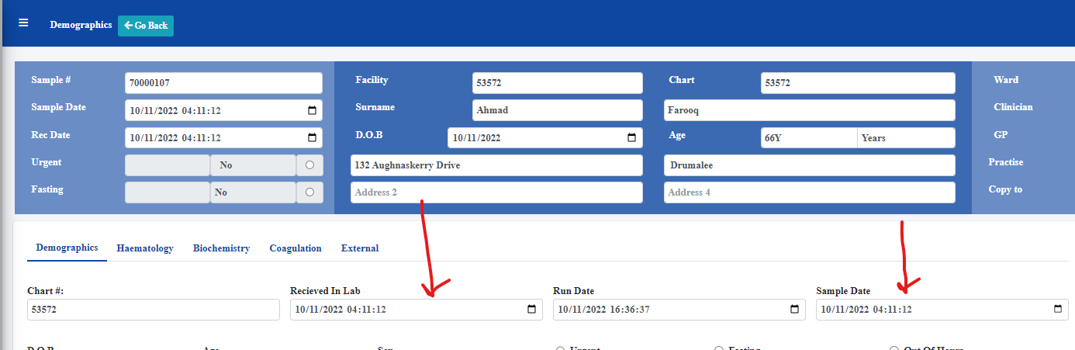

Times completely wrong year is 1970