Sample ordered and resulted on patient today.

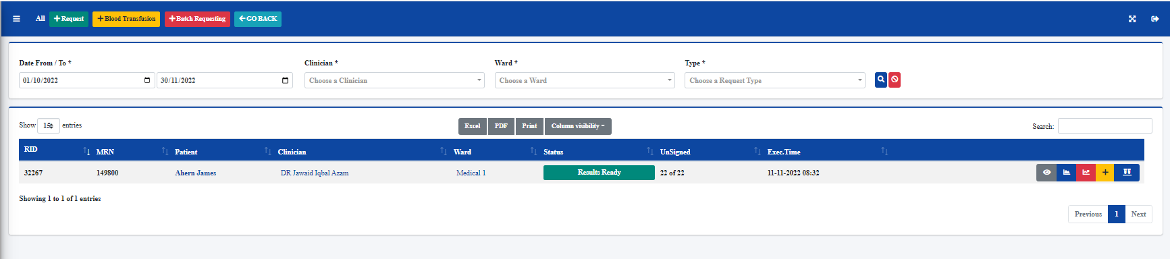

From my patients list I select to add a test to my patient

When the order screen appears there are no clinical details from previous request appearing.

