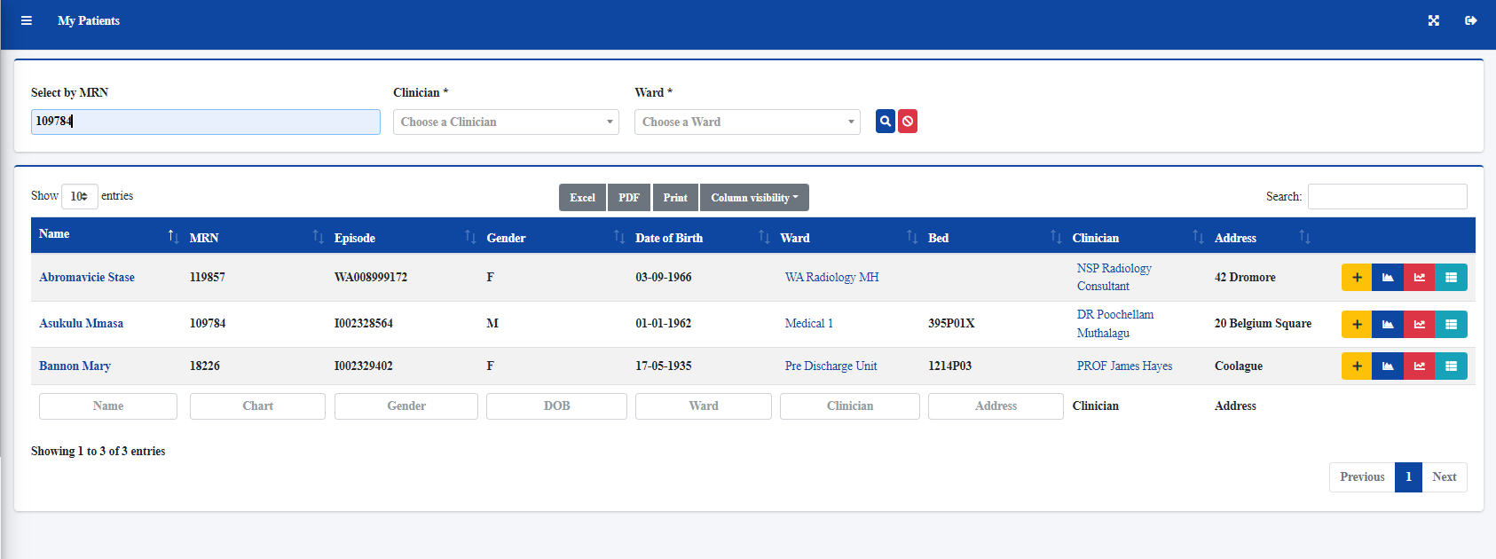

I entered the mrn and clicked to search with MRN number

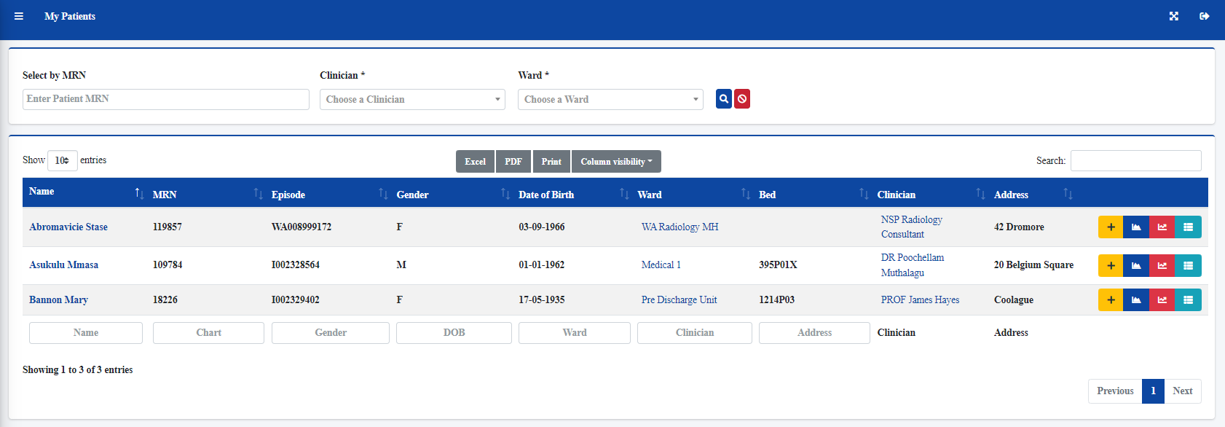

List remains the same, I should only see the patient with the mrn I entered in the search