Logged with micro privileges and there is no printed icon,

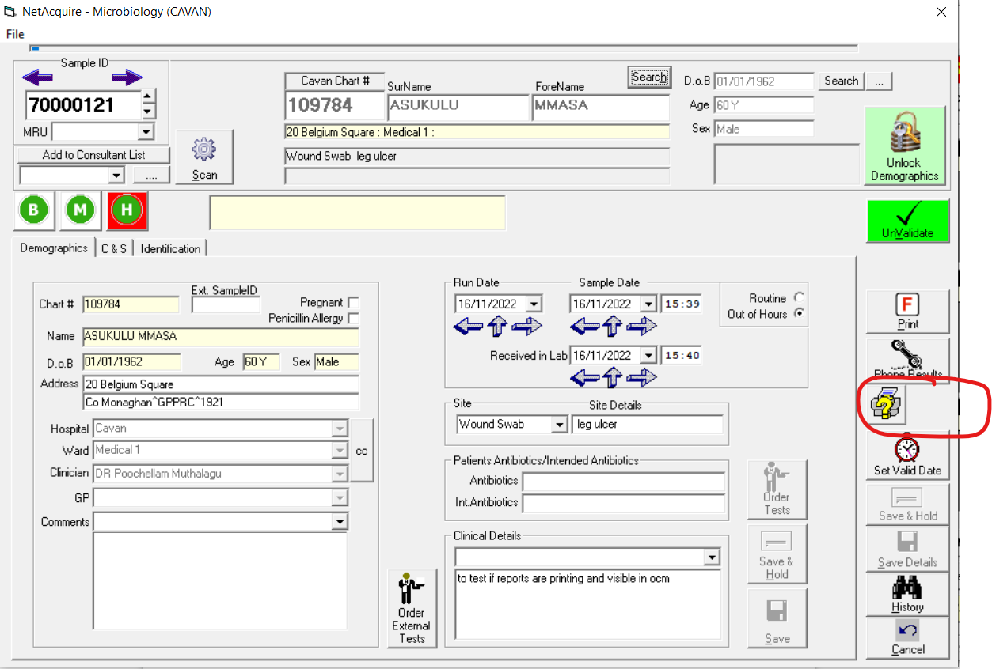

Logged in as user with no micro privileges and the print icon in there suggesting there is a report but there is nothing to view when you click on it

