Open units and precision list

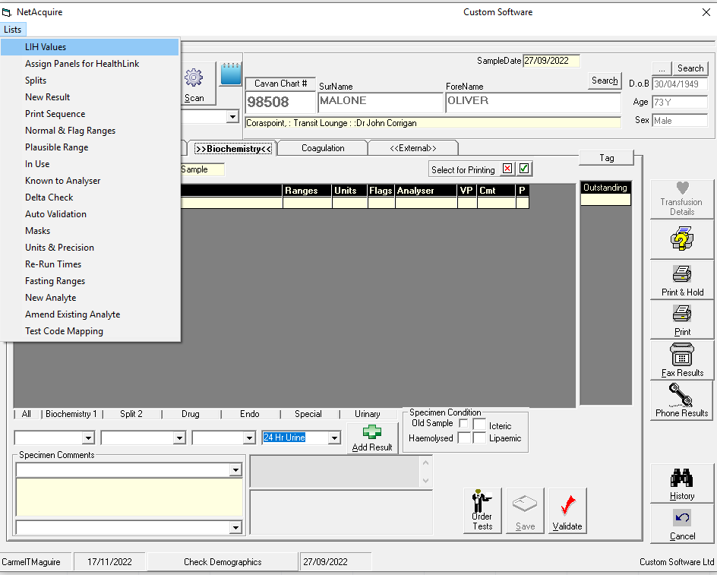

Select spinal fluid from list

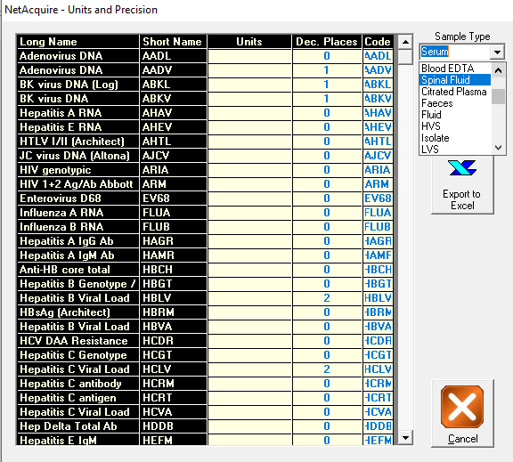

List of test that appears is not the list of sample type spinal fluid it is list of sample type P Edta

It doesn’t matter what sample type you select it list below that appears

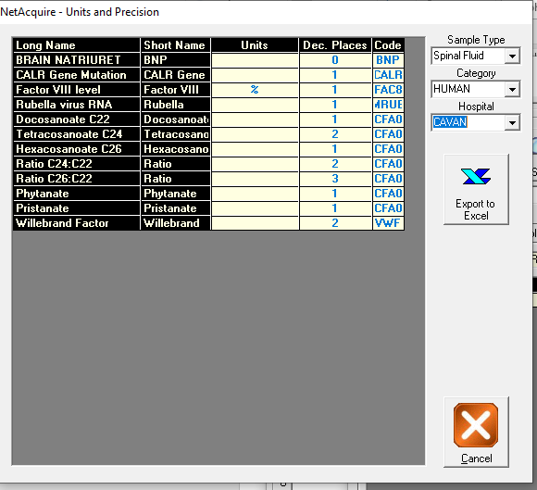

This is the list of tests that should appear when spinal fluid selected

